

**Post Graduate Programme in Management**

**Batch: 2022-24**

**Subject: Decision Analytics for Managers**

**Case Title: ESG Portfolio: Automation of Fundamental Analysis**

**Team 4**

**Team Members**

|  |  |
| --- | --- |
| **Name** | **Roll No.** |
| Meenakshi S. | 2201031 |
| M Sai Vikramadithya | 2201055 |
| Rajjyoti Mazumdar | 2201051 |
| Maharshi Tripathy | 2201027 |

Pinnacle Investments, located in Trichy, specializes in asset wealth management and portfolio management services. The two agendas of the August monthly meeting among team leads are, firstly, to curate an ESG-based portfolio to satisfy the demand of ESG-conscious clients. Secondly, the rising employee costs experienced by the firm with rising demands. After an hour-long discussion, the team expressed their views in favor of creating a personalized ESG Portfolio for the customer through an application. Adithya Sharma was given the responsibility of carrying out this project.

Immediately Aditya Sharma contacted Ms. Ishita, the analytics team lead. After discussion, Ishita agreed to create a pilot app within a week. With the need and trend of the hour, ESG played a critical role. Pinnacle kept this as the top priority since it wanted a first-mover advantage compared to its competitors.

**INDIAN EQUITY MARKET**

The Indian Equity market comprises of two stock exchanges, the National Stock Exchange (NSE) and Bombay Stock Exchange (BSE). The stock exchange facilitates capital raising for companies and allows investors to invest their surplus money. The two critical Indices used as a barometer for the economy are SENSEX and NIFTY50. The economy, Industry and company’s operations and management affect the stock market.

Despite the various economic challenges faced by the global economy, IMF predicts India to grow at a rate of 6.1% in 2023, the fastest growing economy in the world. The driving force behind such a high projection is the government’s investment in technology, enabling it to create more opportunities for growth and employment. IMF projects India’s inflation to ease up to 4.9% in 2023 and 4.4% in 2024.

**ENVIRONMENTAL, SOCIAL AND GOVERNANCE**

Environmental, social and Governance (ESG) is a hot topic in the Indian economy. ESG refers to a framework used to assess the sustainability and ethical aspects of the business. With the increase in awareness, Institutions and investors are not only concerned about the company’s financial performance, but they also consider societal and environmental factors.

The key points covered in environmental factors are carbon emission, resource conservation and waste management. Social factors include the labour practices company’s relationship with various stakeholders such as employees, shareholders, customers, suppliers and society. Governance Factors for a long time have received limelight compared to the above two elements. The factors include the board structure, company leadership, and ethical practices.

**COMPANY BACKGROUND**

Pinnacle Investments has been a highly reputable portfolio advisor for over a decade with around 1 Lakh customers. The company focuses only on the Indian equity market. It has its application on the play store and Apple Store. Its customers highly rate it for its user-friendliness and personalized features. The company generates a revenue of around Rs. 25 Cr and an employee base of 1000 employees.

After meeting with Aditya Sharma, Ishita discussed with the team and listed the required data. The following week, Ishita and Aditya’s team met to finalize the key parameters that would be looked into while performing a Fundamental Analysis (Exhibit 1).

In the meeting, the team agreed to a list of industries that should not be considered while preparing an ESG-based portfolio (Exhibit 2). The meeting concluded with a list of 12 industries that would be included in the pilot stage of the process and 60 companies that would be included (34 large-cap companies, 17 mid-cap companies and 9 small-cap companies). The various parameters to select the industry and the companies were also finalized (Exhibit 3 and 4).

**EXIHIBIT 1**

**INDUSTRY SELECTION PARAMETER**

1. Expected Future Growth Rate
2. GDP Contribution by the sector to the Indian GDP
3. Market Size
4. Threat of new entrants (High/Medium/Low)
5. Majority of the player in organized or unorganized sector
6. Is the industry having a cyclical business
7. Dependencies on government policies
8. Impact of technology on the industry

**EXHIBIT 2**

**INDUSTRIES NOT TO BE CONSIDERED**

1. Coal Industry
2. Tobacco
3. Alcohol
4. Adult entertainment
5. Controversial weapons
6. Nuclear power
7. Gambling

**EXHIBIT 3**

Industry Parameters

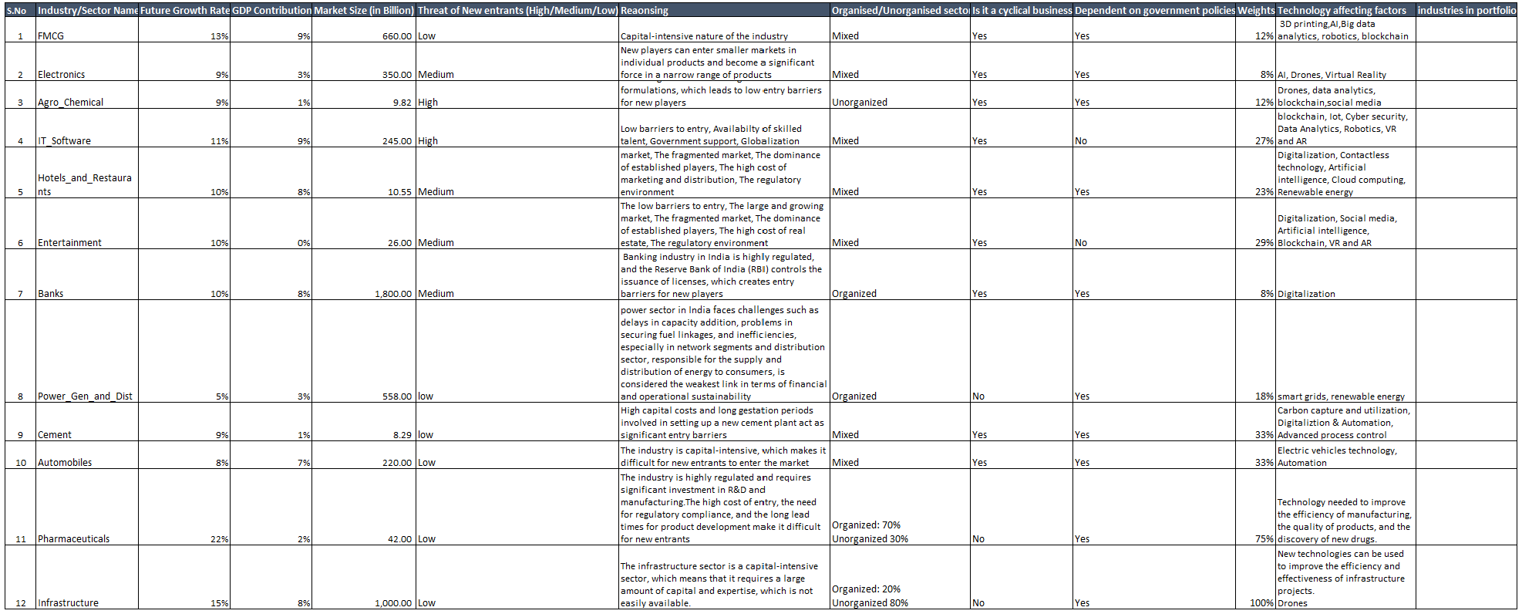

**EXHIBIT 3**

Company Data

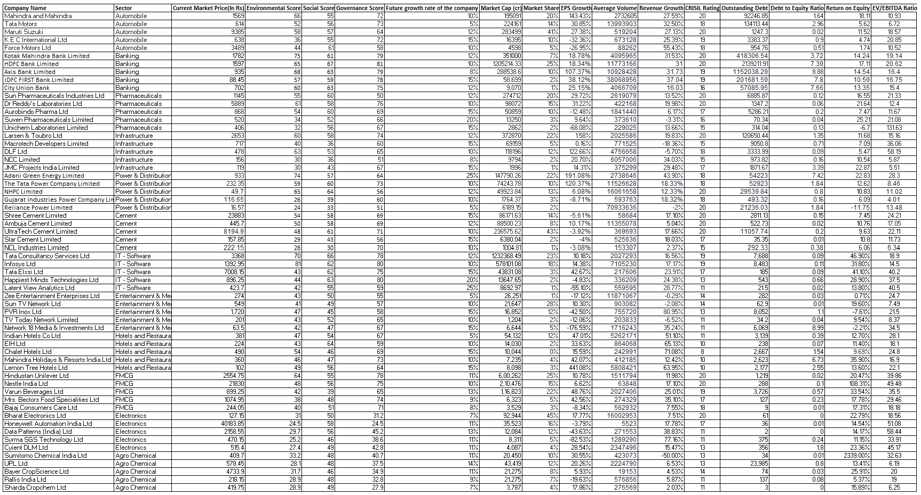

**EXHIBIT 4**

CRISIL Rating

|  |  |  |
| --- | --- | --- |
| **Rating** | **Long-term** | **Short-term** |
| AAA | Highest credit quality | Highest credit quality |
| AA | Very high credit quality | A1 |
| A | High credit quality | A2 |
| BBB | Good credit quality | A3 |
| BB | Speculative | B1 |
| B | Highly speculative | B2 |
| C | Very highly speculative | B3 |
| D | Default | D |

(+) Signifies relatively higher

(-) Signifies relatively lower