# MyLearnMate

**Version 1.0.12.203**

This document is created for informational purposes only.

It provides late-breaking or additional information that supplements the MyLearnMate documentation.

The entire risk of the use or results of the use of this document remains with the user, and Dataminingtools Inc makes no warranties, either express or implied.

Copyright © 2010 Dataminingtools Inc. All Rights Reserved.

## Table of Contents

* Chapter 1. System requirements
* Chapter 2. Documentation
* Chapter 3. Installation

## System requirements

* Microsoft .NET Framework
* Silverlight
* Microsoft Internet Explorer version 7.0 is recommended.

## Documentation

This MyLearnMate.zip includes the following documentation.

## Installation

* Install Silverlight 4.0 prior to installing MyLearnMate. <http://www.microsoft.com/silverlight>
* **Steps to install MyLearnMate:**

1. Download the MyLearnMate.Web.zip
2. Browse for the file Windows installation.

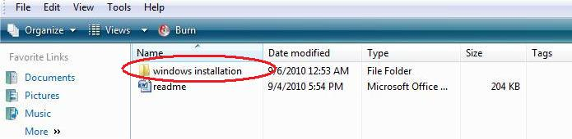

1. Click on the MyLearnMate browser to launch the application.

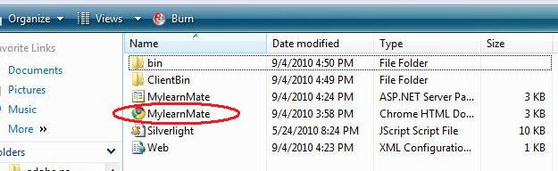

1. Run MyLearnMate on Full Screen. (ALT+ENTER or F11)

On the browser, click Tools > Full Screen

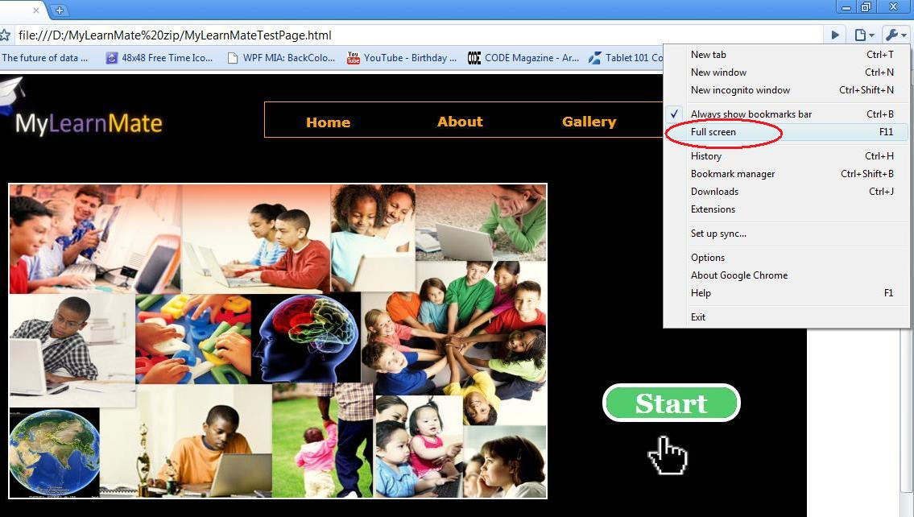

**Use, share and spread with the joy of learning by touch!**

Copyright © 2010 Dataminingtools Inc. All Rights Reserved.