Setting up development environment for RecipeMiner

# Download and install Netbeans 6.8 for javafx:

<http://download.netbeans.org/netbeans/6.9/final/bundles/netbeans-6.9-ml-javafx-windows.exe>

# Download and install H2 database library:

<http://www.h2database.com/h2-setup-2010-06-27.exe>

# Start NetBeans and add the H2 jar to the libraries list:

* Go to Tools->Libraries

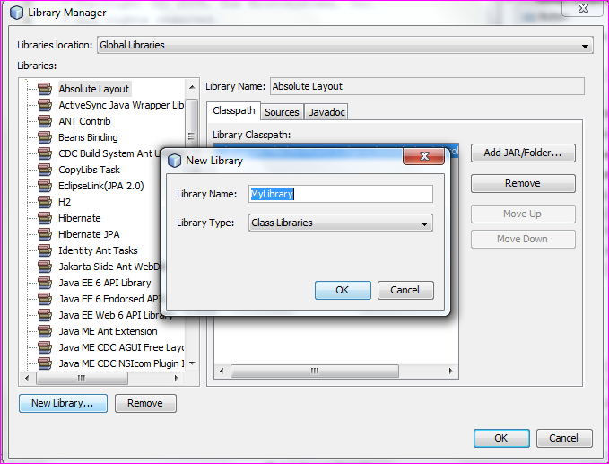

* Click on ‘New Library…’ and add a new library with the following information;
  + Library Name: h2
  + Library Type: Class Libraries

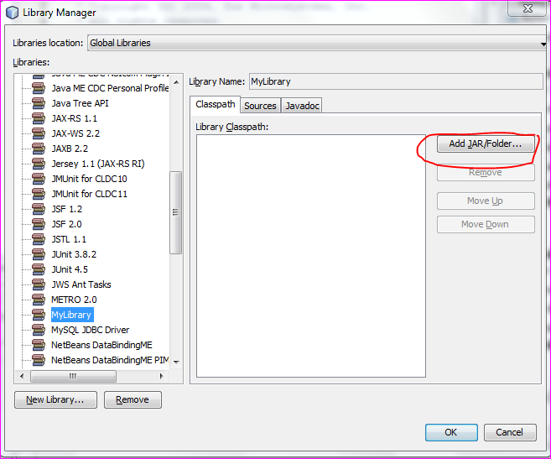

* Click on the new library ‘H2’ and then on ‘Add JAR/Folder…’ and select the file h2<version number>.jar from the installation directory:

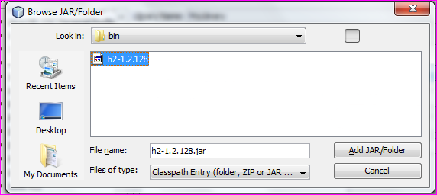

(by default the path is c:\\Program Files\H2\bin\h2<version>.jar)

# Open the RecipeMiner Netbeans project:

* Extract the contents of the RecipeMiner archive available to you and save to a suitable location.
* Click on File->Open Project.. in Netbeans and select the folder named ‘RecipeMiner’ which you extracted in the above step.
* Double click on the project name in navigator pane ‘RecipeMiner’ and right click on ‘Libraries’ and select ‘Add Library’ .. 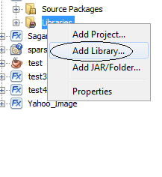
* Select the library ‘H2’ which we created in Step 3 and click on ‘Add Library’

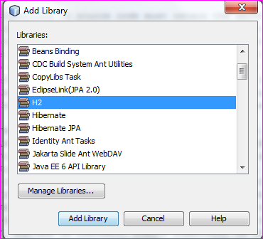

# Run the project by right clicking on the project name and select ‘Run Project’.