STRATEGIES FOR A TOURISM DRIVEN HOSPITALITY MANAGEMENT
Vikramaditya (Vik)
Note: This is gist.This can be expanded to a 100+ Page document with references.

Introduction

Any tourist is lured towards captivating destinations for touring. He gets physically excited, mentally rejuvenated and spiritually elevated by visiting amazing locations of splendour and beauty. Tourists willingly travel, to engage in activities that transcend their experiences to a reality. Tourism Management is an applied field of study and area of professional practice devoted to the design, development and management of leisure and recreation.
Although all types of events have tourism potential, the larger events dominate in tourism as planned events develop the location, bring in revenue and improve the historic heritage. Planned events are spatial–temporal phenomenon, and each is unique because of the interactions among the setting, people and technology—including design elements and the program. The influence of planned events within tourism are of increasing importance for destination competitiveness.
Table 1: Terms
No. | Term | Meaning | Author | Concept
1 | Event | Something that happens | Newman (1950) | Act by people at a specified time and place
2 | Destination | A place where something/someone is being sent or going. | Weaver and Lawton (2002) | Destinations are combinations of tourism products, facilities and services.
3 | Event/ Destination Management | Project management | Terry (1968)  Mc Farland (1979) | Management to create a social experience
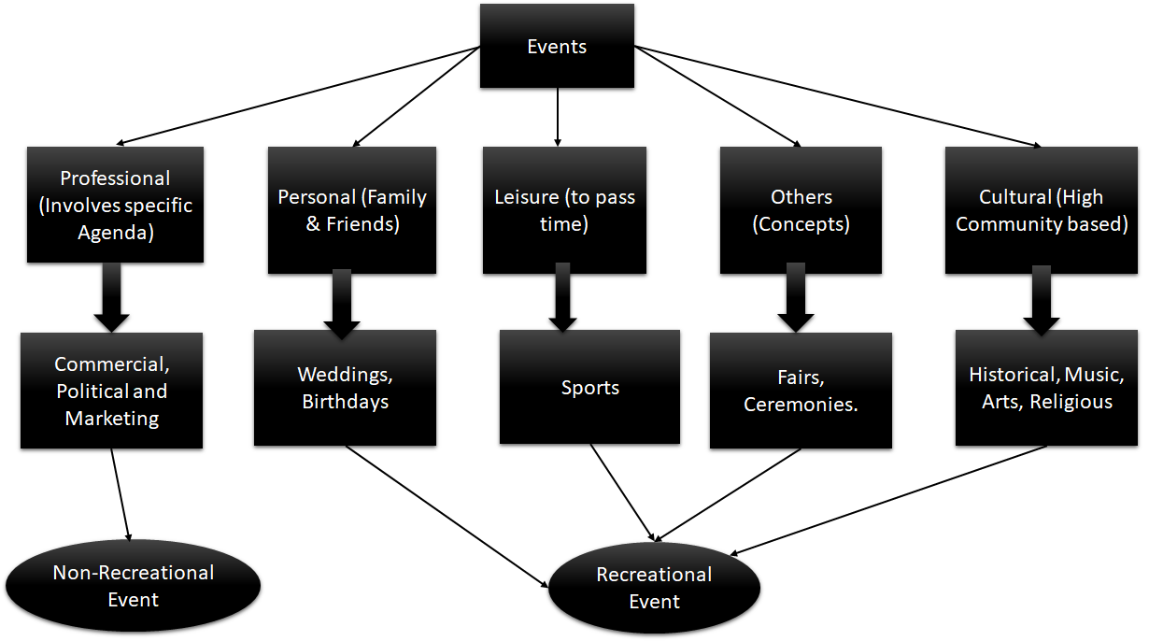
Figure 1: Classification of events towards tourism

People have certain physiological needs, which are essential for their survival, and then they have psychological needs which are important for their well-being. Travel is considered to be one of the several means of satisfying a need. Although it may not necessarily express them. The process of translating a need into visiting a specific destination or to attend event is the motivation which is quite a complex theory for investigation. Tourism, an element of leisure, involves the movement of people away from their place of residence.
Understanding Leisure for Tourism
Time for performing activities by human beings to relax their mind is collectively termed as leisure.
Table 2: Views on work, leisure and recreation
No. | Term | View
1. | Work | Activity carried out through free will or by task - Roadburg (1983)
2. | Leisure | To expand one’s own awareness - Sebastian de Grazia(1964)
2. | Leisure | Engagement to please - Stebbins (1982)
3. | Recreation | Experience - Yukic T. S. (1970)
3. | Recreation | An act to meet the needs- AP John (1986)

Understanding Motivation for Tourism
Motivation is a the major factor for the arousal of feelings of the tourist who is drawn towards the attractions of a destination to attain the desired satisfaction.
On the other hand, physical characteristics related to a destination, like attractions, attributes and other contemplated activities are the factors which are cognitive in nature and arouse the feelings in an individual to travel. The nature of the mind of a traveller who desires to experience the satisfaction can be compared to the joy of driving a locomotive, hauled with a engine.
Understanding Hospitality Services
Tourism researchers described the travel event as a methodological process borne out of life with actions and activities of the traveler. The basic elements which effect the hospitality services are
- The degree of courteousness
- The service teams being knowledgeable
- Overall efficiency: Process + Organization
- Well timed services and availability
- Flexible in rules when applicable or by request.
- Consistent high quality service brings back tourist.
- Communication
- Services should instill trust
- Looks good and exceeds expectations

Table 3: Hospitality in Hotels which are part of tourism industry
No | Activity | Services
1 | Greeting | Pick up  Greeting with a garland on arrival  Offering drinks/beverages for refreshment
2 | Stay | Allotting accommodation based on requirements
2 | i. Provisions in Room | Snack Bar  Bed  Towels, napkins, etc.  Hot and cold beverages  Fruits (Selective)
2 | ii. Bath | Clean toilet/Shower  Soaps  Towels
3 | Personal Service | Answering to room-service requests
4 | Food | Breakfast (Complimentary in Most Locations)  Lunch  Dinner
5 | Recreation | Tours or sightseeing (on request)
6 | Farewell | Services for checking out(Early or late with bag storage)  Dropping at the departure location

STRATEGIES FOR DEVELOPMENT OF A TOURIST DESTINATION
The word ‘strategy’ carries the original meaning to achieve a particular goal, or the ability of governance.
The travel and tourism industry is becoming the single most important business in the world for recreation. It employs over 200 million people around the world, and accounts for 12 per cent of the world’s gross domestic product (GDP).
It is observed that hospitality in modern terms has broken down into four categories of social, private, public and professional. In hospitality experience, the standard for service operations must have zero defects. However, hospitality is found to have a unique definition welcoming and treating even untimely visitor with affection, free will and commitment, which has a significant and unique place in the world.
The key components which impact the development of strategy for a destination are:
- Service Operations
- Tourism travel
- Tourism education
Service operations
The dining styles, the cuisine, has rapidly changed over a the span of 20 years, resulting in a structural change in meals, and food content. The traditional organization of the menu is transfigured. Diet is a selection of foods, which project the lifestyles of ethinic groups that inhabit different parts of the world.
The hotel and restaurant industry is witnessing an rapid growth. Currently for the people who prefer eating outside the fast-growing segment of food service emerged as a business in demand.
The most dramatic force shaping this industry is technology. Technology is helping right from food production, processing, & storage, along with food ordering through applications via mobiles and payments through social and mobile technology. Internet is facilitating the “beat” of online visitors(recommendations and discounts) via web and mobile.
in recent years, fast food also continues its healthy growth with chains such as Mc Donald’s, Domino’s, Pizza Hut, and Subway.
The beliefs and customs of the destination serve as the key element in emerging a winner in the hospitality industry. The non-compliance of the services to the tourist would lead to loss of revenue and further continued ends up damaging the branding.
Tourism Travel
Aviation is used as the first choice of travel by tourists globally.
Tourism education
The education in this field gets the curriculum from various disciplines such as geography, finance, economics, sociology, management, and marketing.
Table 4:Courses in hotel-management education in general (worldwide)
No. | Course | Entry | Duration | Degree Obtained | Areas Covered
1 | Certificate Program | High School | Six months | Certification | Food and Beverage Service, Food Production, Bakery Services, Housekeeping/Guest Services.
2 | Degree Programme,  IntegratedProgrammes | High School | 3 Years  5 years | BBA/BS./BHM | Tourism, Tourism and Hospitality, Hotel Management
3 | PG Program | Degree | 2 Years | MBA/ MS. | Tourism & Hospitality Mgmt., Hotel Management
4 | Research Program | Post Graduate | 3 -5 Year | Ph.D | Tourism and Hospitality, Tourism Management, Hospitality Management.

Table 5: Overall General Strategy
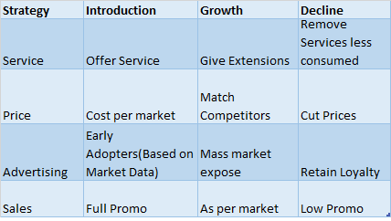
Figure 2: Top strategy

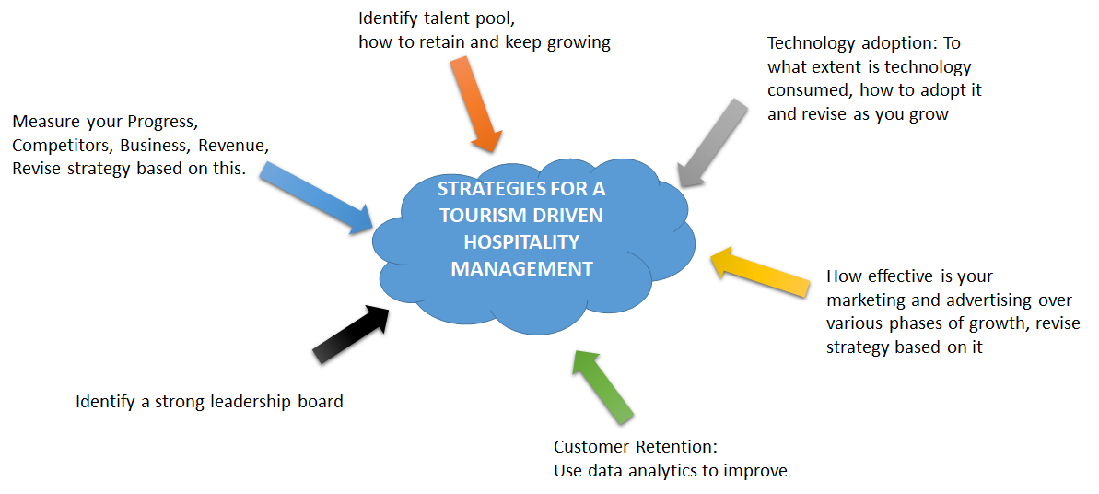Conclusion:
Hospitality has to be undertaken with passion, and care. The pattern in todays world is shifting towards younger generation bringing high revenue, due to increasing wealth and changing life styles.

