**INTERNET PROGRAMMING LAB**

**Ex1**

**Website for International Conference using HTML5 Tags**

**Name : Vikraman S**

**Reg No : 185001195**

**Learning Objective:**

To Develop a Website for an International Conference using HTML5 elements.

1. The conference homepage should consist of the following tabs:

Home, Committee, Call for Papers, Important Dates, Workshops, Registration and Contact.

2. On hovering over the tabs, the content should be highlighted

3. On clicking each tab, it should open in a separate page.

4. The website should contain background Image, logos, header, footer.

5. Use tooltip text for help.

6. For pre-conference workshop registration use form elements.

7. Mandatory Tags: List, Table, Anchor, Image, Semantic Tags

**HTML Code:**

**1.Index.html**

<!DOCTYPE html>

<html>

<head>

  <meta charset="utf-8">

  <title>International Conference on Mobiles</title>

</head>

<body style="background-color:#656da0;text-align:center;font-weight:bold">

  <nav style="font-size:20px">

    <a href="index.html">Home</a> |

    <a href="Commitee.html" target="_blank">Commitee</a> |

    <a href="Papers.html" target="_blank">Call For Papers</a> |

    <a href="Dates.html" target="_blank">Important Dates</a> |

    <a href="Workshop.html" target="_blank">Workshop</a> |

    <a href="Registeration.html" target="_blank">Registeration</a> |

    <a href="Contact.html" target="_blank">Contact Us</a>

  </nav>

<article>

  <header><br><h1>MOBILE WORLD CONGRESS 2021</h1></header>

<footer><p style="color:maroon">MWC21</p></footer>

</article>

<p style="font-size:25px;color:blue"><br>Welcome to MWC 2021!</p>

<p style="font-size:20px">MWC Barcelona is all about Connected Impact. Our key theme for this event which encompasses the most ground-breaking technology of today and explores how it can shape the way we live tomorrow.</p>

<br><p style="font-size:20px;color:darkgreen">Our Goals</p>

<figure>

<br><img src="1.png" usemap="#connectivity" height="200" width="200">

<figcaption>Connectivity</figcaption>

</figure>

<map name="connectivity">

<area shape="rect" coords="0,0,560,470" href="https://en.wikipedia.org/wiki/Internet_access" target="_blank">

</map>

<figure>

<img src="2.png" usemap="#experience" height="200" width="200">

<figcaption>User Experience</figcaption>

</figure>

<map name="experience">

<area shape="rect" coords="0,0,760,470" href="https://en.wikipedia.org/wiki/Customer_experience" target="_blank">

</map>

<figure>

<img src="3.png" usemap="#startup" height="200" width="200">

<figcaption>Start Ups</figcaption>

</figure>

<map name="startup">

<area shape="rect" coords="0,0,860,470" href="https://en.wikipedia.org/wiki/Startup_company" target="_blank">

</map>

<figure>

<img src="4.png" usemap="#ai" height="200" width="200">

<figcaption>Artificial Intelligence</figcaption>

</figure>

<map name="ai">

<area shape="rect" coords="0,0,1060,470" href="https://en.wikipedia.org/wiki/Artificial_intelligence" target="_blank">

</map>

</body>

</html>

**2.Committee.html**

<!DOCTYPE html>

<html>

<head>

  <meta charset="utf-8">

  <title>Commitee</title>

</head>

<body style="background-color:lightcoral;text-align:center;font-weight:bold">

  <nav style="font-size:20px">

    <a href="index.html" target="_blank">Home</a> |

    <a href="Commitee.html">Commitee</a> |

    <a href="Papers.html" target="_blank">Call For Papers</a> |

    <a href="Dates.html" target="_blank">Important Dates</a> |

    <a href="Workshop.html" target="_blank">Workshop</a> |

    <a href="Registeration.html" target="_blank">Registeration</a> |

    <a href="Contact.html" target="_blank">Contact Us</a>

  </nav>

  <br><h1 style="text-align:center">Commitee</h1>

<p style="font-size:25px;color:blue"><br>CEO Reliance Jio - Mathew Oommen</p>

<p style="font-size:25px;color:snow"><br>CEO IBM - Aravind Krishna</p>

<p style="font-size:25px;color:darkgreen"><br>CEO Verizon - Hans Vestberg</p>

<p style="font-size:25px;color:maroon"><br>CEO Neuro ELectrics - Ana Maiques</p>

<p style="font-size:25px;color:gold"><br>CEO Starling Bank - Anne Boden</p>

</body>

</html>

**3.Papers.html**

<!DOCTYPE html>

<html>

<head>

  <meta charset="utf-8">

  <title>Call For papers</title>

</head>

<body style="background-image:url('5g.png');background-attachment:fixed;background-size:cover;text-align:center;font-weight:bold; color:cyan">

  <nav style="font-size:20px">

    <a href="index.html" target="_blank">Home</a> |

    <a href="Commitee.html" target="_blank">Commitee</a> |

    <a href="Papers.html">Call For Papers</a> |

    <a href="Dates.html" target="_blank">Important Dates</a> |

    <a href="Workshop.html" target="_blank">Workshop</a> |

    <a href="Registeration.html" target="_blank">Registeration</a> |

    <a href="Contact.html" target="_blank">Contact Us</a>

  </nav>

  <br><h1 style="text-align:center;color:red">Call For Papers</h1>

<ol>

<li style="text-align:left;color:white;font-size:25px">Connectivity</li>

<ul>

<li style="text-align:left">5g</li>

<li style="text-align:left">Wifi 6</li>

<li style="text-align:left">Cloud Connectivity</li>

<li style="text-align:left">Network Optimisation</li>

<li style="text-align:left">Cyber Security</li>

<li style="text-align:left">Distribution System</li>

</ul>

<li style="text-align:left;color:white;font-size:25px">User Experience</li>

<ul>

<li style="text-align:left">After Sale Support</li>

<li style="text-align:left">Security Patches</li>

<li style="text-align:left">Easy Query</li>

<li style="text-align:left">Feedback Portal</li>

</ul>

<li style="text-align:left;color:white;font-size:25px">Start Ups</li>

<ul>

<li style="text-align:left">Tech Horizon</li>

<li style="text-align:left">Deal Flow</li>

<li style="text-align:left">Cretive Minds</li>

</ul>

<li style="text-align:left;color:white;font-size:25px">Artificial Intelligence</li>

<ul>

<li style="text-align:left">Quantum Computing</li>

<li style="text-align:left">Deep Learning</li>

<li style="text-align:left">Optimisations</li>

<li style="text-align:left">Gaming and Esports</li>

<li style="text-align:left">Smart Data Sensing</li>

</ul>

</ol>

</body>

</html>

**4.Dates.html**

<!DOCTYPE html>

<html>

<head>

  <meta charset="utf-8">

  <title>Important Dates</title>

</head>

<body style="background-image:url('image.png');background-attachment:fixed;background-size:cover;text-align:center;font-weight:bold;">

<nav style="font-size:20px">

    <a href="index.html" target="_blank">Home</a> |

    <a href="Commitee.html" target="_blank">Commitee</a> |

    <a href="Papers.html" target="_blank">Call For Papers</a> |

    <a href="Dates.html">Important Dates</a> |

    <a href="Workshop.html" target="_blank">Workshop</a> |

    <a href="Registeration.html" target="_blank">Registeration</a> |

    <a href="Contact.html" target="_blank">Contact Us</a>

  </nav>

  <br><h1>Important Dates</h1>

<center><br><br>

<table border="1" width="50%" style="background-color:white">

<tr>

<th style="font-size:30px;color:red">Event</th>

<th style="font-size:30px;color:darkgreen">Date</th>

</tr>

<tr>

<td style="font-size:25px;color:slateblue;text-align:center">Inaugural</td>

<td style="font-size:25px;color:brown;text-align:center">June 28, 2021</td>

</tr>

<tr>

<td style="font-size:25px;color:slateblue;text-align:center">New Tech</td>

<td style="font-size:25px;color:brown;text-align:center">June 29, 2021</td>

</tr>

<tr>

<td style="font-size:25px;color:slateblue;text-align:center">Mobile Awards</td>

<td style="font-size:25px;color:brown;text-align:center">June 30, 2021</td>

</tr>

<tr>

<td style="font-size:25px;color:slateblue;text-align:center">Conclusion</td>

<td style="font-size:25px;color:brown;text-align:center">July 1, 2021</td>

</tr>

</table>

</center>

<br><br>

<img src="time.gif" height="300px" width="300px">

</body>

</html>

**5.Workshop.html**

<!DOCTYPE html>

<html>

<head>

  <meta charset="utf-8">

  <title>Workshop</title>

</head>

<body style="background-color:lightseagreen;text-align:center;font-weight:bold">

  <nav style="font-size:20px">

    <a href="index.html" target="_blank">Home</a> |

    <a href="Commitee.html" target="_blank">Commitee</a> |

    <a href="Papers.html" target="_blank">Call For Papers</a> |

    <a href="Dates.html" target="_blank">Important Dates</a> |

    <a href="Workshop.html">Workshop</a> |

    <a href="Registeration.html" target="_blank">Registeration</a> |

    <a href="Contact.html" target="_blank">Contact Us</a>

  </nav>

  <br><h1>Pre Conference Workshop</h1>

<br><p style="font-size:25px;color:maroon"><br>Workshop 1 : Game Development<br>20 June 2021</p>

<br><p style="font-size:25px;color:darkgreen"><br>Workshop 2 : Cloud Computing<br>24 June 2021</p>

</body>

</html>

**6.Registeration.html**

<!DOCTYPE html>

<html>

<head>

  <meta charset="utf-8">

  <title>Registeration</title>

</head>

<body style="background-color:lightsteelblue;text-align:center;font-weight:bold">

  <nav style="font-size:20px">

    <a href="index.html" target="_blank">Home</a> |

    <a href="Commitee.html" target="_blank">Commitee</a> |

    <a href="Papers.html" target="_blank">Call For Papers</a> |

    <a href="Dates.html" target="_blank">Important Dates</a> |

    <a href="Workshop.html" target="_blank">Workshop</a> |

    <a href="Registeration.html">Registeration</a> |

    <a href="Contact.html" target="_blank">Contact Us</a>

  </nav>

  <br><h1>Registeration</h1>

<br><br>

<form style="font-size:20px">

<label for="fname">First name :</label>

<input type="text" id="fname" name="fname" value=""><br>

<br><label for="lname">Last name :</label>

<input type="text" id="lname" name="lname" value=""><br>

<br>Gender :<input type="radio" id="male" name="gender" value="male">

<label for="male">Male</label>

<input type="radio" id="female" name="gender" value="female">

<label for="female">Female</label><br>

<br><label for="dob">DOB :</label>

<input type="date"id="dob"name="dob"><br><br>

<br>Workshop : <input type="checkbox" id="w1" name="w1" value="">

<label for="w1">1. Game Development</label><br>

<input type="checkbox" id="w2" name="w2" value="">

<label for="w2">2. Cloud Computing</label><br>

<br><label for="mail">Email :</label>

<input type="email" id="mail" name="mail" value=""><br>

<br><label for="num">Mobile No. :</label>

<input type="number" id="num" name="num" value=""><br>

<br><br><input type="submit" onclick="alert('Submitted')" value="Submit">

</form>

</body>

</html>

**7.Contact.html**

<!DOCTYPE html>

<html>

<head>

  <meta charset="utf-8">

  <title>Contact Us</title>

</head>

<body style="background-color:lightyellow;text-align:center;font-weight:bold">

  <nav style="font-size:20px">

    <a href="index.html" target="_blank">Home</a> |

    <a href="Commitee.html" target="_blank">Commitee</a> |

    <a href="Papers.html" target="_blank">Call For Papers</a> |

    <a href="Dates.html" target="_blank">Important Dates</a> |

    <a href="Workshop.html" target="_blank">Workshop</a> |

    <a href="Registeration.html" target="_blank">Registeration</a> |

    <a href="Contact.html">Contact Us</a>

  </nav>

  <br><h1>Contact Us</h1>

<br><br><br><br>

<address style="font-size:25px;color:maroon">

Oragniser : <a href="mailto:ramesh@gmail.com"> Ramesh </a>

<br>Mobile No. : <a href="tel:10101 20202">10101 20202</a>

<br><br><br><br>

<address style="font-size:25px;color:darkgreen">

Manager : <a href="mailto:nessa@gmail.com"> Nessa </a>

<br>Mobile No. : <a href="tel:55555 44444">55555 44444</a>

<br><br><br><br>

<address style="font-size:25px;color:purple">

<a href="mailto:helpdesk@gmail.com"> Help Desk</a>

<br>Mobile No. : <a href="tel:1234567890">1234567890</a>

</address>

</body>

</html>

**Screenshots:**

**1.Index.html**

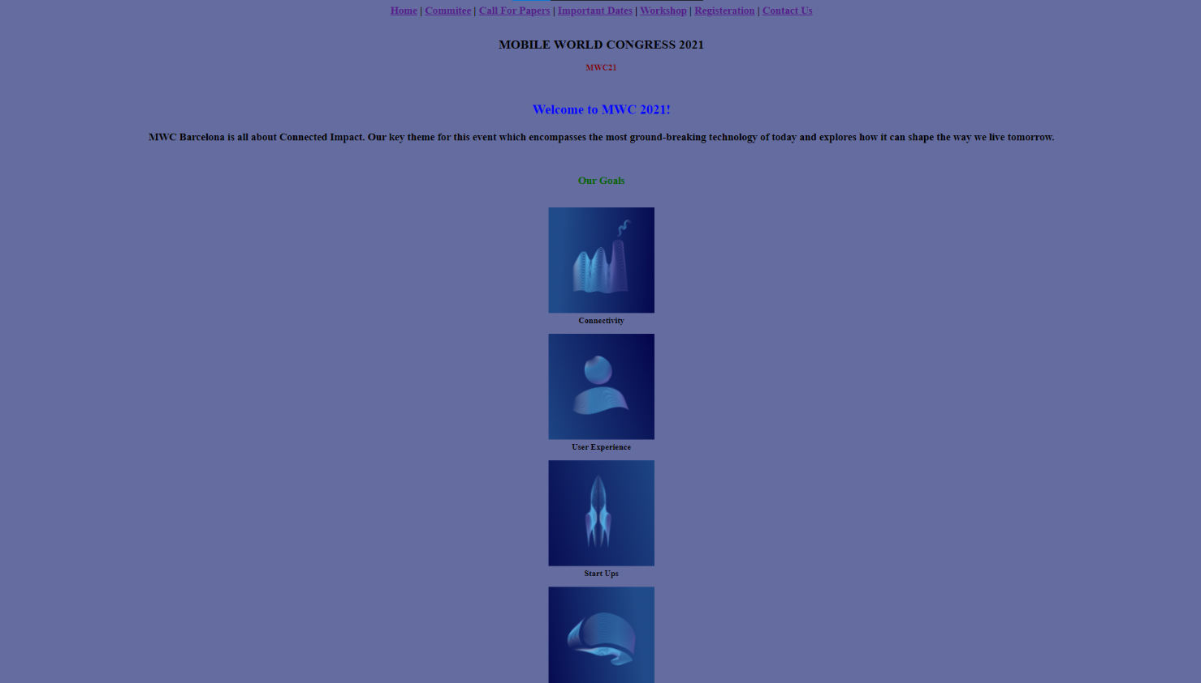

**2.Committee.html**

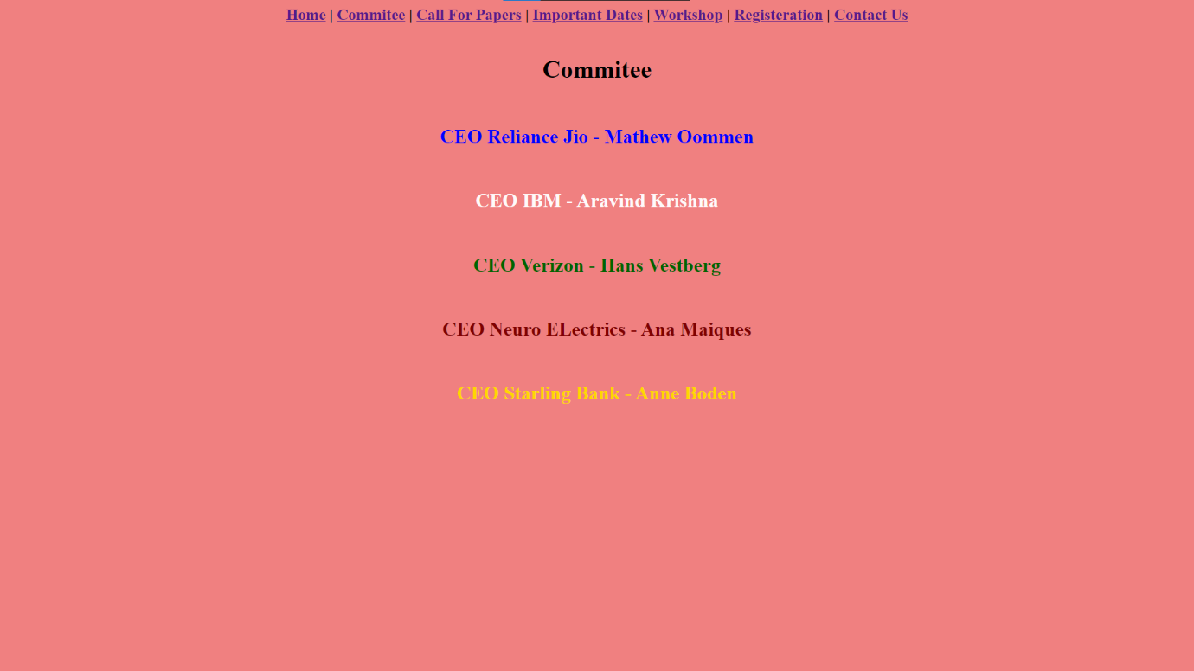

**3.Papers.html**

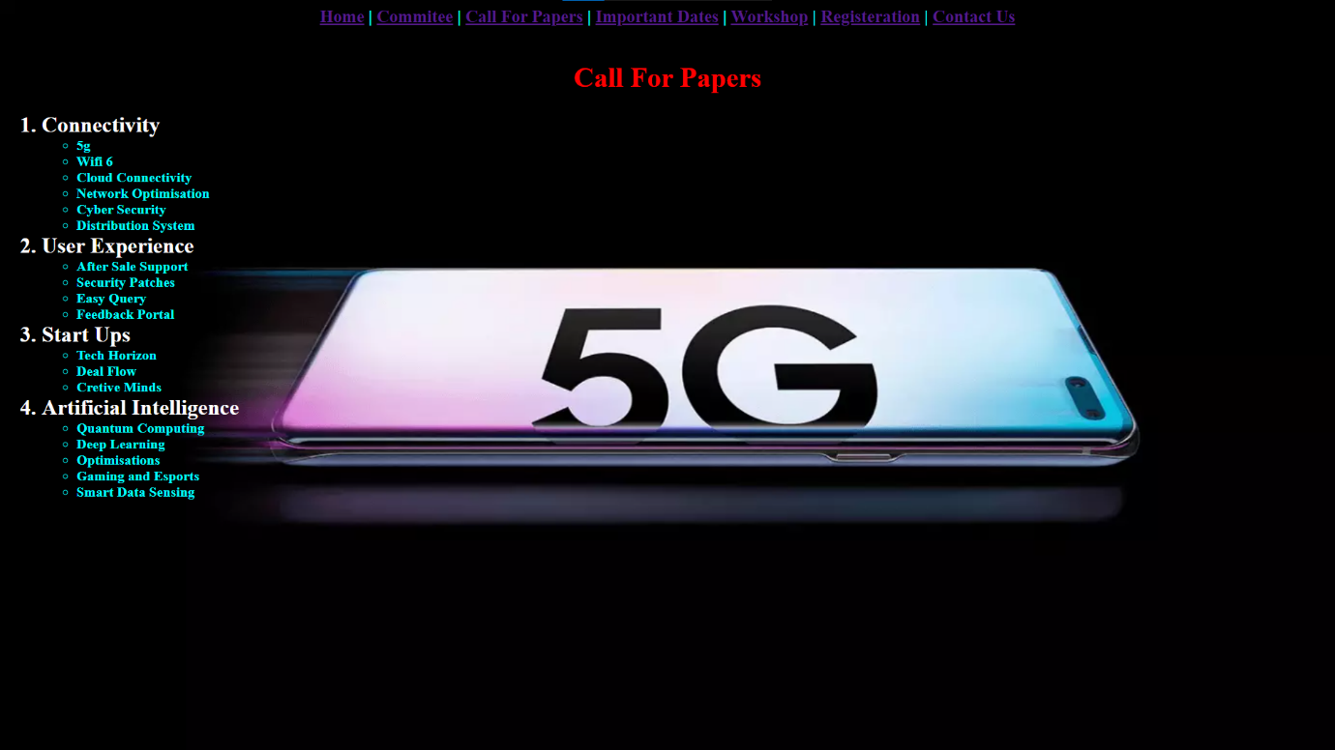

**4.Dates.html**

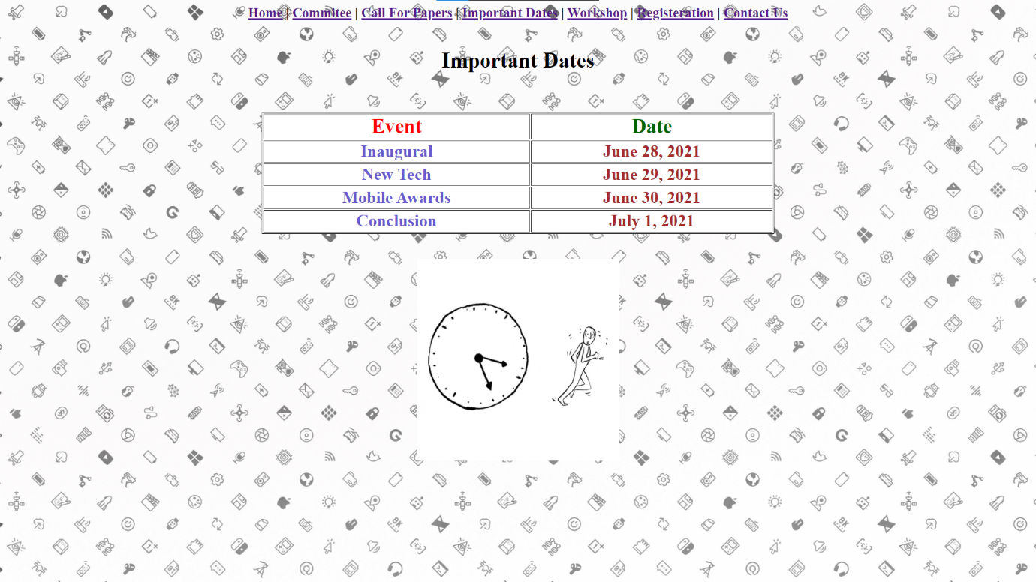

**5.Workshop.html**

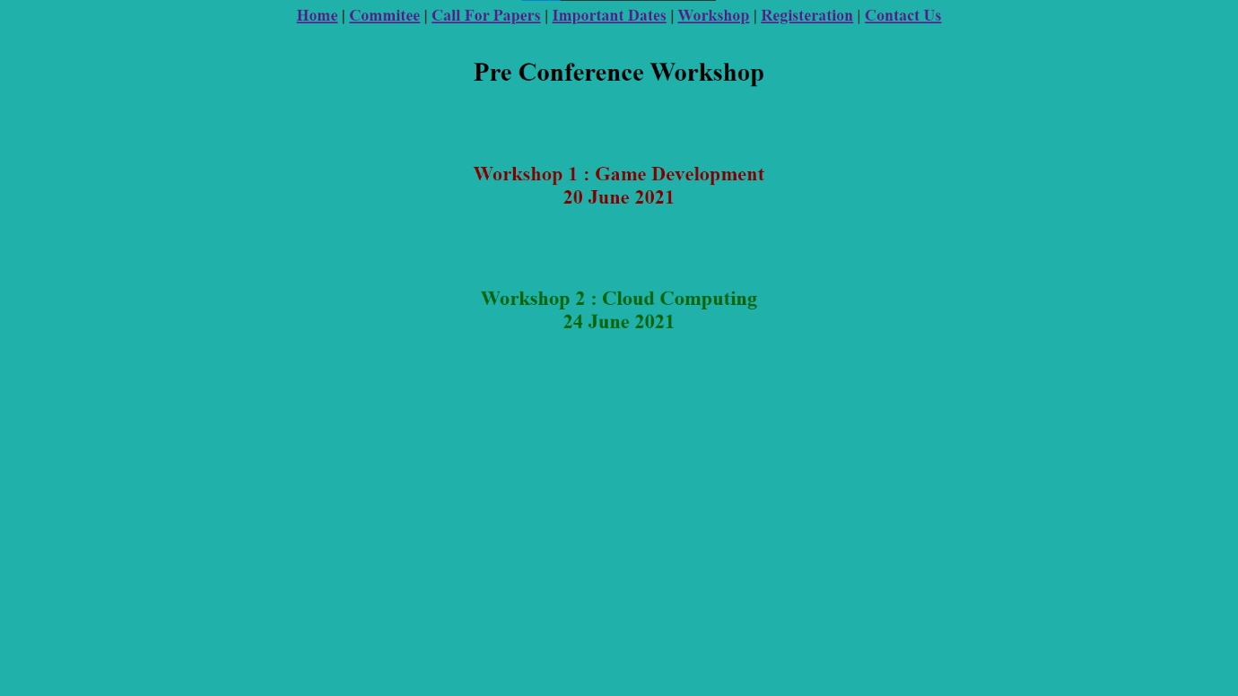

**6.Registeration.html**

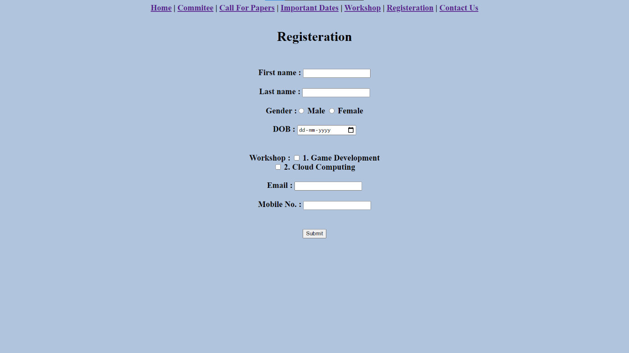

**7.Contact.html**

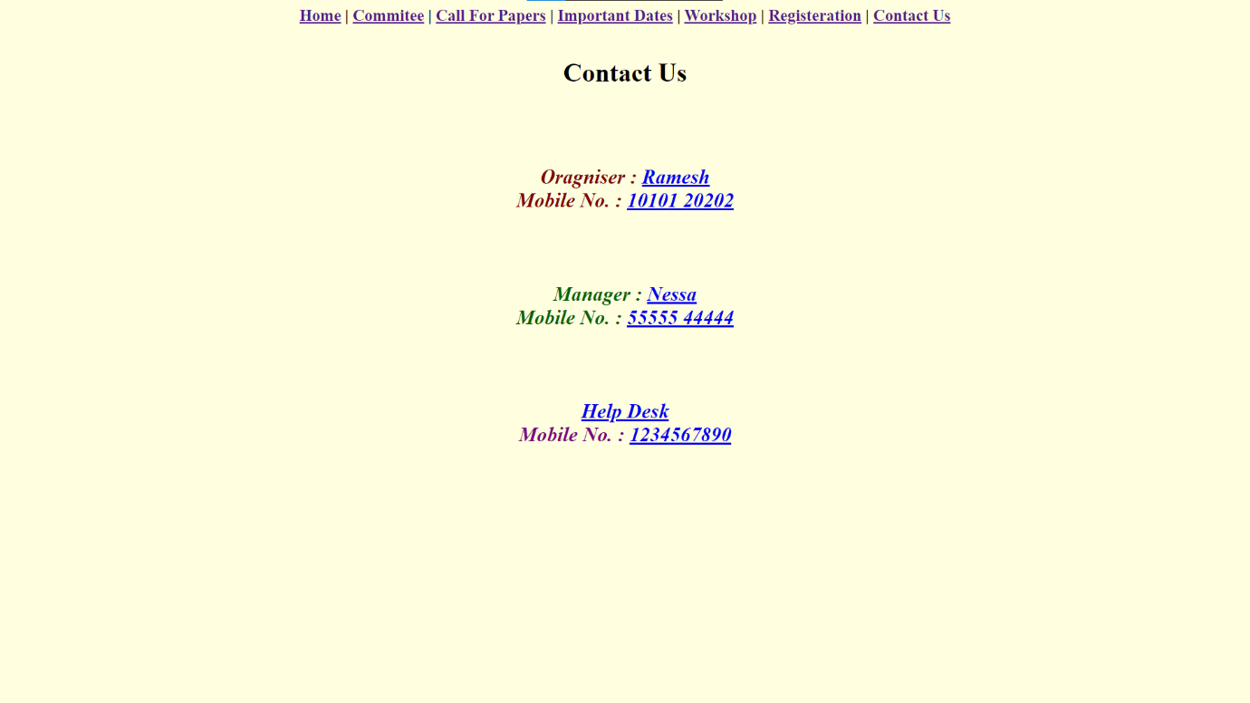

**Learning Outcomes:**

* I have learnt to use basic HTML tags and attributes to implement this webpage.
* I have understood the use of style to make the page look attractive and user friendly.
* I have learnt how to insert image and gif in the web page.
* I have understood the working of image map and anchor tags.
* I have learnt about the various semantic tags and how to use them in the webpage.
* I have learnt about various HTML elements line form, article, tables, etc and implemented them in the webpage.