**INTERNET PROGRAMMING LAB**

**Ex2**

**Website for International Conference using CSS**

**Name : Vikraman S**

**Reg No : 185001195**

**Learning Objective:**

To Develop a Website for an International Conference using HTML5 and Cascading Style Sheets.

**Specifications:**

While designing the web page:

1. Use Inline, Embedded, External Style Sheets.

2. Use box model, outline concepts.

3. CSS concepts with table, list, links, forms, anchor etc.

4. Write rules with rule cascading and inheritance.

5. Include Tooltip, Icons, Graphics, Animations, and Transformations.

**HTML Code:**

**1.index.html**

<!DOCTYPE html>

<html>

<head>

  <meta charset="utf-8">

<meta name="viewport" content="width=device-width, initial-scale=1.0">

<link rel="stylesheet" href="style.css">

<link rel="stylesheet" href="https://cdnjs.cloudflare.com/ajax/libs/font-awesome/4.7.0/css/font-awesome.min.css">

  <title>International Conference on Mobiles</title>

</head>

<body>

<div class="navi">

  <nav>

    <a href="index.html"><div class="tooltip"><i class="fa fa-home"></a></i><span class="tooltiptext">Go to home page</span></div> |

    <a href="Commitee.html" target="_blank">Commitee</a> |

    <a href="Papers.html" target="_blank">Call For Papers</a> |

    <a href="Dates.html" target="_blank">Important Dates</a> |

    <a href="Workshop.html" target="_blank">Workshop</a> |

    <a href="Registeration.html" target="_blank">Registeration</a> |

    <a href="Contact.html" target="_blank">Contact Us</a>

  </nav>

</div>

  <br><h1>MOBILE WORLD CONGRESS 2021</h1>

<p class="trans" style="font-size:25px;color:maroon">MWC21!</p>

<div class="animate">

<marquee behavior="alternate" direction="left" scrollamount="20"><p style="font-size:25px">Welcome to MWC 2021!</p></marquee></div>

<p style="font-size:20px">MWC Barcelona is all about Connected Impact. Our key theme for this event which encompasses the most ground-breaking technology of today and explores how it can shape the way we live tomorrow.</p>

<p style="font-size:30px;color:darkgreen">Our Goals</p>

<div class="column">

<img src="1.png" usemap="#connectivity" height="200" width="200">

<figcaption>Connectivity</figcaption>

<map name="connectivity">

<area shape="rect" coords="0,0,90,435" href="https://en.wikipedia.org/wiki/Internet_access" target="_blank">

</div>

<div class="column">

<img src="2.png" usemap="#experience" height="200" width="200">

<figcaption>User Experience</figcaption>

<map name="experience">

<area shape="rect" coords="0,0,460,435" href="https://en.wikipedia.org/wiki/Customer_experience" target="_blank">

</div>

<div class="column">

<img src="3.png" usemap="#startup" height="200" width="200">

<figcaption>Start Ups</figcaption>

<map name="startup">

<area shape="rect" coords="0,0,840,435" href="https://en.wikipedia.org/wiki/Startup_company" target="_blank">

</div>

<div class="column">

<img src="4.png" usemap="#ai" height="200" width="200">

<figcaption>Artificial Intelligence</figcaption>

<map name="ai">

<area shape="rect" coords="0,0,1220,435" href="https://en.wikipedia.org/wiki/Artificial_intelligence" target="_blank">

</div>

</body>

</html>

**2.Committee.html**

<!DOCTYPE html>

<html>

<head>

  <meta charset="utf-8">

<meta name="viewport" content="width=device-width, initial-scale=1.0">

<link rel="stylesheet" href="style.css">

<link rel="stylesheet" href="https://cdnjs.cloudflare.com/ajax/libs/font-awesome/4.7.0/css/font-awesome.min.css">

  <title>Commitee</title>

<style>

body{

background-color:lightcoral;

text-align:center;

font-weight:bold;

}

</style>

</head>

<body>

<div class="navi">

  <nav>

    <a href="index.html" target="_blank"><div class="tooltip"><i class="fa fa-home"></a></i><span class="tooltiptext">Go to home page</span></div> |

    <a href="Commitee.html">Commitee</a> |

    <a href="Papers.html" target="_blank">Call For Papers</a> |

    <a href="Dates.html" target="_blank">Important Dates</a> |

    <a href="Workshop.html" target="_blank">Workshop</a> |

    <a href="Registeration.html" target="_blank">Registeration</a> |

    <a href="Contact.html" target="_blank">Contact Us</a>

  </nav>

</div>

<div class="animate">

  <br><h1 style="text-align:center">Commitee</h1></div>

<p style="font-size:25px;color:blue"><br>CEO Reliance Jio - Mathew Oommen</p>

<p style="font-size:25px;color:snow"><br>CEO IBM - Aravind Krishna</p>

<p style="font-size:25px;color:darkgreen"><br>CEO Verizon - Hans Vestberg</p>

<p style="font-size:25px;color:maroon"><br>CEO Neuro ELectrics - Ana Maiques</p>

<p style="font-size:25px;color:gold"><br>CEO Starling Bank - Anne Boden</p>

</body>

</html>

**3.Papers.html**

<!DOCTYPE html>

<html>

<head>

  <meta charset="utf-8">

<meta name="viewport" content="width=device-width, initial-scale=1.0">

<link rel="stylesheet" href="style.css">

<link rel="stylesheet" href="https://cdnjs.cloudflare.com/ajax/libs/font-awesome/4.7.0/css/font-awesome.min.css">

  <title>Call For papers</title>

<style>

body{

background-image:url('5g.png');

background-attachment:fixed;

background-size:cover;

text-align:center;

font-weight:bold;

color:cyan;

}

</style>

</head>

<body>

<div class="navi">

  <nav style="font-size:20px">

<a href="index.html" target="_blank"><div class="tooltip"><i class="fa fa-home"></a></i><span class="tooltiptext">Go to home page</span></div> |

    <a href="Commitee.html" target="_blank">Commitee</a> |

    <a href="Papers.html">Call For Papers</a> |

    <a href="Dates.html" target="_blank">Important Dates</a> |

    <a href="Workshop.html" target="_blank">Workshop</a> |

    <a href="Registeration.html" target="_blank">Registeration</a> |

    <a href="Contact.html" target="_blank">Contact Us</a>

  </nav>

</div>

  <br><h1 style="text-align:center;color:red">Call For Papers</h1>

<ol>

<li style="text-align:left;color:white;font-size:25px">Connectivity</li>

<ul>

<li style="text-align:left">5g</li>

<li style="text-align:left">Wifi 6</li>

<li style="text-align:left">Cloud Connectivity</li>

<li style="text-align:left">Network Optimisation</li>

<li style="text-align:left">Cyber Security</li>

<li style="text-align:left">Distribution System</li>

</ul>

<li style="text-align:left;color:white;font-size:25px">User Experience</li>

<ul>

<li style="text-align:left">After Sale Support</li>

<li style="text-align:left">Security Patches</li>

<li style="text-align:left">Easy Query</li>

<li style="text-align:left">Feedback Portal</li>

</ul>

<li style="text-align:left;color:white;font-size:25px">Start Ups</li>

<ul>

<li style="text-align:left">Tech Horizon</li>

<li style="text-align:left">Deal Flow</li>

<li style="text-align:left">Cretive Minds</li>

</ul>

<li style="text-align:left;color:white;font-size:25px">Artificial Intelligence</li>

<ul>

<li style="text-align:left">Quantum Computing</li>

<li style="text-align:left">Deep Learning</li>

<li style="text-align:left">Optimisations</li>

<li style="text-align:left">Gaming and Esports</li>

<li style="text-align:left">Smart Data Sensing</li>

</ul>

</ol>

</body>

</html>

**4.Dates.html**

<!DOCTYPE html>

<html>

<head>

  <meta charset="utf-8">

<meta name="viewport" content="width=device-width, initial-scale=1.0">

<link rel="stylesheet" href="style.css">

<link rel="stylesheet" href="https://cdnjs.cloudflare.com/ajax/libs/font-awesome/4.7.0/css/font-awesome.min.css">

  <title>Important Dates</title>

<style>

body{

background-image:url('image.png');

background-attachment:fixed;

background-size:cover;

text-align:center;

font-weight:bold;

}

</style>

</head>

<body>

<div class="navi">

<nav style="font-size:20px">

    <a href="index.html" target="_blank"><div class="tooltip"><i class="fa fa-home"></a></i><span class="tooltiptext">Go to home page</span></div> |

    <a href="Commitee.html" target="_blank">Commitee</a> |

    <a href="Papers.html" target="_blank">Call For Papers</a> |

    <a href="Dates.html">Important Dates</a> |

    <a href="Workshop.html" target="_blank">Workshop</a> |

    <a href="Registeration.html" target="_blank">Registeration</a> |

    <a href="Contact.html" target="_blank">Contact Us</a>

  </nav>

</div>

  <br><center><h1><span class="blink">Important Dates</span></h1>

<center><br><br>

<table border="1" width="50%" style="background-color:lightyellow">

<tr>

<th style="font-size:30px;color:red">Event</th>

<th style="font-size:30px;color:darkgreen">Date</th>

</tr>

<tr>

<td style="font-size:25px;color:slateblue;text-align:center">Inaugural</td>

<td style="font-size:25px;color:brown;text-align:center">June 28, 2021</td>

</tr>

<tr>

<td style="font-size:25px;color:slateblue;text-align:center">New Tech</td>

<td style="font-size:25px;color:brown;text-align:center">June 29, 2021</td>

</tr>

<tr>

<td style="font-size:25px;color:slateblue;text-align:center">Mobile Awards</td>

<td style="font-size:25px;color:brown;text-align:center">June 30, 2021</td>

</tr>

<tr>

<td style="font-size:25px;color:slateblue;text-align:center">Conclusion</td>

<td style="font-size:25px;color:brown;text-align:center">July 1, 2021</td>

</tr>

</table>

</center>

<br><br>

<img src="time.gif" height="300px" width="300px">

</body>

</html>

**5.Workshop.html**

<!DOCTYPE html>

<html>

<head>

  <meta charset="utf-8">

<meta name="viewport" content="width=device-width, initial-scale=1.0">

<link rel="stylesheet" href="style.css">

<link rel="stylesheet" href="https://cdnjs.cloudflare.com/ajax/libs/font-awesome/4.7.0/css/font-awesome.min.css">

  <title>Workshop</title>

<style>

body{

background-color:lightseagreen;

text-align:center;

font-weight:bold;

}

</style>

</head>

<body>

<div class="navi">

  <nav style="font-size:20px">

<a href="index.html" target="_blank"><div class="tooltip"><i class="fa fa-home"></a></i><span class="tooltiptext">Go to home page</span></div> |

    <a href="Commitee.html" target="_blank">Commitee</a> |

    <a href="Papers.html" target="_blank">Call For Papers</a> |

    <a href="Dates.html" target="_blank">Important Dates</a> |

    <a href="Workshop.html">Workshop</a> |

    <a href="Registeration.html" target="_blank">Registeration</a> |

    <a href="Contact.html" target="_blank">Contact Us</a>

  </nav>

</div>

  <br><h1>Pre Conference Workshop</h1> <br>

<div class="box" style="border: 8px dotted blue;width:750px">

<p style="font-size:25px;color:maroon"><br>Workshop 1 : Game Development<br>20 June 2021</p>

<br><p style="font-size:25px;color:darkgreen"><br>Workshop 2 : Cloud Computing<br>24 June 2021</p>

</body>

</html>

**6.Registeration.html**

<!DOCTYPE html>

<html>

<head>

  <meta charset="utf-8">

<meta name="viewport" content="width=device-width, initial-scale=1.0">

<link rel="stylesheet" href="style.css">

<link rel="stylesheet" href="https://cdnjs.cloudflare.com/ajax/libs/font-awesome/4.7.0/css/font-awesome.min.css">

  <title>Registeration</title>

<style>

body{

background-color:lightsteelblue;

text-align:center;

font-weight:bold;

}

</style>

</head>

<body>

<div class="navi">

  <nav style="font-size:20px">

    <a href="index.html" target="_blank"><div class="tooltip"><i class="fa fa-home"></a></i><span class="tooltiptext">Go to home page</span></div> |

    <a href="Commitee.html" target="_blank">Commitee</a> |

    <a href="Papers.html" target="_blank">Call For Papers</a> |

    <a href="Dates.html" target="_blank">Important Dates</a> |

    <a href="Workshop.html" target="_blank">Workshop</a> |

    <a href="Registeration.html">Registeration</a> |

    <a href="Contact.html" target="_blank">Contact Us</a>

  </nav>

</div>

<div class="animate">

  <br><h1>Registeration</h1></div>

<br><br>

<form style="font-size:20px">

<label for="fname">First name :</label>

<input type="text" id="fname" name="fname" value=""><br>

<br><label for="lname">Last name :</label>

<input type="text" id="lname" name="lname" value=""><br>

<br>Gender :<input type="radio" id="male" name="gender" value="male">

<label for="male">Male</label>

<input type="radio" id="female" name="gender" value="female">

<label for="female">Female</label><br>

<br><label for="dob">DOB :</label>

<input type="date"id="dob"name="dob"><br><br>

<br>Workshop : <input type="checkbox" id="w1" name="w1" value="">

<label for="w1">1. Game Development</label>

<input type="checkbox" id="w2" name="w2" value="">

<label for="w2">2. Cloud Computing</label><br>

<br><label for="mail">Email :</label>

<input type="email" id="mail" name="mail" value=""><br>

<br><label for="num">Mobile No. :</label>

<input type="number" id="num" name="num" value=""><br>

<br><br><div class="tooltip"><input type="button" class="button" value="Submit" onclick="alert('Submitted')"><span class="tooltiptext">Click to Save</span></div>

</form>

</body>

</html>

**7.Contact.html**

<!DOCTYPE html>

<html>

<head>

  <meta charset="utf-8">

<meta name="viewport" content="width=device-width, initial-scale=1.0">

<link rel="stylesheet" href="style.css">

<link rel="stylesheet" href="https://cdnjs.cloudflare.com/ajax/libs/font-awesome/4.7.0/css/font-awesome.min.css">

  <title>Contact Us</title>

<style>

body{

background-color:lightyellow;

text-align:center;

font-weight:bold;

}

</style>

</head>

<body>

<div class="navi">

  <nav>

  <a href="index.html" target="_blank"><div class="tooltip"><i class="fa fa-home"></a></i><span class="tooltiptext">Go to home page</span></div> |

    <a href="Commitee.html" target="_blank">Commitee</a> |

    <a href="Papers.html" target="_blank">Call For Papers</a> |

    <a href="Dates.html" target="_blank">Important Dates</a> |

    <a href="Workshop.html" target="_blank">Workshop</a> |

    <a href="Registeration.html" target="_blank">Registeration</a> |

    <a href="Contact.html">Contact Us</a>

  </nav>

</div>

  <br><h1>Contact Us</h1>

<br><br>

<div class="box">

<address style="font-size:25px;color:maroon">

Oragniser : <a href="mailto:ramesh@gmail.com"> Ramesh </a>

<br>Mobile No. : <a href="tel:10101 20202">10101 20202</a>

<br><br><br><br>

<address style="font-size:25px;color:darkgreen">

Manager : <a href="mailto:nessa@gmail.com"> Nessa </a>

<br>Mobile No. : <a href="tel:55555 44444">55555 44444</a>

<br><br><br><br>

<address style="font-size:25px;color:purple">

<a href="mailto:helpdesk@gmail.com"> Help Desk</a>

<br>Mobile No. : <a href="tel:1234567890">1234567890</a>

</address>

</div>

<br><br><center><span class="blink" style="font-size:30px ;color :maroon"> Thank You!</span>

</body>

</html>

**8.style.css**

body{

margin:0;

background-color:#656da0;

text-align:center;

font-weight:bold;

}

nav{

display: inline;

}

nav a{

padding: 15px 25px;

color: darkgreen;

font-size:20px;

text-decoration: none;

}

div.navi{

margin:0;

width:100%;

padding: 25px 0px;

text-align: right;

background-color:lightblue;

}

a:hover {

color:blue;

}

.column {

float: left;

width: 24%;

padding: 5px;

}

div.box{

width: 800px;

padding: 20px;

border: 8px outset green;

margin: auto;

}

.tooltip {

position: relative;

display: inline-block;

border-bottom: 1px dotted black;

}

.tooltip .tooltiptext {

visibility: hidden;

width: 120px;

background-color: black;

color: white;

text-align: center;

border-radius: 6px;

padding: 5px 0;

position: absolute;

z-index: 1;

opacity: 0;

transition: opacity 1s;

}

.tooltip:hover .tooltiptext {

visibility: visible;

opacity:1;

}

.button {

background-color: #4CAF50;

border: none;

color: white;

padding: 15px 32px;

text-align: center;

text-decoration: none;

display: inline-block;

font-size: 16px;

margin: 4px 2px;

cursor: pointer;

}

p.trans{

transition: transform 2s;

}

p.trans:hover{

transform: rotate(360deg);

}

div.animate {

animation-name: example;

animation-duration: 3s;

animation-iteration-count: infinite;

}

@keyframes example {

from {color: rgb(0, 77, 128);}

to {color: rgb(250, 0, 0);}

}

a{

outline: none;

}

span.blink {

font-size: 25px;

font-family: cursive;

color:blueviolet;

animation: blink 2s linear infinite;

}

@keyframes blink {

0% {

opacity: 0;

}

50% {

opacity: .5;

}

100% {

opacity: 1;

}

}

**Screenshots:**

**1.index.html**

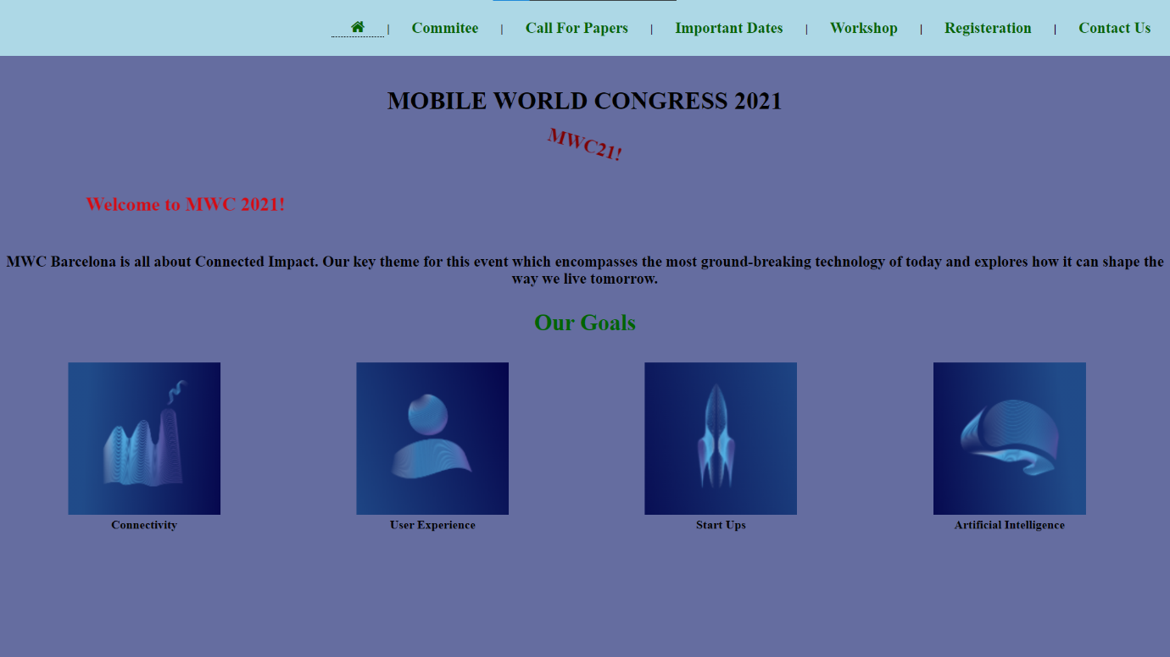

**2.Committee.html**

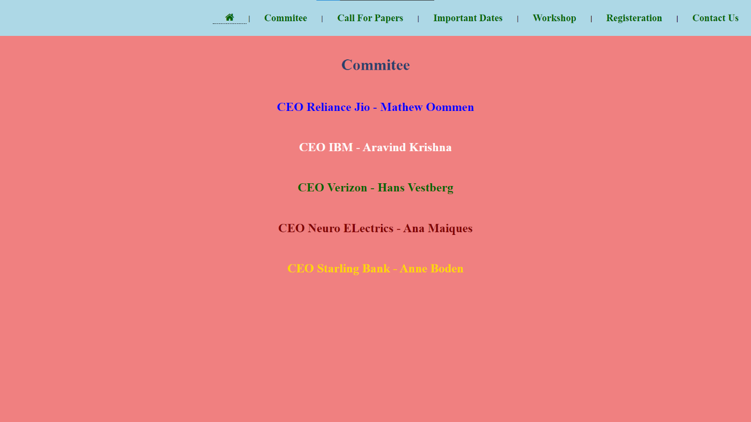

**3.Papers.html**



**4.Dates.html**

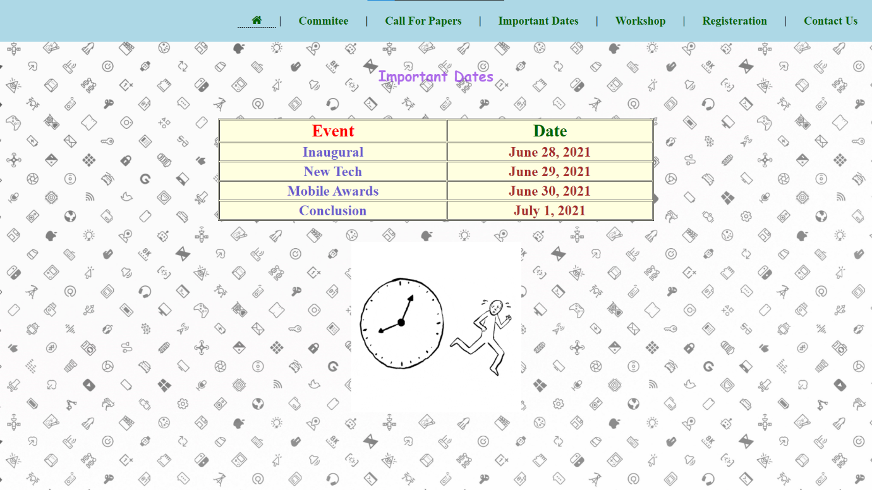

**5.Workshop.html**

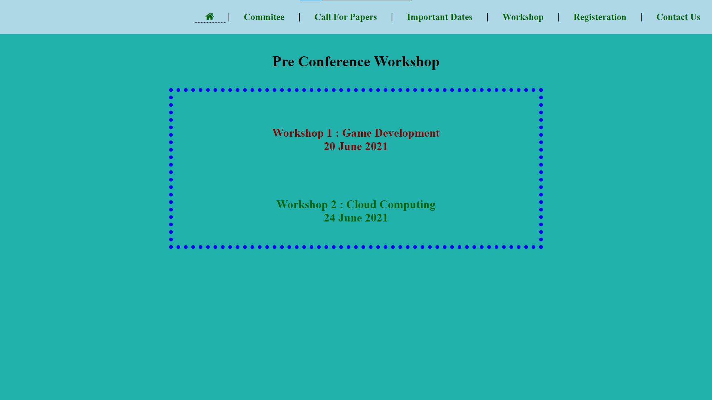

**6.Registeration.html**

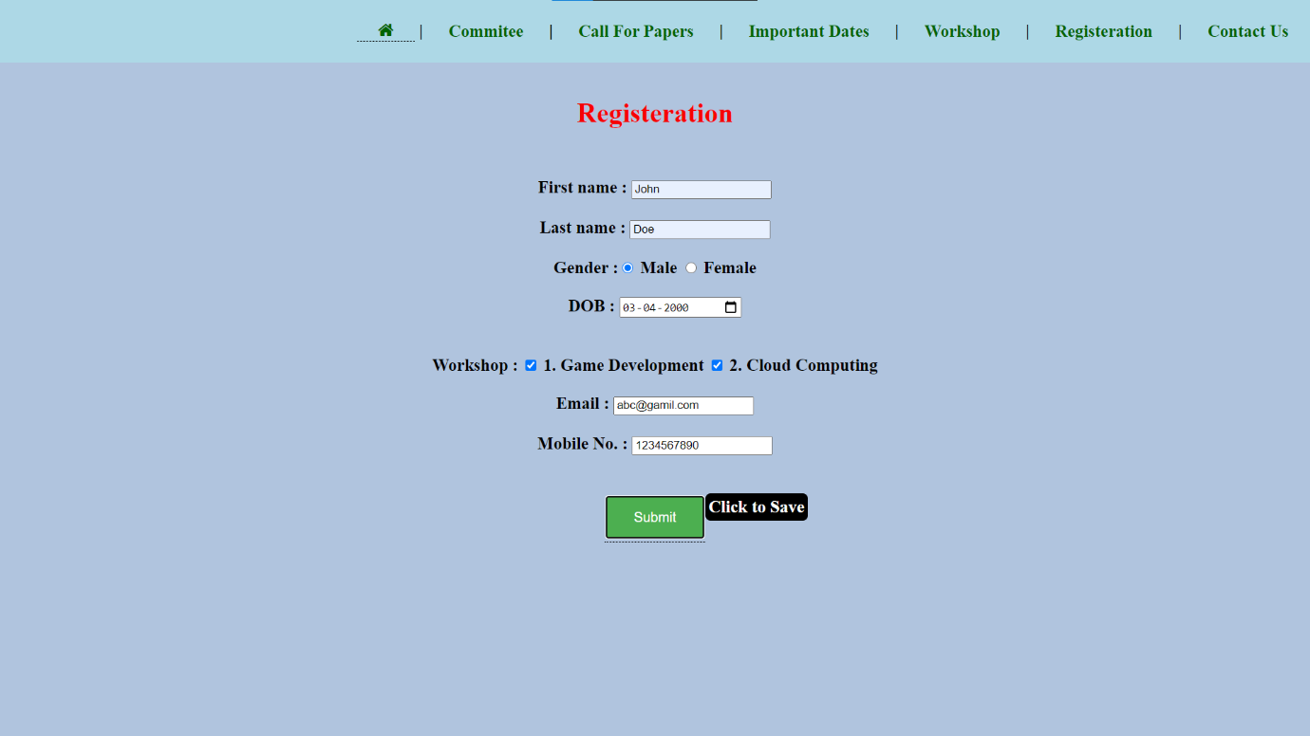

**7.Contact.html**

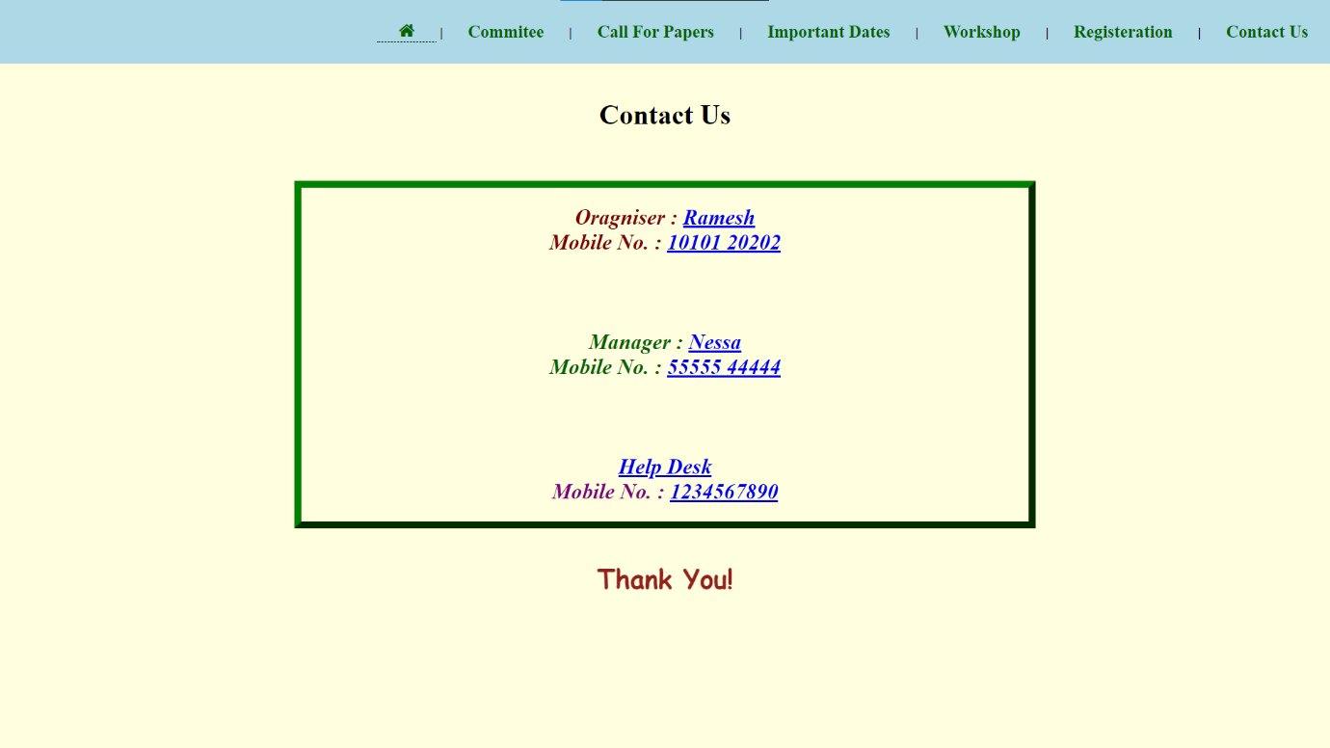

**Learning Outcomes:**

* I have learnt to use HTML and CSS to implement this webpage.
* I have understood the use of various style sheets to make the page look attractive and user friendly.
* I have learnt how cascading and inheritance works in CSS.
* I have understood box model and outline concepts.
* I have learnt about transitions, transformations and animation in CSS.
* I have learnt to customize various HTML elements line form, article, tables, etc using CSS.
* I have learnt to implement hover, tooltip and to add icons in necessary areas.