**INTERNET PROGRAMMING LAB**

**Ex3**

**JavaScript event handling mechanisms, DOM**

**Name : Vikraman S**

**Reg No : 185001195**

**Learning Objective:**

1. To Generate a registration form for a hospital
2. Write a JS program to develop a memory matching game.

**Specifications:**

a) For registration form:

a. Assign a title for the registration form(TextView- textSize, textStyle , typeface)

b. Name. Specify some font and colour. (text, onfocus, onblur, oninvalid)

c. Address (textarea, onselect)

d. Age (onkeypress)

e. Date of Birth (date)

f. Gender (RadioButton)

g. Marital Status (select, onchange)

h. Contact Number (oninvalid)

i. Addiction (text area, use drag and drop from a list-select)

j. Display a digital clock on the top right corner of the webpage

k. Submit (Button, onclick create a new page and display the contents in table format)

l. Reset (Button, onclick)

Validate the form elements. Ex: Name should be only alphabet, address only alpha-numeric character. “required” for all fields etc.

b) For Memory Matching game:

a. Display a timer, Score card.

b. Arrange even number of pairs. (Minimum 5)

c. Shuffle the cards, face down, in rows.

d. Score card changes whenever a pair is found.

e. On click a card, it should flip (event handling).

f. When a match is found, remove the cards using DOM.

g. Set 3 levels.

h. When the player moves to next level, set a new timer with less time duration.

i. Mandatory concepts – Event handling, DOM.

**HTML Code:**

**1. 3a.html**

<!DOCTYPE html>

<html>

<head>

<meta charset="utf-8">

<meta name="viewport" content="width=device-width, initial-scale=1.0">

<link rel="stylesheet" href="style.css">

<title>3a-Hospital Registeration Form</title>

</head>

<body style="background-color:lightgreen" onload="startTime()">

<div id="time"></div>

<center><h1 style="color:maroon">Hospital Registeration Form</h1></center>

<form id="Registeration">

<br><label for="name">Name :</label><br>

   <input type="text" id="name" name="name" placeholder="Enter your Name" value="" size="30" onfocus="fun_onfocus(this)" onblur="fun_onblur(this)" oninvalid="fun_oninvalid(this)" required><br>

<br><label for="address">Address :</label><br>

<textarea rows="5" cols="80" name="address" id="address" form="Registeration" placeholder="Enter your Address" value="" oninvalid="fun_oninvalid(this)" onselect="fun_onselect(this)" required></textarea><br>

<br><label for="age">Age :</label><br>

<input type="number" id="age" name="age" placeholder="Enter your Age" value="" onkeypress="fun_onkeypress(this)" onblur="fun_onblur(this)" required><br>

<br><label for="dob">DOB :</label><br>

<input type="date" id="dob" name="dob" value="" required><br>

<br>Gender:<br>

<input type="radio" id="male" name="gender" value="male" required>

<label for="male" style="color:black">Male</label><br>

<input type="radio" id="female" name="gender" value="female">

<label for="female" style="color:black">Female</label><br>

<br>Marital Status:<br>

<select name="marital_status" id="marital_status" onchange="fun_onchange(this)" required>

<option value="single">Single</option>

<option value="married">Married</option>

<option value="divorced">Divorced</option>

<option value="widowed">Widowed</option>

</select><br>

<br><label for="num">Mobile No. :</label><br>

<input type="tel" id="num" name="num" placeholder="1234567890" value="" oninvalid="fun_oninvalid(this)" required><br>

<br>Addiction:<br>

<p style="color:black;font-size:12px">drag and drop from the list into textarea:</p>

<ul id="list">

<li id="drag1" draggable="true" ondragstart="drag(event)"> Heroine </li><br>

<li id="drag2" draggable="true" ondragstart="drag(event)"> Cocaine </li><br>

<li id="drag3" draggable="true" ondragstart="drag(event)"> Crack </li><br>

<li id="drag4" draggable="true" ondragstart="drag(event)"> Hallucinogens </li><br>

<li id="drag5" draggable="true" ondragstart="drag(event)"> Amphetamines </li><br>

<li id="drag6" draggable="true" ondragstart="drag(event)"> Marijuana </li><br>

<li id="drag7" draggable="true" ondragstart="drag(event)"> Alcohol </li><br>

<li id="drag8" draggable="true" ondragstart="drag(event)"> Inhalants </li><br>

<li id="drag9" draggable="true" ondragstart="drag(event)"> Prescription Drugs </li><br>

</ul>

<div id="box" ondrop="drop(event)" ondragover="allowDrop(event)"></div>

<input type="submit" value="Submit" onclick="fun_table()">

<input type="reset" value="Reset" onclick="fun_reset()">

</form>

<script src="script.js"></script>

</body>

</html>

**2. style.css**

form{

margin-left: 20%;

font-size:17px;

font-family:arial;

font-weight:bold;

color:blue;

background-color:lavender;

padding:30px;

border:5px dotted black;

border-radius: 20px;

width:60%;

}

input,select,textarea{

font-size:17px;

font-family:arial;

padding: 12px 20px;

margin: 8px 0;

}

input[type=submit]{

width:20%;

font-weight: bold;

background-color:lightgreen;

}

input[type=reset]{

width:20%;

font-weight: bold;

background-color:antiquewhite;

margin:40px;

}

input[type=submit]:hover,input[type=reset]:hover{

color:blue;

}

#box{

width: 400px;

height: 200px;

border: 1px solid black;

color:mediumslateblue;

background-color: white;

padding: 12px 20px;

margin: 8px 0;

list-style-type: none;

}

ul{

color:dodgerblue;

font-size:12px;

display: inline;

list-style-type: none;

}

#time{

height: 80px;

width: 120px;

position: absolute;

left:1200px;

font-family: courier;

color:darkblue;

font-size: 40px;

}

table,th,td {

border: 2px solid black;

border-collapse: collapse;

padding: 10px;

}

th {

background-color: #65af79;

font-size: 23px;

color: blue;

font-family: "courier new";

}

td {

background-color: #656da0;

color: gold;

font-size: 20px;

list-style-type: none;

}

table {

margin-left: auto;

margin-right: auto;

text-align: center;

width: 50%;

}

body {

background-color: #FFFFE0

}

**3. script.js**

function fun_onfocus(x){

x.style.backgroundColor="lightblue";

}

function fun_onblur(x){

x.style.backgroundColor="";

}

function fun_oninvalid(x){

alert("Enter "+x.id);

}

function fun_onselect(x){

alert('You have selected some text...!');

}

function fun_onkeypress(x){

x.style.backgroundColor="lightblue";

}

function fun_onchange(x){

var x = document.getElementById("marital_status").value;

alert('You have selected '+x);

}

function validate(){

var pattern1=/[a-zA-z]{1,50}/;

var pattern2=/[a-zA-z0-9]{1,120}/;

var pattern3=/[0-9]{10}/;

var name=document.getElementById("name").value;

var address=document.getElementById("address").value;

var num=document.getElementById("num").value;

var flag=0;

if(!pattern1.test(name))

{

alert("invalid name...!");

flag=1;

}

if(!pattern2.test(address))

{

alert("invalid address...!");

flag=1;

}

if(!pattern3.test(num))

{

alert("invalid mobile number...!");

flag=1

}

if(flag==1)

return false;

else

return true;

}

function allowDrop(x){

x.preventDefault();

}

function drag(x){

x.dataTransfer.setData("text", x.target.id);

}

function drop(x){

x.preventDefault();

var data = x.dataTransfer.getData("text");

x.target.appendChild(document.getElementById(data));

}

function fun_reset(){

document.getElementById("box").innerHTML="";

document.getElementById("address").innerHTML="";

document.getElementById("list").innerHTML='<ul id="list"><li id="drag1" draggable="true" ondragstart="drag(event)"> Heroine </li><br><li id="drag2" draggable="true" ondragstart="drag(event)"> Cocaine </li><br><li id="drag3" draggable="true" ondragstart="drag(event)"> Crack </li><br><li id="drag4" draggable="true" ondragstart="drag(event)"> Hallucinogens </li><br><li id="drag5" draggable="true" ondragstart="drag(event)"> Amphetamines </li><br><li id="drag6" draggable="true" ondragstart="drag(event)"> Marijuana </li><br><li id="drag7" draggable="true" ondragstart="drag(event)"> Alcohol </li><br><li id="drag8" draggable="true" ondragstart="drag(event)"> Inhalants </li><br><li id="drag9" draggable="true" ondragstart="drag(event)"> Prescription Drugs </li><br> </ul>'

alert('Form is resetted...!');

}

function startTime(){

var today = new Date();

var h = today.getHours();

var m = today.getMinutes();

var s = today.getSeconds();

m = checkTime(m);

s = checkTime(s);

document.getElementById("time").innerHTML = h + ":" + m + ":" + s;

var t = setTimeout(startTime, 500);

}

function checkTime(i){

if (i < 10) {i = "0" + i};

return i;

}

function fun_table(){

if(validate())

{

var name=document.getElementById("name").value;

var address=document.getElementById("address").value;

var age=parseInt(document.getElementById("age").value);

var dob=document.getElementById("dob").value;

var gender= document.querySelector('input[name="gender"]:checked').value;

var marital_status=document.getElementById("marital_status").value;

var num=document.getElementById("num").value;

var addiction=document.getElementById("box").innerHTML;

document.writeln("<link rel=\"stylesheet\" href=\"style.css\">");

document.writeln("<body>");

document.writeln("<center><h1>Details</h1></center>");

document.writeln("<table>");

document.writeln("<tr><th>Details</td><th>Value</th></tr>");

document.writeln("<tr><td>Name</td><td>"+name+"</td></tr>");

document.writeln("<tr><td>Address</td><td>"+address+"</td></tr>");

document.writeln("<tr><td>Age</td><td>"+age+"</td></tr>");

document.writeln("<tr><td>Dob</td><td>"+dob+"</td></tr>");

document.writeln("<tr><td>Gender</td><td>"+gender+"</td></tr>");

document.writeln("<tr><td>Marital Status</td><td>"+marital_status+"</td></tr>");

document.writeln("<tr><td>Contact</td><td>"+num+"</td></tr>");

document.writeln("<tr><td>Addiction</td><td>"+addiction+"</td></tr>");

document.writeln("</table>");

}

}

**4. 3b.html**

<!DOCTYPE html>

<html>

<head>

<meta name="viewport" content="width=device-width, initial-scale=1.0">

<link rel="stylesheet" href="game.css">

<title>3b-Memory matching Game</title>

</head>

<body>

<center><h1>Memory Matching Game</h1><br>

<div id="moves"></div>

<div id="timer"></div>

<div id="score"></div></center>

<script src="game.js"></script>

</body>

</html>

**5. game.css**

* {

padding: 0;

margin: 0;

box-sizing: border-box;

}

body {

display: block;

background-image:url('pictures/background.png');

background-size: auto;

background-repeat: no-repeat;

}

.memory-game {

width: 640px;

height: 640px;

margin: auto;

display: flex;

flex-wrap: wrap;

perspective: 1000px;

}

.memory-card {

width: 23%;

height: 30%;

margin: 5px;

position: relative;

transform: scale(1);

transform-style: preserve-3d;

transition: transform .5s;

}

.memory-card:active {

transform: scale(1);

transition: transform .2s;

}

.memory-card.flip {

transform: rotateY(180deg);

}

.front-face,

.back-face {

width: 100%;

height: 100%;

padding: 5px;

position: absolute;

border-radius: 5px;

background: white;

backface-visibility: hidden;

}

.front-face {

transform: rotateY(180deg);

}

#moves{

height: 50px;

width: 200px;

position: relative;

color:darkgreen;

font-size: 20px;

}

#timer,#score{

height: 50px;

width: 200px;

position: relative;

color:darkblue;

font-size: 20px;

}

#score{

color:maroon;

}

**6. game.js**

window.addEventListener("load", create);

var level=0;

var hasFlippedCard = false;

var lockBoard = false;

var firstCard, secondCard;

var clicks=0;

var moves=0;

var score=0;

var i=0,j=0;

var size=6;

var cardname=["captain america","thor","black widow","ironman","batman","superman","spiderman","green lantern","flash","wonder woman"];

var source=["pictures/1.png","pictures/2.png","pictures/3.png","pictures/4.png","pictures/5.png","pictures/6.png","pictures/7.png","pictures/8.png","pictures/9.png","pictures/10.png"];

function create(){

document.getElementById("moves").innerHTML="<b>Level "+(level+1)+"</b><br> No Moves ";

document.getElementById("score").innerHTML="Score : "+score;

let temp=document.createElement("section");

temp.className="memory-game";

temp.id="memory-game";

document.body.appendChild(temp);

var i=0;

for(i=0;i<size;i++)

{

j=0;

for(j=0;j<2;j++)

{

let temp1=document.createElement("div");

temp1.className="memory-card";

temp1.id=cardname[i];

temp.appendChild(temp1);

let temp2=document.createElement("img");

temp2.className="front-face";

temp2.id="front-face";

temp2.src=source[i];

temp1.appendChild(temp2);

let temp3=document.createElement("img");

temp3.className="back-face";

temp3.id="back-face";

temp3.src="pictures/0.png";

temp1.appendChild(temp3);

}

}

shuffle();

}

function shuffle(){

var cards = document.querySelectorAll(".memory-card");

for(i=0;i<cards.length;i++)

cards[i].addEventListener("click", flipCard);

cards.forEach(card => {

var randomPos = Math.floor(Math.random() * cards.length);

card.style.order = randomPos;

});

timer();

}

function flipCard() {

if (lockBoard)

return;

if (this == firstCard)

return;

this.classList.add("flip");

clicks+=1;

moves=Math.floor(clicks/2);

if(moves==1)

document.getElementById("moves").innerHTML="<b>Level "+(level+1)+"</b><br>"+moves+" Move ";

else if(moves>=2)

document.getElementById("moves").innerHTML="<b>Level "+(level+1)+"</b><br>"+moves+" Moves ";

if (!hasFlippedCard) {

hasFlippedCard = true;

firstCard = this;

return;

}

secondCard = this;

checkForMatch();

}

function checkForMatch() {

var isMatch = false;

if(firstCard.id == secondCard.id)

{

isMatch=true;

}

if(isMatch)

{

lockBoard=true;

disableCards();

score++;

document.getElementById("score").innerHTML="Score : "+score;

if(score==size)

stop();

}

else

unflipCards();

}

function disableCards() {

firstCard.removeEventListener("click", flipCard);

secondCard.removeEventListener("click", flipCard);

setTimeout(invisible,1000);

}

function invisible(){

firstCard.style.visibility="hidden";

secondCard.style.visibility="hidden";

firstCard.classList.remove("flip");

secondCard.classList.remove("flip");

resetBoard();

}

function unflipCards() {

lockBoard = true;

setTimeout(unflip, 1000);

}

function unflip(){

firstCard.classList.remove("flip");

secondCard.classList.remove("flip");

resetBoard();

}

function resetBoard() {

hasFlippedCard = false;

lockBoard = false;

firstCard = null;

secondCard = null;

}

var s=100;

function timer(){

s--;

if(s>0)

{

setTimeout(timer,1000);

document.getElementById("timer").innerHTML= s+" s remaining";

}

else if(s==0)

{

document.getElementById("timer").innerHTML= s+" s remaining";

lockBoard=true;

setTimeout(function(){alert('timeout :(');},1000);

}

}

function stop(){

lockBoard=true;

s=-1;

if(level<2)

setTimeout(function(){alert("You have won level "+(level+1)+" :) ...starting level "+(level+2));nextlevel();},1500);

else

setTimeout(function(){alert("You have won level "+(level+1)+" :) ...bye");},1500);

}

function visible(){

cards = document.querySelectorAll(".memory-card");

for(i=0;i<cards.length;i++)

cards[i].style.visibility="visible";

}

function nextlevel(){

level++;

clicks=0;

moves=0;

score=0;

document.getElementById("moves").innerHTML="<b>Level "+(level+1)+"</b><br> No Moves ";

document.getElementById("score").innerHTML="Score : "+score;

visible();

let temp=document.getElementById("memory-game");

for(i=size;i<size+2;i++)

{

j=0;

for(j=0;j<2;j++)

{

let temp1=document.createElement("div");

temp1.className="memory-card";

temp1.id=cardname[i];

temp.appendChild(temp1);

let temp2=document.createElement("img");

temp2.className="front-face";

temp2.id="front-face";

temp2.src=source[i];

temp1.appendChild(temp2);

let temp3=document.createElement("img");

temp3.className="back-face";

temp3.id="back-face";

temp3.src="pictures/0.png";

temp1.appendChild(temp3);

}

}

size+=2;

if(level==1)

s=90;

else if(level==2)

s=80;

shuffle();

}

**Screenshots:**

**Hospital Registration:**

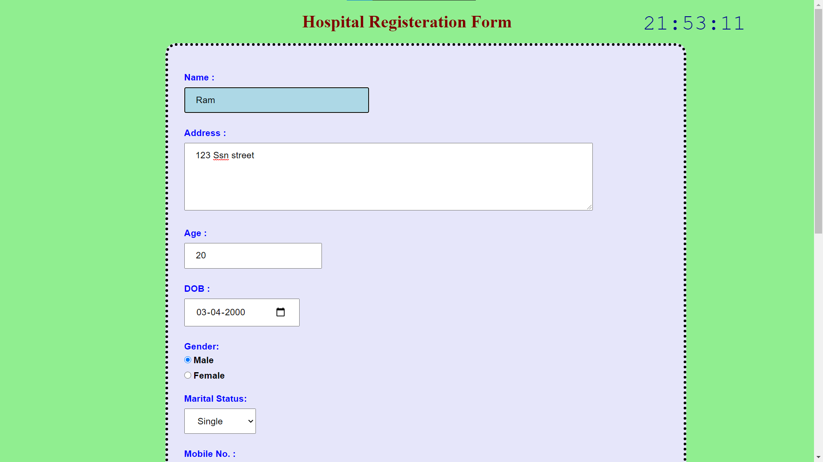

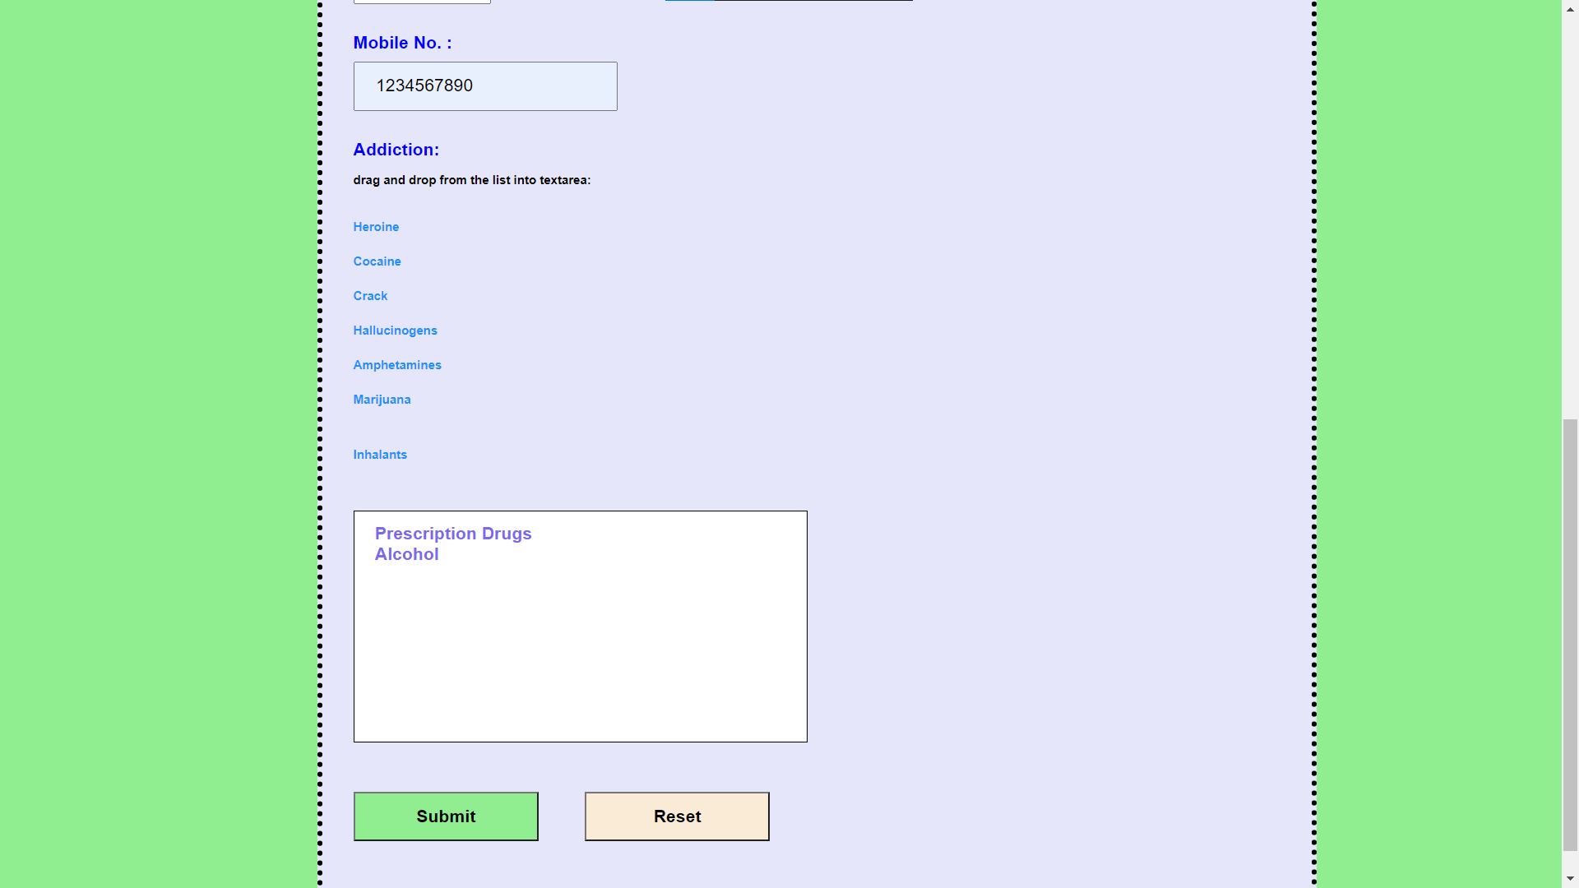

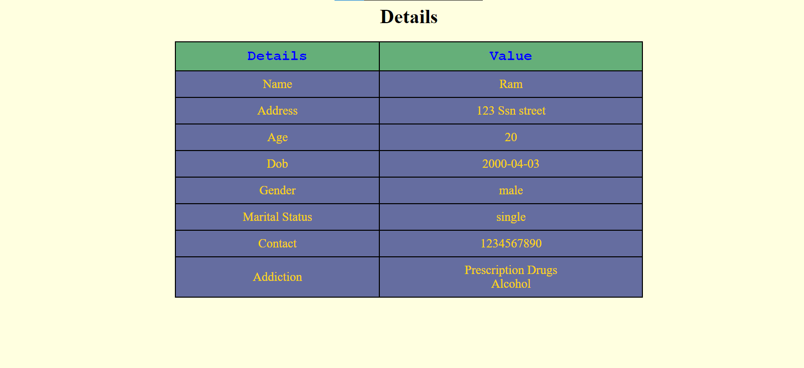

**Memory Matching game:**

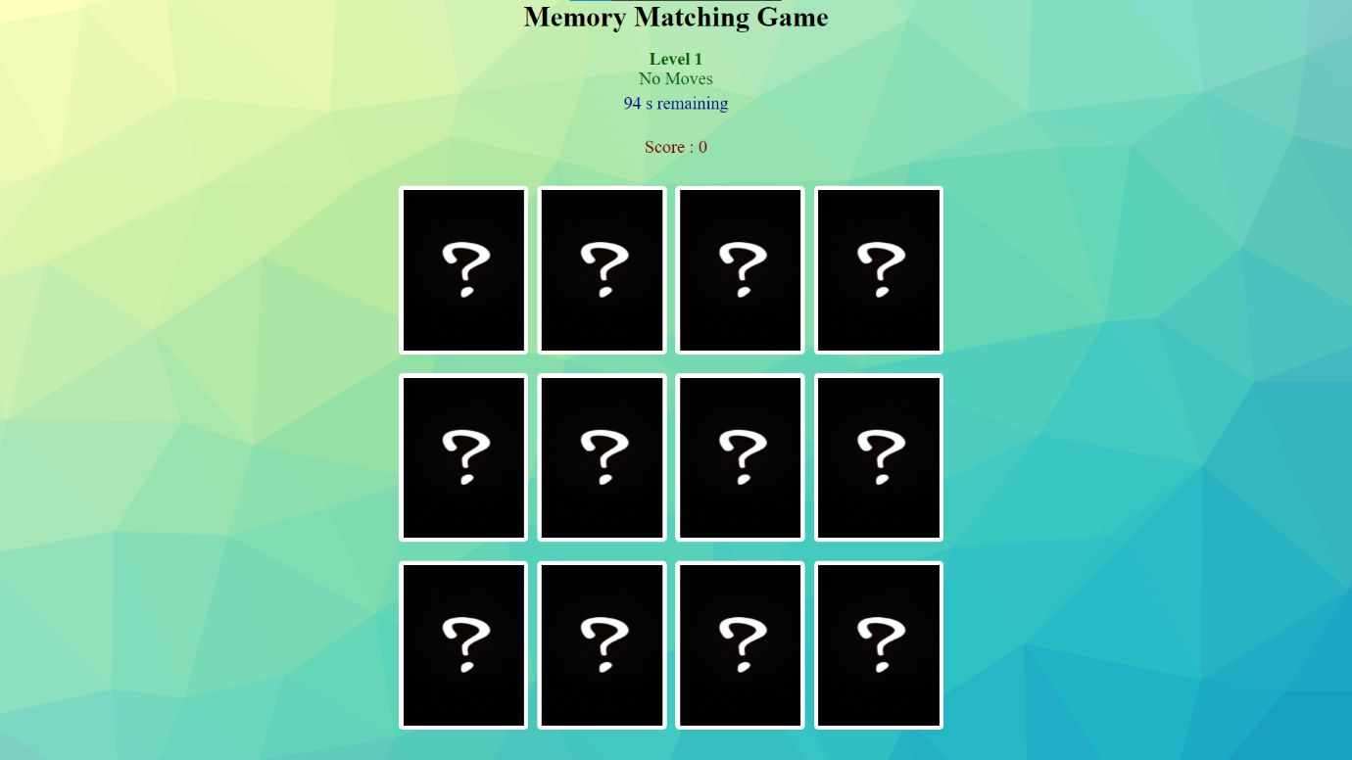

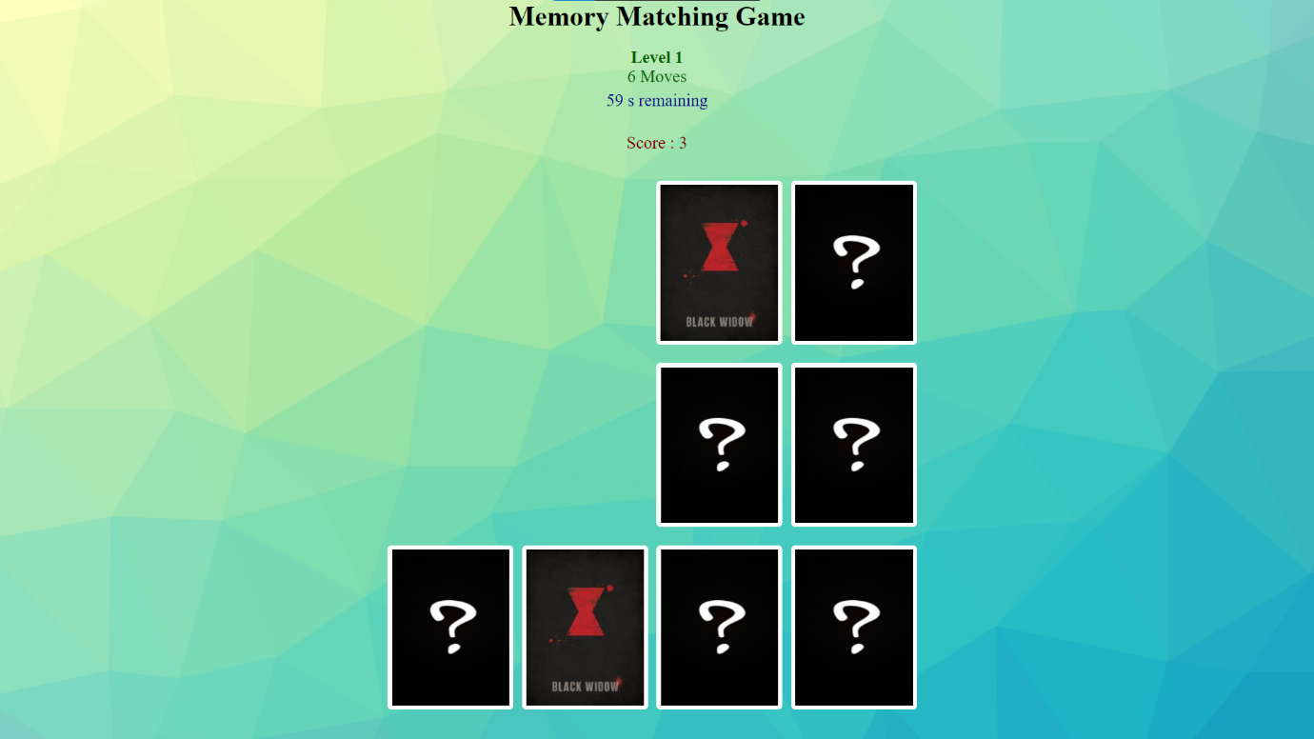

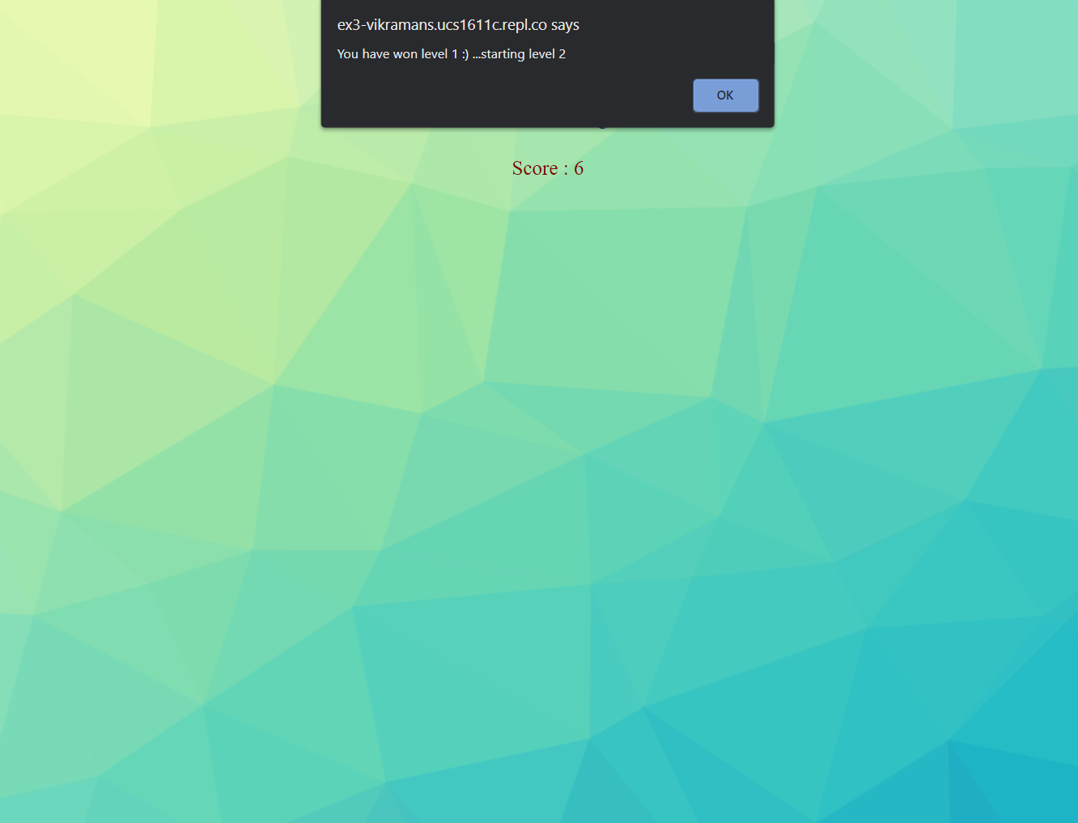

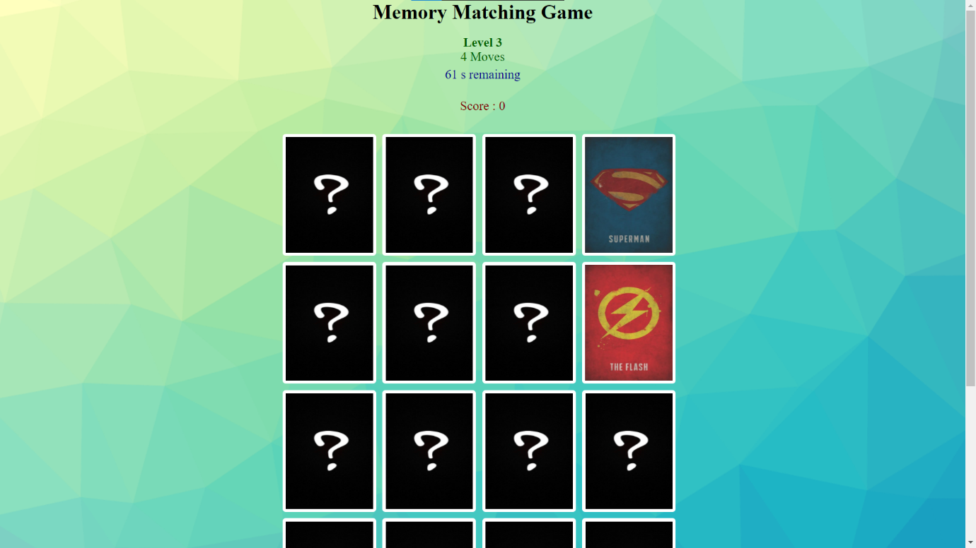

**Learning Outcomes:**

* I have learnt to use of different form elements and events like onclick, onkeypress, oninvalid, onfocus, onblur, etc.
* I have understood the usage of regular expressions to validate the form input.
* I have learnt how Date() works in javascript and used to display the timer.
* I have understood DOM and event handling.
* I have learnt about transitions, transformations and animation in CSS.
* I have learnt the usage of createElement(), appendChild(), removeChild in DOM.
* I have learnt to implement the memory matching game in javascript.