**INTERNET PROGRAMMING LAB**

**Ex6**

**Autocomplete Feature using AJAX**

**Name : Vikraman S**

**Reg No : 185001195**

**Learning Objective:**

To develop an AJAX program that implements the Autocomplete feature for filling the country names.

**Specifications:**

* Use Servlet for server-side scripting.
* Use MySQL database to store the countries names.

**Code:**

**index.html**

<!DOCTYPE html>

<html>

<head>

<meta charset=**"utf-8"**>

<meta name=**"viewport"** content=**"width=device-width, initial-scale=1.0"**>

<link rel=**"stylesheet"** href=**"style.css"**>

<title>**Auto Complete**</title>

</head>

<body>

<br>

<center><div id=**"country"**><br>

<label for=**"cname"** style=**"color:#9B1B30;font-size:30px;font-weight:bold"**>**Country**</label><br><br>

<input type=**"text"** name=**"cname"** id=**"cname"** value=**""** size=**"30"** placeholder=**"Enter country name"** oninput=**"display_list()"**>

<div>

<br>

<div id=**"choice"** style=**"color:snow;font-size:20px;font-weight:bold"**></div>

<div id=**"list"**><div>

</center>

<script>

***function*** display_list**(){**

document.getElementById**(**"choice"**).**style.display**=**"none"**;**

document.getElementById**(**"list"**).**style.display**=**"none"**;**

console.log**(**document.getElementById**(**"cname"**).**value**);**

***var*** xhttp**;**

***var*** v**=**document.getElementById**(**"cname"**).**value**;**

***var*** url**=**"List?val="**+**v**;**

xhttp**=** ***new*** XMLHttpRequest**();**

xhttp.onreadystatechange**=** ***function*()** **{**

***if*(**this.readyState**==**4 **&&** this.status**==**200**)** **{**

***var*** val**=**xhttp.responseText**;**

document.getElementById**(**"list"**).**innerHTML**=**val**;**

***if*(**document.getElementById**(**"cname"**).**value**!=**""**)**

document.getElementById**(**"list"**).**style.display**=**"block"**;**

**}**

**};**

xhttp.open**(**"GET"**,**url**,*true*);**

xhttp.send**();**

**}**

***function*** select**(**a**){**

console.log**(**a.innerHTML**);**

document.getElementById**(**"cname"**).**value**=**a.innerHTML**;**

document.getElementById**(**"list"**).**style.display**=**"none"**;**

document.getElementById**(**"choice"**).**innerHTML**=**"You have selected "**+**a.innerHTML**;**

document.getElementById**(**"choice"**).**style.display**=**"block"**;**

**}**

</script>

</body>

</html>

**style.css**

input**{**

**font-size:17px;**

**font-family:arial;**

**padding: 12px 20px;**

**margin: 8px 0;**

**}**

input**[**type=submit**]:hover{**

**color:blue;**

**}**

p**{**

**font-size:18px;**

**border:1px solid black;**

**border-radius: 5px;**

**width:20%;**

**height:auto;**

**}**

p**:hover{**

**color:snow;**

**background-color:#5B5EA6;**

**cursor:pointer;**

**}**

body **{**

**height: auto;**

**background-image: linear-gradient(to right,#0072B5,#009B77);**

**}**

**List.java**

**import** java**.**io**.*;**

**import** java**.**util**.*;**

**import** javax**.**servlet**.*;**

**import** javax**.**servlet**.**http**.*;**

**import** java**.**sql**.*;**

public class List **extends** HttpServlet

**{**

public void doGet**(**HttpServletRequest request**,** HttpServletResponse response**)** **throws** ServletException**,** IOException

**{**

String JDBC_DRIVER **=** "com.mysql.jdbc.Driver"**;**

String DB_URL**=**"jdbc:mysql://localhost/country_name"**;**

String USER **=** "root"**;**

String PASS **=** "9500"**;**

response**.**setContentType**(**"text/html"**);**

PrintWriter out **=** response**.**getWriter**();**

String cname**=**request**.**getParameter**(**"val"**);**

**try** **{**

// Register JDBC driver

Class**.**forName**(**"com.mysql.jdbc.Driver"**);**

// Open a connection

Connection conn **=** DriverManager**.**getConnection**(**DB_URL**,** USER**,** PASS**);**

// Execute SQL query

Statement stmt **=** conn**.**createStatement**();**

String sql**=**"SELECT name FROM countries WHERE name LIKE '"**+**cname**+**"%'"**;**

ResultSet rs **=** stmt**.**executeQuery**(**sql**);**

**while(**rs**.**next**())**

**{**

out**.**println**(**"<p onclick='select(this)'>"**+**rs**.**getString**(**"name"**)+**"</p>"**);**

**}**

// Clean-up environment

rs**.**close**();**

stmt**.**close**();**

conn**.**close**();**

**}** **catch(**SQLException se**)** **{**

//Handle errors for JDBC

se**.**printStackTrace**();**

**}** **catch(**Exception e**)** **{**

//Handle errors for Class.forName

e**.**printStackTrace**();**

**}**

**}**

**}**

**web.xml**

<web-app>

<servlet>

<servlet-name>**List**</servlet-name>

<servlet-class>**List**</servlet-class>

</servlet>

<servlet-mapping>

<servlet-name>**List**</servlet-name>

<url-pattern>**/List**</url-pattern>

</servlet-mapping>

</web-app>

**Screenshots:**

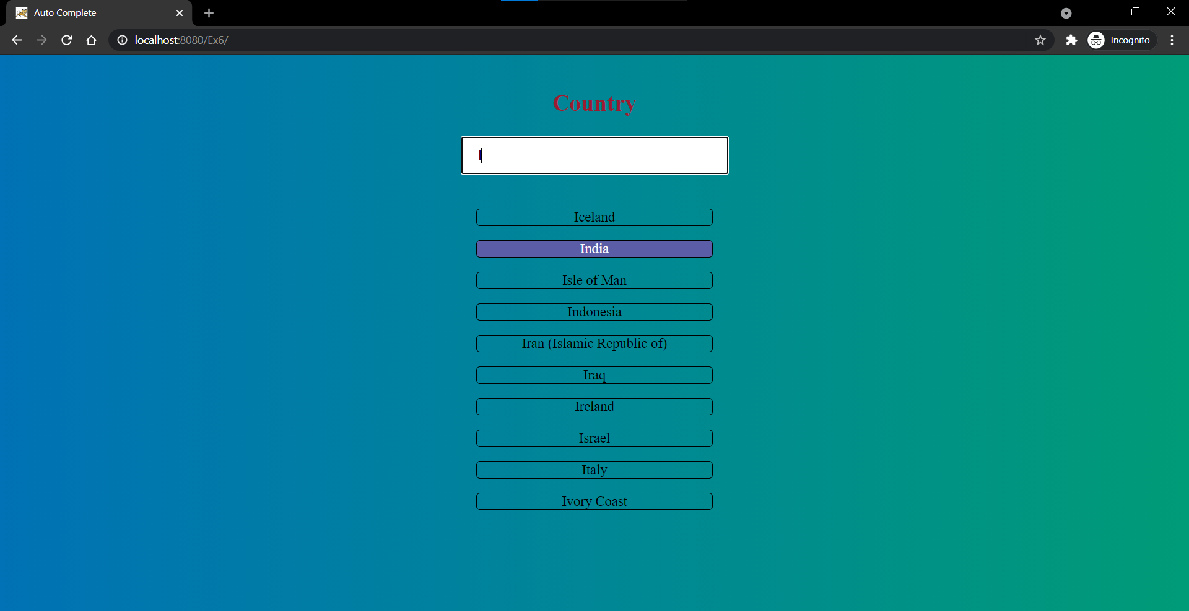

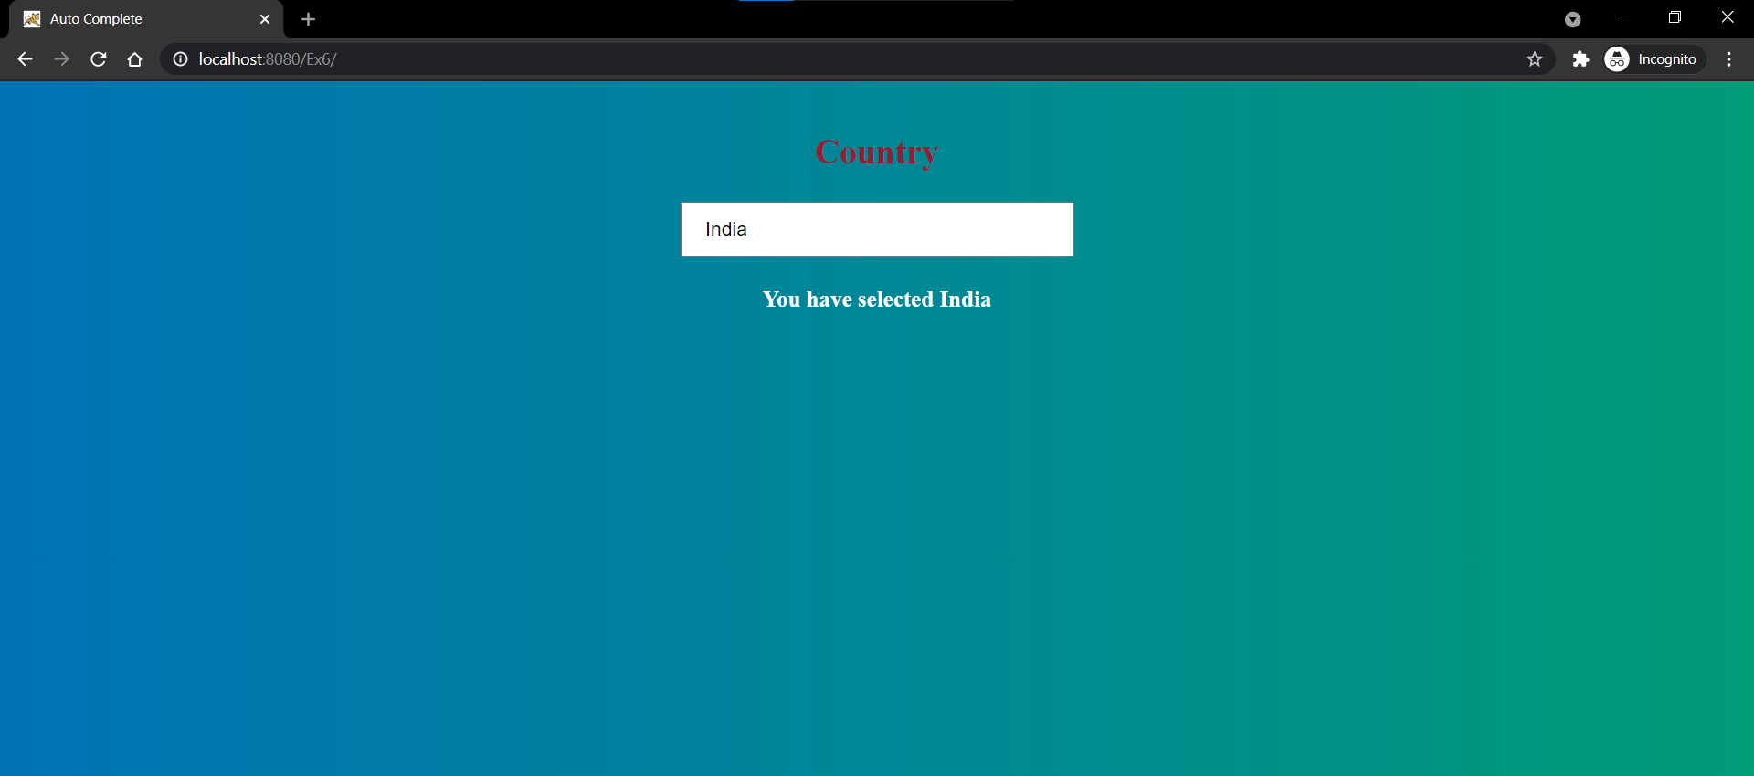

**Learning Outcomes:**

* I have understood the working of ajax with servlet.
* I have learnt how to generate dynamic html response using ajax.
* I have learnt about onreadystatechange property and asynchronous request in ajax.
* I have learnt the database operations in MySQL and using % for pattern matching in sql query.
* I have understood the code for connecting database and servlet part with ajax.