**INTERNET PROGRAMMING LAB**

**Ex8**

**Programs using Node.js**

**Name : Vikraman S**

**Reg No : 185001195**

**Learning Objective:**

To implement programs using Node js.

**Specifications:**

a. Write a Node.js program that reads all the greetings from the file greetings.txt, asks the user "What is your name?", then prints a random greeting followed by the given name. Make sure to check for the case where the file doesn’t exist! For example, if the greeting is "Hey", then the program will print "Hey, Joe" to the console, then pick some other greeting and do the same until finished. Use Non-blocking I/O.

b. Write a Node.js program that reads all the greetings as before. When all the greetings are loaded, it creates a server listening on port number 8080. On request, it checks for whether there is a name value in the query string. If there isn’t, the value of query.name will be undefined.

**Code:**

**greet.js**

**var** fs **=** require**(**"fs"**);**

**var** readline **=** require**(**"readline"**);**

**var** rl **=** readline**.**createInterface**({**

input**:** process**.**stdin**,**

output**:** process**.**stdout

**});**

**if(!**fs**.**existsSync**(**"greetings.txt"**))** **{**

console**.**log**(**"File not found"**);**

rl**.close();**

**}**

**else** **{**

**var** greetingsFile **=** fs**.**readFileSync**(**"greetings.txt"**);**

**var** greetings_string **=** greetingsFile**.**toString**();**

**var** greetings **=** greetings_string**.**split**(**"\r\n"**);**

**var** count**=**0**;**

**var** index**=[];**

rl**.**question**(**"What is your name? "**,** **function(**name**)** **{**

**for(var** i **=** 0**;** count **<** greetings**.**length**;** i**++)** **{**

**var** n**=**Math**.**floor**(**Math**.**random**()** **\*** greetings**.**length**);**

**var** check**=**index**.**includes**(**n**);**

**if(!**check**)**

**{**

index**.**push**(**n**);**

**var** temp**=**greetings**[**n**]+**", "**+**name**;**

console**.**log**(**temp**);**

count**=**count**+**1**;**

**}**

**}**

rl**.close();**

**});**

**}**

**greetser.js**

**var** http **=** require**(**"http"**);**

**var** fs **=** require**(**"fs"**);**

**var** url **=** require**(**"url"**);**

**var** greetings**;**

fs**.**readFile**(**"greetings.txt"**,** **function(**err**,** body**)** **{**

**if** **(**err **===** **null)** **{**

greetings **=** body**.**toString**().**split**(**"\r\n"**);**

**if** **(**greetings**.**slice**(-**1**)** **==** ""**)** **{**

greetings**.**pop**();**

**}**

**var** server **=** http**.**createServer**(function(**req**,** res**)** **{**

res**.**writeHead**(**200**);**

**var** query **=** url**.**parse**(**req**.**url**,** **true).**query**;**

**var** name **=** query**.**name**;**

**var** greeting **=** greetings**[**Math**.**floor**(**Math**.**random**()** **\*** greetings**.**length**)];**

**if** **(**name**)** **{**

res**.**end**(**greeting **+** ", " **+** name**);**

**}** **else** **{**

res**.**end**(**greeting**);**

**}**

**});**

server**.**listen**(**8080**);**

**}** **else** **{**

console**.**log**(**err**);**

**}**

**});**

**greetings.txt**

Hello

Hey

Hi

What's up

Welcome

**Screenshots:**

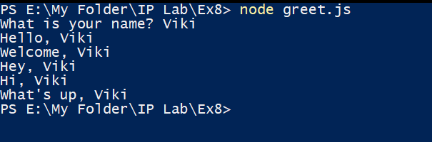

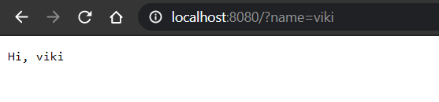

**Learning Outcome:**

* I have understood the working of Node js server.
* I have learnt to use JSX arrow functions.
* I have learnt to print the output in console.
* I have learnt about random function and arrays in node js.
* I have understood file manipulation using node js.