This document shows how we can author the components created in AEM:

1. Edit the Crypto Tile component:

<http://localhost:4502/editor.html/content/CryptoCurrency/en/CryptoHome.html>

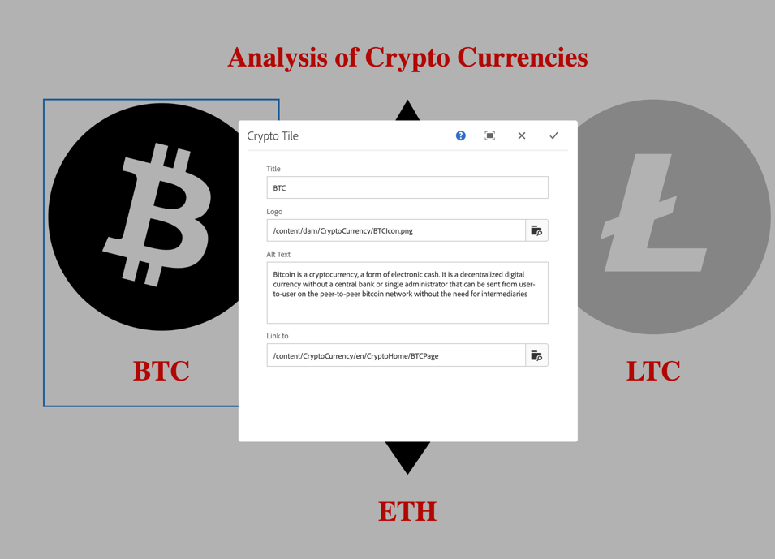

1. Edit the cryptoprofit component

<http://localhost:4502/editor.html/content/CryptoCurrency/en/CryptoHome/LTCPage.html>

