Following are the screen you will see in the application:

<http://localhost:4502/content/CryptoCurrency/en/CryptoHome.html>

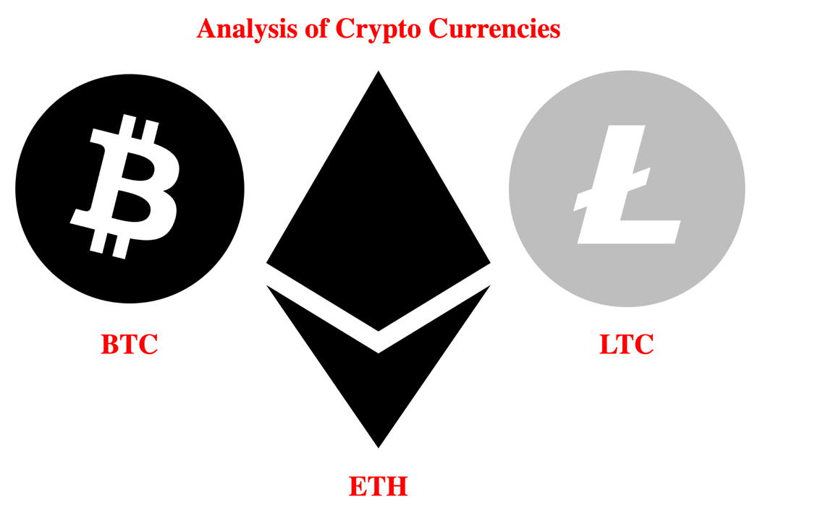

<http://localhost:4502/content/CryptoCurrency/en/CryptoHome/BTCPage.html>

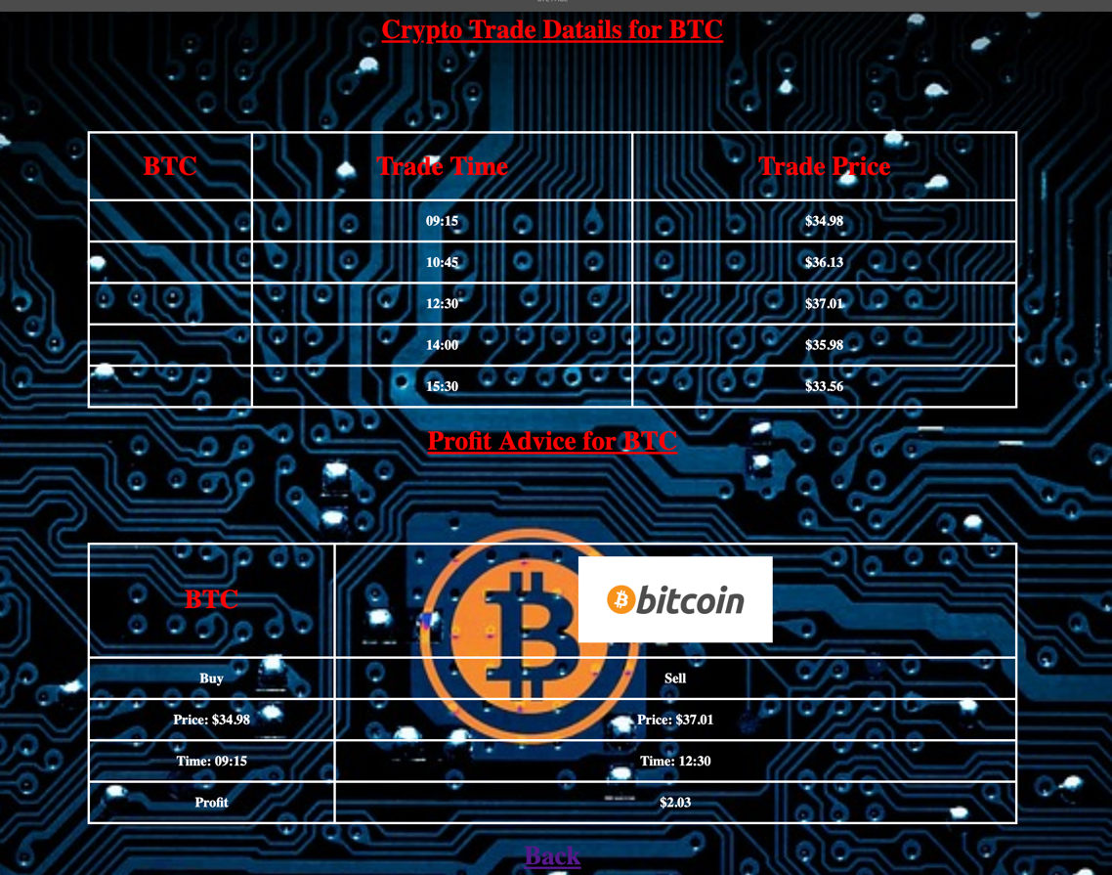

<http://localhost:4502/content/CryptoCurrency/en/CryptoHome/ETHPage.html>

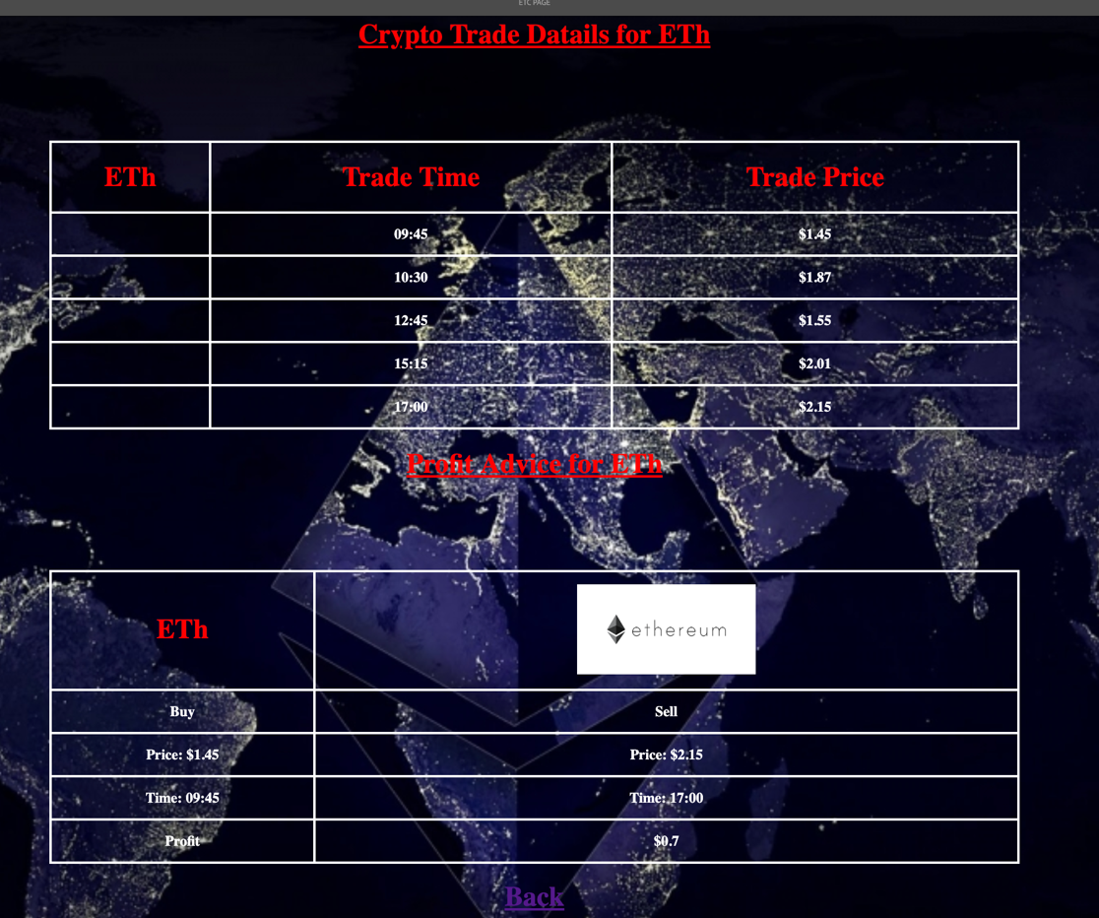

<http://localhost:4502/editor.html/content/CryptoCurrency/en/CryptoHome/LTCPage.html>

