**SMART WATCHES FOR HUMAN HEALTHCARE**

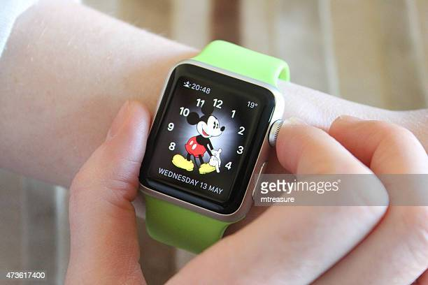 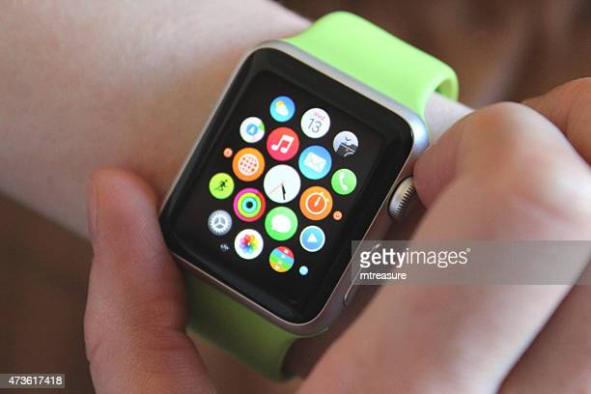

INTRODUCTION :-

Smartwatch is a wearable computer that is designed to be worn on the wrist, similar to a traditional wristwatch. It offers features and functions that go beyond time keeping, such as activity tracking, health monitoring, phone notifications, and voice assistants, among other things.

When it comes to human healthcare Smartwatches can be helpful in various ways.

There are some main sensors that help that smartwatches to predict human health those are:

1. Sleep monitor
2. Pedometer
3. Calorimeter
4. Bio-impedance sensor
5. GPS and tracking
6. Heart rate sensor
7. Oxygen level sensing
8. Body composition

**WHAT IS SLEEP MONITOR :-**

Sleep monitoring in a smartwatch typically works by tracking the users movement and heart rate while they sleep. The watch's sensors, such as an accelerometer and a heart rate monitor, can detect the wearer's movements and changes in heart rate throughout the night.

The watch uses this data to determine when the user is sleeping, how long they are sleeping, and the quality of their sleep. Some smartwatches also use machine learning algorithms to analyze the data and provide insights into sleep patterns and habits.

* **Sleep monitoring in a smartwatch can also provide additional features, such as:**

1. Sleep stages: Some smartwatches can track different sleep stages, including light, deep, and REM sleep, which can provide more insight into the quality of sleep.
2. Sleep score: Some smartwatches can provide a sleep score or rating that takes into account various factors, such as sleep duration, sleep stages, and interruptions.
3. Sleep goals: Some smartwatches allow users to set sleep goals and provide feedback to help them achieve these goals.

Overall, sleep monitoring in a smartwatch can be a useful tool for individuals who want to better understand their sleep habits and make changes to improve their sleep quality.

**Sleep monitor majorly works based on 2 sensors**

1. Accelerometer :- 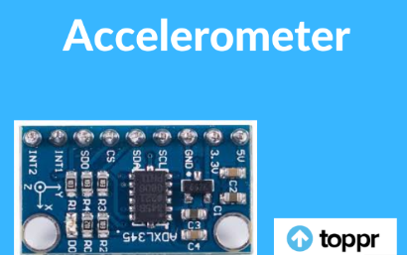

The accelerometer in a smartwatch can be used to track a user's movements during sleep and determine their sleep patterns. When a person sleeps, their movements are usually reduced, and the accelerometer can detect changes in movement patterns and orientation to determine when they are asleep, when they are awake, and the different sleep stages they experience.

In a smartwatch, the accelerometer can measure the wearer's movement by detecting changes in acceleration and orientation. This data is then used by the watch's software to determine the users sleep patterns, such as when they fall asleep, how long they are asleep, and when they wake up.

The accelerometer can also be used to determine sleep quality by measuring movement during sleep. For example, a person in deep sleep will usually move less than a person in light sleep, and the accelerometer can detect these differences in movement patterns. Additionally, the accelerometer can detect movements such as tossing and turning, which can indicate that the person is experiencing restless sleep.

Overall, the accelerometer is a key component in a smartwatch's sleep monitoring features, providing valuable data on sleep patterns and quality. By tracking this data, users can gain insights into their sleep habits and make changes to improve their sleep health.

1. Gyroscope :- 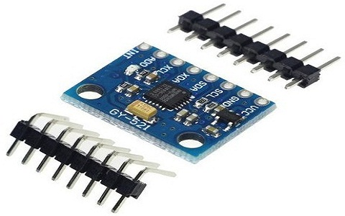

While the accelerometer is the primary sensor used for sleep monitoring in a smartwatch, some smartwatches also use a gyroscope to provide additional information about the user's movement and sleep patterns.

A gyroscope is a sensor that measures angular velocity, which is the rate of change of an object's orientation. In a smartwatch, a gyroscope can be used to detect rotational movement, such as when the user turns over during sleep.

The gyroscope works by measuring changes in angular velocity and orientation, which can be used to determine the user's movements during sleep. This data can be combined with the accelerometer data to provide a more complete picture of the user's sleep patterns, including the amount of time spent in different sleep stages, the number of times the user woke up during the night, and the overall quality of sleep.

However, it's worth noting that not all smartwatches include a gyroscope, and many sleep tracking features can be achieved using just the accelerometer data. Additionally, the use of a gyroscope can increase power consumption, which can affect battery life.

Overall, while a gyroscope can provide additional data for sleep monitoring in a smartwatch, its use is not essential, and the accelerometer can provide sufficient data for most sleep tracking fractures.

**WHAT IS PEDOMETER :-** 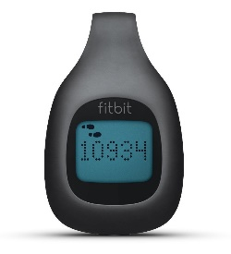

A pedometer in a smartwatch is a sensor that measures the wearer's movement and translates it into step counts. The pedometer works by using an accelerometer to detect movement, specifically the up-and-down motion of the user's steps.

When the wearer takes a step, the accelerometer in the smartwatch detects the motion and translates it into a step count. The pedometer can also use other data, such as the user's height, weight, and age, to calculate the distance travelled and the number of calories burned during the activity.

To accurately measure steps, a pedometer needs to be calibrated to the user's gait, which is the specific way they walk. This calibration is usually done during the setup process when the user inputs their height and weight, and the pedometer adjusts to their specific stride length.

In addition to step counting, some smartwatches also include features like goal setting, progress tracking, and activity monitoring to encourage users to be more active and maintain a healthy lifestyle.

Overall, the pedometer is a valuable sensor in a smartwatch that can help users track their physical activity and maintain a healthy lifestyle. By providing data on steps, distance, and calories burned, the pedometer can help users set and achieve fitness goals and stay motivated to stay active.

**SENSORS IN PEDOMETER :-**

The primary sensor used in a pedometer to count steps is an accelerometer. An accelerometer is a device that measures changes in velocity or acceleration. In a pedometer, the accelerometer detects the up-and-down motion of the user's steps and translates it into step counts.

The accelerometer works by measuring the acceleration and deceleration of the user's movements. When the user takes a step, the accelerometer detects the initial acceleration and then detects the deceleration when the user's foot hits the ground. This pattern of acceleration and deceleration is what is used to determine the number of steps taken.

Some smartwatches may include a gyroscope that can provide additional information about the wearer's movement and orientation, which can help to distinguish between different types of movement, such as running or walking.

Overall, the accelerometer is the primary sensor used in a pedometer to count steps, but other sensors can be used to supplement the data and improve accuracy. By accurately measuring steps, a pedometer can provide valuable data on physical activity and help users maintain a healthy lifestyle.

**What is Calorimeter?**

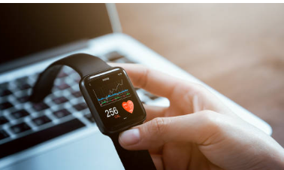

Calorimetry is the technique of calculating how much heat the body produces when engaged in physical exercise. The fundamental thing of calorimetry is that heat is produced by the body as a result of metabolic activities, such as the digestion of food and the transformation of energy into motion. A calorimeter, a tool that calculates how much heat the body produces, can be used to quantify this heat. Smart watches can use various types of calorimeters to measure calorie expenditure, including:

**Direct Calorimetry**: This method involves measuring the amount of heat generated by the body directly, typically by placing the person in a small chamber that is designed to measure heat exchange between the body and the environment. While accurate, this method is not practical for use in smart watches.

**Indirect Calorimetry**:

This method involves measuring the amount of oxygen consumed and carbon dioxide produced during physical activity. By measuring the respiratory exchange ratio (RER), which is the ratio of carbon dioxide produced to oxygen consumed, the body's energy expenditure can be estimated. Smart watches can use this method by incorporating sensors that measure heart rate and oxygen saturation.

**Activity-Based Calorimetry**:

This method estimates calorie expenditure based on the intensity and duration of physical activity. Smart watches can use sensors such as accelerometers to measure the frequency and intensity of physical activity, which can be used to estimate calories burned daily.

Technologies that are used in Smart Watches for not only calorimeter but for sleep-monitoring as well as bio-impedance sensors are

**Accelerometers**: These sensors measure changes in motion and acceleration, which can be used to estimate the amount of physical activity a person is engaging in. Optical Sensors: These sensors, such as photoplethysmography (PPG), can measure heart rate and oxygen saturation, which are used in indirect calorimetry. Machine Learning Algorithms: Smart watches use machine learning algorithms to analyze the data collected from sensors and provide accurate estimates of calorie expenditure. These algorithms can learn and improve over time, providing more personalized and accurate estimates.

**Body composition**

**What is Body composition?**

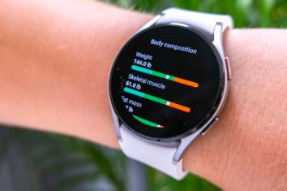

It refers to the percentage of fat, bone and muscle in your body. It helps to find the level of health in our body.

**Smart watches to measure the body composition:**

Body fat percentage, bone density and muscle weight are the things that smart watches able to predict accurately. Many sensors such as Bio-impedance, optical sensors, accelerometer can be used to acquire these readings. Smart watches frequently employ bioelectrical impedance analysis (BIA) to calculate body fat percentage. BIA measures the resistance to a tiny electrical current that is passed through the body. The quantity of resistance may be used to calculate the proportion of body fat since fat has a higher resistance than other tissues.

Smart watches also utilize optical sensors, such photoplethysmography (PPG), to determine body composition. PPG measures how much light is absorbed or reflected by shining a light through the skin. This technique may be used to calculate body fat percentage as well as other factors like muscle mass and bone density since various tissues absorb and reflect light differently. Another sort of sensor that is frequently used in smart watches for assessing body composition is the accelerometer. A person's level of physical activity may be inferred from these sensors' ability to detect changes in motion and acceleration. Smart watches are able to estimate factors such as energy expenditure and metabolic rate, which are significant markers of total body composition, by integrating accelerometer data with other metrics like heart rate and body weight

**Technologies used in smart watches for body composition measurement**

Smart watches use a variety of technologies to enable body composition measurement. Some of the key technologies include: 1**)Sensors:** As discussed earlier, smart watches use various sensors such as BIA, optical sensors, and accelerometers to measure different parameters related to body composition.

2) **Machine Learning Algorithms**: Smart watches use machine learning algorithms to analyze the data collected from the sensors and provide insights on body composition. These algorithms can learn and improve over time, allowing for more accurate and personalized measurements. 3**) Cloud Computing:** Many smart watches use cloud computing to store and process the large amounts of data generated by body composition measurement. This allows for more sophisticated analysis and provides users with real-time feedback on their body composition.

Bio impedance sensor:

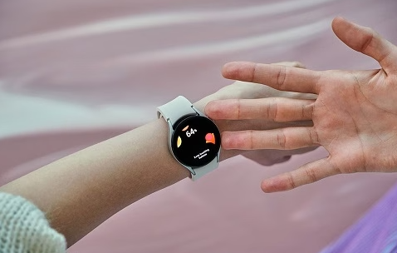

What is a Bio-impedance sensor?

It is based on the bio-impedance analysis which sends a weak current into the body to determine level of body fat, water and also lean mass. Smart watches frequently employ bioelectrical impedance analysis (BIA) to calculate body fat percentage. BIA measures the resistance to a tiny electrical current that is passed through the body. The quantity of resistance may be used to calculate the proportion of body fat since fat has a higher resistance than other tissues.

Working:

BIA (Bio impedance analysis) is used to analyse the body composition by applying a small alternating current to our body and measuring the impedance offered by our body. The smaller the electrode of BIA device, more is the error measurement by contact between body and the electrode.

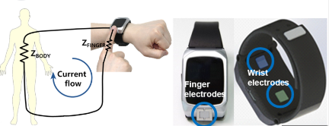

**GPS and tracking:**

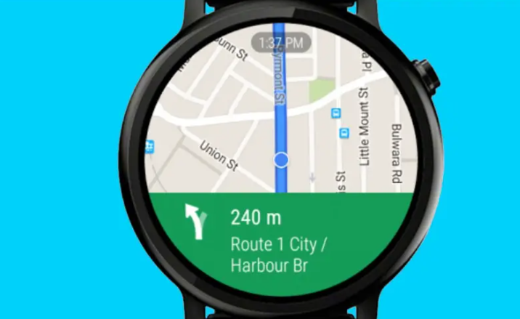

Nowadays in most of modern smart watches the GPS tracking is fixed to know the particular location where you are and to reach our destination when we are confused with the route. It is not an ordinary feature in smart watches, involves lot of technicalities.

Smart watch has a built-in GPS tracker to trace out the location. It is similar to GPS on your smartphone, but data and location results may vary based on the watch’s satellite system.

The GPS enhances the safety and fitness features on the watch. Depending upon the watch it gives the data and analysis from the satellite. It helps to track your distance while running, cycling or other outdoor activities.

**Working:**

The **smartwatch captures the signal data and uses the triangulation meth**od to pinpoint your exact location. The GPS receiver must detect at least three satellites for latitude and longitude and four satellites to measure your altitude.Furthermore, it counts when the signal was sent from the satellite and when it was received on the device. This technique can detect how far the satellite is from your location.

**Oxygen level sensing:**

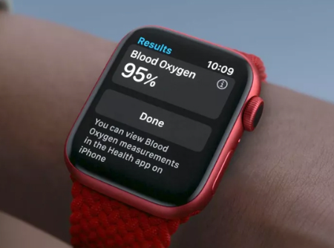 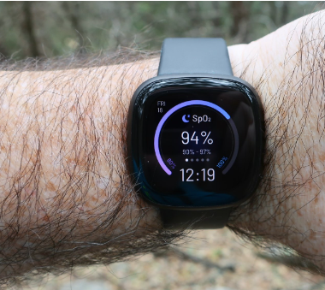

We all live with food and water. Then, what is the role of oxygen in our body. The food should be converted into energy. It is a chemical process called oxidization. With the help of oxygen, in the chemical process, energy is released and is utilized in various parts of the body as per its need.

The oxygen which we inhale into our lungs, will be circulated to various parts of the body through our blood circulatory system. Our heart and a pigment in the blood called haemoglobin play very vital role. While, heart pumps the blood, it is the chemical haemoglobin which absorbs the oxygen and supplies to various parts of the body.

Of course, there has been awareness among public to monitor the oxygen level in the body due to the onset of pandemic Covid 19. This virus attacks the lungs and impairs its functioning. Thus, supply of oxygen gets reduced leading to severe problems to the physiology of the body functioning.

Now a days, there is an increase in the utilization of ‘oximeter’ to measure the level of oxygen in the body. However, it is observed some people are prone to risk of facing shortage of oxygen in the body. They are patients having some ailments related to breathing. There are other people who work in such areas, where oxygen availability is less. To help such people, there should be an instrument, which monitors their oxygen level minute to minute.

Now a days, people are using smart watches. Some of these watches are equipped with oximeters. However, these meters are not very much reliable from medical point of view. So, we have to improve our technology further to make sure that these oximeters fitted with these smart watches are more reliable. Thus, the lives of more and more people will be saved.

The blood oxygen measurement function of the smart watch actually judges health by measuring the human arterial blood oxygen saturation. The blood oxygen saturation specifically refers to the percentage of hemoglobin combined with oxygen in the blood, that is, the concentration of blood oxygen in the blood.

Generally speaking, if the blood oxygen saturation is below 94%, it will be regarded as insufficient oxygen supply. Many clinical diseases will cause insufficient oxygen supply, which directly affects the normal metabolism of cells, and in severe cases, it can be life-threatening. Therefore, blood oxygen testing is very important for clinical medicine.

The principle of measuring blood oxygen with a smart watch is similar to acupressure measurement, but the difference is that the part illuminated by the light source of the watch is the wrist, which is not as "transparent" as the finger. Visible light and infrared light cannot penetrate, so it is more challenging.

However, as a wearable device with a very high frequency of use, the stimulation brought by the development space of smart watches is far greater than the challenges they need to face.

Because the blood oxygen saturation can be detected anytime and anywhere through smart wearable devices, the application scenarios of blood oxygen detection are very wide.

(1) Assist in judging the state of sleep breathing

Intermittent apnea may occur during sleep, which may cause insufficient oxygen supply. Through continuous blood oxygen detection, the blood oxygen saturation data during sleep can be recorded, and the data can be used to analyze whether there is hypoxia during sleep, so as to determine the sleep health status.

In addition, like some people who often work overtime, they can also use the blood oxygen saturation detection function to judge the current state. If the blood oxygen saturation is low, you may need to take a quick rest, and that is friendly to your health.

(2) Monitor the physical state during exercise

The blood oxygen saturation detection function not only allows you to know your physical condition at any time in your daily life, but also can play a better health support role in some special scenes. For example, in outdoor extreme mountaineering and other sports scenes, you can know your physical condition at any time through blood oxygen saturation, determine whether you need to rest or adjust the exercise intensity, so as to better cope with various sports scenes.

(3) Monitor the health of parents

Generally, the APP on the mobile phone can synchronize the health data of the smart wearable device, so even if you are away from home, as long as you equip your parents with a smart wearable device, you can learn about your parents’ blood oxygen data and some other health data through remotely synchronized data. , adding more details for your concern.

At present, the blood oxygen measurement function on a smart watch has not been certified by NMPA or FDA, that is, it has reached the level of medical diagnosis.

The blood oxygen monitoring module of the smart watch consists of three parts: an optical sensor, a front-end signal acquisition system, and an algorithm. The principle is based on the different absorption rates of oxyhemoglobin (HbO2) and deoxyhemoglobin (Hb) in the blood to red light and infrared light, the red light and infrared light are irradiated to the skin through an optical sensor, and then the blood vessels under the skin are obtained. After the reflection of the red light and infrared light, the blood oxygen is calculated by the algorithm.

The optical sensor is the core of the blood oxygen detection module, which is usually composed of several LED lights and diodes. Apple's official website shows that the blood oxygen sensor equipped with Apple Watch 6 consists of four groups of LED light clusters and four photodiodes, and is integrated in the crystal glass back.

If a smart watch is required to measure both heart rate and blood oxygen, it can be achieved through the same optical sensor.

The accuracy requirements of consumer and medical products are different. Taking the heart rate as an example, there is no problem with a few beats on the wrist, but in medical treatment, there can only be a difference of 1-2 beats.

**Heartrate sensor in smartwatch**

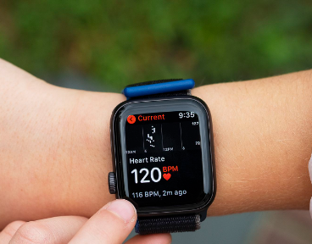

However, the following organs play an important role to ensure that the blood carried out the above functions smoothly. They are

1. Heart: It is a pumping station of the body. Entire circulatory system is dependent on this organ. So, one has to ensure that this organ is functioning normally and close monitoring is required. The heart works with certain rhythm and pressure. The pressure at which, the heart pumps blood to various parts is called systolic pressure and pressure at which it received blood is called diastolic pressure . Normal range may differ from person to person and it should not be too high or too low. There are many physiological and psychological factors which contribute to the malfunction of the heart. The following are risk factors

i. Obsesity, over-weight, high cholesterol level

ii. Wrong eating habits and irregular sleeping habits

iii. Lack of proper exercise

iv. Pressure, tension and anxiety disorders.

Measuring heart rate using light is called [photoplethysmography](https://iopscience.iop.org/article/10.1088/0967-3334/28/3/R01). The device measures the change in concentration of red blood cells as the blood vessels expand and contract – ie expanded blood vessels absorb more green light, contracted blood vessels absorb less green light. The detector measures the reflected light and a software algorithm converts the changes in light intensity into your pulse rate.

The newest devices and software use advanced algorithms to monitor pulse rate data and detect issues such as atrial fibrillation (irregular heartbeat). The accuracy and reliability of the algorithms for regular health monitoring is still under investigation though, mainly due to variations that could be caused by different skin pigmentations. A recent [large-scale study](https://doi.org/10.1056/NEJMoa1901183) found that more than a third of participants who were notified of an irregular pulse by their smartwatch had atrial fibrillation

Modern smartwatches use a flashing green light to measure our heart rate from our wrist. Spectroscopy tells us that blood absorbs green light because red and green are opposite each other on the colour wheel. The rear of the smartwatch contains an optical sensor to detect the reflected light. The main difference from spectrometers is that the light source and detector are positioned on the same side in smartwatches, while they are opposite each other in spectrometers. The layout used in smartwatches can result in lower accuracy compared to spectrometers because the detector is entirely dependent on the amount of light reflected from the sample, i.e your blood.

Bio impedance sensor and GPS tracking- Thrivikram katari (SE20UECE096)

Pedometer and sleep monitoring- Likhitha sai Karanam (SE20UEEE015)

Body composition and calorimeter – Krishna swamy (SE20UECE037)

Oxygen level sensing and heart beat sensor – Kaundinya swarna (SE20UECE034)