**Technologies used :**

1. Spring Boot 1.4.2.RELEASE
2. Spring 4.3.4.RELEASE
3. Tomcat Embed 8.5.6
4. Maven 3
5. Java 8

**1. Project Directory**

Clone or Download project from GitHub : <https://github.com/Vikramkodati2003/ABNAmroFutures.git>

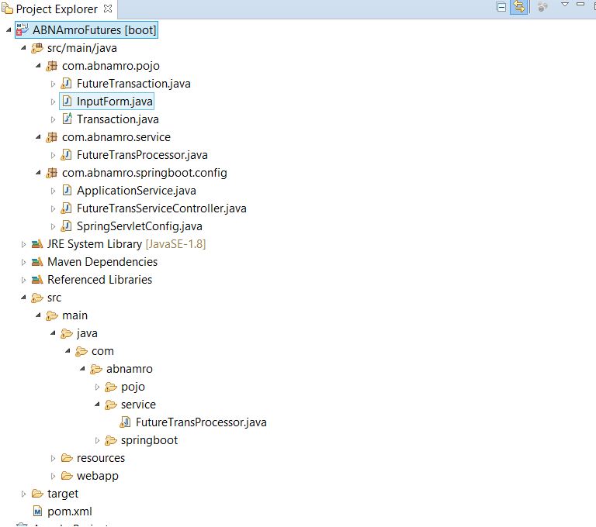

**2. Demo**

2.1 Start the Spring Boot web app.

Goto project root directory and execute command “mvn spring-boot:run” as shown below

**project$ mvn spring-boot:run**

2.2 Access <http://localhost:8080>

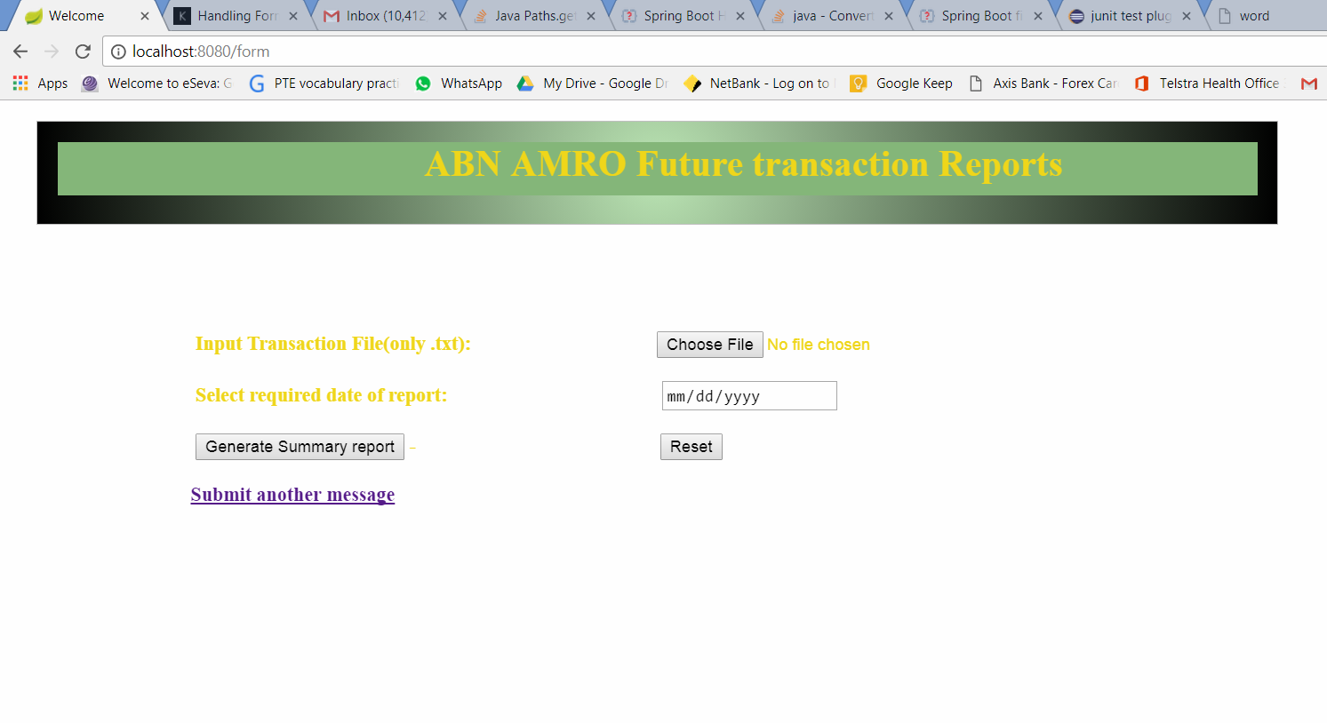

**3. Use cases**

**Choose the input text file and date for which report is required.**

**The input text only accepts txt files.**

**Please note that if there is no record available for selected date it would should error page.**

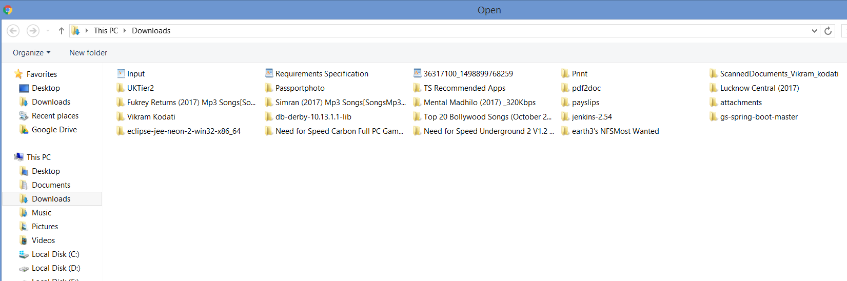

**Date and Input text selected.**

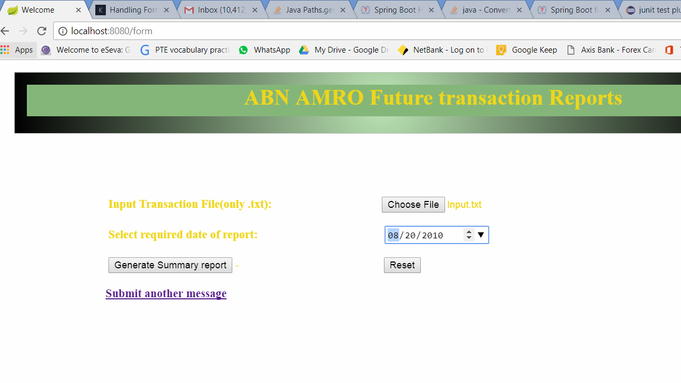

If the report is generated without error, then it would show below message

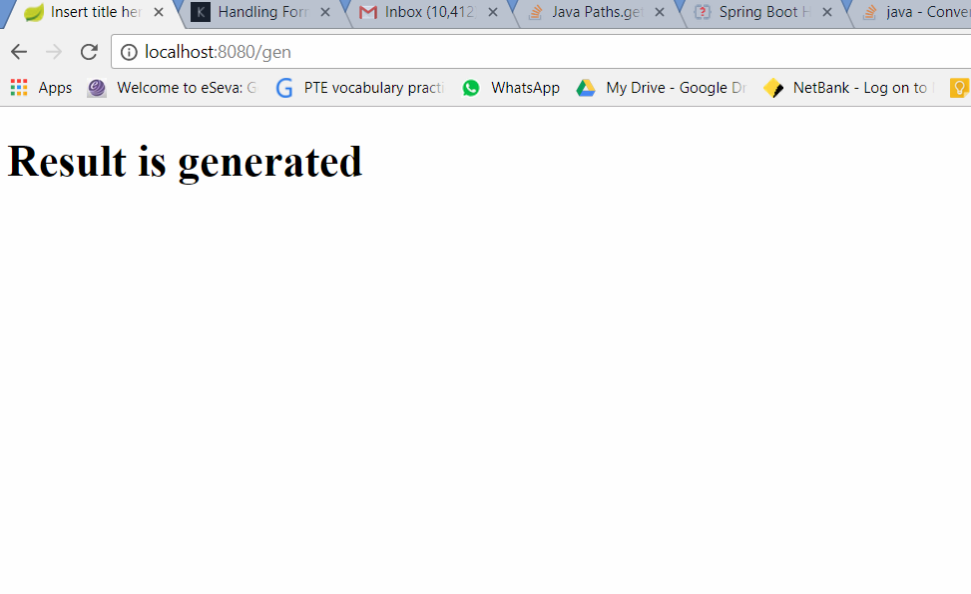

The out file will be stored at c://temp directory in Windows and /temp/ directory on linux machines respectively.

