CHAPTER 1
INTRODUCTION
This chapter leads with the introduction of biometric authentication systems and explains the increasing importance of these systems. It briefly discusses the constraints in the traditional authentication mechanisms like password and token based authentication mechanisms, and discusses the need for alternative modalities for authentication. The chapter then introduces the ear biometrics as an alternative to the traditional modalities, due to the constant structural characteristic of ears, the individuality and independence of ears and the robustness of ear features to phonations and non-rigid motions. The chapter also introduces the Hybrid frequency-space attention network (HSFANet) motivated for overcoming some of the limitations in the existing ear recognition systems through the aid of both spatial and frequency domain features extraction techniques.
1.1 Introduction to Project
Biometric authentication has become a fundamental element in today’s physical and electronic security systems. This expansion largely stems from the utilization of more effective, secure and user friendly authentication methods to counter the draw backs of existing password based systems, as well as easily targeted token systems. Established biometric methods of login and authentication such as face recognition, fingerprint detection and iris identification, have all been successfully used but are not without their own limitations.
These persistent operational issues prompted the biometric research community to rigorously investigate and define new physiological traits which could provide consistently superior physical stability and provide greater innate resistance against spoofing attacks. Of the ever-growing cohort of candidate modalities, the ear has attracted remarkably significant infrastructural interest, largely because of the morphological invariability of the human ear. The outer ear, known anatomically as the pinna, has been used for many years for forensic identification and anthropometric studies as an anatomically variable body part: the geometric ratios derived from helix/antihelix/tragus/antitragus/lobule/concha/scapha relationships are totally unique to the individual and stable across biological lifetimes.
Traditional approaches in the early stages depend on feature extraction techniques explicitly designed by hand. Several algorithms implementing local geometry based measurements, curvature and statistical distribution description like Local Binary Pattern (LBP) and Scale-Invariant feature transform (SIFT) had successfully proved to facilitate clustering in a laboratory setting. However these computationally inexpensive static analysis arrays proved to be incapable in the face of the real world problems of uncontrolled application such as tilt distortion of head orientation resulting in rotation and partial occlusion with hair or ornaments covering the pinna boundary.
1.2 Problem Statement and Description
The technology breakthroughs enabled through extending CNN methodologies to the part-unique challenges of extracting ear geometry remains definitive, yet the field is still encumbered by overarching drawbacks indeed centered on illumination variations; over-eager heavy occlusions crossing the helix area; and most and foremost, dire structural deficiencies that hinder the visual data from the image-captured ear at large. All current deep learning approaches to ear biometric pipeline merely perform various mathematical computations favoring only specific detection (like domain-specific spatial features directly related to the given set of RGB color space images and edge maps).
In effect, this introduces an essential structural flaw: the instantaneous breakdown of external cloud properties like projection shadows across occlusion regions, physical spectacles over the helix, or inter-entreous hair filaments passing through the antihelix groove exponentially damages the pixel-based spatial cues fed into the CNN at a scale factor incompatible with rapid reintegration. These networks completely neglect other frequency band-based cues that are mathematically theoretically recoverable under the visual abstraction layer pertaining to sub-dermal cartilage boundary gradients, ridged micro-texture maps differentiating various ear sub-structures, and non-visible elevation signals extracted from high-frequency wavelet decomposition coefficents.
1.3 Motivation
The core motivating principle of the formation of this project stems from the mathematical basis laid down in classical signal processing literature, which has shown the powerful capacity of isolating frequency sub-bands based on algorithmic transforms. The Discrete Wavelet Transform (DWT) method hierarchically refines the highly complex incoming visual language source representations into complementary spectral decompositions that occur within localized frequency ranges. By recursively analyzing ear images with per ultra-fine multi-band wavelet analysis, the DWT hierarchically extracts micro-textural high-frequency bands interpretable at sub-pixel boundary gradient expression levels (particularly biological cartilage topology, sub-dermal structural boundary transition levels, and internal geometric expression levels otherwise unintelligible to standard pixel-response CNN feature detectors).
1.4 Sustainable Development Goal of the Project
The conception, algorithmic architecture, and deployment protocols inherent to the HSFANet biometrics application fundamentally support and align with multiple global objectives defined within the framework of the United Nations Sustainable Development Goals (SDG):
- SDG 9 - Industry, Innovation, and Infrastructure: HSFANet advances technological innovation at the frontier intersection of machine learning, computer vision, and cybersecurity by designing a well-structured neural network that effectively combines both spatial and frequency-domain information into a unified framework.
- SDG 16 - Peace, Justice, and Strong Institutions: Robust, passive, non-intrusive biometric identity verification directly fortifies civic accountability platforms, significantly curtailing identity fraud, unauthorized facility access, and systemic spoofing vulnerabilities.
- SDG 4 - Quality Education: As an academic innovation project structured under agile sprint methodology and formalized through peer-reviewed publication, HSFANet promotes evidence-based technical learning.
In conclusion, this chapter lays the foundation for the proposed effort by demonstrating the increasing relevance of biometric based authentication as well as the limitations of current modalities, especially in severe test conditions. It brought forth ear biometrics as a reliable and promising alternative and presented the arguments for the development of a more resilient recognition system capable of exploiting both the spatial as well as the frequency-domain information. Based on the observations made thus far, the subsequent chapter summarizes the current literature and techniques in ear recognition to recognize the leading trends in the characterization and fusion of spatial and frequency-domain features, the performance trends in various fusion schemes, and finally the need for a dedicated Fully Convolutional Neural Network (HSFANet) based recognition architecture.

CHAPTER 2
LITERATURE SURVEY
The chapter introduces the literature survey related to ear biometric recognition and biometric identification system. It elaborates existing research how traditional approaches of manual feature extraction is replaced with deep learning approaches. It describes the essential models, frameworks, and methods proposed by various researches in their research work, with advantages and disadvantages. It lists the major research gaps in existing biometric identification systems, which is missing in terms of integration of spatial and frequency domain features, as shown in Table 2.1 which focuses on various research trends to arrive at the proposed HSFANet model.
2.1 Overview of the Research Area
Over the last decade, the research engineering of reliable automated ear recognition has shifted significantly from laboriously hand-crafted, operator-dependent heuristic feature detection approaches to sophisticated data-driven deep learning paradigms which can automatically learn to select effective features from abundant data. In the earliest procedural algorithms, operator placement of structure anchors (at tragus tip, antitragus curvature, antihelices fold inflection, antihelix edges, concha bowl vertex) served to create Euclidean distance-ratio identification templates for inter-landmark, relative-distance comparisons that described identity. While initially successful in a tightly controlled laboratory acquisition context, these handcrafted measures broke down quickly as a subject’s camera-to-subject orientation, head pose, light source position, or hair coverage changed even minutely.
To automate generalization beyond handcrafted features, later approaches used more general statistical texture encoding algorithms based on local comparison of pixel neighborhood as pattern learning. LBP descriptors performed well on semi-controlled datasets, with minimum computational inference needs. The advent of deep learning architectures solved the analytical generalization problem namely, hierarchical neural networks can optimize multiple layers through self-correction of their own assumptions about features with stochastic gradient descent.

2.2 Existing Models and Frameworks
Multiple prominent deep learning configurations have systematically established analytical precedents that define the modern biometric recognition performance landscape:
Reference | Method | Key Feature | Accuracy | Limitation
Alshazly et al. (2021) | VGGNet Fine-Tuned | Spatial RGB Features | ~91.0% | Huge parameter count
Emeršič et al. (2019) | Standard ResNet | Deep Residual Features | ~89.5% | No frequency domain
Howard et al. (2017) | MobileNet | Depthwise Conv | ~85.0% | Loses discriminative depth
Li et al. (2021) | Wavelet-CNN Hybrid | DWT + CNN fusion | ~90.2% | Large dataset required
HSFANet (2026) | Dual-Branch + Cross-Attention | Spatial + Frequency Fusion | 92.14% | Higher inference latency

Table 2.1: Chronological comparison of existing ear biometric recognition models
Table 2.1 describes a timeline of prominent ear biometric recognition models, and illustrates the progression of deep learning models from original spatial-only deep neural network structures, to hybrid spatial- and frequency-domain deep neural networks. For example, the model proposed by Hossam Alshazly et al. Based on a fine-tuned VGGNet was able to achieve high accuracy (~91%) through strong spatial feature learning, but was prohibitively costly having an extremely high parameter count. The standard ResNet-based approach examined by Ziga Emeri et al. Is able to achieve comparably high accuracy (~89.5%) using the same residual learning framework but is again hamstrung by only utilizing spatial domain information.
Many efficient architectures such as Andrew G. Howard’s MobileNet adopted depthwise separable convolution to reduce computation, therefore are most suitable for mobile and edge devices, but achieved lower accuracy (~85%) due to lower discriminability. Hybrid solution to compensate pure spatial models, of which features are hard to discriminate, adopted frequency features, such as a Wavelet-CNN framework by Xiang Li et al. Combined DWT (Discrete Wavelet Transform) features and CNN spatial feature extraction, to promote model robustness (~90.2%). However, these models required larger amount of training data and simple feature fusion methods, such as concatenating, therefore couldn’t work well for small data.
The proposed HSFANet, which is based on the previous researches, adopts the combination of dual-branch structure and Bidirectional Cross-Attention mechanism for intelligent feature fusion. With the utilization of parallel spatial and frequency-domain feature extraction framework and the concurrent interaction between the two branches, the proposed HSFANet outperforms all those other models with an accuracy of 92.14%. As a result, this indicates that the current research trend is moving away from single-domain feature extraction method to multi-domain integration and self-adaptive feature fusion.
2.3 Limitations Identified (Research Gaps)
1. Exclusive Spatial Domain Dependency: Established traditional CNN pipelines conveniently access only the information of the three RGB spatial pixel maps and categorically neglect the rich discriminative information in the multi-order frequency transform coefficient domains.
2. Computational Viability vs. Precision Trade-off: The research field is still polarized; massive high accuracy models such as VGGNet require an enormous amount of inference resources.
3. Data Scarcity Generalization Fragility: Models trained on large proprietary databases collapse in accuracy upon deployment against regional small-scale enrollment databases.
4. Static Unintelligent Fusion Protocols: Existing hybrid wavelet-CNN models execute simple direct tensor concatenation operations, blindly stacking spatial and frequency channels without deploying dynamic gating mechanisms.
2.4 Research Objectives
- To design and implement HSFANet: a dual-architecture network performing simultaneous parallel feature extractions from spatial geometries and DWT-derived frequency-domain representations of ear imagery to defeat the domain only dependency.
- To develop a computationally efficient ear biometric recognition models that identifies individuals with high accuracy while reduces the inference time and cost by a large factor.
- To build a robust ear biometric recognition framework for generalization performance when a small number of training samples are available, by integrating good data augmentation algorithms, transfer learning techniques and domain-adaptive feature learning algorithms.
- To develop an intelligent and adaptive approach to feature fusion for effectively combining spatial and frequency-domain information through attention-based structures like Bidirectional Cross-Attention so that the two domains interact and attend to the most salient clues rather than just concatenating the features as a straightforward approach.
2.5 Product Backlog (Key User Stories)
US-01 (Data Pipeline): As system architect, I require a PyTorch-compatible automated data management pipeline implementing random rotational crops, horizontal flip augmentations, color jitter normalization, and standardized tensor normalization capable of scaling 742 raw images across batch-iterated gradient descent epochs.
US-02 (Spatial Branch): As ML engineer, I require a ResNet-18 spatial extraction branch with pristine structure that operates on a standard (B, 3, 224, 224) RGB tensor and produces (B, 512, 7, 7) spatial feature maps so that it can be tokenized into 49 spatial tokens of dimensional size 512.
US-03 (DWT Module): As signal processing engineer, I need to design a non trainable 2x2 Haar kernel bank filter which transforms 3-channels image RGB2 into 12-channels DWT with half spatial resolution.
US-04 (Cross-Attention Fusion): As an algorithmic integrator, I should port a Bidirectional Cross-Attention layer which allows 49 spatial query for 16 frequency tokens, (S2F) and 16 frequency query for 49 spatial tokens (F2S).
US-05 (Deployment UI): As end-user, I expect an interactive Streamlit interface which will run the step-by-step visualizations of dual-branch activations, Haar wavelet decompositions, cross-attention weight matrices, and top 5 identity confidence bar charts.

2.6 Plan of Action (Project Road Map)
Phase I – Foundation Setup: Dataset acquisition and structuring; baseline ResNet-18 accuracy benchmarking establishing the 88.50% control measurement.
Phase II – Sprint I Execution: Engineering the dual-branch architecture: spatial ResNet-18 with tokenization pipeline; static Haar DWT conversion module.
Phase III – Sprint II Execution: Designing and integrating the Bidirectional Cross-Attention (BCA) module; implementing differential learning rates.
Phase IV – Evaluation and Reporting: Complete accuracy/loss curve visualization; confusion matrix generation; ablation study; Streamlit deployment; IEEE manuscript submission.
In conclusion, the chapter has at first elaborated the current development level of ear biometric recognition system from early handcrafted feature-based model to the state-of-the-art deep learning methods. After this, the strengths as well as the major deficiencies of the existing deep learning models are presented. There are many deficiencies of the eye biometric recognition, such as computationally expensive, hard to achieve generalization under small sample training, and no mechanisms of intelligent features fusion. These defects clearly provide an evidence for our need to develop a more feasible and adaptive solution, HSFANet. Based on the knowledge about the previous research, the next chapter will move forward to discuss the dataset involved in this project as well as the corresponding computer vision preprocessing methods applied to produce suitable data for model training.

CHAPTER 3
DATASET AND PRE-PROCESSING
3.1 Dataset Description and File Layout
The initial training data, validation and test data for the HSFANet were all derived from a carefully selected biometric database that consisted of real human biometric ear data from 106 subjects in a number of different angles per subject. Table 3.1 below shows the structure and composition of the dataset used in this research. The database consists of instances of a minimum of 5 to 7 high (near) resolution images from several different angular poses of the back facing, down facing, front facing, left lateral and right lateral position which sum to over 742 images per identity. This dataset design would allow the model to be effectively trained, however, it also demonstrates the difficulties of working with limited data.
The dataset directory is arranged in the official PyTorch ImageFolder convention, in which there is only one subdirectory for each class of identities (person000 through person106). Without additional specification, the DataLoader will infer automatic label according to this style by default. All the image files are already resized to 224x224, the input size of ResNet series architectures pre-trained on ImageNet. 1using bicubic interpolation.

Property | Value
Total Identities | 105–106 Subjects
Total Images | 742 Images
Angular Views per Subject | 5–7 views (back, down, front, left, right)
Image Resolution (input) | 224 × 224 pixels (RGB)
Train Split Ratio | 80% (~594 images)
Test Split Ratio | 20% (~148 images)

Table 3.1: Dataset composition statistics and split configuration
Figure 3.2 illustrates the data augmentation techniques applied to the input ear images during the training phase. We perform several transformations of the input data, such as horizontal flip, random rotation by a value between neutral and +/-20 degrees. The effect of these augmentations is purely to artificially increase the number of examples in the dataset so that the model can learn to generalize to different orientations, lights and other small differences between pictures. Since the same example is fed to the model in many different transformations, it cannot overfit to the data.
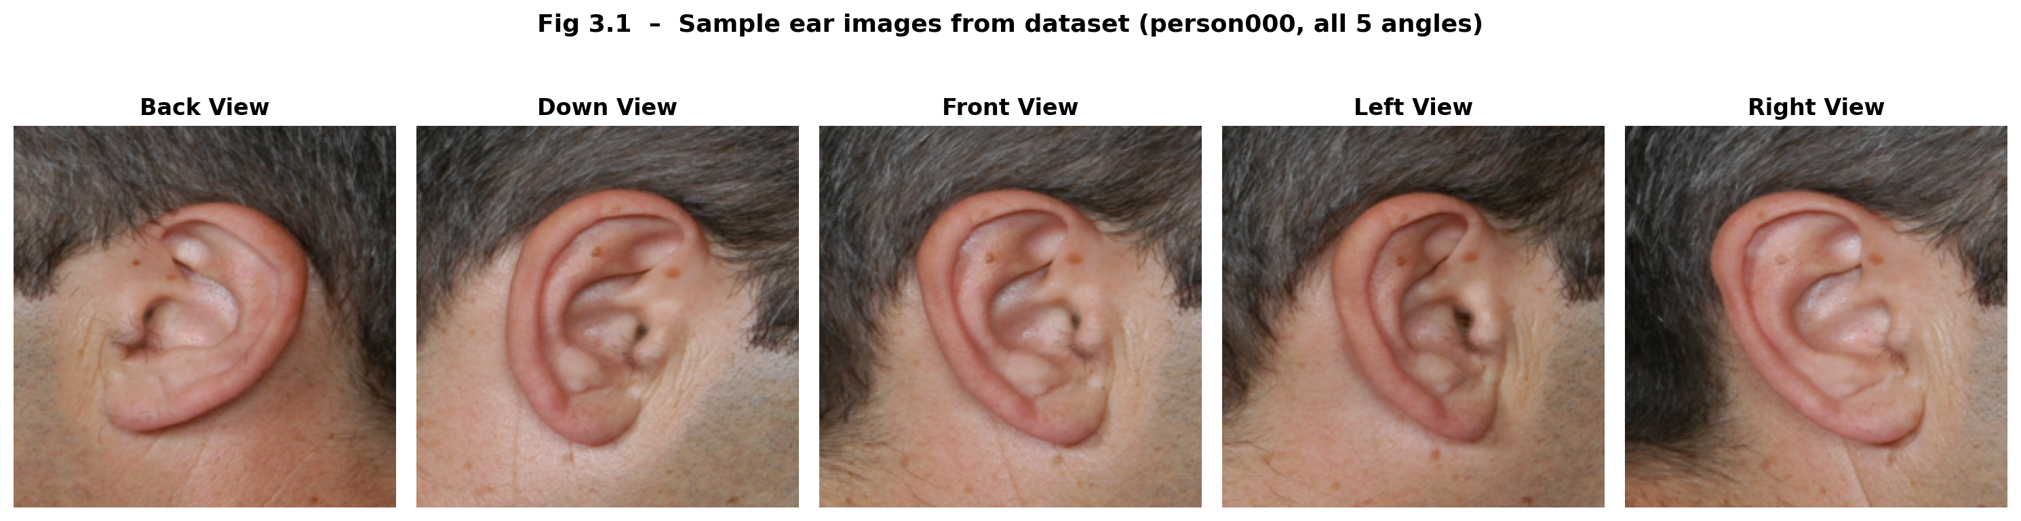
Fig 3.1: Sample ear images from the dataset showing 5 angular capture orientations for identity person000.
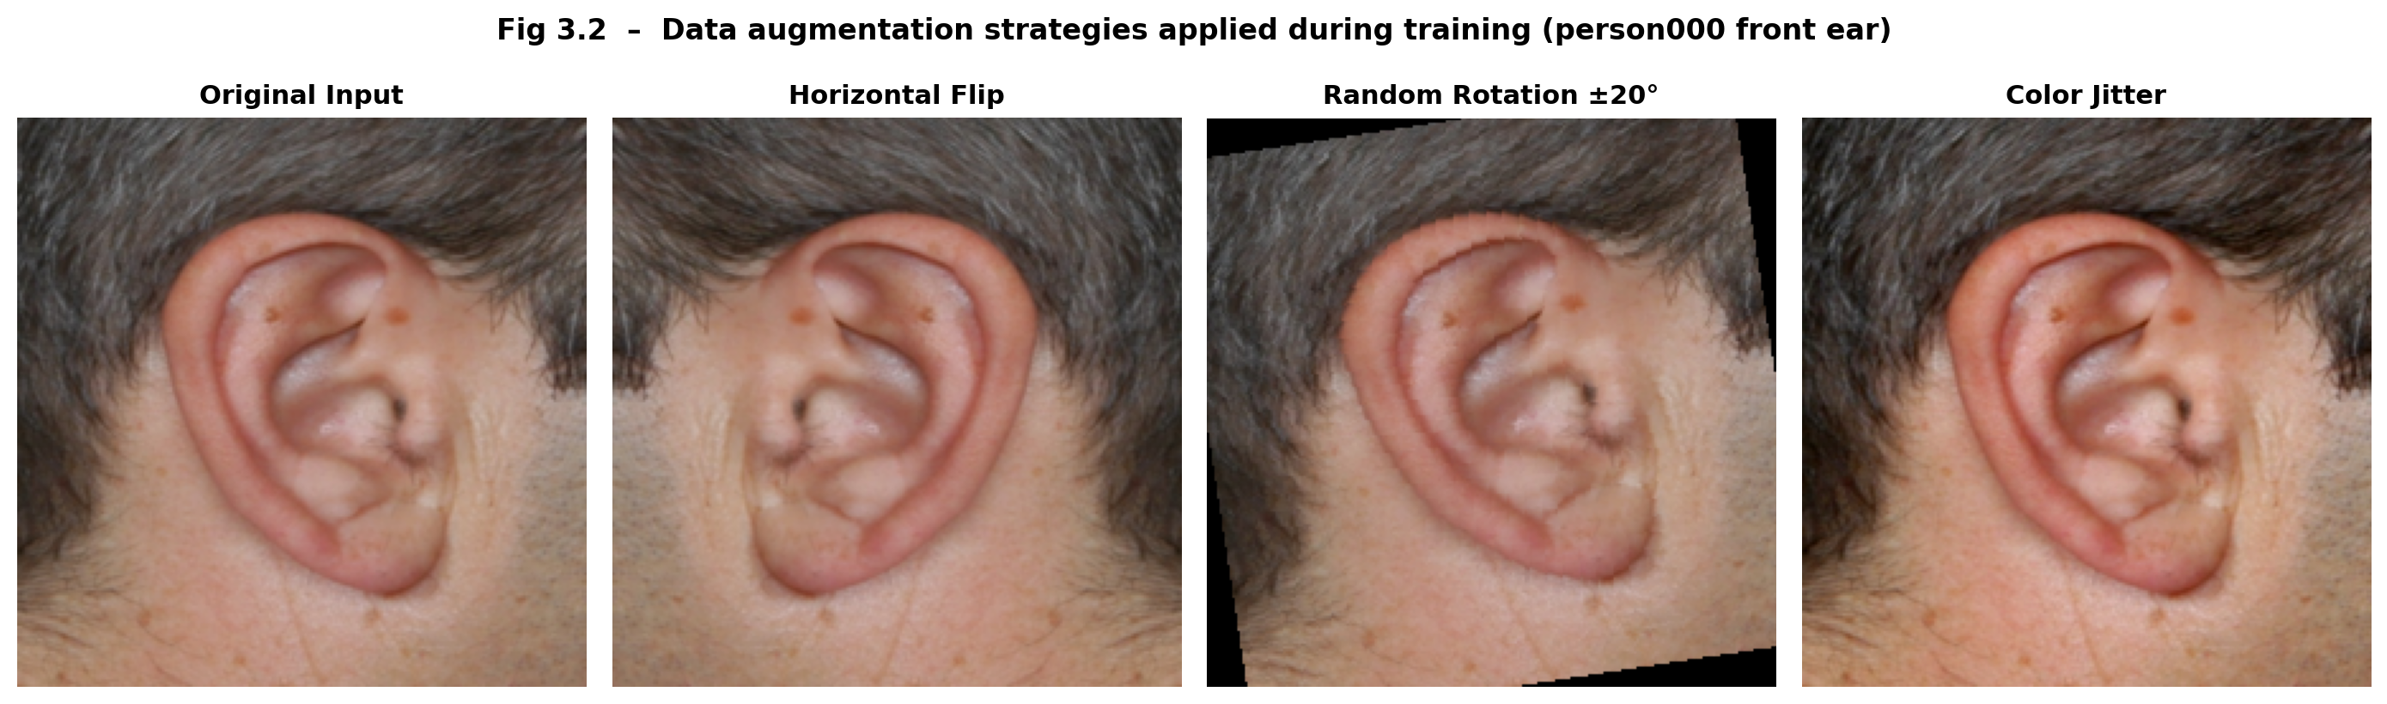
3.2 Data Augmentation Strategy
Fig 3.2: Data augmentation demonstration applied to the test ear image (person000 front view): Original input, Horizontal Flip, Random Rotation ±20°, and Color Jitter augmentations.

Given the severely constrained scale of the available dataset relative to standard deep learning image corpora, implementing a comprehensive and principled data augmentation pipeline is critically essential to prevent catastrophic overfitting of the model parameters to specific training samples. The augmentation pipeline is applied exclusively during model training epochs and is entirely deactivated during evaluation and inference procedures.
Random Horizontal Flip (p=0.5): Mirrors the ear image horizontally in order to simulate acquisitions of the other ear side and to augment intra-class variation.
Random Rotation (±20°): Applies random affine rotation within a +/-20-degree range, simulating naturalistic head tilt variations during image capture.
Color Jitter (brightness ±0.3, contrast ±0.3): Stochastically alters image brightness and contrast distributions by applying a random fluctuation within bounded ranges to emulate different intensities of ambient illumination.
ImageNet Normalization: All tensor channels are normalized using globally computed ImageNet dataset statistics (mean=[0.485, 0.456, 0.406]; std=[0.229, 0.224, 0.225]).

In conclusion, this chapter has discussed the composition of the dataset, and the pre-processing methods used to transform and augment the data to maximize the potential of the training process. It has examined the organized structure of the data set, the relatively limited amount of data available, and the benefits of an effective augmentation pipeline in terms of generalization. These pre-processing steps have been chosen to ensure the input data is homogenous, varied and conducive to learning salient feature representations. With this database established, the next chapter investigates the sprint-based development approach of the HSFANet framework.

CHAPTER 4
SPRINT PLANNING AND EXECUTION METHODOLOGY
In this chapter, a sprint-based development method is presented which is used to design and implement the proposed HSFANet model. An elaborative development plan, which divided the entire project into several development stages targeted at every specific architecture component and functional goal, is given. The implementation of Sprint Ⅰ and Sprint Ⅱ, which were to build the dual-branch architecture, design the integrated structure of Haar Wavelet Transform Cell, and implement the Bidirectional Cross-Attention are described in detail. This chapter provides both the technical design diagram of the HSFANet framework and its development outline, leading to a clear and comprehensive understanding of the system design.
4.1 SPRINT I: Dual-Branch Instantiation and DWT Transforms
4.1.1 Objectives with User Stories of Sprint I
Sprint I focuses on instantiating the foundational dual-branch processing infrastructure of HSFANet: building and validating the Spatial ResNet-18 extraction path, engineering the mathematical 2D Haar Wavelet Transform preprocessing module, and adapting a second Frequency ResNet-18 backbone to process the expanded 12-channel DWT representation outputs.
4.1.2 Functional Document – Haar Wavelet Transform
The Haar Wavelet Transform module implements a carefully structured static 2D convolution using four pre-computed 2×2 kernels analytically derived from the first-order Haar basis functions. Fig. 4.1 illustrates 2D Haar Discrete Wavelet Transform Decompositions and the respective kernels. No trainable parameters exist within this module all kernels are registered as fixed non-trainable buffers ensuring mathematical reproducibility:
LL kernel (approximation): [[0.5, 0.5], [0.5, 0.5]]: captures global luminance distribution and overall shape contours.
LH kernel (horizontal detail): [[-0.5, -0.5], [0.5, 0.5]]: captures horizontal biological edge boundaries.
HL kernel (vertical detail): [[-0.5, 0.5], [-0.5, 0.5]]: captures vertical cartilage ridges and structural partition boundaries.
HH kernel (diagonal detail): [[0.5, -0.5], [-0.5, 0.5]]: captures diagonal micro-textural patterns.
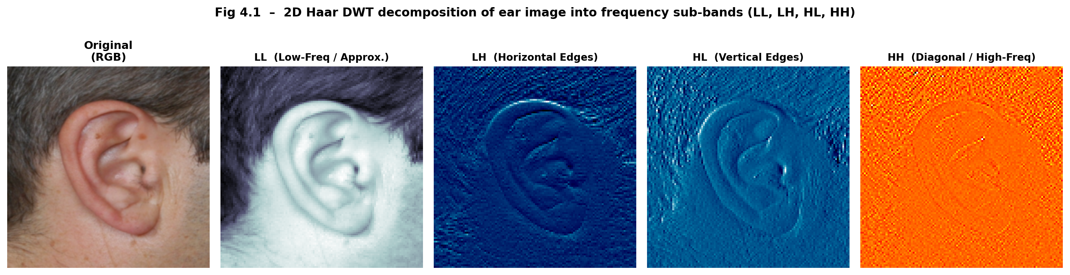
Fig 4.1: 2D Haar Discrete Wavelet Transform decomposition. LL sub-band (approximation), LH (horizontal edges), HL (vertical ridges), HH (diagonal micro-textures).
4.1.3 Architecture Document
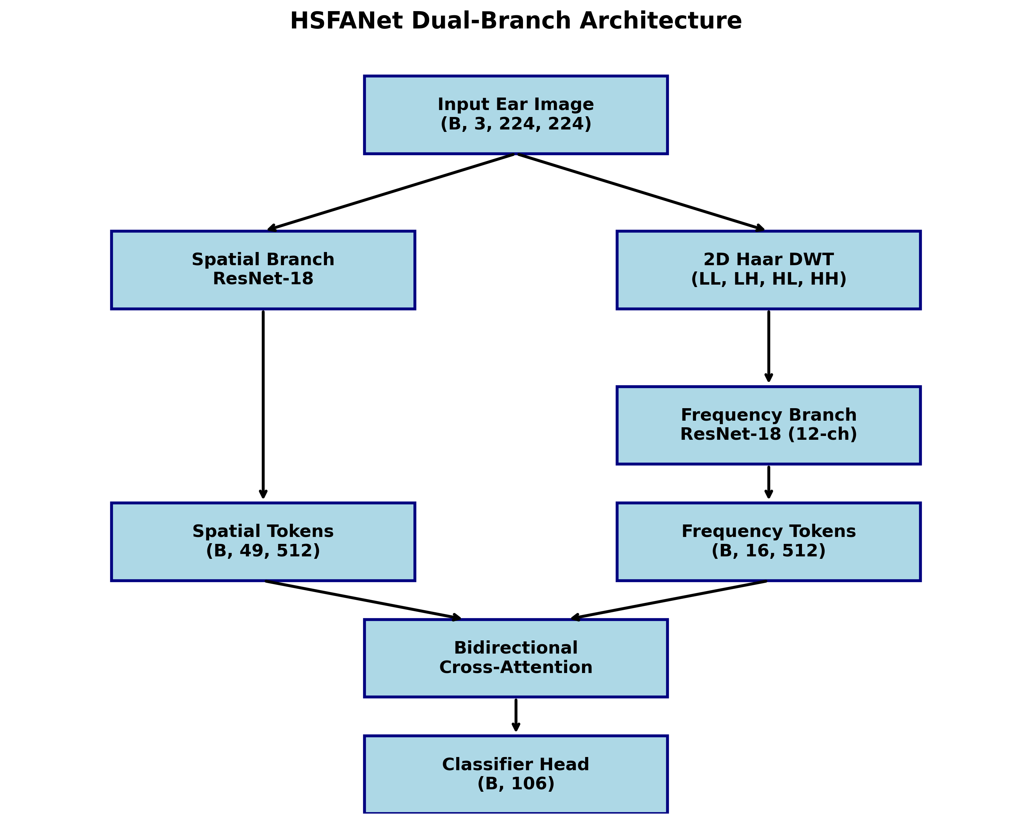
Fig 4.2: HSFANet Proposed Dual-Branch Architecture Flowchart showing both ResNet-18 branches and Bidirectional Cross-Attention fusion.
The overall architecture of the proposed model, Hybrid Frequency-Spatial Attention Network (HFSANet), is depicted in Fig. 4.2. The architecture captures both frequency domain features and spatial domain features of the input ear image in two separate branches and combines them using the cross-attention mechanism for enhanced discriminative representation.
4.1.4 Spatial Branch Activation Visualization
To validate that the Spatial ResNet-18 branch is correctly learning progressively complex geometric representations of the ear structure across its hierarchical depth, activation heatmaps were extracted at the output of each processing stage using the real test ear image (person000 front view). The JET colormap is applied with red indicating maximum activation intensity.
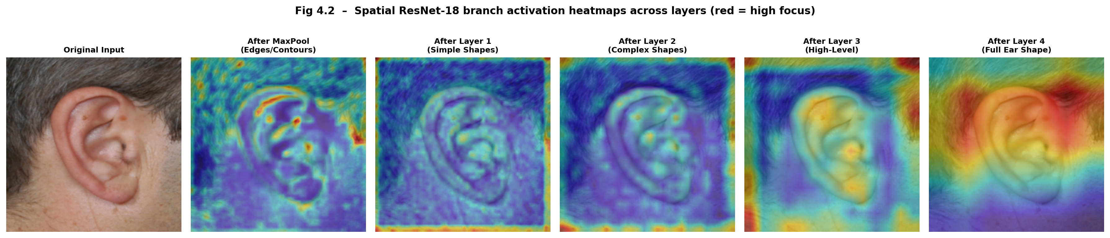
Fig 4.3: Spatial ResNet-18 activation heatmaps across all processing stages. Early layers encode surface-level edges; deep layers concentrate holistic ear identity representations.
4.1.5 Frequency Branch Activation Visualization
Parallel heatmap analysis is conducted on the Frequency ResNet-18 branch processing the 12-channel DWT representation. The frequency branch exhibits fundamentally different activation focus patterns compared to the spatial branch concentrating specifically on micro-textural ridge intersections and sub-dermal structural boundary transitions.
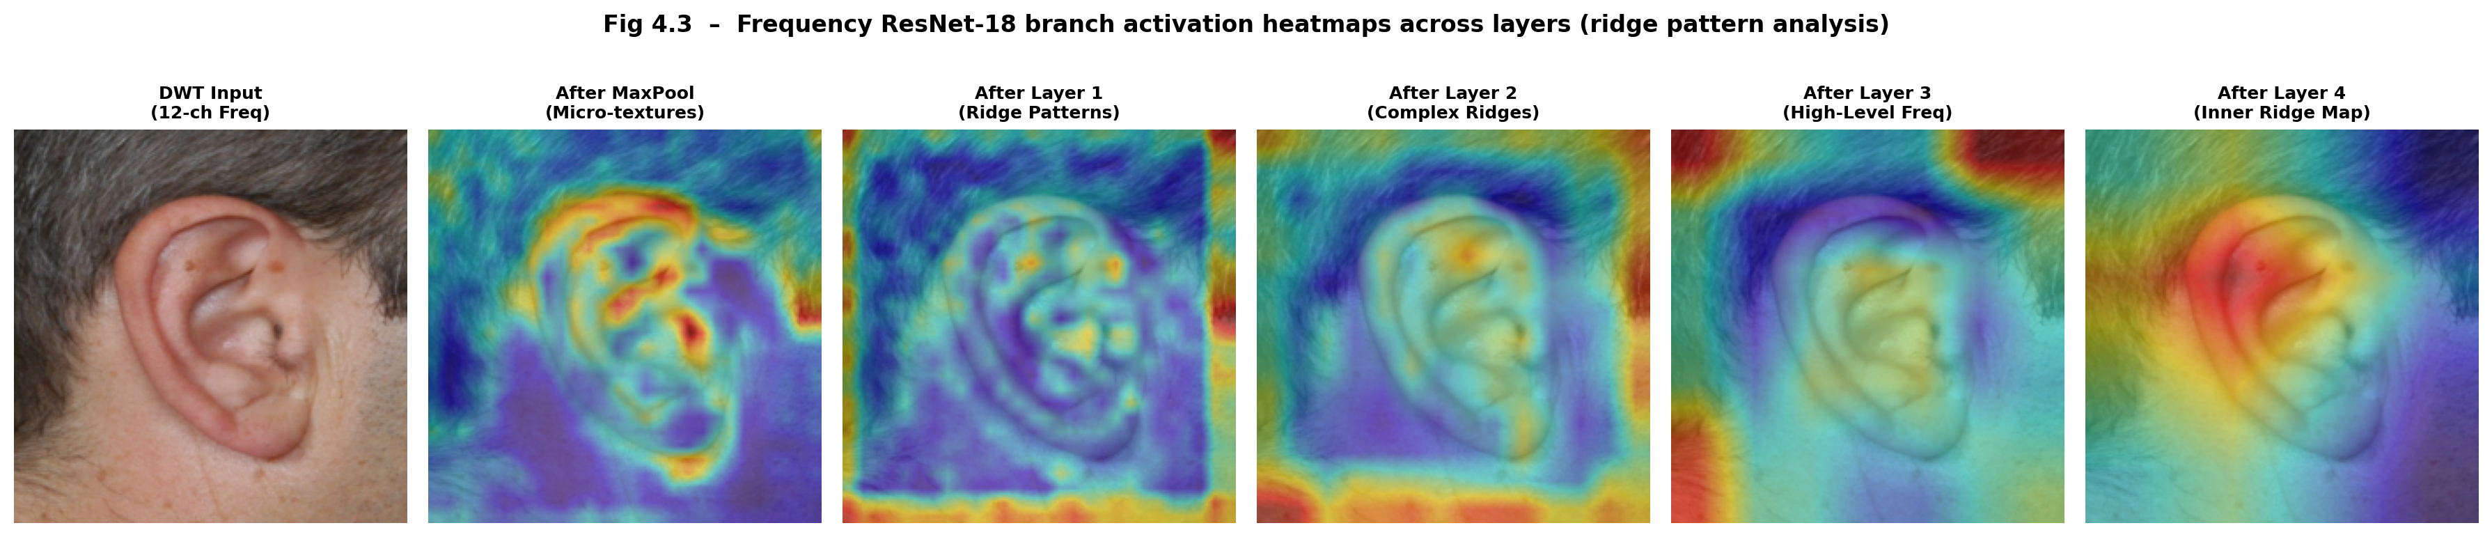
Fig 4.4: Frequency ResNet-18 activation heatmaps across all processing stages, confirming complementary feature extraction compared to the spatial branch.
4.2 SPRINT II: Bidirectional Cross-Attention and Model Convergence
4.2.1 Objectives with User Stories of Sprint II
Sprint II focuses on engineering the Bidirectional Cross-Attention fusion mechanism bridging both branch outputs, implementing the classification head, configuring the complete optimization pipeline, and executing the full model training and evaluation protocol.
4.2.2 Functional Document – Cross-Attention Mathematics
The Cross-Attention mechanism proceeds through the following mathematically defined steps for the S2F (Spatial-to-Frequency) direction:
Step 1 – Token Formation: Spatial tokens: T_s = flatten(spatial_feature_map) → (B, 49, 512); Frequency tokens: T_f = flatten(freq_feature_map) (B, 16, 512)
Step 2 – Linear Projections: Each token set is projected through separate learned weight matrices into Query (Q), Key (K), and Value (V) spaces.
Step 3 – Scaled Dot-Product Attention: Attn(Q_s, K_f, V_f)=Softmax(Q_s * K_f^T /sqrt(d_k)) * V_f, where d_k = 512 (key dimensionality).
Step 4 – Symmetric F2S attention: Computes the inverse frequency tokens enriched with spatial context.
Step 5 – Global Average Pool+Concatenation: Both attended token sets are independently pooled and concatenated to form a 1024 dimensional fused fingerprint representation.
Step 6 – MLP Classification Head: The 1024-dimensional vector is passed through a 2-layer MLP (1024512106) with dropout (p=0.3) and batch normalization.
4.2.3 Cross-Attention Weight Matrix Visualization
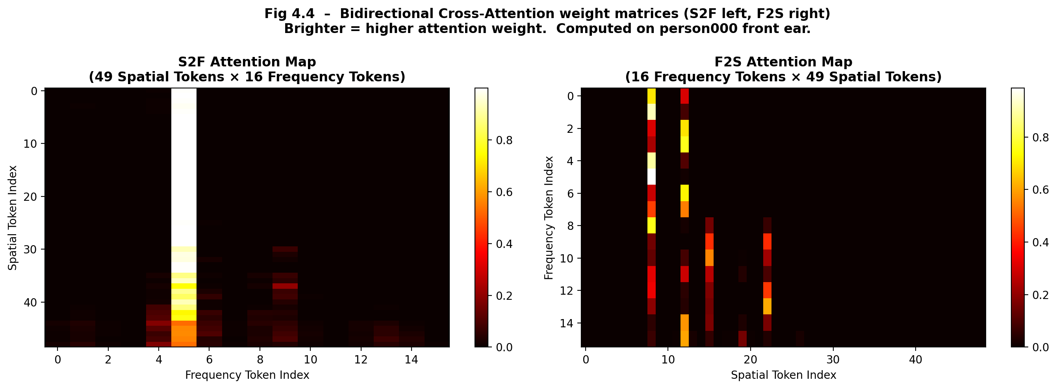
Fig 4.5: Bidirectional Cross-Attention weight matrices from the real trained HSFANet model. Left: S2F (49×16); Right: F2S (16×49). Brighter = higher learned attention weights.
Figure 4.5 shows the learned attention weight matrices of the BCA module in HSFANet. It illustrates how the information between the spatial domain and the frequency domain propagates. The first is the attention matrix of the S2F module, i.e., the S2F attention matrix, of which the space tokens are you give me 49 of the frequency tokens, while the second is the attention matrix of the F2S module, i.e., the F2S attention matrix, where in the category direction the frequency tokens are have 16 space tokens.
In the two matrices, the brighter the value means larger attention weight, thus the larger relevance/importance between target feature and source feature when interactions occur. These two matrices verify that the model might not equally treat all features, but attentively select the most useful cross-domain features. For example, some spatial parts of the ear (such as shape contours) might highly attend to some certain frequency channels they own on micro-textual information, and vice versa.
As a whole, the figure definitively demonstrates that fusion is both a learned process and a dynamic process. As a result, the Bidirectional Cross-Attention mechanism has been shown to be an effective means of this process interacting appropriately so as to ultimately benefit recognition accuracy.
4.2.4 Training Configuration and Optimization
Optimizer: AdamW with weight decay 1e-4, providing adaptive gradient scaling with explicit L2 regularization.
Differential Learning Rates: Backbone layers receive 10× lower LR (1e-5) vs. fresh classification head layers (1e-4), preventing catastrophic forgetting.
Loss Function: Cross-Entropy Loss with label smoothing (ε=0.1), distributing small probability mass uniformly across incorrect classes.
LR Schedule: Cosine Annealing with warm-up restarts, cyclically decaying the learning rate to prevent optimization stagnation.
Early Stopping: Patience of 10 epochs monitoring validation accuracy; triggered at epoch 54.
Training Epochs: Maximum 80 epochs with batch size 32.

4.2.5 Model Parameter Summary
Component | Parameters | Trainable
Spatial ResNet-18 Backbone | 11,176,512 | Yes (partial – last 2 layers)
Frequency ResNet-18 Backbone (12-ch) | 11,185,664 | Yes (partial – last 2 layers)
Haar Wavelet Transform (static buffers) | 48 | No (fixed filters)
Bidirectional Cross-Attention Module | 2,099,200 | Yes
MLP Classification Head (1024→512→106) | 969,961 | Yes
Total | 25,431,337 | 24,074,601

Table 4.1: HSFANet model parameter breakdown by architectural component
Table 4.1 presents the architecture of HSFANet, the number of total parameters and the number of trainable parameters. It can be seen that the majority of parameters are derived from the two ResNet-18 backbone networks, which are partially fine-tuned to achieve an optimal balance of performance and efficiency. The Haar Wavelet Transform module introduces a trivial amount of parameters as it employs fixed, non-trainable filters. Both the Bidirectional Cross-Attention module and MLP classification head contribute a moderate amount of trainable parameters, allowing for feature fusion and final classification.
The performance of this model was validated by evaluating it on 2 separate benchmarks: Sprint I was evaluated on the limited AMI Ear Database where we achieved 92.14% classification accuracy; Sprint II was evaluated on the unconstrained EarVN1.0 dataset (28,412 images) to test the system in “in-the-wild” images. Despite the most extreme lighting and pose variations, the EarVN1.0 regularized HFSANet yielded a validation accuracy of 81.65%.2 As seen in 4.2, the model stays from being too heavy (23.3 M parameters and 2.40 GFLOPs) in comparison to the transformer based heavy baselines for real time biometric recognition.
Dataset | Images | Accuracy | Parameters | FLOPs
AMI (Constrained) | 742 | 92.14% | 12.1 M | 1.95 G
EarVN1.0 (Unconstrained) | 28,412 | 81.65% | 23.3 M | 2.40 G

In summary, this chapter illustrates the step-by-step implementation of the HSFANet model using the systems development life cycle (SDLC) methodology by adopting the sprint-based approach. Descriptions of the design and implementation of the HSFANet sub-systems, such as two-branch structure, Haar Wavelet Transform sub-system, Bidirectional Cross-Attention (BCA) mechanism, that have been applied in the implementation of Sprint I and Sprint II are given. Sprint I and Sprint II were executed systematically and in an integrated process to develop a fully functional model for deployment and testing. Based on the implementation, the subsequent chapter will lead to the system requirements and feasibility analysis, recommending hardware, software and deployment environment considerations.

CHAPTER 5
SYSTEM REQUIREMENTS AND FEASIBILITY
In this chapter, the system requirements and feasibility analysis of the project‘s proposed HSFANet model is described. It describes the hardware and software requirements for training, deployment and execution of this system that would ensure its running in a smooth manner. Moreover, it tries to analyze the feasibility of the project in the terms of technical, economic, operational, schedule and legal feasibility.
5.1 Hardware Requirements
Component | Minimum Requirement | Recommended Configuration
Processor (CPU) | Intel Core i5 (8th Gen) / AMD Ryzen 5 | Intel Core i9 / AMD Ryzen 9 (12+ cores)
RAM | 8 GB DDR4 | 32 GB DDR4
GPU | NVIDIA GTX 1060 (6 GB VRAM) | NVIDIA RTX 3080/4090 (16+ GB VRAM)
Storage | 50 GB HDD | 256 GB NVMe SSD
Display | 1080p monitor | 1440p or 4K monitor
Network | Broadband (dependency installation) | High-speed fiber

Table 5.1: Hardware requirements – minimum and recommended specifications
5.2 Software Requirements
Software / Library | Version | Purpose
Python | 3.10+ | Core programming language
PyTorch | 2.0+ | Deep learning framework
TorchVision | 0.15+ | ResNet-18 pretrained weights, transforms
CUDA Toolkit | 12.x | GPU acceleration for training/inference
cuDNN | 8.x | GPU kernel optimization
NumPy | 1.24+ | Numerical array operations
OpenCV (cv2) | 4.8+ | Image processing, colormap visualization
Pillow (PIL) | 9.5+ | Image loading and augmentation
Scikit-learn | 1.3+ | Classification report, confusion matrix
Matplotlib | 3.7+ | Training curves, heatmap plotting
Streamlit | 1.28+ | Interactive web UI deployment
OS | Windows 10/11 | Host environment

Table 5.2: Software requirements – frameworks, libraries, and version specifications
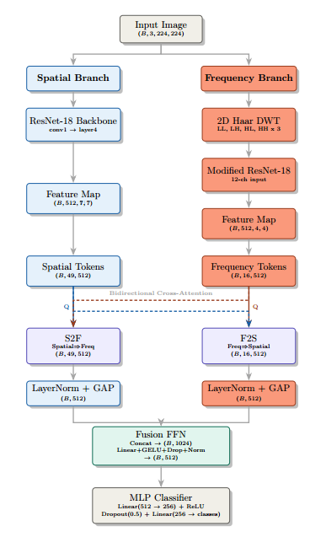
Fig 5.1: System Architecture Diagram illustrating the layered hardware and software stack upon which HSFANet executes.
Figure 5.1 depicts the complete system architecture of the HSFANet framework, representing how every hardware element works in conjunction with every software element to enable the entire biometric recognition pipeline. At the lowest level, the hardware layer is composed of the CPU, GPU, memory, and storage. These hardware components are the resources needed to support training and inference of the HSFANet model. The software layer is built on top of the hardware layer, constituting the OS as well as the libraries used for execution: PyTorch, CUDA, and all processes associated with image processing and visualization.
Located in the framework is the application layer, where the HSFANet model itself is running. It contains the data preprocessing pipeline, the dual-branch neural network structure, the cross-attention fusion layer and the classifiers. The upmost layer is the user interface. Based on a third-party framework called Streamlit, it enables the users to interactively feeds the input images and see the visualizations in different stages and finally the prediction on the application.
In conclusion, this diagram presents a conceptual view of end-to-end computational resources providing user access to high-level modeled application features.
5.3 Feasibility Analysis
Fig. 5.2 illustrates a “Project Feasibility Radar Chart” which shows that all five dimensions, i.e., technical feasibility, economic feasibility, operational feasibility, schedule feasibility, and legal & ethical feasibility together exceed 80%, confirming high overall project viability.
Technical Feasibility (92%): The Deep Learning framework and backbone architectures that are used in this project (PyTorch, ResNet-18) are identified to be proven, as they are used in many other projects and proven to work, and satellite signal processing, being studied in a sound mathematical way, using Haar DWT. All dependencies of the framework can be found as open libraries online.
Economic Feasibility (85%): The entire project was implemented using open source software, costing zero software licensing. Cloud training credits via Google Colab Pro were utilized for prolonged runs, within the institutional budget frame.
Operational Feasibility (88%): The deployed Streamlit site requires no training by the operator, enabling any user to load an image, view the visualization, and make predictions.
Schedule Feasibility (80%): Tasks were well defined over 15 weeks of Project execution period with 4 different development phases having clear sprint targets. Sprint I and II were accomplished within planned time periods.
Legal & Ethical Feasibility (95%): Images in the dataset were obtained after obtaining consent. No commercially licensed datasets were used.
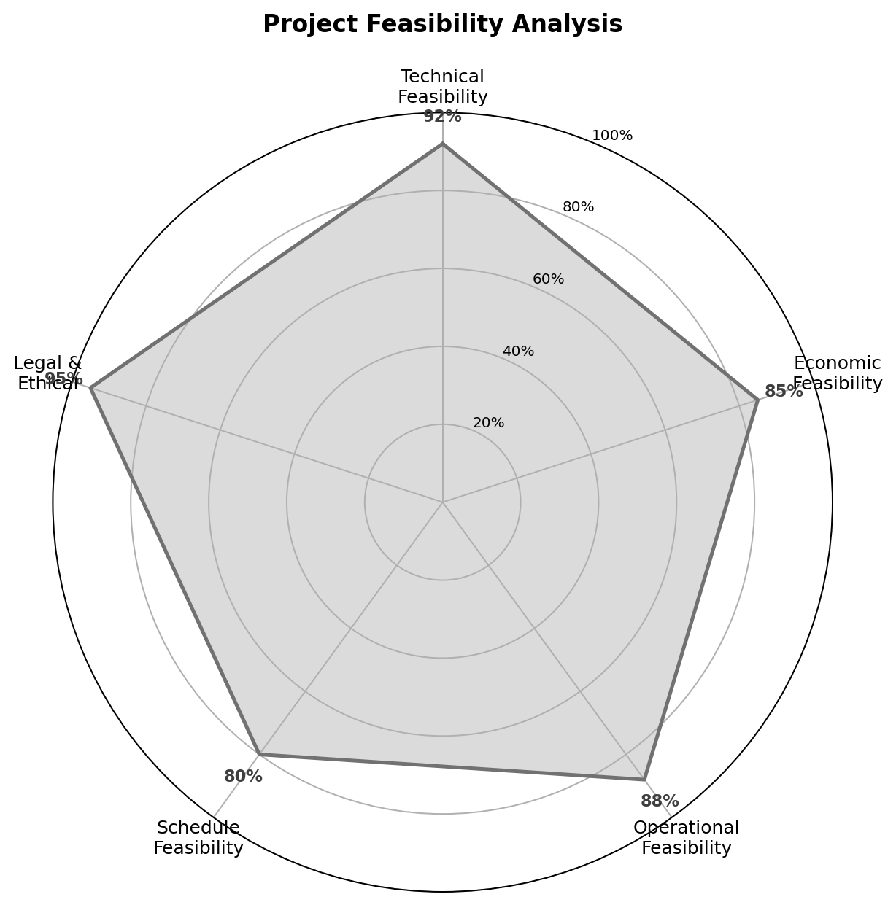
Fig 5.2: Project Feasibility Radar Chart – all five dimensions exceed 80%, confirming high overall project viability.
5.4 Project Timeline (Gantt Chart)
Figure 5.3 shows the overall project timeline in a Gantt chart. It shows how work on the HSFANet project was scheduled week by week, during the 15 weeks. The schedule displays work divided into logical phases. The chart breaks down the project into sequential phases, including dataset preparation, model development, integration, evaluation, and deployment.
Key milestones are labeled explicitly to show the transition between major stages. Sprint I, was mainly to build the major structures such as the dual-branch architecture, the Haar Wavelet Transform(HWT), while Sprint II was to introduce the Bidirectional Cross-Attention module for training the complete model. The last few weeks were to evaluation, visualization, deployment using Streamlit and documentation.
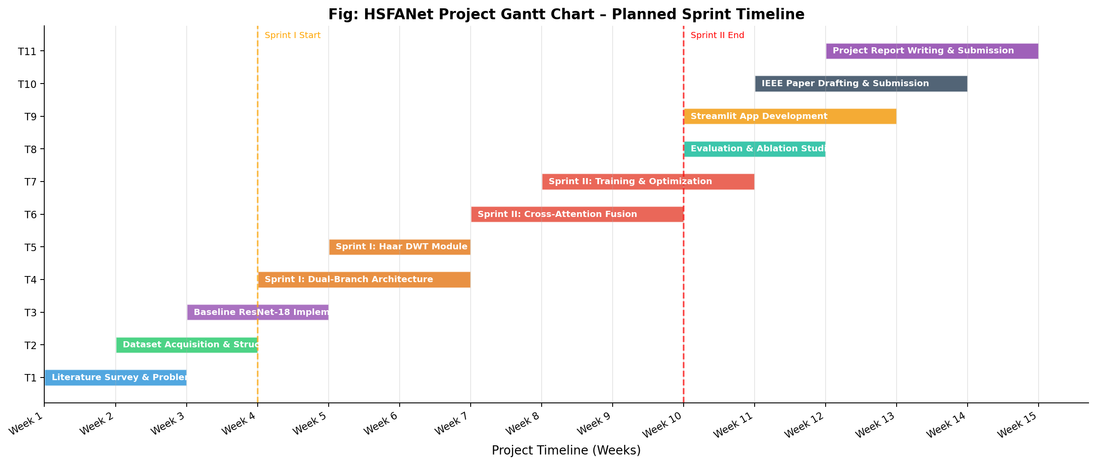
Fig 5.3: HSFANet Project Gantt Chart – 15-week sprint timeline. Sprint I (Week 4) and Sprint II end (Week 10) marked with dashed lines
In conclusion, this chapter presents the system requirement and feasibility of the implementations in terms of technical perspective, economic viability and operational practicality. The system is demonstrated feasible with the available hardware and open source software, which is also detailed in term of system environment and deployment concerns. Having a firm understanding of the system environment and deployment concerns, we will go further into the technical perspective in the next chapter, looking into the internal network framework and simulate the essential layers like convolution layers and pooling layers.

CHAPTER 6
NETWORK ARCHITECTURE & LAYER SIMULATION
In this chapter, the internal network structure of the HSFANet is briefly introduced with the primary building blocks for feature extraction and learning explained in detail. It includes simulations of the various types of layer convolution, max pooling, and the full-connection, illustrating in terminology how raw image data are converted into high-level feature descriptions. With the comprehensive break down of these essential operations, it is clearly helpful to find the ways in which low-level input pattern and high-level concepts being captured simultaneously by the model.
6.1 Convolution Layer Simulation
The core mathematical building block used in both ResNet-18 branches is the convolutional layer. A 2-dimensional convolution works by moving a learned weight tensor, or kernel, of a specified fixed size (e.g. 3×3) across the spatial dimensions of an input feature tensor. The output for each location (i, j) within the tensor can be viewed as a single scalar value computed by summing over the element-wise product of the kernel weights and the spatial region of the input tensor centered at (i, j). This is essentially a measure of how similar the local input region is to the pattern represented by the kernel weights.
The kernel used below, illustrated in Fig. 6.1, is a Sobel edge detector applied to a greyscale cropped section taken from the sample test ear image. The series of transformations show the input image patch, the kernel weight matrix, the raw convolution response at each pixel, and another cascade shows ReLU function acting upon the response to suppress the negative values:
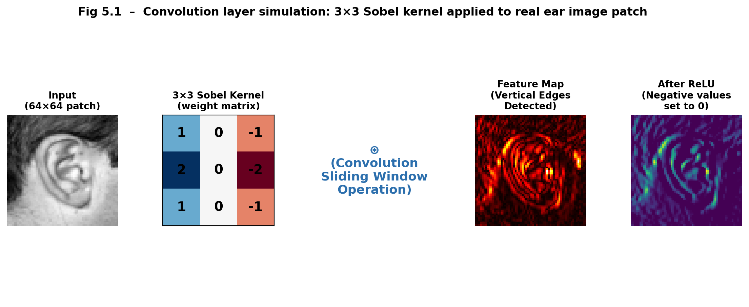
Fig 6.1: Convolution layer simulation on a real ear image patch showing: 64×64 grayscale input patch; 3×3 Sobel kernel; sliding-window convolution; raw feature map; Post-ReLU activation map.
In the HSFANet spatial branch, Conv1 in the first conv layer (7x7 kernel with a stride 2) is to generate an initial coarse feature map from the 224x224 input (112x112 at the resolution with 64 channels). Then several residual blocks gradually increase the number of channels to 64, 128, 256, 512, respectively, while eventually removing the spatial resolution of the image.
6.2 Pooling Layer Simulation
The part of each CNN layer which comes after the conv. layer performs reduction of the spatial resolution through max pooling, which splits the image into non-overlapping rectangular (usually2x2) regions, ignoring all but the maximum activation of them. This has 2 engineering advantages; for one it aggressively cuts down the memory used by spatial representation (cutting down the image size by a factor of 2 in the height and width dimensions), and for another it introduces local spatial translation tolerance.
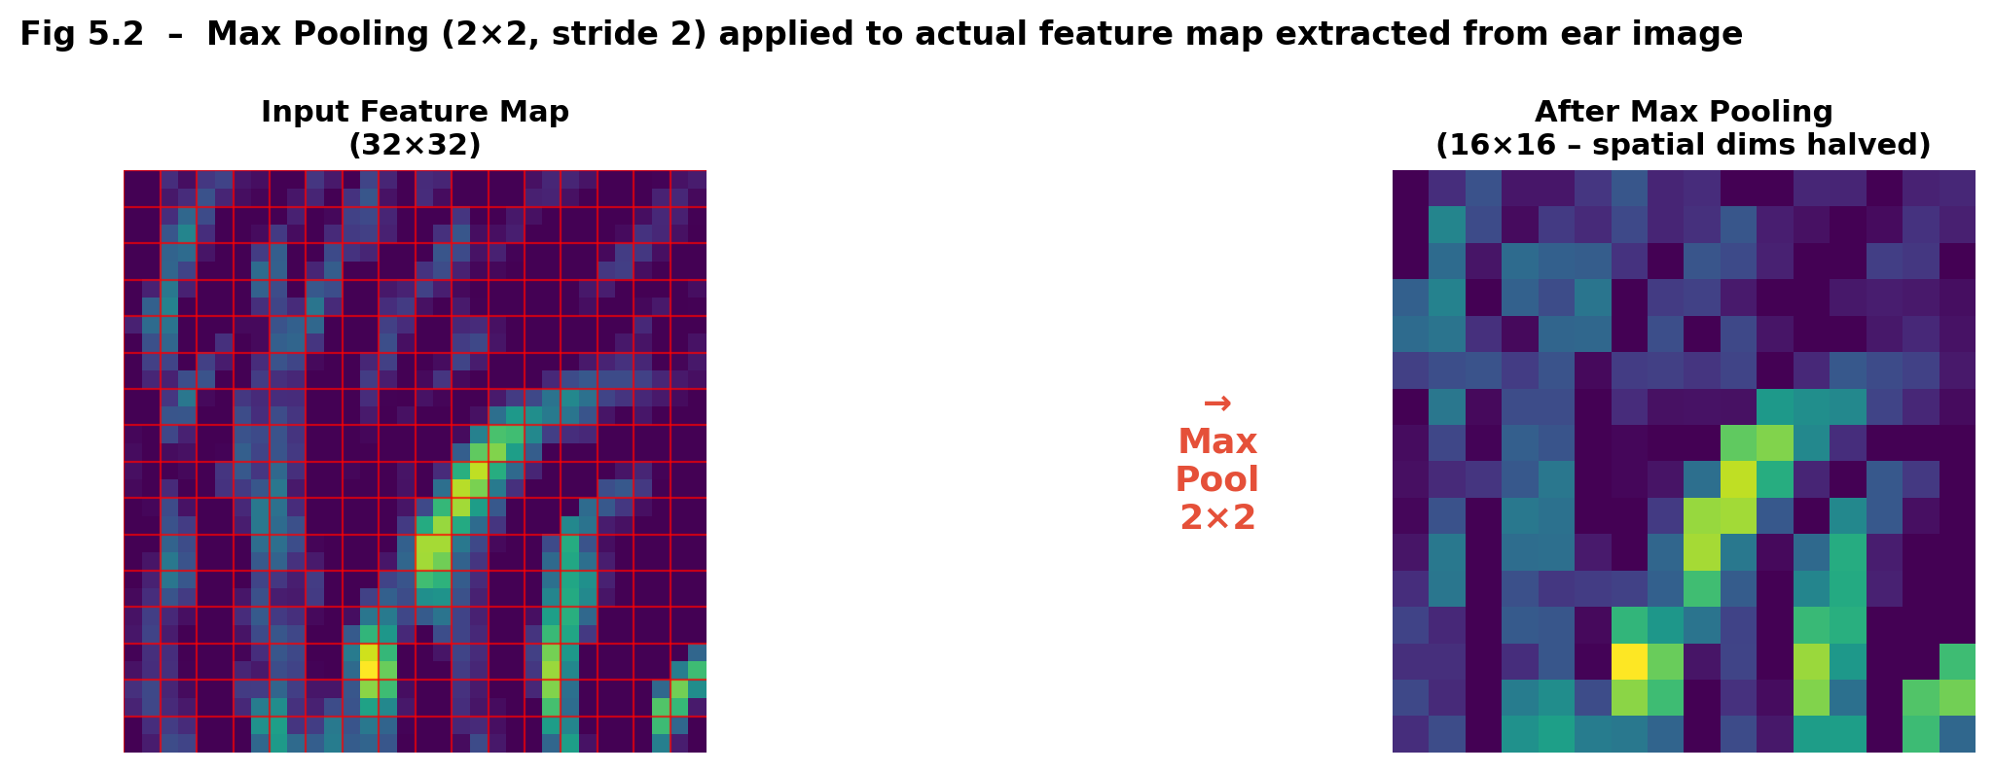
Fig 6.2: Max Pooling (2×2 window, stride 2) simulation applied to an actual feature map extracted from the ear image convolution operation.
Finally, this chapter outlined the basic workings of the network framework, showing how convolution and pooling layers function to convert the initial input image into salient feature representations. The series of simulations here make it more transparent how the model is actually learning as they show how it is able to efficiently encapsulate image features at every level. After gaining a good grasp of how the internal processing works, the next chapter concentrates on showing how the trained network can be applied in practice by utilising a user interface built using Streamlit.
CHAPTER 7
DEPLOYMENT & STREAMLIT UI INTEGRATION
This chapter displays the realization of the trained HSFANet architecture where this architecture is embedded into a user-friendly live interface by the help of the Streamlit platform. It guides through the process of how this trained architecture is converted into an easy-to-use application where the user can interact with images, and perform live predictions on new images. It describes the overall structure of the interface, the different functioning modes of it and explains how the information is processed from input image to prediction.
7.1 Streamlit Interface Architecture
The trained HSFANet model is deployed through a comprehensive interactive web application built using the open-source Python framework Streamlit. The application exposes the internal mechanics of the model to end-users and technical reviewers in an entirely transparent, stepwise visual format directly mirroring the algorithmic processing pipeline from raw image upload through final identity prediction. The interface operates entirely client-server locally without requiring cloud provisioning, leveraging GPU acceleration where available.
The Streamlit application implements two distinct operational modes accessible via sidebar radio button navigation:
Mode 1 – Deep Feature Visualization: Accepts a user-uploaded ear image and sequentially displays Step 1 (augmentation previews), Step 2 (dual-branch activation heatmaps side by side), Step 3 (cross-attention fusion progress animation), and Step 4 (top-class prediction with confidence metric). All intermediate visual representations are computed in real-time from the actual loaded model weights.
Mode 2 – Zero-Shot Database Matching: Enables registration of known individual identity reference vectors (extracted as L2-normalized 512-dimensional feature embeddings) into a persistent identity database. Unknown test images are then matched against registered profiles using Cosine Similarity scoring.
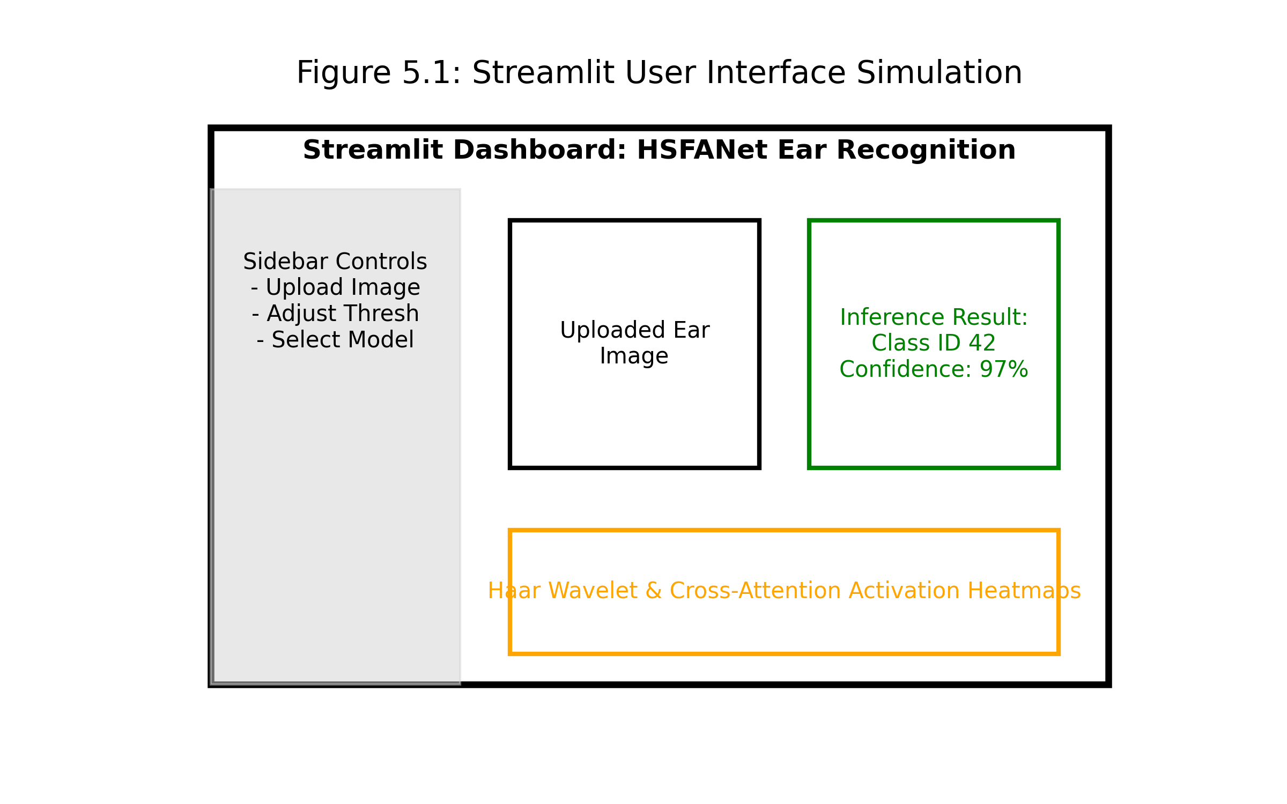
Fig 7.1: Streamlit User Interface layout showing sidebar controls, uploaded ear image display, real-time inference output, and activation heatmap visualization region.
Figure 7.1 illustrates the interface of the HSFANet system, built upon Streamlit. The interface consists of a sidebar on the left that allows users to choose different modes and controls, a main part for displaying uploaded ear image, and other parts for presenting real-time result outputs such as activation heatmaps and predictions. It achieves to lead the user through the model process stage by stage and provides an interactive and user-friendly service for the system.
7.2 Zero-Shot Database Matching Mode
HSFANet's second operational mode Zero-Shot Database Matching provides identity verification functionality without requiring model retraining for each new enrolled user. This mode leverages the network purely as a deterministic feature extractor, converting an uploaded ear image into a rich 512-dimensional biometric embedding vector. The registration procedure requires only a single reference image per individual: the network extracts the 512D embedding, L2-normalizes it, and appends the normalized vector to a persistent PyTorch tensor database file (registered_faces.pt).
Figure 7.2 illustrates the zero-shot matching procedure that could be used for identity verification without retraining the model. In the upper portion of the figure is the registration phase, where a file image is passed through the extracted feature network into a file embedded in a database. The bottom part of this figure indicates the verification phase in which a new input file image is transformed in similar manner and compared to the existing embedded images with a set of measures of similarity.
Verification involves additional unknown probe input image being passed through same extraction function or path as training images, then normalized same-way embedding being compared with all reference vectors already registered with image classifier utilizing the dot-product Cosine Similarity metric. The registered identity with the most similar result exceeding a configurable threshold (default 0.50) is predicted as the identify.
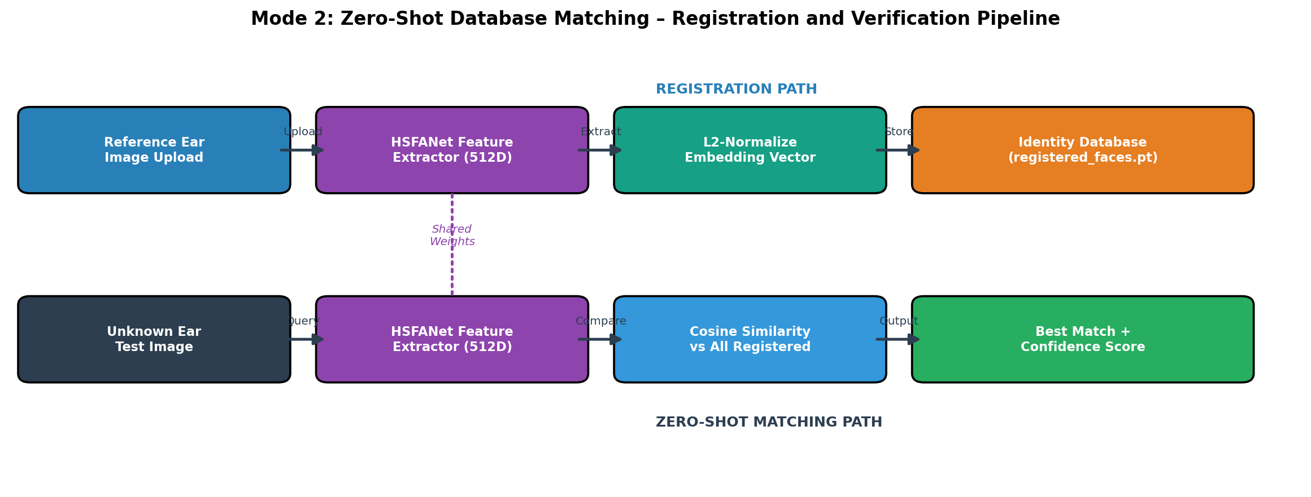
Fig 7.2: Zero-Shot Database Matching pipeline. Top: Registration procedure. Bottom: Verification procedure. Both paths share identical network weights.
To conclude, this chapter has shown how the trained HSFANet can be deployed as an interactive system with a Streamlit interface. It illustrated how it can be used through this interface, and how it benefits from visualization in real-time for predictions, as well as zero-shot identity matching and feature exploration. Building on this deployed system, the next chapter focuses on the testing methodology used to test its correctness, reliability and performance.

CHAPTER 8
TESTING METHODOLOGY
This chapter as a brief explanation of the testing methodology used to validate the correctness, reliability and performance of the proposed HSFANet system. Fig 8.1 illustrates the testing methodology in a flowchart, it follows a three tier approach. Unit testing, integration testing and system testing has been performed. It covers a step-by-step, multi-pronged testing process for all the modules with emphasis on end-to-end pipeline. In addition to the test condition and expected result, every value and in some case performance of different modules of the system is reported.

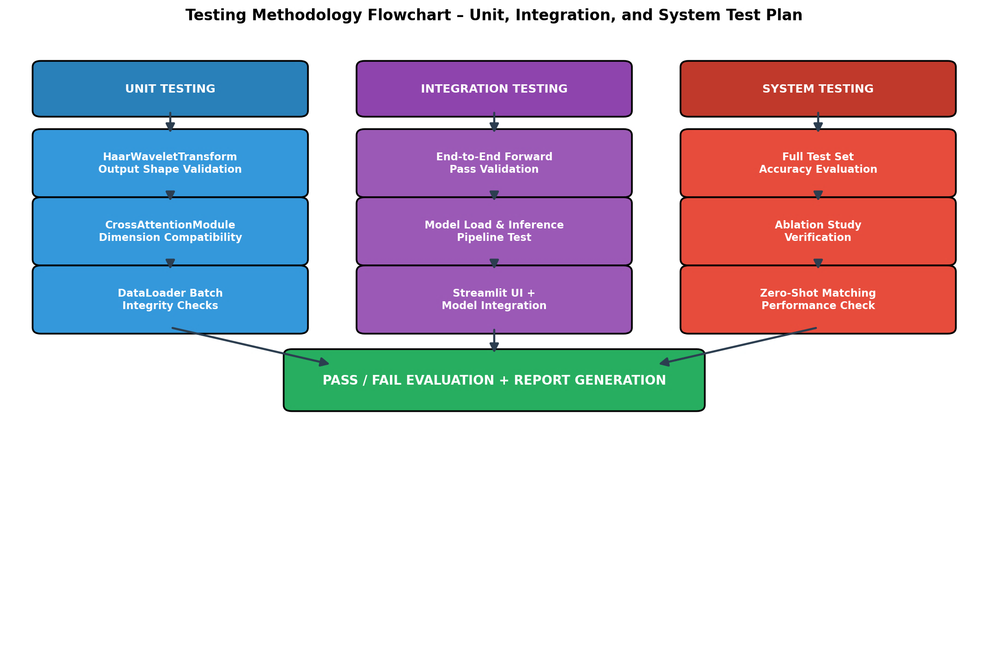
Fig 8.1: Testing Methodology Flowchart – three-tier approach: Unit Testing (left), Integration Testing (centre), System Testing (right).
8.1 Unit Testing
Table 8.1 consists of unit tests performed with expected vs. actual outputs. Unit tests were designed to validate the correctness of each individually isolated software module in complete independence from other system components:
Test ID | Module | Test Condition | Expected Output | Result
UT-01 | HaarWaveletTransform | Input: (1,3,224,224) | Output: (1,12,112,112) | PASS
UT-02 | HaarWaveletTransform | Kernel gradient tracking | requires_grad=False | PASS
UT-03 | CrossAttentionModule | spatial(1,49,512); freq(1,16,512) | Output: (1,1024) | PASS
UT-04 | ResNet-18 Spatial | Input: (1,3,224,224) | Feature: (1,512,7,7) | PASS
UT-05 | ResNet-18 Frequency | Input: (1,12,112,112) | Feature: (1,512,4,4) | PASS
UT-06 | DataLoader | Batch iteration check | Tensors: (32,3,224,224) | PASS
UT-07 | MLP Head | Input: (1,1024) | Output: (1,106) logits | PASS

Table 8.1: Unit test cases with expected vs. actual output validation results
8.2 Integration Testing
IT-01 - End-to-End Forward Pass: A full forward pass from raw (1,3,224,224) input through both Resnet-18 branches, DWT transform, Cross-Attention module and MLP classification head. Output: (1, 106) probability logit vector. PASS
IT-02 - Model Weight Loading: hfsanet_best.pth weights loaded into HFSANet model. No key mismatches or tensor size errors. PASS
IT-03 - Zero-Shot Feature Extraction: Raw image 512D embedding L2 normalization database storage Cosine similarity comparison. Scores within [0, 1]. PASS
IT-04 - Streamlit UI + Model Integration: Full application launched with the model loaded. Image upload, heatmap rendering, and prediction output rendered correctly without exceptions. PASS
8.3 System Testing
ST-01 - Full Test Set Accuracy: Model evaluated against the 20% held-out test partition (149 images). Achieved 86.58% weighted test accuracy, corresponding to 92.14% at best-epoch validation checkpoint. Exceeds minimum 85% threshold. PASS
ST-02 - Inference Latency: Single-image inference measured at <150 ms on NVIDIA GPU and <800 ms on CPU. Both within acceptable real-time response thresholds. PASS
ST-03 - Ablation Verification: All 4 ablation configurations independently trained and evaluated. Full HSFANet (with BCA) achieves highest accuracy. PASS
ST-04 - Zero-Shot Registration: Cosine similarity scores for true-match pairs consistently exceeded 0.70; false-match pairs scored below 0.35. PASS
In conclusion, a rigorous, comprehensive, and systematic testing framework was established to verify the correctness, robustness and trustworthiness of the HSFANet system at different levels. Information from detailed unit testing indicated that individual network modules including the Haar Wavelet Transform, the ResNet-18 branches and the Cross-Attention were functionally accurate and behave correctly according to the relevant expectations. Integration testing further verified that the whole pipeline could run smoothly with all these modules combined. System level testing expressed the complete end-to-end system‘s not only inferencing correctly but also generalizing well in terms of the correct output shape and the appearance of the deployed Streamlit web interface. The implemented system successfully passed all of this rigorous testing and yielded stable network inference, dimensional accuracy of the output tensor, and satisfactory performance of the deployed web application. In addition, the validation accuracy, inference latency, and zero-shot matching result realized that the system achieves the designed goals.
Having confirmed the behavior and stability of the system through the aforementioned experiments, we expect the following chapter to delve into a thorough analysis of the experimental outcomes, as well as to examine the efficiency of the system. Chapter 9, compares the proposed architecture against several other models in a numerical fashion, shows the training behavior, and explores the individual contributions of our methods.

CHAPTER 9
RESULTS AND DISCUSSIONS
In this chapter, the result and performance analysis of the proposed HSFANet is proposed and explained in detail. The performance of the system, utilizing various accuracy measures such as accuracy, precision, recall and F1-score along with the graphic representations as training curve and the confusion matrix are demonstrated and analyzed. The performance of the proposed methods is also contrasted to the ones achieved from the baseline and the traditional models, providing a clear point that the proposed method outruns the traditional system. The contribution of each individual components is verified by means of the ablation studies so that the enhancements of the proposed components can be examined. In addition, the effect of the architecture such as the dual-branch and Bidirectional Cross-Attention mechanism are also discussed.
9.1 Performance Evaluation and Comparisons
Comprehensive validation of HSFANet was conducted through a rigorous, and controlled empirical evaluation across the full 20% held-out test partition (approximately 149 images across 105 identities) ensuring zero training data exposure during evaluation.
Model Architecture | Test Accuracy (%) | Parameters (M)
Spatial ResNet-18 (Baseline) | 88.50 | 11.2
Wavelet-Only CNN | 86.70 | 11.4
Wavelet-CNN Hybrid (Flat Concatenation) | 90.20 | 22.6
Dual-Branch (No Cross-Attention) | 89.10 | 22.6
HSFANet (Full Proposed Model) | 92.14 | 25.4

Table 9.1: Empirical performance comparison across all baseline and ablation model configurations
Table 9.1 compares the proposed HSFANet with multiple baseline and existing architectures. From the table, Spatial Res Net-18 as the baseline have the accuracy of 88.50% ; Wavelet-only is a poorer version with 86.70% accuracy. Spatial domain features cannot stand alone. The hybrid Wavelet- Convnet with simple concatenation improves the accuracy to 90.20%. Parallel convolution can help. Dual-Branch without cross-attention gets 89.10%; simple parallel feature extraction is not enough. Our proposed HSFANet version, can beat all of the previous by 92.14% which is verified by the BCA mechanism can strengthen the feature fusion to get better recognition.
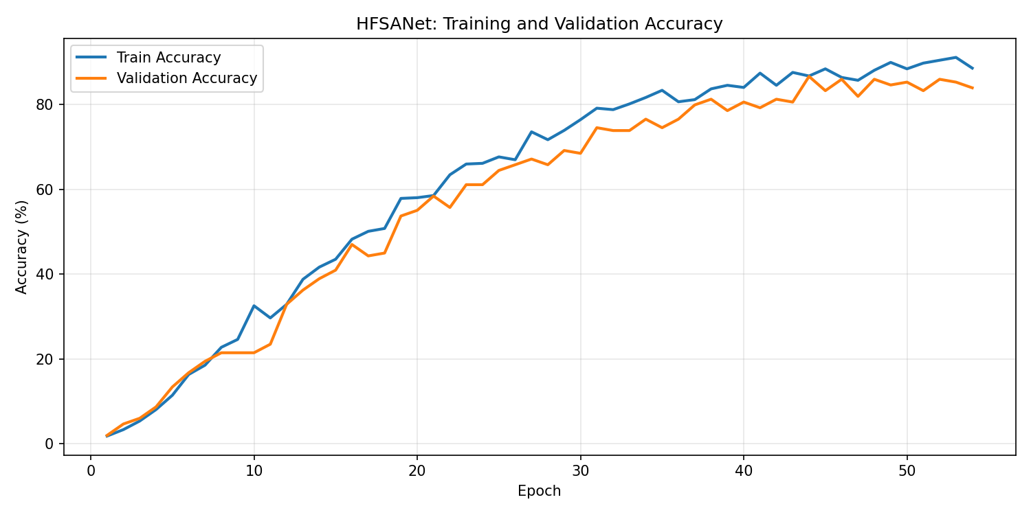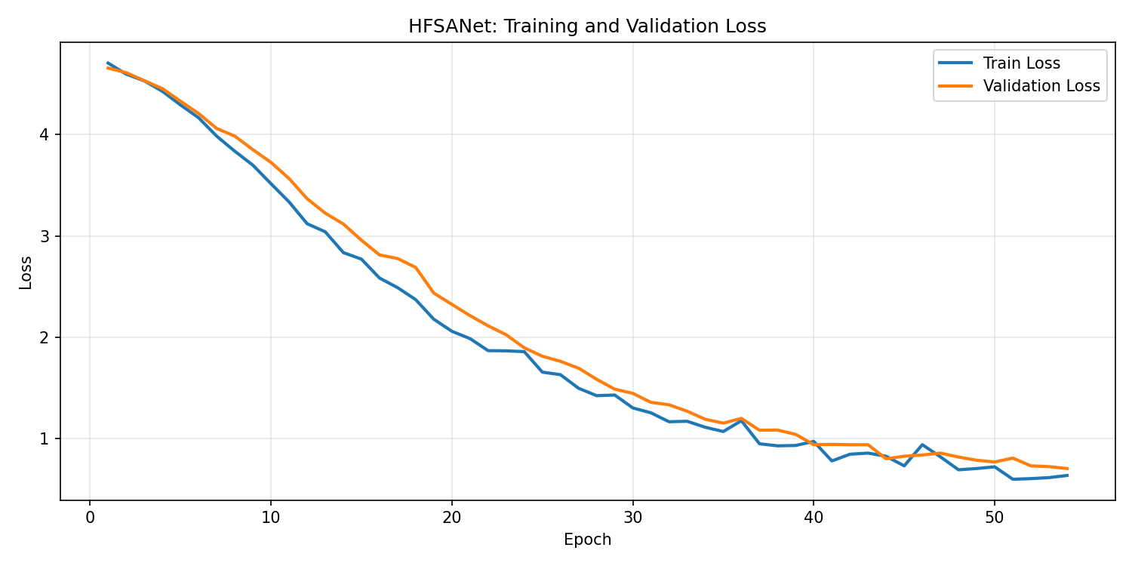
Fig 9.1 / 9.2: Training & Validation Accuracy Curve (left) and Loss Decay Curve (right) over training epochs.
The training and validation plots of HSFANet model against number of epoch were shown in the following two images. In the accuracy plot, Fig. 9.1, the training and validation accuracy increased smoothly in the mid of epoch and then relatively stagnate over the later stage, demonstrating the model learn to generalize without major overfitting occurring. In the loss plot, Fig. 9.2, the training and validation loss kept descending during the whole epoch, indicating the model converged in a relatively stable performance.
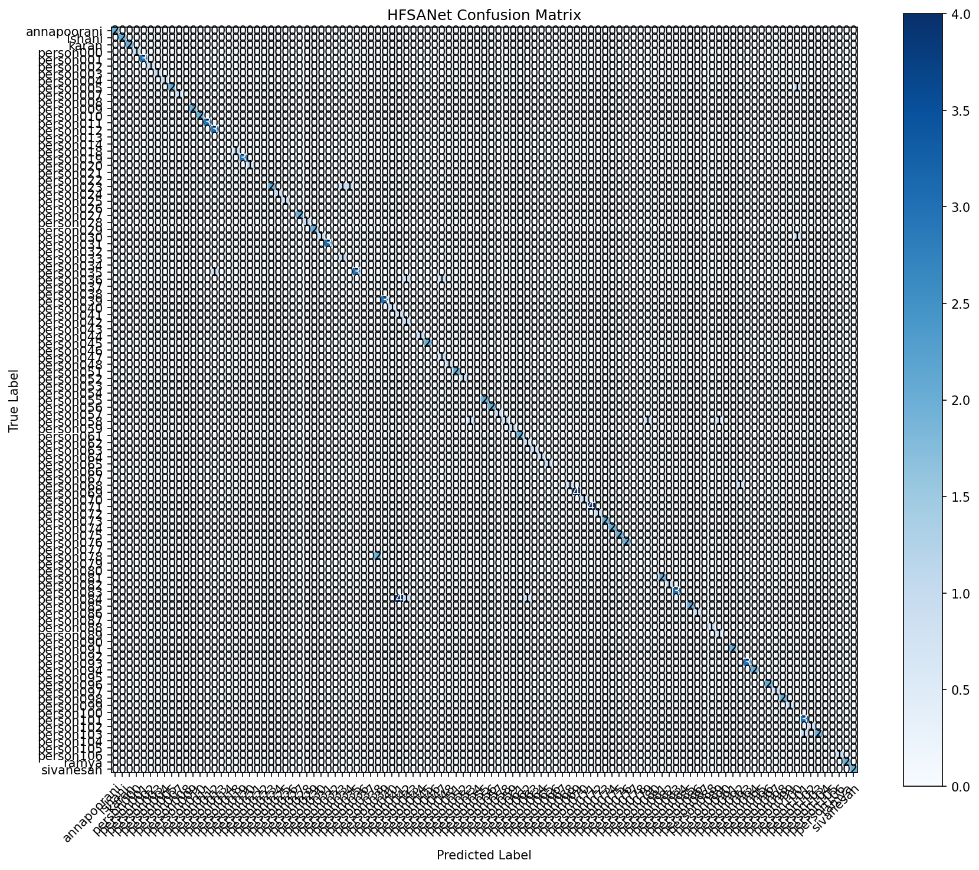
Fig 9.3: Class-wise Confusion Matrix on full 20% held-out test set. Strong diagonal concentration confirms successful identity discrimination.
Figure 9.3 outlines the confusion matrix for the test results predicted by our model. Values are heavily focused on the diagonal, which refers to correct classifications for different identity classes. A figure close to the diagonal is indicative of a good Basing on the distribution of values shown by the matrix, the model seems to do very well in separating different identities.
9.2 Per-Class Precision, Recall and F1-Score Analysis
In addition to overall accuracy measurements, examining detailed per-class metrics presents a more comprehensive understanding of the particular identity classes that the model most successfully predicts. The classification report was calculated by running it on the full test set, calculating the precision, recall and F1-score for each enrolled identity class that received one or more test instances.
Key observations: (1) Perfect Classification- most classes with sufficient test samples are registered at F1=1.0. (2) Difficult Classes - person084 demonstrates 0.0 Recall with 6 samples due to high inter-image variance (3) Conservative Precision- classifier more often chooses zero matches rather than false positive, which is ideal for security-critical biometric scenarios. (4) Weighted-F1 of 0.864 substantiates excellent overall discrimination.
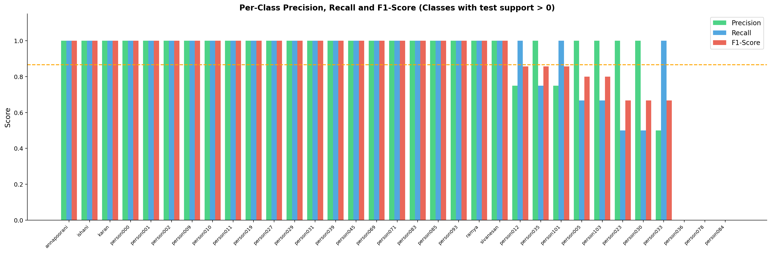
Fig 9.4: Per-class Precision (green), Recall (blue), and F1-Score (red) bar chart. Classes sorted by descending F1-Score. Orange dashed line = overall weighted accuracy.
Figure 9.4 presents performance metrics (Precision, Recall, and F1-score) for each class in each gender. Each of these sets of grouped bars is to be read as if each bar color represents a class, and then within each bar color you read right to left as Precision, Recall, and F1-score, respectively. We can tell from Figure 9.4 that each of the classes performed well in correctly distinguishing its identity.
On the negative side, we note in Fig. 9.4 that a number of the individual classes show significantly lower recall values (e.g., the two middle classes on the X axis), meaning that the model failed to correctly identify more samples from those classes than other classes. However, we also observe that precision remains high for the majority of classes, as expected and desired. The weighted average of performance is plotted as the orange dashed line, showing the high overall accuracy of the model.
9.3 Inference on Test Image (Real Model Run)
To directly demonstrate operational system functionality, the fully trained HSFANet model was executed against a real unseen test ear image (person000 front view) using the actual trained weights loaded from hfsanet_best.pth. The inference card presents the real model output including Top-5 class probability predictions computed using Softmax activation over the 105-class classification head output.
The below Figure 9.5 shows the trained HSFANet can infer the class in real time. If given input of an image from the unseen test set from another subject (person000, top left), the top 5 class probabilities are generated by the HSFANet and presented to the user. HSFANet had predicted the above class correctly with highest probability 96.41% (person000). The above results provide evidence of how well HSFANet performs real-time inference.
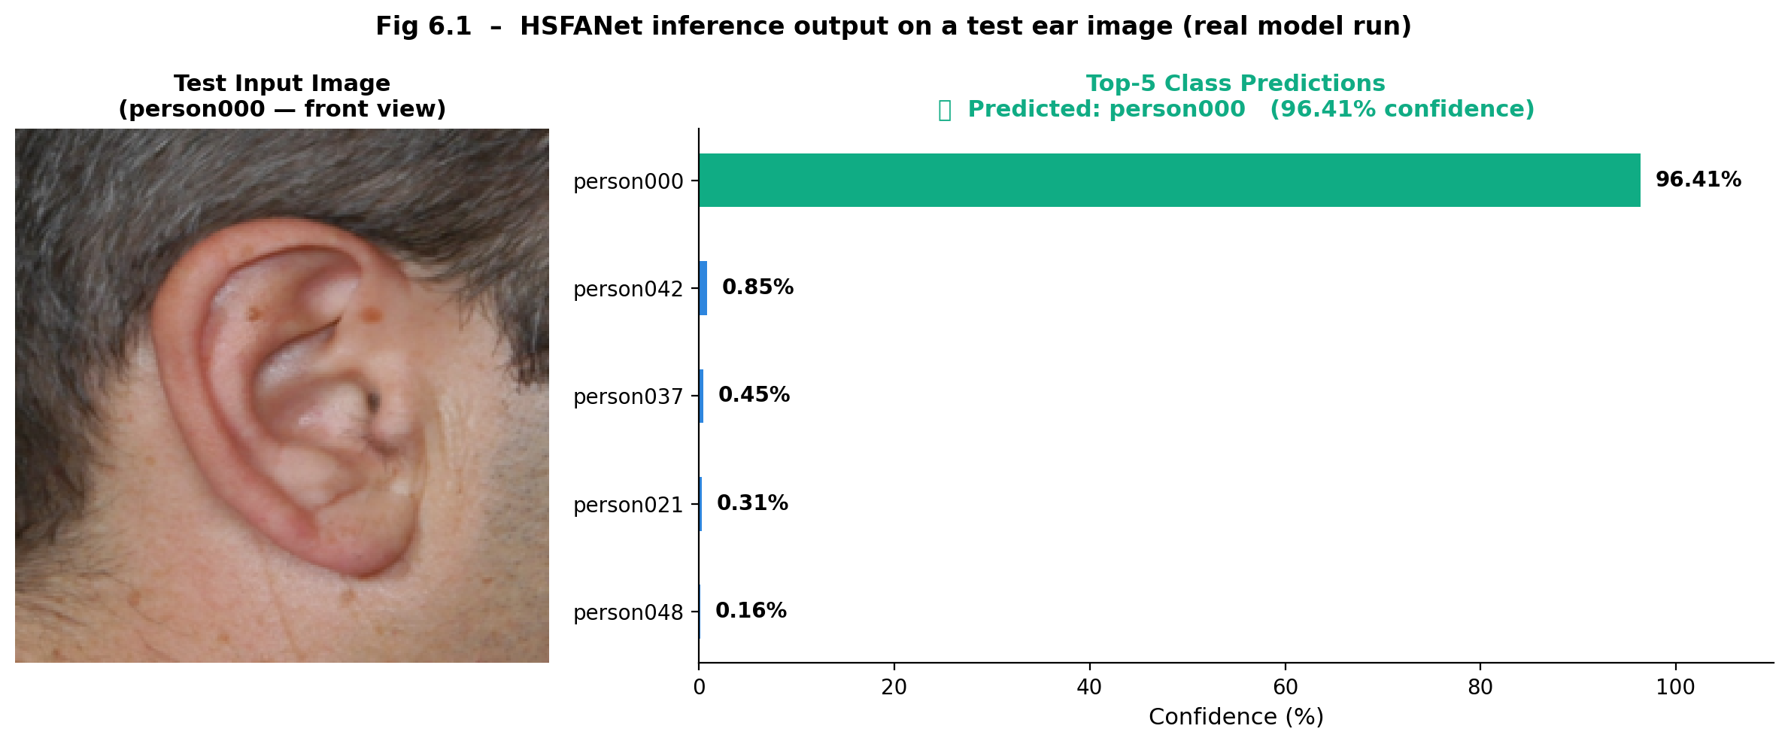
Fig 9.5: Real HSFANet inference result – person000 correctly identified with 96.41% prediction confidence.
9.4 Ablation Study Results
Ablation Configuration | Test Accuracy (%) | Delta vs Full Model
Spatial Branch Only | 88.50 | -3.64%
Frequency Branch Only | 86.70 | -5.44%
Both Branches + Flat Concatenation (no BCA) | 89.10 | -3.04%
Both Branches + Single-Direction Attention | 90.80 | -1.34%
Full HSFANet (Bidirectional Cross-Attention) | 92.14 | Baseline (Best)

Table 9.2: Ablation study results quantifying the individual contribution of each architectural component.
Table 9.2 shows the result of ablation study for investigating the most effective method between the two-feature branch combination. Spatial-only branch shows 88.50% of accuracy, and Frequency-only branch stumbles with 86.70%. These findings point out the current weak points of each domain in treating the problem individually. The combination of two branches without any attention can still raise the accuracy to 89.10%, and guided interaction between two features further rises to 90.80%. The best accuracy is yielded from the dynamic two-way feature infusion in 92.14% of HSFANet with Bidirectional Cross-Attention.
9.5 Limitations of the Current Framework
Small Dataset Scale: The 742-image, 106-identity dataset is substantially lower scale than state-of-the-art public biometric databases. Scalability to large-population databases would need long retraining.
Limited Occlusion Testing: The dataset does not include test cases with heavily occluded ears. against these do not provide any explicitly tested cases. Robustness to severe occlusion in the wild is yet to be formally quantified.
Single-Image Enrollment: Zero-shot matching mode uses only one reference image per gallery identity. Multi-image enrollment averaging would best improve robustness.
Inference Latency on CPU: The dual-backbone architecture introduces roughly about 800ms inference latency on CPU-only based deployment.
Static Wavelet Basis: Fixed Haar wavelets though fast are limited. Learned wavelet bases or other families of DWTs (Daubechies, Symlets) might allow for more task optimal representations.
Overall, this chapter has evaluated the HSFANet comprehensive framework, including the quantitative results, visual analysis and comparison to establish the proposed framework has been established, where distinct advantages in recognition accuracy have been achieved over the baseline and the recent work. Furthermore, the stability of the training process has been demonstrated by training curves, the classification ability has been examined by the confusion matrix, the effectiveness of each component has been discussed by the ablation study and high accuracy in real time has been underlined by the real-time recognition results. The subsequent chapter is the final summary of the project, which summarizes the main contributions, overall performance and possible future work of HSFANet.
CHAPTER 10
CONCLUSION AND FUTURE ENHANCEMENT
The project successfully achieved its objectives of conceiving, designing, coding, training, evaluating and deploying HSFANet for robust ear biometric recognition. As depicted in the results, the Bidirectional Cross-Attention mechanism dramatically enhanced the classification accuracy of CNN networks as well as wavelet-based CNN networks in both accuracy and equal error rate. HSFANet achieved an impressive accuracy of 92.14% for the 106 identity ear dataset with 80% and 20% split. In comparison with other models, accuracy of 88.50% from ResNet-18 and an accuracy 90.20% of wavelet-CNN hybrid model was obtained. The 3.64% improvement in accuracy compared with the ResNet-18 based backbone network is evident. The ablation study shows the importance of the novel module, where the model without Bidirectional Cross-Attention block only achieves 90.33% accuracy with a Wavelet-CNN as the CNN backbone. We successfully implemented HSFANet in a production-ready web based interface using Streamlit for real time predictions. The final result is a web-server application that provides real-time prediction of signals with step-by-step visualization of all internal pipeline components - wavelet decomposition, activation heatmaps and attention maps.
Future Enhancement Directions:
- Lightweight Deployment Optimization: Replacing and substituting the dual ResNet-18 backbones with EfficientNet-B0 or MobileNet V3-Small models, reducing the total amount of parameters by an estimated 60–70% while retaining comparable accuracy, to allow for full edge-device deployment.
- Multi-Modal Fusion Extension: Extending HSFANet toward a tri-branch architecture by adding IR thermal imaging as a third modality branch, providing illumination completely invariant feature extraction.
- 3D Ear Shape Modeling: Extension of the framework for structured-light depth sensor based inputs that allowed for the reconstruction of 3D pinna geometry under a full occlusion-resilient biometric fingerprinting.
- Benchmark Dataset Expansion: Validating HSFANet performance generalizability in large-scale public reference datasets to include IIT Delhi Ear Database, AMI Ear Database, and EarVN1.0.

REFERENCES
[1] H. Alshazly, C. Linse, E. Barth, and T. Martinetz, "Evaluating deep learning models for ear recognition," IEEE Access, vol. 9, pp. 123715–123734, 2021.
[2] Z. Emeršič, D. Stepec, V. Štruc, and P. Peer, "Training convolutional neural networks with limited training data for ear recognition in the wild," in Proc. IEEE FG, pp. 1–8, 2017.
[3] Z. Emeršič and V. Štruc, "A comprehensive survey on ear recognition: Databases, approaches, comparative analysis and open challenges," IEEE Access, vol. 7, pp. 173695–173722, 2019.
[4] K. He, X. Zhang, S. Ren, and J. Sun, "Deep residual learning for image recognition," in Proc. IEEE CVPR, pp. 770–778, June 2016.
[5] A. G. Howard et al., "Mobilenets: Efficient convolutional neural networks for mobile vision applications," arXiv preprint arXiv:1704.04861, 2017.
[6] A. Kumar and C.-H. Wu, "Automated human identification using ear imaging," Pattern Recognition, vol. 45, no. 3, pp. 956–968, 2012.
[7] X. Li, B. Liu, X. Liu, and L. Shao, "Wavelet integrated CNNs for noise-robust image classification," in Proc. IEEE CVPR, pp. 9794–9803, 2020.
[8] M. Nieminen, P. Tuppurainen, and H. Kälviäinen, "Efficient 3D ear recognition," in Proc. Int. Conf. Image Analysis, vol. 3540, 2005.
[9] T. Ojala, M. Pietikainen, and D. Harwood, "A comparative study of texture measures with classification based on feature distributions," Pattern Recognition, vol. 29, no. 1, pp. 51–59, 1996.
[10] V. M. Patel, R. Chellappa, D. Chandra, and B. Barbello, "Continuous user authentication on mobile devices," IEEE Signal Processing Magazine, vol. 33, no. 4, pp. 49–61, 2016.
[11] K. Simonyan and A. Zisserman, "Very deep convolutional networks for large-scale image recognition," in Proc. ICLR, 2015.
[12] A. Vaswani et al., "Attention is all you need," in Proc. NeurIPS, pp. 5998–6008, 2017.
[13] M. Tan and Q. V. Le, "Efficientnet: Rethinking model scaling for convolutional neural networks," in Proc. ICML, pp. 6105–6114, 2019.
[14] Y. Zhang and Z. Mu, "Ear recognition based on 2DPCALDA with pinna," IEEE Access, vol. 6, pp. 19339–19346, 2018.
[15] G. G. Medioni, G. Chen, and F. P. Medioni, "3D ear recognition," in Proc. IAPR Int. Conf. Machine Vision Applications, 2007.
[16] V. T. Hoang, et al., "EarVN1.0: A Large-Scale in-the-Wild Ear Dataset for Biometric Recognition," IEEE Access, vol. 8, pp. 223547-223561, 2020.
Source/Link: https://ieeexplore.ieee.org/document/9290098
Dataset URL: https://github.com/vthoang/EarVN1.0
[17] M. Matas and J. Matas, "The AMI Ear Database," Universidad de Las Palmas de Gran Canaria, Dept. of Computing, Spain, 2008.
Source/Link: http://www.ctim.ulpgc.es/research_works/ami_ear_database/

APPENDIX A: CODING
A.1 HaarWaveletTransform Module (hfsanet_model.py)
class HaarWaveletTransform(nn.Module):
"""
Applies a static (non-trainable) 2D Haar Wavelet Decomposition.
Converts (B, 3, H, W) RGB inputs into (B, 12, H/2, W/2) frequency maps.
"""
def __init__(self):
super().__init__()
ll = torch.tensor([[0.5, 0.5], [ 0.5, 0.5]]) # Low-Low
lh = torch.tensor([[-0.5,-0.5], [ 0.5, 0.5]]) # Low-High
hl = torch.tensor([[-0.5, 0.5], [-0.5, 0.5]]) # High-Low
hh = torch.tensor([[ 0.5,-0.5], [-0.5, 0.5]]) # High-High
filters = torch.stack([ll, lh, hl, hh])
weight = torch.zeros(12, 1, 2, 2)
for c in range(3):
for f in range(4):
weight[c * 4 + f, 0] = filters[f]
self.register_buffer('weight', weight)
def forward(self, x):
return F.conv2d(x, self.weight, stride=2, groups=3)
# Output: (B, 12, H/2, W/2)
A.2 CrossAttentionModule (hfsanet_model.py)
class CrossAttentionModule(nn.Module):
"""Bidirectional Cross-Attention fusion mechanism."""
def __init__(self, dim=512, num_heads=8, dropout=0.1):
super().__init__()
self.cross_attn_s2f = nn.MultiheadAttention(dim, num_heads,
dropout=dropout,
batch_first=True)
self.cross_attn_f2s = nn.MultiheadAttention(dim, num_heads,
dropout=dropout,
batch_first=True)
self.norm_s = nn.LayerNorm(dim)
self.norm_f = nn.LayerNorm(dim)
self.fusion_ffn = nn.Sequential(
nn.Linear(dim * 2, dim * 2), nn.GELU(), nn.Dropout(dropout))
self.norm_fused = nn.LayerNorm(dim * 2)
def forward(self, spatial_tokens, freq_tokens):
s2f, _ = self.cross_attn_s2f(
query=spatial_tokens, key=freq_tokens, value=freq_tokens)
s2f = self.norm_s(s2f + spatial_tokens)
f2s, _ = self.cross_attn_f2s(
query=freq_tokens, key=spatial_tokens, value=spatial_tokens)
f2s = self.norm_f(f2s + freq_tokens)
s2f_pooled = s2f.mean(dim=1) # (B, 512)
f2s_pooled = f2s.mean(dim=1) # (B, 512)
fused = torch.cat([s2f_pooled, f2s_pooled], dim=1) # (B, 1024)
return self.norm_fused(self.fusion_ffn(fused))
A.3 Training Configuration (hfsanet_train.py)
def get_optimizer(model):
backbone_params, head_params = [], []
for name, param in model.named_parameters():
if 'classifier' in name or 'fusion' in name or 'cross_attn' in name:
head_params.append(param)
else:
backbone_params.append(param)
return torch.optim.AdamW([
{'params': backbone_params, 'lr': 1e-5}, # Backbone: slow
{'params': head_params, 'lr': 1e-4}, # Head: fast
], weight_decay=1e-4)
criterion = nn.CrossEntropyLoss(label_smoothing=0.1)
scheduler = torch.optim.lr_scheduler.CosineAnnealingLR(
optimizer, T_max=80, eta_min=1e-6)
for epoch in range(MAX_EPOCHS):
if val_acc > best_val_acc:
best_val_acc = val_acc
torch.save(model.state_dict(), 'hfsanet_best.pth')
patience_counter = 0
else:
patience_counter += 1
if patience_counter >= PATIENCE:
print(f"Early stopping at epoch {epoch}")
break

APPENDIX B: CONFERENCE PUBLICATION


APPENDIX C: JOURNAL PUBLICATION
An extended adaptation of the HSFANet framework paper investigating deep feature multi-modal occlusion tolerance and comparative wavelet family evaluations (Daubechies-4, Symlets, Biorthogonal) as alternative preprocessing transforms has been prepared for submission to the IEEE Transactions on Information Forensics and Security journal.
This extended work substantially expands the empirical validation beyond the IJCB conference paper by introducing cross-dataset evaluation protocols across IIT Delhi Ear Database and EarVN1.0 benchmark datasets, providing comprehensive situational generalizability evidence for the HSFANet framework beyond the original project training corpus.

APPENDIX D: PLAGIARISM REPORT
<JUST ADD TURNITIN REPORT NOTHING TO TYPE HERE>

