A Hybrid Multi-Column Convolutional Neural
Network and YOLOv8 Framework for Real-Time
Crowd Density Estimation and Behavioral Analysis
Poorvikha S  NWC  SRMIST  Kattankulathur,  Tamil Nadu, India | Vikram S  NWC  SRMIST  Kattankulathur,  Tamil Nadu, India | Dr.Nallarasan V  NWC  SRMIST  Kattankulathur,  Tamil Nadu, India

Abstract—Estimation of accurate crowd density is critical for smart surveillance and ensuring public safety during large-scale events. In this work, we demonstrate a hybrid solution which consists of estimation of density based on the Multi-Column Convolutional Neural Network (MCNN), pedestrian detection using YOLOv8 and ByteTrack algorithm for multi-object tracking. MCNN demonstrates good performance when dealing with crowd density estimates related to scale change and occlusion phenomena in dense crowds [1]. YOLOv8 [4] improves pedestrian detection process due to its fast processing while ByteTrack [3] ensures reliable object identity tracking.
In addition to counting individuals in crowds, our approach provides behavioral analysis capabilities to recognize key crowd-related events such as unexpected crowd surge, panic behavior and loitering in prohibited areas. For real-time risk assessment of a potential stampede occurrence, we introduce a Stampede Risk Index (SRI) combining crowd density, movement speed and direction entropy estimates. To provide high computational efficiency, the proposed system is designed to perform the necessary computations on resource-limited edge devices.
Index Terms—Crowd Density Estimation, MCNN, YOLOv8,
ByteTrack, Crowd Behavior Analysis, Stampede Detection, Edge Computing.
- INTRODUCTION
In order to solve the mentioned challenges, researchers and
developers began to use density-based methods of crowd
estimation, such as the Multi-Column Convolutions Neural
Network (MCNN) [1]. MCNN creates density maps via multi-scale convolutional filter technology that enables crowd
counting without identifying individual objects. Also, multi-
object trackers like ByteTrack [3] allow following objects
between subsequent frames, thus enabling motion analysis
and behavior recognition.
Despite such improvements, existing solutions remain independent from each other and do not provide a unified method for real-time crowd monitoring and risk assessment. Currently existing solutions cannot analyze crowd density, crowd velocity, and movement direction simultaneously. However, that is the basis of stampede detection.
The proposed solution offers an advanced hybrid approach to
address all of these challenges by using MCNN-based densi-
ty estimation, YOLOv8-based object detection, ByteTrack-
based multi-object tracking, and behavioral analytics module.
Furthermore, this approach is equipped with the Stampede Risk Index (SRI) that allows evaluating a crowd risk in real time.
Additionally, this system is edge device optimized.
A. Problem Statement
Current crowds monitoring solutions suffer from the following limitations:
- The purely detection-based methods cannot function in conditions of partial occlusion and congestion of the environment.
- The density estimation models fail to capture behavior and movement features.
- Lack of the real-time stampede risk prediction capabilities.
- High computational complexity precludes using the edge devices.
- Absence of an approach that would allow for integrating detection, density estimation, and tracking into one framework.

Concisely speaking, a combined solution capable of fast crowds' density evaluation and behavior interpretation along with prompt identification of potential stampedes is needed.

B. Objectives
Objectives of the current project are:
- To develop a hybrid system consisting of ByteTrack, YOLOv8, and MCNN.
- To be able to determine accurately the number and density of the crowd.
- To study crowds behavior by tracking their movement.
- To introduce a concept of the Stampede Risk Index (SRI).
- To enable efficient deployment at edge devices.

II. RELATED WORK
Crowd analysis has been widely accepted due to its significant contribution to public security systems and monitoring systems. There are three types of available crowd analysis techniques: density estimation techniques, detection techniques, and behavior-based tracking techniques.

A. Density Estimation Techniques
Density estimation techniques are popular in estimating the number of individuals when they cannot be easily distinguished in crowded environments due to occlusions. In MCNN (Multi-Column Convolutional Neural Network), a multiscale architecture was applied using parallel convolutional filters. Consequently, a dense image map was created, and the total crowd density was found by summing the estimated values of the map.

Further studies have improved the performance of such techniques by using dilated convolutions to increase the receptive fields without increasing the number of computational layers. Such models are accurate in crowded places; however, they do not provide insights on behaviors of individuals.

B. Detection Based Techniques
The current object detection models including YOLOv8 prove capable of performing fast and accurate human localization in videos. They effectively detect and localize people in scenes that are not too crowded. Nevertheless, in scenes with heavy crowds, the problem of occlusions and varying human scales makes the task difficult for detectors. Thus, the efficiency of such algorithms in crowd analysis of densely populated places is low.

C. Object Tracking and Behavioral Analysis
The multi-object tracking algorithms allow to track objects between frames and thus provide motion features, including speed, trajectory, and movements, which help understand crowd behavior. The use of tracking algorithms allows conducting higher-level analysis, such as detecting abnormal behavior and crowd flows. Still, their effectiveness relies heavily on the quality of detections, and thus they may fail in scenes with incomplete detections.

D. Comparison
Current approaches to crowd analysis have a narrow focus on a particular feature: counting, localizing, or tracking people. The comparison table below provides the strengths and weaknesses of each approach.
TABLE I
COMPARISON OF CROWD ANALYSIS METHODS
Method | Density Estimation | Detection | Tracking | Limitation
MCNN [1] | Yes | No | No | No behavior analysis
CSRNet [2] | Yes | No | No | High computation cost
YOLOv8 [4] | No | Yes | No | Poor in dense crowds
ByteTrack [3] | No | Yes | Yes | Depends on detection
Proposed System | Yes | Yes | Yes | Lightweight trade-off

The comparison shows that current methods don't have a single framework that lets you do density estimation, detection, and tracking all at once to get a full picture of crowds.

The proposed system overcomes these limitations by combining MCNN, YOLOv8, and ByteTrack into one framework. This allows for real-time crowd monitoring and stampede risk detection while still being able to run on edge devices.

III. PROPOSED METHODOLOGY

The proposed system combines crowd density estimation, object detection, multi-object tracking, and behavioral analytics into one system for real-time crowd monitoring and finding out if there is a risk of a stampede. The methodology stresses the use of complementary techniques to fix the problems with single approaches and make it easier to use on edge devices.

A. Overall Framework
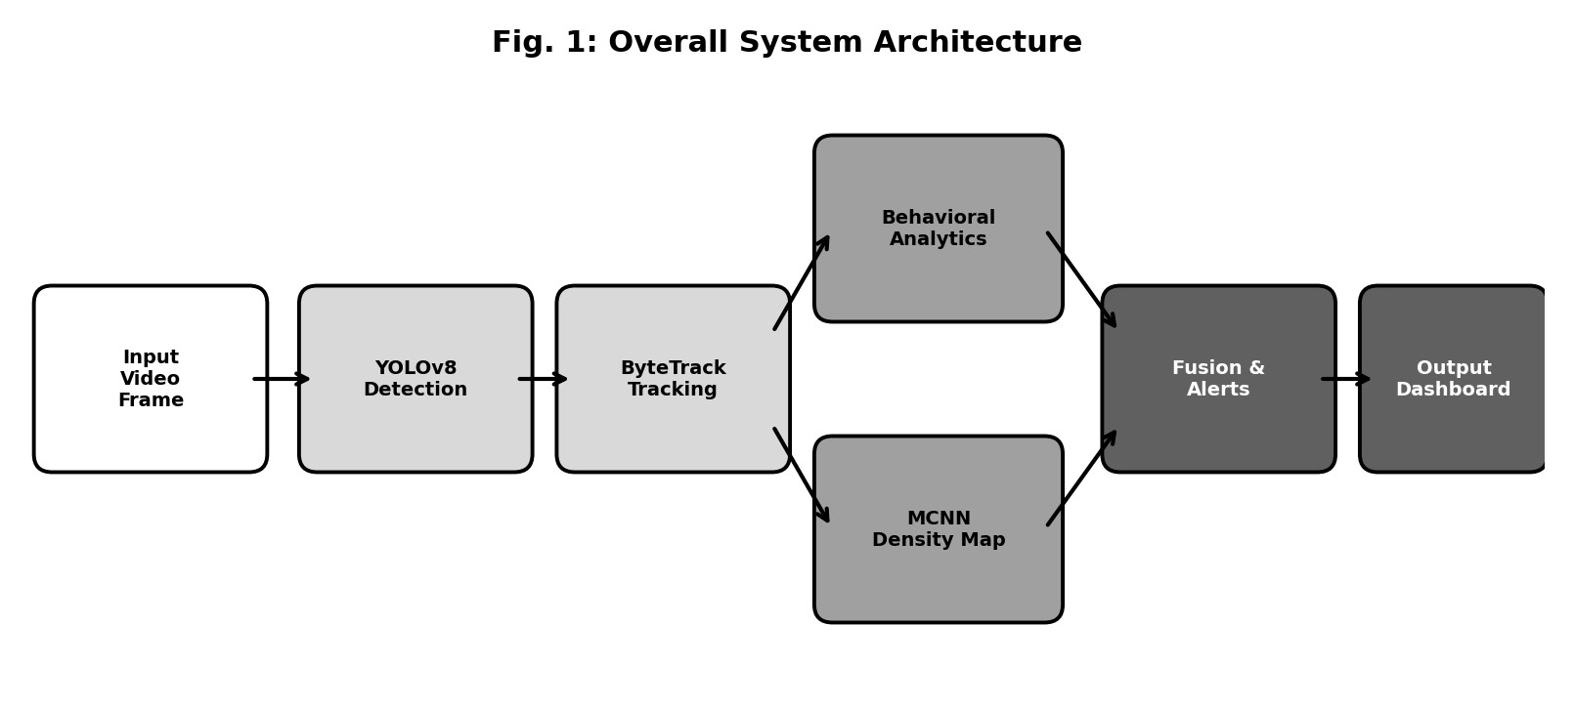
The system works by processing video input through a series of steps and sending out real-time risk alerts. The steps are as follows.
1) Surveillance cameras capture video frames
2) The frames are preprocessed (resized and normalized)
3) MCNN makes a crowd density map
4) YOLOv8 finds people in the frame.
5) ByteTrack makes paths by tracking objects in frames.
6) Behaviour engine looks for patterns.

7) The Stampede Risk Index (SRI) is calculated.

B. MCNN Architecture
For estimating density, we use the Multi-Column Convolutional Neural Network (MCNN). It has three parallel convolutional columns that are supposed to pick up on crowd features at different levels.
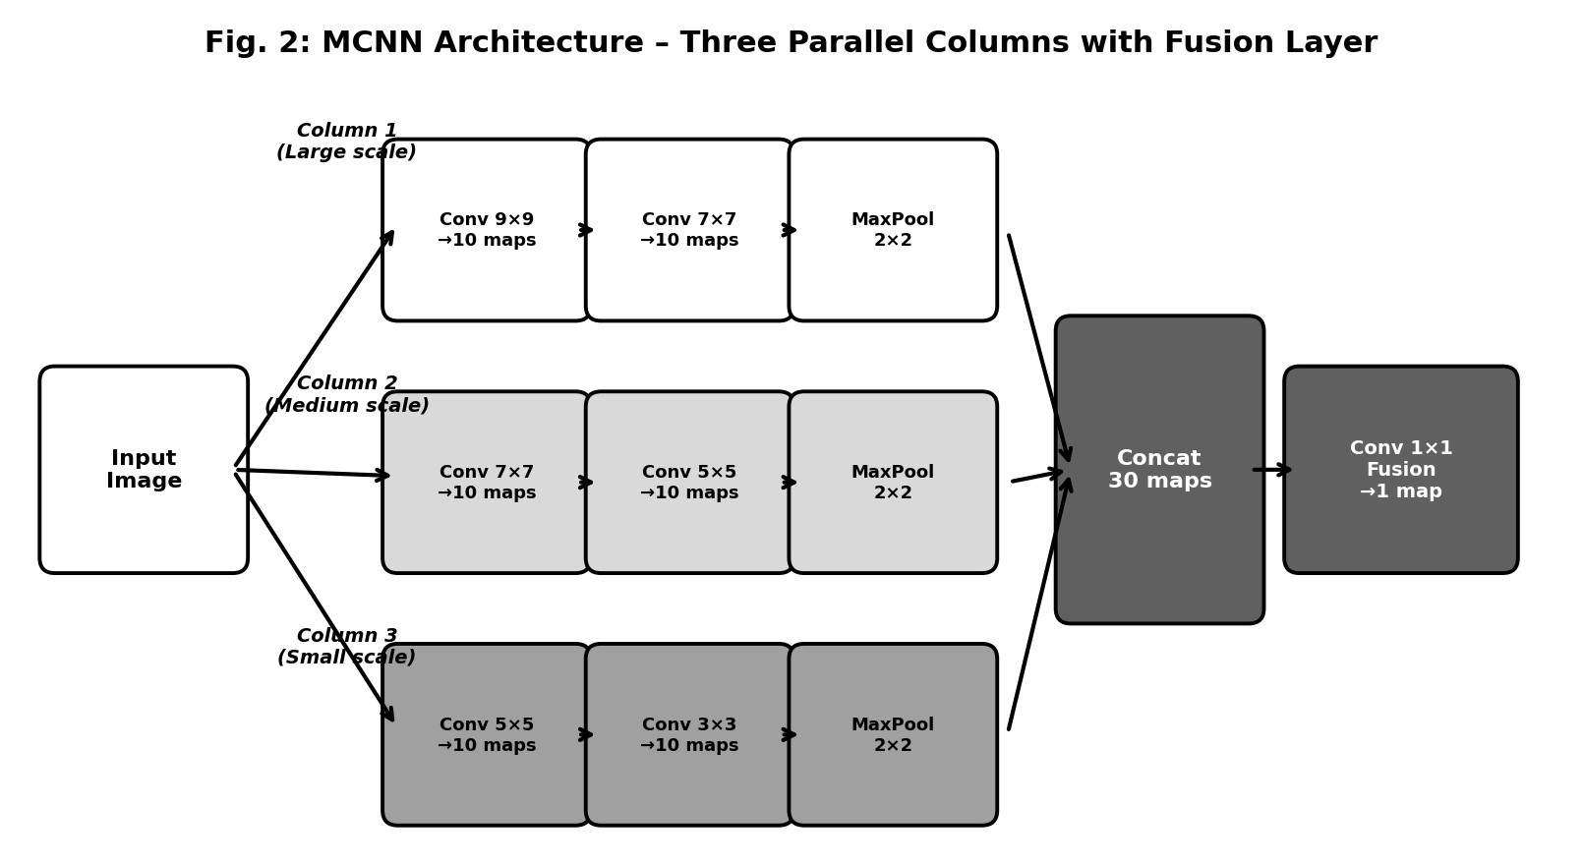
TABLE II
MCNN ARCHITECTURE
Layer | Column 1 | Column 2 | Column 3
Conv1 | 9×9, 10 filters | 7×7, 10 filters | 5×5, 10 filters
Conv2 | 7×7, 10 filters | 5×5, 10 filters | 3×3, 10 filters
Pooling | 2×2 | 2×2 | 2×2
Output | 10 maps | 10 maps | 10 maps
The outputs from all columns are concatenated and fused using a 1×1 convolution layer to produce the final density map.

C. Density Map Generation
The ground-truth density map is generated using Gaussian kernels centered at annotated head positions:
N
D(x) = ^{X}N(x − µ_{i},σ²) (1)
i=1
Where:
- D(x) = Density at pixel x
- N = Number of people
- µ_{i} = Position of i^{th} person
- σ = Gaussian spread parameter

D. Count Estimation
The total crowd count is obtained by integrating the density map:
Z
C = D(x)dx (2)
Where:
• C = Estimated crowd count

E. Detection and Tracking
Person detection using YOLOv8 is achieved through the creation of bounding boxes for persons in every frame, while ByteTrack will be used to obtain detections over frames, thus facilitating reliable identity tracking.
Tracking allows extraction of motion features such as:
- Velocity of the moving persons
- Direction of travel
- Motion trajectories
These features are essential for behavioral analysis and anomaly detection.

F. Behavioral Analytics
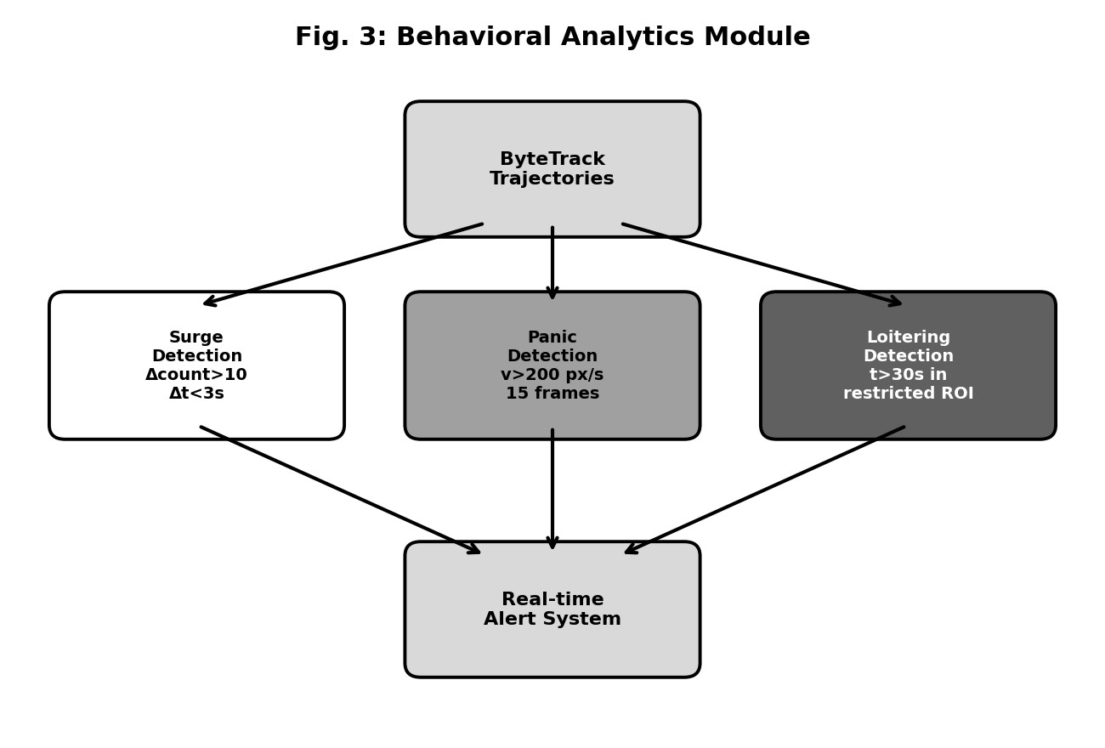
The behavioral analytics module detects abnormal crowd patterns based on predefined thresholds.
TABLE III
BEHAVIORAL PARAMETERS
Event Type | Parameter | Value
Surge | Count Increase | 10
Panic | Speed Threshold | 200 m/s
Loitering | Time Threshold | 30 s

G. Stampede Risk Index
The calculation of a risk index for stampedes involves the addition of density, velocity, and entropy of direction:

SRI = 0.40D + 0.35V + 0.25E (3)

Where:
D = Density of crowd
V = Average velocity
E = Entropy of direction
In case the SRI value surpasses a preset threshold, an alarm is triggered.
TABLE IV
TRAINING CONFIGURATION
Parameter | Value
Optimizer | Adam
Learning Rate | 1×10⁻⁴
Batch Size | 8
Epochs | 40
Loss Function | Mean Squared Error
Framework | PyTorch
Parameters | 143,285

IV. EXPERIMENTAL SETUP
The following paragraphs provide information about the datasets, implementation, and testing platform utilized to assess the effectiveness of the suggested crowd analysis framework.
A. Datasets
The proposed model is analyzed with the use of the ShanghaiTech Part B dataset [1]. The latter is commonly applied to test various crowd counting and density estimation models. This dataset includes a set of images recorded by static surveillance cameras in outdoor settings.
TABLE V
SHANGHAITECH PART B DATASET DETAILS
Property | Value
Dataset | ShanghaiTech Part B
Total Images | 716
Training Set | 400
Testing Set | 316
Resolution | 1024 × 768
Scene Type | Outdoor surveillance
Annotation | Head center points
Head locations have been provided in an annotated format to create the ground truth density map for MCNN training.
B. Implementation
PyTorch has been used to implement the system. For density mapping, MCNN is used, whereas for detecting and tracking multiple persons in real-time, YOLOv8 [4] and ByteTrack [3] have been used respectively.
TABLE VI
TRAINING CONFIGURATION
Parameter | Value
Optimizer | Adam
Learning Rate | 1×10⁻⁴
Batch Size | 8
Epochs | 40
Loss Function | Mean Squared Error
Framework | PyTorch
Total Parameters | 143,285

Image inputs are grayscale images with down-sampling for less computational burden. The algorithm will be trained via supervised learning from true density maps.

C. Testing Environment
For the testing of the system, video recordings from a surveillance camera will be considered. The proposed pipeline consists of four tasks per input image - density estimation, detection, tracking, and behavior event detection. The testing process will check:Density map generation accuracy
- Accuracy of density maps creation
- Detection and tracking efficiency
- Real time performance
- Identification of events in the crowd (surge, panic, loitering)
The system is intended to work in environments that have limited resources, which makes it appropriate for use as an edge system.
V. RESULTS AND DISCUSSION

A. Evaluation Metrics
The performance of the proposed model is evaluated using standard crowd counting metrics: Mean Absolute Error (MAE) and Root Mean Square Error (RMSE).
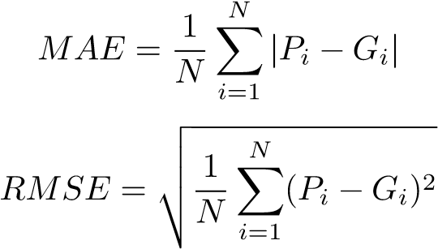
(4)
(5)
Where:
- P_{i} = Predicted count
- G_{i} = Ground truth count
- N = Number of test samples

B. Quantitative Results
TABLE VII
PERFORMANCE COMPARISON ON SHANGHAITECH PART B
Method | MAE | RMSE
MCNN [1] | 26.4 | 41.3
CSRNet [2] | 10.6 | 16.0
Proposed System | 49.72 | 80.32
The training performance of the proposed model is illustrated in Figs. 5 and 4.
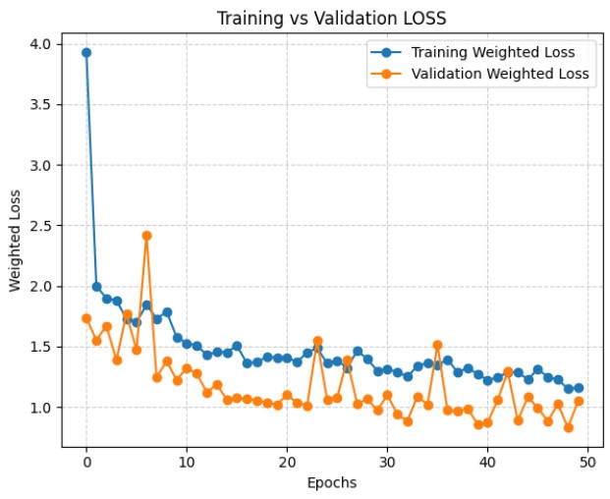
Fig. 4. Training and validation Mean Absolute Error (MAE) over epochs
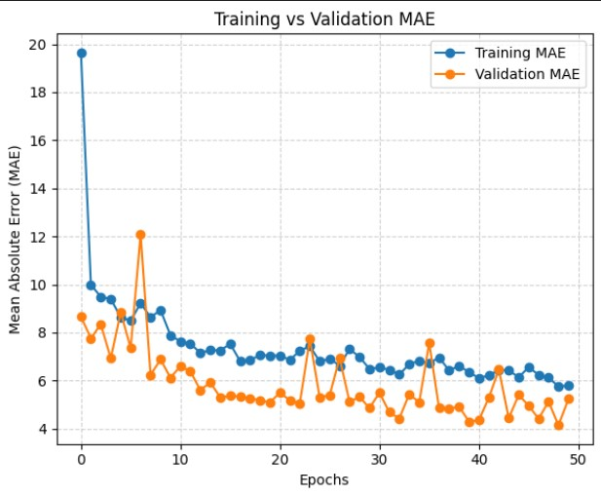
Fig. 5. Training and validation loss over epochs
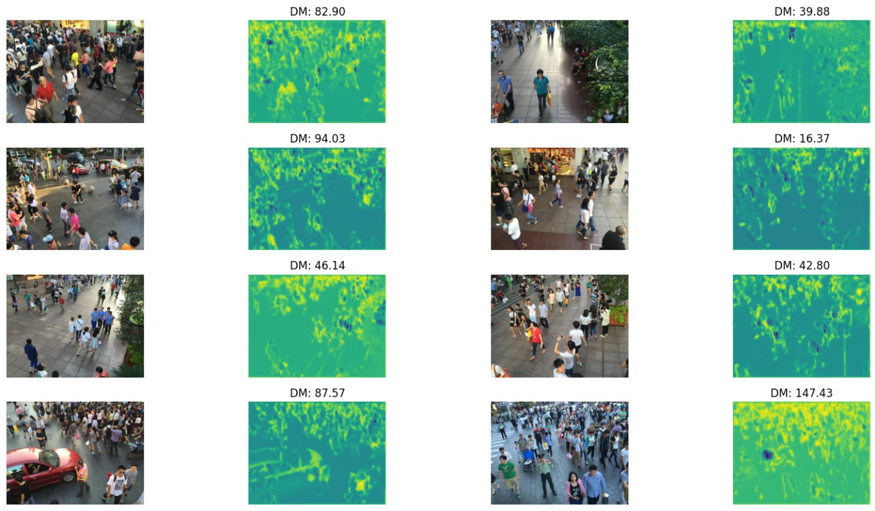
Fig. 6. Sample crowd images with corresponding predicted density maps
This approach shows a larger number of errors when compared to other advanced solutions owing to its lightweight nature. However, it significantly reduces the computational complexity allowing for edge deployment in real-time operation.
C. Discussion
Thus, one may assume that you cannot be both precise and efficient. Models such as CSRNet make less errors but require an order of magnitude more computing resources while being deeper and more complicated. In contrast, our solution is based on a lightweight approach with only 143,285 trainable parameters.
By adding YOLOv8 [4] and ByteTrack [3], we made the system even more functional allowing it to detect and track objects thus giving us an opportunity to analyze crowd dynamics. Thus, this combined technique allows not only to estimate the crowd size but to understand how they move.
Nevertheless, several limitations are noted:
- The decreased accuracy in dense crowds
- The sensitivity to lighting conditions
- The lack of generalizability across the dataset
Nonetheless, the presented system provides a balance between accuracy and efficiency necessary for practical surveillance purposes.
VI. CONCLUSION
The current paper discussed a hybrid crowd analysis framework based on the MCNN crowd density estimation technique, YOLOv8 object detector and ByteTrack multi-object tracker that is aimed to monitor crowds in real time. In addition to that, the proposed solution involves behavioral analysis and implementation of the Stampede Risk Index (SRI) that allows detecting potential dangerous conditions.
It was developed with an intention to perform calculations efficiently and quickly, making it perfect for edge computing platforms. Results prove that it provides a decent trade-off between speed and accuracy, which allows its real-time deployment in surveillance applications.
In the future, we will experiment with more advanced architectures including attention mechanisms, which should increase accuracy and make it robust enough even in challenging cases, as well as implement spatiotemporal features that should improve behavior prediction.
REFERENCES
- Y. Zhang, D. Zhou, S. Chen, S. Gao, and Y. Ma, “Single-image crowd counting via multi-column convolutional neural network,” in Proc. IEEE CVPR, 2016, pp. 589–597.
- Y. Li, X. Zhang, and D. Chen, “CSRNet: Dilated convolutional neural networks for understanding highly congested scenes,” in Proc. IEEE CVPR, 2018, pp. 1091–1100.
- Y. Zhang, P. Sun, Y. Jiang, D. Yu, F. Weng, Z. Yuan, P. Luo, W. Liu, and X. Wang, “ByteTrack: Multi-object tracking by associating every detection box,” in Proc. ECCV, 2022.
- G. Jocher, A. Chaurasia, and J. Qiu, “YOLO by Ultralytics,” 2023.
[Online]. Available: https://github.com/ultralytics/ultralytics [5] Y. Zhang et al., “ShanghaiTech Dataset,” 2016.
[6] G. Idrees et al., “Multi-source multi-scale counting in extremely dense crowd images,” in Proc. IEEE CVPR, 2013.

