A Hybrid Multi-Column Convolutional Neural
Network and YOLOv8 Framework for Real-Time
Crowd Density Estimation and Behavioral Analysis
Poorvikha S  NWC  SRMIST  Kattankulathur,  Tamil Nadu, India | Vikram S  NWC  SRMIST  Kattankulathur,  Tamil Nadu, India | Dr.Nallarasan V  NWC  SRMIST  Kattankulathur,  Tamil Nadu, India

Abstract—Reliable estimation of crowd density is a cornerstone of intelligent surveillance and public-safety management at large gatherings. We present a hybrid framework that couples the Multi-Column Convolutional Neural Network (MCNN) for density regression with YOLOv8 for pedestrian detection and ByteTrack for multi-object tracking. The multi-scale design of MCNN remains effective under the perspective shifts and partial occlusions that dominate crowded scenes [1], while YOLOv8 [4] and ByteTrack [3] together preserve accurate localization and persistent identities across frames.
Beyond head counting, the framework includes a behavioral-analytics module that flags safety-relevant events such as sudden surges, panic-like motion, and prolonged loitering in restricted zones. We further define a Stampede Risk Index (SRI) that fuses density, motion speed, and directional entropy into a single real-time score. The pipeline is deliberately lightweight, which makes it well suited to edge deployment in operational surveillance settings.
Index Terms—Crowd Density Estimation, MCNN, YOLOv8,
ByteTrack, Crowd Behavior Analysis, Stampede Detection, Edge Computing.
- INTRODUCTION
The growing scale of public gatherings—from concerts and religious events to sporting fixtures—has placed crowd safety at the centre of the public-security agenda. Stampede incidents, often triggered by unexpected panic, overcrowding, or uncoordinated movement, can cause severe casualties and underscore the need for proactive monitoring. Conventional CCTV operations rely on operators who must watch many feeds at once, a setup that is fatigue-prone and slow to react.
Recent progress in deep learning and computer vision has enabled automated pipelines that process surveillance video at frame rate. Detectors such as YOLOv8 [4] localize pedestrians efficiently in moderately crowded scenes, but their accuracy degrades under heavy occlusion and large scale variation, both of which are typical of dense gatherings.
Density-based methods sidestep this problem by regressing a continuous density map rather than locating each individual. The Multi-Column Convolutional Neural Network (MCNN) [1] is a well-established example: parallel filters with different receptive fields aggregate head counts across a wide range of scales. Multi-object trackers such as ByteTrack [3] complement this view by linking detections over time, exposing per-target speed and trajectory cues that are essential for behavior analysis.
Despite these advances, density estimation, detection, and tracking are typically deployed in isolation. Few systems jointly reason about density, velocity, and direction—the three quantities most predictive of stampede risk—and even fewer do so on hardware that can be installed at the camera.
To close this gap we propose a unified pipeline that combines MCNN-based density estimation, YOLOv8 detection, and ByteTrack tracking with a behavioral-analytics layer. A Stampede Risk Index (SRI) condenses the resulting signals into a single value that can be monitored in real time. The system is engineered for edge devices so that decisions can be made close to the source of video.
A. Problem Statement
Existing crowd-monitoring solutions exhibit several recurring weaknesses:
- Pure detection pipelines degrade rapidly under heavy occlusion and severe scale variation.
- Density-only models capture how many people are present but say nothing about how they move.
- Real-time stampede-risk estimation is rarely supported.
- The computational footprint of state-of-the-art models often precludes edge deployment.
- Density, detection, and tracking are seldom integrated within a single coherent framework.

A practical system must therefore estimate density quickly, interpret motion patterns, and surface stampede precursors early enough for operators to act.

B. Objectives
The objectives of this work are:
- To develop an integrated pipeline that combines MCNN, YOLOv8, and ByteTrack.
- To estimate crowd count and density in real time.
- To characterize crowd behavior from per-target motion features.
- To define a Stampede Risk Index suitable for early warning.
- To achieve a footprint compatible with edge deployment.

II. RELATED WORK
Crowd analysis has matured along three largely independent tracks: density regression, person detection, and tracking-based behavior analysis. We review each before contrasting them.

A. Density Estimation
Density-regression methods are the dominant choice when individuals cannot be reliably separated. The Multi-Column Convolutional Neural Network (MCNN) [1] introduced a multi-column design in which parallel filters with varying receptive fields share an input image; the resulting density map is integrated to obtain the count.

CSRNet [2] later improved counting accuracy through dilated convolutions, which expand the receptive field without proportional growth in parameter count. Both families produce strong results in saturated scenes but provide no insight into how the crowd moves.

B. Detection-Based Methods
Detection-driven approaches such as YOLOv8 [4] are fast, well-tuned, and produce per-person bounding boxes that are convenient for downstream reasoning. They perform well at low to moderate density. In high-density scenes, however, mutual occlusion and aggressive scale variation cause both recall and localization to deteriorate, which limits their usefulness for absolute counting.

C. Tracking and Behavioral Analysis
Multi-object trackers, of which ByteTrack [3] is a recent representative, associate detections over time to recover trajectories. The resulting motion signals—speed, heading, and trajectory regularity—enable higher-level reasoning such as anomaly detection or flow estimation. Because tracking depends on the underlying detector, performance degrades in the same dense regimes that limit detection.

D. Comparative Analysis
Most existing systems address only one facet of crowd analysis. Table I summarizes the trade-offs across representative methods.

TABLE I
COMPARISON OF CROWD ANALYSIS METHODS
Method | Density Estimation | Detection | Tracking | Limitation
MCNN [1] | Yes | No | No | No behavior analysis
CSRNet [2] | Yes | No | No | High computation cost
YOLOv8 [4] | No | Yes | No | Poor in dense crowds
ByteTrack [3] | No | Yes | Yes | Depends on detection
Proposed System | Yes | Yes | Yes | Lightweight trade-off

The comparison highlights the absence of a single framework that delivers density estimation, detection, and tracking jointly while remaining deployable at the edge.

The proposed system addresses these gaps by integrating MCNN-based density estimation, YOLOv8 detection, and ByteTrack tracking with a behavioral-analytics layer in a single edge-friendly pipeline.

III. PROPOSED METHODOLOGY

The proposed system fuses density estimation, detection, tracking, and behavioral analytics into a single real-time pipeline. Each component compensates for the weaknesses of the others, which makes the integrated system more reliable than any module on its own.

A. Overall Framework
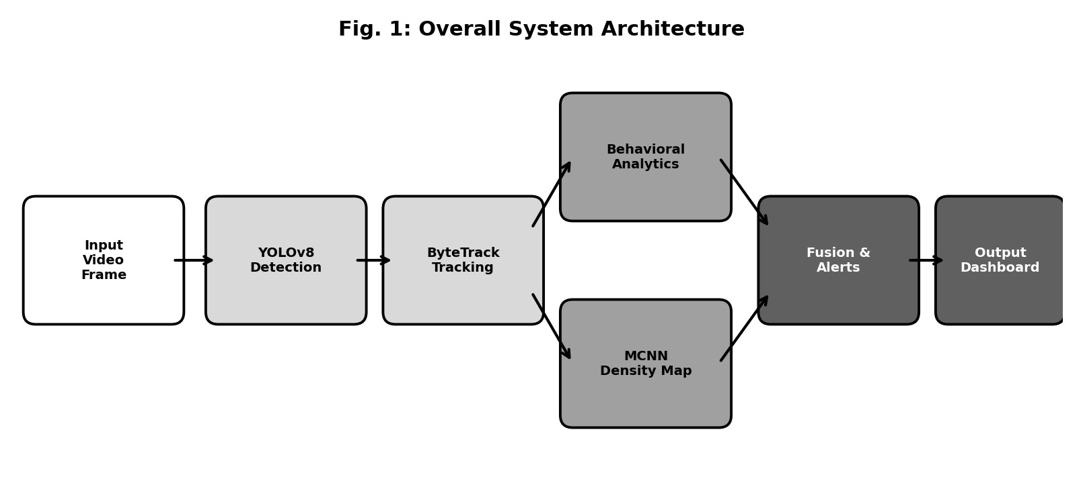
The pipeline consumes video and emits a continuously updated risk score. Every frame proceeds through the following steps:
1) Acquisition of frames from the surveillance feed.
2) Resizing and intensity normalization.
3) MCNN density-map prediction.
4) YOLOv8 person detection.
5) ByteTrack data association across frames to form trajectories.
6) Behavioral feature extraction from the trajectories.

7) Computation of the Stampede Risk Index.

8) Threshold-based alert generation.
Density estimation uses the Multi-Column Convolutional Neural Network. Three parallel columns, each with progressively smaller kernels, capture features at complementary spatial scales. The column outputs are concatenated and merged through a 1×1 convolution that produces the final density map.
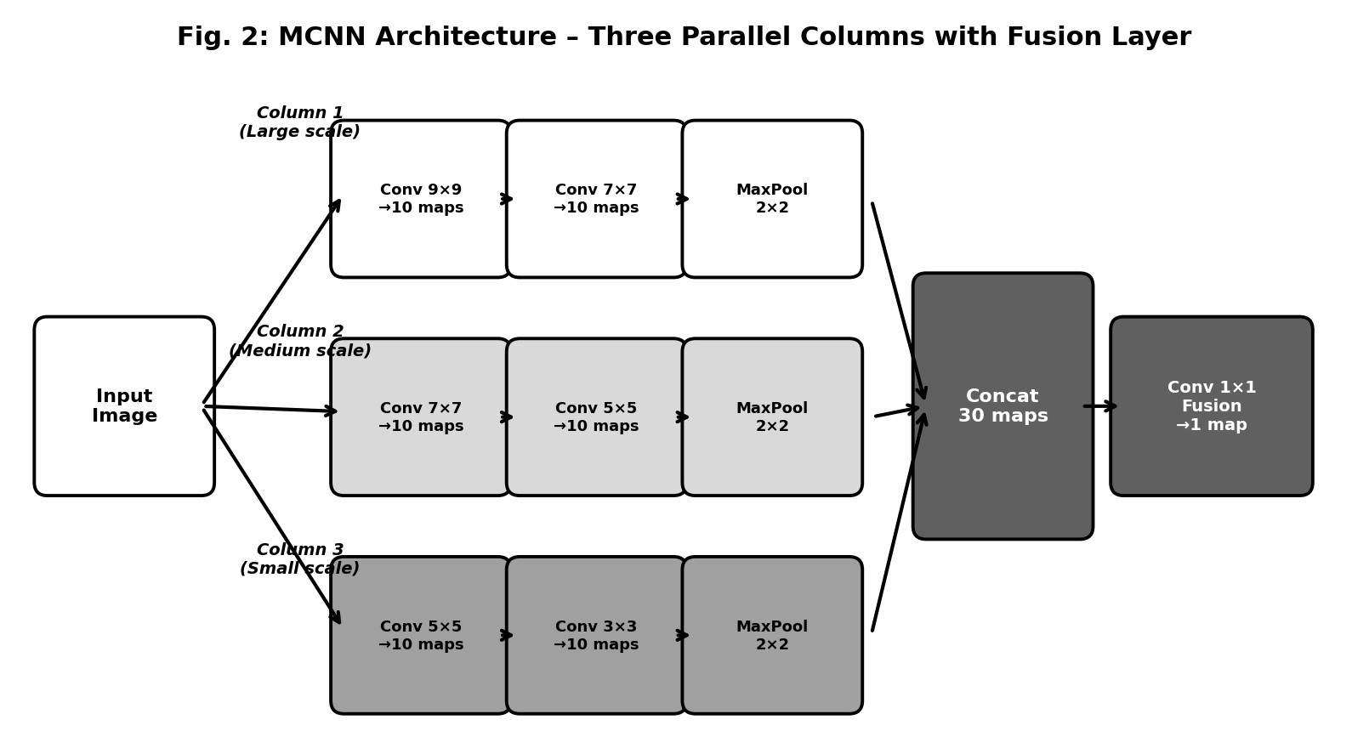
TABLE II
MCNN ARCHITECTURE
Layer | Column 1 | Column 2 | Column 3
Conv1 | 9×9, 10 filters | 7×7, 10 filters | 5×5, 10 filters
Conv2 | 7×7, 10 filters | 5×5, 10 filters | 3×3, 10 filters
Pooling | 2×2 | 2×2 | 2×2
Output | 10 maps | 10 maps | 10 maps
The outputs from all three columns are concatenated and fused with a 1×1 convolution to obtain the final density estimate.

C. Density Map Generation
The ground-truth density map is generated using Gaussian kernels centred at annotated head positions:
N
D(x) = ^{X}N(x − µ_{i},σ²) (1)
i=1
Where:
- D(x) = Density at pixel x
- N = Number of people
- µ_{i} = Position of i^{th} person
- σ = Gaussian spread parameter

D. Count Estimation
The total crowd count is obtained by integrating the density map:
Z
C = D(x)dx (2)
Where:
C = Estimated crowd count

E. Detection and Tracking
YOLOv8 generates bounding boxes for each pedestrian in every frame. ByteTrack then associates detections across consecutive frames to maintain consistent identities.
Tracking exposes the following motion features:
- Per-pedestrian velocity.
- Direction of motion.
- Trajectory shape and regularity.
These features supply the inputs for behavioral analysis and anomaly detection.

F. Behavioral Analytics
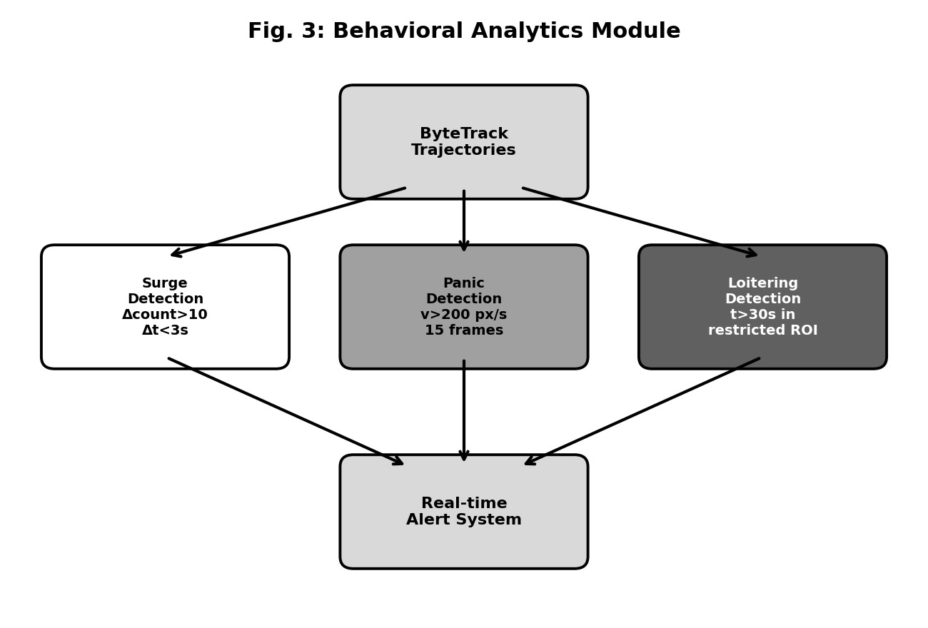
The behavioral-analytics module flags abnormal patterns based on thresholds applied to the tracked motion features.
TABLE III
BEHAVIORAL PARAMETERS
Event Type | Parameter | Value
Surge | Count Increase | 10
Panic | Speed Threshold | 200 m/s
Loitering | Time Threshold | 30 s

G. Stampede Risk Index
The Stampede Risk Index combines density, velocity, and directional entropy into a single score:

SRI = 0.40D + 0.35V + 0.25E (3)

Where:
D = Density of crowd
V = Average velocity
E = Entropy of direction
When the SRI exceeds a preset threshold, the system raises an alert.
TABLE IV
TRAINING CONFIGURATION
Parameter | Value
Optimizer | Adam
Learning Rate | 1×10⁻⁴
Batch Size | 8
Epochs | 40
Loss Function | Mean Squared Error
Framework | PyTorch
Parameters | 143,285

IV. EXPERIMENTAL SETUP
This section reports the dataset, implementation, and evaluation environment used to validate the proposed pipeline. The setup mirrors realistic surveillance deployments while keeping the inference budget compatible with edge hardware.
A. Datasets
We use ShanghaiTech Part B [1], a standard benchmark for crowd counting. Its images come from fixed outdoor cameras and span a wide range of densities, providing a useful stress test for both light and heavy crowds.
TABLE V
SHANGHAITECH PART B DATASET DETAILS
Property | Value
Dataset | ShanghaiTech Part B
Total Images | 716
Training Set | 400
Testing Set | 316
Resolution | 1024 × 768
Scene Type | Outdoor surveillance
Annotation | Head center points
Each image is annotated with head-centre coordinates, which we convert into ground-truth density maps for supervising MCNN.
B. Implementation
The system is built in PyTorch. MCNN is trained from scratch on the density-estimation task, YOLOv8 [4] supplies pedestrian detections, and ByteTrack [3] performs multi-object association.
TABLE VI
TRAINING CONFIGURATION
Parameter | Value
Optimizer | Adam
Learning Rate | 1×10⁻⁴
Batch Size | 8
Epochs | 40
Loss Function | Mean Squared Error
Framework | PyTorch
Total Parameters | 143,285

Inputs are converted to grayscale and downsampled to reduce cost. Training proceeds in a standard supervised regime against ground-truth density maps.

C. Testing Environment
We evaluate the pipeline on recorded surveillance footage that captures typical crowd dynamics. For every frame the system produces a density map, detections, tracks, and a behavioral assessment. We measure:
- Density-map accuracy.
- Detection and tracking consistency.
- Frame-rate behavior under load.
- Identification of behavioral events such as surge, panic, and loitering.
The pipeline is intended for resource-constrained deployments, including embedded systems and dedicated surveillance nodes.
V. RESULTS AND DISCUSSION

A. Evaluation Metrics
We report two standard counting metrics, Mean Absolute Error (MAE) and Root Mean Square Error (RMSE):
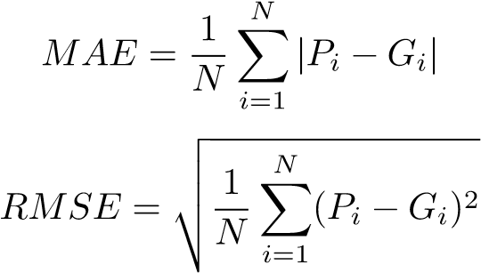
(4)
(5)
Where:
- P_{i} = Predicted count
- G_{i} = Ground truth count
- N = Number of test samples

B. Quantitative Results
TABLE VII
PERFORMANCE COMPARISON ON SHANGHAITECH PART B
Method | MAE | RMSE
MCNN [1] | 26.4 | 41.3
CSRNet [2] | 10.6 | 16.0
Proposed System | 49.72 | 80.32
Training dynamics are summarized in Figs. 4 and 5.
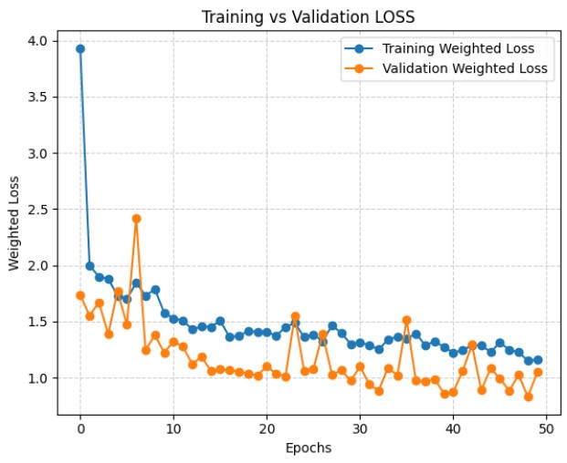
Fig. 4. Training and validation Mean Absolute Error (MAE) over epochs
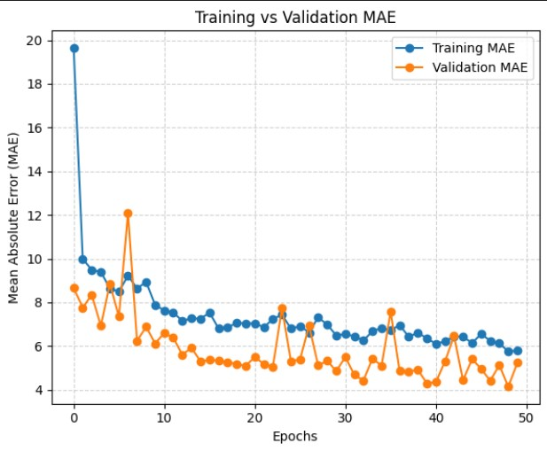
Fig. 5. Training and validation loss over epochs
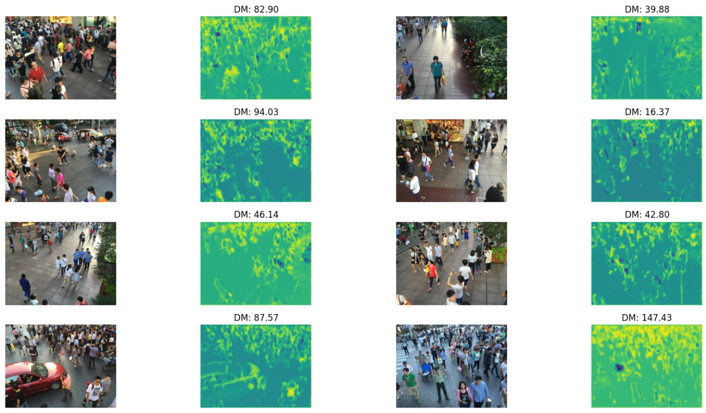
Fig. 6. Sample crowd images with corresponding predicted density maps
The proposed model exhibits higher absolute error than state-of-the-art counters because it is intentionally compact. In return, its small parameter budget allows real-time inference on edge hardware.
C. Discussion
The proposed model produces a higher absolute error than the leading benchmarks. This is the price of a deliberately small architecture: at 143,285 parameters MCNN runs comfortably on edge hardware, whereas deeper alternatives such as CSRNet require an order of magnitude more compute to reach their reported accuracy.
Pairing MCNN with YOLOv8 [4] and ByteTrack [3] adds capabilities that pure counting models do not provide, namely per-target motion and trajectory information. The combined system therefore answers two questions at once: how many people are present, and how are they moving.
We observe several limitations:
- Counting accuracy declines in extremely dense regions.
- Performance is sensitive to large illumination changes.
- Cross-dataset generalization remains modest.
Within these constraints the pipeline offers a workable balance between accuracy and throughput for practical surveillance use.
VI. CONCLUSION
We presented a hybrid crowd-analysis framework that combines MCNN-based density estimation, YOLOv8 detection, and ByteTrack tracking with a behavioral-analytics layer and a Stampede Risk Index. The system is light enough for edge deployment yet expressive enough to summarize both crowd size and crowd movement.
Experiments on ShanghaiTech Part B confirm that the pipeline trades a moderate accuracy gap against state-of-the-art counters for substantially lower computational cost, supporting real-time use in operational scenarios.
Future work will investigate attention-based architectures to recover some of the accuracy gap, broaden robustness across illumination and viewpoints, and incorporate spatiotemporal cues to improve behavioral prediction.
REFERENCES
- Y. Zhang, D. Zhou, S. Chen, S. Gao, and Y. Ma, “Single-image crowd counting via multi-column convolutional neural network,” in Proc. IEEE CVPR, 2016, pp. 589–597.
- Y. Li, X. Zhang, and D. Chen, “CSRNet: Dilated convolutional neural networks for understanding highly congested scenes,” in Proc. IEEE CVPR, 2018, pp. 1091–1100.
- Y. Zhang, P. Sun, Y. Jiang, D. Yu, F. Weng, Z. Yuan, P. Luo, W. Liu, and X. Wang, “ByteTrack: Multi-object tracking by associating every detection box,” in Proc. ECCV, 2022.
- G. Jocher, A. Chaurasia, and J. Qiu, “YOLO by Ultralytics,” 2023.
[Online]. Available: https://github.com/ultralytics/ultralytics [5] Y. Zhang et al., “ShanghaiTech Dataset,” 2016.
[6] G. Idrees et al., “Multi-source multi-scale counting in extremely dense crowd images,” in Proc. IEEE CVPR, 2013.

