**Redistributing Routing Protocols**

**Contents**

**Introduction**

**Prerequisites**

Requirements

Components Used

Conventions

**Metrics**

**Administrative Distance**

**Redistribution Configuration Syntax and Examples**

IGRP and EIGRP

OSPF

RIP

**PROJECT**

**ABSTRACT**

Routing protocols determine the best routes to transfer data from one node to another and specify how routers communicate between each other in order to complete this task. There are different classes of routing protocols, two of which are Exterior Gateway Protocol (EGP) and Interior Gateway Routing (IGR). A routing protocol can be dynamicor static, as well as distance-vector or link-state.In this project, we will focus on Routing Information Protocol (RIP),Open Shortest Path First (OSPF), and Enhanced Interior Gateway Routing Protocol (EIGRP). All three protocols are dynamic IGP’s, meaning that these protocols route packets within one Autonomous System (AS).RIP is a distance-vector protocol;EIGRP is an enhanced distance vector protocol developed by Cisco and OSPF is a link-state routing protocol. Detailed descriptions of these routing protocols are provided later in this report. We will study characteristics such as convergence time and routing trafficsent within small and large topologies. Using OPNET, we will obtain simulation results for the specified routing protocols and compare performance in order to determine the best routing protocol for a given network topology.

**Introduction**

The use of a routing protocol to advertise routes that are learned by some other means, such as by another routing protocol, static routes, or directly connected routes, is called redistribution. While running a single routing protocol throughout your entire IP internetwork is desirable, multi−protocol routing is common for a number of reasons, such as company mergers, multiple departments managed by multiple network administrators, and multi−vendor environments. Running different routing protocols is often part of a network design. In any case, having a multiple protocol environment makes redistribution a necessity.

Differences in routing protocol characteristics, such as metrics, administrative distance, classful and classless capabilities can effect redistribution. Consideration must be given to these differences for redistribution to succeed.

**Prerequisites**

**Requirements**

There are no specific requirements for this document.

**Components Used**

The information in this document is based on these software and hardware versions:

* Cisco IOS® Software Release 12.2(10b)
* Cisco 2500 Series Routers

**Metrics**

When you redistribute one protocol into another, remember that the metrics of each protocol play an important role in redistribution. Each protocol uses different metrics. For example, the Routing Information Protocol (RIP) metric is based on hop count, but Interior Gateway Routing Protocol (IGRP) and Enhanced Interior Gateway Routing Protocol (EIGRP) use a composite metric based on bandwidth, delay, reliability, load, and maximum transmission unit (MTU), where bandwidth and delay are the only parameters used by default. When routes are redistributed, you must define a metric that is understandable to the receiving protocol. There are two methods to define metrics when redistributing routes.



You can define the metric for that specific redistribution only:

router rip

redistribute static metric 1

redistribute ospf 1 metric 1

Or you can use the same metric as a default for all redistribution (Using the **default−metric** command saves work because it eliminates the need for defining the metric separately for each redistribution.):

router rip

redistribute static

redistribute ospf 1

default−metric 1

**Administrative Distance**

If a router is running more than one routing protocol and learns a route to the same destination using both routing protocols, then which route should be selected as the best route? Each protocol uses its own metric type to determine the best route. Comparing routes with different metric types cannot be done. Administrative distances take care of this problem. Administrative distances are assigned to route sources so that the route from the most preferred source will be chosen as the best path. Refer to Route Selection in Cisco Routers for more information about administrative distances and route selection.

Administrative distances help with route selection among different routing protocols, but they can cause problems for redistribution. These problems can be in the form of routing loops, convergence problems, or inefficient routing. See below for a topology and description of a possible problem.

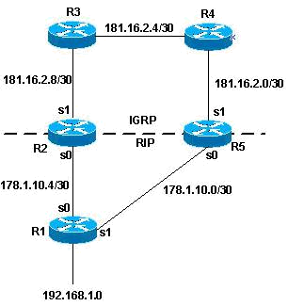

In the above topology, if R1 is running RIP, and R2 and R5 are running both RIP and IGRP and redistributing RIP into IGRP, then there is a potential problem. For example, R2 and R5 are both learning about network 192.168.1.0 from R1 using RIP. This knowledge is redistributed into IGRP. R2 learns about network

192.168.1.0 through R3, and R5 learns about it from R4 using IGRP. IGRP has a lower administrative distance than RIP (100 versus 120); therefore, the IGRP route is what is used in the routing table. Now there is a potential routing loop. Even if split horizon, or any other feature meant to help prevent routing loops comes into play, there is still a convergence problem.

If R2 and R5 are also redistributing IGRP into RIP (otherwise known as mutual redistribution) and the network, 192.168.1.0, is not directly connected to R1 (R1 is learning from another router upstream from it), then there is a potential problem that R1 will learn the network from R2 or R5 with a better metric than from the original source.

**Note:** The mechanics of route redistribution is proprietary on Cisco routers. The rules for redistribution on aCisco router dictate that the redistributed route be present in the routing table. It is not sufficient that the route be present in the routing topology or database. Routes with a lower Administrative Distance (AD) are always installed in the routing table. For example, if a static route is redistributed into IGRP on R5, and then IGRP subsequently redistributed into RIP on the same router (R5), the static route is not redistributed into RIP because it never got entered into the IGRP routing table. This is due to the fact that static routes have an AD of 1 and IGRP routes have an AD of 100 and the static route is installed in the routing table. In order to redistribute the static route into IGRP on R5, you need to use the **redistribute static** command under the **router rip** command.

The default behavior for RIP, IGRP and EIGRP is to advertise directly connected routes when a **network** statement under the routing protocol includes the connected interface subnet. There are two methods to get a connected route:

* An interface is configured with an IP address and mask, this corresponding subnet is considered a connected route.
* A static route is configured with only an outgoing interface, and not an IP next−hop, this is also considered a connected route.

Router#**conf t**

Router(config)#**ip route 10.0.77.0 255.255.255.0 ethernet 0/0**

Router(config)#**end**

Router#**show ip route static**

10.0.0.0/24 is subnetted, 1 subnets

S 10.0.77.0 is directly connected, Ethernet0/0

A **network** command configured under EIGRP, RIP or IGRP that includes (or "covers") either of these types of connected routes includes that subnet for advertisement.

For example, if an interface has address 10.0.23.1 and mask 255.255.255.0, the subnet 10.0.23.0/24 is a connected route and will be advertised by these routing protocols when a **network** statement is configured as follows:

router rip | igrp # | eigrp #

network 10.0.0.0

This static route, 10.0.77.0/24, is also advertised by these routing protocols, because it is a connected route and it is "covered" by the **network** statement.

See the Avoiding Problems Due to Redistribution section of this document for tips on how to avoid this problem.

**Redistribution Configuration Syntax and Examples**

**Route Redistribution Basics**

It is preferable to employ a single routing protocol in an internetwork environment, for simplicity and ease of management. Unfortunately, this is not always possible, making multi-protocol environments common.

Route Redistribution allows routes from one routing protocol to be advertised into another routing protocol. The routing protocol receiving these redistributed routes usually marks the routes as external. External routes are usually less preferred than locally-originated routes.

At least one redistribution point needs to exist between the two routing domains. This device will actually run both routing protocols. Thus, to perform redistribution in the following example, RouterB would require at least one interface in both the EIGRP and the OSPF routing domains

**IGRP and EIGRP**

Enhanced Interior Gateway Routing Protocol (EIGRP) is an advanced distance vector routing protocol based on the principles of the Interior Gateway Routing Protocol (IGRP).

EIGRP is a successor to the Interior Gateway Routing Protocol (IGRP). Both are owned by Cisco and operate only on their devices. Cisco introduced EIGRP because it needed a protocol with faster converging abilities, route selection and calculation and the ability to record information from neighboring devices.

**EIGRP has the following characteristics:**

1. Advanced operational efficiency
2. Capabilities of both link state and distance vector
3. A classless routing protocol
4. Unique features including use of Reliable Transport Protocol (RTP), a diffusing update algorithm (DUAL), updates and updated information about neighbors
5. Faster converging because it precalculates routes and does not broadcast hold-down timer packets before converging .

This output shows an IGRP/EIGRP router redistributing static, Open Shortest Path First (OSPF), RIP, and Intermediate System−to−Intermediate System (IS−IS) routes.

router igrp/eigrp 1

network 131.108.0.0

redistribute static

redistribute ospf 1

redistribute rip

redistribute isis

default−metric 10000 100 255 1 1500

IGRP and EIGRP need five metrics when redistributing other protocols: bandwidth, delay, reliability, load, and MTU, respectively. An example of IGRP metrics follows:

|  |  |  |
| --- | --- | --- |
| **Metric** | **Value** |  |
|  |  |
| bandwidth | In units of kilobits per second; 10000 for Ethernet |  |
|  |  |
| delay | In units of tens of microseconds; for Ethernet it |  |
|  | is100 x 10 microseconds = 1 ms |  |
|  |  |  |
| reliability | 255 for 100 percent reliability |  |
|  |  |
| load | Effective load on the link expressed as a number |  |
|  | from 0 to 255 (255 is 100 percent loading) |  |
|  |  |  |
| MTU | Minimum MTU of the path; usually equals that for |  |
|  | the Ethernet interface, which is 1500 bytes |  |
|  |  |  |

Multiple IGRP and EIGRP processes can run on the same router, with redistribution between them. For example, IGRP1 and IGRP2 can run on the same router. However, running two processes of the same protocol on the same router is rarely necessary, and can consume the router's memory and CPU

The redistribution of IGRP/EIGRP into another IGRP/EIGRP process does not require any metric conversion, so there is no need to define metrics or use the **default−metric** command during redistribution.

A redistributed static route takes precedence over the summary route because the static route has an administrative distance of 1 whereas Eigrp summary route has an administrative distance of 5. This happens when a static route is redistributed with the use of **redistribute static** under the Eigrp process and the Eigrp process has a default route.

**OSPF**

Open Shortest Path First (OSPF) is a link state routing protocol (LSRP) that uses the Shortest Path First (SPF) network communication algorithm (Dijkstra's algorithm) to calculate the shortest connection path between known devices.

OSPF bis an Interior Gateway Protocol (IGP) that routes Internet Protocol (IP) packets within a single routing network domain only. OSPF finds the best network layout (topology) by calculating shortest device connection paths using the Shortest Path First (SPF) algorithm.

For example, a person in city A wants to travel to city M and is given two options:

* Travel via cities B and C. The route would be ABCM. And the distance (or bandwidth cost in the networking case) for A-B is 10 miles, B-C is 5 miles and C-M is 10 miles.
* Travel via city F. The route would be AFM. And the distance for A-F is 20 miles and F-M is 10 miles.

The shortest route is always the one with least amount of distance covered in total. Thus, the ABCM route is the better option (10+5+10=25), even though the person has to travel to two cities as the associated total cost to travel to the destination is less than the second option with a single city (20+10=30). OSPF performs a similar algorithm by first calculating the shortest path between the source and destination based on link bandwidth cost and then allows the network to send and receive IP packets via the shortest route.

This output shows an OSPF router redistributing static, RIP, IGRP, EIGRP, and IS−IS routes.

router ospf 1

network 131.108.0.0 0.0.255.255 area 0

redistribute static metric 200 subnets

redistribute rip metric 200 subnets

redistribute igrp 1 metric 100 subnets

redistribute eigrp 1 metric 100 subnets

redistribute isis metric 10 subnets

The OSPF metric is a cost value based on 108/ bandwidth of the link in bits/sec. For example, the OSPF cost of Ethernet is 10: 108/107 = 10

**Note:** If a metric is not specified, OSPF puts a default value of 20 when redistributing routes from allprotocols except Border Gateway Protocol (BGP) routes, which get a metric of 1.

When there is a major net that is subnetted, you need to use the keyword subnet to redistribute protocols into OSPF. Without this keyword, OSPF only redistributes major nets that are not subnetted.

It is possible to run more than one OSPF process on the same router. However, running more than one process of the same protocol is rarely needed, and consumes the router's memory and CPU.

You do not need to define metric or use the **default−metric** command when redistributing one OSPF process into another.

**RIP**

**Note:** The principles in this document apply to RIP versions I and II.

Routing Information Protocol (RIP) is a dynamic protocol used to find the best route or path from end-to-end (source to destination) over a network by using a routing metric/hop count algorithm. This algorithm is used to determine the shortest path from the source to destination, which allows the data to be delivered at high speed in the shortest time.

RIP plays an important role providing the shortest and best path for data to take from node to node. The hop is the step towards the next existing device, which could be a router, computer or other device. Once the length of the hop is determined, the information is stored in a routing table for future use. RIP is being used in both local and wide area networks and is generally considered to be easily configured and implemented.

This output shows a RIP router redistributing static, IGRP, EIGRP, OSPF, and IS−IS routes.

router rip

network 131.108.0.0

redistribute static

redistribute igrp 1

redistribute eigrp 1

redistribute ospf 1

redistribute isis

default−metric 1

The RIP metric is composed of hop count, and the maximum valid metric is 15. Anything above 15 is considered infinite; you can use 16 to describe an infinite metric in RIP. When redistributing a protocol into RIP, Cisco recommends that you use a low metric, such as 1. A high metric, such as 10, limits RIP even further. If you define a metric of 10 for redistributed routes, these routes can only be advertised to routers up to 5 hops away, at which point the metric (hop count) exceeds 15. By defining a metric of 1, you enable a route to travel the maximum number of hops in a RIP domain. But, doing this increases the possibility of routing loops if there are multiple redistribution points and a router learns about the network with a better metric from the redistribution point than from the original source, as explained in the Administrative Distance section of this document. Therefore, you have to make sure that the metric is neither too high, preventing it from being advertised to all the routers, or too low, leading to routing loops when there are multiple redistribution points.

**BGP**

Border Gateway Protocol (BGP) is a routing protocol used to transfer data and information between different host gateways, the Internet or autonomous systems. BGP is a Path Vector Protocol (PVP), which maintains paths to different hosts, networks and gateway routers and determines the routing decision based on that. It does not use Interior Gateway Protocol (IGP) metrics for routing decisions, but only decides the route based on path, network policies and rule sets.  
  
Sometimes, BGP is described as a reachability protocol rather than a routing protocol.

BGP roles include:

* Because it is a PVP, BGP communicates the entire autonomous system/network path topology to other networks
* Maintains its routing table with topologies of all externally connected networks
* Supports classless interdomain routing (CIDR), which allocates Internet Protocol (IP) addresses to connected Internet devices

When used to facilitate communication between different autonomous systems, BGP is referred to as External BGP (EBGP). When used at host networks/autonomous systems, BGP is referred to as Internal BGP (IBGP).

Redistribution commands for BGP:

router bgp <bgp number>

redistribute <protocol name><protocol autonomous no>

**NETWORK LAYOUT**

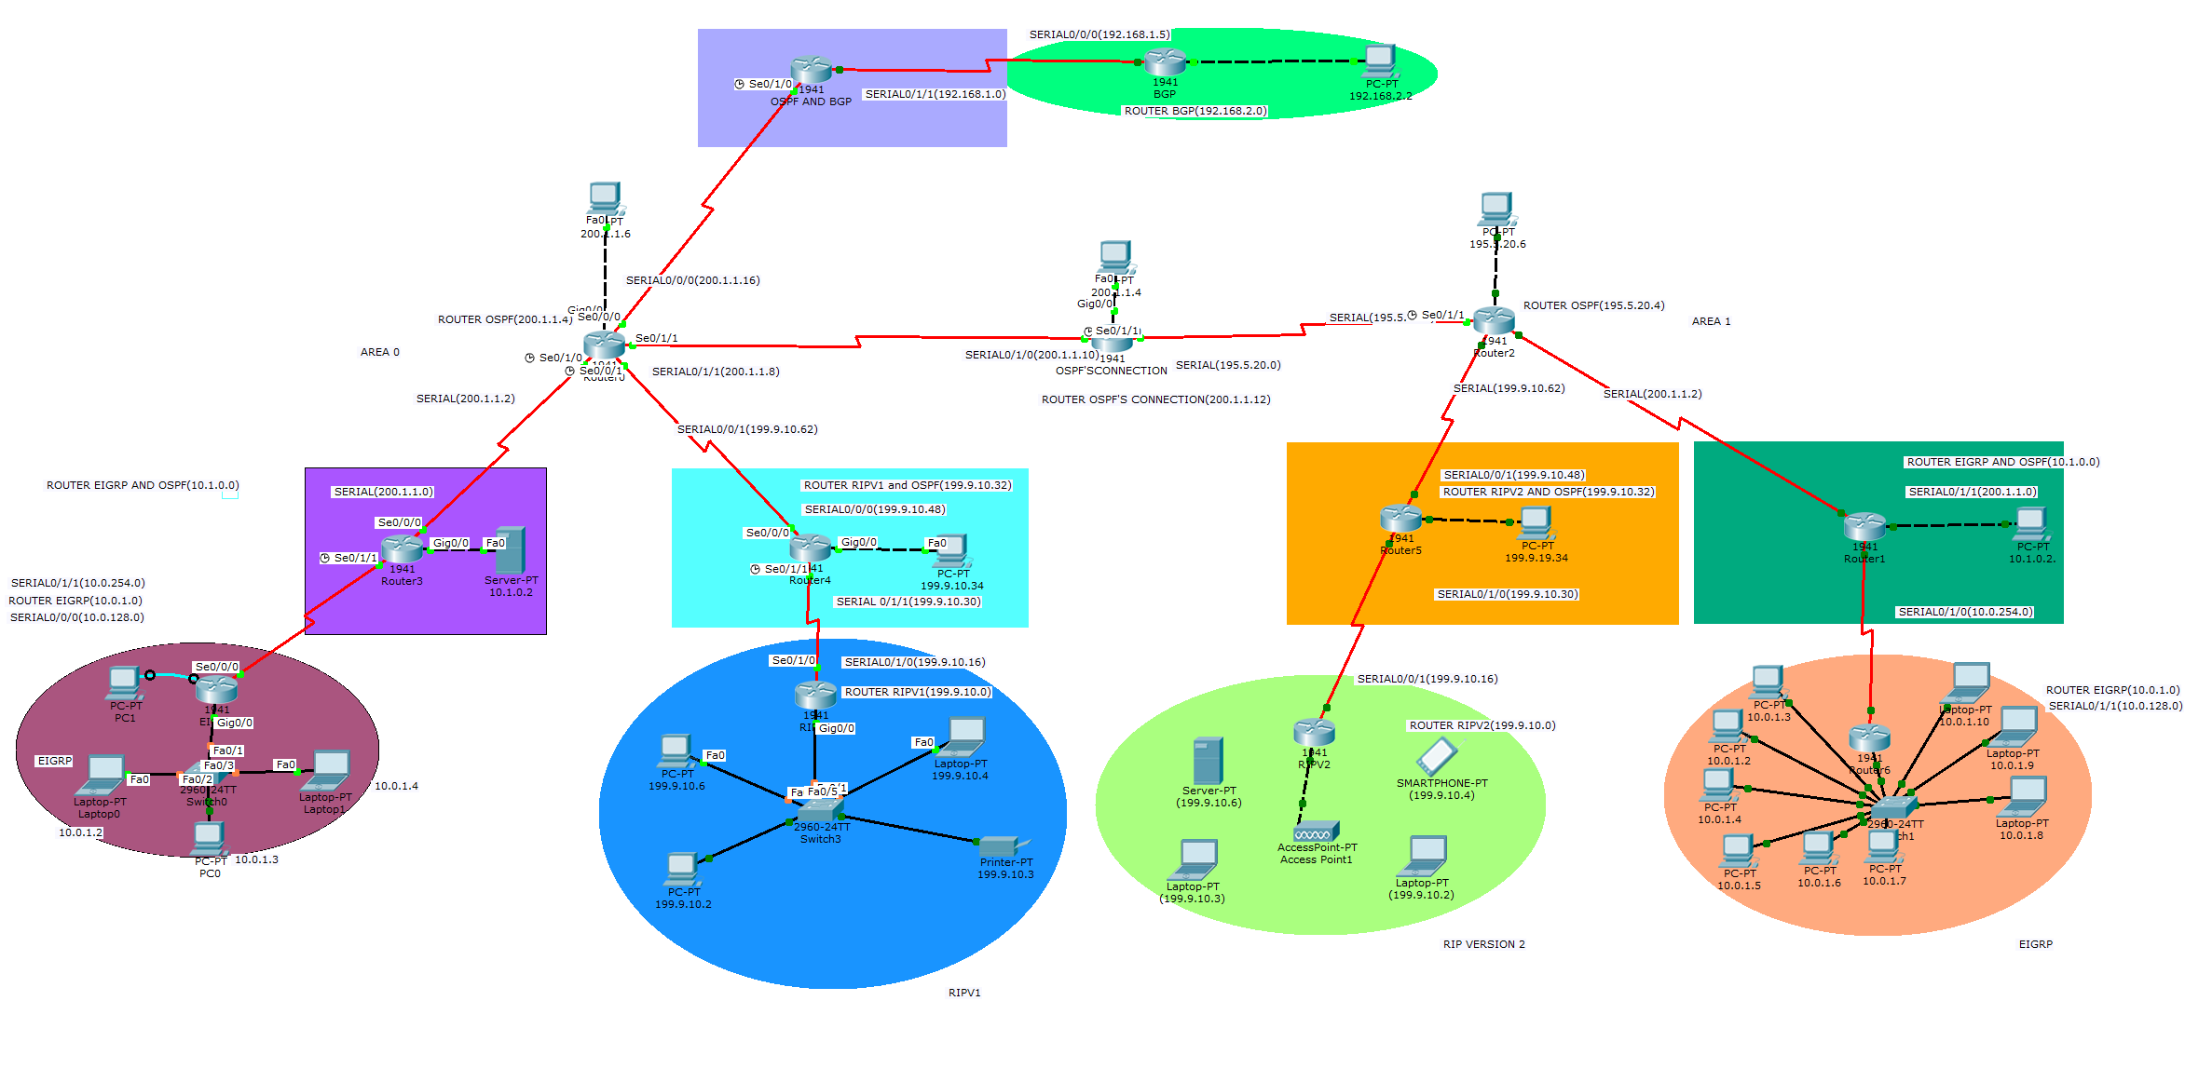

**NETWORK PHYSICAL TOPOLOGY**

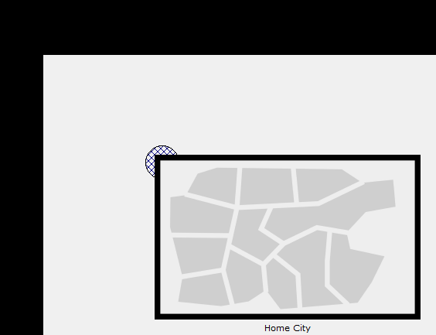

**CONFIGURATION OF NETWORK**

**CONFIGURATION OF EIGRP**

**ROUTER (EIGRP ROUTER)**

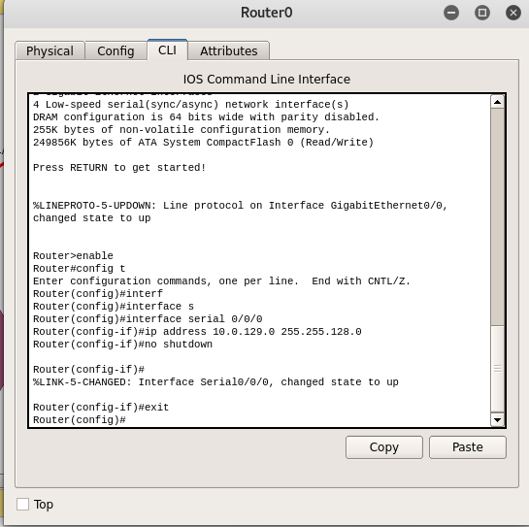

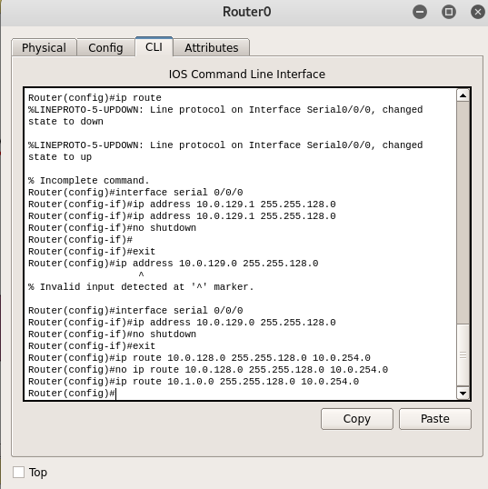

**ROUTER (OSPF NAD EIGRP)**

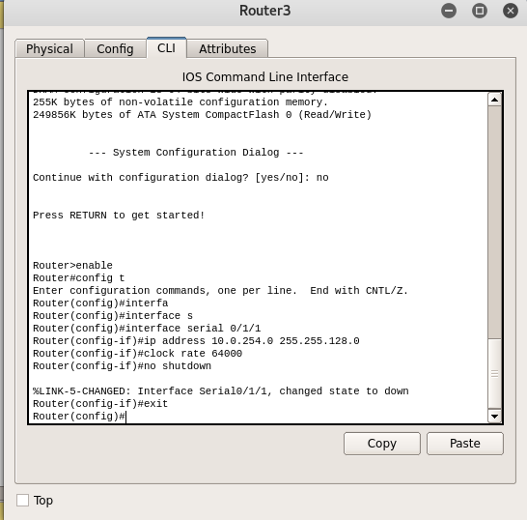

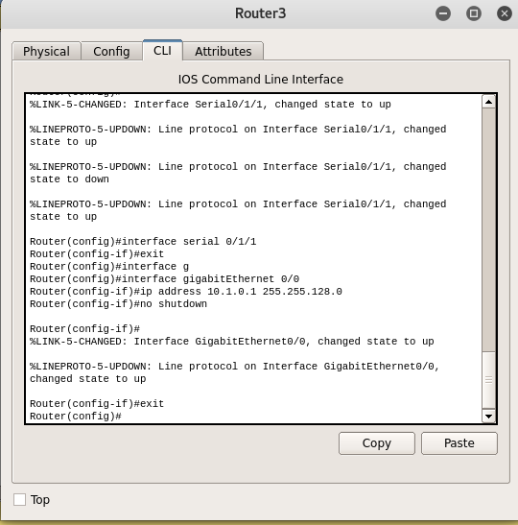

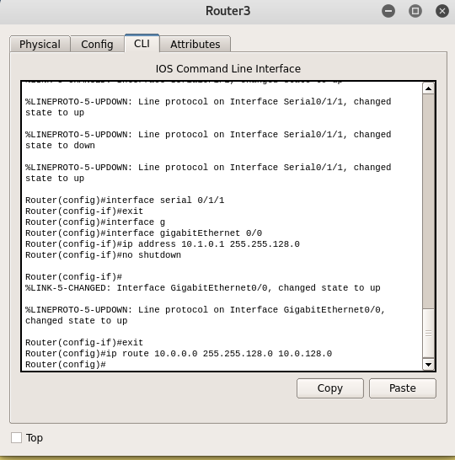

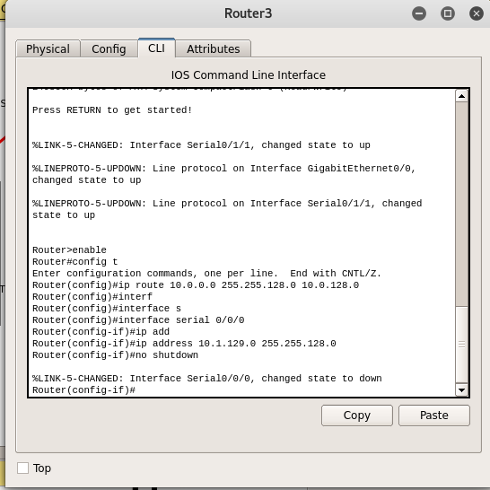

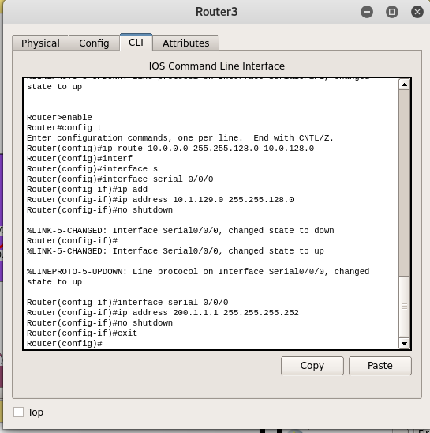

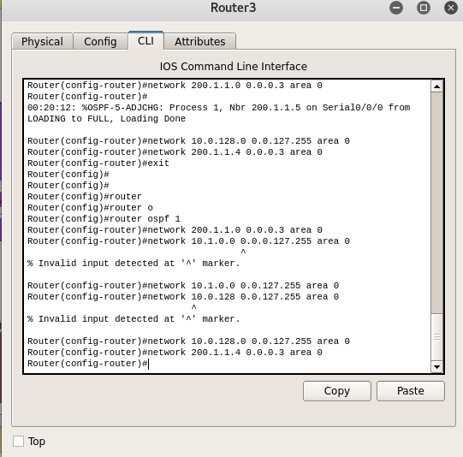

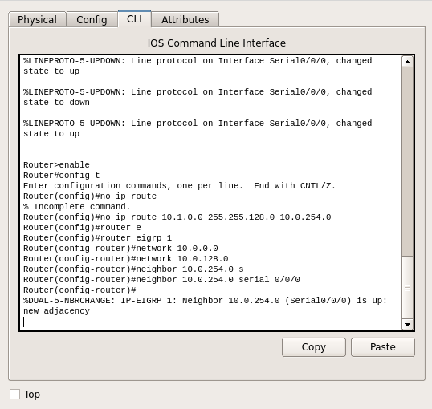

**ROUTER OSPF (AREA 0)**

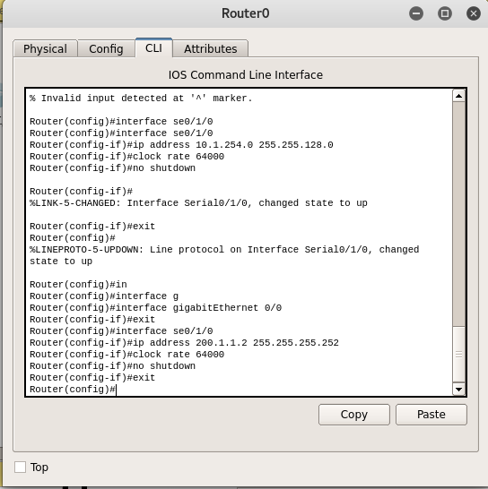

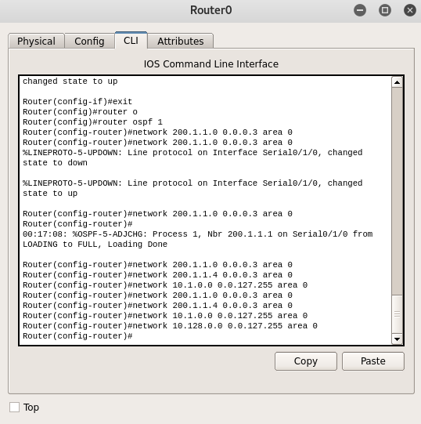

**REDISTRIBUTION AT ROUTER (OSPF AND EIGRP)**

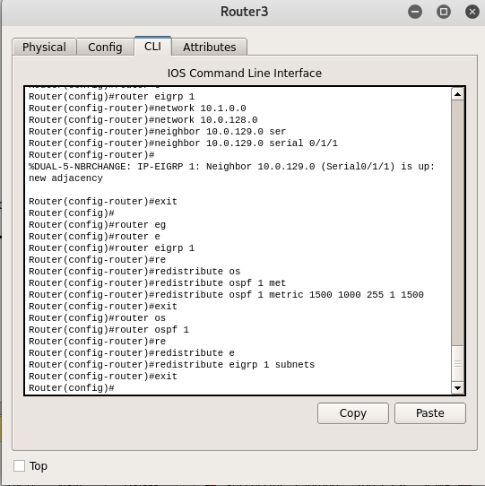

**CONFIGURE RIP VERSION 1**

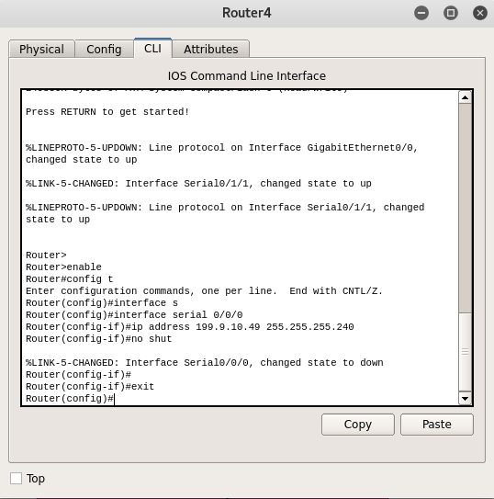 **ROUTER (RIP AND OSPF)**

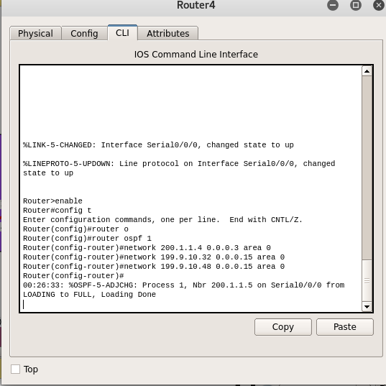

**ROUTER RIP VERSION 1**

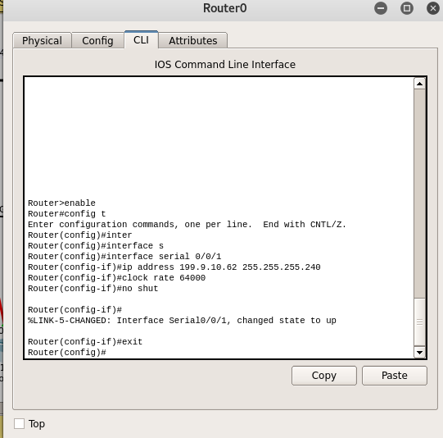

**ROUTER OSPF(AREA 0)**

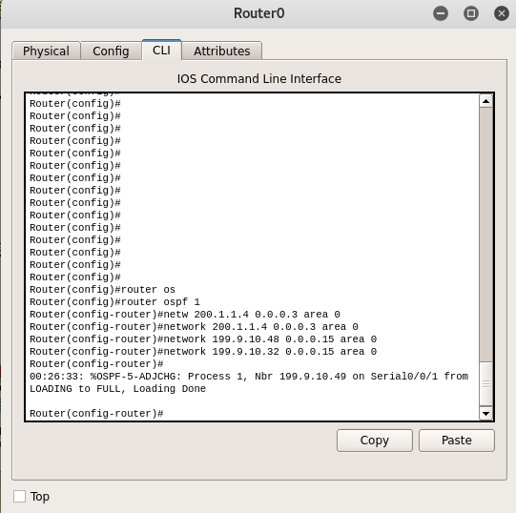

**REDISTRIBUTION IN RIP V1 AND OSPF (ROUTER OSPF AND RIP)**



**CONFIGURE RIP VESION 2**

**ROUTER RIP VERSION 2**

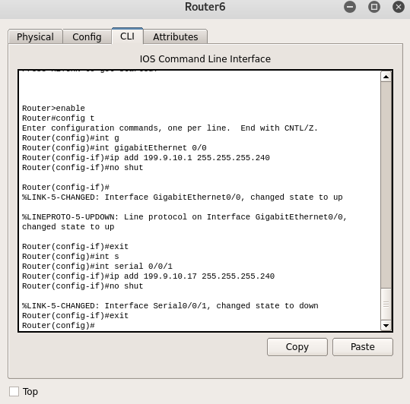

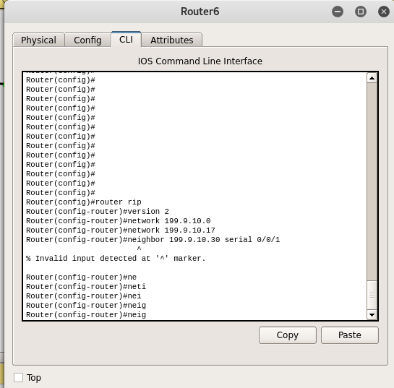

**ROUTER OSPF (AREA 1) AND RIP VERSION 2**

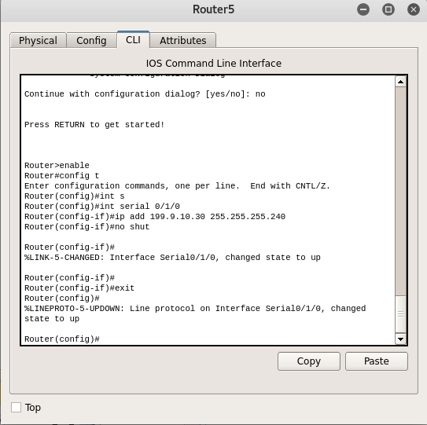

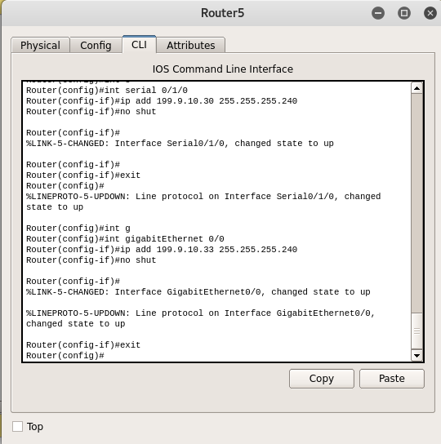

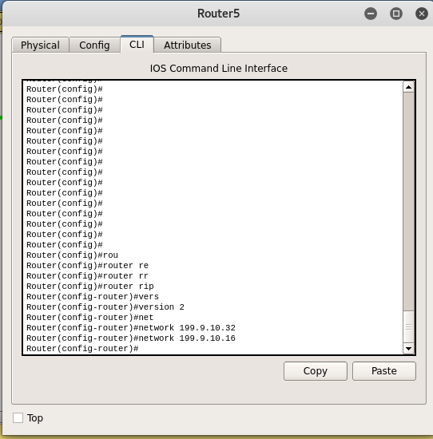

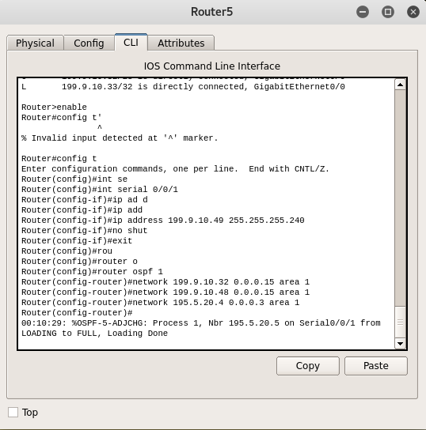

**ROUTER OSPF (AREA 1)**

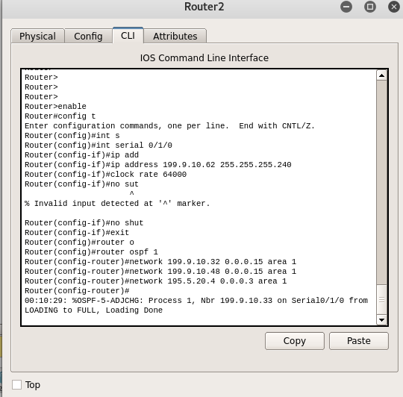

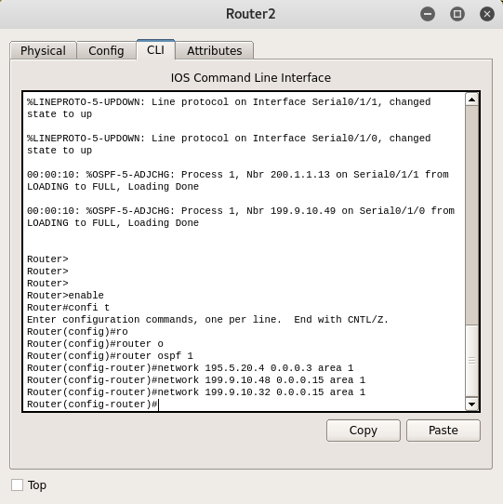

**REDISTRIBUTION IN RIP VERSION 2 AND OSPF AREA 1**

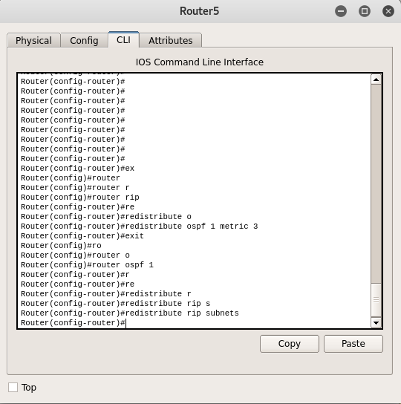

**CONFIGURE EIGRP IN AREA 1**

**ROUTER EIGRP**

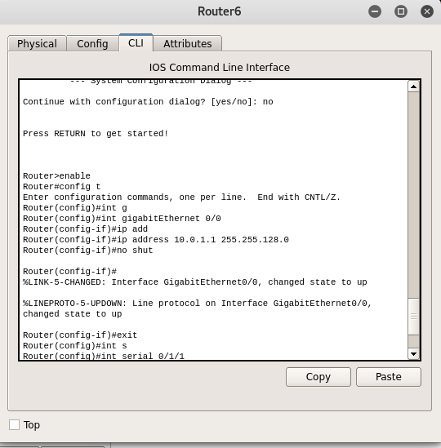

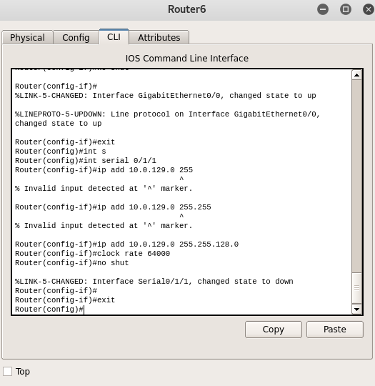

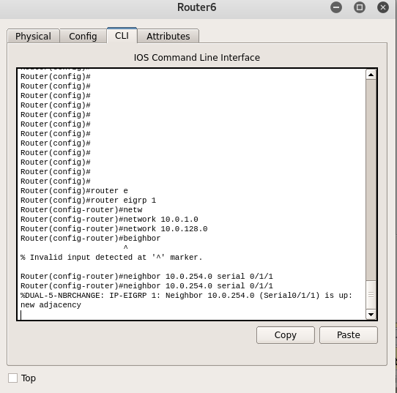

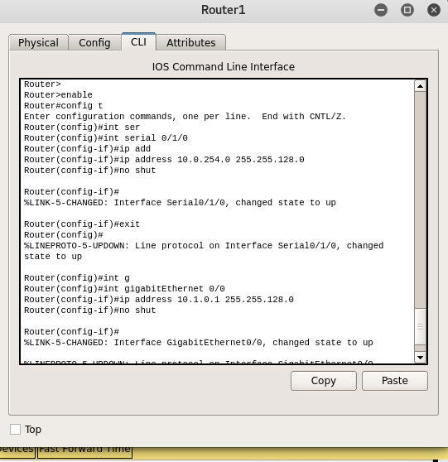**ROUTER EIGRP AND OSPF AREA 1**

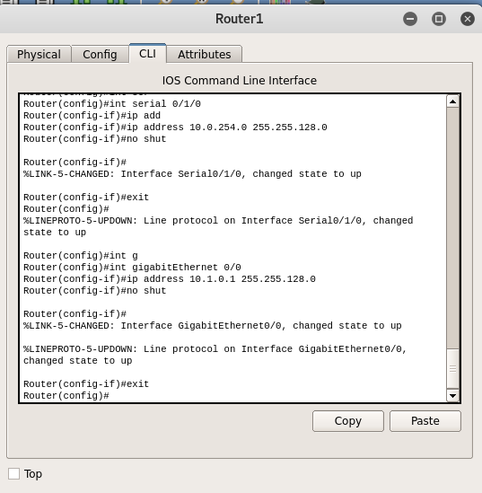

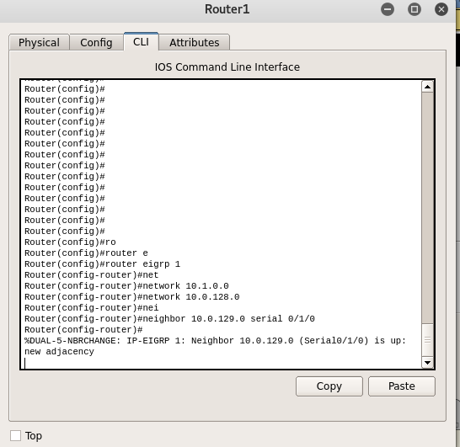

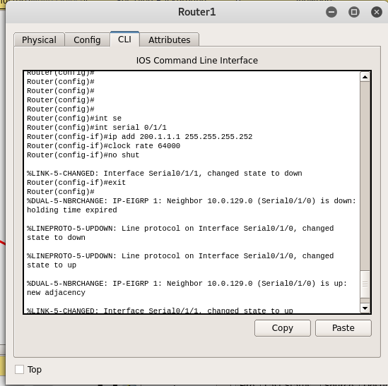

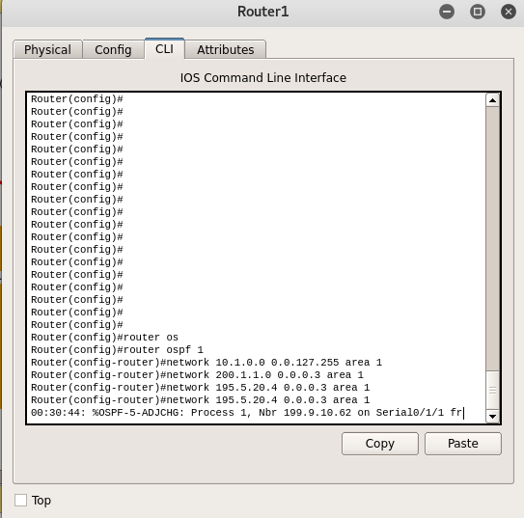

**ROUTER OSPF AREA 1**

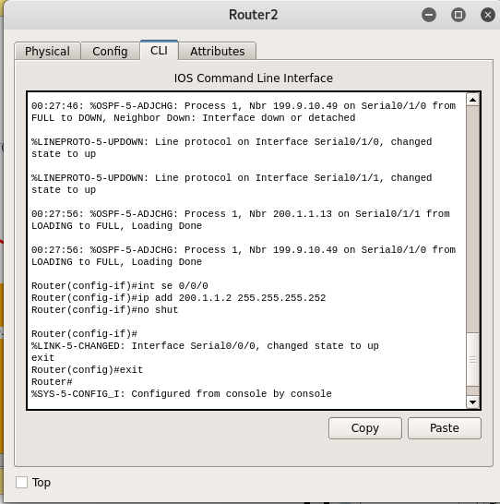

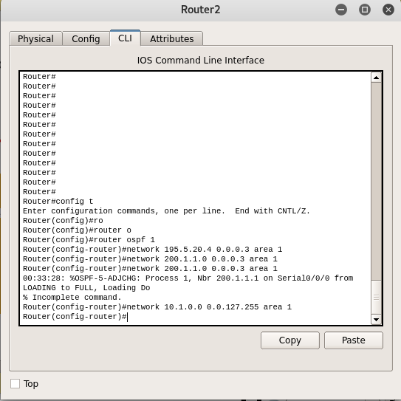

**REDISTRIBUTION IN EIGRP AND OSPF AREA 1**

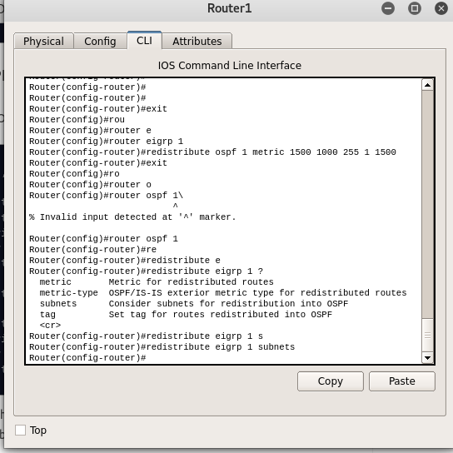

**CONFIGURE OSPF’S OF AREA 0 AND AREA 0**

**ROUTER OSPF AREA 0**

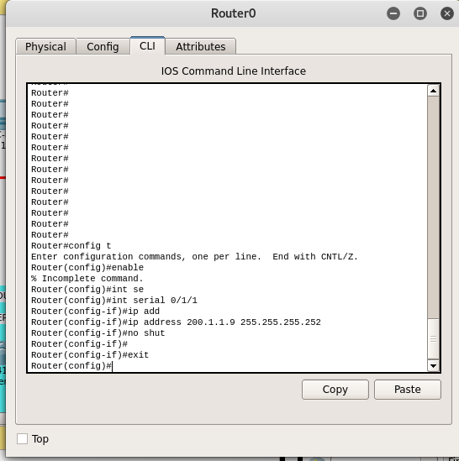

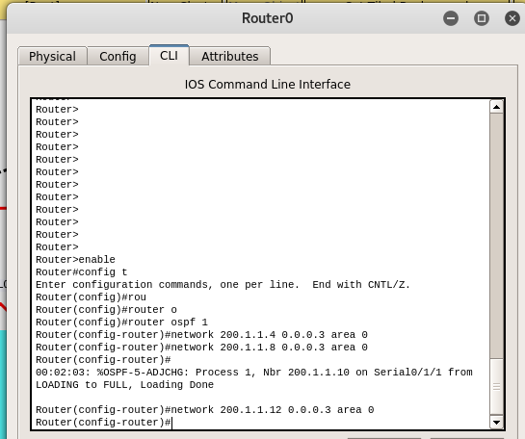

**ROUTER OSPF AREA 1**

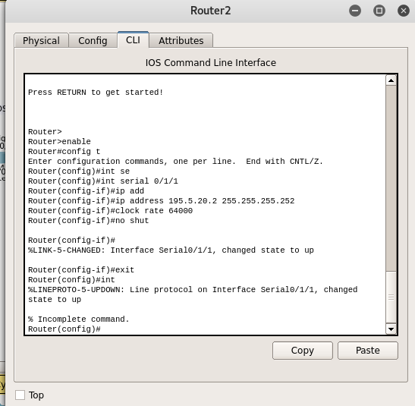

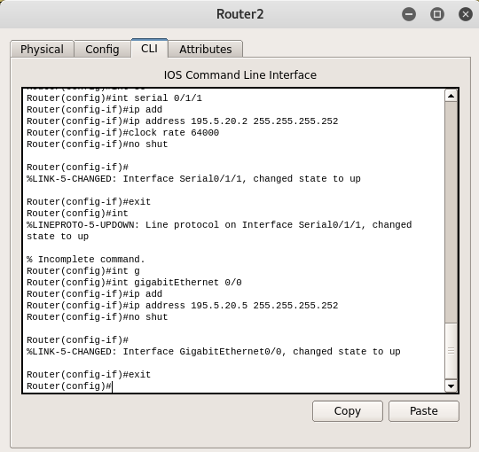

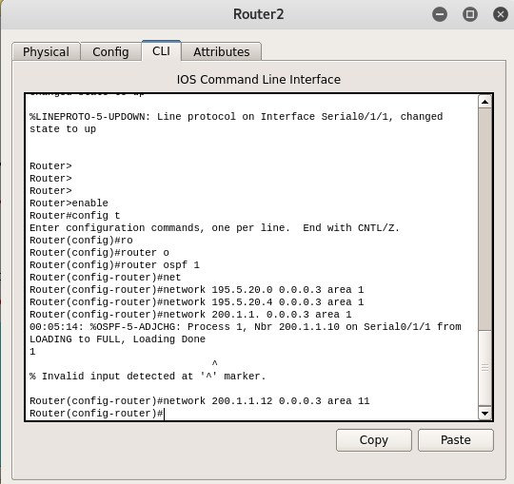

**MIDDLE ROUTER FOR OSPF’S CONNECTION**

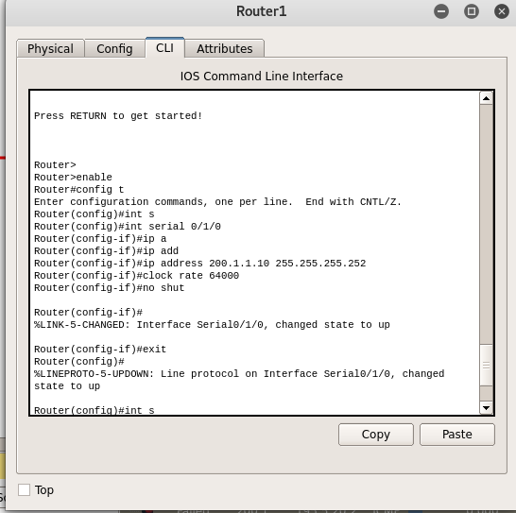

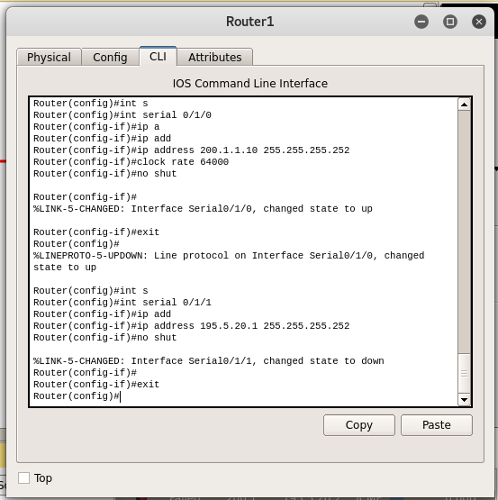

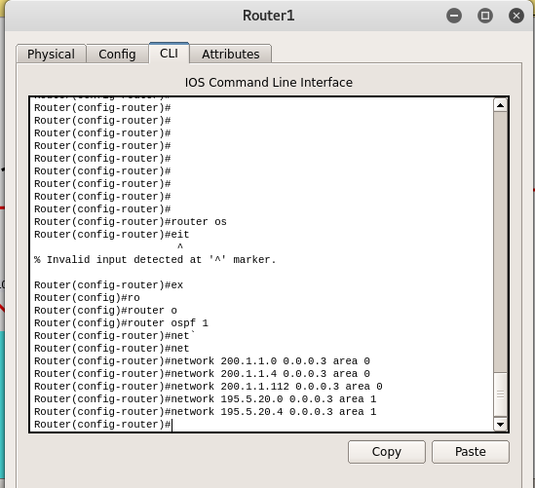

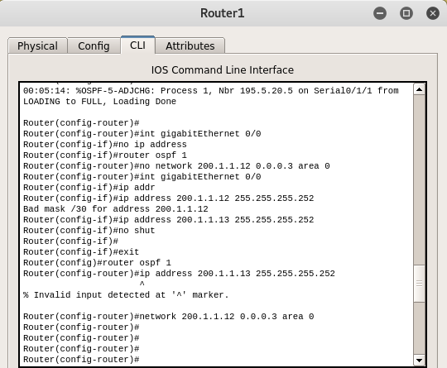

**CONFIGURE BGP WITH OSPF**

**ROUTER OSPF AREA 0**

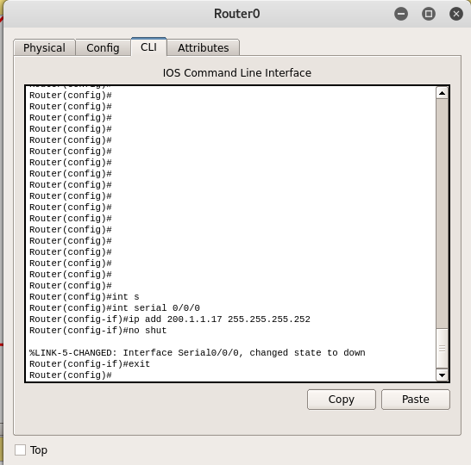

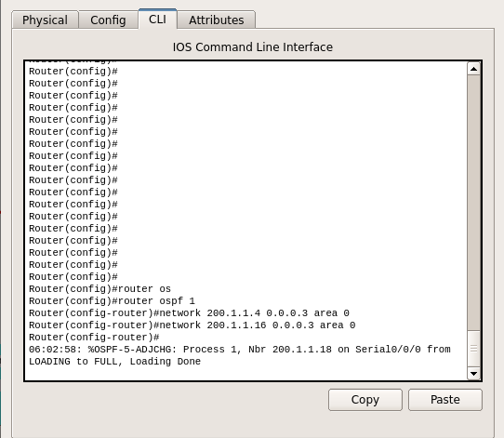

**ROUTER BGP**

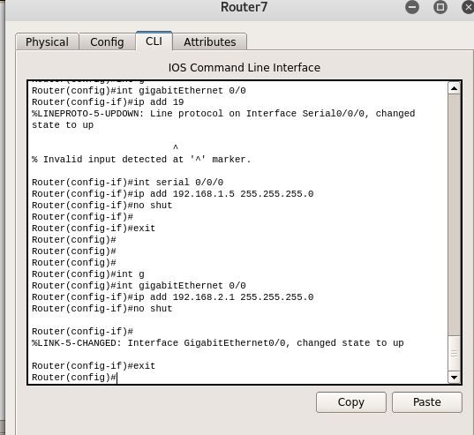

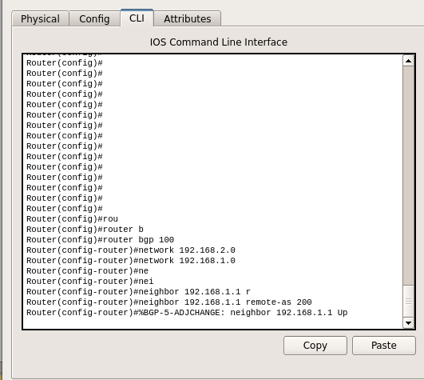

**ROUTER BGP AND OSPF**

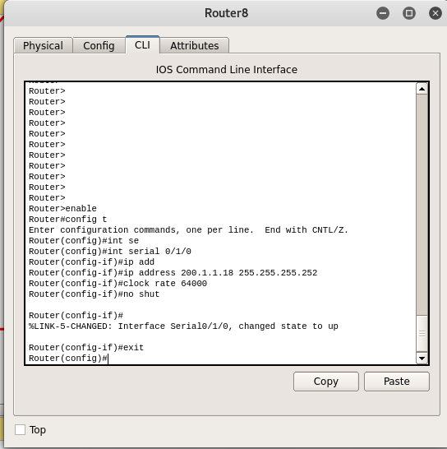

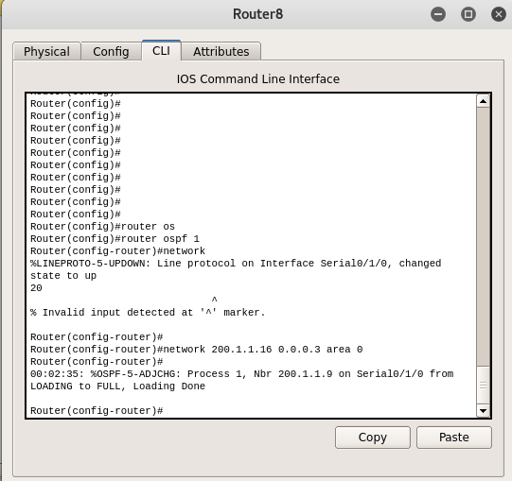

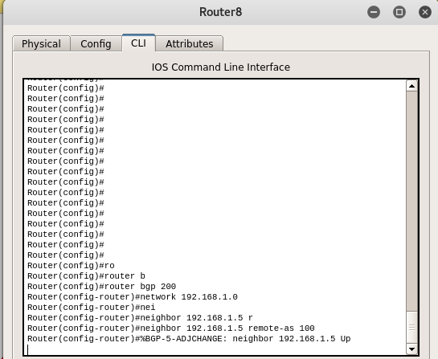

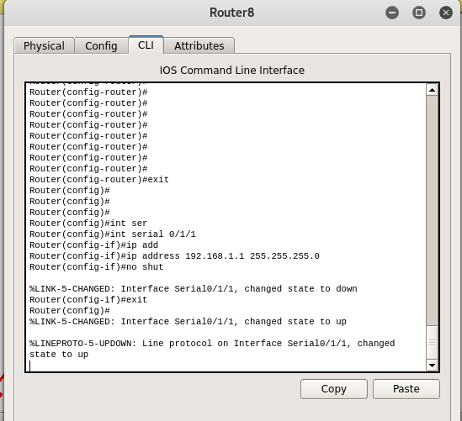

**REDISTRIBUTION BETWEEN OSPF AND BGP**

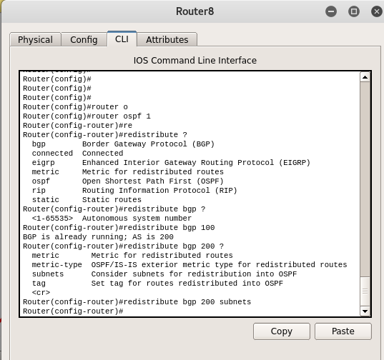

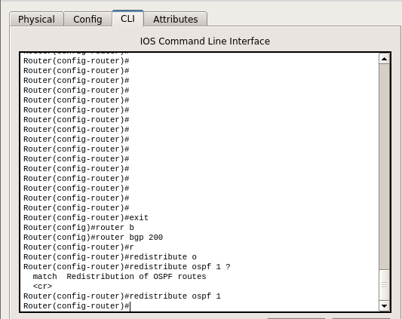

**FUTURE AND NEED OF REDISTRIBUTION OF PROTOCOLS**

The common wisdom these days is that the networking world is inevitably converging on Internet Protocol (IP). And that may well be true, but there are still circumstances when other protocols can get jobs done more easily or more efficiently. How can you, as a network administrator, know when to deploy which network protocols? This tip, excerpted from [*Managing IP Networks with Cisco Routers*](https://www.techtarget.com/network), published by O'Reilly Associates, gives details.

The benefits of routing non-IP protocols are non trivial:

* Most network protocols are more similar than different. A router that can route one efficiently can generally route another efficiently.
* Routing non-IP protocols in a network's IP routers means that the protocols are administered by the same staff that administers the IP protocol family, reducing duplication of effort and equipment.
* Many non-IP protocols are the most efficient way for a LAN to operate. For example, Novell Netware (IPX) and Banyan Vines provide more efficient file and print services for a PC than IP's Network File System.
* Routing non-IP protocols increases the flexibility of your network to meet the needs of your users

So, we can use these protocols with any still present and future comming protocols to communicate with each other without any changes in old network .