Food Monitoring System
An Arduino Based Project

Katrin Danny Mainson
B.Tech CSE
School of Computer Science and Engineering
Lovely Professional University
12523441
Gurav Jaydeep Vinayak
B.Tech CSE
School of Computer Science and Engineering
Lovely Professional University
12511181
Harsh Kumar
B.Tech CSE
School of Computer Science and Engineering
Lovely Professional University
12519425
Jasrun Nisha
B.Tech CSE
School of Computer Science and Engineering
Lovely Professional University
12520280
Vikrant Shekhawat
B.Tech CSE
School of Computer Science and Engineering
Lovely Professional University
12516511

Abstract—In the modern era, ensuring food safety and minimizing waste are critical global challenges. Traditional methods of preserving and monitoring food freshness often rely on manual inspection or estimated expiration dates, which are frequently inaccurate and can lead to health risks or unnecessary waste. To address this, this project proposes a "Food Monitoring System," an automated IoT-based solution designed to detect early signs of food spoilage and monitor environmental conditions.
The system is constructed using a microcontroller-based architecture that integrates an MQ-135 gas sensor for analyzing air quality and detecting spoilage-related gases, and a DHT-11 sensor for real-time monitoring of temperature and humidity. An ESP-32 module is employed to facilitate wireless communication, allowing sensor data to be displayed remotely on a laptop webpage. The core operational logic continuously reads sensor inputs and compares them against a predefined safety threshold value (set at 300).
Upon detecting values exceeding this threshold, the system triggers an immediate multi-modal alert mechanism: a buzzer provides an audio alarm, and a Red LED activates to visually signal "Food Spoiled." Conversely, if conditions remain within safe limits, a Green LED indicates "Food Not Spoiled," and real-time data is presented on a local LCD screen. This system provides a cost-effective, reliable, and user-friendly method for household food monitoring, ensuring consumer health and promoting efficient food storage.
Keywords—Food Monitoring System, Internet of Things (IoT), MQ-135, ESP-32, DHT-11, Food Spoilage Detection, Smart Kitchen.

Introduction
In the contemporary era of rapid technological advancement, the concept of the "Smart Home" has evolved from a luxury to a necessity, yet food safety remains a critical area often overlooked by affordable automation. Global statistics indicate that approximately one-third of all food produced for human consumption is lost or wasted, with a significant portion of this occurring at the household level due to improper storage and unnoticed spoilage. This spoilage is largely caused by environmental factors such as uncontrolled humidity and temperature, which accelerate bacterial growth and chemical decomposition. Traditional methods of assessing food quality rely heavily on manual inspection, smell, sight, or static expiration dates, ,which are frequently inaccurate and can lead to the consumption of unsafe food, resulting in foodborne illnesses. To address this critical gap, this project proposes the "Food Monitoring System." This IoT-enabled solution utilizes advanced sensing technology to continuously monitor the internal environment of food storage units. By detecting the specific volatile gases emitted during the early stages of decomposition, the system provides a proactive, automated safeguard for consumer health and food economy.

Literature Review
2.1 Overview of Food Safety Technologies

The domain of food safety has witnessed a paradigmatic shift over the last decade, moving from manual, sensory-based inspection to automated, sensor-based monitoring. The integration of the Internet of Things (IoT) has been the primary driver of this evolution. A review of recent literature from 2020 to 2024 indicates a consensus among researchers that the most effective method for early spoilage detection lies in monitoring the volatile organic compounds (VOCs) emitted by decaying food. This foundational concept is explored in [1] and [2], which demonstrated that low-cost microcontrollers could be effectively interfaced with gas sensors to detect the presence of spoilage agents like methane and ammonia. This research established the feasibility of using embedded systems for household food safety, replacing subjective "smell tests" with quantifiable digital data. This early work laid the groundwork for the "Smart Kitchen" concept discussed in [8], which argues that real-time quality monitoring is an essential component of modern home automation.

2.2 Evolution into IoT and Wireless Monitoring

While early systems focused on local detection, subsequent research in 2021 broadened the scope to include wireless connectivity, transforming standalone devices into true IoT systems. Studies [3] and [4] highlighted the limitations of offline systems, proposing architectures that not only detect spoilage but also transmit this data to users remotely. This was further refined in [5], which introduced "freshness detectors" that utilize internet connectivity to provide continuous status updates. This evolution addresses a critical gap: alerting the user when they are not physically present in the kitchen. The transition from basic microcontrollers to Wi-Fi-enabled solutions allowed for the development of systems that could send alerts to mobile devices, a feature that [9] emphasizes as crucial for preventing food poisoning and reducing waste in real-time scenarios.

2.3 Advanced Sensing and Cloud Integration

As the technology matured between 2022 and 2023, the complexity of the proposed systems increased to include multi-parameter monitoring. Papers [6] and [7] presented systems that did not rely on a single data point but rather integrated multiple sensors to cross-reference gas levels with environmental factors. This multi-sensor approach is critical because food spoilage is often accelerated by specific temperature and humidity conditions. Research in [10] took this a step further by incorporating cloud computing, suggesting that the vast amounts of data collected by these sensors could be stored and analyzed remotely. These advanced systems aim to create a comprehensive safety net, ensuring that even minor fluctuations in food quality are detected and reported before they pose a health risk.

2.4 Synthesis and Proposed Methodology

The review of the cited literature reveals a clear technological progression: from basic gas detection [1, 2] to IoT connectivity [3, 4] and finally to multi-sensor environmental monitoring [6, 7]. The Food Monitoring System proposed in this project synthesizes these advancements into a streamlined, efficient prototype. Drawing on the gas detection principles established in [1], this project utilizes the MQ-135 sensor, which offers a broader detection range for air quality compared to earlier specific-gas sensors. Furthermore, aligning with the multi-parameter approach suggested in [7], this system integrates a DHT-11 sensor to monitor temperature and humidity, acknowledging that environmental control is as important as gas detection. Finally, utilizing the connectivity principles found in [4], the system employs an ESP-32 module to facilitate efficient data processing and alerting. The proposed system simplifies the complex cloud architectures of [10] into a practical, threshold-based logic (set at value 300), ensuring immediate, binary decision-making (Fresh vs. Spoiled) that is user-friendly and cost-effective for household implementation.

Design of System
The architectural design of the Food Monitoring System is structured around a centralized embedded system framework. The core processing unit is the ESP-32 microcontroller (or Arduino), selected for its robust processing power and integrated Wi-Fi capabilities, which are essential for IoT applications. The system design is divided into three distinct blocks: Input, Processing, and Output.
The Input Block consists of the sensor array: the MQ-135 Gas Sensor is responsible for sensing air quality and detecting volatile organic compounds (VOCs) emitted by rotting food, while the DHT-11 Sensor provides critical data regarding ambient temperature and relative humidity.
The Processing Block involves the microcontroller, which receives analog signals from the gas sensor and digital signals from the DHT-11. It performs Analog-to-Digital Conversion (ADC) and executes the logic algorithms.
The Output Block comprises the user interface and alert mechanisms. This includes a 16x2 LCD Display for visualizing real-time data, a Piezo Buzzer for audible alarms during critical events, and status LEDs (Red and Green) for immediate visual feedback.

Block Diagram

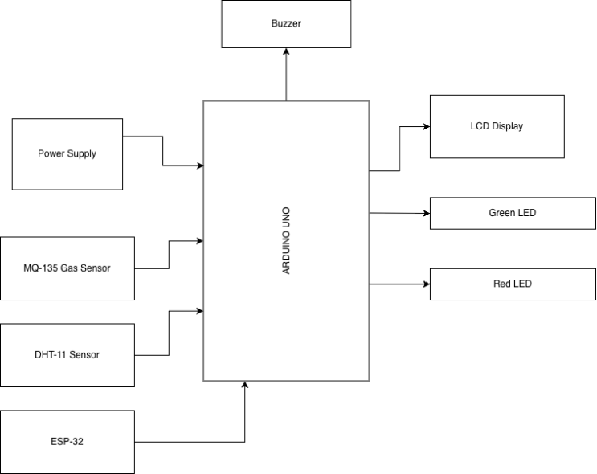

Implementation
The implementation of the project was executed in two concurrent phases: hardware assembly and software development.
Hardware Implementation: The circuit was constructed by interfacing the sensors and actuators with the microcontroller's GPIO (General Purpose Input/Output) pins. The MQ-135 sensor's analog output pin was connected to the analog input of the controller to read variable voltage levels corresponding to gas concentration. The DHT-11 was connected to a digital pin using a pull-up resistor to ensure stable data transmission.
Software Implementation: The firmware was developed using the Arduino IDE C++ environment. The code structure involves including specific libraries (such as DHT.h and WiFi.h) to manage sensor communication and network connectivity. A critical calibration step was performed to determine the "fresh air" baseline, leading to the establishment of a threshold value of 300. The main program loop continuously polls the sensors, processes the data, and drives the output logic based on conditional statements (if/else), ensuring the system responds instantly to any environmental changes. the scroll down window on the left of the MS Word Formatting toolbar.
Components Used
1. ESP-32 Microcontroller (NodeMCU) -
The ESP-32 serves as the "brain" of the entire system. Unlike standard Arduino boards, the ESP-32 is a low-cost, low-power system on a chip (SoC) with integrated Wi-Fi and dual-mode Bluetooth.
Role in Project: It is responsible for reading raw data from the sensors, performing the threshold comparison (checking if values > 300), and managing the Input/Output operations for the LEDs and Buzzer. Its Wi-Fi capability is crucial for sending data to the web interface.
Key Features: Dual-core processor, built-in Wi-Fi (802.11 b/g/n), multiple Analog-to-Digital Converter (ADC) pins, and low power consumption.
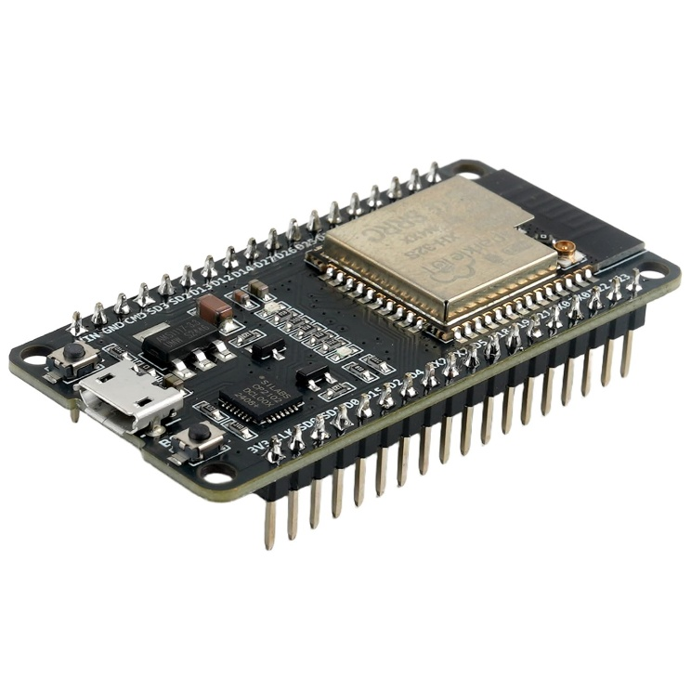
2. MQ-135 Gas Sensor-
The MQ-135 is an air quality sensor used here to detect the volatile gases emitted by spoiling food. It belongs to the family of Metal Oxide Semiconductor (MOS) sensors.
Role in Project: It acts as the primary spoilage detector. When food rots, it releases gases like Ammonia (NH3), Carbon Dioxide (CO2), and other organic compounds. The sensor detects these by lowering its internal resistance, which the ESP-32 reads as an increasing analog voltage.
Key Features: High sensitivity to Ammonia, Sulfide, and Benzene; fast response time; and long life. It requires a 5V power supply to heat the internal coil.
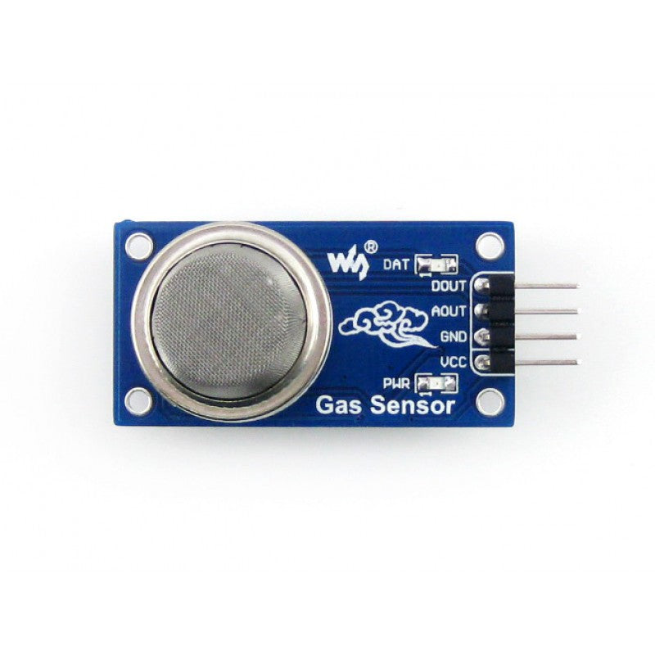

3. DHT-11 Temperature & Humidity Sensor-
The DHT-11 is a basic, low-cost digital sensor used for measuring the ambient environment inside the food storage area.
Role in Project: Since temperature and humidity are the two biggest factors accelerating food spoilage, this sensor monitors these conditions in real-time. It ensures the environment is suitable for storage (e.g., verifying the fridge is cold enough).
Key Features: Measures humidity from 20-90% and temperature from 0-50°C. It provides a calibrated digital signal output, making it easy to interface with the microcontroller without complex calculations.
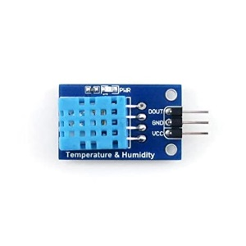
4. 16x2 LCD Display (Liquid Crystal Display)-
This is an alphanumeric display module capable of showing 16 characters per line across 2 lines.
Role in Project: It serves as the local user interface. It displays the real-time status (e.g., "Food Not Spoiled") and the current values read by the sensors. This allows the user to check the system status without needing a computer or phone.
Key Features: Wide viewing angle, high contrast, and typically uses an I2C interface module to reduce the number of wiring connections required to the ESP-32.
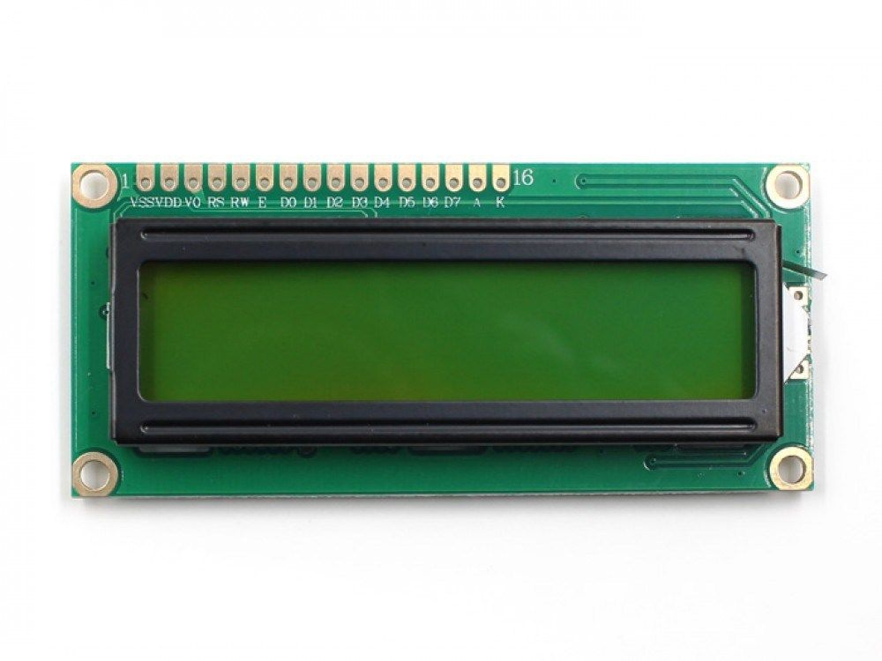

5. Piezo Buzzer-
The buzzer is an audio signaling device.
Role in Project: It acts as an immediate alarm. If the gas sensor reading exceeds the safety threshold of 300, the buzzer emits a continuous tone to alert anyone nearby that spoilage has been detected.
Key Features: Simple 2-pin operation (VCC and GND). It utilizes the piezoelectric effect to generate sound when voltage is applied.writing Figure axis labels to avoid confusing the reader. As an example, write the quantity “Magnetization”, or “Magnetization, M”, not just “M”. If including units in the label, present them within parentheses. Do not label axes only with units. In the example, write “Magnetization (A/m)” or “Magnetization {A[m(1)]}”, not just “A/m”. Do not label axes with a ratio of quantities and units. For example, write “Temperature (K)”, not “Temperature/K”.
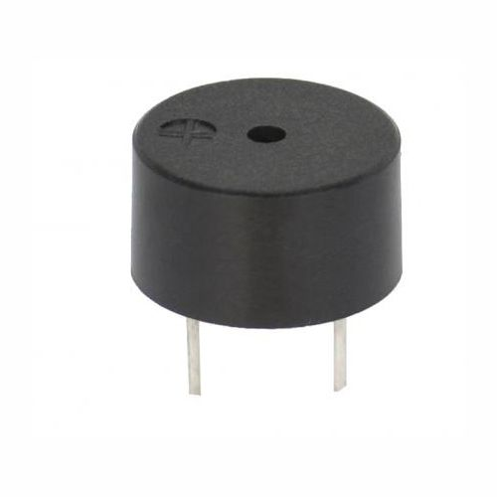

6. Light Emitting Diodes (LEDs)-
Two LEDs are used as visual status indicators.
Red LED: Activates when the sensor value > 300, visually signaling danger/spoilage.
Green LED: Remains active when the sensor value ≤ 300, visually signaling that the food is fresh and safe.
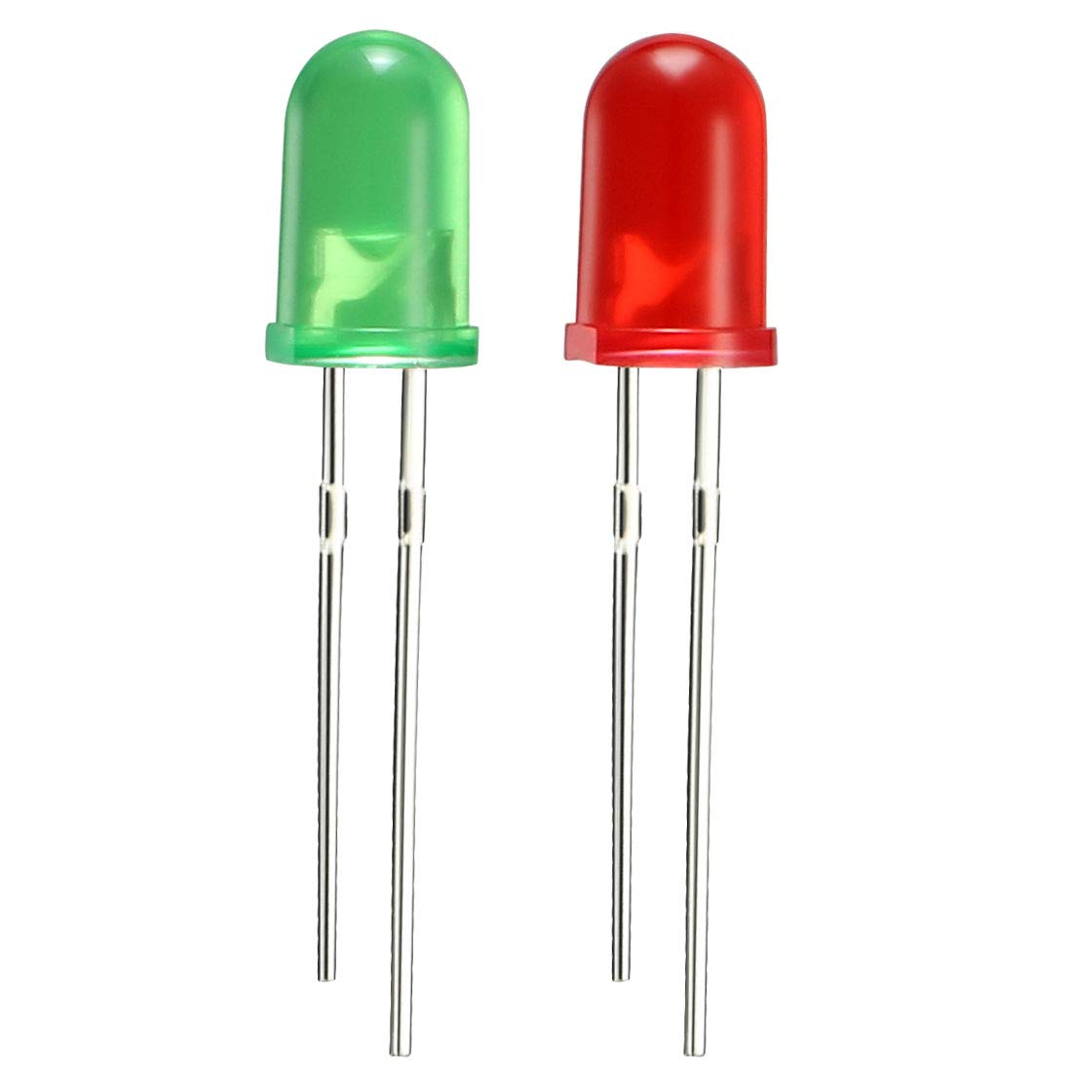

Working of Your Project
The operational workflow of the Food Monitoring System is designed to be autonomous and continuous. Upon powering the system, the microcontroller initializes the sensor modules and allows for a brief "warm-up" period for the MQ-135 heater coil to stabilize. Once active, the system enters its primary monitoring cycle. The MQ-135 continuously samples the air for gases like ammonia and methane. As gas concentration increases, the internal resistance of the sensor decreases, resulting in a higher voltage output which the microcontroller reads as a digital integer. Simultaneously, the DHT-11 samples the temperature and humidity. The processor compares the gas sensor's reading against the pre-set safety threshold of 300.

Scenario A (Fresh): If the reading is below 300, the system maintains a "Safe" state: the Green LED remains illuminated, and the LCD cycles through the current temperature and humidity values.

Scenario B (Spoiled): If the gas concentration spikes above 300, the processor triggers the "Alert" state: the Red LED is energized, the buzzer emits a warning tone, and the LCD displays a "Food Spoiled" warning. This immediate feedback loop ensures the user is alerted the moment food quality degrades.

Flow Chart Description
The algorithmic logic of the system is represented by a linear control flow diagram. The process begins with the Start node, leading directly to the Hardware Initialization block where pins and variables are defined. The flow then proceeds to the Data Acquisition stage, where the system reads inputs from the MQ-135 and DHT-11 sensors. The core decision-making logic is represented by a decision diamond asking: "Is Sensor Value > 300?"
True Path: If the condition is met (value > 300), the flow branches to the Alert Subroutine. Here, commands are sent to turn on the Red LED and activate the Buzzer, signaling spoilage.
False Path: If the condition is not met (value ≤ 300), the flow branches to the Monitoring Subroutine. Here, commands are sent to turn on the Green LED and update the LCD display with current sensor readings.
Both paths eventually loop back to the Data Acquisition stage, creating an infinite loop that ensures continuous, 24/7 monitoring of the food storage environment.

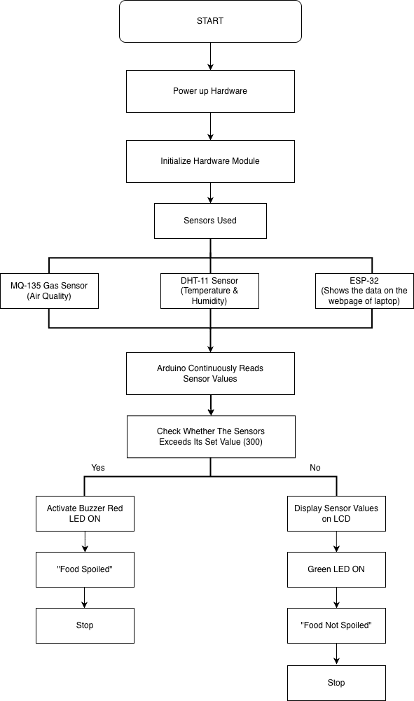

Coding
Code of Arduino:

#include <Wire.h>
#define RED_LED 9
#define BUZZER 10
#define DHTPIN 2
#define DHTTYPE DHT11
#define GAS_THRESHOLD 300

DHT dht(DHTPIN, DHTTYPE);
SoftwareSerial SWSerial(10, 11); // RX = 10, TX = 11

void setup() {
Serial.begin(115200);
SWSerial.begin(9600);
lcd.init();
lcd.backlight();
dht.begin();

pinMode(GREEN_LED, OUTPUT);
pinMode(RED_LED, OUTPUT);
pinMode(BUZZER, OUTPUT);

lcd.setCursor(0,0);
lcd.print("Food Monitoring");
lcd.setCursor(0,1);
lcd.print(" System Ready ");
delay(2000);
lcd.clear();
}

void loop() {
int gasValue = analogRead(MQ135_PIN);
float humidity = dht.readHumidity();
float temperature = dht.readTemperature();

if (isnan(temperature) || isnan(humidity)) {
Serial.println("DHT read failed");
lcd.setCursor(0,0);
lcd.print("DHT Error ");
delay(2000);
return;
}

lcd.setCursor(0, 0);
lcd.print("G:"); lcd.print(gasValue);
lcd.print(" T:"); lcd.print(temperature, 0);
lcd.print((char)223); lcd.print("C ");

lcd.setCursor(0, 1);
lcd.print("H:"); lcd.print(humidity, 0);
lcd.print("% ");

String status = (gasValue < GAS_THRESHOLD) ? "SAFE" : "SPOILED";

if (status == "SAFE") {
digitalWrite(GREEN_LED, HIGH);
digitalWrite(RED_LED, LOW);
noTone(BUZZER);
lcd.print("Food Safe ");
} else {
digitalWrite(GREEN_LED, LOW);
digitalWrite(RED_LED, HIGH);
tone(BUZZER, 1000);
lcd.print("Food Spoiled");
}

String out = String(gasValue) + "," + String(temperature,1) + "," + String(humidity,1) + "," + status;
SWSerial.println(out);
Serial.println("Sent-> " + out);

delay(2000);
}

Code of esp32:

#include <WiFi.h>
#include <WebServer.h>

WebServer server(80);

// Data from Arduino
String temp = "--";
String hum = "--";
String gas = "--";

const char* ssid = "Vikki";
const char* password = "vikki098890";

void handleRoot() {

String status = (gas.toInt() < 300) ? "Food Safe" : "Food Spoiled";
String color = (gas.toInt() < 300) ? "green" : "red";

String html = R"====(
<html>
<head>
<meta http-equiv='refresh' content='3'>
<style>
body { font-family: Arial; text-align:center; padding-top:20px; }
.status { font-size:24px; font-weight:bold; }
</style>
</head>
<body>
<h2>Food Monitoring System</h2>
)====";

html += "<p><b>Temperature:</b> " + temp + " °C</p>";
html += "<p><b>Humidity:</b> " + hum + " %</p>";
html += "<p><b>Gas Value:</b> " + gas + "</p>";
html += "<p class='status' style='color:" + color + ";'>" + status + "</p>";

html += "</body></html>";

server.send(200, "text/html", html);
}

void setup() {
Serial.begin(115200); // Debug only

Serial2.begin(9600, SERIAL_8N1, 16, 17);
// RX = GPIO 16, TX = GPIO 17

WiFi.begin(ssid, password);
while (WiFi.status() != WL_CONNECTED) delay(500);

Serial.print("Connected! IP: ");
Serial.println(WiFi.localIP());

server.on("/", handleRoot);
server.begin();
}

void loop() {
server.handleClient();

if (Serial2.available()) {
String data = Serial2.readStringUntil('\n'); // Example: "26,60,245"

int first = data.indexOf(',');
int second = data.indexOf(',', first + 1);

temp = data.substring(0, first);
hum = data.substring(first + 1, second);
gas = data.substring(second + 1);
}
}

Simulation / Testing
To validate the system's reliability, rigorous testing and simulation were conducted under controlled conditions. The "fresh" state was tested in a standard room environment, where the system consistently displayed stable temperature and humidity readings with the Green LED active. To simulate the "spoilage" condition, the MQ-135 sensor was exposed to gas sources (such as smoke or alcohol vapor) that mimic the volatile compounds of rotting food. The simulation results showed a rapid response time; as the gas concentration rose, the serial monitor values increased linearly. The moment the value crossed the 300 threshold, the transition to the Red LED and Buzzer alarm was instantaneous. Further testing involved manipulating humidity levels (by breathing on the DHT-11) to verify that the LCD updated dynamic values correctly without system lag.

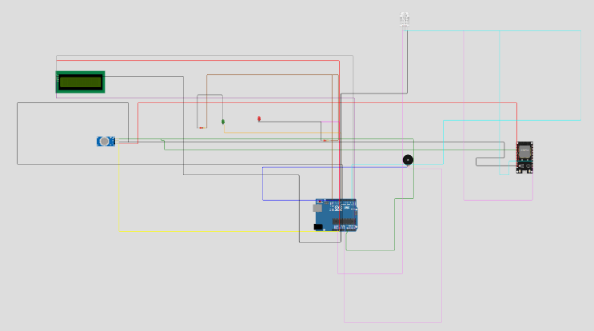

Result & Discussion
The final prototype of the Food Monitoring System successfully met all design objectives. The system demonstrated high sensitivity to changes in air quality, effectively distinguishing between clean air and air contaminated with spoilage-related gases. The integration of the LCD provided clear, readable metrics for temperature and humidity, which are crucial factors in food preservation. The threshold value of 300 proved to be an effective calibration point, balancing sensitivity with a low rate of false alarms. The discussion of these results indicates that while the system is a prototype, the underlying technology is robust. The correlation between the sensor voltage outputs and the presence of gases validates the feasibility of using low-cost metal-oxide sensors for biological spoilage detection.

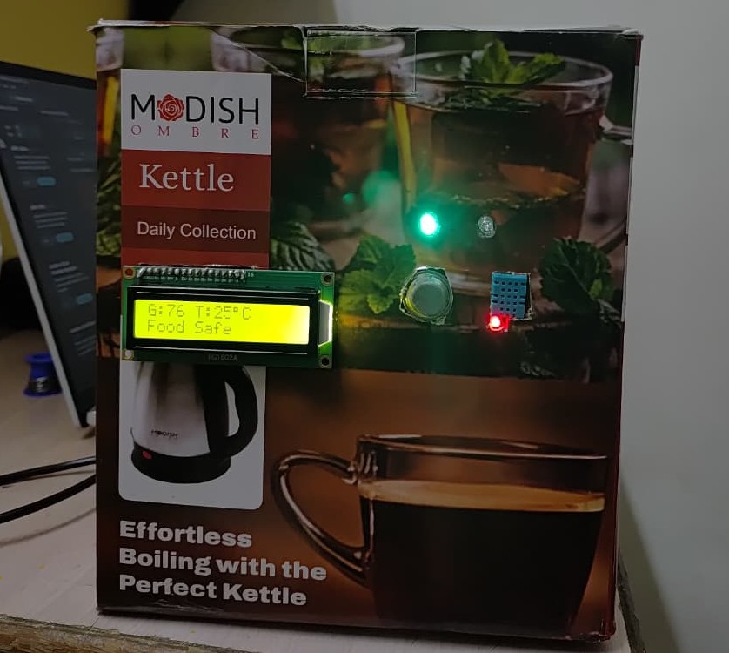

Conclusion
In conclusion, this project successfully designed and implemented an IoT-based Food Monitoring System capable of real-time spoilage detection. By integrating the MQ-135 gas sensor, DHT-11 environmental sensor, and ESP-32/Arduino microcontroller, the system provides a comprehensive solution to the problem of household food waste. It effectively bridges the gap between manual inspection and expensive smart appliances. The system not only alerts users to immediate spoilage via audio-visual alarms but also empowers them to monitor storage conditions (temperature/humidity) to prevent spoilage before it happens. Ultimately, this technology contributes to a healthier lifestyle by reducing the risk of food poisoning and promotes economic efficiency by minimizing food wastage.

Future Scope
Machine Learning Integration: Future iterations could employ Machine Learning algorithms to analyze sensor data patterns over time, allowing the system to "learn" the specific spoilage signatures of different food types (e.g., distinguishing between fruit fermentation and meat spoilage).
Mobile App Connectivity: Developing a dedicated mobile application would allow users to receive push notifications on their smartphones when they are away from home, as well as view historical graphs of their fridge's temperature performance.
Biosensor Implementation: To increase accuracy, the system could be upgraded with specialized biosensors capable of detecting specific pathogens like Salmonella or E. coli.
Hardware Miniaturization: Transitioning from a breadboard prototype to a custom Printed Circuit Board (PCB) would allow the device to be miniaturized, enabling it to be embedded directly into Tupperware containers or retrofitted inside standard refrigerator shelves.

References
[1] A. Kumar, "An Arduino sensor based for detecting the food spoilage," International Journal of Engineering Applied Sciences and Technology, vol. 5, no. 3, 2020.

[2] S. Parmar, T. Manke, and N. Badhan, "An efficient system to detect freshness and quality of food," International Research Journal of Engineering and Technology (IRJET), vol. 7, no. 4, Apr. 2020.

[3] T. Gayathri, A. S. R. Devi, and P. Premkumar, "IoT based food spoilage detection system," in 2021 Third International Conference on Intelligent Communication Technologies and Virtual Mobile Networks (ICICV), 2021, pp. 1-6.

[4] P. K. Madhavan, S. K. S. L. Preeth, and S. U. N. Kumar, "IoT based food spoilage detection system," in 2021 6th International Conference on Communication and Electronics Systems (ICCES), 2021, pp. 1-5.

[5] K. Lakshmi, V. S. S. N. Gupta, and K. R. Rao, "Smart food freshness detector using IoT," International Journal of Engineering Research & Technology (IJERT), vol. 10, no. 5, 2021.

[6] M. B. Devi, C. G. Devi, and K. V. Vardhan, "IoT based food spoilage detection using Arduino," International Journal of Creative Research Thoughts (IJCRT), vol. 6, no. 4, Jul. 2022.

[7] P. S. Deshpande, "IoT based food quality monitoring system," International Journal of Advanced Research in Science, Communication and Technology (IJARSCT), vol. 2, no. 1, 2022.

[8] S. V. Kumar and R. S. Priya, "Smart kitchen: Real-time food quality monitoring using IoT," International Journal of Recent Technology and Engineering (IJRTE), vol. 9, no. 2, 2020.
[9] R. Swetha and G. M. Kumar, "Food spoilage detection and alert system using IoT," International Journal of Research in Applied Science and Engineering Technology (IJRASET), vol. 11, no. 5, May 2023.

[10] V. R. S. Reddy, "Advanced food spoilage detection system using IoT and cloud computing," International Journal of Scientific Research in Science and Technology, vol. 10, no. 2, 2023.

