
Field documentation · Bichom · 2026
Revival  of Memory  Bugun fibre, from the plant on the hillside  to the thread on the spindle | 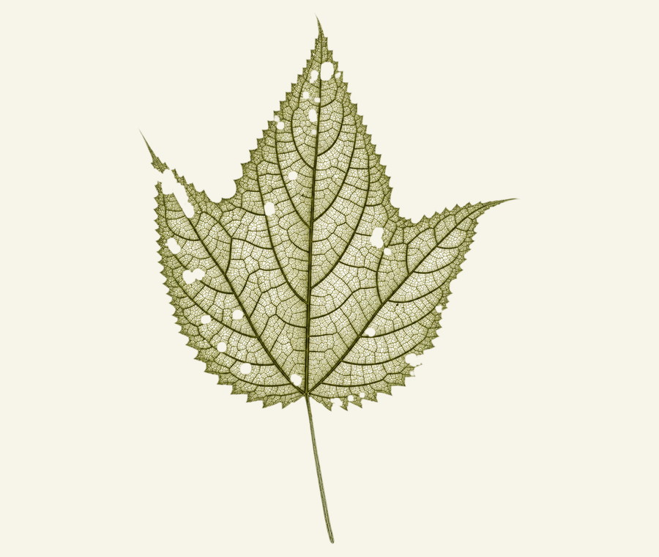

Vikrant Charak
Goh Bugun Cultural Memory Project
Dakshina Dvaraka Foundation · CRDT, IIT Delhi
20 September – 11 October 2026
Compiled 21 October 2026 · plant to thread, complete
Plant  six names |  | Bark  peeled |  | Fibre  cleaned |  | Thread  spun
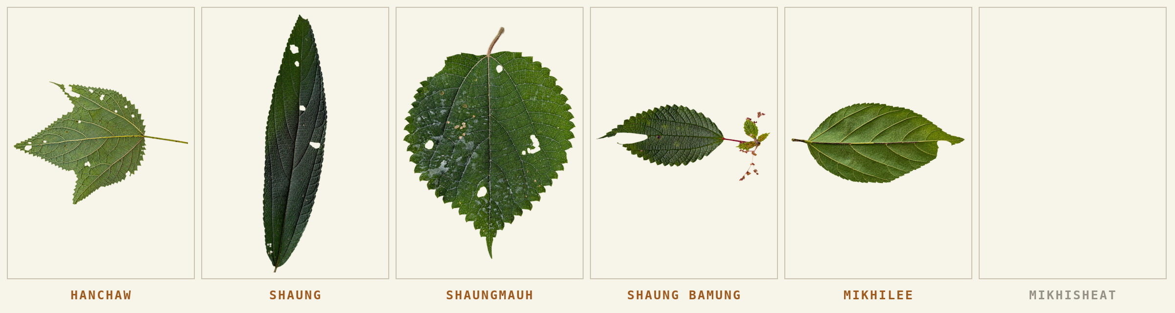

reading the report
What this record holds
A practice described through what was done, in the order it was done, by the people who did it.
Tradition is usually taken to be the thing that does not change, and it is usually defined through texts rather than through practice. The fibre work at Bichom allows neither habit: there is no text, only a sequence of actions two men have reassembled from memory and from handling the material. So this record follows the actions. It gathers the plant photographs, field positions, conversations and process records of 20 September to 11 October 2026 in the order the work takes them, from the plant on the hillside to the thread on the spindle, and every stage in it was photographed while it was being done.
The chain is closed
Every stage from the standing plant to the finished thread was photographed while it was being done: cutting and peeling, boiling with ash, beating and washing at the river, drying, quarrying and sieving the clay, working it in, drying again, beating it out, carding and spinning. Weaving comes next.

How evidence is described | What it means
Photographed / recorded | An image, transcript or saved position exists.
Reported | Somebody described a method, memory, duration or result.

Inside the report
Place and people | The making
Who the Bugun are · 3  A history kept by saying it · 4  Where the Bugun are · 5  Where this is, and the two clay faces · 6  What this work is · 7  Knowing without measuring · 8  Who this came from · 9  How the record grew · 10  Working places around Bichom · 11  Why the cloth stopped · 38  What was made from it · 39  A thread tied on a newborn · 40  Remembering through doing · 41 | The plants, six names · 12  The plant plates · 13–17  Shaungkaan, which is not here · 18  Where the fibre is cut from · 19  Before the bark reaches the fire · 19  The sequence, and the tools · 20–21  Boiling, beating, drying · 22–27  The clay, and Map 04 · 28–31  Clay on, clay off, carding · 32–34  The two tools, and the thread · 35–37  Beside the fieldwork · 42  Words, and what they are glossed by · 43–44  Where the report comes from · 45–46

Sources: the field compilation (F1); the process transcripts (F2); the naming sessions and the clay recording of 7 October (F9).

the community
Who the Bugun are
A small community, a language with no script, and twelve villages in one sub-division.
The Bugun live in the Singchung sub-division of West Kameng, in western Arunachal Pradesh. They are constitutionally recognised as Khowa; the community calls itself Bugun. A village-by-village count made in 2022 put the whole population at 2,075 across twelve villages, which makes them one of the smaller Scheduled Tribes of the state.
Their language belongs to the small Kho-Bwa group, every member of which is spoken in this one corner of the eastern Himalaya, and which is counted among the endangered languages of India. There is no script. What is remembered is remembered by being said, which is why the spelling of a plant name can move between one telling and the next, and why writing one down carefully is itself part of the work.
Village | 2022 | Village | 2022
Singchung | 450 | Sachida | 98
Bichom | 377 | Ditching | 96
Wangho | 282 | Namfri | 82
New Kaspi | 250 | Ramu | 33
Dikhiyang | 138 | Chitu | 25
Lichini | 124 | Magopam | 120

Bichom is the second largest. The three villages in bold are the ones this survey worked in. Clans at Bichom, Lichini, Ramu and Chitu are Lali, Bachung and Hagam.
The older name
Khowa is the name they were known by before Bugun: pehle puraane mein humko Khowa se pehchaante hain. It is Harnam Hagam’s own account of what the community was called, and it is the only earlier name this report carries.
A forest set aside by the community
In 2017 the Bugun set aside seventeen square kilometres of their own forest as the Singchung Bugun Village Community Reserve, patrolled from the village. It was done for a bird found here in 1995 and described in 2006, which lives nowhere else. The same forest holds the nettle.

Population and clan figures: a doctoral thesis on Bugun religious identity, field work 2022–24. Names: naming session, 7 October 2026.

the community · a history
A people who keep their history by saying it
There is no script here, so the past is not stored. It is performed — and performance is a different kind of keeping, with different rules.
The Bugun call themselves Bugun. The Constitution calls them Khowa, and has done since the Scheduled Tribes Order of 1950, which makes them one of the earliest communities in the country to be recognised under that Order and one of the smallest to be recognised at all. Both names are in use. The distance between them is not a clerical matter: one is what a people say of themselves and the other is what was written down about them, and nearly everything in this report sits in the space between those two kinds of record.
A name made of fire and water
Their language belongs to the Kho-Bwa group, every member of which is spoken in this one corner of the eastern Himalaya, and which is counted among the endangered languages of India. The name of the group is itself a piece of evidence. It was proposed in 2001, assembled by a linguist out of the words these languages use for fire and for water. Working at Bichom twenty-five years later we arrived at the second half of that name from the opposite direction, and without looking for it: khow is water, confirmed three times over in a single afternoon — in Diga Khow and Khatong Khow, the two names of the river; in Khowlut, damming a stream to take fish, from khow and lut, to strike; and in Pham Kho, where pham is the mountain.
A term coined far away out of comparative word-lists, and a word still doing ordinary work in a sentence about fishing, turn out to be the same word. That is worth pausing on, not as a coincidence but as a demonstration of where this kind of knowledge actually lives. It does not live in the texts that describe it. It lives in the practice that keeps using it, which is also why it can be lost in one generation that stops practising, and why a report like this one is written at all.
Twelve villages, and what holds them together
Twelve villages, and a village-by-village count made in 2022 that put the whole population at 2,075. The clans are exogamous, so marriage carries people and knowledge between villages rather than keeping either in one place; Lali, Bachung and Hagam are the clans at Bichom, Lichini, Ramu and Chitu. Farming is the base of the year, with fishing, hunting and cattle beside it, and the harvest is marked at Pham Kho Sowai, now fixed to the tenth of September. The older religious ground is animist; Mahayana Buddhism reached these valleys from the Sherdukpen in the early twentieth century and sits alongside it.
Tradition as a way of doing, not a line of descent
A tradition is easiest to describe as a genealogy — parampara, who learned from whom and how far back it goes. It is harder, and truer, to describe it as a paddhati, a modality: a way of doing that each generation negotiates against the conditions it actually has in front of it. That act of negotiation is not a departure from tradition; it is the core value of it. Which is why two men relearning this process from memory, with a bought pair of cards and a spindle they cut themselves, are not a thinned-out version of something older. They are what a tradition looks like while it is still working.

Population and clan figures: a doctoral thesis on Bugun religious identity, field work 2022–24. Language family: van Driem (2001). Names and river vocabulary: naming session, Bichom, 7 October 2026.

map 01 · the twelve villages
Where the Bugun are
Twelve villages in one sub-division, and the whole community inside them.
Seven of the twelve were reached and positioned in the course of this work. They string along the valleys rather than cluster, which is how two thousand people cover a sub-division running from five hundred and fifty metres to over three thousand. Singchung is the largest and the administrative centre; Bichom, where this record was made, is the second; Chitu, at twenty-five people, is the smallest village of a small community, and it stands eight hundred metres from a fibre ground.
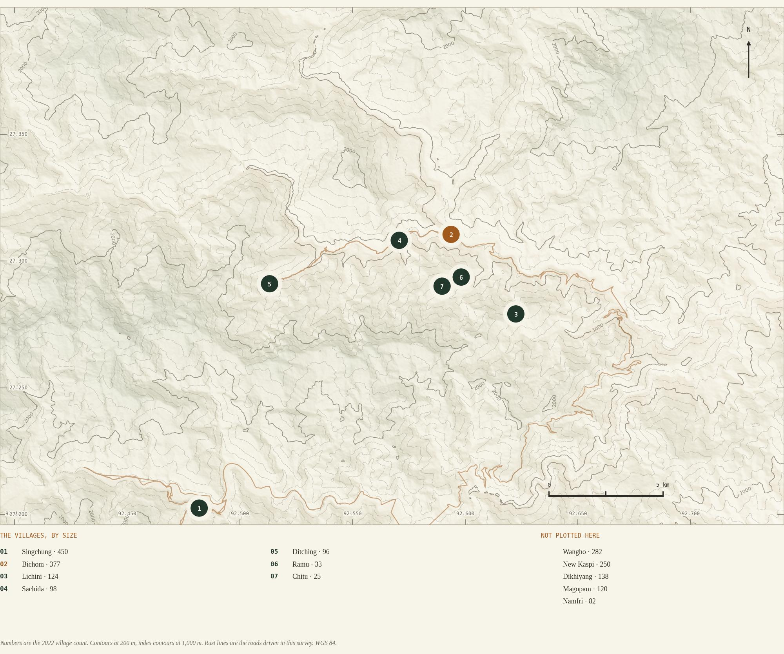

A forest given away
In 1995 a bird was found in this forest that lives nowhere else on earth, and in 2006 it was described and named for the community whose ground it was found on. In 2017 the Brai Dua clan set aside seventeen square kilometres of their own land as the Singchung Bugun Village Community Reserve, patrolled from the village by people from the village. The same forest holds the nettle. A community that gives up its own ground for a bird it did not know it had is not a community waiting to be told what its heritage is worth; it is one already making the calculation about what is worth keeping, and at what cost. The fibre in these pages is that same calculation, made about a different kind of inheritance.

map 02 · location
Where this is
One valley, seven villages, and about twenty kilometres between the far ends of the work.
Bichom village sits at about 810 metres on the Bichom river. The sub-division runs from roughly 556 metres in the southern part of the Bichom valley up to 3,244 metres at the Eaglenest pass, so a day’s walk here crosses more climate than a day’s drive does in most places. The whole village — school, post office, community hall, panchayat bhawan, co-operative, bus stand, the shops — fits inside four hundred metres of road. Singchung, the sub-divisional headquarters, and the Tenga market lie about thirteen and seventeen kilometres to the south-west, at the bottom corner of the map.
The river carries two names and a sex. Diga Khow is the male and Khatong Khow the female, both spelled out letter by letter when Harnam Hagam was asked what the Bichom is called. In Bugun khow is water, confirmed three ways over: in those two names, in Khowlut — damming a stream to take fish, from khow and lut, to strike — and in Pham Kho, where pham is the mountain.
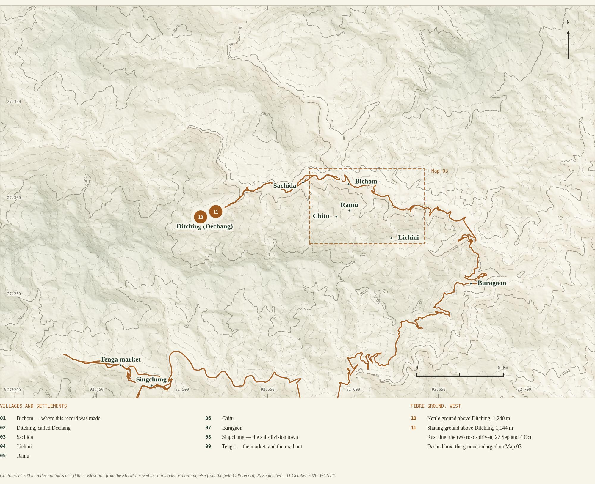

the commission
What this work is
Who asked for it, what it was asked to find, and the rules it was done under.
This survey belongs to Revival of Memory, the Goh Bugun Cultural Memory Project, run with the Dakshina Dvaraka Foundation. The field work at Bichom was done between 20 September and 11 October 2026, on foot, by one observer.
What it was asked to find is easy to say and harder to do: whether the Bugun still have the plants they once made thread from, whether anyone still knows how it was done, and whether any of it can be written down before the people who hold it stop being able to tell it. The answer to the first is yes, and there are six. The answer to the second takes the rest of this report.
How it was done
By walking. The plants were found by going to them with somebody who knew where they were, and the names were written down standing in front of the plant rather than afterwards from memory. The making was watched: the pot on the fire on 30 September, the ash going in on 1 October, the beating at the river and the drying on 2 October. What could not be watched was asked about, and what came back as description rather than demonstration is marked as description throughout.
The rules it worked under
Nothing is written down that was not said or seen. Where the record has a hole, the hole is printed rather than filled.
The knowledge is not the project’s. It belongs to named people at Bichom and Lichini who agreed to be recorded. Where a man was translating his elders rather than speaking for himself, he said so first, and that distance is kept.
Some of it is held back on purpose. Exact positions of the wild stands are not circulated. Where a bark with a market has been located precisely in print, harvesting has followed and the people doing it have moved from cutting the bark to cutting the plant down. That decision belongs to the village Nimiyang and to the Community Reserve committee, not to this project.
The method this sits inside
Goh Bugun works through four movements, and this report belongs to the first two of them. RESEARCH maps what is remembered and what is being forgotten in technique, form and material. REMEMBER makes those practices visible again inside the community, through storytelling and family history rather than through instruction. REVIVE restores the relationship with latent skill, on three principles: revive the value of local teachers, start from known techniques and tools, and let the community set the pace. RECONNECT treats craft as a network — of knowledge, skill, material and social relationship — on the understanding that a stronger network gives a community a better capacity to adapt.
Whose work this is, and which part of it
Everything here is the first phase: taking the fibre out of the plant. That is the work of Harnam Hagam and Cheten Lagiyang, with Adang Hagam behind them as the source of the older knowledge. The second phase, turning thread into cloth and into bags, is the women’s work and a separate record. This is not a botanical survey: no plant was collected, and the scientific names are read off photographs.

how this report treats knowledge
A way of knowing that does not pass through numbers
Why this record keeps the practitioner’s own criterion rather than converting it into a measurement.
The question came up at the pot and at every stage since. How much ash goes in? You can tell by looking. How much water into the clay? ek limit mein — within a limit. How much fibre onto the card? itna hi lagta hai — this much fits. There is no scale in the house and he does not look for one.
There are two ways to write that down. One treats it as a hole: go back with a balance, fill in the grams, publish a recipe. The other treats it as the thing itself — a body that has learned to judge, which is what craft knowledge largely is. This report takes the second view. Should we not first understand how a thing is actually done, before securing it in a form the doing never took? The first way is what most documentation does, and it is not neutral: it converts a practice into a text and then treats the text as the practice. The position is not invented here — Annapurna Mamidipudi argues it for Indian handloom, and André Lepecki for the body as an archive rather than a store (R5, R6).
Craft knowledge has a somatic limit
Annapurna Mamidipudi’s study of Indian handloom puts it exactly. Craft expertise is somatic: human embodiment places limits on the use of propositional knowledge, which is why craft knowledge stays tacit and is acquired by immersion rather than by instruction. Her weavers and dyers have a vocabulary for this that no measurement replaces — saadhana, disciplined practice; manodharma, the creative move inside the form; and shareeramlo ayipovadam, programmed into a body.
The same thing is described elsewhere as the body as archive: not a storehouse holding a past intact but a system that transforms what passes through it, so what comes back out is never a copy. Which is a precise description of what Harnam Hagam and Cheten Lagiyang have been doing.
What this report does with it
The practitioner’s own criterion is recorded first, and in his own words. Five are in these pages: the ash judged by eye, the water within a limit, the fibre done when it washes white and smooth, the clay chosen for being soft and slippery, the carding charge that is as much as fits. Not five gaps — one way of knowing, at five points, in one pair of hands.
None of this argues against measuring. Weigh the ash if it helps the next person learn — but weigh it after he has judged, as a translation of what he already knew, not as the correction of a mistake.
Why the order matters, and not only academically
A practice that cannot state its measures is read from outside as a practice without technical knowledge, and the offer that follows is always the same: supply the measures, the kit, the training. What came out of the artisans’ own working then stops coming, and a community that was holding knowledge becomes a community receiving a scheme. The errors have to stay theirs as much as the successes.

Mamidipudi, A. (2016) Towards a Theory of Innovation in Handloom Weaving in India, Maastricht University (R5). Lepecki, A. (2010) “The Body as Archive”, Dance Research Journal 42(2) (R6). This is a stated position, not a proof; it argues about the order of recording, not against measurement.

people
Knowledge has a name
The plant names, demonstrations and memories come from people, not from the report.
Person | Contribution in this record
Harnam Hagam | Demonstrates and explains boiling, ash addition, river cleaning, drying, the clay and the tools. Also translates elders’ accounts into Hindi, and gave the spellings in this report.
Adang Hagam | Named as a source of plant knowledge; Harnam’s father, and the man who planted the Shaungmauh at the house. The April 2026 newspaper account also names his guidance.
Cheten Lagiyang | Named in plant identification and revival work; relearning the process alongside Harnam.
Dajee Hagam, Livi Hagam, Buruah Bachung | Named as elders contributing Bugun histories.
Sangnorbu Lali; Bidoi Bachung | Land chairman at Bichom and gamura at Lichini.

Two men, teaching themselves
Asked who had been part of the work of remembering the process, Harnam named Cheten and then himself and stopped: hum dono hi tha — it was the two of us. Nobody showed them. They worked it out and practised it. Asked whether anyone else is learning it now, the answer was as short: abhi tak to koi nahin seekh raha hai.
Six plants, one worked method, two men carrying it, and nobody learning it from them.
Attribution and return
Every name, pronunciation, translation and caption here stands in the name of the person who gave it, and goes back to them. Recording a conversation and agreeing to publish a portrait are separate decisions, and this project treats them so.

Sources: F1 pp. 2–4, 46; R1.

field sequence
How the record grew
What each field period added to the record.
Field period | What entered the record
20–21 Sep | Village places, and the named arrangement of a household hearth.
26 Sep | The home-grown fibre plant and the farming plot beside it.
27 Sep | Western field locations near Ditching and Sachida.
29 Sep | Plants on the Khamlueung and Lichini side.
30 Sep–1 Oct | Pan, water, fire and ash: conversations and photographs at the hearth.
2 Oct | River work, the first drying, the tools, the quantities, and the family account of the cultivated plant.
Through 5 Oct | Further locations and context consolidated.
7 Oct, afternoon | The clay quarried at the face, broken, sieved and handled, with photographs; two sources driven to and pinned. 15:17 to 16:02 by the saved track.
7 Oct, evening | A naming session with the written variants in front of the speaker: the fourth plant named, a lost plant named, the firewood corrected.
8 Oct | The clay worked into the fibre, the second drying, the clay beaten out, carding and spinning, all photographed. Thread.
10 Oct | Ramu and Chitu, the two smallest Bugun villages, walked and positioned.
11 Oct | The last day: the small water stream above the farm, and the two new fibres found growing on both of its banks.

One process, recorded once
The making was recorded end to end on a single fibre, because the sequence is the same for all of them. Boiling, washing, drying, claying, carding and spinning do not change from plant to plant; what changes is the thread that comes out, and that is shown separately for each.

map 03 · working places
Working places around Bichom
A village that is one road long, and the one working place that is off it.
Everything official in Bichom stands on one kilometre of road: the bus stand at the north end, then the marketing shed, the community hall, the panchayat bhawan and the co-operative, with the school, the post office and the shops strung along after them. Two bamboo craftsmen work at the top of that line. The washing place is the one point that leaves the road — down on the river, about four hundred and fifty metres west of the school and some thirty-five metres below it.
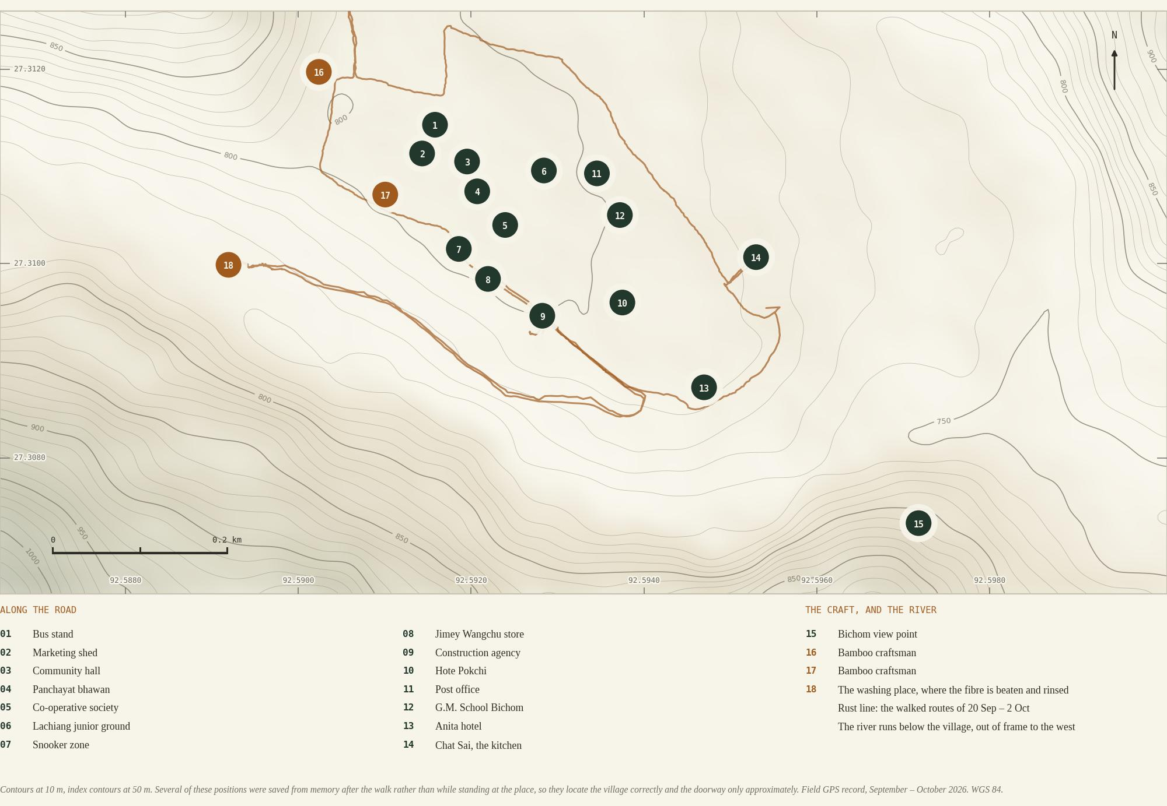

plant records
Six names, and which is which
The makers’ names lead the record. A botanical name sits beside them where there is one, never above them.
Every spelling in the column on the left was given letter by letter by Harnam Hagam with the written variants in front of him, and is his choice between them rather than this report’s.
 | Local name | What it is in this record | Where it stands
 | KHINYA | Not a plant but the word for a nettle — any nettle that stings when you take hold of it. The plants below sit under it or beside it. | A category, not a place.
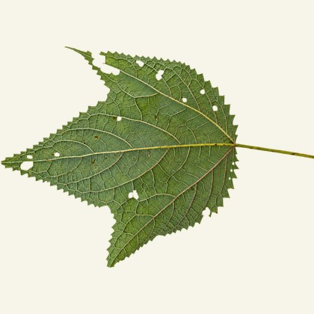 | HANCHAW | The stinging fibre plant. Mature leaves deeply lobed; bark strips in long clean lengths. Spins pale cream. Hanchong is the same plant said differently. | Wild. Starts highest of them all, around 1,400 m.
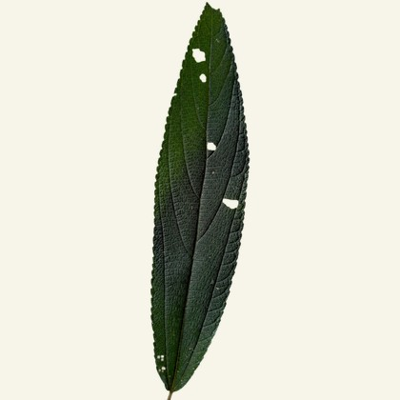 | SHAUNG | Does not sting. The bowstring was this and nothing else. Rougher than Hanchaw and spins brown. The stem runs through three colours as it ages. | Wild, beginning a little lower on the same slope.
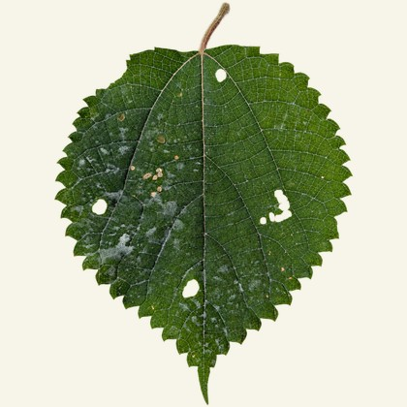 | SHAUNGMAUH | Broad leaves with a pale underside. Planted at the house on the midden, where the ground is rich. | Cultivated. Not found in forest.
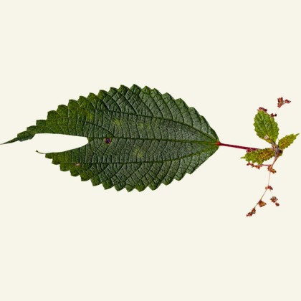 | SHAUNG BAMUNG | Within the Shaung group, and small. Leaves set singly where the others pair theirs. Fibre comes out of it. | Wild, on the Lichini road. The lowest of the three that grow together.
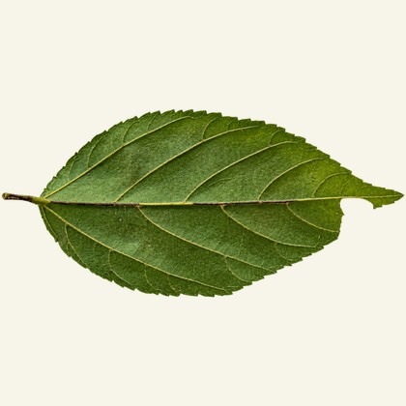 | MIKHILEE | The newest of them. Named by Harnam and Cheten, who are working with it now. The fibre is neither rough nor very smooth, and it comes out the whitest of any of them. | Wild, and the nearest to the village.
 | MIKHISHEAT | The second of the two new ones, named alongside Mikhilee and worked with by the same hands. | Wild.
 | SHAUNGKAAN | Also a Shaung, not a nettle. Planted at houses within living memory and not found here now: yahaan mein hai hi nahin — they have looked. | Not found in this search.

What the names do and do not do
Shaungmauh is one word, and mauh carries no meaning on its own; say it by itself and nobody will know what you mean. Khinya covers the stinging plants and is not a substitute for a plant’s own name. The Shaung group holds four of the eight entries above, which makes it the widest word in the fibre vocabulary and the one that does most of the sorting.

plant plate 01
Hanchaw
The stinging fibre plant, and the highest of them.
Hanchaw · Himalayan giant nettle · Girardinia diversifolia
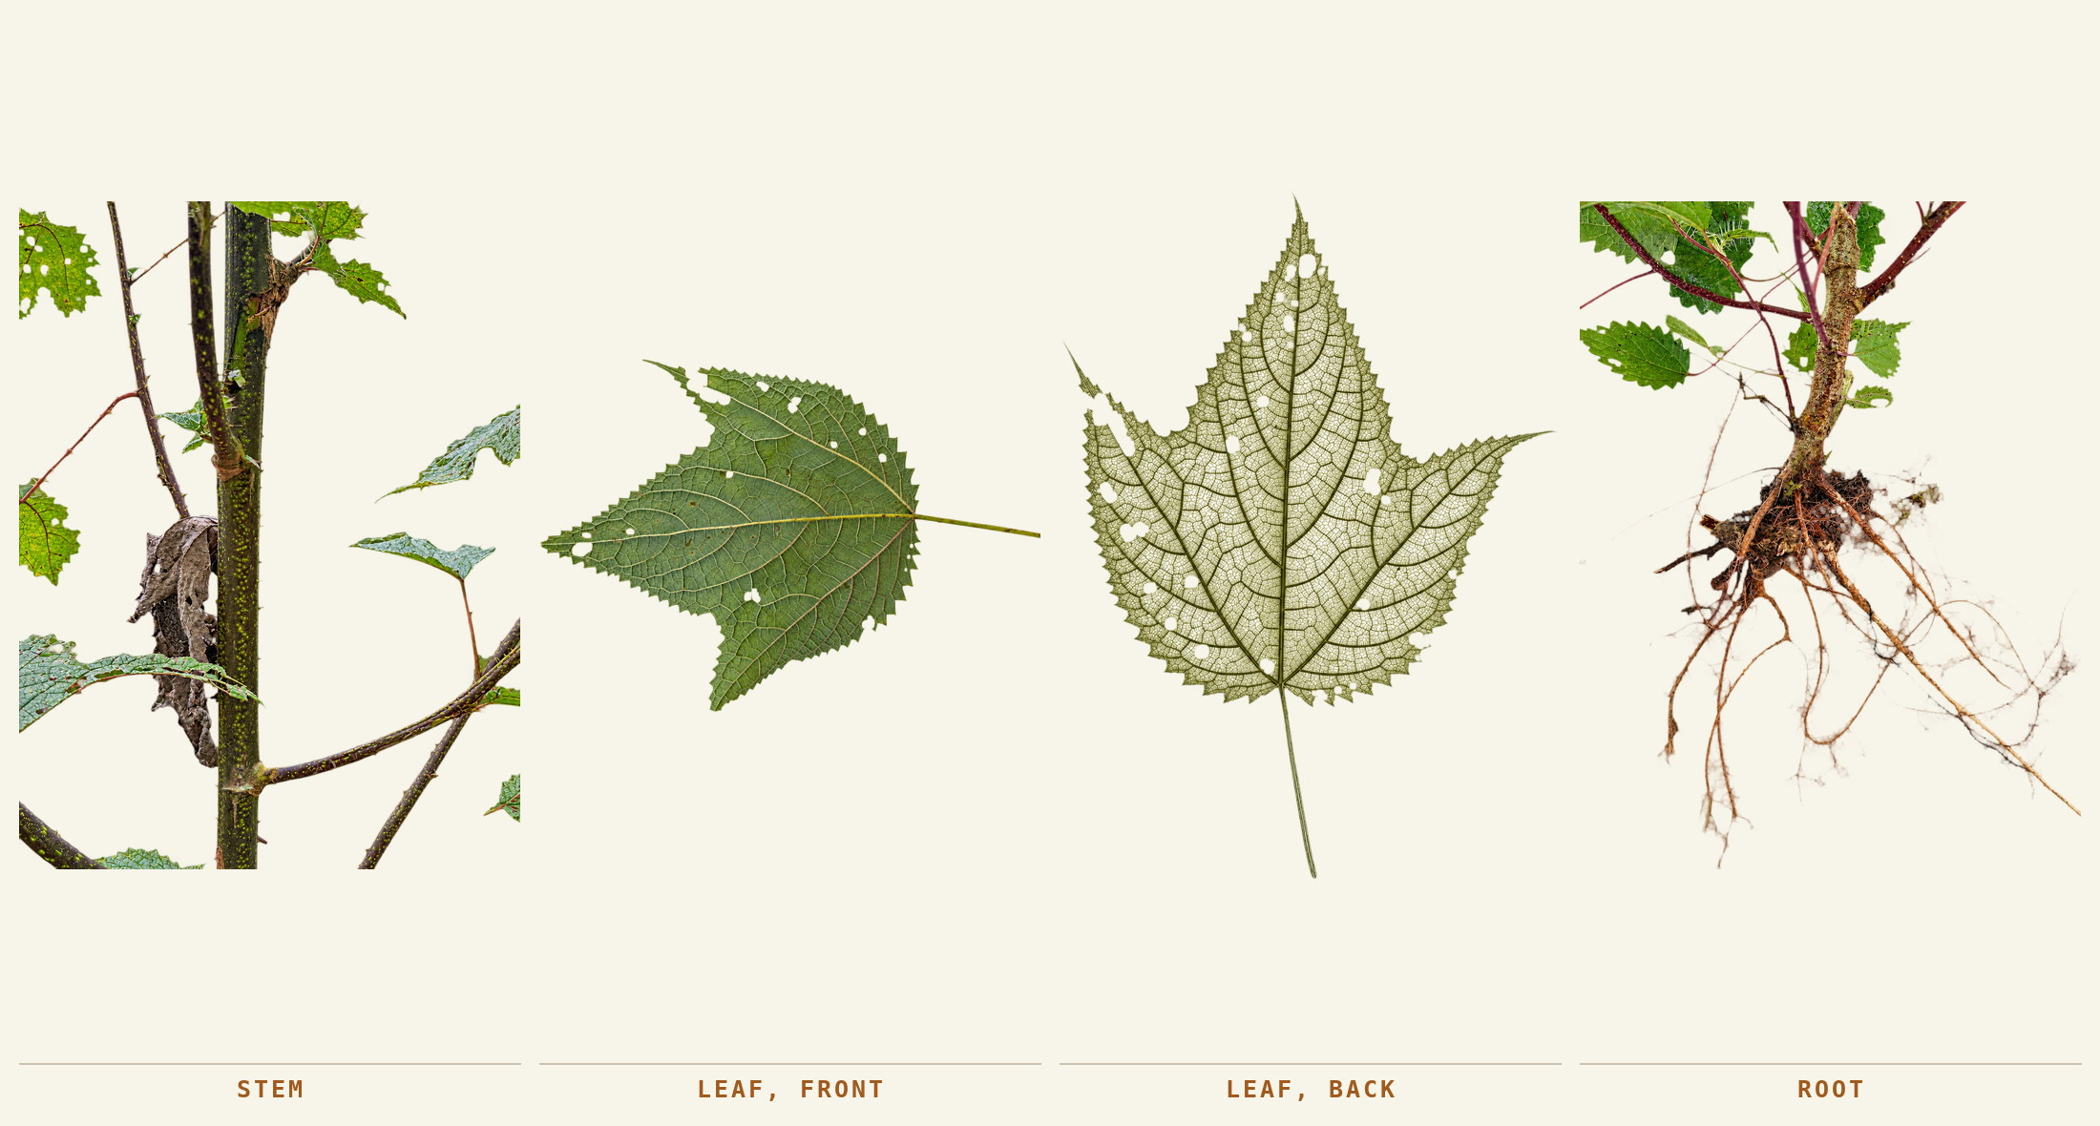
Stem, leaf from both faces, and the root the whole plant stands on. Bichom, September 2026.
Two names come back and they are the same plant: Hanchaw and Hanchong, one said by some people and one by others. It is a nettle, so it is also a Khinya. The mature leaf divides into pointed lobes with toothed edges, the younger leaves can look quite different, and the stem carries stinging hairs that work.
The part taken | When it is taken | What it becomes
The bark of the main stem. The stem is cut, the bark peeled downward from the top, and the woody core left at the place it was cut. | June, July and August, for the new growth of that year. Peeled and boiled the same day: bark left to dry goes taan — tight and hard — and will not give the fibre up afterwards. | A pale cream thread, the finer of the two that have been spun, against Shaung’s brown.

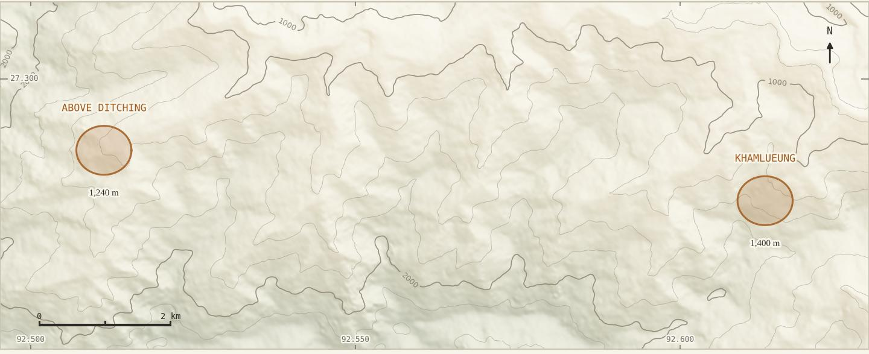
Two grounds, nine kilometres apart: the slope above Khamlueung at about 1,400 m, walked 29 September 2026 at 10:34, and the ground above Ditching at about 1,240 m, walked 27 September at 10:13. The ring is the stand, not a single plant.
A plant that defends the thing you want
The sting is on the stem, which is exactly where the bark is. Everything about gathering this plant — the season, the gloves, the way the stem is held — is arranged around getting past a defence that sits directly on top of the fibre.

plant plate 02
Shaung
The bowstring plant, and the one that changes colour as it ages.
Shaung · a false-nettle · Boehmeria macrophylla Hornem.
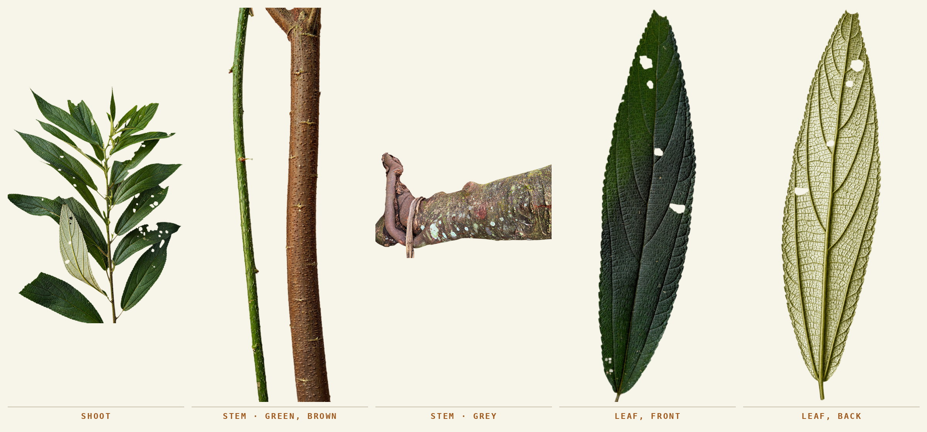
Shoot; the stem green and brown on one piece; the old stem gone grey; and the leaf from both faces. Bichom, September 2026.
It does not sting. Asked what a bowstring was made of, Harnam did not hesitate and did not generalise: the cord is Shaung, sirf Shaung ka — this one only. Long narrow leaves, dark above and pale beneath.
The part taken | When it is taken | What it becomes
The bark of the stem, and the choice of stem is the whole skill. Green is taken, brown accepted, grey left. | June, July and August, the same three months as the nettle — dono ka season lagbhag same hi hai. Boiled on its own, never mixed with Hanchaw. | A brown thread, rougher than Hanchaw. Bowstring and fishing net, both named without prompting and named precisely: this plant, not the group.

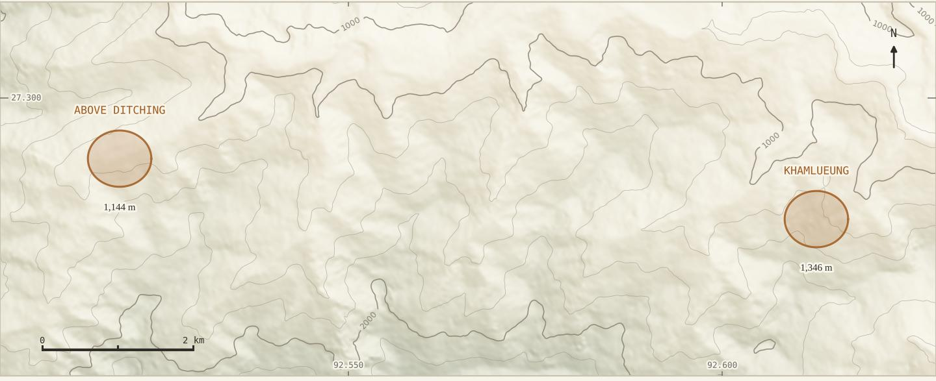
Also two grounds: Khamlueung at 1,346 m, 29 September 2026 at 10:20, and above Ditching at 1,144 m, 27 September at 11:20.
Three colours on one plant
The youngest stem is green, and that is the one to take. The second is brown, not as good but good. The third is grey, past its use for this. Green bark is thin-walled and the bast lifts in one sheet; by grey it has gone corky and the fibre inside has stiffened. Take green, accept brown, leave grey — one look, no tools, and it sets everything downstream.

plant plate 03
Shaungmauh
A plant kept at the house, and an account of how it got there.
Shaungmauh · ramie · Boehmeria nivea
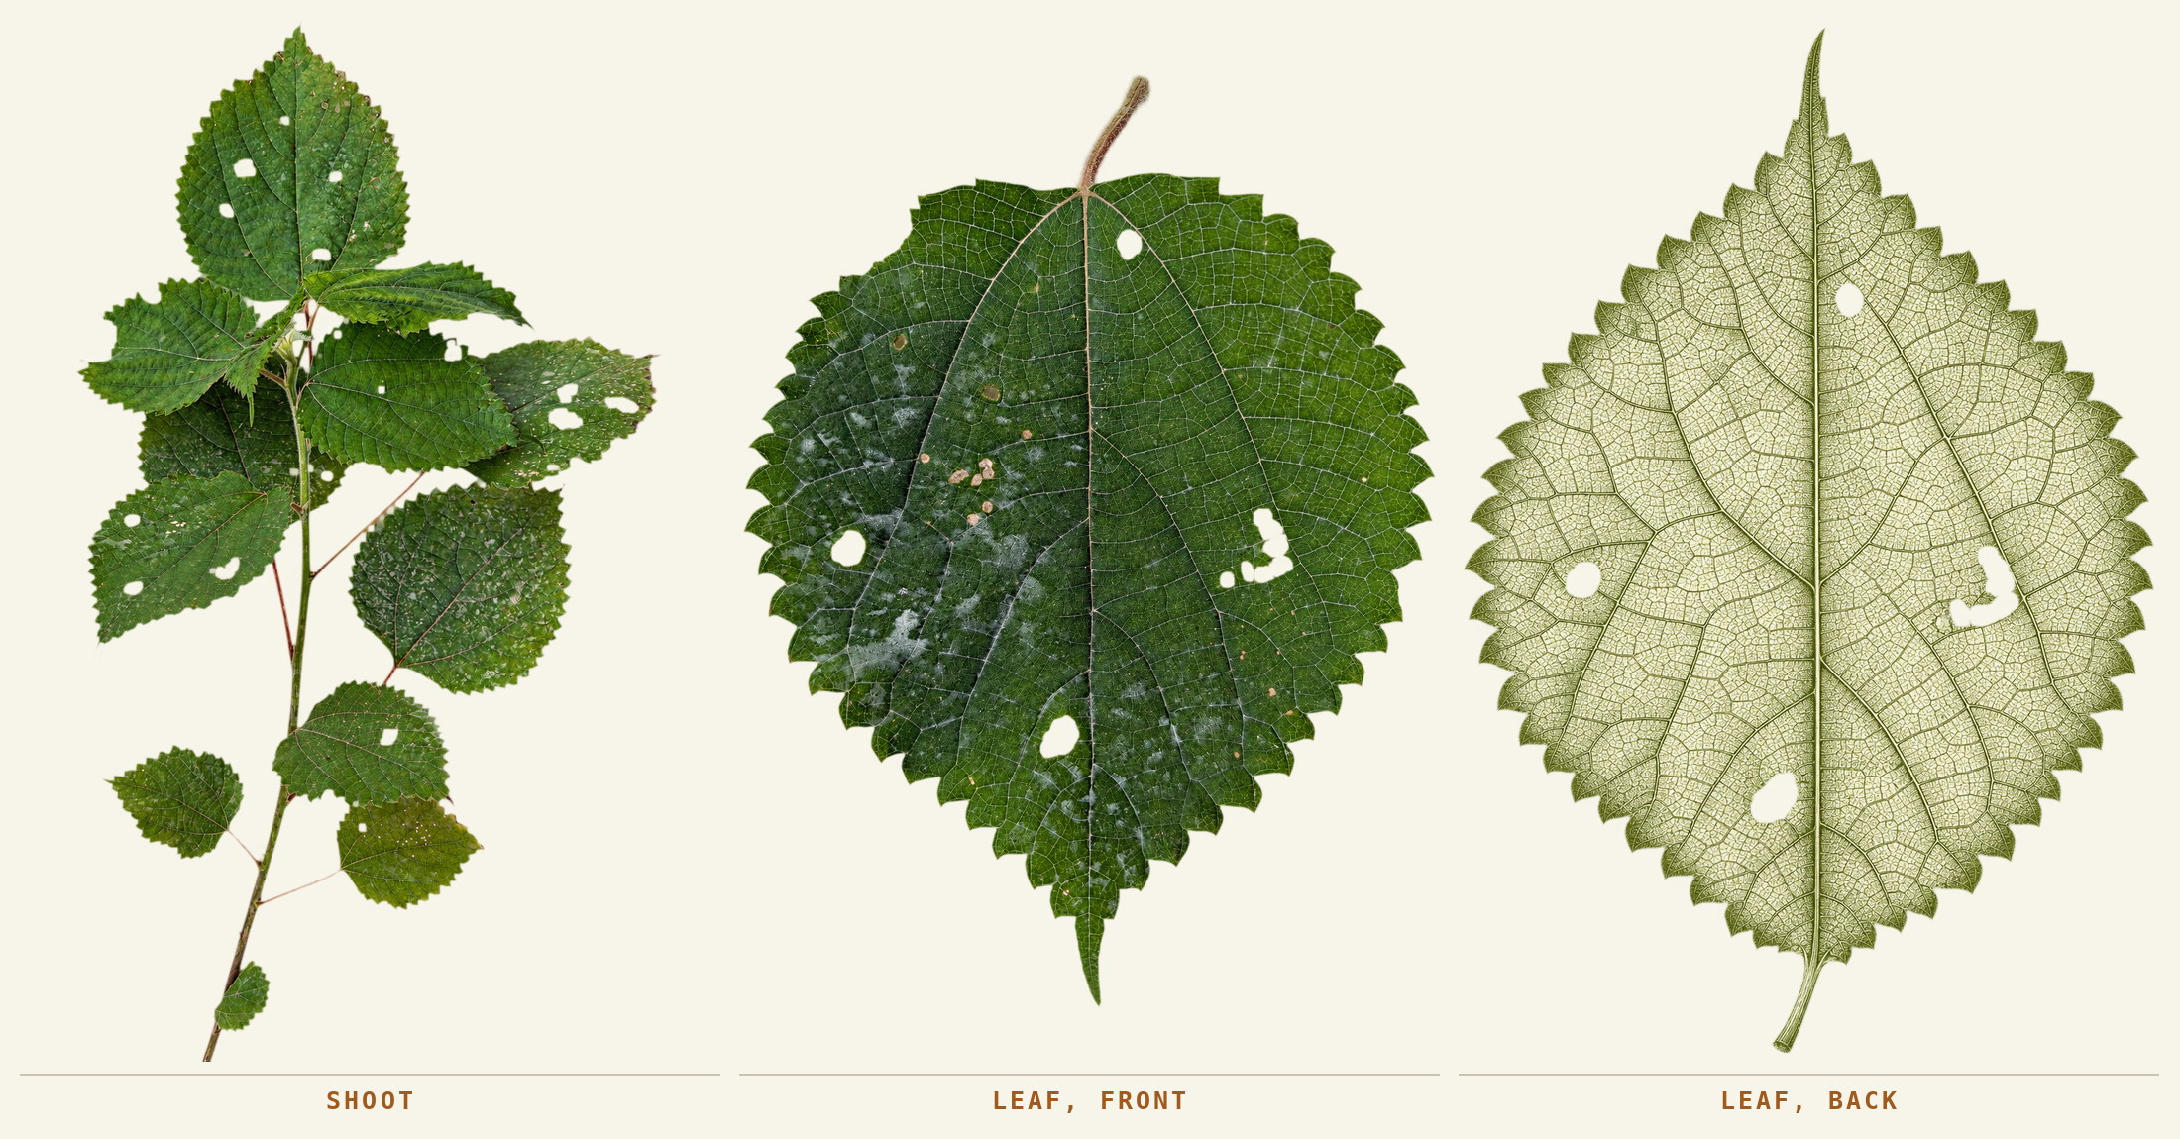
Shoot, and the leaf from both faces. Bichom, September 2026.
One word, with no space in it — he was explicit about that. And mauh is not a word that can be taken out of it: asked whether saying mauh on its own would be understood, the answer was no, twice. The plant is said whole or not at all.
The part taken | When it is taken | What it becomes
The stem bark, as in the others. | Grown rather than gathered. Harnam’s father brought it from his maternal uncle’s field and planted it at the family home, on the midden where the ground is fed. It stands there against the day it is wanted. | The household says plainly that this one is not found wild, which makes it the only fibre plant in the record that somebody decided to keep.

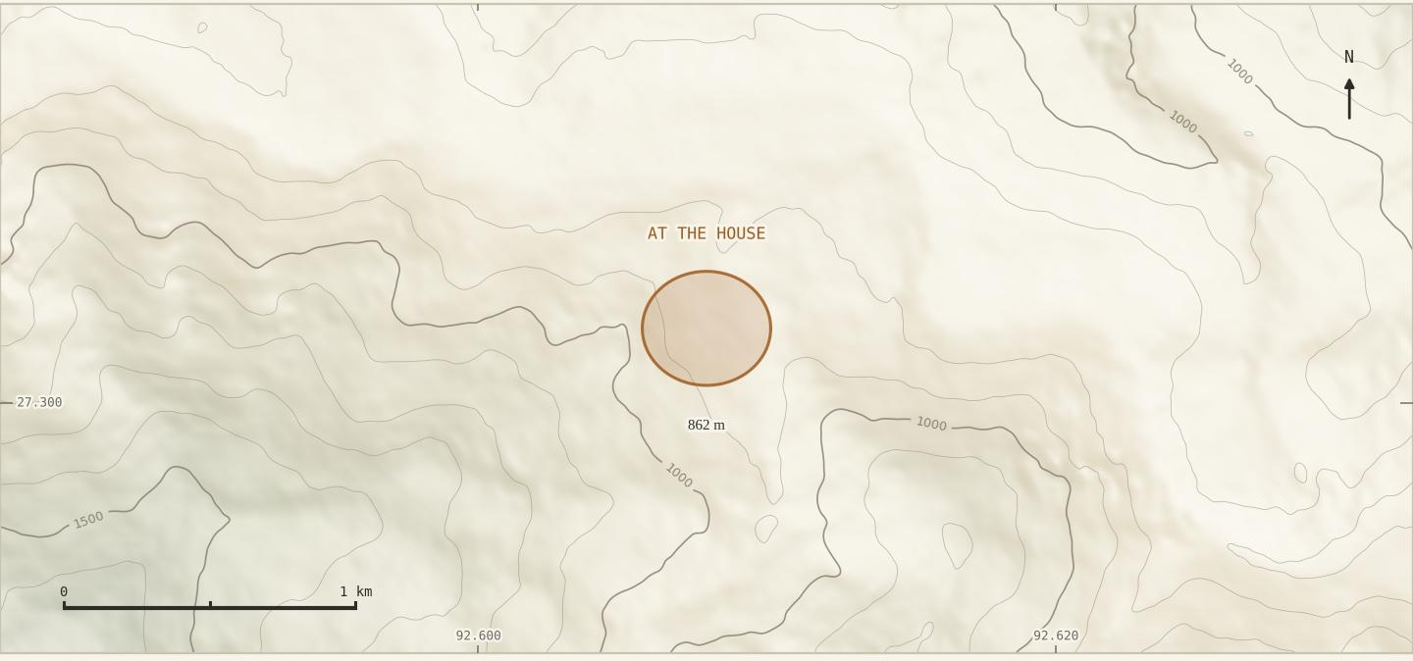
One stand, at the house on the midden, 862 m. Recorded 26 September 2026 at 17:12.
Two plants, one kind of ground
Shaungmauh and Shaungkaan are the two that get planted rather than gathered, and both are kept in the same place: beside the house, on soil that has been fed. A fibre plant that moves indoors moves on to the midden.

plant plate 04
Shaung Bamung
The smallest of the group, and the last to be named.
Shaung Bamung · no English name · Boehmeria, within the Shaung group
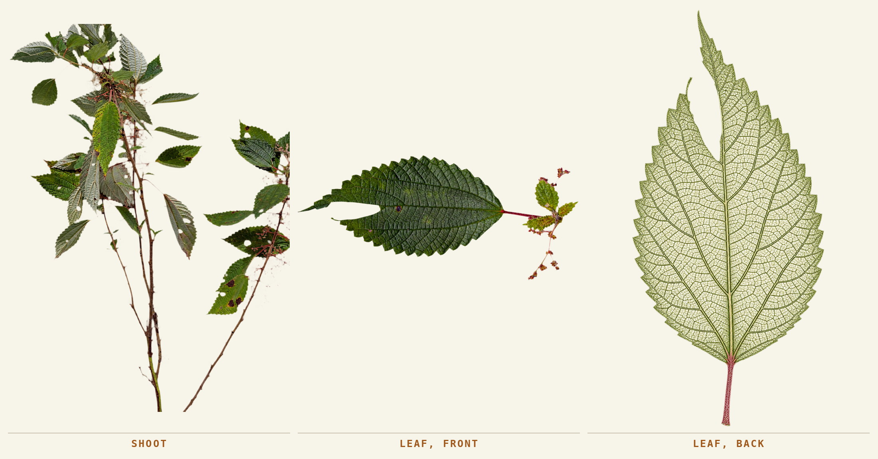
Shoot, and the leaf from both faces. Bichom, September 2026.
Shown the photographs on 7 October, Harnam named it at once — Shaung Bamung — and placed it: woh bhi Shaung hi hai, it is in the Shaung group, but the plant is small. The leaf arrangement separates it on sight: set singly along the stem, where the others carry theirs in pairs.
The part taken | When it is taken | What it becomes
The stem bark, as with the rest of the Shaung group. | With the others, June to August. | Fibre for the fishing net, which is what this one and Shaung are both put to. Usse bhi fibre nikalta hai — fibre does come out of it.

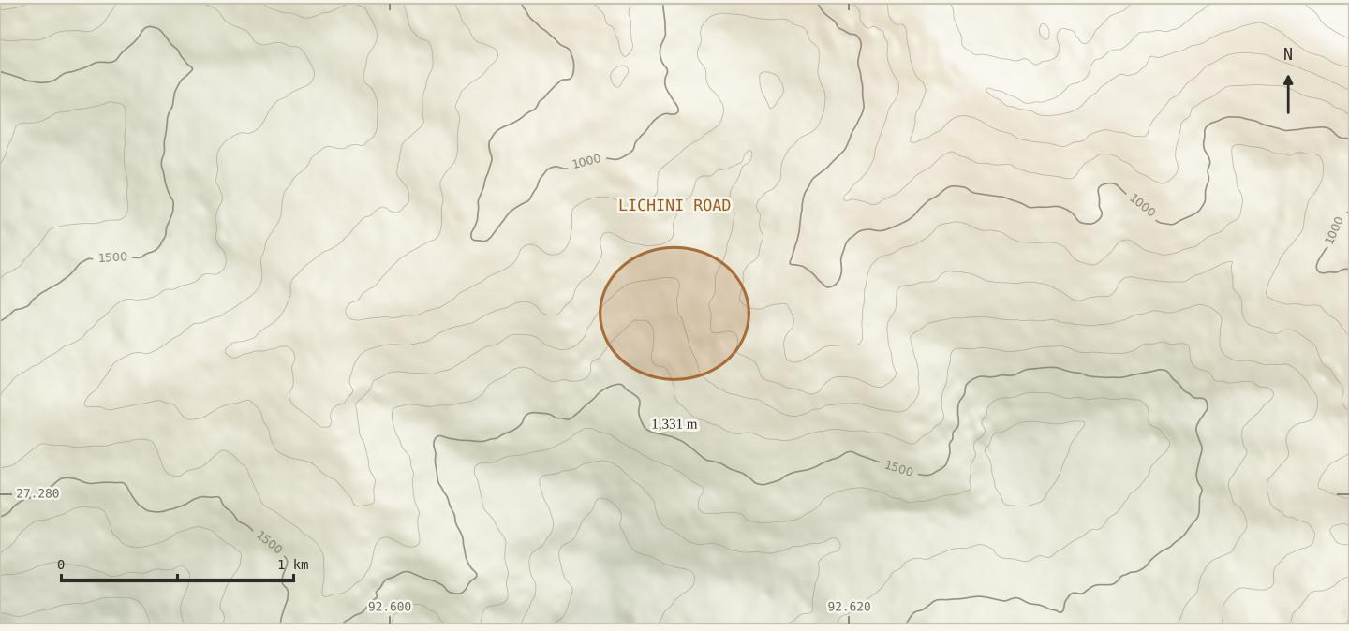
On the Lichini road at 1,331 m, the lowest of the three that grow together. Recorded 29 September 2026 at 10:11.
Three plants on one slope
Shaung Bamung, Shaung and Hanchaw come one after another as the ground rises, and at the top all three grow together in quantity. One walk crosses the whole wild range of the craft.

plant plate 05
Mikhilee
A new fibre, being worked out now.
Mikhilee · no English name · an elm — Ulmaceae
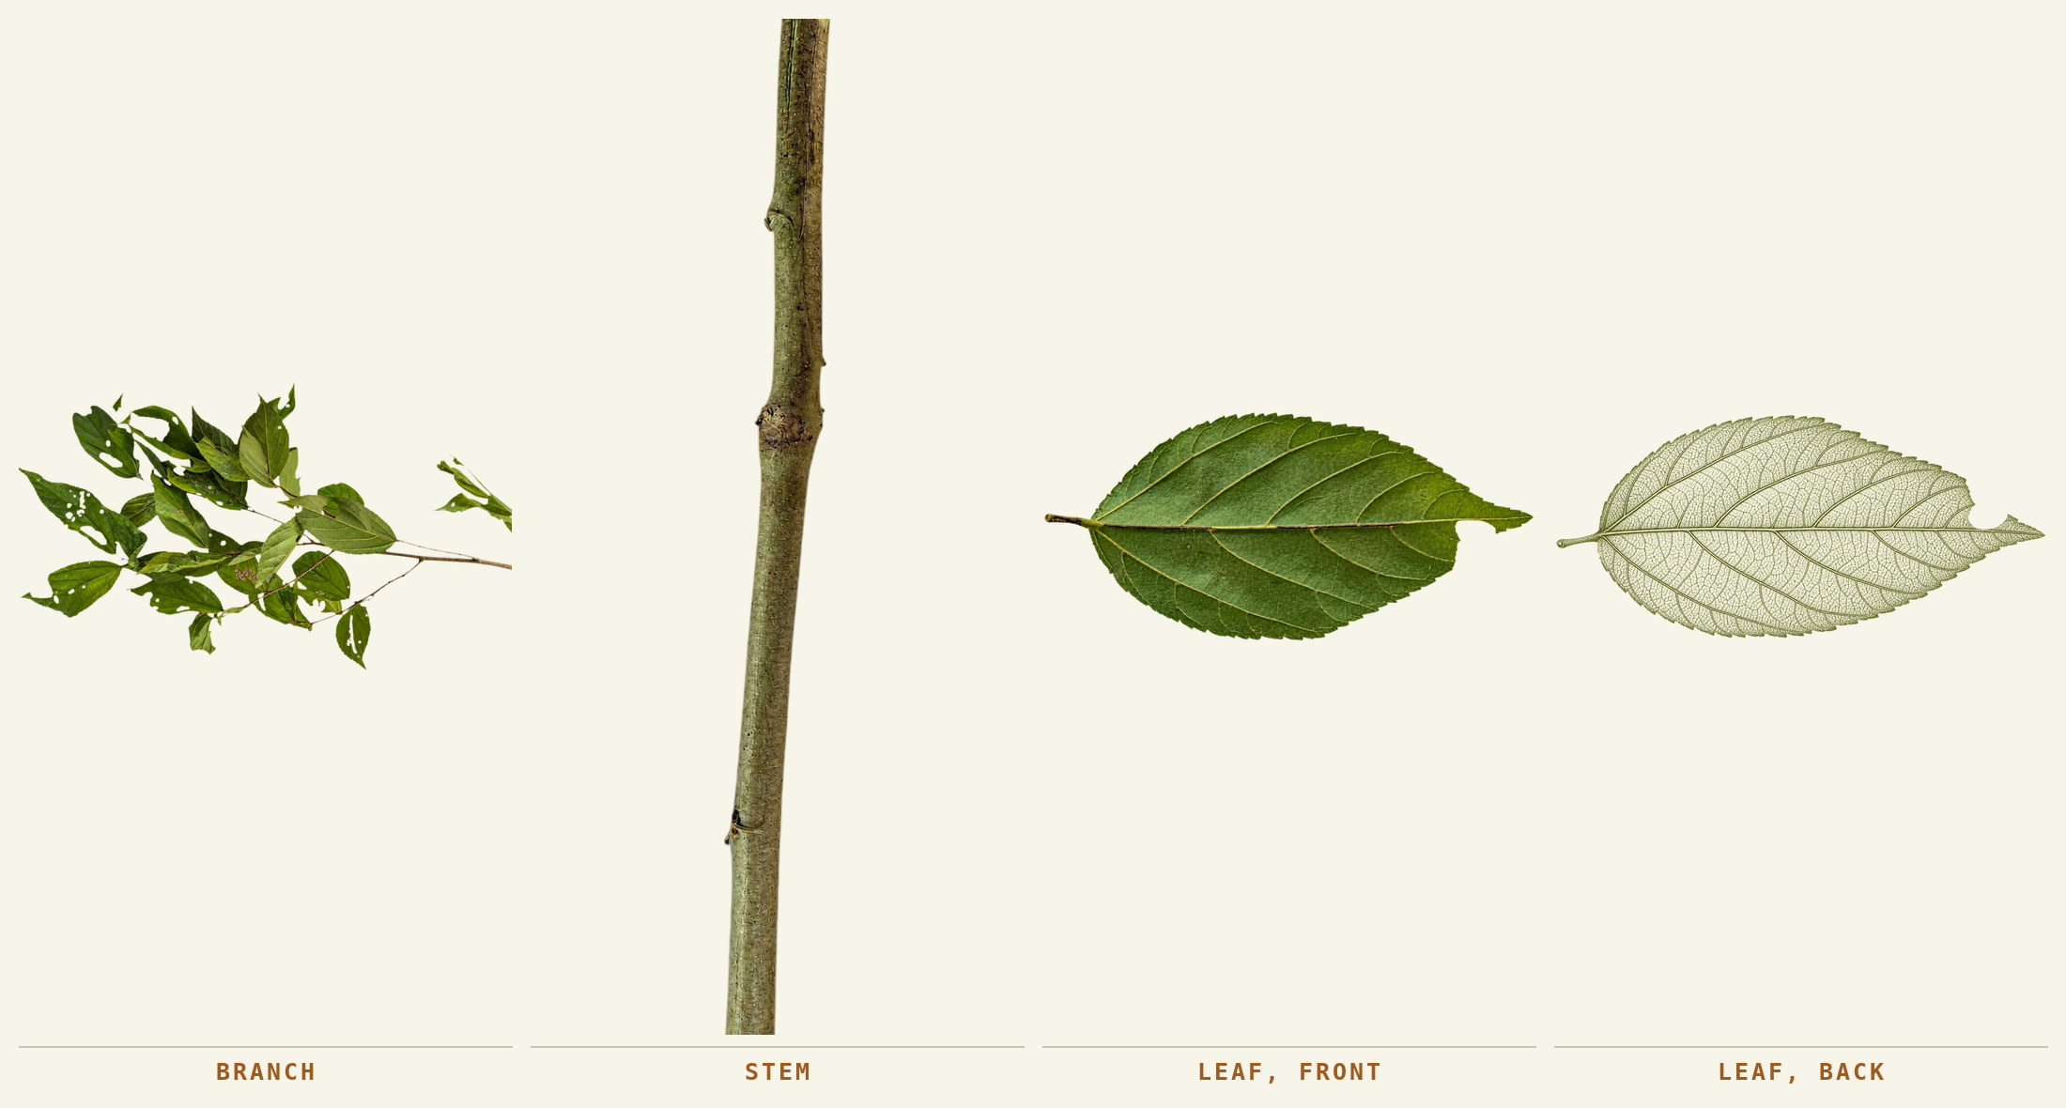
Branch, stem, and the leaf from both faces. Bichom, October 2026.
The name is given by Harnam and Cheten, the two working with the plant. The leaf runs out to a long point and sits unevenly on its stalk, one side of the base lower than the other, and the leaves alternate in a flat plane along a slender twig. Those are the marks of an elm rather than a nettle — a different family bearing a usable bast. It is rare, and where it is found it stands in a cluster.
The part taken | When it is taken | What it becomes
The bark of the slender twig. | April is the season for this one, two months ahead of the nettles. It grows nearest the village of any of them, on both banks of a small water stream. | The whitest fibre in this record — neither rough nor very smooth.

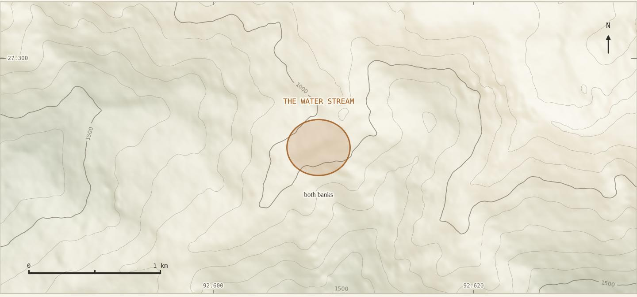
Both banks of one small water stream above the farm, where it stands in a cluster. Mikhilee recorded 11 October 2026 at 10:53, Mikhisheat forty metres away at 10:42.
Found by trying it
Harnam and Cheten have been experimenting with this plant, and what they found is that it gives good fibre. That is the whole of it, and it is how the list of six came to be six: not by being remembered, but by being tried.

plant records · absence
Shaungkaan
A fibre plant named from memory, looked for, and not found.
Asked straight out which fibre plant is no longer to be had, Harnam gave one name without pausing over it: Shaungkaan. Like Shaung Bamung it belongs to the Shaung group rather than to the nettles — neta nahin, woh Shaung ka hi prajaati hai.
He has not seen it. He knows of it because somebody who used to plant it said so, and that is also how he knows where it stood: at the house, like the Shaungmauh, not out in the forest. Both of the plants that get planted rather than gathered are kept on the same ground, beside the home, on soil that has been fed.
It has been looked for. Yahaan mein hai hi nahin, nahin mila abhi tak bhi hum dhoondha hai — there is none here; we have searched and not found it. That is a search by one household in one valley, not a regional survey, and it is the only search this report knows of.
What this entry is
A name, a family of plants, a growing place and a search that came back empty, all from one speaker on one afternoon. A cultivated plant that stops being planted disappears from a village without disappearing from the hill, which is the thing worth holding on to here.

Why it belongs in a fibre report at all
Because a craft that can name a plant it no longer has still knows the shape of its own material range. The loss happened close enough that a man in his working life can name the thing and say where it used to stand.

Source: naming session, Bichom, 7 October 2026.

process 01–02 · gathering
Before the bark reaches the fire
Season, plant condition and the time between gathering and boiling all matter to the maker.
Part of the record | What the record holds
Place | Wild plants around moist ground, stream edges and some fallow areas.
Season | June, July and August, the same three months for the nettle and for Shaung alike: dono ka season lagbhag same hi hai. What is wanted is the new growth of that year. Mikhilee is the exception: April.
Stem choice | Green material preferred; brown takes longer; grey is left.
Harvest | Cut the main stem, peel the bark downward from the top, leave the woody part at the collection place.
Time | Boiled the same day it is peeled. Bark that dries first goes taan and will not give the fibre up.

The step, done as it is done here | What the fibre does when it is not
Take the main stem while the bark is still green. Peel downward from the top so the bark lifts in one length — stripping it green is what other bast traditions call decortication, and doing it by hand on the slope saves breaking the dried stalk later. Leave the woody core where it was cut, and put the bark on to boil the same day. | A stem left until the surface is grey has gone corky, and the bark breaks into short pieces instead of lifting in a sheet. Peeled bark that is not boiled that day dries to taan — tight and hard — and the fibre will not come out of it afterwards.

process at a glance
From stem to thread
Eleven stages. Ten of them were watched; the eleventh has not been reached.
01 | Locate and recognise  Name the plant at the place where it grows.

02 | Cut and peel  Take bark from the stem; identify the batch. Do not let it dry.

03 | Boil with wood ash  Water, iron pan, sieved ash, heat and a lid.

04 | Beat and rinse  Alternate striking and washing until the outer layer loosens.

05 | Dry  Hang the cleaned fibre; drying time depends on the weather.

06 | Quarry and sieve the clay  Lever the soft layer out of a roadside face, break it, and put it through the sieve until the powder is fine.

07 | Work the clay in  Damp the powder in the pan and knead the dried fibre through it until it is coated.

08 | Dry again, and beat it out  Five or six days in good sun, then strike the stiff hank until the clay falls away.

09 | Carding  Draw the fibre between two toothed cards until it opens.

10 | Spinning → thread  Draw and twist on the Chhauk.

11 | Weaving → cloth  Not reached. Nobody has woven this thread.

Gather  peel |  | Hearth  ash |  | Wash  rinse |  | Dress  clay |  | Open  card |  | Spin  twist
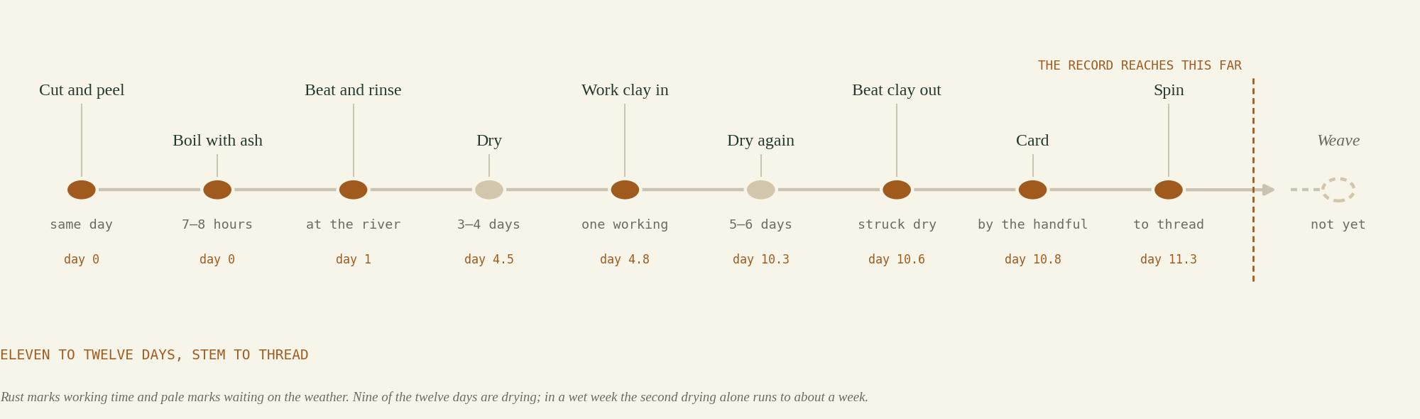

tool plate 01
Objects that make the work possible
Eight tools. Six carry a Bugun name; two are called by the English word.
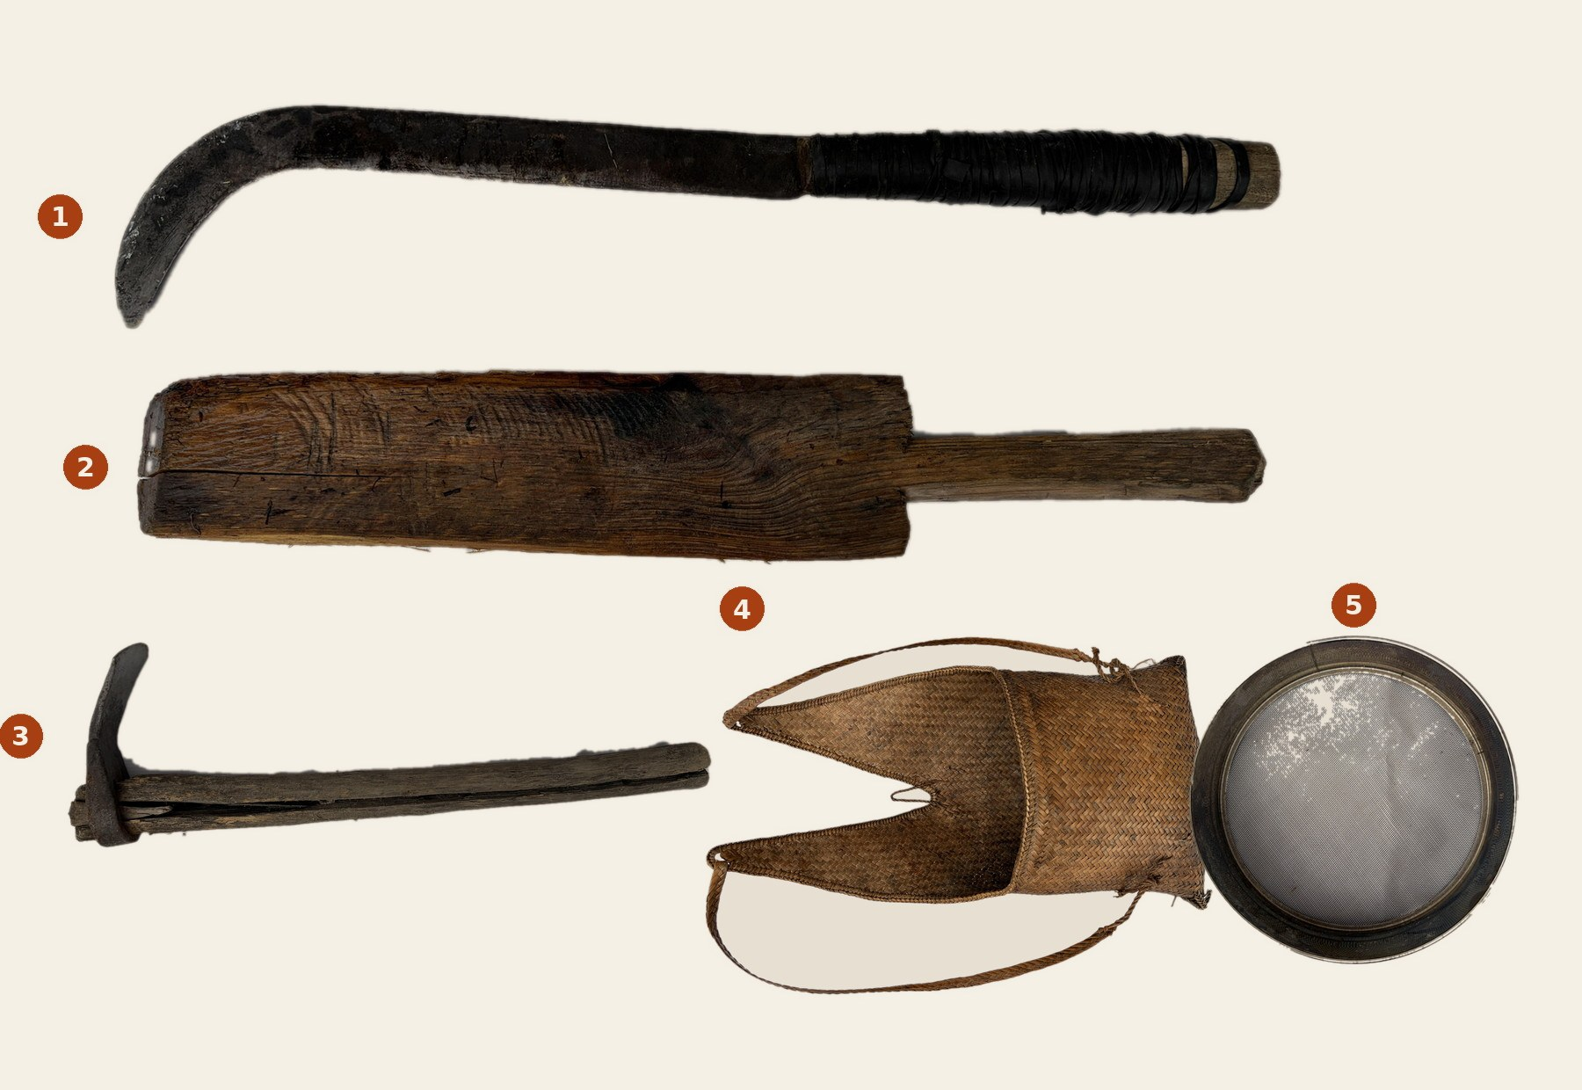
The five named tools, lifted from their studio sheets on to one ground. Numbers correspond to the table below.
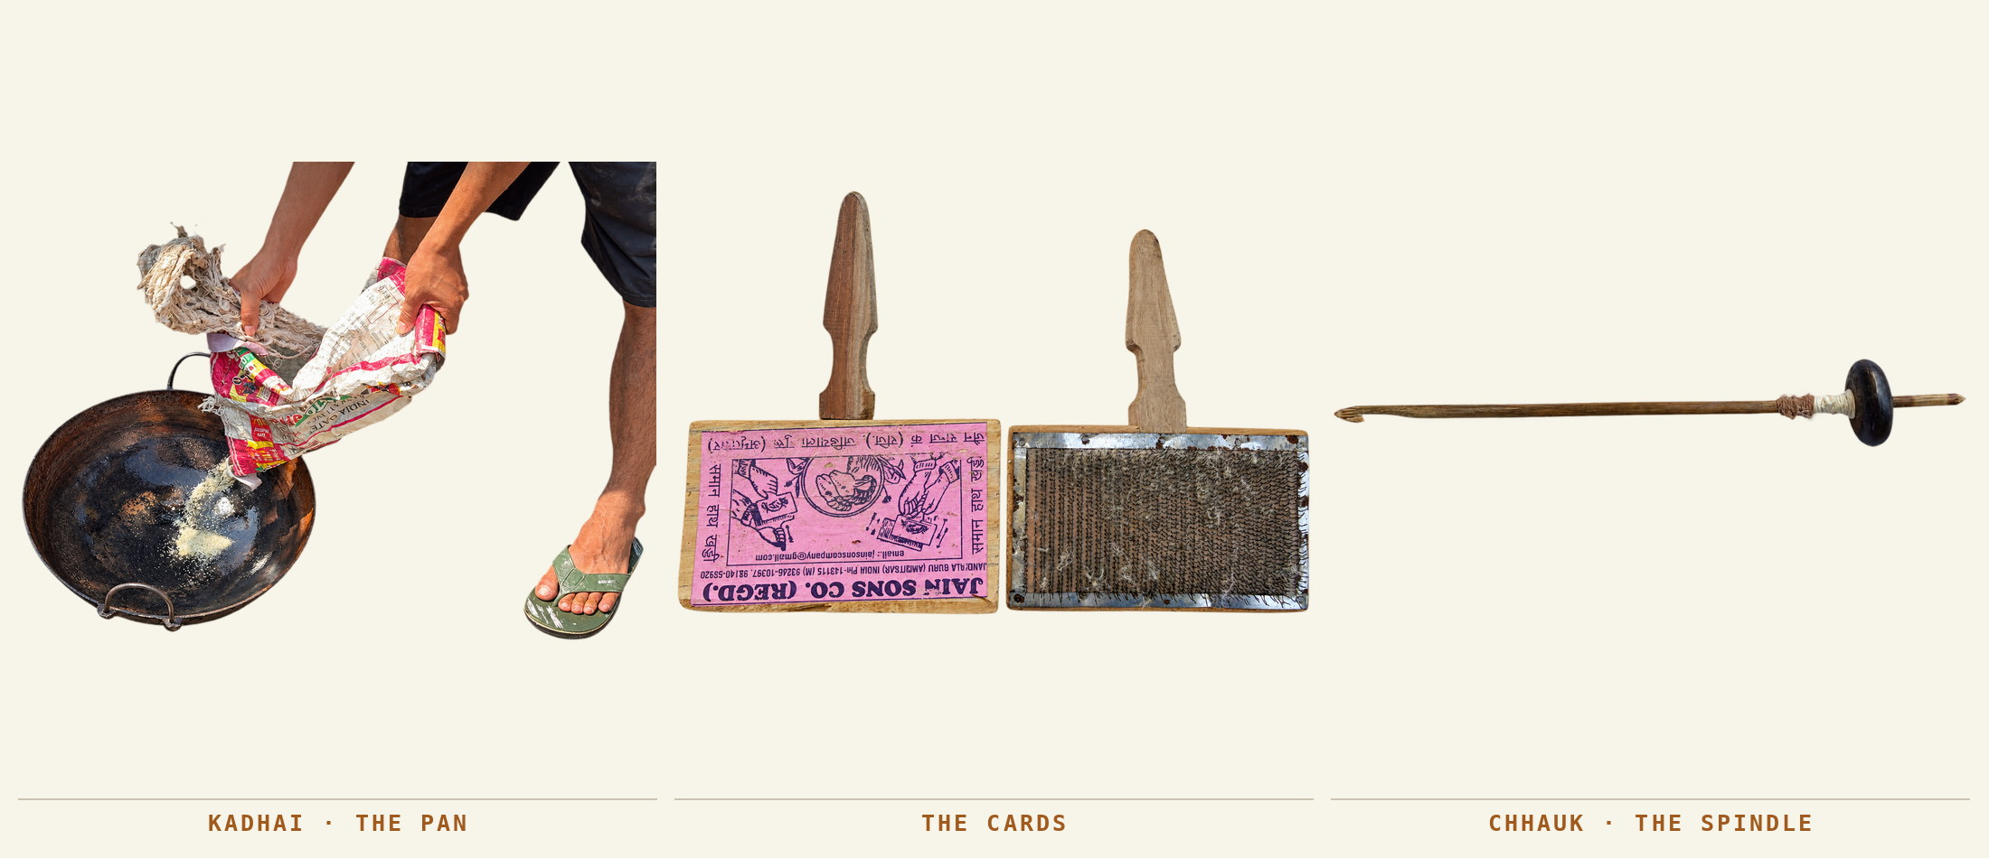

No. | Name | Role in this record
1 | Baraie | The cutting blade — a billhook. Used for the nettle, for firewood and for anything else: a household blade that cuts fibre too, rather than a fibre tool.
2 | The beater | Flat and bat-like, made that shape to sit in the hand; the proper form is remembered as round wood. No Bugun name settled, so the English word stands.
3 | Zhakham | The digging tool for the clay: a small iron blade in a split haft. At the face a long iron bar was used instead.
4 | Dhatau / Dathaw | The carrying bag, worn on the shoulders. Both spellings are his. Described as the men’s one.
5 | Dhasai | The sieve, settled on 7 October. Like the one for flour, used for both the clay and the ash.
6 | The cards | A bought pair, wire teeth set in board. The last cleaning before the thread.
7 | Chhauk | The spindle. Bamboo, with a hook cut into the top. Made here.
8 | Tachhai | The whorl on the Chhauk — a hard seed, not turned wood. Also given as Tachhairang.

process 03 · the hearth
Putting the bark on to boil
The household fire becomes a place for fibre work.
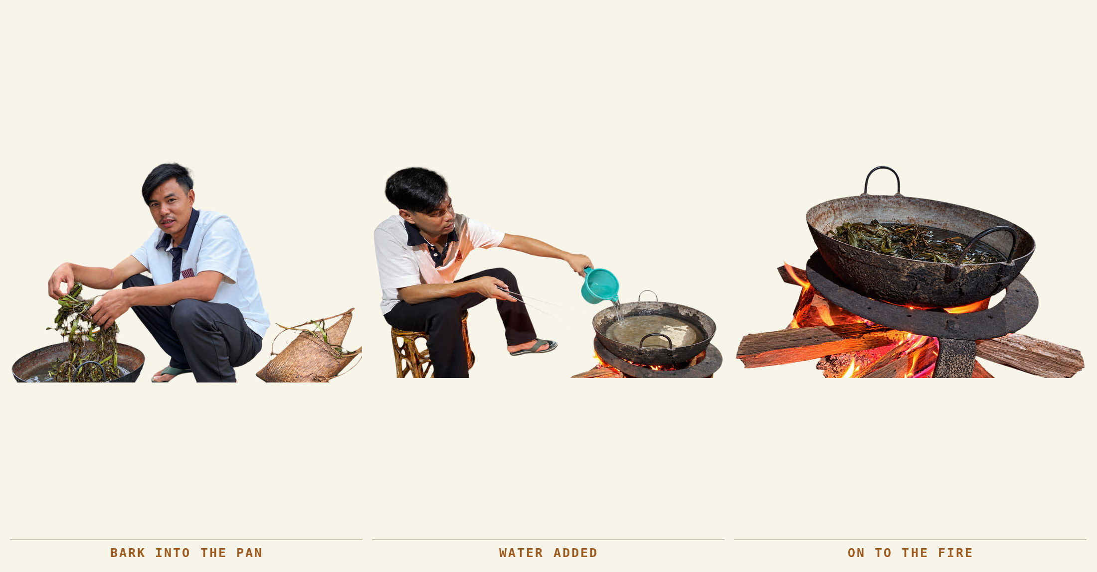
The bark into the pan, the water added, and the pan on to the fire. bark. Bichom, the evening of 30 September 2026.
The bark goes into water in an iron kadhai the same day it is peeled, without a separate preliminary wash, and the pan goes over the fire. The ash goes in at this starting stage, with the bark and the water, not later. Stir it through, put the lid on, and keep the heat steady while watching the water, which darkens from brown to near black as the gum comes out of the bark.
Each fibre is boiled on its own. The time is close to the same for all of them and so is everything else about the method; what differs between the six is the fibre that comes out — its type and its colour — not the way it is cooked. Harnam prefers iron for the pan.
The step, done as it is done here | What the fibre does when it is not
Peel in the morning, boil the same day. Iron pan, enough water to cover, oak ash in at the start, lid on, steady heat for seven to eight hours. One plant to a pan. | Bark that waits a day goes taan, tight and hard, and no amount of boiling will loosen it afterwards. A short boil leaves the gum in place and the outer skin will not come away at the river. Two plants boiled together cannot be told apart again.

process 03 · wood ash
Sieve, add, stir, cover
The ash goes in at the start, with the bark and the water, and not later.
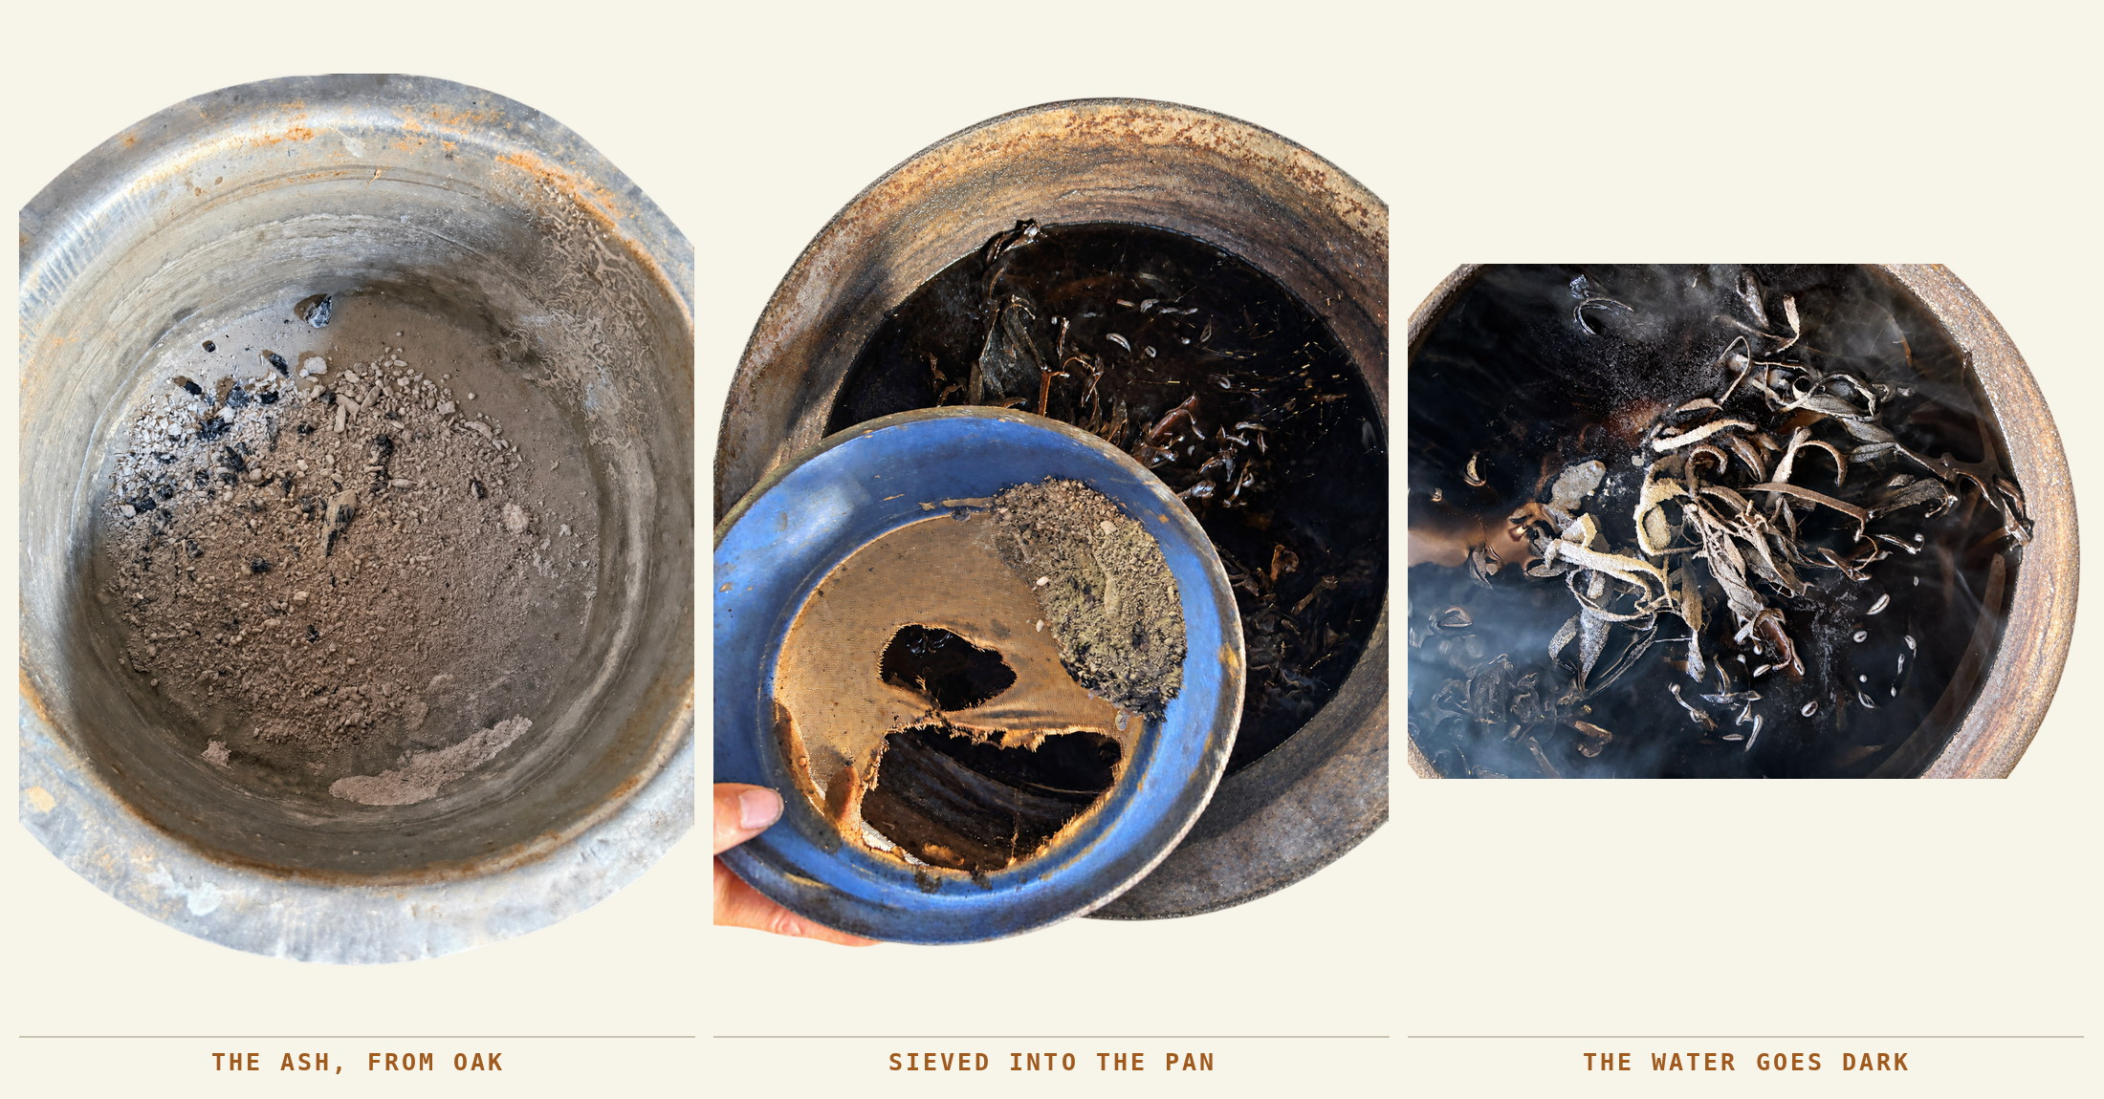
The ash as it is kept, the ash going through the sieve into the pan, and the water going dark around the bark. The sieve that morning was a plastic stand-in for the iron one.
Ash is collected from the wood fire and allowed to cool — yesterday’s fire, taken out in the morning and put aside in a container. It is sieved into the pot, stirred through the material, and the lid goes on. An iron sieve is preferred but could not be found during this recording.
Quantity described | Status
About 100–200 g ash per 1 kg bark | Estimated by eye; no measured trial or moisture basis.
About 3–4 kg for 20 kg material | Another estimate; not a prescribed recipe.

The step, done as it is done here | What the fibre does when it is not
Oak ash — Bajarat — from yesterday’s fire, cooled overnight and put through the sieve into the pot at the start, about a hundred to two hundred grams to the kilogram of bark. | Bamboo ash does not work for this, and a soft or hollow wood will not either. Too little ash and the gum stays in: the washing becomes hard work and the fibre comes out stiff. Ash tipped in unsieved leaves charcoal through the fibre to be picked out by hand later.

The ash is oak ash
The wood matters, and it is named: Bajarat, oak — woh oak ka hai, oak tree, said twice over against a question about bamboo. Bamboo ash is not good for this. What can stand in for oak is another hard tree, not any tree at hand, so the preference is for a class of wood rather than for one species. Hardwood ash runs richer in potash than ash from soft or hollow stems, which is the difference the pot is feeling.

process 03 · judgement
Knowing when it is ready
Time is one clue. Texture and the next stage of work are others.
7–8 hours
The working boiling duration given by Harnam. He says batch size affects the time. A full start-to-finish boil has not yet been continuously timed.
What the maker notices | What it means in the account
Too little cooking | The outer layer does not come away easily during river cleaning.
Longer cooking | Can make removal easier, but very prolonged cooking is described as producing sticky material. The threshold is not measured.
Water falling too low | More water is added. The material should not be left to dry in the pan.
Readiness | Softening and loosening of the outer layer, with fibre becoming visible.

The step, done as it is done here | What the fibre does when it is not
Seven to eight hours over a steady heat, and then the fibre is asked rather than the clock: it is ready when the outer skin lifts between finger and thumb and the material washes white and smooth. | Lifted off early, the skin stays bonded, the beating at the river turns into hard work and the thread that follows runs uneven. Left far past it, the fibre softens and loses the strength that made it worth taking.

White and smooth
There is one test and it is not a clock. Asked how he knows when the beating and washing can stop, Harnam described what appears rather than how long it takes: safed-safed — the fibre begins to show white of its own accord, and when it washes out white and smooth the process has gone well. Brown skin still on it means the opposite: it was not cooked properly, and it has gone hard.
The same two words sit at both ends of the craft. The clay is chosen because it is smooth in the hand; the fibre is finished when it is smooth in the hand. Nothing is measured at either end, and in both cases the judgement is made by touch.
The fire, and the method not taken
The fire is kept limit mein — within a limit. More heat does no harm, he says, but it must not drop; it has to stay hot. Asked whether the bark could simply be left to soak instead, the answer was that it could, and that they had tried it: it takes a month, or ten to fifteen days at best, and the fire does the same work far quicker. So the much-repeated statement that this process involves no soaking is accurate, and it is a choice rather than an absence — a method tested and set aside.

process 04 · at the water
Beat, rinse, look, repeat
The fibre becomes visible as the outer layer is taken off it, one round at a time.
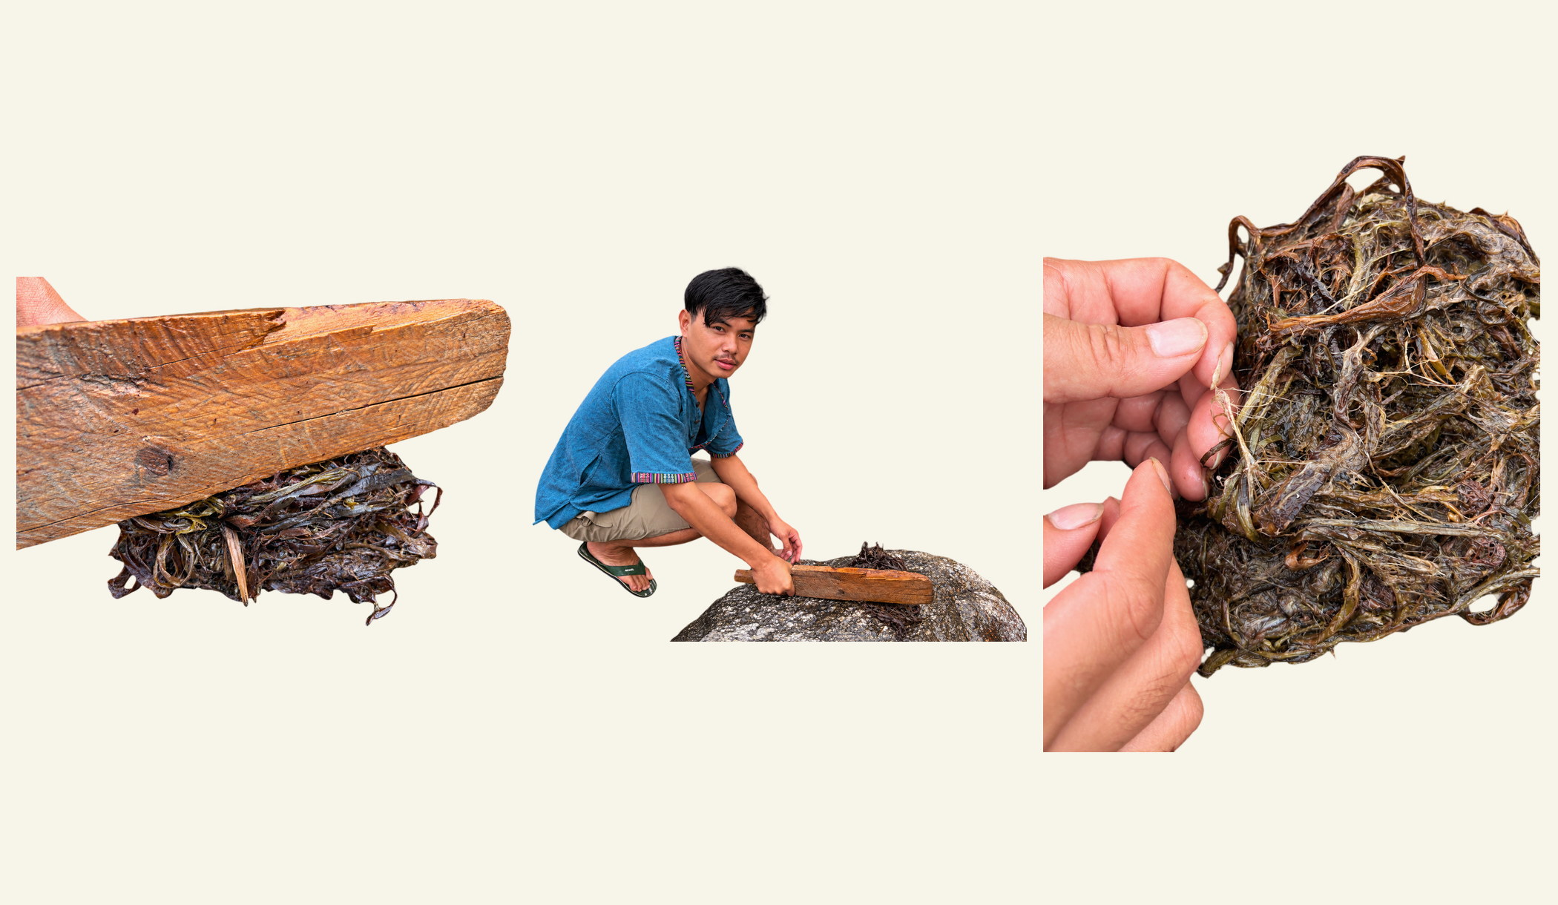
The beater coming down on the bark, the rinsing between rounds, and one strand drawn out of the mass. At the river, 2 October 2026.
The material is struck against a rock with the wooden beater and rinsed between rounds, until the unwanted outer layer comes away. The first visible fibres appear after two or three rounds; that is a sign to look for, not a fixed count.
The river is used because the flow carries the loosened material away; Harnam says it can be done at home with enough water. Each plant stays separate here, as it was in the pan. Beating the softened bark with a blunt wooden tool to scrape the fibre clear of what surrounds it is the same action that other bast traditions call scutching.
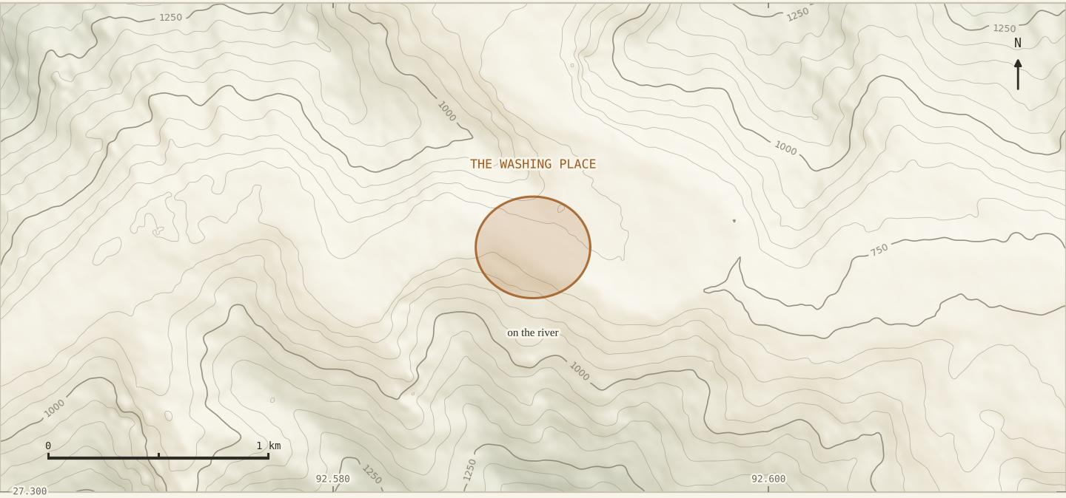
The washing place, four hundred and fifty metres west of the school and thirty-five metres below it. Recorded 2 October 2026 at 15:23.
The step, done as it is done here | What the fibre does when it is not
Lay the boiled bundle on a rock and strike it with the wooden beater, then rinse it in running water, then look at it, then strike again. Two or three rounds, and the number is set by the fibre rather than fixed in advance. | Beating round after round without rinsing in between drives the loosened skin back into the fibre instead of washing it out. Done in standing water the fibre comes out grey rather than white, and the colour does not come back.

effort and material
What the estimates tell us
Numbers make the experience clearer, but these batches were not measured experiments.
Reported estimate | What must stay attached to it
5–10 minutes for about 1 kg | For material cooked promptly and well. This is beating and cleaning time, not whole production time.
About 30 minutes for 1–2 kg | For material left in sun before boiling and harder to clean. Batch sizes and conditions differ.
2–3 kg material gives about 0.5 kg fibre | A conversational estimate. Input stage and input / output moisture are not securely established.

The limit is in the hand
The reason there are estimates here rather than measurements is not an oversight, and when it was pressed the answer was exact. Asked whether the ash could be weighed, Harnam said there is nothing in the house to weigh it with, and then said the thing that matters: hum apna haath mein limit hota hai — our limit is in the hand. He knows how much to put in by looking at it.
That is not a gap in the knowledge; it is the form the knowledge takes, and the same form as the clay chosen by feel and the fibre judged done when it is white and smooth. The reason to put a number beside it is not that the hand is unreliable — it is that a hand cannot be printed, and somebody learning this from a page has no hand yet. The number is a translation of his judgement and comes after it. See page 8.
Taan
Describing what happens to bark that dries out before it reaches the pot, Harnam reached for a word of his own, unprompted and in the middle of his own sentence: the fibre will not come out properly, woh taan ho jaayega — it goes tight, it goes hard. Taan is his working word for that condition, and this report takes it from him rather than offering it to him.
The step, done as it is done here | What the fibre does when it is not
Hang the washed fibre out in full sun and leave it three or four days, until it is dry all the way through and moves loosely in the hand. | Dried in shade or taken in while still damp, the fibre darkens and can go mouldy, and the clay will not take evenly on it at the next stage.

Figures given by eye
Every quantity on this page was given from experience rather than from a scale. They are the proportions a maker carries in the hand, and they are recorded here in that form because that is the form in which the craft holds them.

process 05 · drying
Letting the water leave
Three or four days of sun, and the fibre has to be fully dry before the clay touches it.
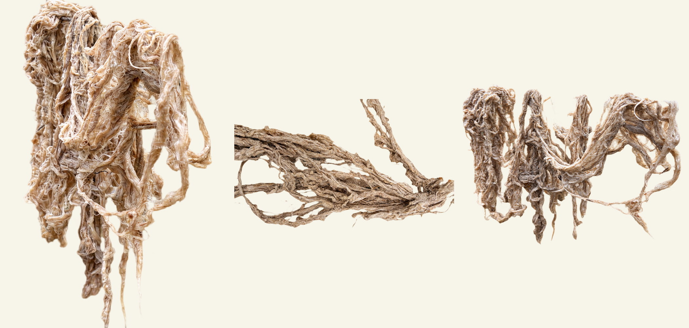
Hanks over a wire with the maize behind them, a length hanging against the house, and a whole dried lot held in one hand. Three photographs of 2 October 2026 in one frame. They must not be assumed to belong to the same batch as the river recording.
Conditions described | Time reported
Good sunshine | About one or two days.
Little or no sunshine | About five or six days; an earlier general account said three or four.
Above a fire | Tried, but the smoke discoloured the fibre and it was disliked.

Different drying times can reflect weather or different batches; they are not automatically contradictory. On the next batch, record when drying starts, where the fibre is hung, each weather change, and the sign used to decide it is dry.
No timed drying trial, final moisture measurement or comparison of drying methods is established by the available material.

process 06 · the face
Getting the clay out of the hill
The last unseen stage had no place, no tool in use and no account of itself. On 7 October it got all three.
For three weeks the clay was a sentence — thoda sa raasta mein, somewhere along the way: a step everybody agreed happened, at a place nobody outside the household could point to. On the afternoon of 7 October two such places were driven to, and the material was levered out of one of them with a bar.
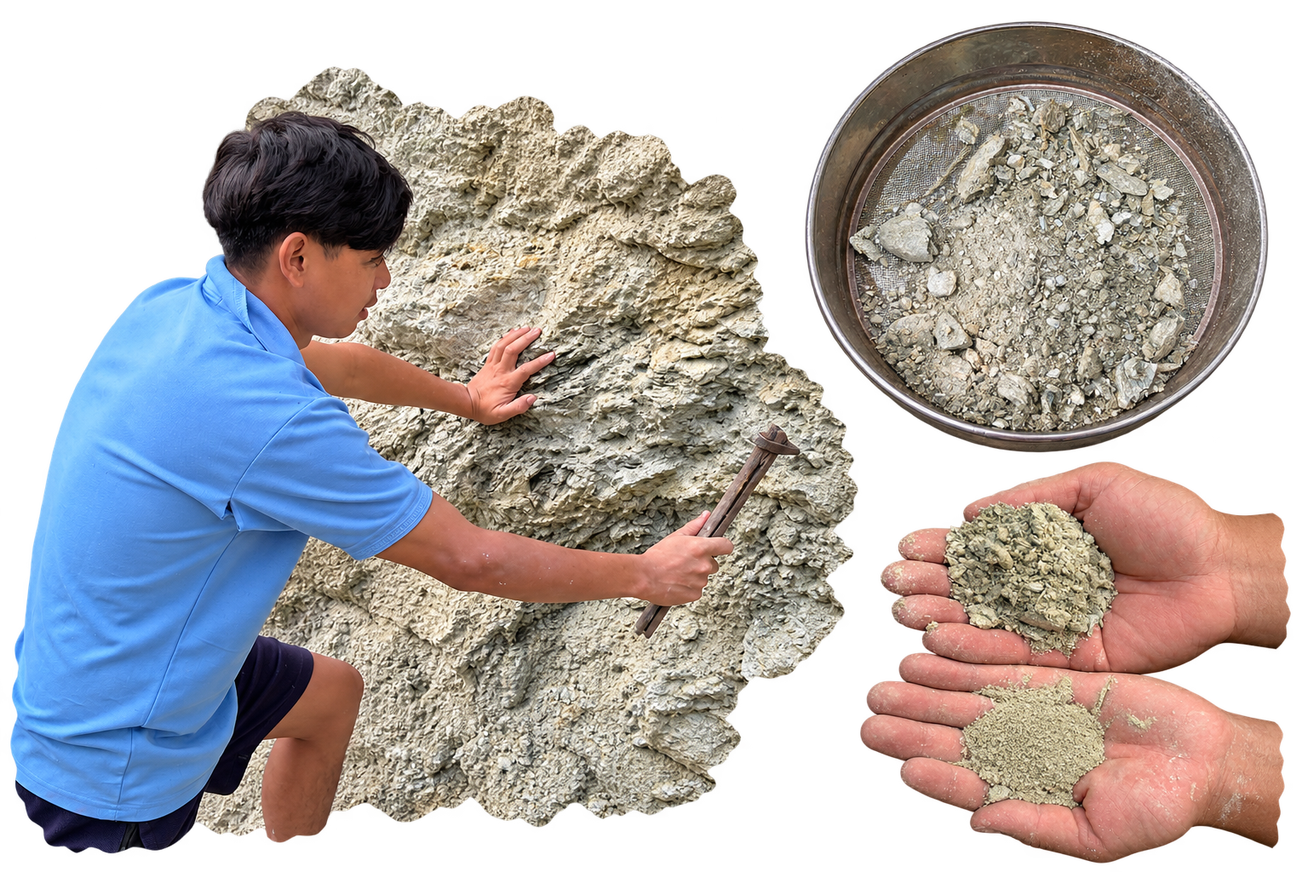
Levering the material out of the roadside face, the sieve with the coarse fragments left on the mesh, and the two grades in two hands. 7 October 2026.
1 A bar, not the Zhakham  A long iron bar is driven in along the soft band and levered. The named tool for this job is the Zhakham, a small hoe; it is not what was used. | 2 A pale layered band  Pale grey-white rock in thin layers, soft enough to lever, set in a harder face around it. | 3 Coarse out, fine through  Thin plates stay on the mesh; the fine grey-green powder falls through.

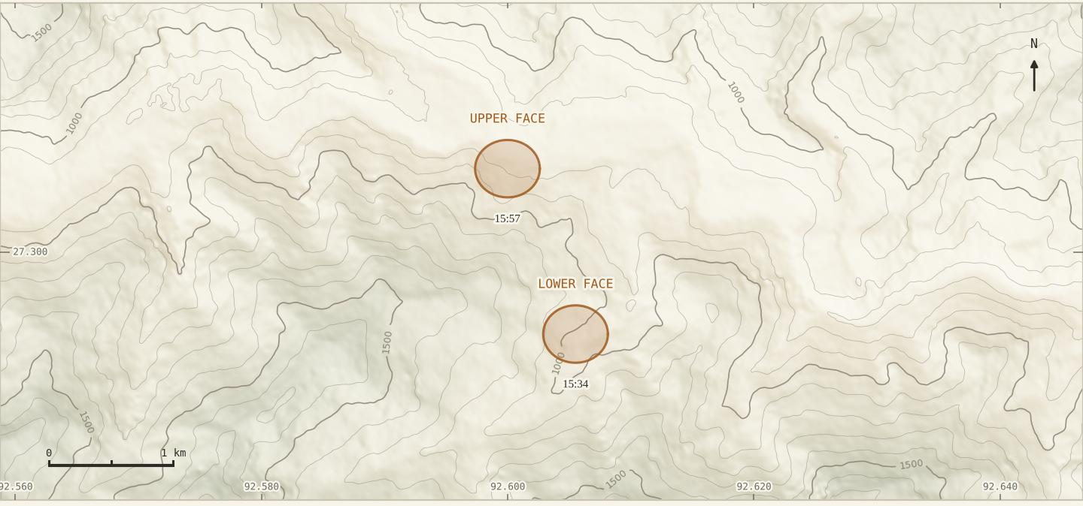
The two faces, 1.44 km apart with a hundred and ninety metres of height between them. Both on the road, both used. 7 October 2026, 15:34 and 15:57.

map 04 · the working ground
Every place the fibre comes from
Four kilometres of hillside holds all of it: the plants, the clay, the water and the two houses the work is done at.
The whole craft fits inside one view. From the village at eight hundred metres the ground runs south-east past Harnam Hagam’s farm, where the Shaungmauh is planted at the house, to a small water stream with the two new fibres on both of its banks. The two clay faces sit between the village and the stream, on the road, about 1.44 km apart with a hundred and ninety metres of height between them. Beyond all of that the ground climbs to Khamlueung, and the wild plants come one after another as it rises.
Walking that rise is the clearest thing on the map. Shaung Bamung begins at 1,331 metres, Shaung at 1,346, Hanchaw at 1,401, and at 1,408 all three grow together in quantity. Seventy-seven metres of height separates the first from the last, one walk crosses the entire wild range of the craft. Lichini sits over the shoulder beyond it. Nothing here is far: bark can be cut and carried down in a morning, which is what the material needs, because bark that dries before it reaches the pot goes taan.
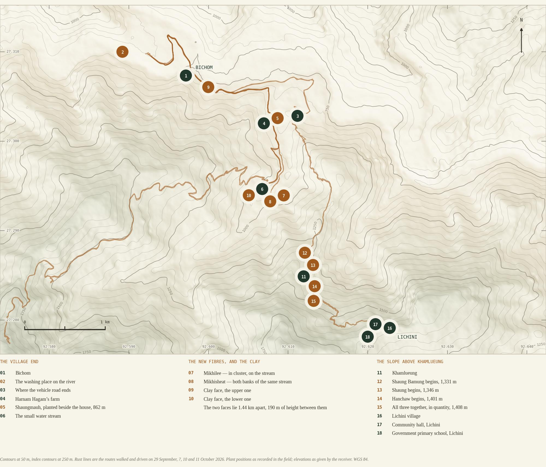

process 06 · sai
Breaking it, and putting it through
A material chosen by hand, and an action with a name of its own.
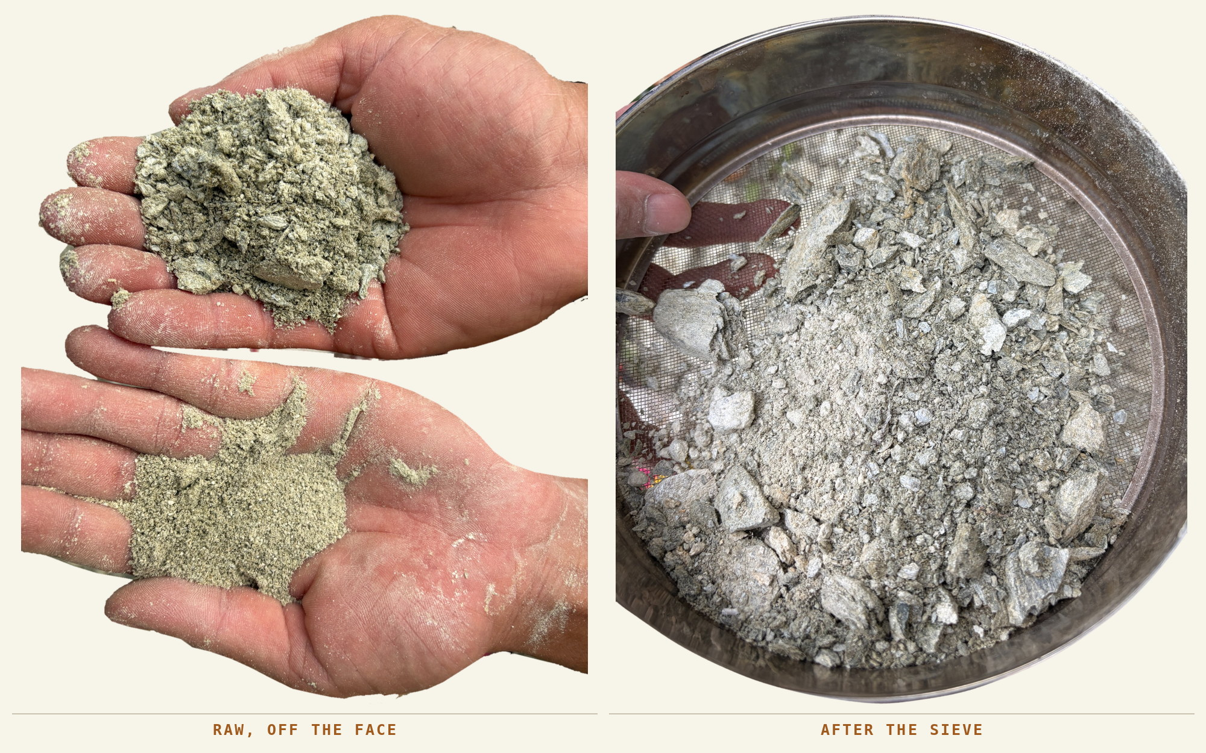

What comes off the face cannot be used as it comes. It goes through the Dhasai, the same sieve that takes the lumps out of the ash, and the action has a name of its own: to sieve is Sai. The word for sieving sits inside the word for the sieve.
Soft, slippery, silky
He chose this face for reasons that are all about touch: it is soft — mulaayam — and it is slip, his word, in English, in the middle of a Hindi sentence. Sieved, it is bahut smooth.
The property he selects for is the property the fibre needs. Dried bark is stiff and the strands catch on each other; a fine slippery powder worked in lets them slide and separate, which is what has to happen before anything can be spun. “Soft and slippery” is a specification, not a taste.
He is also not alone in it. In Nepal the same stage has a name: after the ash boil, allo fibre is rubbed with kamero mato, a micaceous clay, to lubricate the strands, then sun-dried and dusted off. Among the Rai of Sankhuwasabha it is done in roughly equal weights of clay and fibre, and about two-thirds of the households asked still did it. That is this sequence, step for step (R4).
The step, done as it is done here | What the fibre does when it is not
Lever the soft pale band out of the face, break it down, and put it through the Dhasai until only the flour falls through. Keep what falls; the plates left on the mesh are not used. | Material used as it comes off the face scours the fibre instead of lubricating it, and the thin plates in it cut the strands rather than sliding between them.

Learned, not inherited
Nobody taught him where to find this. Hum khud seekha hai — he worked it out himself. The step is older than the search; the search supplied the local source, and the hand that judged it.

process 06 · the material
What the clay actually is
Everything about it in the hand says one thing, and everything about it in the ground says another.
In the photographs it behaves as rock, not as the clay of a riverbank. It has to be levered out of a face, it breaks into flat splintery fragments with the layering still in them, and sieved it is gritty and faintly green rather than smooth and plastic. What stays on the mesh is a pile of thin plates. That is not a contradiction: a layered rock weathering in place is exactly where clay minerals form, and what is being dug is that face at the stage where it has gone soft enough to cut and not yet soft enough to squeeze. The working word for it is clay because of what it does in the hand.
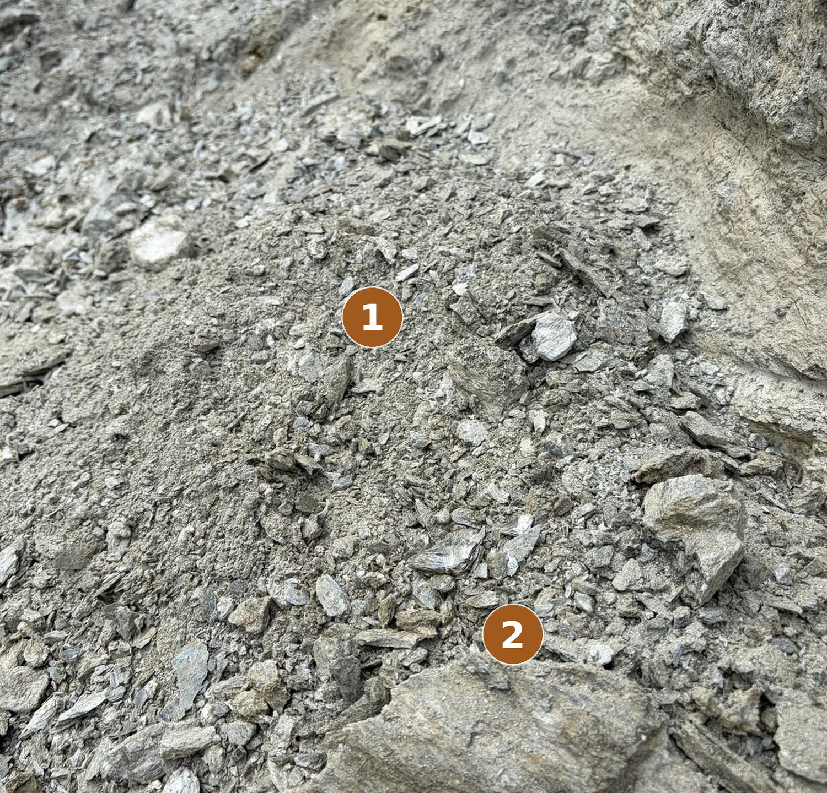
The broken material at the foot of the face, 7 October 2026. Unaltered photograph; the numbers are laid over it.
1 Plates, not crumbs  The fragments break flat and thin, the way a layered rock breaks and not the way a clay behaves. | 2 The layering survives  In the larger pieces the banding of the parent rock is still there in the broken face.

Soft, slippery, silky and pale is how a talc- or mica-rich weathered band behaves in country like this, and that would account for the hand test exactly: a ground mineral rather than a clay. It is quarried like rock and it works like flour.
Why the word matters
Whatever this material turns out to be, it behaves in the hand the way the work requires: it sieves to a fine powder, it damps to a paste that stays on wet fibre, and it leaves the fibre when struck dry. Those are the properties the process uses. The mineral name is a separate question, and the report leaves it open rather than settling it from a photograph.

process 07 · the paste
Working the clay in
The same pan, dry and off the fire, and a judgement made entirely by hand.
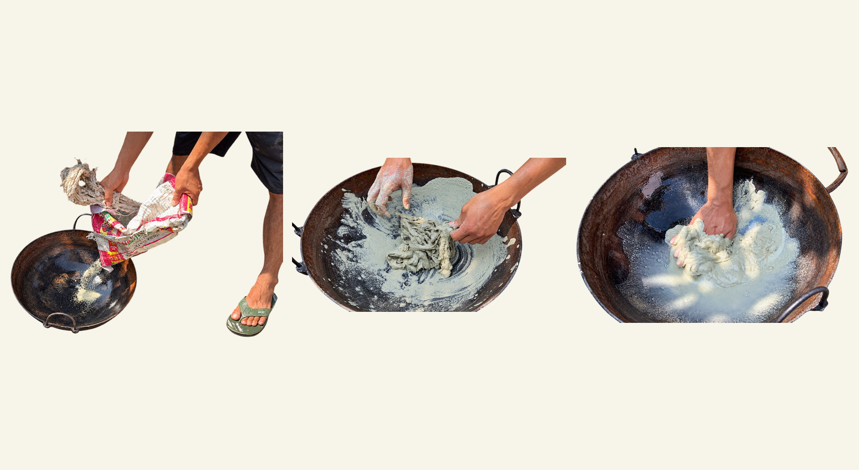
The sieved powder tipped into the pan with the washed fibre waiting above it; the paste worked up with water; and the fibre pushed down into it by hand. Bichom, 8 October 2026.
The fibre had been three or four days in the sun and came out of a rice sack. The clay had been fetched the day before, so quarrying and using it are separate journeys on separate days. Both go into the iron kadhai — the same pan the bark was boiled in, now dry, off the fire and standing on the washing slab outside.
Water goes in ek limit mein, within a limit. Not much: zyaada paani nahin hona hai. There is no measure for it and he does not look for one; it is the same hand that knows how much ash to put in the pot. Then the fibre is pushed down into the paste and worked through it with the whole hand until it is covered — achhe se mitti lagaana hai — and lifted out grey-green and heavy.
The step, done as it is done here | What the fibre does when it is not
Dry pan, off the fire. Sieved clay in, then water within a limit, worked up to a paste. Push the dried fibre down into it and work it through with the whole hand until every part of it is covered, then lift it out grey-green and heavy. | Too much water and the paste runs off the fibre and does nothing to it; too little and it will not take hold at all. Wherever the coat is thin the fibre comes out of the beating still stiff, and that patch will not card.

Source: field recording and photographs, Bichom, 8 October 2026 (F9).

process 08 · the second drying
Six days, and then it is beaten out
The clay is not rinsed away. It is left to do its work, and then struck out dry.
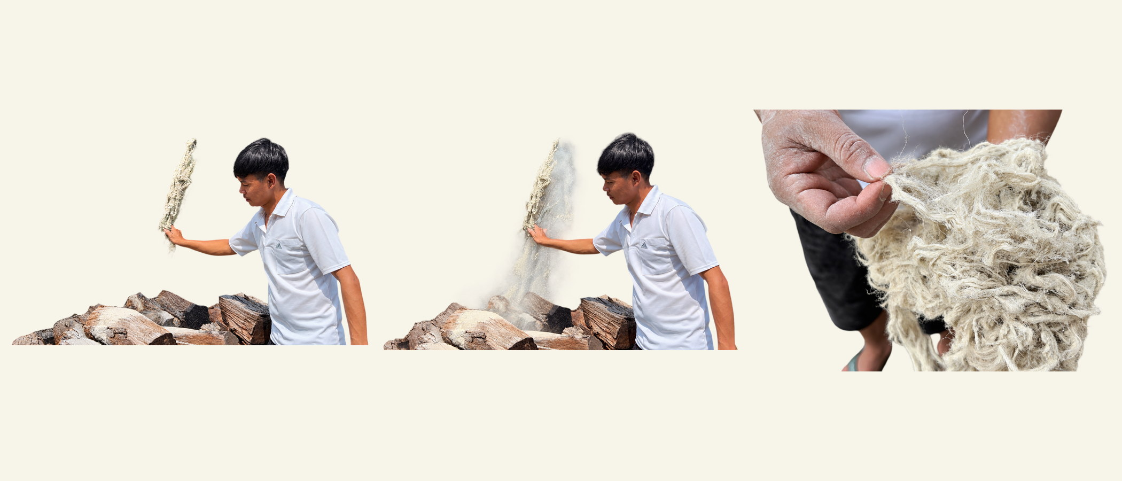
The dried hank lifted, the clay coming off it as dust under the beating, and the fibre opened in the hand afterwards. Bichom, 8 October 2026.
Coated, it goes back into the sun — and this is a much longer drying than the first. Six days with good sun, about a week without. It came off the wire after five or six days and it comes off stiff: the hank in the first frame is rigid, cracked and the colour of plaster.
Rain is the one thing that ruins it. mitti chala jaayega to phir kharaab ho jaayega — the clay goes and the batch is spoiled. So the clay must stay in while it dries, and then it is taken out dry, by striking the hank against a hard surface until the dust flies off. He says there is a proper place for this and his is out of use, so it was done against the woodpile.
The step, done as it is done here | What the fibre does when it is not
Back into the sun, coated, for five or six days with good sun and about a week without. It comes off the line stiff, cracked and the colour of plaster. Then strike the hank against a hard surface until the dust stops coming off it. | Rain is the one thing that ruins it: the clay washes out before it has done its work and the batch is spoiled. Beaten before it is properly dry, the clay smears instead of falling away, and what stays in the fibre has to be carded out later.

Source: field recording and photographs, Bichom, 8 October 2026 (F9).

process 09 · carding
Carding
The last opening of the fibre before it is spun, and the one place where the tool decides the result.
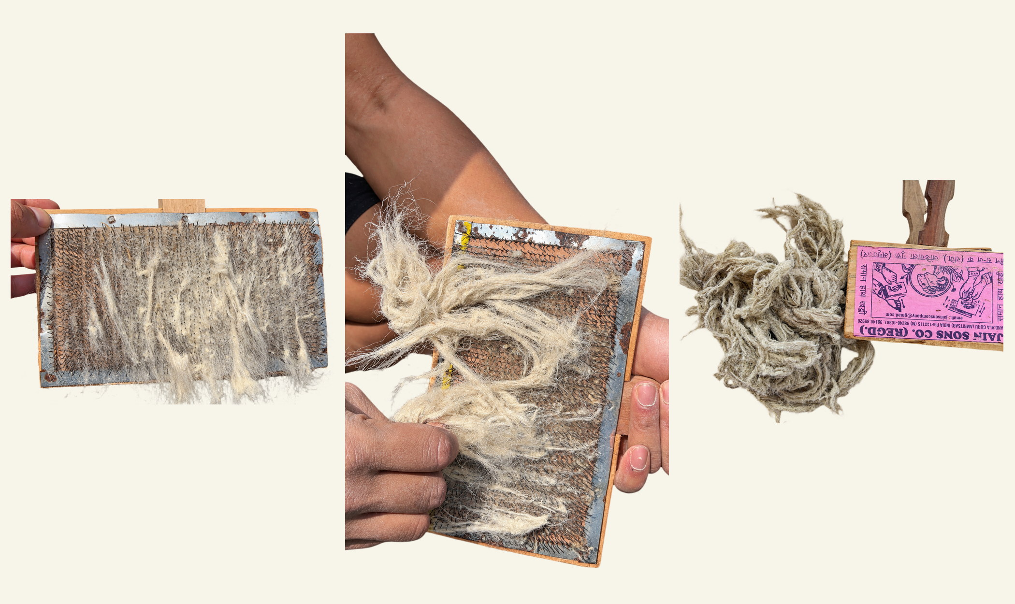
The fibre laid across the teeth, the pair drawn against one another, and the card filling.
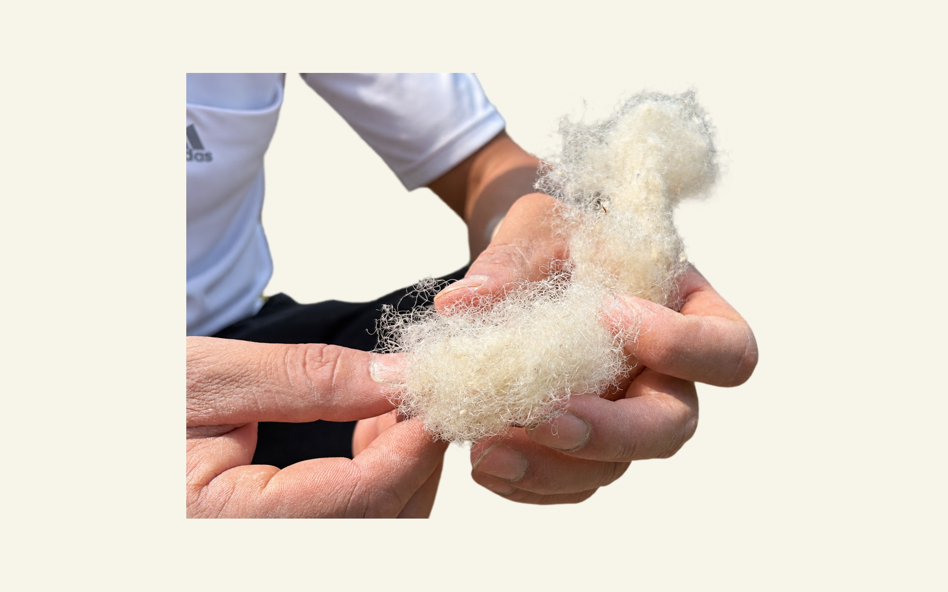
What comes off them: the fibre opened, aligned and clean.
A handful is broken off — limit mein, itna hi lagta hai, within a limit, this much fits — and drawn between the cards. He named all three things it does, and the third is worth noticing: jo chamda saaf nahin hua wo bhi niklega, the skin that did not come off comes off here. The outer bark survives the pan, the river and the clay, and is still being taken out at the ninth stage.
The step, done as it is done here | What the fibre does when it is not
Break off a handful — as much as the card will hold — lay it across one card and draw the other against it. It does three things at once: opens the knots, takes out the clay the beating left, and lifts off the skin that survived the pan and the river. | Cards with blunt or bent teeth leave kaanti, neps, right through the carded fibre, and nepped fibre cannot be drawn evenly however carefully it is spun. Too large a charge and the teeth only comb the surface of it.

The cards come as a pair. No Bugun word has been offered for them, so in this report they are the cards, and the action is carding, which is what he calls it too.
Source: field recording and photographs, Bichom, 8 October 2026 (F9).

tool plate 02 · the last cleaning
The tool that finishes the cleaning
Everything the pan, the river and the clay left behind comes out here. After this there is only twist.
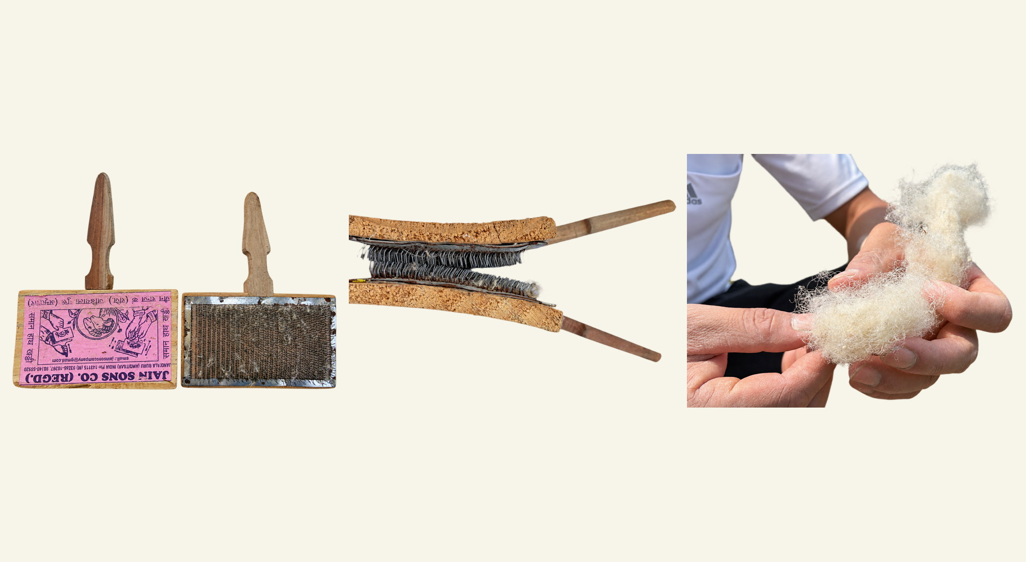
The pair of cards seen from both sides, the teeth meeting when the two are drawn together, and the fibre that comes off them. Bichom, 8 October 2026.
The cards work as a pair: a bed of wire teeth set in board, one held and the other drawn across it. No Bugun word has been offered for them, so here they are the cards and the action is carding, which is what he calls it too.
What the cleaning removes
Four things come off on these teeth — the three he named, and the short fibre that falls away with them — and between them they say what every earlier stage left behind. The remaining clay, the dust the beating did not knock loose. The skin — jo chamda saaf nahin hua wo bhi niklega — the outer bark that has now survived the pan, the river and six days under the clay and is still coming out at the ninth stage. The short and broken fibre, falling away from the long. And the knots, the kaanti, opened or combed free.
What stays on the card is fibre of one kind: long, parallel, clean, loose enough to draw. Everything up to here has been removal — gum, skin, water, clay — and this is the last of it. Nothing is added after this point; it is only twisted.
The step, done as it is done here | What the fibre does when it is not
Take as much as the card holds and no more. Lay it across the teeth and draw the second card against it, lightly first and then firmer, lifting the fibre back and drawing again until it comes off in one open, even mass. | Overload the card and the teeth comb only the surface, leaving the inside of the handful as matted as it went on. Draw hard on fibre that is not fully dry and it breaks instead of combing, turning long fibre into short.

In other bast traditions this work is split between two tools: a hackle or comb, which pulls out the short tangled fibre and leaves the long, and a pair of cards, which opens the mass before spinning. One pair of cards does both jobs here.

process 10 · the spindle
Chhauk
A bamboo shaft, a seed for a whorl, and the end of the chain.
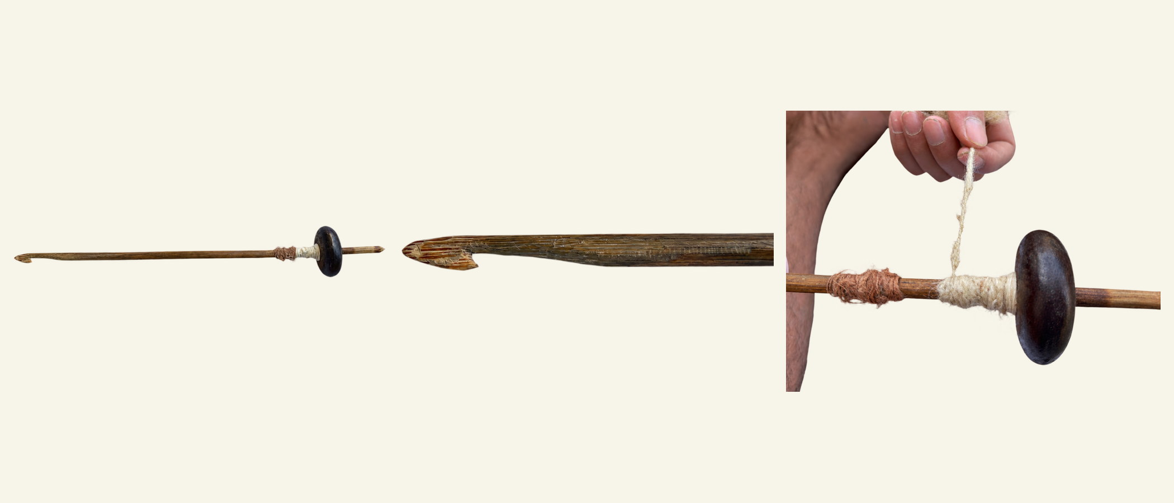
The whole spindle; the hook cut into the head of the shaft; and both threads wound on the one shaft, brown behind pale. Bichom, 8 October 2026.
1 A hook, cut in  The leading thread catches in a hook carved into the bamboo shaft. | 2 Tachhai — a seed  Not turned wood. ye ek seed hai — a seed of something, and he does not know the plant. | 3 Both plants, one shaft  Brown Shaung below, pale Hanchaw above.

The spindle is Chhauk, given in Bugun; the whorl is Tachhai, which he first said longer, as Tachhairang. These are the only two Bugun tool names in the last four stages, and both belong to the one tool made here: bamboo from the valley, a seed for a flywheel, a hook cut with a knife.
Field recording and photographs, Bichom, 8 October 2026 (F9). Neither spelling has yet been given letter by letter.

process 10 · the thread
Thread, and which plant it came from
The chain closes, and the finished thread turns out to carry its own evidence.
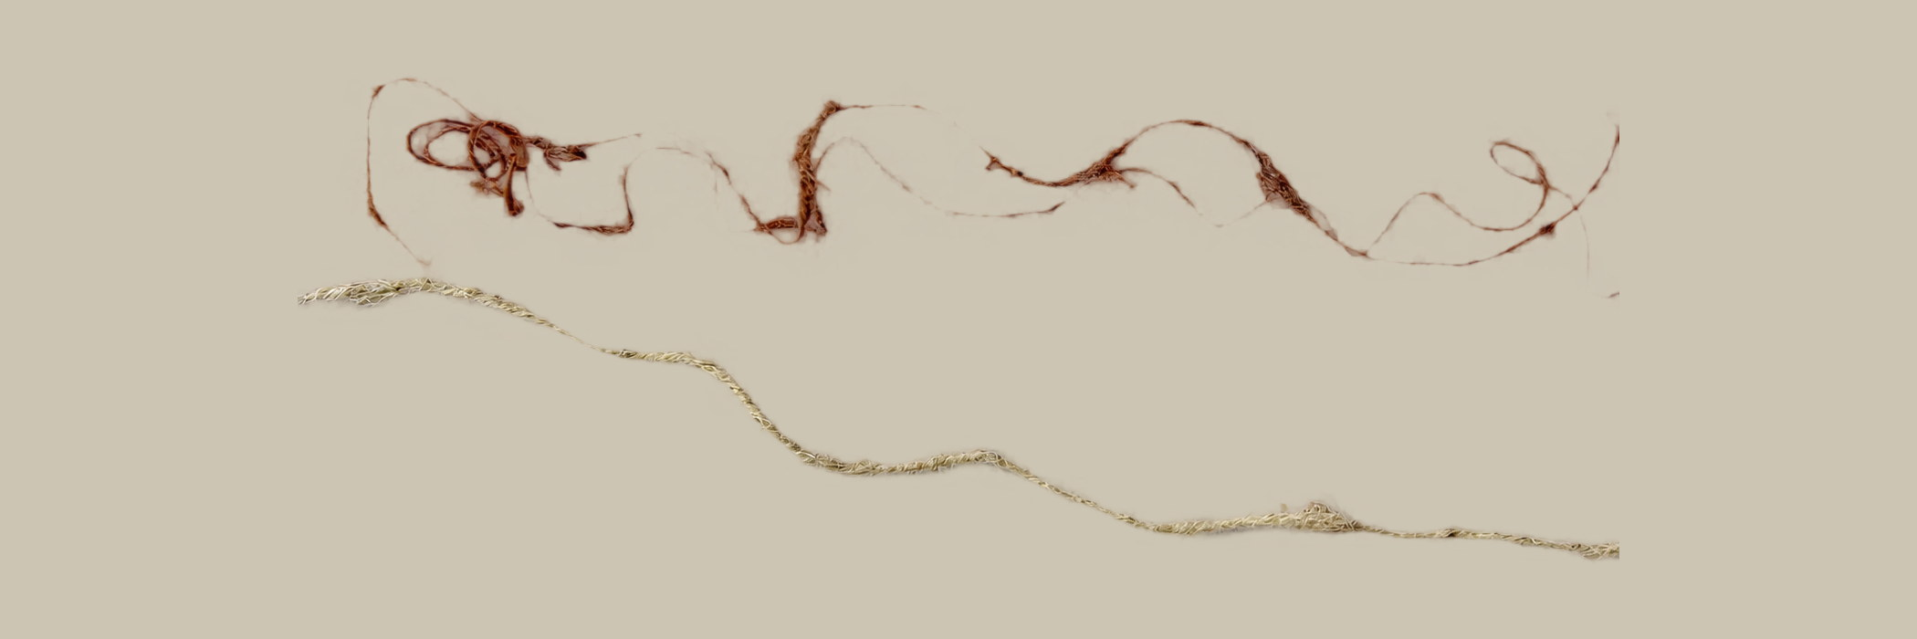
The two finished threads laid out together on a toned ground, so the pale one can be seen: Shaung above in brown, Hanchaw below in cream. Bichom, 8 October 2026.
Shaung spins brown and Hanchaw spins pale. He pointed at the two threads on the shaft and said so — Shaung ka colour thoda brown mein dekhne milega — and they lie side by side in the photographs, one rust-coloured and one cream. It is the only character in this record that can be read off a finished object; every other way needs the plant, the bark, or the person who cut it.
The step, done as it is done here | What the fibre does when it is not
Draw a little of the carded fibre out, let the Chhauk turn, and keep the draft even so the twist runs into a thread of one thickness. Wind on against the whorl and draw again. | Any kaanti left in from the carding stops the draft where it sits, and the thread goes thick and thin on either side of the knot. The fault is upstream: one good pair of cards changes the thread at this end of the chain, and costs almost nothing.

transmission
Why the cloth stopped
One elder’s answer: nothing was banned and nothing was forgotten. Something quicker arrived.
An elder at Lichini answered this in about four sentences, without being pressed. What follows is his account of it.
Ask him where thread came from and he does not begin with a plant. “Dhaaga pehle… hum log Assam se leta hai.” Thread — we used to get it from Assam. It came up the hill with salt, betel, beads, needles, cloth and a red blanket, and it came ready-made. Making it yourself takes time. The bought thing is there at once.
He places that five or six generations before his own lifetime. He never watched the cloth made. What he saw as a boy was one piece of it: his father wore a cloth underneath and tied another over the top. He has neither now, and he cannot make them.
The same reason, about something else
Ten days earlier, at the year’s fish harvest, bleaching powder went into the water instead of the old root. Asked why, the answer was not that the root had been forgotten or that the plant had gone. It was that the root takes time and the powder is there at once — the same reasoning, about a different craft, from different people.
One account, not a history
This is one man’s explanation, offered without being pressed, for something he places well before his own lifetime. No other cause was named by anybody, and nobody else has yet been asked the question at all.

Sources: Lichini interview, F2; fish-harvest notes, 20 September 2026.

the object
What was made from it
One object described, one piece of clothing remembered, and a name that did not hold.
The archer’s hand-piece
One object came out of the field work with a use attached to it: a cloth made thick, and made well, and kept on the hand for shooting — teer maarne mein, for loosing an arrow. A woven hand-piece made from their own thread. That is a made thing with a job, not a general word for cloth, and whether one still exists anywhere in the four villages is a question with a short answer: somebody has one in a box, or nobody does.
The name is a different matter. Put to Harnam Hagam on 7 October, with the written form in front of him, he did not recognise the word at all — Pathyang nahin pata hai. So the object stays in this report, because it was described to the project by somebody; the name is not carried in the plant and tool lists, because the speaker who was asked does not use it. Two accounts that differ are kept apart rather than averaged.
And the clothing
The elder’s father wore two pieces, one underneath and one tied over. A thesis on Bugun religious identity records a wider dress vocabulary that this field work has not heard: weaving is Murrock; a woman wears Shingkhou with the coat Ranjiong Padhak, belted with Rathang; a man wears Rugut and wraps his legs in ranath; a bag is Bhua.
A gap worth noticing
That same thesis names the only cloth fibre it knows as silk, and records Eri Chaddar coming in by barter from the Sherdukpen and Monpa. A document that knows seven Bugun words for garments records the cloth as bought in. Which is exactly the gap this work is standing in.

Dress vocabulary: doctoral thesis on Bugun religious identity, ch. II.

the thread that did not stop
A thread tied on a newborn
The cloth ended. On this evidence the thread did not.
Everything above is about cloth, and about cloth the elder is right. But a doctoral thesis on Bugun religion, built on interviews across this sub-division between 2022 and 2024, contains one sentence in a list of birth rituals that nobody looking for a textile would ever find.
“A new thread made from Sowang — a fibre obtained from the bark of a locally known tree called Sowang — is tied around the baby’s waist. The women of the village perform this ritual.”
Tashek-Shia, performed four days after a girl is born and five days after a boy. Quoted as printed, chapter III, printed page 104.
Read exactly what is in it, and no more. A thread, described as new, so it is made for the occasion. From the bark of a named plant. The plant and the fibre share the name Sowang. And the women of the village perform the ritual — which is what the passage says, and all it says. Who makes the thread is not in it.
Sowang is Shaung
The correspondence this report could only guess at has now been put to a speaker. Shown Sowang and Shaung together and asked which was right, Harnam read them as one word and said so plainly: it is the same thing, and which you write depends on how you say it — pronunciation ke oopar hai. A language with no script carries its names in the mouth, so the spelling moves and the plant does not. The thread in that birth ritual is made from the bark of Shaung, the second plant in this report.
And then the other half did not follow
What does not follow is the rite. Tashek-Shia was not known to the man asked. Harnam had not heard it — woh shayad hota bhi hoga par humko bhi itna pata nahin hai, it may well happen, we do not know of it. Whether a thread is tied at a birth here, he could not say, and one person’s answer is one person’s answer.
But something surfaced while he was saying no. Pressed once more on whether any cord is made when a child is born, he gave a word that is in neither the thesis nor any earlier list: Jya — Jya hai, ek rassi hota hai woh. Jya is a cord. That is the whole of what is known about it, and it arrived in the middle of a denial, which is often where the useful thing is.
What ended was the garment
A craft that supplies clothing competes with a mill and loses, which is the reason the elder gave. A craft that supplies one thread for one newborn competes with nothing: no loom, no dye, no scale, no market, and one household can carry it.

Thesis on Bugun religious identity, ch. III p. 104, quoted as printed. Sowang, Tashek-Shia and Jya: naming session, 7 October 2026.

memory and transmission
Transmission without a teacher
A failed attempt, an easier grip and a word taken back are not lapses in the knowledge. They are the knowledge, in the only form it comes in here.
Transmission ordinarily runs from a teacher to a student, and a practice that loses its teachers is usually described as broken. What is happening at Bichom is something else: two men without a living teacher are recovering a paddhati, a way of doing, by putting the material in their hands and letting it correct them. The corrections are visible in the record, and they are the most valuable part of it.
Three small learning stories
The first boil came off too soon. The later cleaning was difficult, and the next boiling time changed.
The beater was reshaped. A flat, bat-like form was made easier to hold, while a round wooden tool was remembered.
A word was taken back. Working through the vocabulary a second time, Harnam reached for his own term for a condition of the fibre instead of the one on the sheet, and that is the word this report keeps.
Negotiation is not a departure from tradition
The field record shows people trying, explaining and adjusting. It does not show an intact method being copied without change, and it should not be read as a thinner version of one that was. Every generation of a practice negotiates what it remembers against the conditions in front of it, and that act of negotiation is the core value of a tradition rather than a falling away from it. Present choices and remembered practice both stay visible in these pages, on purpose.

Work fitted around other work
An earlier conversation describes gathering material while farming and processing it at home in mornings or evenings. Only some people made fibre. If thread was needed, it could be obtained from somebody who had it. Prices, dates and the households involved remain open.
“Apne ke liye.” — “For myself.”
An elder at Lichini, asked whether he would make it if it were taught again. The answer sets the first market for this fibre, and it is a local one: a practice is sustained by the people nearest to it before it is sustained by anybody else.

reading beside the fieldwork
What other sources add
Comparisons help us ask better questions. They do not supply missing Bugun steps.
Source | Useful contribution | Limit
Basar, unpublished RGU thesis | A published description of Bugun fibre work: bark of Rusa, Hochong and Chaura soaked in shallow water three to four months, then beaten on stone. | A different method from the one watched here. No pot, no ash. Sourced to one Singchung interview in 2017.
Thesis on religious identity, ch. III | A new Sowang bark thread tied on a newborn in the Tashek-Shia rite, which the women of the village perform. | Sowang is confirmed at Bichom as Shaung. The rite is not: Tashek-Shia was not known to the one speaker asked. The passage does not say who makes the thread.
Gurung et al., 2012 | A detailed account of Himalayan nettle use and processing at Sikles, Nepal. A model for recording tools, actions and social roles. | Do not transfer its timings, quantities, gender roles or species identification to Bichom.
Ethnobotanical study, 2023 | Names informants, sites and botanical vouchers. Bugun field work at Wanghoo and Singchung. | Its single Urticaceae record is Urtica dioica, eaten as a cooked vegetable. No fibre use, and no local plant name anywhere in the paper.
Wilson, SOAS, 1970 | A dated documented negative, citing Elwin: the Bugun have no weaving. | Contradicted by the dress vocabulary and by the archer’s hand-piece. Worth citing as a measure of what outsiders recorded.

Two routes, and a way to settle them
One recorded account soaks the bark for months; the demonstration here boils it with ash in an afternoon. Neither is a general Bugun recipe and neither needs to be declared wrong on paper. Ret a bundle beside a boiled one, spin both, and the thread will say which the plant answers to — which is how a craft settles its own history without anybody outside it adjudicating.

working vocabulary
Keep the local word with its source
Spellings given letter by letter on 7 October with the written variants in front of the speaker, the last two said on 8 October. Working transcriptions, not a standardised Bugun dictionary.
Word | Meaning / use here | Status
KHINYA | A nettle — any plant that stings when held | Settled. Covers the stinging plants; not a name for a particular one.
HANCHAW | A stinging fibre plant | Settled. Hanchong is the same plant said differently; both spellings accepted.
SHAUNG | A wild fibre plant that does not sting | Settled, chosen off a sheet of variants. Sowang is this word.
SHAUNGMAUH | The cultivated fibre plant at the house | Settled; one word. Mauh alone means nothing.
SHAUNG BAMUNG | A small plant within the Shaung group | Settled, named on 7 October.
SHAUNGKAAN | A Shaung not found here now | Settled as a name. No plant.
KHOW · PHAM | Water · mountain | Settled, through Diga Khow, Khatong Khow, Khowlut and Pham Kho.
SAI | To sieve | Settled at the clay face. Compare Dhasai.
DHASAI | The sieve, for clay and for ash | Settled. Anything that sieves is commonly a dasai.
BARAIE · ZHAKHAM | The cutting blade · the clay-digging tool | Photographed. A bar stood in for the Zhakham on the day.
DHATAU / DATHAW | The carrying bag | Written one way on his sheet and said the other; both are his.
BAJARAT | Oak; the firewood whose ash is used | Settled, and it is not bamboo.
JYA | A cord | New, and barely known. Offered when a birth thread was asked about.
NIMIYANG | The public; the people | Thap Nimiyang is the village public, Thap the village.
PHAVI | The priest | Written Phabi elsewhere. Samuie is his assistant.
CHHAUK | The spindle | New, 8 October. Bamboo, made here.
TACHHAI | The whorl — a hard seed | New, 8 October. Also given longer, as Tachhairang.
— (beater, cards) | The wooden bat; the carding pair | No Bugun name given for either.

Kadhai is Hindi. Where no Bugun name was given, this report uses the plain English word rather than leaving a blank.

glossary of technical terms
The second vocabulary, kept here
What these steps are called in textile language, gathered in one place.
The report is written in the words used at Bichom. A second vocabulary describes the same actions — the one used in textile science and in development work. Where a trade term earns its place in the account it is used there; the rest are gathered here, because a term set beside a maker’s words tends to look like a correction of them.
In this report | The term elsewhere | What the equivalence does and does not carry
Peeling the bark off the green stem by hand | Stripping; decortication | Separating the inner bark from the woody core. Done green and by hand here, so the stalk never has to be broken first.
Boiling the bark with sieved wood ash | Alkaline degumming | Ash in water is a mild alkali. The step loosens the gums and pectins binding the fibre bundles to one another and to the bark. The equivalence is to the purpose, not to a concentration, a temperature or a time.
The bark, and the fibre taken from it | Bast fibre | The long fibre lying in the inner bark of a stem, as against fibre from a seed or a leaf. All the plants here give bast fibre.
Soaking bark in shallow water for months, in the other recorded account | Retting | Breakdown in water over time rather than in a pot over a fire. A different route to the same separation, and the reason the two accounts are worth testing against each other.
Beating the boiled bark against a rock with the wooden beater | Scutching | Striking softened bark with a blunt tool to scrape the fibre clear of what the boil loosened. The same action, under another name.
Working the sieved clay through the dried fibre and striking it out dry | Mineral dressing; lubrication | A fine powder worked between the strands so they slide and separate instead of catching. Not a wash and not a dye: it is put on, left while the fibre dries, and taken off again.
Drawing the fibre across the toothed boards | Carding | Opening and aligning the fibres and taking out what the earlier stages left. The word is his own; the tool has no Bugun name.
Combing the short and broken fibre out of the long | Hackling; tow and line | Elsewhere a separate tool and stage: the short fibre combed out is the tow, the long that stays is the line. Here the cards do both in one pass.
kaanti — the little knots that break the draw | Neps | Small tangles in the prepared fibre. He named the fault and its cause in one sentence, which is a diagnosis.
The handful lifted off the cards, ready to spin | Rolag | The roll of carded fibre a hand-carder lifts off the teeth. A sliver is the continuous rope the same web is drawn into on a machine; what comes off these cards is the roll, not the rope.
Turning the Chhauk while pulling the fibre out | Twist and draft | The two actions that make thread; doing them together is the skill.
How long one fibre runs | Staple length | Relevant to what can be spun and how fine. Nothing in this record measures it.

source trail
Where the report comes from
Every statement above can be traced back to one of nine files.
Every statement above traces to one of nine files. F1 is the 63-page Bichom fibre documentation — people, locations, plants, household, process, tools. F2 is the Hindi transcripts. F3 is the GPX exports and map data, cross-checked against the F1 register. F4 the plant photographs; F5 the household and hearth files; F6 the seven thesis chapters, whose bibliographic metadata is still not established; F7 the comparative reading; F8 the further ethnographic extracts. F9 is the material of 7 October: the clay recording, the naming sessions, and the GPX behind Map 04.
Photographic plates are the field author’s own; composite plates set several photographs on one ground and the originals are retained. The terrain maps come from the project design set, and their relief is background rather than survey.

references and continuation
A record to return to the makers
What was read beside the fieldwork, and where it sits in relation to it.
R1 · Revival already underway
Chetry, Prem. “Men on a mission to revive extinct fabrics.” The Arunachal Times, 26 April 2026. Names Harnam Hagam and Cheten Lagiyang, and Adang Hagam’s guidance.
R2 · A comparative nettle study
Gurung, A., Flanigan, H., Ghimeray, A. K., Karki, R., Bista, R. & Gurung, O. P. (2012). “Traditional Knowledge of Processing and Use of the Himalayan Giant Nettle… Among the Gurungs of Sikles, Nepal.” Ethnobotany Research and Applications, 10, 167–174. doi:10.17348/era.10.0.167-174. The author list follows the article PDF; the journal’s landing page prints a shorter one.
R3 · Botanical reference
Royal Botanic Gardens, Kew. Plants of the World Online, powered by the Kew Science data. The reference used for the botanical names printed beside the local ones, and for the author citations that separate same-named species.
R5 · The theoretical ground for the unmeasured step
Mamidipudi, Annapurna. Towards a Theory of Innovation in Handloom Weaving in India. PhD dissertation, Maastricht University, 2016. Science and technology studies; work with handloom weavers and natural dyers. The source for craft expertise as somatic, for propositional knowledge having a somatic limit, and for tradition as a continuous process of innovation rather than its opposite.
R6 · The body as archive
Lepecki, André. “The Body as Archive: Will to Re-Enact and the Afterlives of Dances.” Dance Research Journal 42, no. 2 (Winter 2010): 28–48. Written about dance, not craft. Used here only for its central claim: the body is not a storehouse holding a past intact but a system that transforms what passes through it.
R4 · The clay parallel
Barakoti, T. P. & Shresta, K. P. “Commercial Utilization of Allo (Girardinia diversifolia) by the Rais of Sankhuwasabha for Income Generation.” Banko Janakari 18, no. 1: 18–24. doi:10.3126/banko.v18i1.2162. The source for kamero mato, the micaceous clay rubbed through boiled allo before spinning, which is the closest published parallel to what is done at Bichom. The journal page spells the second author Shresta and dates the issue 2008 while the citation metadata gives 2009; both are reproduced here rather than resolved.
R7 · The two theses
Basar, Ritter. Socio-Cultural History of the Bugun Tribe of Arunachal Pradesh since Nineteenth Century. Unpublished PhD thesis, Rajiv Gandhi University. Cited as both 2021 and 2022; the year needs confirmation from the title page.
An untitled doctoral thesis on emerging religious identity among the Bugun, chapters I–VII, field work 2022–2024.

in closing
What a record like this is for, and what it is not
A practice does not survive because it has been written about. It survives because somebody can still sell what it makes, to somebody close enough to buy it, and the first market for a Bugun thread is a Bugun one. What a document can do is narrower: hold the names steady, keep a method in the order the hands do it, and leave a community with its own account to hand when somebody else arrives carrying theirs. This one is written to be read at Bichom first, and it belongs to the people whose work it describes.

Prepared from field material gathered between 20 September and 11 October 2026.

