Ansible安装
- 进入yum源
[root@qi ~]# cd /etc/yum.repos.d/

- 配置163源
[root@qi yum.repos.d]# vi CentOS-Base.repo
[163base]

name=CentOS-$releasever - Base - 163.com

baseurl=http://mirrors.163.com/centos/$releasever/os/$basearch/

#mirrorlist=http://mirrorlist.centos.org/?release=$releasever&arch=$basearch&repo=os

gpgcheck=1

gpgkey=http://mirror.centos.org/centos/RPM-GPG-KEY-CentOS-6

#released updates
[163updates]

name=CentOS-$releasever - Updates - 163.com

baseurl=http://mirrors.163.com/centos/$releasever/updates/$basearch/

#mirrorlist=http://mirrorlist.centos.org/?release=$releasever&arch=$basearch&repo=updates

gpgcheck=1

gpgkey=http://mirror.centos.org/centos/RPM-GPG-KEY-CentOS-6

#additional packages that may be useful
[163extras]

name=CentOS-$releasever - Extras - 163.com

baseurl=http://mirrors.163.com/centos/$releasever/extras/$basearch/

#mirrorlist=http://mirrorlist.centos.org/?release=$releasever&arch=$basearch&repo=extras

gpgcheck=1

gpgkey=http://mirror.centos.org/centos/RPM-GPG-KEY-CentOS-6

- 配置epel源
[root@qi yum.repos.d]# vi epel.repo

[epel]

name=CentOS-$releasever - epel

baseurl=https://mirrors.tuna.tsinghua.edu.cn/epel/6/x86_64/

#mirrorlist=http://mirrorlist.centos.org/?release=$releasever&arch=$basearch&repo=os

gpgcheck=0

- yum安装ansible
[root@qi yum.repos.d]# yum -y install ansible
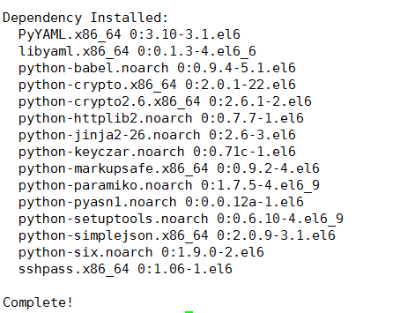

- 进入ansible配置hosts
[root@qi yum.repos.d]# cd /etc/ansible/
[root@qi ansible]# ls
[root@qi ansible]# rm -rf hosts
[root@qi ansible]# vi hosts
[slave]
192.168.121.133 ansible_ssh_user=root ansible_ssh_port=22 ansible_ssh_pass=666666

- ping测试
[root@qi ansible]# ansible slave -m ping

