修改mysql binlog日志路径

首先登陆192.168.10.26 DB3服务器上
# ps -ef|grep mysql
# /etc/init.d/mysqld stop

修改my.cnf
把log-bin=mysql-bin修改为log-bin=/data/a/mysql-bin
#sed -i 's#log-bin=mysql-bin#log-bin=/data/a/mysql-bin#g' /etc/my.cnf
#mkdir /data/a
#chown -R mysql.mysql /data/a/

#/etc/init.d/mysqld start
# /etc/init.d/mysqld status

然后登陆192.168.10.27 DB4服务器上
#vim /usr/local/mysql/data/master.info （这里有主从信息）
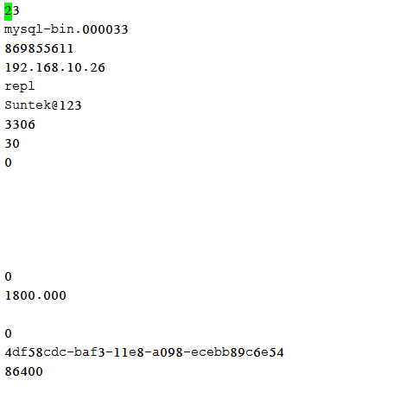

# mysql -uroot -p
#Suntek!WC123
# stop slave;

mysql> CHANGE MASTER TO
-> MASTER_HOST='192.168.10.26',
-> MASTER_USER='repl',
-> MASTER_PASSWORD='Suntek!WC123',
-> MASTER_LOG_FILE='mysql-bin.000035',
-> MASTER_LOG_POS=50800043;

#start slave;

