Openssh升级部署
- 停止服务
[root@qishengkun ~]# service sshd stop

- 备份服务
[root@qishengkun ~]#mv /etc/ssh /etc/ssh.old

- 查询卸载openssh
[root@qishengkun ~]#rpm -qa | grep openssh
[root@qishengkun ~]#rpm -e --nodeps openssh-5.3p1-94.el6.x86_64
[root@qishengkun ~]#rpm -e --nodeps openssh-server-5.3p1-94.el6.x86_64
[root@qishengkun ~]#rpm -e --nodeps openssh-clients-5.3p1-94.el6.x86_64

- 将安装包openssh-7.9p1.tar.gz解压
[root@qishengkun ~]#tar xzvf openssh-7.9p1.tar.gz

- 进入解压后的路径安装
[root@qishengkun ~]#cd openssh-7.9p1

- 编译
[root@qishengkun openssh-7.9p1]#./configure --prefix=/usr --sysconfdir=/etc/ssh --with-md5-passwords --with-pam --with-ssh1 --with-zlib --with-openssl-includes=/usr --with-privsep-path=/var/lib/sshd

如果出现此类报错：configure: error: PAM headers not found
请安装rpm -ivh pam-devel-1.1.1-17.el6.x86_64.rpm


- 编译安装
[root@qishengkun openssh-7.9p1]#./configure --prefix=/usr --sysconfdir=/etc/ssh --with-md5-passwords --with-pam --with-ssh1 --with-zlib --with-openssl-includes=/usr --with-privsep-path=/var/lib/sshd && make && make install

- 检查是否成功
[root@qishengkun openssh-7.9p1]#echo $?
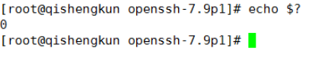

- 安装后环境配置

[root@qishengkun openssh-7.9p1]#cp ./contrib/redhat/sshd.init /etc/init.d/sshd

- 加执行权限
[root@qishengkun openssh-7.9p1]#chmod +x /etc/init.d/sshd

- 开机启动sshd
[root@qishengkun openssh-7.9p1]#chkconfig --add sshd

- 启动ssh服务
[root@qishengkun openssh-7.9p1]#service sshd start

- 判断升级是否成功
[root@qishengkun openssh-7.9p1]# ssh -V
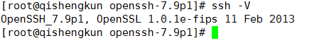

- 修改sshd_config
[root@qishengkun openssh-7.9p1]# vim /etc/ssh/sshd_config
添加PermitRootLogin yes到文件末尾
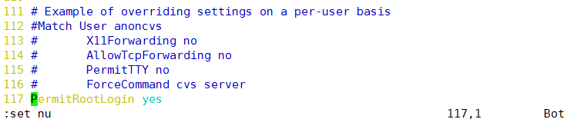

- 保存，退出重启sshd服务
[root@qishengkun openssh-7.9p1]# /etc/init.d/sshd restart

Linux升级OpenSSH7.9后无法用root加密码登陆的问题
[root@qishengkun openssh-7.9p1]# vim /etc/init.d/sshd
success || failure这一行上面加上 OPTIONS="-f /etc/ssh/sshd_config"


