Tomcat部署及升级

1. 下载完的jdk二进制包解压

[root@qi ~]# tar xf jdk-8u144-linux-x64.tar.gz -C /usr/local/

1. 给jdk做个软链接

[root@qi ~]# ln -s /usr/local/jdk1.8.0_144/ /usr/local/jdk

1. 配置Java环境变量

[root@qi ~]# sed -i.ori '$a export JAVA_HOME=/usr/local/jdk\nexport PATH=$JAVA_HOME/bin:$JAVA_HOME/jre/bin:$PATH\nexport CLASSPATH=.$CLASSPATH:$JAVA_HOME/lib:$JAVA_HOME/lib/tools.jar' /etc/profile

1. 查看一下环境变量

[root@qi ~]# tail -3 /etc/profile



1. 让java环境变量立刻生效

[root@qi ~]# source /etc/profile

1. 检查java命令

[root@qi ~]# which java

1. 看java版本

[root@qi ~]# java -version



1. 解压安装tomcat

[root@qi ~]# tar xf apache-tomcat-9.0.5.tar.gz -C /usr/local/

1. 给tomcat做软链接

[root@qi ~]# ln -s /usr/local/apache-tomcat-9.0.5/ /usr/local/tomcat

1. 配置tomcat环境变量

[root@qi ~]# echo 'export TOMCAT_HOME=/usr/local/tomcat' >> /etc/profile

1. 立即生效

[root@qi ~]# source /etc/profile

1. 对jdk及Tomcat安装目录递归授权root

[root@qi local]# chown -R root.root /usr/local/jdk/ /usr/local/tomcat

1. 检查全局变量

[root@qi local]# tail -4 /etc/profile

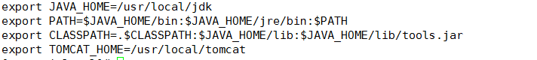

1. 启动tomcat

[root@qi local]# /usr/local/tomcat/bin/startup.sh

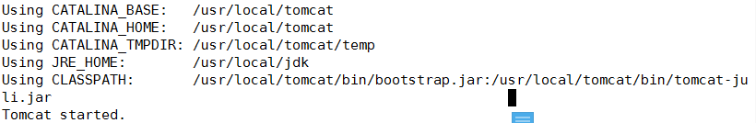

1. 检查tomcat是否存在

[root@qi local]# netstat -antlp|grep java

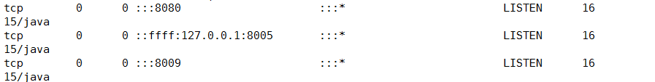

1. 登录web。ip：port

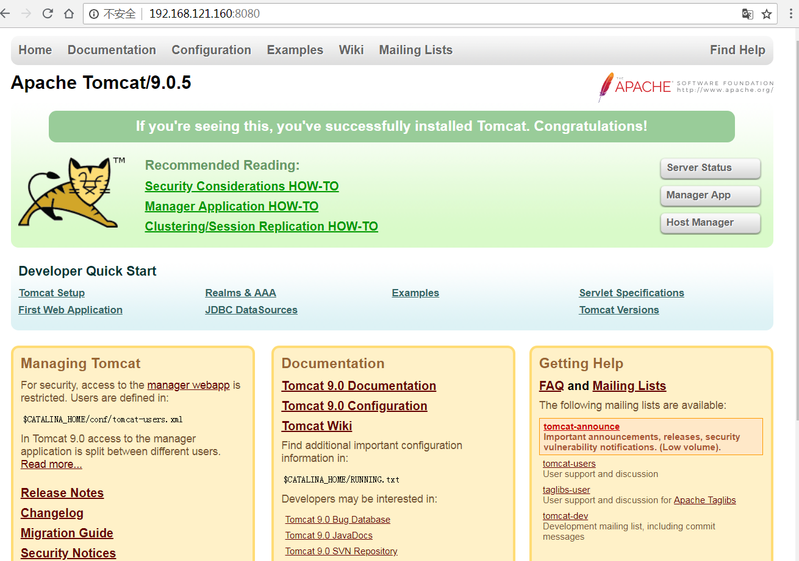

现版本tomcat9.0.5升级到tomcat9.0.12

1. 关掉老版本tomcat程序

[root@qi ~]# /usr/local/tomcat/bin/shutdown.sh

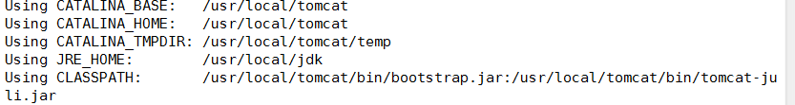

1. 检查是否关闭(注：过滤为空才算关闭)

[root@qi ~]# ps -ef |grep tomcat |grep -v grep

1. 之前tomcat老版本目录改名字

[root@qi local]# mv /usr/local/tomcat /usr/local/tomcat.old

1. 解压9.0.12版本tomcat

[root@qi ~]# tar xf apache-tomcat-9.0.12.tar.gz -C /usr/local/

1. 9.0.12版本tomcat创建软链接

[root@qi ~]# ln -s /usr/local/apache-tomcat-9.0.12/ /usr/local/tomcat

1. 对tomcat递归授权

[root@qi ~]# chown root.root /usr/local/tomcat

1. 对应老版本tomcat.old的初始脚本修改里面配置

[root@qi ~]# vim /usr/local/tomcat/bin/catalina.sh

1. 对应老版本tomcat.old的启动脚本修改里面配置如端口号等

[root@qi ~]# vim /usr/local/tomcat/conf/server.xml

1. 将老版本webapp下的应用程序war包拷贝到对应目录下

[root@qi ~]# /bin/cp -r /usr/local/tomcat.old/webapps/* /usr/local/tomcat/webapps/

1. 重新启动tomcat

[root@qi ~]# /usr/local/tomcat/bin/startup.sh

Using CATALINA_BASE: /usr/local/tomcat

Using CATALINA_HOME: /usr/local/tomcat

Using CATALINA_TMPDIR: /usr/local/tomcat/temp

Using JRE_HOME: /usr/local/jdk

Using CLASSPATH: /usr/local/tomcat/bin/bootstrap.jar:/usr/local/tomcat/bin/tomcat-juli.jar

Tomcat started.

1. 查看启动进程

[root@qi ~]# netstat -antlp|grep java



1. Web查看已经更新到tomcat9.0.12

