

FIAT Services

Medical Check Scheduling & Tracking
Business Blue Print

FIAT Services

0.5

Confidentiality/Disclaimer:

This document and all information contained within is the property of NorthgateArinso International. It is issued in confidence and must not be reproduced in whole or in part or used or given or communicated to any third party without the prior written consent of NorthgateArinso International.
This document does not form or constitute part of a contractual agreement, and its submission does not imply acceptance of any commercial terms.

Any statements and recommendations made or advice given shall not in any circumstances be deemed to constitute a warranty by NorthgateArinso International as to the accuracy of such statements, recommendations or advice. NorthgateArinso International shall not be liable for any loss, expense, damage or claim arising from the statements made or omitted to be made, or advice given or not given in this document.

Copyright NorthgateArinso International ©

Version Management:
Version | Date | Author | Comments
0.1 | 15.12.2012 | Boris Pijetlović | 1st Draft
Document Distribution:
Name | Responsibility | Organization
Darko Čelebić | Supervisor | SDD ITG
Petrina Makakova | Project Manager | TMF
Liborio Pagano |  | FS

Contact Details:

Telephone: +381 11 2773964
Fax: +381 11 2781938
Mob:
Email: darko@sdditg.com

Confidentiality/Disclaimer:
This document and all information contained within is the property of NORTHGATEARINSO International (hereafter referred to as NORTHGATEARINSO). It is issued in confidence and must not be reproduced in whole or in part or used or given or communicated to any third party without the prior written consent of NORTHGATEARINSO.
This document does not form or constitute part of a contractual agreement, and its submission does not imply acceptance of any commercial terms.
Any statements and recommendations made or advice given shall not in any circumstances be deemed to constitute a warranty by NORTHGATEARINSO as to the accuracy of such statements, recommendations or advice. NORTHGATEARINSO shall not be liable for any loss, expense, damage or claim arising from the statements made or omitted to be made, or advice given or not given in this document.
Copyright NorthgateArinso International ©2006

Changing history
List of chapters modified:

Table of Contents
Changing history 4
Table of Contents 5
1 Introduction 6
2 SHORT DESCRIPTION 7
3 IMPACTS ON OTHER SYSTEMS 9
3.1 Time management (TM) 9
3.2 Personal administration (PA) 9
3.3 Synchronisation engine between PA and TM 9
4 ROLES 10
5 Bussiness processes 11
5.1 Medical department stuff 11
5.2 BC SUPERVISOR 12
5.3 WC 13
5.4 WCDR 14
5.5 FAS CEO 14

Introduction
This document analyzes the business processes and business requirements related to designing and implementing the new tool for scheduling and tracking the medical checks (STMCT).
This document has been prepared on the basis of information collected through a standard questionnaire and direct interviews with key users from Fiat Services Italy in the period from late November to mid December 2012.
There is no existing tool for same / similar purposes used in FAS, so comparative analyse and existing functionalities support is not performed.
The fit between the business requirements and the functionalities of the system has been denoted with the following symbols:

N | Note
Χ | Alternative process
??? | Open Point
The legal entities within the scope of this document are:
- Fiat Automobili Srbija doo Kragujevac (FAS)
Other legal entities:
- Fiat Services doo Kragujevac (FS)
- Magneti Marelli doo Kragujevac (MM doo)
- Magneti Marelli Automotive doo Kragujevac (MM automotive).
are out of scope.

N | Introducing new legal entity will not be change request if same business processes are implemented. If there are some differences in business logic for other legal entities it will be subject of new evaluation (change request).
To avoid extra cost (using existing tools and structures), this elaboration is made concerning the fact that this tool is functional dependent on PA, TM and can not be standalone tool.

SHORT DESCRIPTION
Fiat Services Kragujevac needs a new tool for scheduling and tracking the medical checks for FAS employees. The tool will have certain data exchange with the PA and TM systems. The new tool will be used by the FAS Medical Department (MD), BC supervisors, FAS CEO, HR SSC.
The medical checks to be performed will depend on the occupational risks of each employee. The risks will not be dependent on the employee’s position in PA, i.e. each employee will be assigned a set number of risks.
Each risk has the associated medical checks which should be performed at a pre-defined period (rotation; initial one is calculated starting from hiring date). The standard schedule of medical checks per employee will be calculated by the tool and updated / confirmed by the MD. The MD should be able to schedule medical checks only during the shift of the employee.
The MD has to schedule the medical checks for the following month by the 21st day of the current month.
The MD should have the following visibility:
- Employees for whom the medical checks have to be performed but are not yet scheduled;
- Employees who have had scheduled medical checks in the past but who did not have them (e.g. the employee did not come to the medical check);
- Employees for whom the medical checks have been scheduled and performed.
Also BC Supervisor or WCDR can request medical check on demand (out of regular rotation), so MD department will be alerted, and MD can make schedule on demand for some employee.

??? | OPEN POINT nr. 1  BC supervisor or WCDR can request medical check on demand via MSTMCT or do it by regular email. MD via MSTMCT can make schedule (must be functionality).  If BC supervisor / WCDR request is done via MSTMCT, this functionality need to be developed, and this raise cost of designing. For role WCDR, for other planned functionalities there is no need to have direct access to tool (will automatically receive email).

The FAS CEO (or some other FAS department) should have read only access to all data, in order to track activities, so special read only role need to be developed.

After a medical check has been scheduled, a coupon will be created in a pre-defined format. The coupons for the BC medical checks will be printed out and distributed by the supervisors. Supervisors will receive e-mails reminding them that there are coupons for printing and distribution. WC will receive their coupons by e-mail (and WCDR will be in carbon copy).
The MD will validate the completion of each medical check in the new tool. The MD should also confirm whether the employee is within the norm for the respective medical check. In case the MD stuff establishes that the employee is below the norm for a certain risk, that risk should be flagged. MD department according to results of medical examination can make decision that employee is not able to do some activities (permanent or temporary) and enter this information in system. Supervisors should have access to the medical check results (see risks and temporary or permanent certain disability for some work activities).

When appointment is scheduled once, there will no additional check if shift is changed. It will be in responsibility of supervisor.

The tool should allow the MD / supervisors to make various reports.
??? | OPEN POINT nr. 2  FS need to provide description of requested reports (alternatively standard set of report will be designed: listed data retrieved applying filter according the UI)

The tool need to have functionality to authorise access (users & roles)
MD stuff will enter only data of possible risks into system. Tracking and keeping any medical data (e.g. blood pressure value that is measured during medical examination) is not supported. Free text (without any background processing) can be entered related to certain medical check.
Libraries:
- Risks
- Work activities
will be in this system and will not be synchronised with and other system (PA or TM). The tool will provide maintenance of this registers (entering, updating or deleting).
Initial medical check is performed before employee is officially hired (employee is not in any system; nor PA or TM), so results can be entered after hiring. Only users with direct access to system can enter data.

??? | OPEN POINT nr. 3  Proposal of FS is that BC Supervisor enters initial risks. This is possible, but it is not defined process for other categories of employee (e.g. WC).

Χ | ALTERNATIVE PROCESS  Initial medical check is done by FAS medical department. After hiring MD department can enter this information (previously written on some form in paper). System can provide filter for all new employees with missing information about initial check

IMPACTS ON OTHER SYSTEMS

Time management (TM)
There is no changes in TM. Only time schema data will be retrieved from TM system.

Personal administration (PA)
There is no changes in PA.

N | If there is no need to show new attributes of employee than one existing in TM, there is no need for change. If some additional attribute is needed (which exists in PA and is not transferred to TM) some changes need to be done. From side of SDDITG if new attribute is required during design process, this situation will be treated as fine tuning and will not be subject of change request.

Synchronisation engine between PA and TM
There is no changes.

ROLES
This chapter describes roles (specific users will have one or more roles), which give user desired functionalities and performing specified business activities.

Roles should be:

Role | System access
Medical department stuff | DIRECT ACCESS
BC SUPERVISOR | DIRECT ACCESS
FAS CEO | DIRECT ACCESS
WC | NO DIRECT ACCESS (email)
WCDR | NO DIRECT ACCESS (email)

Following diagram depicture required roles:
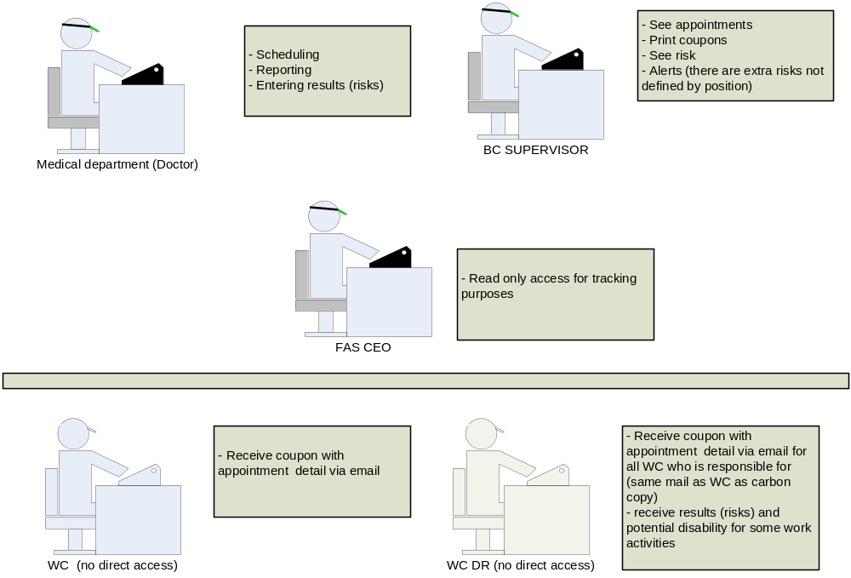

Bussiness processes
This chapter describes business processes in system performed by separate roles.

Medical department stuff
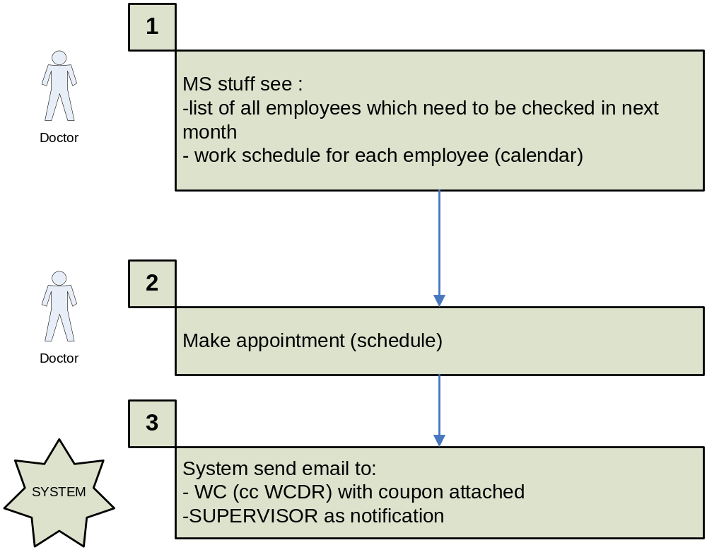

BC SUPERVISOR

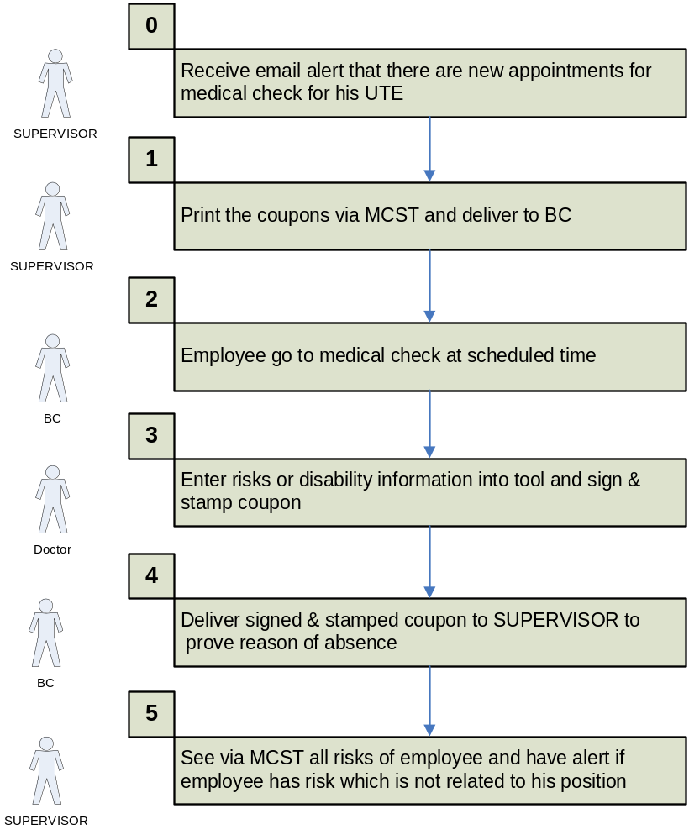

WC
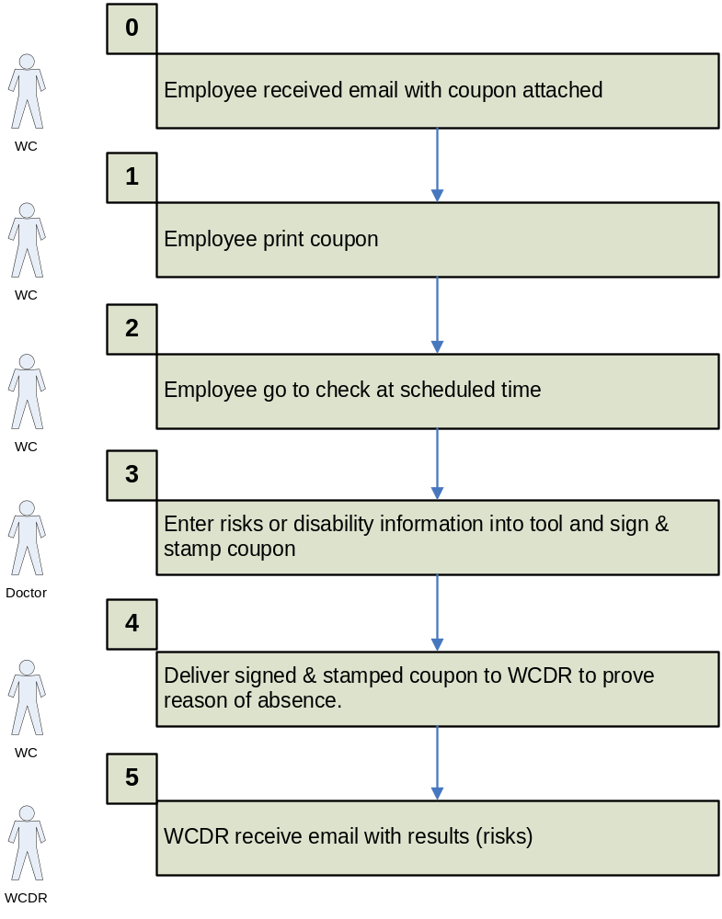

WCDR
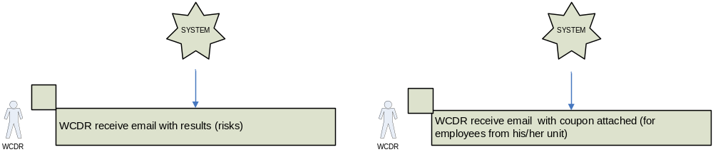

FAS CEO
Read only access to all system functionalities.

