Task #3

Given:

eps = 1e-6

refl, expan, contr = 1, 0.5, 2

simplex = list([(-1.0,-1.0),(-1.0,-2.0), (-3.0,-2.0)])

Result:

func_min = -106.76453076037151 iterations = 53

test point ([-3.13004039 -1.58210909])

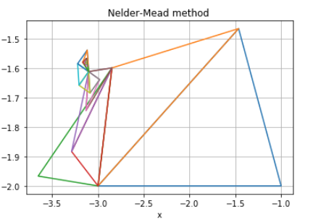

Given:

eps = 1e-6

refl, expan, contr = 1, 0.5, 2

simplex = list([(-4.5,-2.0),(-3.0,-6.0), (-7.0,-8.0)])

Result:

func_min = -106.76453674925574 iterations = 47

test point [-3.13024566 -1.58214159]

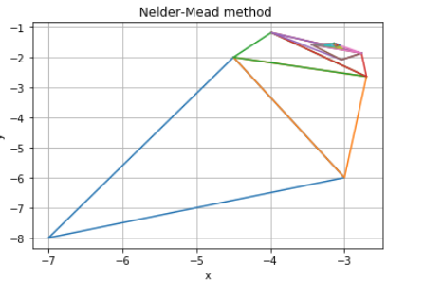

Given:

eps = 1e-6

simplex = list([(-4.5,-2.0),(-3.0,-6.0), (-7.0,-8.0)])

|  |  |  |  |  |  |  |
| --- | --- | --- | --- | --- | --- | --- |
| # | F min | Last Point | reflection | expansion | contraction | iterations |
| 1 | -106.764536749 | -3.13024477 -1.58214304 | 1 | 0.5 | 2 | 47 |
| 2 | -102.027 | -3.0997595 -1.39631015 | 2 | 0.25 | 1.5 | 95 |
| 3 | -106.66637667 | -3.1189989 -1.55781545 | 0.75 | 0.75 | 1.75 | 69 |
| 4 | -63.867308 | -3.58028,-2.037996 | 0.25 | 0.75 | 1.2 | 25 |
| 5 | -106.76453 | -3.13024477 -1.58214304 | 1.5 | 1.75 | 4.2 | 64 |

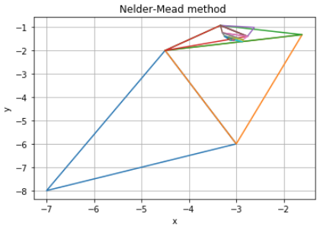  
Case 3: min =-106.666

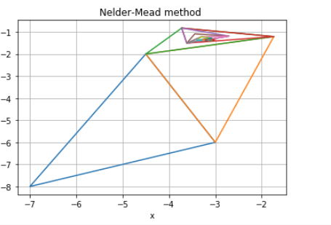  
 Case 2: min = -102.027

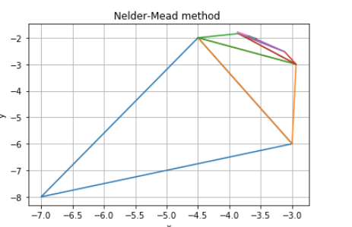  
Case 4: min = -63.867

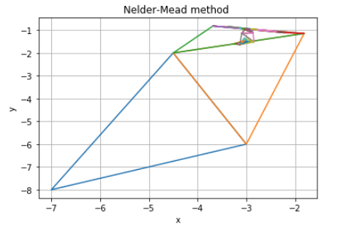  
Case 5