# 2 Single Rooms for rent

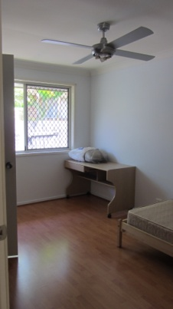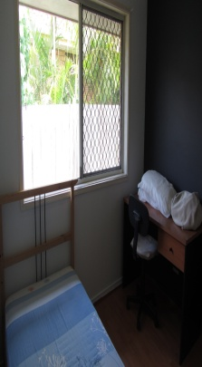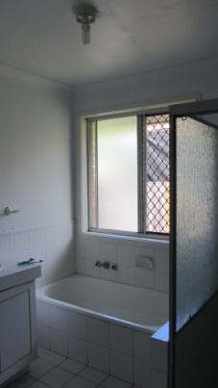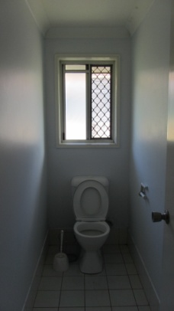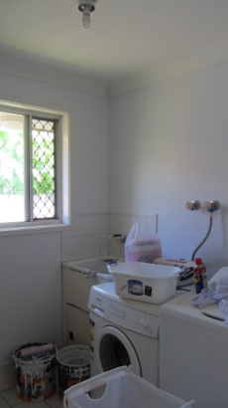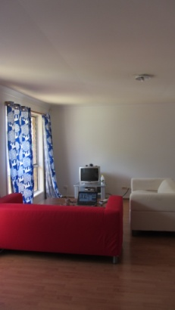

**Location**: Sunnybank Hills – Hellawell Road (close to Pinelands road; further down a little would be Mains Road).

It is close to Pinelands Plaza, Sunnybank Plaza, Market Square, Sunny Park. Really easy and convenient to do your shopping or to find delicious food.

Plus a bus stop that is very near (only 50m away) has buses 130, 131, 140 (and others) that bring you straight into the city, Uni of Queensland, or Griffith Uni.

**Duration**: Preferably at least 6 months of stay.

**Availability**: Immediately.

Rent per week: For the small room – $120. For the big room – $140. (A couple can share the big room for $200.)

**Rent:** includes sensible use of water, electricity and internet (unlimited ADSL 2+ Wi-Fi).

Each room is FULLY FURNISHED with the following features:

|  |  |  |
| --- | --- | --- |
| - Single bed | - Built-in wardrobe | - Ceiling fan. |
| - Desk | - Chair |  |

The dining room, toilet, bathroom, kitchen, and washing machine are shared.

There are currently two friendly, quiet tenants in the house (one male, one female). We are looking for clean, tidy, and responsible people to share the house with. Cleanliness of the public areas (kitchen, toilet, bathroom, living room) must be maintained by everyone.

**No smoking and no pets please**. **You** **are welcome to inspect the house.**­­

|  |  |  |  |  |  |  |  |  |  |  |  |  |  |  |
| --- | --- | --- | --- | --- | --- | --- | --- | --- | --- | --- | --- | --- | --- | --- |
| 0  4  3  0  1  3  1  3  9  5 | 0  4  3  0  1  3  1  3  9  5 | 0  4  3  0  1  3  1  3  9  5 | 0  4  3  0  1  3  1  3  9  5 | 0  4  3  0  1  3  1  3  9  5 | 0  4  3  0  1  3  1  3  9  5 | 0  4  3  0  1  3  1  3  9  5 | 0  4  3  0  1  3  1  3  9  5 | 0  4  3  0  1  3  1  3  9  5 | 0  4  3  0  1  3  1  3  9  5 | 0  4  3  0  1  3  1  3  9  5 | 0  4  3  0  1  3  1  3  9  5 | 0  4  3  0  1  3  1  3  9  5 | 0  4  3  0  1  3  1  3  9  5 | 0  4  3  0  1  3  1  3  9  5 |