Project Analysis

Case description

Student Housing BV owns different buildings where students can stay during their study period. However, the company has recently been receiving complaints that are related to the everyday life in these student houses. The company wants to create an application which would be used to fix all of those problems. The software application should be written in C# and should be created in Visual Studio.

Problem Statement

There are a lot of different problems in the student houses which need to be fixed. For example, some of the appointed people don’t clean the shared facilities, don’t do the garbage disposal on time and the groceries are not done or paid for. Aside from that, there have also been complaints about unannounced parties and gatherings which disturb some of the students. We would also want a feature where the tenants can see and make arrangements between each other and another feature to edit the rules and to make sure that the students can see them.

Stakeholders

The people who will make the application are Viktor Skachkov, Alexander Petrov, Desislav Hristov and Matija Mandarelo. The clients who have ordered it are Student House BV and the end users who will utilize it are the students themselves and the admins who will regulate the everyday life.

Requirements

- The application should contain a login feature which prevents strangers who don’t live in the student houses from creating their own accounts. Also, there is a prevention of the students who don’t belong to the housing company by making every account pending and after that only the admin can approve accounts. The application should also recognize if the user is a student or an admin.

- Also, the students should be separated in different house addresses because the company manages more than one property. When we have this feature we can track more easily each house on a local level.

-Every admin will have a separate tab only for complaints which will be on queue. When the admin selects a complaint he will be able to check that specific house and contact all the students if needed. On the other side each student will be able to send complaints to the admins from the application anonymously.

-The task distribution is an important part of our project. The students should have schedule of doing the tasks such as:

-Garbage disposal/daily

Cleaning shared facilities:

-cleaning the left dishes/daily

-cleaning the bathroom/weekly

-cleaning the whole property/weekly

-swiping the whole property/daily.

They are separated as daily or weekly because not every task should be done every day, but weekly. The application will separate the tasks for each student, so it will be fair.

-Each data will be stored in SQL database, so we won’t lose the input data when we close the application. *//bonus feature*

-Buying of shared items. Overall when a student buys something shared, he can just input it into the application the name, the price and the quantity of the item and then the application will split the amount of money which every student should pay.

-Events/announcements. Here all the students can announce events or something else to their roommates.

Diagram

(Note: This is just a start version of the diagram. We will fix it once we have finished with the whole project.)

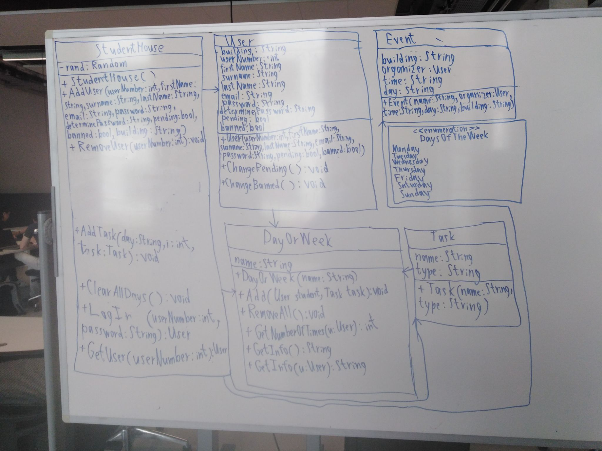

Process and Results

|  |  |  |
| --- | --- | --- |
| Week | Process | Results |
| Week 13 | Each of us presented some of their ideas about the application. Viktor did some coding and created a startup version of the login feature. Desislav presented an idea about the different features being separated by tabs and about a common chat, shared by all the tenants. Another one of his ideas was about a feature about complaints. Matija presented other features and one of his ideas was about an event feature to notify everyone else. | We came to the conclusion that the feature should be separated by tabs and should use a login feature which prevents outsiders from making an account. We also agreed that the login feature should be simplified and should only use a password and something else (like user name or number). |
| Week 14 | We separated the work among each other. Viktor made corrections to the login feature, making it more simple to use and also moved the feature to register new accounts from the startup form. Alexander is going to do the feature to register new accounts on a different form. He is also going to give an authority to the admins to approve or reject the creation of new accounts as an extra security. Desislav is going to create a feature which the students can use to send complaints to the admins and Desislav is going to create the features that allow the users to edit and read the different schedules (about the garbage disposal, the groceries and the cleaning of the common facilities). | Viktor created an updated version of the login feature which sends the user to a Student Form or to an Admin Form depending on their credentials. He also created a feature which allows the admin to edit the rules and the students to view them. Alexander is almost done with the feature about registering a new account and he has only a few more things to fix. Matija and Desislav are still working on their tasks but they are almost done as well. We already have the base where we will put the other features of the application. |
| Week 15 |  |  |
| Week 16 |  |  |
| Week 17 |  |  |

Conclusions and Recommendations