Design Document

Viktor Skachkov

Картина, която съдържа текст, лице, лаптоп, закрито

Описанието е генерирано автоматично

**20-03-2022**

Tutors: Tim Kurvers and Paixão Márcio

# Table of content

Съдържание

Table of content 2

Introduction 2

System Context 4

Containers and tech choices 5

Components 6

Persistence per component 7

Sequence diagrams 8

Ordering 8

Security 9

Log In 9

Register 9

Reservation 10

Make reservation 10

Reject reservation 10

Assign table to reservation 10

CRUD 11

Add 11

Remove 11

Update 11

Interfaces or API documentation 12

Versioning Table

|  |  |
| --- | --- |
| Version | Changes |
| 1.1 | I created the document |
|  |  |
|  |  |

# Introduction

Oliver wants to open a new pizzeria in Eindhoven and has tasked me to make an application which would allow clients to make orders and reserve tables and would also allow the employees to add, remove and edit different meals.

This document will show how the application will look like by using C4 architecture diagrams.

# System Context

Картина, която съдържа текст, екран, екранна снимка

Описанието е генерирано автоматично

# Containers and tech choices

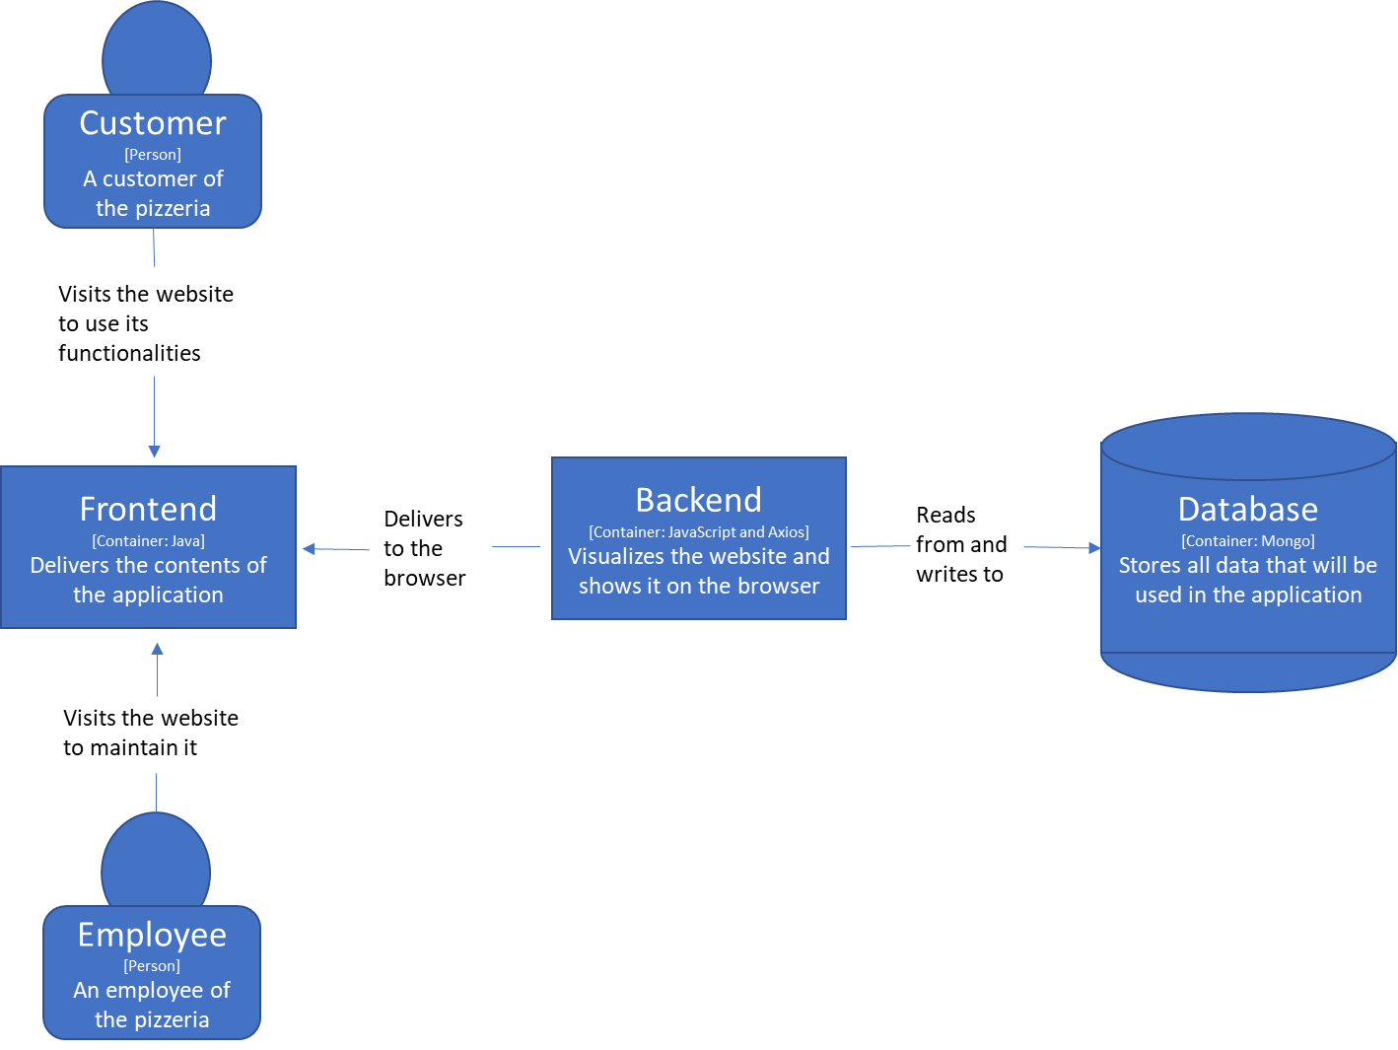

# Components

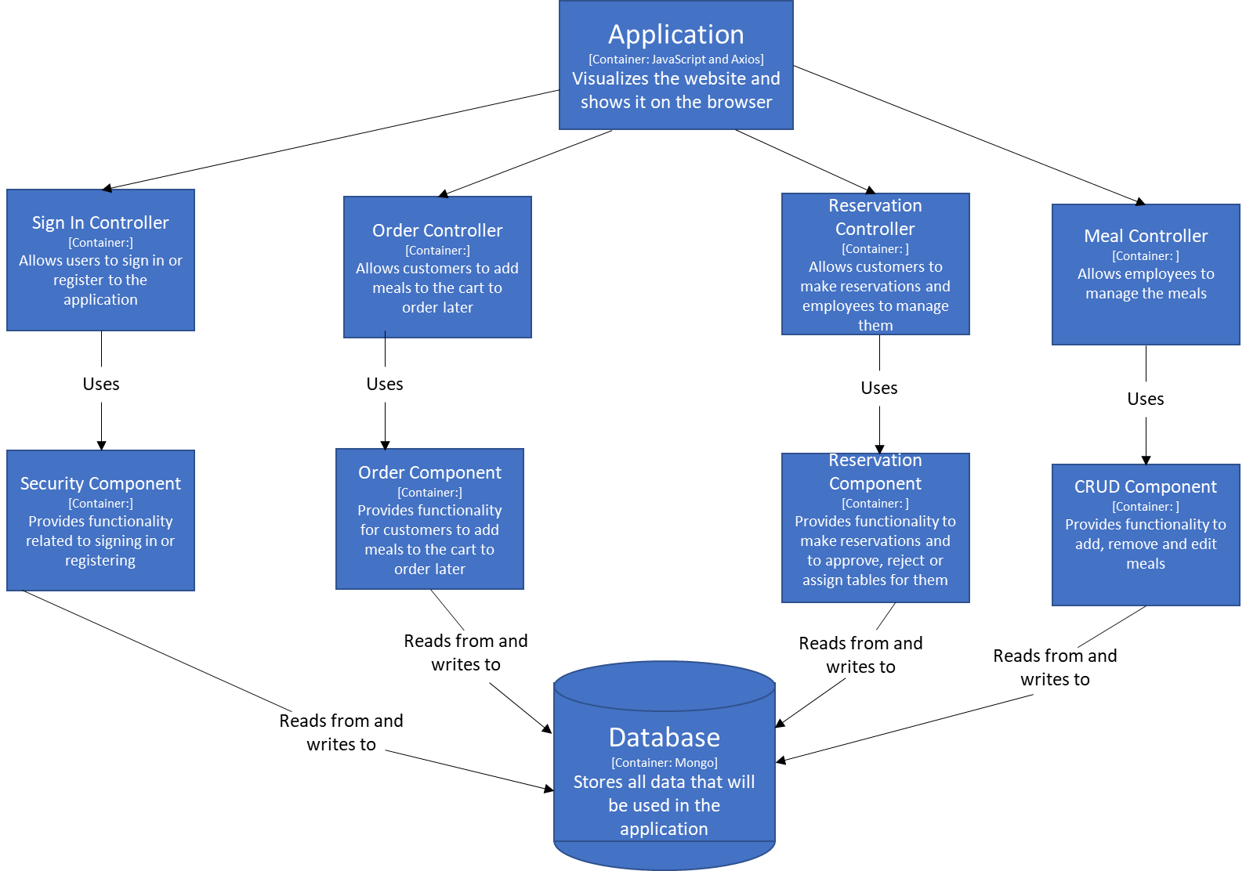

# Persistence per component

# Sequence diagrams

## Ordering

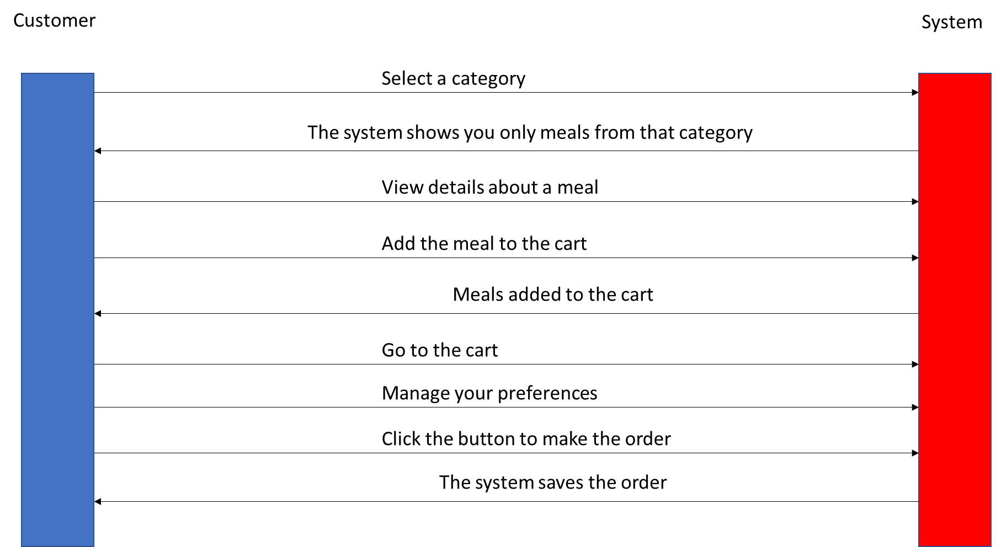

## Security

### Log In

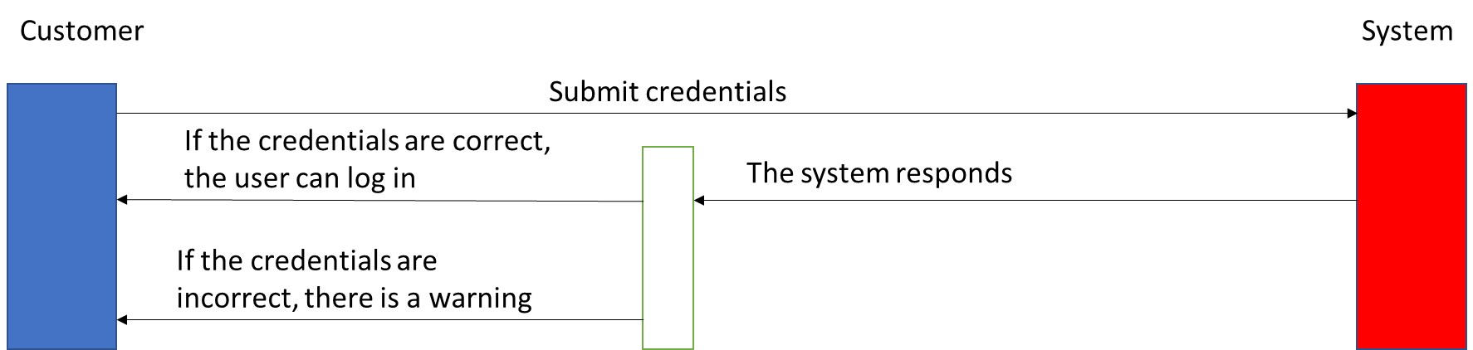

### Register

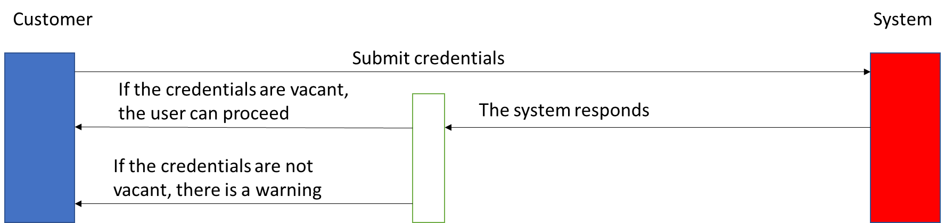

## Reservation

### Make reservation

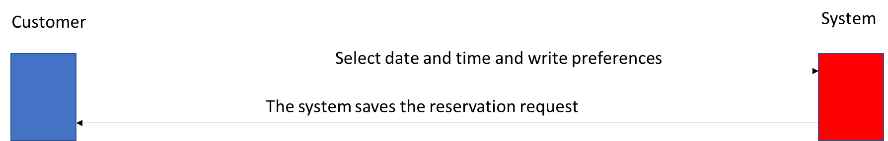

### Reject reservation

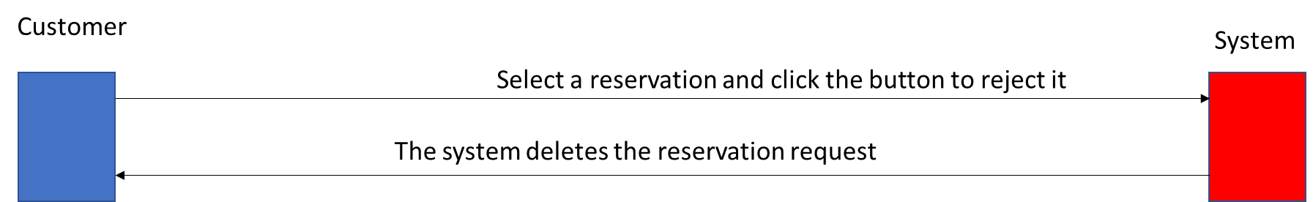

### Assign table to reservation

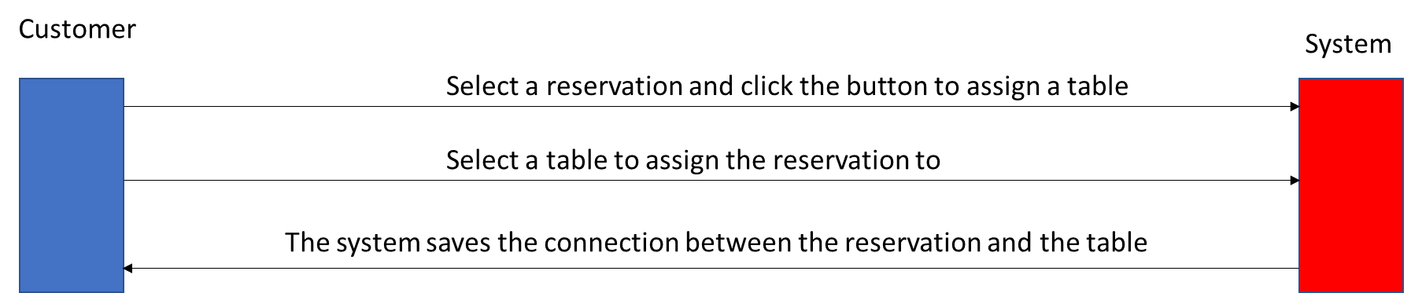

## CRUD

### Add

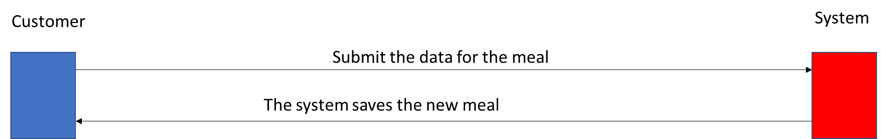

### Remove

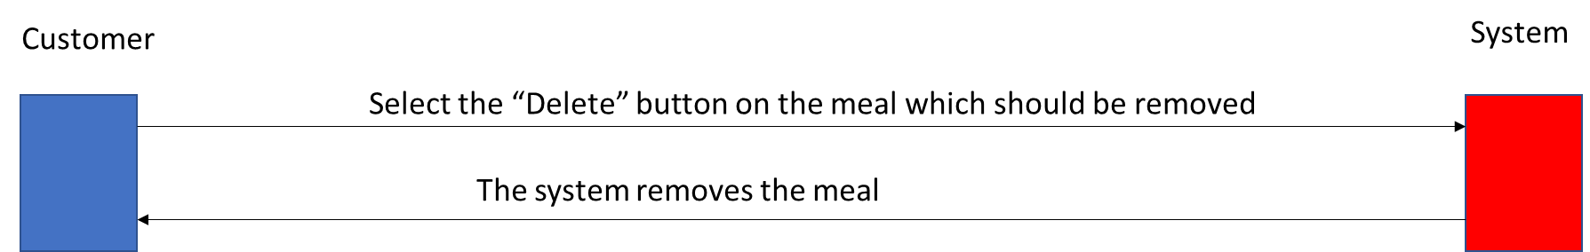

### Update

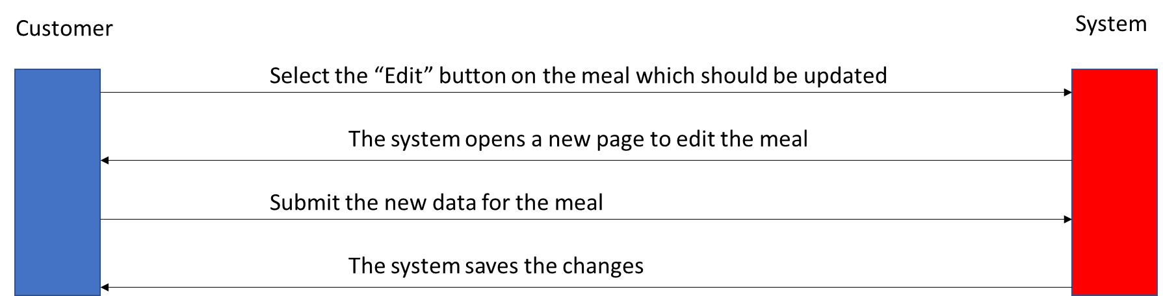

# Interfaces or API documentation