Design Document

Viktor Skachkov

Картина, която съдържа текст, човек, на закрито, лаптоп

Описанието е генерирано автоматично

**22-03-2023**

Tutors: **Márcio Paixão Dantas and Erik van der Schriek**

# Table of contents

Съдържание

Table of contents 2

Versioning Table 3

Introduction 4

System Context 5

Containers and tech choices 6

Components 7

# Versioning Table

|  |  |
| --- | --- |
| Version | Changes |
| 1.1 | I created the document |
|  |  |
|  |  |

# Introduction

Company Red Scar wants a website where they can sell their videogames because they believe this would boost their sales. It has tasked us to create the website which allows users to buy videogames and additions, give reviews to them and read news articles. It should also allow employees to add, edit and remove games, additions and news articles.

# System Context

The videogame webshop would have two types of users – employees and customers. Customers would be able to order videogames and additions, read news and give reviews.

Картина, която съдържа диаграма

Описанието е генерирано автоматично

# Containers and tech choices

I use React for the frontend because compared to other frontend frameworks, the React code is easier to maintain and is flexible which saves huge amounts of time and costs. It builds interactive user interfaces and web applications quickly and efficiently with significantly less code than you would with vanilla JavaScript.

I use Java for the backend because it’s a platform-independent language which means it can run on different operating systems, has efficient memory management, and it supports high scalability. It was designed to be easy to use and easy to write, compile, debug, and learn.

I use MySQL because of its high-performance query engine, tremendously fast data insert capability, and strong support for specialized web functions like fast full text searches.

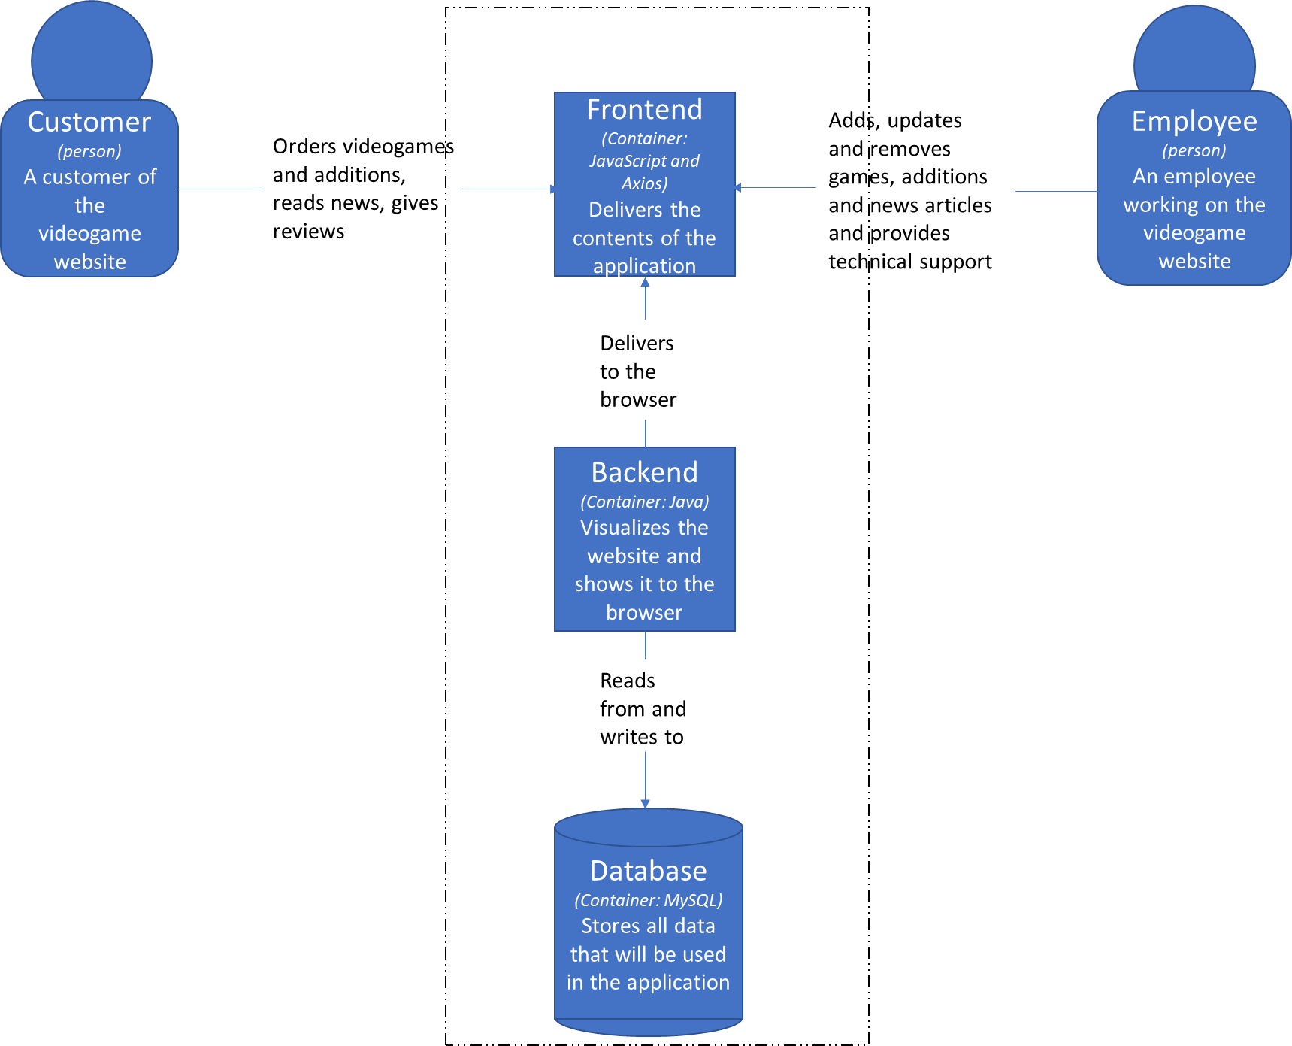

# Components

The application would contain users, videogames, news, additions, reviews, addition orders and game orders. The users would perform different actions in the application, the videogames and the additions would be the products that could be bought, the news articles would contain information regarding different videogames and the users would also be able to give reviews to videogames or additions.

You need to first start Umlet.exe and open ComponentsDiagram before you can view the diagram.

# Code

The UML diagram is in the file UMLDiagram.uxf because it’s too big to be presented here. The classes are structured in a way which implements 4 different layers _ controller, business, persistence and domain. I have only shown the controller, the business and the persistence layers on the diagram.

You need to first start Umlet.exe and open UMLDiagram before you can view the diagram.