**Start semester  
Orientation phase  
Personal Experience Portfolio**

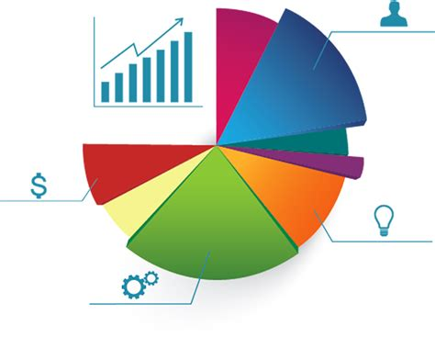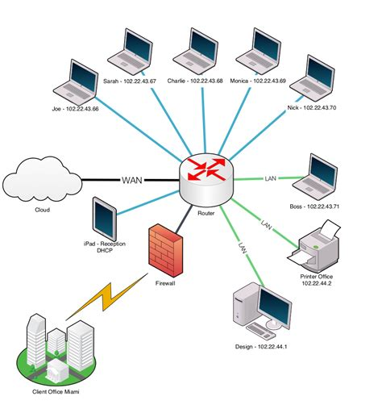





**Student name: <Your name>  
Student number: <Your student number>**

**Class: <your class>  
  
Version: 1.1  
Date: 25-8-2022**

# Purpose of this document

You fill in this document on a regular basis to demonstrate your understanding and growth and performance with respect to all the learning outcomes – both technical and professional.

You record and reflect on your work based on the feedback received from your teachers.

The technical learning outcomes are mentioned further in the document, the professional sills learning outcomes are as follows:

**You display professional behaviour in the areas of**

**future-oriented organisation,**

**investigative problem solving,**

**personal leadership and**

**targeted interaction.**

You may provide details under the following headings in this document, as evidence of your work, feedback, reflection, learning, growth, and goals for both professional and technical skills.

* Evidence of your relevant skills and abilities(foto’s, screenshots, video’s)
* Which learning outcomes both professionally and technically did you work on
* Feedback that you received
* What was your approach?
* What went well and why, can you improve?
* What research did you do?
* Used Resources

Table of contents

Purpose of this document 2

Table of contents 3

Exercises based on learning outcomes 4

Week 1 5

Week 2 6

Week 3 7

Week 4 8

Week 5 9

Week 6 10

Week 7 11

Week 8 12

# Exercises based on learning outcomes

|  |
| --- |
| **Learning outcome 1**:You demonstrate how to convert data into information in order to achieve a recommendation that will make an improvement for a process in an organization |
| **Learning outcome 2:** You are able to develop and implement interactive prototypes in an iterative process for the target users based on trends and developments. |
| **Learning outcome 3:** You demonstrate a self-developed, secured network environment with hosts and servers based on a specific application requirement (services) |
| **Learning outcome 4**: **You develop software applications with attention for algorithmics and hereby demonstrate the basic skills of object-oriented programming** |
| **Learning outcome 5:** You develop and programme interactive embedded systems in which you use sensors and actuators and apply various I/O techniques |

|  |  |  |  |  |  |
| --- | --- | --- | --- | --- | --- |
| Assignment | Learning outcome 1 | Learning outcome 2 | Learning outcome 3 | Learning outcome 4 | Learning outcome 5 |
| Flowcharts (x6) |  |  |  | - |  |
| Python code for flowchart 1-3 |  |  |  | - |  |
| Python code for flowchart 4-6 |  |  |  | - |  |
| Python functions |  |  |  | - |  |
| Python client/server with flask |  | - |  | - |  |
| Arduino Hello world |  |  |  |  | - |
| Arduino LED’s and buttons |  |  |  |  | - |
| Arduino LED with dimmer |  |  |  |  | - |
| Arduino and Python |  |  |  |  | - |
| Flowcharts (x3) |  |  |  | - |  |
| Prototype personal page |  | - |  |  |  |
| My first HTML |  | - |  |  |  |
| My first CSS |  | - |  |  |  |
| Personal page |  | - |  |  |  |
| Measurements Dashboard | - |  |  |  |  |
| Business analysis | - |  |  |  |  |
| Data analysis | - |  |  |  |  |
| Network diagram |  |  | - |  |  |
| Group Project Pizzeria | - | - | - | - | - |

# Week 1

|  |  |
| --- | --- |
|  | Key take aways of this week |
|  | 1. Flowcharts are a great way to make a plan before writing the actual code  2. Loops are a great way to repeat the same code multiple times  3. Prototyping is an important part of developing anything because it saves time and nerves |

**Evidence of your relevant skills and abilities(foto’s, screenshots, video’s)**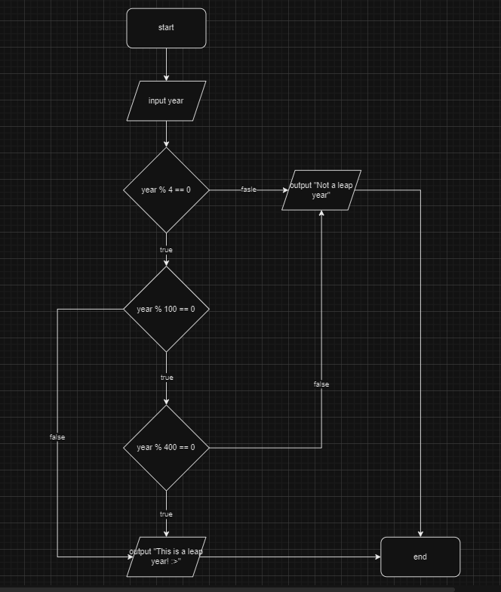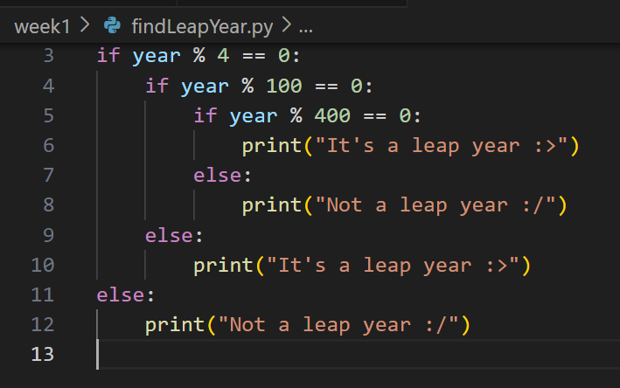

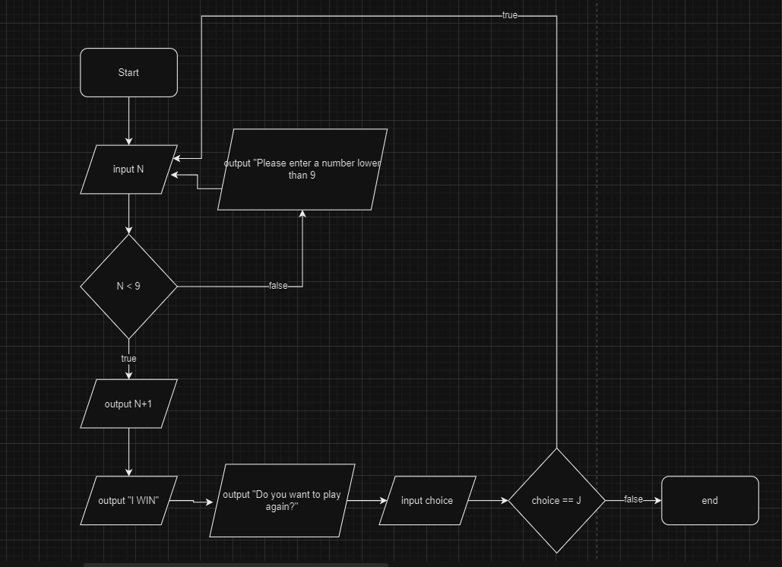

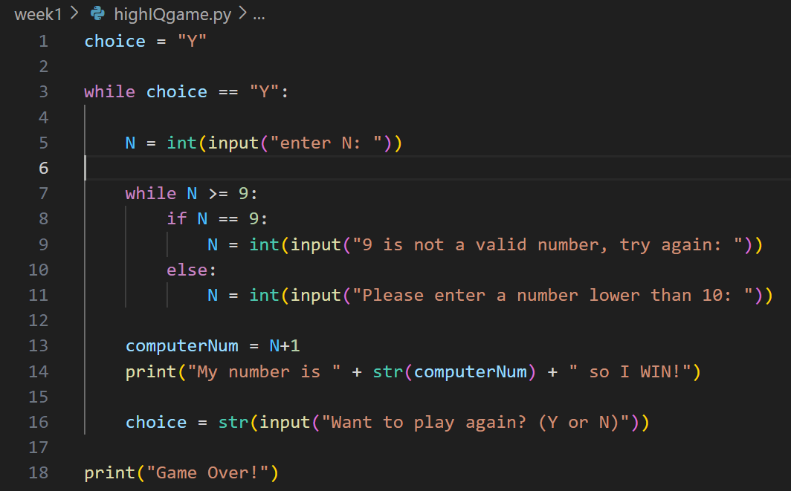

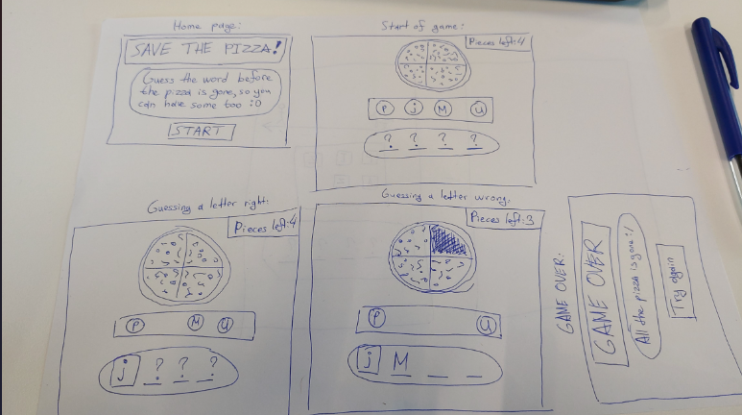

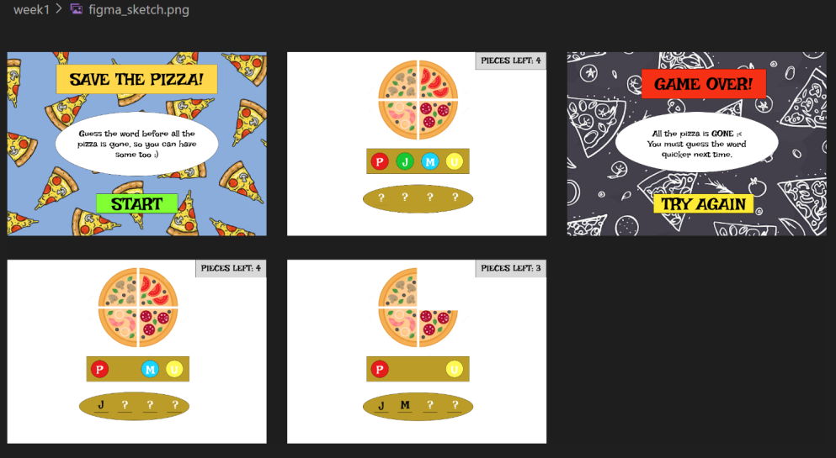

**Which learning outcomes both professionally and technically did you work on:**

**Learning Outcome 4: You develop software applications with attention for algorithmics and hereby demonstrate the basic skills of object-oriented programming.**

By completing Python exercises using if/else and while loops, you demonstrated your ability to write code in Python. Also by doing the flowcharts, I have shown attention to algoritums.

**Learning Outcome 2: You are able to develop and implement interactive prototypes in an iterative process for the target users based on trends and developments.**

By designing a website on paper and in the web application Figma I showcase my ability to create interactive prototypes, which is a very important part of developing anything because it saves time and nerves.

**Learning Outcome 1: You demonstrate how to convert data into information to achieve a recommendation that will make an improvement for a process in an organization.**While working on the Python exercises, I had to process data (input) to produce specific outputs based on conditions and logic (if/else and while loops).

**Feedback that you received**

**What was your approach?**

My approach for the flowcharts was using the right flowchart notations for the different boxes and make the flowcharts as simple and short as possible. My approach for the Python excersises was to use if and else statements to make the needed true or false checks, and to use while loops when there was a need to execute the same lines of code several times.

**What went well and why, can you improve?**

In my opinion everything went well since I already have previous experience with making flowcharts and writing code.

**What research did you do?**

I used YouTube to watch a tutorial on how to use Figma as a beginner

I used the presentations provided by the teachers combined with W3Schools for help every time I had difficulties with writing the code. For example I used W3Schools to understand how loops like while and for work in Python.

**Used Resources**

W3Schools

Teacher Presentations

Internet

# Week 2

|  |  |
| --- | --- |
|  | Key take aways of this week |
|  | 1.  2.  3. |

**Evidence of your relevant skills and abilities(foto’s, screenshots, video’s)**

<…>

**Which learning outcomes both professionally and technically did you work on**

<…>

**Feedback that you received**

<…>

**What was your approach?**

<…>

**Why did things went well? What made it went well?**

<…>

**What research did you do?**

<…>

**Used Resources**

**<…>**

# Week 3

|  |  |
| --- | --- |
|  | Key take aways of this week |
|  | 1.  2.  3. |

**Evidence of your relevant skills and abilities(foto’s, screenshots, video’s)**

<…>

**Which learning outcomes both professionally and technically did you work on**

<…>

**Feedback that you received**

<…>

**What was your approach?**

<…>

**Why did things went well? What made it went well?**

<…>

**What research did you do?**

<…>

**Used Resources**

**<…>**

# Week 4

|  |  |
| --- | --- |
|  | Key take aways of this week |
|  | 1.  2.  3. |

**Evidence of your relevant skills and abilities(foto’s, screenshots, video’s)**

<…>

**Which learning outcomes both professionally and technically did you work on**

<…>

**Feedback that you received**

<…>

**What was your approach?**

<…>

**Why did things went well? What made it went well?**

<…>

**What research did you do?**

<…>

**Used Resources**

**<…>**

# Week 5

|  |  |
| --- | --- |
|  | Key take aways of this week |
|  | 1.  2.  3. |

**Evidence of your relevant skills and abilities(foto’s, screenshots, video’s)**

<…>

**Which learning outcomes both professionally and technically did you work on**

<…>

**Feedback that you received**

<…>

**What was your approach?**

<…>

**Why did things went well? What made it went well?**

<…>

**What research did you do?**

<…>

**Used Resources**

**<…>**

# Week 6

|  |  |
| --- | --- |
|  | Key take aways of this week |
|  | 1.  2.  3. |

# Week 7

|  |  |
| --- | --- |
|  | Key take aways of this week |
|  | 1.  2.  3. |

# Week 8

|  |  |
| --- | --- |
|  | Key take aways of this week |
|  | 1.  2.  3. |