**Start semester  
Orientation phase  
Personal Experience Portfolio**

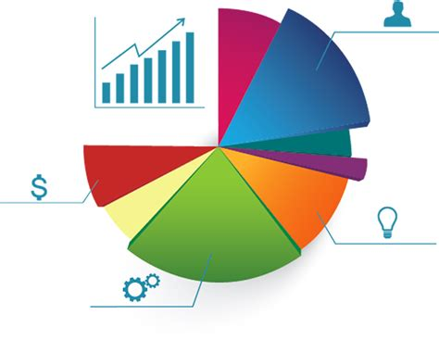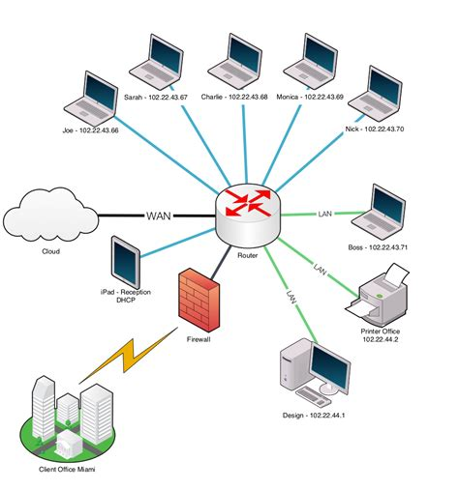

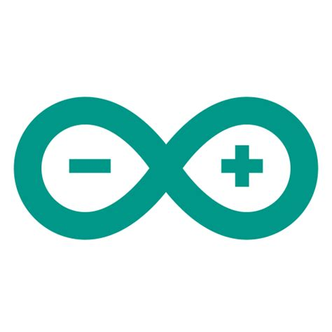



**Student name: Viktor Velizarov   
Student number: 5055121**

**Class: P-CB03  
  
Version: 1.1  
Date: 25-8-2022**

# Purpose of this document

You fill in this document on a regular basis to demonstrate your understanding and growth and performance with respect to all the learning outcomes – both technical and professional.

You record and reflect on your work based on the feedback received from your teachers.

The technical learning outcomes are mentioned further in the document, the professional sills learning outcomes are as follows:

**You display professional behaviour in the areas of**

**future-oriented organisation,**

**investigative problem solving,**

**personal leadership and**

**targeted interaction.**

You may provide details under the following headings in this document, as evidence of your work, feedback, reflection, learning, growth, and goals for both professional and technical skills.

* Evidence of your relevant skills and abilities(foto’s, screenshots, video’s)
* Which learning outcomes both professionally and technically did you work on
* Feedback that you received
* What was your approach?
* What went well and why, can you improve?
* What research did you do?
* Used Resources

Table of contents

Purpose of this document 2

Table of contents 3

Exercises based on learning outcomes 4

Week 1 5

Week 2 6

Week 3 7

Week 4 8

Week 5 9

Week 6 10

Week 7 11

Week 8 12

# Exercises based on learning outcomes

|  |
| --- |
| **Learning outcome 1**:You demonstrate how to convert data into information in order to achieve a recommendation that will make an improvement for a process in an organization |
| **Learning outcome 2:** You are able to develop and implement interactive prototypes in an iterative process for the target users based on trends and developments. |
| **Learning outcome 3:** You demonstrate a self-developed, secured network environment with hosts and servers based on a specific application requirement (services) |
| **Learning outcome 4**: **You develop software applications with attention for algorithmics and hereby demonstrate the basic skills of object-oriented programming** |
| **Learning outcome 5:** You develop and programme interactive embedded systems in which you use sensors and actuators and apply various I/O techniques |

|  |  |  |  |  |  |
| --- | --- | --- | --- | --- | --- |
| Assignment | Learning outcome 1 | Learning outcome 2 | Learning outcome 3 | Learning outcome 4 | Learning outcome 5 |
| Flowcharts (x6) |  |  |  | - |  |
| Python code for flowchart 1-3 |  |  |  | - |  |
| Python code for flowchart 4-6 |  |  |  | - |  |
| Python functions |  |  |  | - |  |
| Python client/server with flask |  | - |  | - |  |
| Arduino Hello world |  |  |  |  | - |
| Arduino LED’s and buttons |  |  |  |  | - |
| Arduino LED with dimmer |  |  |  |  | - |
| Arduino and Python |  |  |  |  | - |
| Flowcharts (x3) |  |  |  | - |  |
| Prototype personal page |  | - |  |  |  |
| My first HTML |  | - |  |  |  |
| My first CSS |  | - |  |  |  |
| Personal page |  | - |  |  |  |
| Measurements Dashboard | - |  |  |  |  |
| Business analysis | - |  |  |  |  |
| Data analysis | - |  |  |  |  |
| Network diagram |  |  | - |  |  |
| Group Project Pizzeria | - | - | - | - | - |

# Week 1

|  |  |
| --- | --- |
|  | Key take aways of this week |
|  | 1. Flowcharts are a great way to make a plan before writing the actual code  2. Loops are a great way to repeat the same code multiple times  3. Prototyping is an important part of developing anything because it saves time and nerves |

**Evidence of your relevant skills and abilities(foto’s, screenshots, video’s)**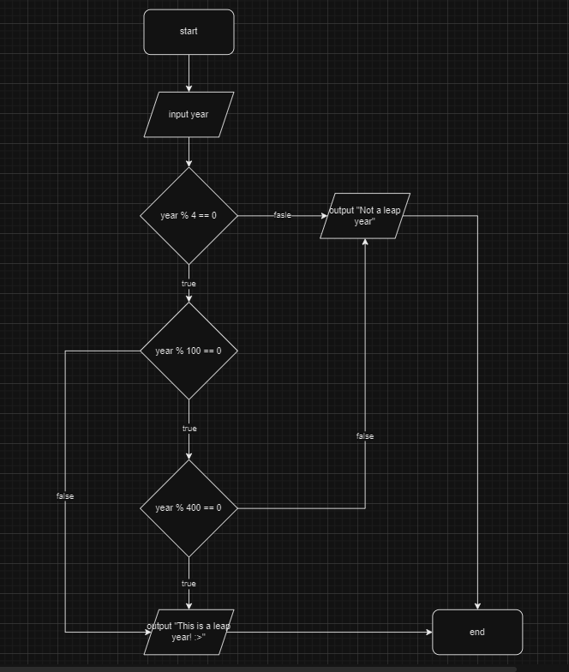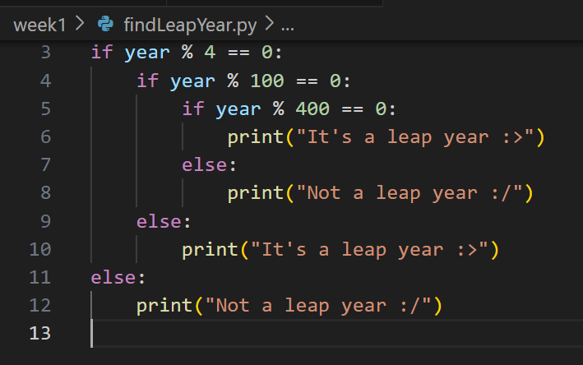

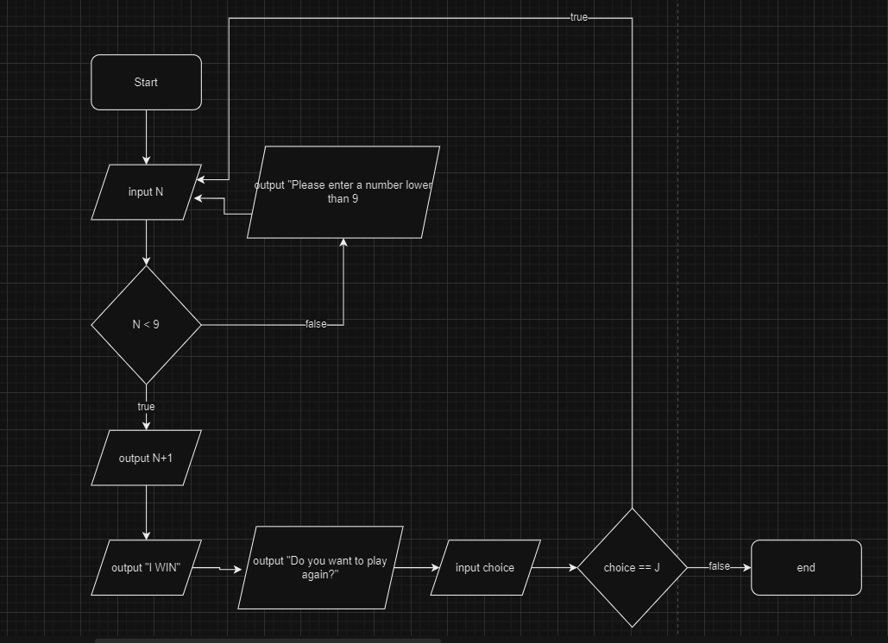

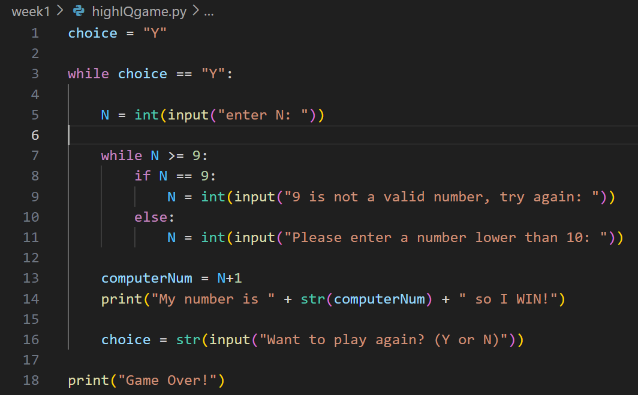

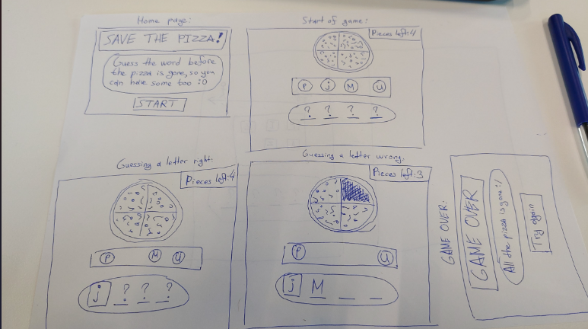

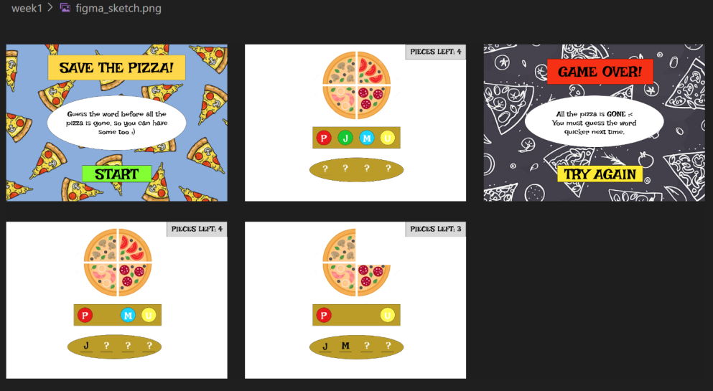

**Which learning outcomes both professionally and technically did you work on:**

**Learning Outcome 4: You develop software applications with attention for algorithmics and hereby demonstrate the basic skills of object-oriented programming.**

By completing Python exercises using if/else and while loops, you demonstrated your ability to write code in Python. Also by doing the flowcharts, I have shown attention to algoritums.

**Learning Outcome 2: You are able to develop and implement interactive prototypes in an iterative process for the target users based on trends and developments.**

By designing a website on paper and in the web application Figma I showcase my ability to create interactive prototypes, which is a very important part of developing anything because it saves time and nerves.

**Learning Outcome 1: You demonstrate how to convert data into information to achieve a recommendation that will make an improvement for a process in an organization.**While working on the Python exercises, I had to process data (input) to produce specific outputs based on conditions and logic (if/else and while loops).

**Feedback that you received**

**???**

**What was your approach?**

My approach for the flowcharts was using the right flowchart notations for the different boxes and make the flowcharts as simple and short as possible. My approach for the Python excersises was to use if and else statements to make the needed true or false checks, and to use while loops when there was a need to execute the same lines of code several times.

**What went well and why, can you improve?**

In my opinion everything went well since I already have previous experience with making flowcharts and writing code.

**What research did you do?**

I used YouTube to watch a tutorial on how to use Figma as a beginner

I used the presentations provided by the teachers combined with W3Schools for help every time I had difficulties with writing the code. For example I used W3Schools to understand how loops like while and for work in Python.

**Used Resources**

W3Schools

Teacher Presentations

Internet

# Week 2

|  |  |
| --- | --- |
|  | Key take aways of this week |
|  | 1.I learned how to host a page with FileZilla and liked it since it was something new for me  2. I learned how to use data structures like Lists and Dictionaries in Python, i have used them in other languages but now I also know how they work in Python  3. |

**Evidence of your relevant skills and abilities(foto’s, screenshots, video’s) Which learning outcomes both professionally and technically did you work on**

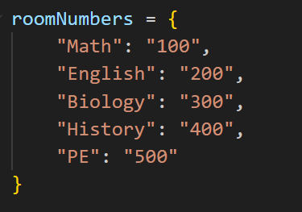

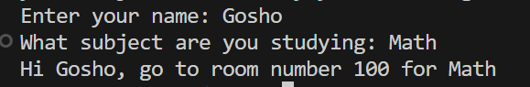

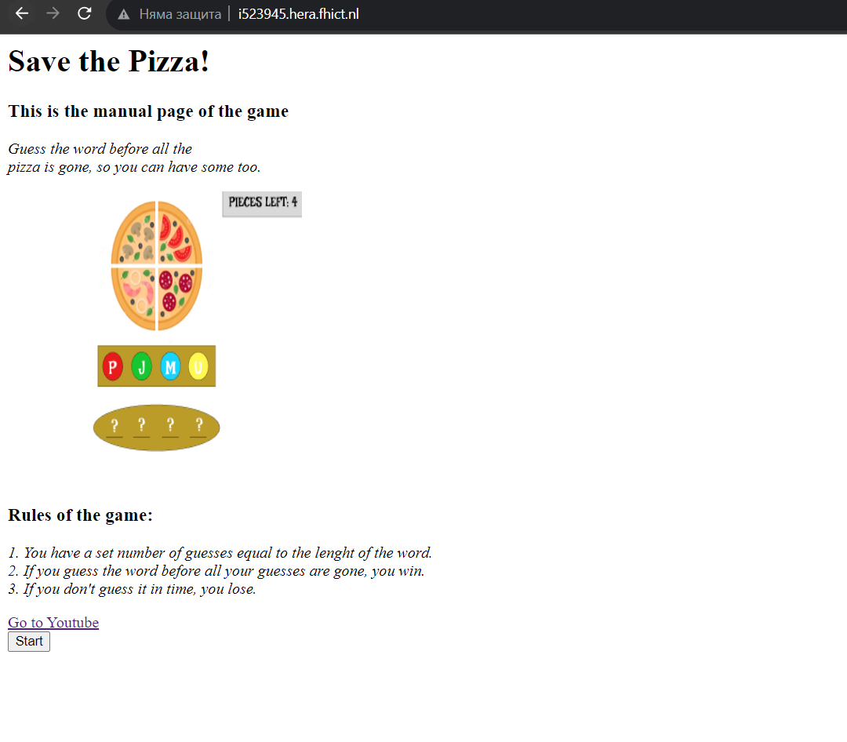

**Which learning outcomes both professionally and technically did you work on:**

**Learning Outcome 4: You develop software applications with attention for algorithmics and hereby demonstrate the basic skills of object-oriented programming.**

I achived this outcome by writing the code for the Pyhton excersises and using structures like Lists and Dictionaries and loops like while and for

**Learning Outcome 2: You are able to develop and implement interactive prototypes in an iterative process for the target users based on trends and developments.**

I achived this outcome by doing flowcharts for my Python programs before writing the code, which in my opinion is a type of prototyping

**Learning outcome 3: You demonstrate a self-developed, secured network environment with hosts and servers based on a specific application requirement (services)**

I achived this by using FileZilla to host my index.html file

**Feedback that you received**

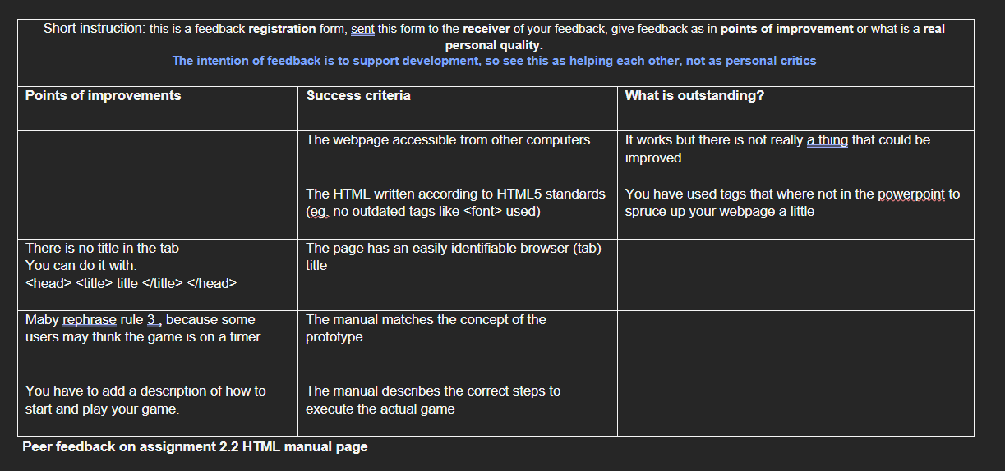

**What was your approach?**

My approach for the Python excersises was to use while loops in places where I need to repeat the same code while a given condition is true, I also used for loops for when I again needed to repeat the same code multiple times but the number of repeats were based on a given range, not on a condition like with while. I also used Lists and Dictionaries where I needed to organize and access Data.

My approach for the HTML part was to do a very simple website so I get the job done but not overcomplicate simple tasks. I didn’t use any styling since we are gonna learn CSS in week3.

**Why did things went well? What made it went well?**

Things went well because I have previous experience with Python and HTML, so the excersises weren’t difficult for me. The hosting of a website was new to me though so I it was interesting to do it for the first time with FileZilla, but that wasn’t hard either because our teacher explained it very well.

**What research did you do?**

I did research on some simple stuff like how to bold a text in html or how to iterate through the items of a dictionary in Python.

**Used Resources**

Teacher presentations

W3schools

# Week 3

|  |  |
| --- | --- |
|  | Key take aways of this week |
|  | 1. I learned how to use functions in Python, since I had only used them in other programming languages before  2. I refised how to write C for Arduino since I hadnt done it in a while, but I still love software more then tech  3. We had an infrastructure lecture and I didnt like infrastructure at all |

**Evidence of your relevant skills and abilities(foto’s, screenshots, video’s)**

Python functions

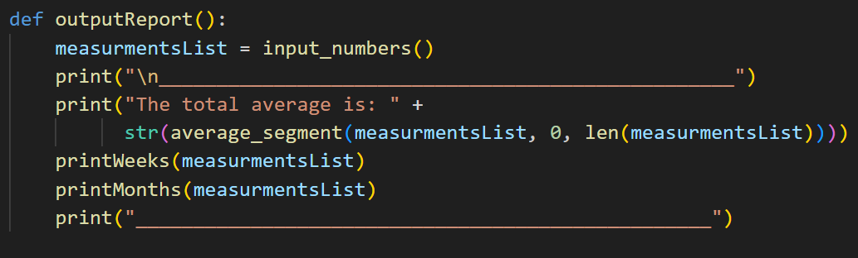

CSS

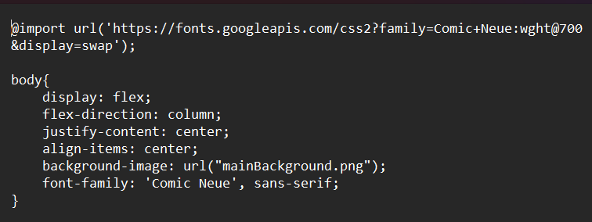

Arduino

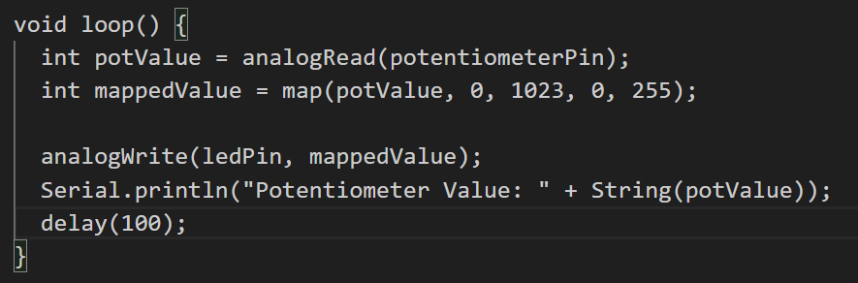

**Which learning outcomes both professionally and technically did you work on**

**Learning Outcome 2:** You are able to develop and implement interactive prototypes in an iterative process for the target users based on trends and developments.

I created the CSS for the website which I prototyped in the previous week and made sure that the CSS design corresponds to the design I made in Figma

**Learning Outcome 1:** You demonstrate how to convert data into information to achieve a recommendation that will make an improvement for a process in an organization.

While working on the Python exercises, I had to process data (input) to produce specific outputs based on conditions and logic (if/else and while/for loops).

**Learning outcome 5:** You develop and programme interactive embedded systems in which you use sensors and actuators and apply various I/O techniques

I made the Arduino excersises where I used LED lights, buttons and a potentiometer.

**Feedback that you received**

The only feedback I received was from the teachers and they told me that everything is ok for now, so I don’t know what else to add here

**What was your approach?**

Follow the lectures and teacher presentations and research on the Internet for anything else that I can’t find there. Things were pretty easy since I have already done Python, Arduino and CSS before in High School. I didn’t like the infrastructure lecture though, its not my thing.

**Why did things went well? What made it went well?**

Everything went well again since I have previous experience with software and technology. I don’t know what else to say

**What research did you do?**

I used W3Schools for some CSS stuff like how to use the :hover property

**Used Resources**

W3Schools

Teachers Presentation

# Week 4

|  |  |
| --- | --- |
|  | Key take aways of this week |
|  | 1. Arduino can be used with Python also instead of C, but in my opinion its easier and more practical to use it in C  2. We learned Network Diagrams but I didnt really enjoy the subject cause I don’t enjoy infrastructure in general  3. We learned that doing business analysis can help a business find and fix its problems, but I also didnt enjoy that topic much because business is not my thing. |

**Evidence of your relevant skills and abilities(foto’s, screenshots, video’s)**

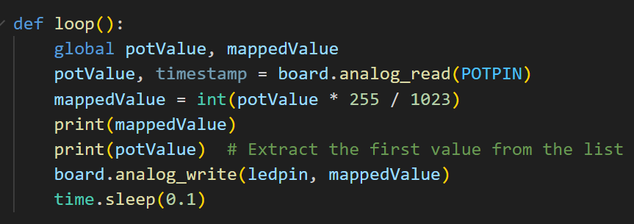

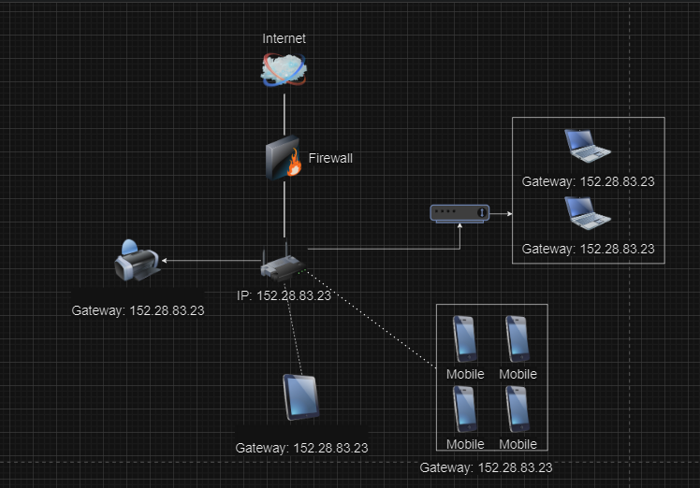**Which learning outcomes both professionally and technically did you work on**

**Learning Outcome 2:** You are able to develop and implement interactive prototypes in an iterative process for the target users based on trends and developments.

I demonstrate this outcome by doing the Network Diagrams which in my opinion is a type of prototyping for infrastructure.

**Learning Outcome 1:** You demonstrate how to convert data into information to achieve a recommendation that will make an improvement for a process in an organization.

I made a business analysis for a Greenhouse company and recommended them a solution to the organization’s biggest problems.

**Learning outcome 5:** You develop and programme interactive embedded systems in which you use sensors and actuators and apply various I/O techniques

I made programs for the Arduino excersises written in Python where I had to control different LEDs, potentiometers and buttons.

**Feedback that you received**

The only feedback I received was from the teachers and they told me I am on the right path. Again I don’t know what else to add here.

**What was your approach?**

**Why did things went well? What made it went well?**

Things went well because I have worked with Arduinos and Python before so the material is not entirely new to me. Also I used the provided resourses like examples and presentations as much as possible when I needed to do something which is new to me.What research did you do?

**What research did you do?**

Reseach on how to improve a Greenhouse

Research on how network diagrams work

**Used Resources**

Youtube

W3Schools

Teacher Presentations

# Week 5

|  |  |
| --- | --- |
|  | Key take aways of this week |
|  | 1.  2.  3. |

**Evidence of your relevant skills and abilities(foto’s, screenshots, video’s)**

<…>

**Which learning outcomes both professionally and technically did you work on**

<…>

**Feedback that you received**

<…>

**What was your approach?**

<…>

**Why did things went well? What made it went well?**

<…>

**What research did you do?**

<…>

**Used Resources**

**<…>**

# Week 6

|  |  |
| --- | --- |
|  | Key take aways of this week |
|  | 1.  2.  3. |

# Week 7

|  |  |
| --- | --- |
|  | Key take aways of this week |
|  | 1.  2.  3. |

# Week 8

|  |  |
| --- | --- |
|  | Key take aways of this week |
|  | 1.  2.  3. |