МИНИСТЕРСТВО ОБРАЗОВАНИЯ И НАУКИ РОССИЙСКОЙ ФЕДЕРАЦИИ

ФЕДЕРАЛЬНОЕ ГОСУДАРСТВЕННОЕ БЮДЖЕТНОЕ

ОБРАЗОВАТЕЛЬНОЕ УЧРЕЖДЕНИЕ

ВЫСШЕГО ПРОФЕССИОНАЛЬНОГО ОБРАЗОВАНИЯ

МОСКОВСКИЙ АВИАЦИОННЫЙ ИНСТИТУТ

(национальный исследовательский университет)

«МАИ»

Кафедра 806

Отчет по расчетно-графической работе

По дисциплине **«Численные методы»**

**Вариант 10**

**Задание 1**

Выполнил студент группы 3О-210Б:

Кофман М.С.

Принял:

Старший преподаватель каф. №806

Кринецкий Олег Евгеньевич

Москва, 2015

# Задание:

Методом Гаусса и простой итерации с точностью Е = 0,01 решить СЛАУ.

$$\left\{\begin{aligned}-4.75x_{1}+1.3x_{2}-0.76x_{3}=2.7 \\ 0.74x_{1}+5.9x_{2}-2.63x_{3}=4.1 \\ -1.2x_{1}-2.3x_{2}+7.6x_{3}=6.2\end{aligned}\right.$$

# Структурная схема алгоритма метода Гаусса:

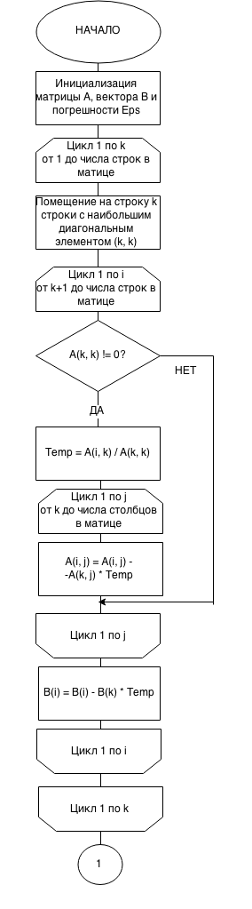

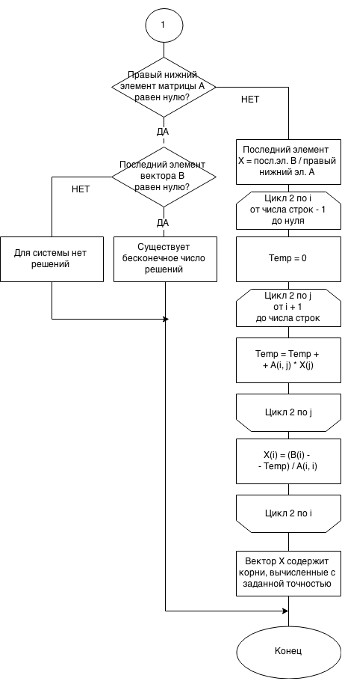

Текст программы для метода Гаусса на языке Visual Basic 6.0:

Dim Arr() As Double, Barr() As Double, X() As Double

Dim snum As Integer, cnum As Integer, eps As Integer

Private Sub Command3_Click()

snum = Val(Text3.Text)

cnum = Val(Text4.Text)

eps = Val(Text6.Text)

ReDim Barr(snum)

ReDim X(snum)

ReDim Arr(snum, cnum)

Frame1.Visible = True

End Sub

Private Sub Command1_Click()

Dim sFile As String, sWhole As String, outstr As String

Dim v As Variant

sFile = ".\InputA.txt"

Open sFile For Input As #1

sWhole = Input$(LOF(1), 1)

Close #1

v = Split(sWhole, vbNewLine & " ")

outstr = ""

For Each Item In v

outstr = outstr & Item

Next

Text1.Text = outstr

End Sub

Private Sub Command5_Click()

Dim sFile As String, sWhole As String, outstr As String

Dim v As Variant

sFile = ".\InputB.txt"

Open sFile For Input As #1

sWhole = Input$(LOF(1), 1)

Close #1

v = Split(sWhole, vbNewLine & " ")

outstr = ""

For Each Item In v

outstr = outstr & Item

Next

Text5.Text = outstr

End Sub

Private Sub Command2_Click()

Dim sFile As String, sWhole As String, oustr As String, outd As Double

Dim v() As String

Dim s As String, i As Integer, j As Integer

sFile = ".\Output.txt"

Open sFile For Output As #1

Print #1, Text1.Text

Close #1

sFile = ".\Output.txt"

Open sFile For Input As #1

sWhole = Input$(LOF(1), 1)

Close #1

v = Split(sWhole, vbNewLine & " ")

outstr = ""

For Each Item In v

outstr = outstr & Item

Next

outstr = outstr & "\n"

Dim k As Integer

k = 0

Do While (True)

i = 1

l = 0

s = vbNullString

c:

j = i

Do While (True)

s = Mid(outstr, j, 1)

If StrComp(s, " ") = 0 Then GoTo A 'переход с j=номер крайней цифры+1

If StrComp(s, vbLf) = 0 Then GoTo B 'переход j=позиция перехода на след.строку

If StrComp(s, vbNullString) = 0 Then GoTo D

j = j + 1

Loop

A:

Arr(k, l) = Val(Mid(outstr, i, j - i))

l = l + 1

i = j + 1

GoTo c

B:

Arr(k, l) = Val(Mid(outstr, i, j - 1 - i))

l = 0

k = k + 1

i = j + 1

GoTo c

Loop

D:

Frame5.Visible = True

End Sub

Private Sub Command4_Click()

Dim sFile As String, sWhole As String, outstr As String

Dim v() As String

Dim iTemp As Integer

Dim max As Double, Temp As Double

Dim str As String

sFile = ".\Output.txt"

Open sFile For Output As #1

Print #1, Text5.Text

Close #1

sFile = ".\Output.txt"

Open sFile For Input As #1

sWhole = Input$(LOF(1), 1)

Close #1

v = Split(sWhole, vbNewLine & " ")

outstr = ""

For Each Item In v

outstr = outstr & Item

Next

outstr = outstr & "\n"

Dim k As Integer

k = 0

Do While (True)

i = 1

l = 0

s = vbNullString

B:

j = i

Do While (True)

s = Mid(outstr, j, 1)

If StrComp(s, vbLf) = 0 Then GoTo A 'переход j=позиция перехода на след.строку

If StrComp(s, vbNullString) = 0 Then GoTo c

j = j + 1

Loop

A:

Barr(k) = Val(Mid(outstr, i, j - 1 - i))

k = k + 1

i = j + 1

GoTo B

Loop

c:

'Гаусс:

'сортировка по максимальным элементам на диагонали:

For k = 0 To snum - 1

max = Abs(Arr(k, k))

iTemp = k

For i = k + 1 To snum - 1

If Abs(Arr(i, k)) > max Then

max = Abs(Arr(i, k))

iTemp = i

End If

Next

For j = 0 To cnum - 1

Temp = Arr(k, j)

Arr(k, j) = Arr(iTemp, j)

Arr(iTemp, j) = Temp

Next

Temp = Barr(k)

Barr(k) = Barr(iTemp)

Barr(iTemp) = Temp

'Прямой ход с выводом:

If Arr(k, k) <> 0 Then

Temp = Arr(k, k)

For j = 0 To cnum - 1

Arr(k, j) = Arr(k, j) / Temp

Next

Barr(k) = Barr(k) / Temp

End If

For i = k + 1 To snum - 1

If Arr(k, k) <> 0 Then

Temp = Arr(i, k) / Arr(k, k)

For j = k To cnum - 1

Arr(i, j) = Arr(i, j) - Arr(k, j) * Temp

Next

Barr(i) = Barr(i) - Barr(k) * Temp

End If

Next

For i = 0 To snum - 1

For j = 0 To cnum - 1

str = str & Round(Arr(i, j), eps) & vbTab

Next

str = str & vbTab & Round(Barr(i), eps) & vbCrLf

Next

str = str & vbCrLf

Next

'Обратный ход с выводом:

If Arr(snum - 1, snum - 1) = 0 Then

If Barr(snum - 1) = 0 Then

str = str & "Существует бесконечное число решений исходной системы."

Else: str = str & "Для этой системы нет решений."

End If

Else

X(snum - 1) = Barr(snum - 1) / Arr(snum - 1, snum - 1)

For i = snum - 2 To 0 Step -1

Temp = 0

For j = i + 1 To snum - 1

Temp = Temp + Arr(i, j) * X(j)

Next

X(i) = (Barr(i) - Temp) / Arr(i, i)

Next

For i = 0 To snum - 1

str = str & Round(X(i), eps) & vbTab

Next

End If

Text2.Text = str

Frame6.Visible = True

sFile = ".\Output.txt"

Open sFile For Output As #1

Print #1, Text2.Text

Close #1

End Sub

Private Sub Text3_Click()

Text3.Text = ""

End Sub

Private Sub Text4_Click()

Text4.Text = ""

End Sub

Private Sub Text6_Click()

Text6.Text = ""

End Sub

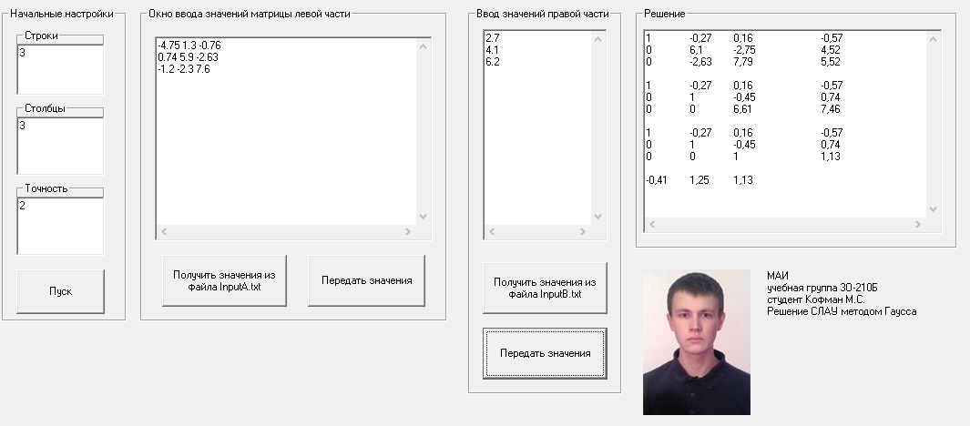Скриншот программы для метода Гаусса**:**

# Структурная схема алгоритма метода простой итерации:

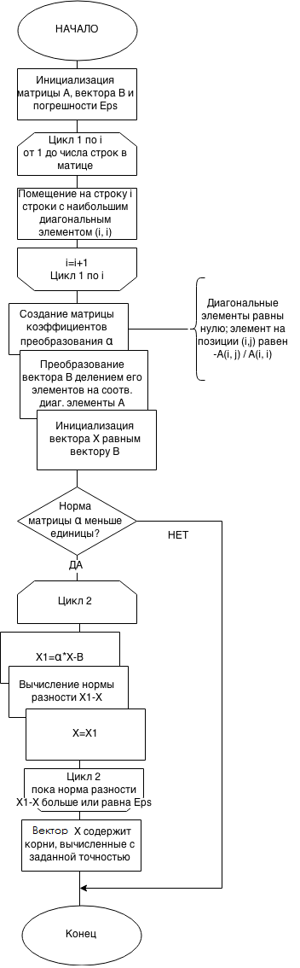

# Текст программы для метода простой итерации

# на языке Visual Basic 6.0:

Dim Arr() As Double, Barr() As Double, X() As Double, X1() As Double, Alpha() As Double

Dim snum As Integer, cnum As Integer, eps As Double

Private Sub Command1_Click()

snum = Val(Text1.Text)

cnum = Val(Text2.Text)

eps = 1

Dim i As Integer

For i = 1 To Val(Text3.Text)

eps = eps / 10

Next

ReDim Barr(snum)

ReDim X(snum)

ReDim X1(snum)

ReDim Arr(snum, cnum)

ReDim Alpha(snum, cnum)

Frame2.Visible = True

End Sub

Private Sub Command2_Click()

Dim sFile As String, sWhole As String, outstr As String

Dim v As Variant

sFile = ".\InputA.txt"

Open sFile For Input As #1

sWhole = Input$(LOF(1), 1)

Close #1

v = Split(sWhole, vbNewLine & " ")

outstr = ""

For Each Item In v

outstr = outstr & Item

Next

Text4.Text = outstr

End Sub

Private Sub Command4_Click()

Dim sFile As String, sWhole As String, outstr As String

Dim v As Variant

sFile = ".\InputB.txt"

Open sFile For Input As #1

sWhole = Input$(LOF(1), 1)

Close #1

v = Split(sWhole, vbNewLine & " ")

outstr = ""

For Each Item In v

outstr = outstr & Item

Next

Text5.Text = outstr

End Sub

Private Sub Command3_Click()

Dim sFile As String, sWhole As String, oustr As String, outd As Double

Dim v() As String

Dim s As String, i As Integer, j As Integer

sFile = ".\Output.txt"

Open sFile For Output As #1

Print #1, Text4.Text

Close #1

sFile = ".\Output.txt"

Open sFile For Input As #1

sWhole = Input$(LOF(1), 1)

Close #1

v = Split(sWhole, vbNewLine & " ")

outstr = ""

For Each Item In v

outstr = outstr & Item

Next

outstr = outstr & "\n"

Dim k As Integer

k = 0

Do While (True)

i = 1

l = 0

s = vbNullString

c:

j = i

Do While (True)

s = Mid(outstr, j, 1)

If StrComp(s, " ") = 0 Then GoTo A 'переход с j=номер крайней цифры+1

If StrComp(s, vbLf) = 0 Then GoTo B 'переход j=позиция перехода на след.строку

If StrComp(s, vbNullString) = 0 Then GoTo D

j = j + 1

Loop

A:

Arr(k, l) = Val(Mid(outstr, i, j - i))

l = l + 1

i = j + 1

GoTo c

B:

Arr(k, l) = Val(Mid(outstr, i, j - 1 - i))

l = 0

k = k + 1

i = j + 1

GoTo c

Loop

D:

Frame3.Visible = True

End Sub

Private Sub Command5_Click()

Dim sFile As String, sWhole As String, outstr As String

Dim v() As String

Dim iTemp As Integer

Dim max As Double, Temp As Double

Dim str As String

sFile = ".\Output.txt"

Open sFile For Output As #1

Print #1, Text5.Text

Close #1

sFile = ".\Output.txt"

Open sFile For Input As #1

sWhole = Input$(LOF(1), 1)

Close #1

v = Split(sWhole, vbNewLine & " ")

outstr = ""

For Each Item In v

outstr = outstr & Item

Next

outstr = outstr & "\n"

Dim k As Integer

k = 0

Do While (True)

i = 1

l = 0

s = vbNullString

B:

j = i

Do While (True)

s = Mid(outstr, j, 1)

If StrComp(s, vbLf) = 0 Then GoTo A 'переход j=позиция перехода на след.строку

If StrComp(s, vbNullString) = 0 Then GoTo c

j = j + 1

Loop

A:

Barr(k) = Val(Mid(outstr, i, j - 1 - i))

k = k + 1

i = j + 1

GoTo B

Loop

c:

'Простые итерации:

'Cортировка по максимальным элементам на диагонали:

For k = 0 To snum - 1

max = Abs(Arr(k, k))

iTemp = k

For i = k + 1 To snum - 1

If Abs(Arr(i, k)) > max Then

max = Abs(Arr(i, k))

iTemp = i

End If

Next

For j = 0 To cnum - 1

Temp = Arr(k, j)

Arr(k, j) = Arr(iTemp, j)

Arr(iTemp, j) = Temp

Next

Temp = Barr(k)

Barr(k) = Barr(iTemp)

Barr(iTemp) = Temp

Next

'Вычисление матрицы коэффициентов преобразования:

For i = 0 To snum - 1

For j = 0 To cnum - 1

If i = j Then

Alpha(i, j) = 0

Else

Alpha(i, j) = -Arr(i, j) / Arr(i, i)

End If

str = str & Round(Alpha(i, j), Val(Text3.Text)) & vbTab

Next

str = str & vbCrLf

Next

'Необходимые изменения вектора B и инициализация X:For i = 0 To snum - 1

Barr(i) = Barr(i) / Arr(i, i)

X(i) = Barr(i)

Next

'Проверка условия norma(Alpha)<1:

Dim norma As Double

norma = 0

For i = 0 To snum - 1

Temp = 0

For j = 0 To cnum - 1

Temp = Temp + Abs(Alpha(i, j))

Next

If norma < Temp Then: norma = Temp

Next

If norma >= 1 Then

str = str & "Норма матрицы коэффициентов: " & norma & vbCrLf & "Метод не сходится"

GoTo Fin

End If

'Собственно, метод простых итераций с промежуточным выводом:

k = 1

While True

'X(i)=Alpha(i,0)*X(0)+...+Alpha(i,snum-1)*X(snum-1)-Barr(i)

str = str & "Итерация " & k & ": "

For i = 0 To snum - 1

Temp = 0

For j = 0 To cnum - 1

Temp = Temp + Alpha(i, j) * X(j)

Next

X1(i) = Temp + Barr(i)

Next

'проверка на достижение точности

norma = 0

For i = 0 To snum - 1

If norma < Abs(X1(i) - X(i)) Then: norma = Abs(X1(i) - X(i))

Next

For i = 0 To snum - 1

X(i) = X1(i)

str = str & Round(X(i), Val(Text3.Text) + 1) & vbTab

Next

str = str & vbCrLf

k = k + 1

If norma < eps Then: GoTo Fin

Wend

Fin:

Text6.Text = str

Frame4.Visible = True

sFile = ".\Output.txt"

Open sFile For Output As #1

Print #1, Text6.Text

Close #1

End Sub

Private Sub Text1_Click()

Text1.Text = ""

End Sub

Private Sub Text2_Click()

Text2.Text = ""

End Sub

Private Sub Text3_Click()

Text3.Text = ""

End Sub

# Скриншот программы для метода простой итерации:

# Литература:

1. Пирумов У. Г. Численные методы, Москва, издательство МАИ 1998г.
2. 4us Самоучитель Visual Basic 6.0, http://vbzero.narod.ru (18.04.2015)