МИНИСТЕРСТВО ОБРАЗОВАНИЯ И НАУКИ РОССИЙСКОЙ ФЕДЕРАЦИИ

ФЕДЕРАЛЬНОЕ ГОСУДАРСТВЕННОЕ БЮДЖЕТНОЕ

ОБРАЗОВАТЕЛЬНОЕ УЧРЕЖДЕНИЕ

ВЫСШЕГО ПРОФЕССИОНАЛЬНОГО ОБРАЗОВАНИЯ

МОСКОВСКИЙ АВИАЦИОННЫЙ ИНСТИТУТ

(национальный исследовательский университет)

«МАИ»

Кафедра 806

Отчет по расчетно-графической работе

По дисциплине **«Численные методы»**

**Вариант 10**

**Задание 2**

Выполнил студент группы 3О-210Б:

Кофман М.С.

Принял:

Старший преподаватель каф. №806

Кринецкий Олег Евгеньевич

Москва, 2015

# Задание:

Методом прогонки решить СЛАУ, Е = 0,01.

$$\left\{\begin{aligned} 8x_{1}-2x_{2} =12 \\ -x_{1}+6x_{2}-2x_{3} =6 \\ 2x_{2}+10x_{3}-4x_{4}=16 \\ -x_{3}+6x_{4}=10\end{aligned}\right.$$

# Структурная схема алгоритма метода прогонки:

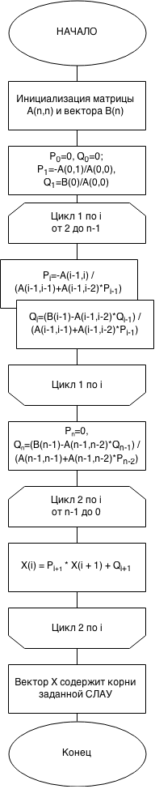

Текст программы для метода прогонки на языке Visual Basic 6.0:

Dim Arr() As Double, Barr() As Double, X() As Double, P() As Double, Q() As Double

Dim snum As Integer, cnum As Integer, eps As Double

Private Sub Command1_Click()

snum = Val(Text1.Text)

cnum = Val(Text2.Text)

eps = Val(Text3.Text)

ReDim Barr(snum)

ReDim X(snum)

ReDim P(snum + 1)

ReDim Q(snum + 1)

ReDim Arr(snum, cnum)

Frame2.Visible = True

End Sub

Private Sub Command2_Click()

Dim sFile As String, sWhole As String, outstr As String

Dim v As Variant

sFile = ".\InputA.txt"

Open sFile For Input As #1

sWhole = Input$(LOF(1), 1)

Close #1

v = Split(sWhole, vbNewLine & " ")

outstr = ""

For Each Item In v

outstr = outstr & Item

Next

Text4.Text = outstr

End Sub

Private Sub Command4_Click()

Dim sFile As String, sWhole As String, outstr As String

Dim v As Variant

sFile = ".\InputB.txt"

Open sFile For Input As #1

sWhole = Input$(LOF(1), 1)

Close #1

v = Split(sWhole, vbNewLine & " ")

outstr = ""

For Each Item In v

outstr = outstr & Item

Next

Text5.Text = outstr

End Sub

Private Sub Command3_Click()

Dim sFile As String, sWhole As String, oustr As String, outd As Double

Dim v() As String

Dim s As String, i As Integer, j As Integer

sFile = ".\Output.txt"

Open sFile For Output As #1

Print #1, Text4.Text

Close #1

sFile = ".\Output.txt"

Open sFile For Input As #1

sWhole = Input$(LOF(1), 1)

Close #1

v = Split(sWhole, vbNewLine & " ")

outstr = ""

For Each Item In v

outstr = outstr & Item

Next

outstr = outstr & "\n"

For i = 0 To snum - 1

For j = 0 To cnum - 1

Arr(i, j) = 0

Next

Next

Dim k As Integer

k = 0

Do While (True)

i = 1

l = 0

s = vbNullString

c:

j = i

Do While (True)

s = Mid(outstr, j, 1)

If StrComp(s, " ") = 0 Then GoTo A 'переход с j=номер крайней цифры+1

If StrComp(s, vbLf) = 0 Then GoTo B 'переход j=позиция перехода на след.строку

If StrComp(s, vbNullString) = 0 Then GoTo D

j = j + 1

Loop

A:

If k > 0 Then

Arr(k, l + k - 1) = Val(Mid(outstr, i, j - i))

Else: Arr(k, l + k) = Val(Mid(outstr, i, j - i))

End If

l = l + 1

i = j + 1

GoTo c

B:

If k > 0 Then

Arr(k, l + k - 1) = Val(Mid(outstr, i, j - 1 - i))

Else: Arr(k, l + k) = Val(Mid(outstr, i, j - i))

End If

l = 0

k = k + 1

i = j + 1

GoTo c

Loop

D:

Frame3.Visible = True

End Sub

Private Sub Command5_Click()

Dim sFile As String, sWhole As String, outstr As String

Dim v() As String

Dim iTemp As Integer

Dim max As Double, Temp As Double

Dim str As String

sFile = ".\Output.txt"

Open sFile For Output As #1

Print #1, Text5.Text

Close #1

sFile = ".\Output.txt"

Open sFile For Input As #1

sWhole = Input$(LOF(1), 1)

Close #1

v = Split(sWhole, vbNewLine & " ")

outstr = ""

For Each Item In v

outstr = outstr & Item

Next

outstr = outstr & "\n"

Dim k As Integer

k = 0

Do While (True)

i = 1

l = 0

s = vbNullString

B:

j = i

Do While (True)

s = Mid(outstr, j, 1)

If StrComp(s, vbLf) = 0 Then GoTo A 'переход j=позиция перехода на след.строку

If StrComp(s, vbNullString) = 0 Then GoTo c

j = j + 1

Loop

A:

Barr(k) = Val(Mid(outstr, i, j - 1 - i))

k = k + 1

i = j + 1

GoTo B

Loop

c:

'Прогонка:

'Прямой ход с выводом

P(0) = 0

Q(0) = 0

P(1) = -Arr(0, 1) / Arr(0, 0)

Q(1) = Barr(0) / Arr(0, 0)

str = str & "P1" & "=" & Round(P(1), eps) & vbTab & vbTab & "Q1" & "=" & Round(Q(1), eps) & vbCrLf

For i = 2 To snum - 1

P(i) = -Arr(i - 1, i) / (Arr(i - 1, i - 1) + Arr(i - 1, i - 2) * P(i - 1))

Q(i) = (Barr(i - 1) - Arr(i - 1, i - 2) * Q(i - 1)) / (Arr(i - 1, i - 1) + Arr(i - 1, i - 2) * P(i - 1))

str = str & "P" & i & "=" & Round(P(i), eps) & vbTab & vbTab & "Q" & i & "=" & Round(Q(i), eps) & vbCrLf

Next

P(snum) = 0

Q(snum) = (Barr(snum - 1) - Arr(snum - 1, snum - 2) * Q(snum - 1)) / (Arr(snum - 1, snum - 1) + Arr(snum - 1, snum - 2) * P(snum - 2))

str = str & "P" & snum & "=" & Round(P(snum), eps) & vbTab & vbTab & "Q" & snum & "=" & Round(Q(snum), eps) & vbCrLf

'Обратный ход с выводом

For i = snum - 1 To 0 Step -1

X(i) = P(i + 1) * X(i + 1) + Q(i + 1)

Next

For i = 0 To snum - 1

str = str & Round(X(i), eps) & vbTab

Next

Text6.Text = str

Frame4.Visible = True

sFile = ".\Output.txt"

Open sFile For Output As #1

Print #1, Text6.Text

Close #1

End Sub

Private Sub Text1_Click()

Text1.Text = ""

End Sub

Private Sub Text2_Click()

Text2.Text = ""

End Sub

Private Sub Text3_Click()

Text3.Text = ""

End Sub

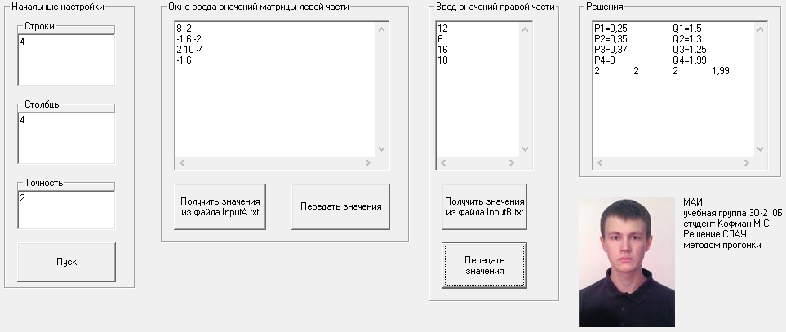Скриншот программы для метода прогонки**:**

# Литература:

1. Пирумов У. Г. Численные методы, Москва, издательство МАИ 1998г.
2. 4us Самоучитель Visual Basic 6.0, http://vbzero.narod.ru (18.04.2015)