МИНИСТЕРСТВО ОБРАЗОВАНИЯ И НАУКИ РОССИЙСКОЙ ФЕДЕРАЦИИ

ФЕДЕРАЛЬНОЕ ГОСУДАРСТВЕННОЕ БЮДЖЕТНОЕ

ОБРАЗОВАТЕЛЬНОЕ УЧРЕЖДЕНИЕ

ВЫСШЕГО ПРОФЕССИОНАЛЬНОГО ОБРАЗОВАНИЯ

МОСКОВСКИЙ АВИАЦИОННЫЙ ИНСТИТУТ

(национальный исследовательский университет)

«МАИ»

Кафедра 806

Отчет по расчетно-графической работе

По дисциплине **«Численные методы»**

**Вариант 10**

**Задание 6**

Выполнил студент группы 3О-210Б:

Кофман М.С.

Принял:

Старший преподаватель каф. №806

Кринецкий Олег Евгеньевич

Москва, 2015

# Задание:

Для таблицы задания 5 выписать кубические сплайны дефекта 1 на каждом отрезке $X∈\left[X_{i-1},X_{i}\right], i=1..4$

y=ctg(x)

xi = 0,1; 0,2; 0,3; 0,4; 0,5.

Структурная схема алгоритма:

# C:\Users\M\Desktop\Безымянный.png

Текст программы для метода кубических сплайнов на языке Visual Basic 6.0:

Dim N, NX, memb, Ni As Integer, func(), str As String, Eps, X(), F(), P(), Q(), B(), C(), D() As Double

Private Sub Text1_Click()

Text1.Text = ""

End Sub

Private Sub Text10_Click()

Text10.Text = ""

End Sub

Private Sub Text2_Click()

Text2.Text = ""

End Sub

Private Sub Text3_Click()

Text3.Text = ""

End Sub

Private Sub Text6_Click()

Text6.Text = ""

End Sub

Private Sub Text7_Click()

Text7.Text = ""

End Sub

Private Sub Command1_Click()

Frame4.Visible = False

N = Val(Text1.Text)

NX = Val(Text6.Text)

If Val(Text6.Text) < 2 Then

Frame4.Visible = True

Text4.Text = "Применение метода кубических сплайнов невозможно"

GoTo Err

End If

ReDim func(N, 5)

ReDim X(NX)

ReDim F(NX)

ReDim B(NX)

ReDim C(NX)

ReDim D(NX)

ReDim P(NX - 1)

ReDim Q(NX - 1)

memb = 0

Eps = Val(Text7.Text)

If memb = N - 1 Then

Command2.Visible = False

Command3.Visible = True

End If

Frame3.Visible = True

Err:

End Sub

Private Sub Command2_Click()

func(memb, 0) = Val(Text8.Text)

If func(memb, 0) >= 0 Then

str = str & "+" & func(memb, 0)

Else

str = str & func(memb, 0)

End If

If Option1.Value = True Then

func(memb, 1) = "S"

str = str & "Sin("

End If

If Option2.Value = True Then

func(memb, 1) = "C"

str = str & "Cos("

End If

If Option3.Value = True Then

func(memb, 1) = "T"

str = str & "Tg("

End If

If Option4.Value = True Then

func(memb, 1) = "N"

str = str & "Ctg("

End If

If Option5.Value = True Then

func(memb, 1) = "L"

str = str & "Ln("

End If

If Option6.Value = True Then

func(memb, 1) = "E"

str = str & "e^("

End If

If Option7.Value = True Then

func(memb, 1) = ""

str = str & "("

End If

func(memb, 2) = Val(Text9.Text)

func(memb, 3) = Val(Text2.Text)

If func(memb, 3) >= 0 Then

str = str & "(" & func(memb, 2) & "+"

Else

str = str & "(" & func(memb, 2)

End If

str = str & func(memb, 3) & "x^"

func(memb, 4) = Text3.Text

str = str & func(memb, 4) & ")"

memb = memb + 1

If memb = N - 1 Then

Command2.Visible = False

Command3.Visible = True

End If

End Sub

Private Sub Command3_Click()

func(memb, 0) = Val(Text8.Text)

If func(memb, 0) >= 0 Then

str = str & "+" & func(memb, 0)

Else

str = str & func(memb, 0)

End If

If Option1.Value = True Then

func(memb, 1) = "S"

str = str & "Sin("

End If

If Option2.Value = True Then

func(memb, 1) = "C"

str = str & "Cos("

End If

If Option3.Value = True Then

func(memb, 1) = "T"

str = str & "Tg("

End If

If Option4.Value = True Then

func(memb, 1) = "N"

str = str & "Ctg("

End If

If Option5.Value = True Then

func(memb, 1) = "L"

str = str & "Ln("

End If

If Option6.Value = True Then

func(memb, 1) = "E"

str = str & "e^("

End If

If Option7.Value = True Then

func(memb, 1) = ""

str = str & "("

End If

func(memb, 2) = Val(Text9.Text)

func(memb, 3) = Val(Text2.Text)

If func(memb, 3) >= 0 Then

str = str & "(" & func(memb, 2) & "+"

Else

str = str & "(" & func(memb, 2)

End If

str = str & func(memb, 3) & "x^"

func(memb, 4) = Text3.Text

str = str & func(memb, 4) & ")" & vbCrLf & "Узлы:" & vbCrLf

Command3.Visible = False

Frame8.Visible = True

Ni = 0

End Sub

Private Sub Command4_Click()

If Ni < NX - 1 Then

X(Ni) = Val(Text10.Text)

Ni = Ni + 1

Text10.Text = "Введите узел " & Ni + 1

Else

X(Ni) = Val(Text10.Text)

For j = 0 To NX - 1

str = str & X(j) & vbTab

Next

For i = 0 To N - 1

F(i) = 0

Next

For i = 0 To NX - 1

For k = 0 To N - 1

If func(k, 1) = "S" Then

F(i) = F(i) + func(k, 0) * Sin(func(k, 2) + func(k, 3) * (X(i) ^ func(k, 4)))

End If

If func(k, 1) = "C" Then

F(i) = F(i) + func(k, 0) * Cos(func(k, 2) + func(k, 3) * (X(i) ^ func(k, 4)))

End If

If func(k, 1) = "T" Then

F(i) = F(i) + func(k, 0) * Tan(func(k, 2) + func(k, 3) * (X(i) ^ func(k, 4)))

End If

If func(k, 1) = "N" Then

F(i) = F(i) + func(k, 0) * 1 / Tan(func(k, 2) + func(k, 3) * (X(i) ^ func(k, 4)))

End If

If func(k, 1) = "L" Then

F(i) = F(i) + func(k, 0) * Log(func(k, 2) + func(k, 3) * (X(i) ^ func(k, 4)))

End If

If func(k, 1) = "E" Then

F(i) = F(i) + func(k, 0) * Exp(func(k, 2) + func(k, 3) * (X(i) ^ func(k, 4)))

End If

If func(k, 1) = "" Then

F(i) = F(i) + func(k, 0) * (func(k, 2) + func(k, 3) * (X(i) ^ func(k, 4)))

End If

Next

Next

P(0) = 0

Q(0) = 0

C(0) = 0

If NX > 2 Then

For i = 1 To NX - 2

P(i) = -(X(i + 1) - X(i)) / ((X(i) - X(i - 1)) * P(i - 1) + 2 * ((X(i + 1) - X(i)) + (X(i) - X(i - 1))))

Q(i) = (6 * ((F(i + 1) - F(i)) / (X(i + 1) - X(i)) - (F(i) - F(i - 1)) / (X(i) - X(i - 1))) - (X(i) - X(i - 1)) * Q(i - 1)) / ((X(i) - X(i - 1)) * P(i - 1) + 2 * ((X(i + 1) - X(i)) + (X(i) - X(i - 1))))

Next

C(NX - 1) = (6 * ((F(NX - 1) - F(NX - 2)) / (X(NX - 1) - X(NX - 2)) - (F(NX - 2) - F(NX - 3)) / (X(NX - 2) - X(NX - 3))) - (X(NX - 1) - X(NX - 2)) * Q(NX - 2)) / (2 * ((X(NX - 1) - X(NX - 2)) + (X(NX - 2) - X(NX - 3))) + (X(NX - 2) - X(NX - 3)) * P(NX - 2))

For i = NX - 2 To 1 Step -1

C(i) = P(i) * C(i + 1) + Q(i)

Next

End If

For i = NX - 1 To 1 Step -1

B(i) = (X(i) - X(i - 1)) * (2 * C(i) + C(i - 1)) / 6 + (F(i) - F(i - 1)) / (X(i) - X(i - 1))

D(i) = (C(i) - C(i - 1)) / (X(i) - X(i - 1))

Next

str = str & vbCrLf & "Сплайн:" & vbCrLf

For i = 1 To NX - 1

str = str & "S(" & i + 1 & ")=" & Round(F(i), Eps) & "+" & Round(B(i), Eps) & "*(x-" & X(i) & ")+" & Round(C(i), Eps) & "*((x-" & X(i) & ")^2)/2+" & Round(D(i), Eps) & "*((x-" & X(i) & ")^3)/6" & vbCrLf

Next

Picture1.ScaleMode = vbPixels

Picture1.BackColor = RGB(255, 255, 255)

dx = Abs((X(NX - 1) - X(0))) / Picture1.ScaleWidth

Dim max, min As Double

max = F(0)

min = F(NX - 1)

For k = 1 To NX - 1

For i = X(k - 1) To X(k) - dx Step dx

If max < F(k) + B(k) * (i - X(k)) + C(k) * ((i - X(k)) ^ 2) / 2 + D(k) * ((i - X(k)) ^ 3) / 6 Then

max = F(k) + B(k) * (i - X(k)) + C(k) * ((i - X(k)) ^ 2) / 2 + D(k) * ((i - X(k)) ^ 3) / 6

End If

If min > F(k) + B(k) * (i - X(k)) + C(k) * ((i - X(k)) ^ 2) / 2 + D(k) * ((i - X(k)) ^ 3) / 6 Then

min = F(k) + B(k) * (i - X(k)) + C(k) * ((i - X(k)) ^ 2) / 2 + D(k) * ((i - X(k)) ^ 3) / 6

End If

Next

Next

If X(0) < X(NX - 1) Then

Picture1.Scale (X(0), max)-(X(NX - 1), min)

Else

Picture1.Scale (X(NX - 1), max)-(X(0), min)

End If

Picture1.Line (X(0), 0)-(X(NX - 1), 0)

Picture1.Line (0, max)-(0, min)

For k = 1 To NX - 1

For i = X(k - 1) To X(k) - dx Step dx

Dim func1, func2 As Double

func1 = F(k) + B(k) * (i - X(k)) + C(k) * ((i - X(k)) ^ 2) / 2 + D(k) * ((i - X(k)) ^ 3) / 6

func2 = F(k) + B(k) * (i + dx - X(k)) + C(k) * ((i + dx - X(k)) ^ 2) / 2 + D(k) * ((i + dx - X(k)) ^ 3) / 6

Picture1.Line (i, func1)-(i + dx, func2), RGB(0, 0, 0)

Next

Next

Frame4.Visible = True

Text4.Text = str

Frame5.Visible = True

End If

sFile = ".\Output.txt"

Open sFile For Output As #1

Print #1, Text4.Text

Close #1

End Sub

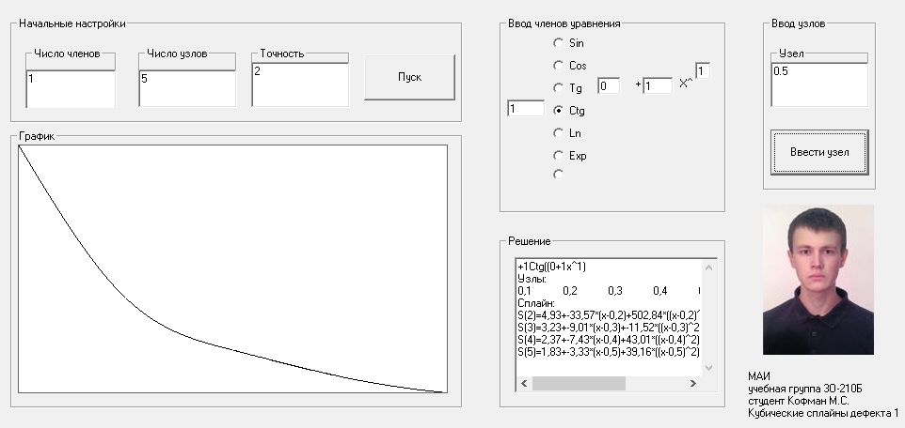Скриншот программы**:**

# Лог решения:

+1Ctg((0+1x^1)

Узлы:

0,1 0,2 0,3 0,4 0,5

Сплайн:

S(2)=4,93+-33,57*(x-0,2)+502,84*((x-0,2)^2)/2+5028,4*((x-0,2)^3)/6

S(3)=3,23+-9,01*(x-0,3)+-11,52*((x-0,3)^2)/2+-5143,63*((x-0,3)^3)/6

S(4)=2,37+-7,43*(x-0,4)+43,01*((x-0,4)^2)/2+545,29*((x-0,4)^3)/6

S(5)=1,83+-3,33*(x-0,5)+39,16*((x-0,5)^2)/2+-38,41*((x-0,5)^3)/6

# Литература:

1. Пирумов У. Г. Численные методы, Москва, издательство МАИ 1998г.
2. 4us Самоучитель Visual Basic 6.0, http://vbzero.narod.ru (18.04.2015)