Introduction to Artificial Intelligence
Assignment 2 (Music Generation)

Made by: Rotaru Victoria BS2-1
Verified by: Munir Makhmutov

This is a ReadMe document that explains how my musicGeneration project works.

First of all I choose major tonality and the piano instrument. So my melody contains 4 bars each with 4 chords that was generated by Particle Swarm Algorithm and each chord has one pair note that play simultaneously. For correctly melody generation I used the following criteria:
Each single note played simultaneously with the chord should have a value which is by modulo 12 equal to one of chord’s note. So, for tonic triad in C major (60, 64, 67) single note’s values should be 60+12*N or 64+12*N or 67+12*N. N is an octave difference between chords and melody. Chords represent accompaniment for melody. Difference between neighbor notes should not exceed 12. Difference between lowest notes of neighbor chords also should not exceed 12.
My project consists of 5 classes each one with its specifications. ChordsPSO.java and NotesPSO.java are the classes that use the PSO algorithm to generate the best chords and notes for a good melody in some kind of random way. Chord.java is the skeleton of chord, Music.java is the class that actually generates music. It uses the other 3 classes and make the melody, while Main.java is the class that makes the project to work.

ChordsPSO and NotesPSO:

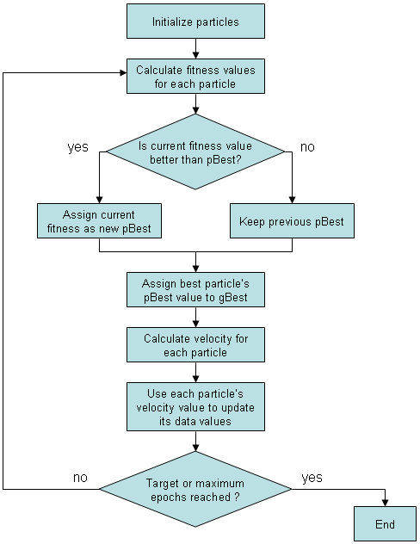
My Particle Swarm Optimization Algorithm works in the way that is represented in the scheme below. First I initialized the particles. My class particle has array of notes, velocity etc. Then I calculate the fitness values.
- Fitness function checks if chord notes are in the range [36, 48].
- Second note from the chord should be in range +4, third note in the range +7 from the first one.
- For a good melody first note should be 36, 41 or 43.
For the notes:
- First note from the pair note should be equal to one of the notes from chord in modulo 12.
- Second note from the pair notes should be random in range [-6, +6] from first note but bigger than 60 and smaller than 72.
Then I check if the current fitness value is better than myBest and if it is I assign it to myBest but if not, then I keep previous value. After that, I assign best particle’s myBest to globalBest, I calculate velocity for each particle, I use each particle’s velocity value to update its data values and I check if the target or maximum epochs reached. If it is false then I call the fitness function and I do the steps I mentioned but if it is true I finish and I got the notes I was looking for.

Conclusion:
It was quite challenging assignment but still very interesting and different from other assignments that I had. At the end of my work I saw the result, I mean I could show my little melody to others and I feel proud with my job. It was a pleasure for me to listen the music, my program created and I like it not just because it has a rhythm and a specific sequence of notes but because it is mine. I created this and I am very thankful to the TA that gave us such a practical assignment.

Example of output:

Iteration = 250
Base chords [64, 68, 65, 69, 71, 72, 66, 65, 68, 65, 66, 62, 62, 61, 65, 63]
Best Fitness: 0.10248467861271049
Best chord: [64 68 71]
Best Fitness: 0.4101228813878284
Best chord: [68 72 75]
Best Fitness: 0.20889550686133518
Best chord: [65 69 72]
Best Fitness: 0.2510885575666313
Best chord: [69 73 76]
Best Fitness: 0.36232507364576083
Best chord: [71 75 78]
Best Fitness: 0.4435154580973011
Best chord: [72 76 79]
Best Fitness: 0.28444086075172503
Best chord: [66 70 73]
Best Fitness: 0.2821180347572385
Best chord: [65 69 72]
Best Fitness: 0.3450416917365353
Best chord: [68 72 75]
Best Fitness: 0.190310392202786
Best chord: [65 69 72]
Best Fitness: 0.050930990024807166
Best chord: [66 70 73]
Best Fitness: 0.09367460540471662
Best chord: [62 66 69]
Best Fitness: 0.2777028727974935
Best chord: [62 66 69]
Best Fitness: 0.096439677528398
Best chord: [61 65 68]
Best Fitness: 0.0733340117878516
Best chord: [65 69 72]
Best Fitness: 0.23443403007669206
Best chord: [63 67 70]
All chords:
[ 64 68 71 ]
[ 68 72 75 ]
[ 65 69 72 ]
[ 69 73 76 ]
[ 71 75 78 ]
[ 72 76 79 ]
[ 66 70 73 ]
[ 65 69 72 ]
[ 68 72 75 ]
[ 65 69 72 ]
[ 66 70 73 ]
[ 62 66 69 ]
[ 62 66 69 ]
[ 61 65 68 ]
[ 65 69 72 ]
[ 63 67 70 ]
----------------------------- Writing MIDI File ------------------------------
Converting to SMF data structure...
Part 0 'Chords' to SMF Track on Ch. 0: Phrase 0:. Phrase 1:. Phrase 2:. Phrase 3:. Phrase 4:. Phrase 5:. Phrase 6:. Phrase 7:. Phrase 8:. Phrase 9:. Phrase 10:. Phrase 11:. Phrase 12:. Phrase 13:. Phrase 14:. Phrase 15:. Phrase 16:. Phrase 17:. Phrase 18:. Phrase 19:. Phrase 20:. Phrase 21:. Phrase 22:. Phrase 23:. Phrase 24:. Phrase 25:. Phrase 26:. Phrase 27:. Phrase 28:. Phrase 29:. Phrase 30:. Phrase 31:. Phrase 32:. Phrase 33:. Phrase 34:. Phrase 35:. Phrase 36:. Phrase 37:. Phrase 38:. Phrase 39:. Phrase 40:. Phrase 41:. Phrase 42:. Phrase 43:. Phrase 44:. Phrase 45:. Phrase 46:. Phrase 47:.
Part 1 'Notes' to SMF Track on Ch. 1:
MIDI file 'VictoriaRotaru.mid' written from score 'Music' in 0.206 seconds.
------------------------------------------------------------------------------

