bugs from transfermarkt.com

-Tooltips are not working on the 2nd and further pages

1. Open transfermarkt.com site and navigate to any page that contains table (e.g. market values -> Most valuable players, market values -> most valuable clubs, Transfers&Rumours -> Free agents)

2. Focus mouse on any of the table item (e.g. Player name, club name) and check that tooltip appears

3. Navigate to the second page of this table and focus mouse on any item of the table

AR: No tooltip appears

ER: Tooltip should appear

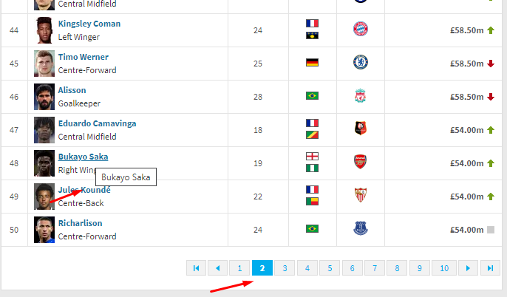

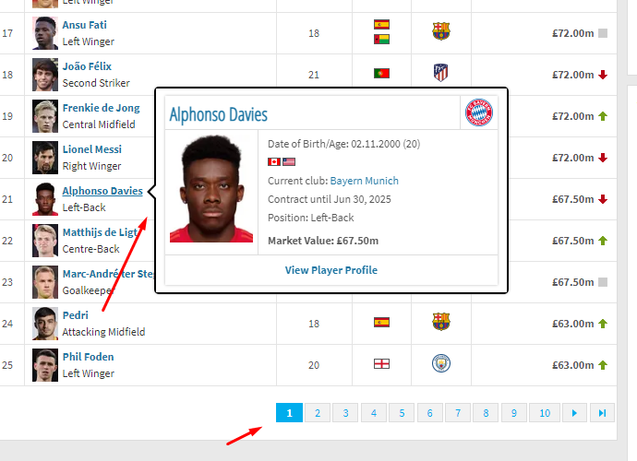

-Translations are not exist for some items

1. Open Transfermarkt.com and select another domain - .com.br

2. Focus mouse on Transfers&Rumours and check Player Agent section

ER: All tabs of this section are in Portuguese

AR: Some items are written in English

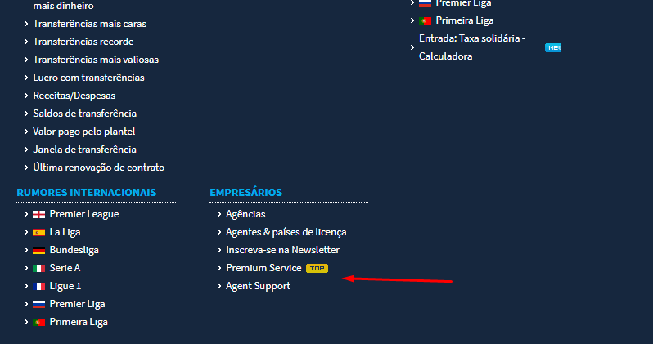

-Some titles are started with lowercase letters

1. Open Transfermarkt.com

2. Select MY TM tab and check titles in this section

AR: Some titles started with lowecase letters

ER:All titles should started with uppercase letters

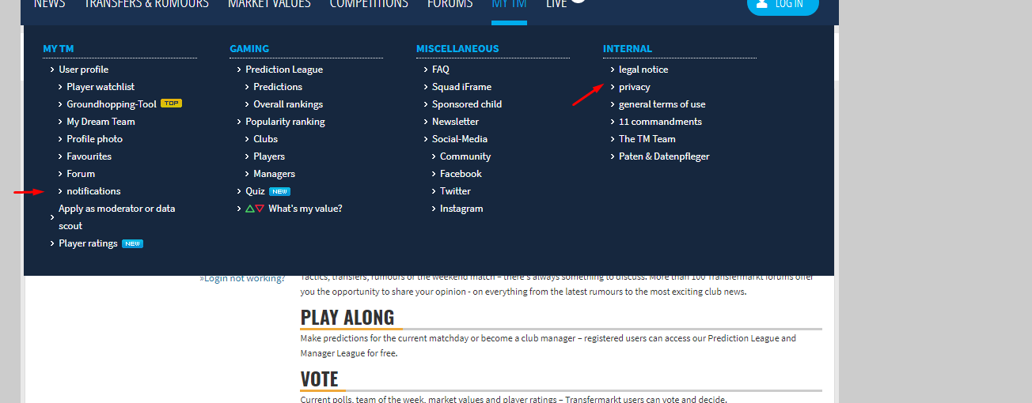

bugs from https://saucelabs.com/

- When working with the site and returning to the main page, the section headers are shifted

1. Open https://saucelabs.com/

2. click on the site title in the header

AR: The title moves to the left

EX: title does not shift

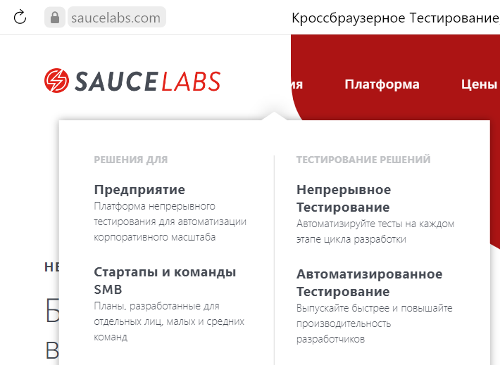

bugs from http://wenger.by/

- When placing an order, you can enter the phone number in letters

1. Open //wenger.by/

2. Add the product to the cart

3. Go to the shopping cart

4. Сlick to place an order

5. Сlick continue and enter letters into Phone number field

ER: possible to enter only numbers

AR: no validation message/error, possible to put invalid symbols into phone number field

