**Урок 9 Chemical Engineering**

although - хотя

approximate - приближенный

batch – пакет/партия

beverage - напиток

capacity - вместимость

consider factors – рассматривать факторы

constraints - ограничения

continuous - непрерывный

costs - расходы

efficient - эффективный

eliminate – устранить/ликвидировать

fluid - жидкость

haphazard – случайный/бессистемный

initial - начальный

manufacture - производство

natural gas – природный газ

nowadays – в настоящее время

oil refinery – нефтеперерабатывающий завод

on a large scale – в больших масштабах

otherwise - иначе

petrochemical - нефтехимический

pollute - загрязнять

process - процесс

profit – выгода/доход

raw material - сырье

remove - удалить

sensitive - чувствительный

simultaneous – одновременный

typically – типично

unprofitable - невыгодный

utilize - утилизировать

via something – посредством чего-то

**Урок 10 From Chemical Science to Forensics**

applied - прикладной

apply something to something – применить что-то к чему-то

attach - прикреплять

bind - связать

coat – оболочка/слой

coil - наматывать

derivative - производное

dissolve - растворить

emphasize - акцентировать

enforcement - правоприменение

forensic chemistry – судебно-медицинская химия

reveal - раскрыть

sequence - последовательность

slightly – слегка/немного

solvent - растворитель

vaporize – испарять/выпаривать

**Урок 11 Green: the New Colour of Chemistry**

accompany – сопровождать

adverse - неблагоприятный

community - сообщество

degrade - ухудшать

device - устройство

efforts – усилие/стремление

enormous amounts – огромные объемы

giant - гигантский

habitat – среда обитания

maintain - поддерживать

numerous - многочисленные

on a huge scale – в огромных масштабах

soil - почва

to refer to as – обозначать как

wastes - отходы

The Arrangement of the Chemical Plant

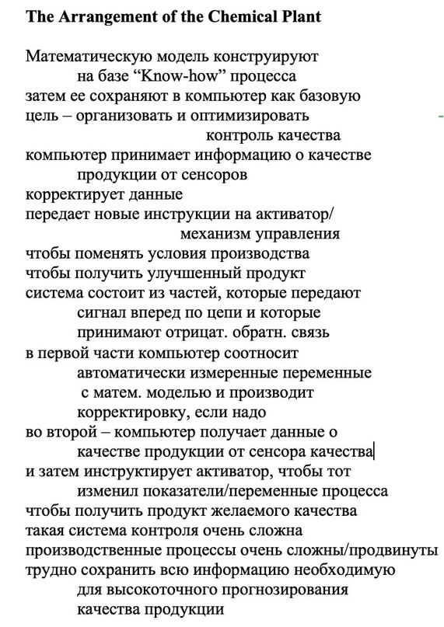

What is Ecology?

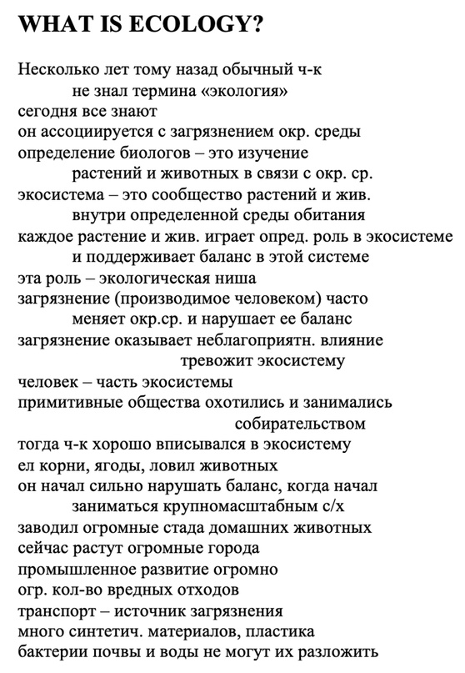

Green Chemistry

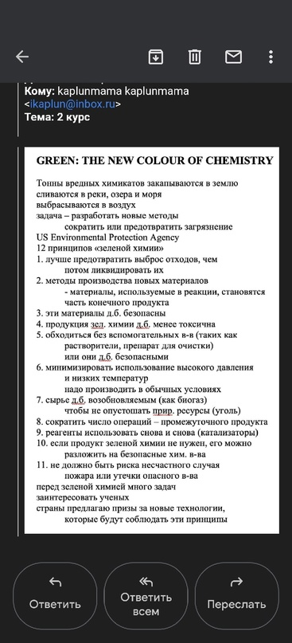

Forensic Chemistry

Forensic chemistry is the application of chemistry to law enforcement.

It is used to find production mistakes.

There are many analytical methods to detect chemical changes during some kind of incident.

Forensic chemistry helps to reconstruct the sequence of events.

Forensic chemistry is unique in that it meets the needs of both the scientific and legal communities.

One particularly useful method the use of a gas chromatograph-mass spectrometer.

This method simultaneously separates, identifies and quantifies the components of an unknown substance or mixture.

Gas chromatography-mass spectrometry consists of two connected instruments.

The gas chromatograph is a hot oven at a temperature of (150-350 °C).

It contains a bent or coiled, specially packed or coated glass column one or a few meters long.

A little unknown substance is dissolved in an organic solution of chloroform and methanol.

Then they are quickly introduced into the column.

These volatile substances evaporate and are displaced to the end of the column by a stream of intermediate gas usually helium.

There are special chemicals inside the column.

They come into contact with substances in the vaporized mixture with different force.

As a result, different substances appear at the end of the column in differing amounts of time, which is known as the "retention time".

Then the retention time is compared with the standards.

This comparison provides presumptive identification of the presence of any compound in the unknown sample.

Gas chromatograph is used for separation and quantification, not for identification.

Forensic chemists work in a sterile laboratory to reduce the risk of contamination of the sample.

Personal Finance

There’s a basic formula to win at personal finance: spend less money than you make.

One of the reasons that we’re bad with money is because money is taboo.

One of the best ways to learn about personal finance is through books.

3 personal finance books:

The total money makeover by Dave Ramsey

I will teach you to be rich by Ramit Sethi

Unshakeable by Tony Robbins

We need to avoid lifestyle creep. We to be not inflate spending as our income rises. 5,10 years down the road we’re gonna be able to live a lot more comfortably and we’re gonna have so much more security than if we continue to increase our lifestyle every year.

We don't have to buy extra things. Advertising driven to make us feel as if we deserve the indulgence. We face pressure from advertising, social media and ourselves. But you need to understand that you deserve not living paycheck to paycheck.

You need to make some sacrifices to get to a point where you can start to take risks. Put your push yourself outside of your comfort zone. First of all, you need to understand that financial freedom. financial freedom when we truly understand why we don’t want to be living paycheck to paycheck.

We face a lot of pressure. But if you can out maneuver these forces, if you can build a healthy relationship with money and create positive habits that stick. You will be able to become financially free.