First of all I’ve created a Interface that was mentioned in task

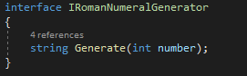

Then I started to think, how can I convert Arabic number into roman format. There was a lot of problems that needed to be solved, like how exactly I will calculate roman numbers. How do I solve the problem with the correct placement of Roman characters and do not allow such things in calculation like more than three equal roman symbols in a row like “9” in roman should not be equal to IIIIV.

So first thing that I’ve decited to make was roman dictionary, that will contain the arabic number value(integer) and string as a roman format value.

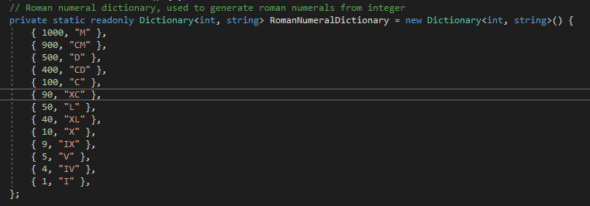

I’ve decited to take such numbes as 1,4,5,9,10 this combination of numbers should be enough to convert integer in diapazone from 1 to 3999 to roman format. I’ve decited to calculate roman numerals using dictionary by looping it’s each value one by one:

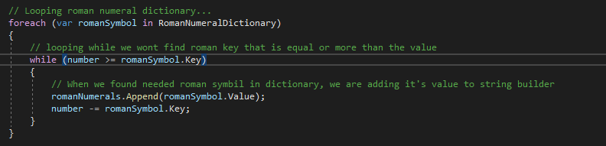

Let’s take as an example 3999 number, when we will execute method, first thing that it will start doing is search in dictionary roman numeral that integer number is less or equal compering to number that we want to convert. When the roman numeral is being found, in our case in the first loop it will be 1000:M,

After that using string builder I’ve saving the roman value(M) and then subtracting roman integer value from the number that we are trying to convert, so at the moment of a second loop, now I will have only 2999 number to convert, after three loops I’ll have something like 999 number left to convert and “MMM” roman format in string builder, on the fourth loop , next value in dictionary that it will get is 900:



So again, string value I’ve add to string builder and then once again subtracting the roman integer value from the number(integer) that we are trying to convert so it will be something like 99 and the value in string Builder will be “MMMCM”, and the same logic will go on till the number that we are trying to convert wont be equal to zero, so at the end method should return string with such value as “MMMCMXCIX”, but this dictionary is allowing us to convert numbers only in diapason from 1 to 3999,

Because as I told before, there cannot be four same roman symbols in a row, like if I would try to convert 4000 number with this logic, it will give you answer “MMMMCMXCIX” that would not be correct answer, that’s why I’ve also added a statement in the code that will prevent such thing

