**Games Physics: CA5 – Assignment 2**

**DECLARATION (Team member 1):**

I declare that:

* The work submitted for this assessment is entirely my own, and no part of it has been copied from any other person’s words or ideas.
* No part of this alternative assessment has been written or completed for me, it has not been discussed or collaborated on by me with any other person
* I understand that I am bound by the DkIT Academic Integrity Policy. I understand that I may be penalised if I have violated the policy in any way;

Type Your Full name: **Vilandas Morrissey (D00218436)**

..........................................................................................................................

Date: **09/12/2020**

……………………………………………………………………………………………….

**DECLARATION (Team member 2):**

I declare that:

* The work submitted for this assessment is entirely my own, and no part of it has been copied from any other person’s words or ideas.
* No part of this alternative assessment has been written or completed for me, it has not been discussed or collaborated on by me with any other person
* I understand that I am bound by the DkIT Academic Integrity Policy. I understand that I may be penalised if I have violated the policy in any way;

Type Your Full name:

..........................................................................................................................

Date:

……………………………………………………………………………………………….

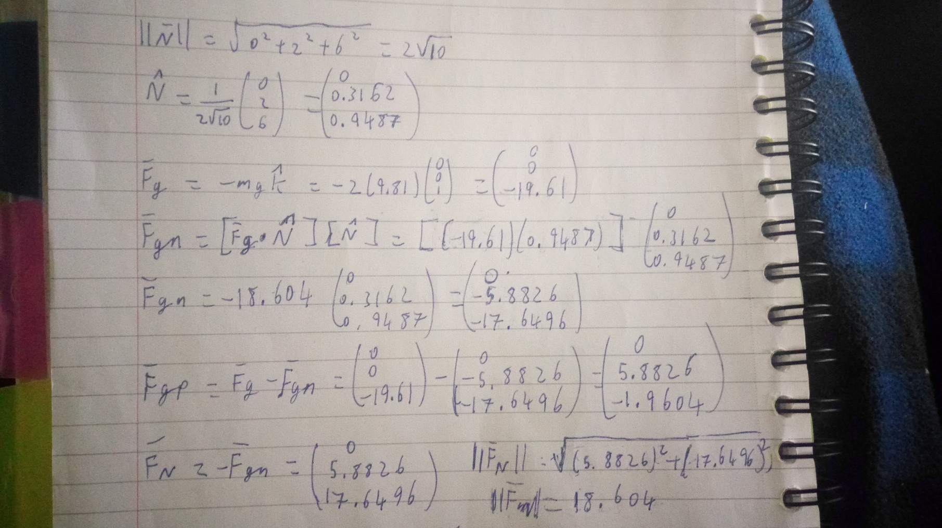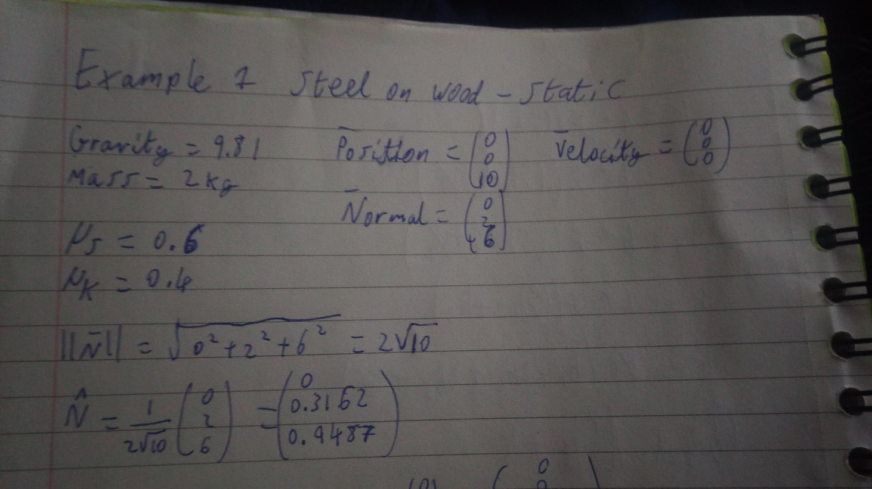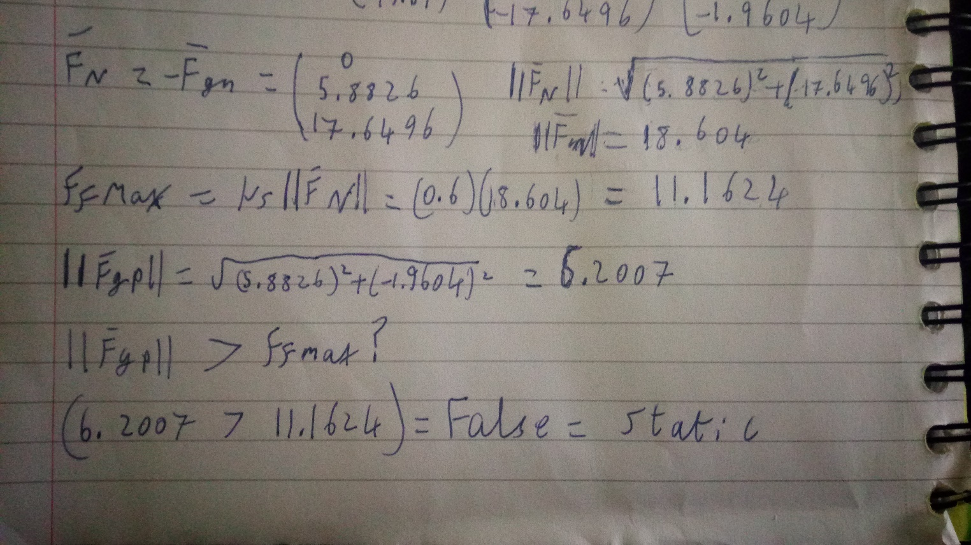Example 1: Steel block sliding on wood, demonstrating static object on a slope.

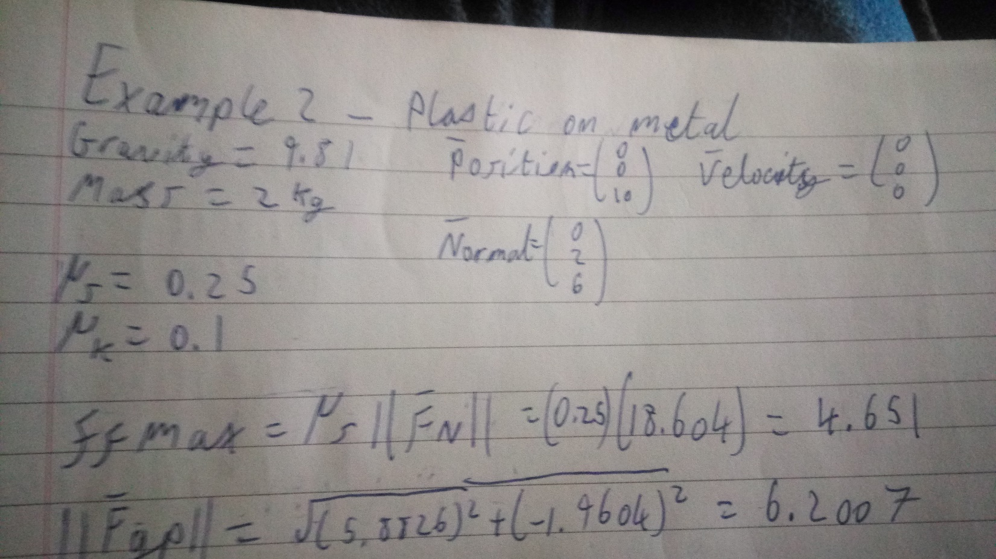Example 2: Plastic block sliding on metal, demonstrating kinetic object on a slope.

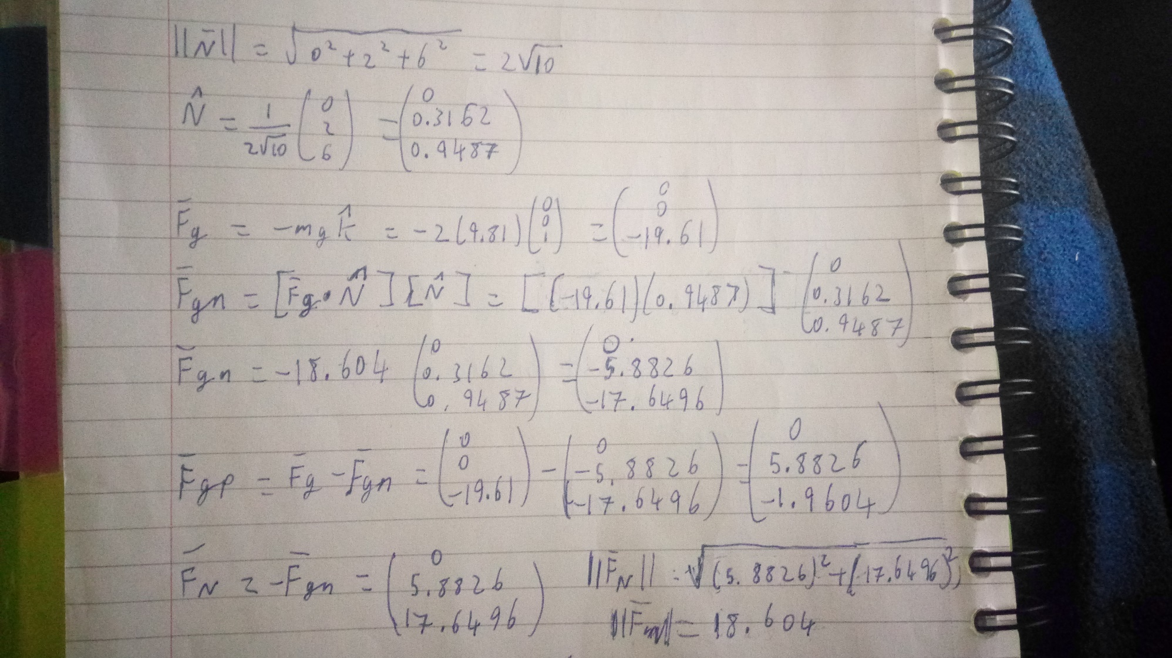

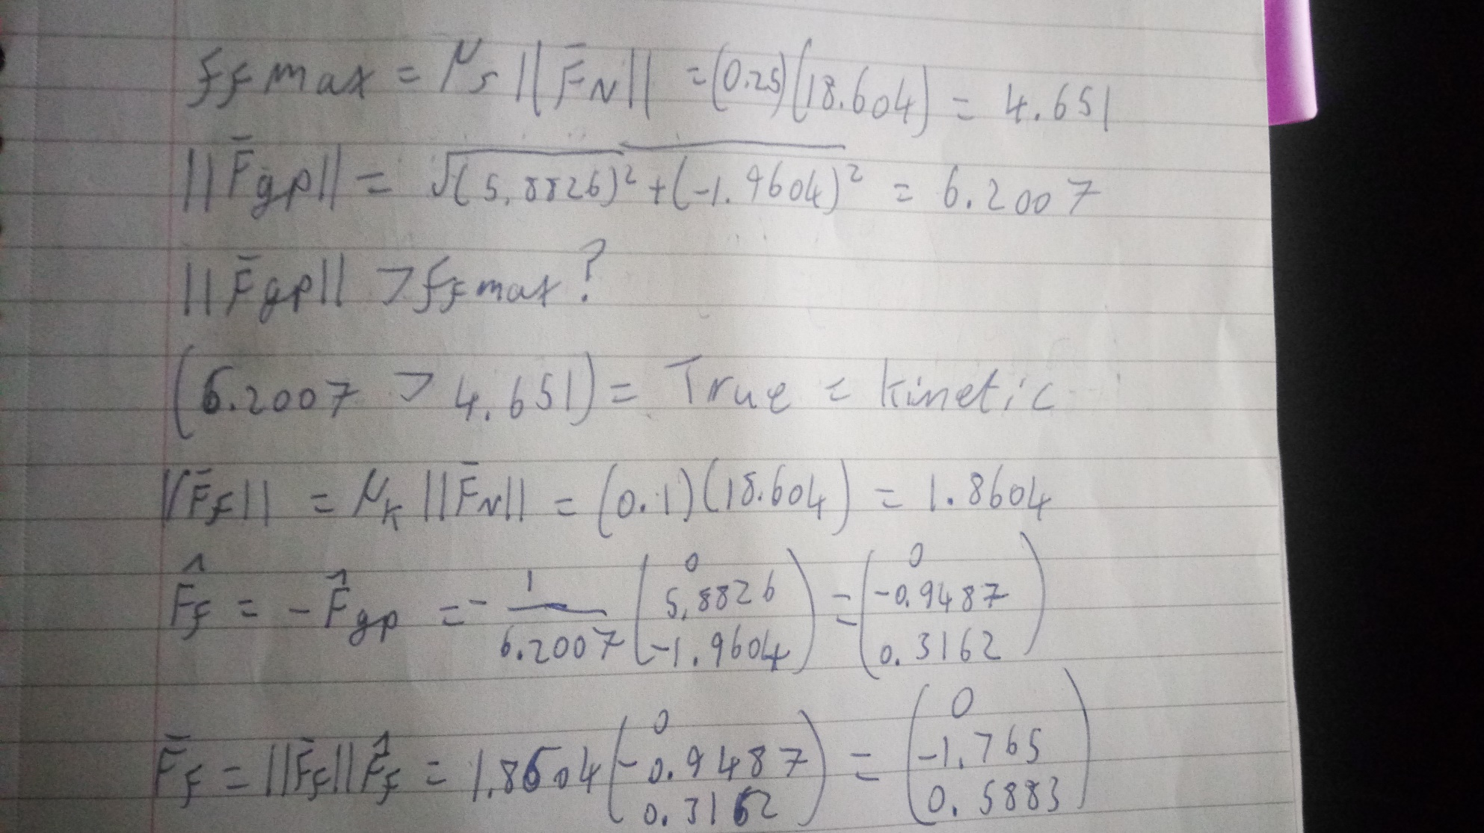

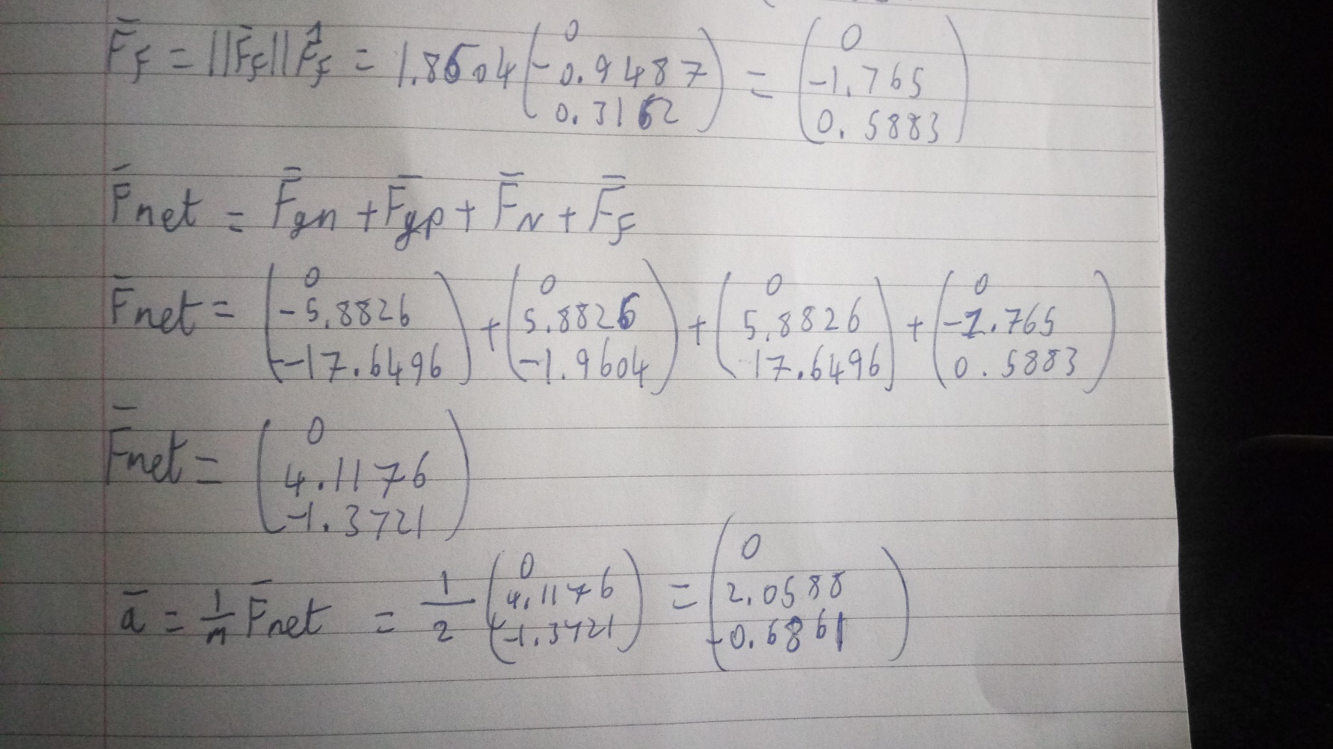

Example 3: Steel sliding on ice plane with a small slope