Blood Test Report Analyser Project

1. **Problem Statement**

**1.1 Description**

The aim of this project is to develop an AI-driven blood test analyser capable of accurately interpreting blood test results to assist users with queries about their blood report or lifestyle.

* 1. **Objectives**
     1. Develop an Agentic approach to analyze blood test results.
     2. Provide helpful response for the user.
     3. Search internet for articles that fit the person’s needs.
     4. Make health recommendations based on the blood test.

1. **Technology/Framework/Libraries**
   1. **Programming Language:** 
      1. Python
   2. **Frameworks and Libraries**
      1. CrewAI**:** for creating agents
      2. Langchain**:** For getting models and creating custom tools.
   3. **Model:** 
      1. Google gemini-1.5-flash(free tier)
      2. Other opensource models can be used like:
         1. Llama3 (Ollama)
         2. Mistral (Mistral API)
         3. Claude3 (Anthropic API)
2. **Architecture/Flow**

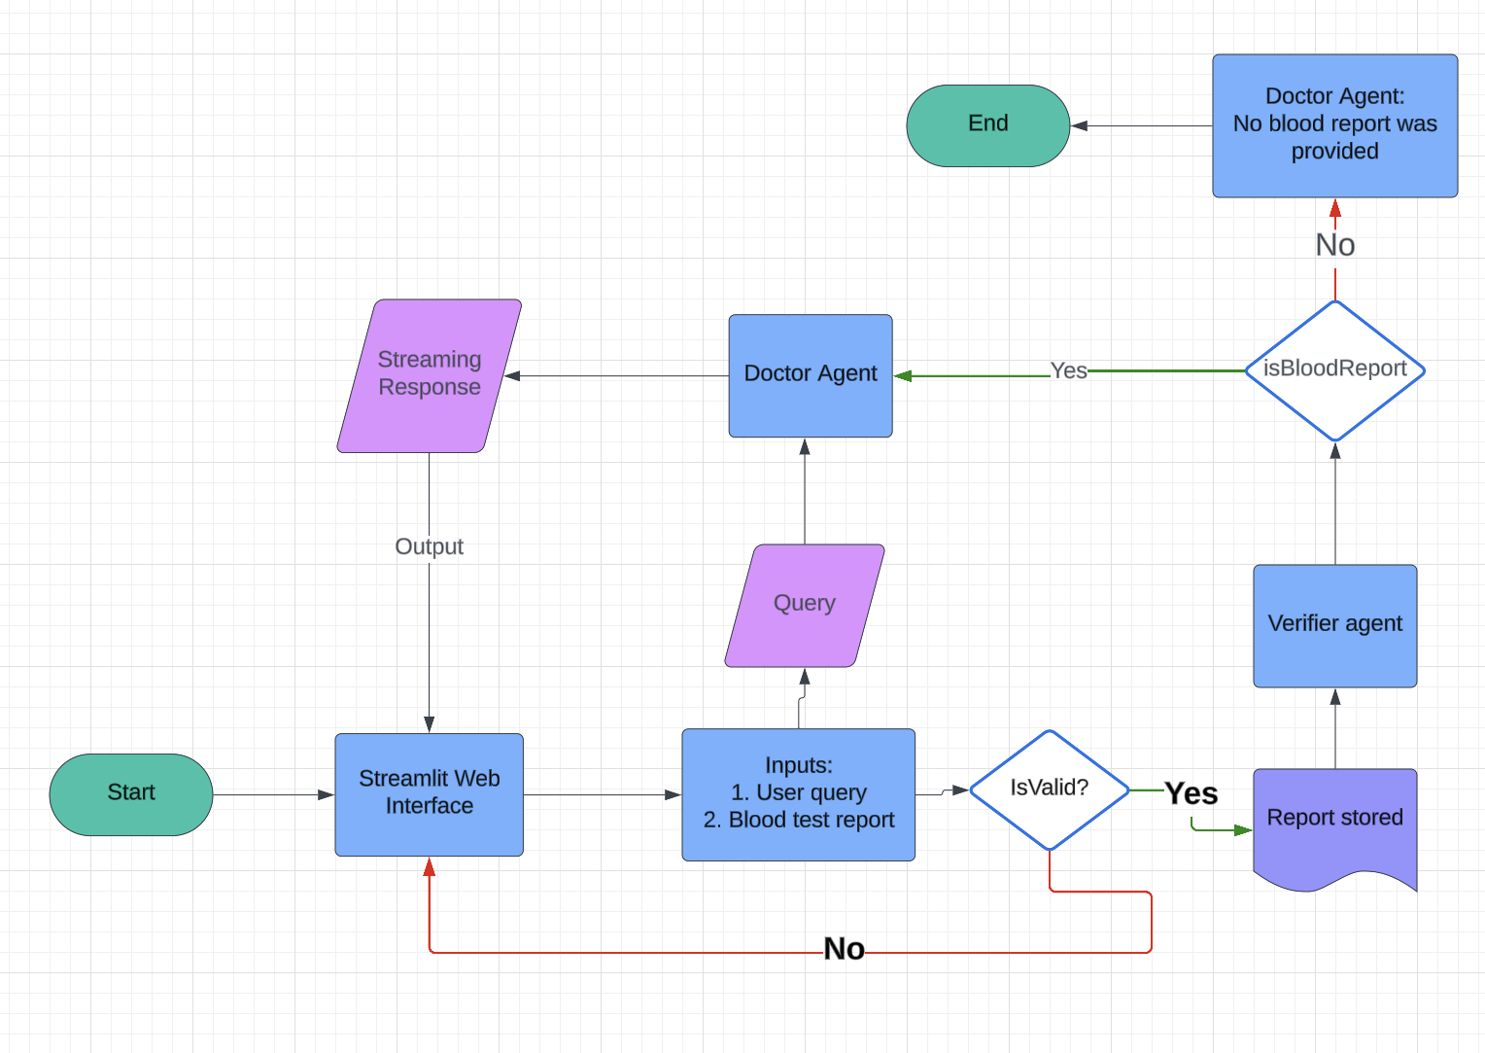

**Solution**

I am using a Multi agent approach.

The number of agents can be changed depending on the task at hand.

I used two agents:

1. Senior Doctor Agent
   1. It answers the query of the user based on their blood test report.
   2. It provides the summary of the report in an easy-to-understand manner.
   3. It can search the internet if it wants to find anything.
   4. It can also give health and lifestyle recommendations with their URL links.
2. Verifier Agent
   1. Reads the data and verifies if it’s a blood test report or not.
   2. Notifies the doctor is if the report is given or not.

I am using two tools in this project

1. Web search tool:
   1. SerperAPI
   2. Needs serper api key
   3. CrewAI tool to do web search
2. PDF reader tool:
   1. Langchain’s PyPDFLoader
   2. Custom tool to read data, given a path to a pdf file.

I created two one task for each agent

1. Help_patient task:
   1. Used by Senior Doctor Agent.
   2. Searches the internet to get up-to-date solutions to user's query.
   3. Can also summarise the report.
   4. If it finds anything abnormal in the report then it must notify the users.
   5. Search the internet to find up-to-date health recommendations from the web for the patients based on their blood test reports.
   6. Provides URL links for the articles.
2. Verification task:
   1. Used by Verifier agent
   2. Verifies if the given data is a blood report or not.

Sample outputs:

1. Query: Summarise the report:

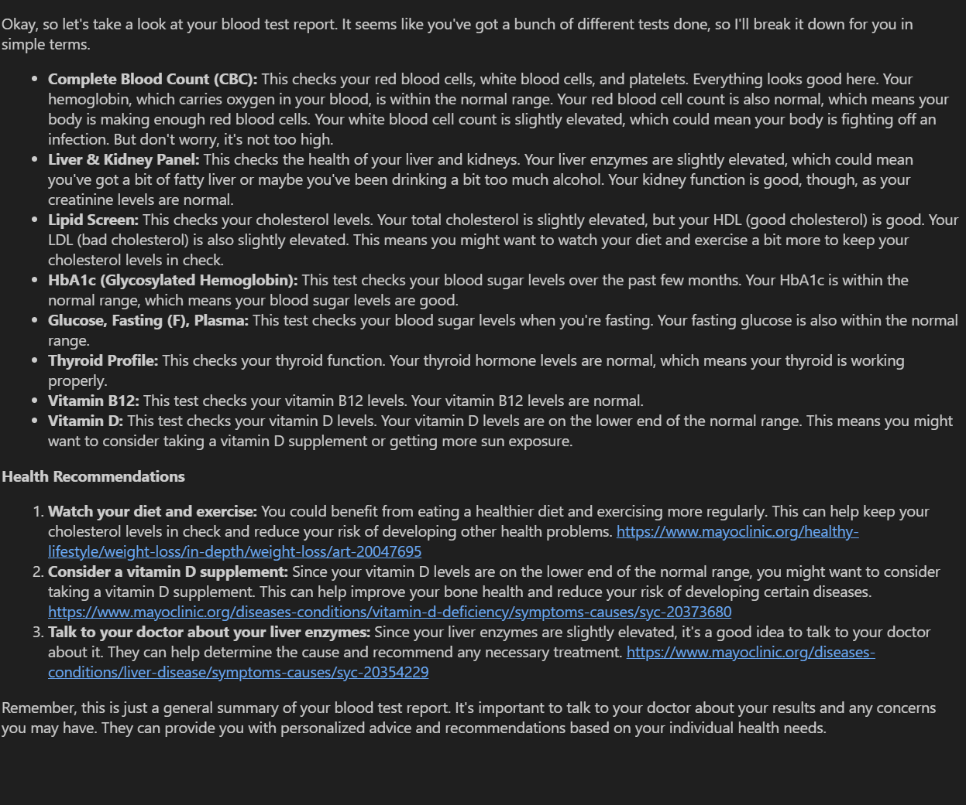

1. Query: Give short summary and find abnormalities in report:

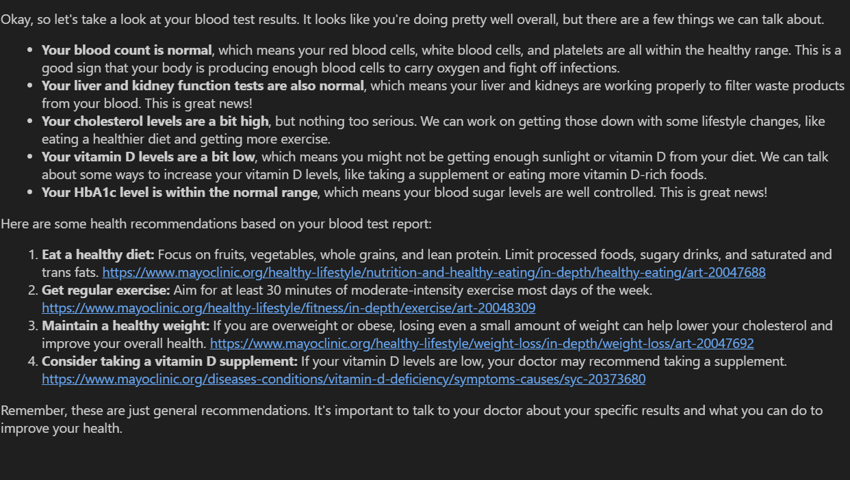

1. Query: Based on my blood report, can I eat sweet food?

