**Problem Statement**

To build a classification methodology to determine whether a customer is placing a fraudulent insurance claim.

**Architecture**

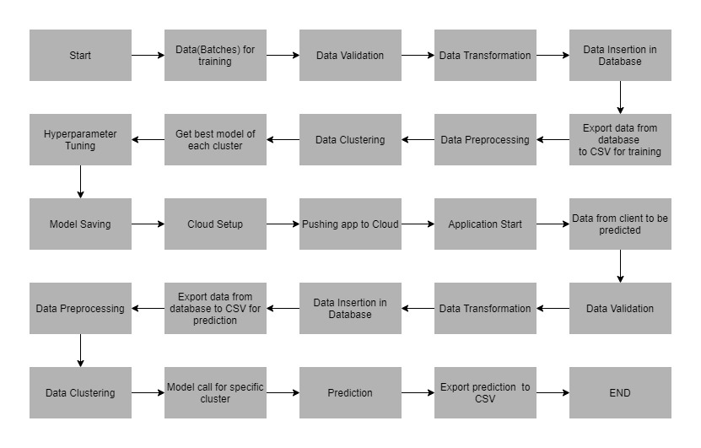

**Data Description**

The client will send data in multiple sets of files in batches at a given location. The data has been extracted from the census bureau.

The data contains the following attributes:

**Features:**

1. **months_as_customer:** It denotes the number of months for which the customer is associated with the insurance company.
2. **age**: continuous. It denotes the age of the person.
3. **policy_number**: The policy number.
4. **policy_bind_date**: Start date of the policy.
5. **policy_state**: The state where the policy is registered.
6. **policy_csl**-combined single limits. How much of the bodily injury will be covered from the total damage.

<https://www.berkshireinsuranceservices.com/arecombinedsinglelimitsbetter>

1. **policy_deductable**: The amount paid out of pocket by the policy-holder before an insurance provider will pay any expenses.
2. **policy_annual_premium**: The yearly premium for the policy.
3. **umbrella_limit**: An umbrella insurance policy is extra liability insurance coverage that goes beyond the limits of the insured's homeowners, auto or watercraft insurance. It provides an additional layer of security to those who are at risk of being sued for damages to other people's property or injuries caused to others in an accident.
4. **insured_zip**: The zip code where the policy is registered.
5. **insured_sex**: It denotes the person's gender.
6. **insured_education_level:** The highest educational qualification of the policy-holder.
7. **insured_occupation:** Theoccupation of the policy-holder.
8. **insured_hobbies**: Thehobbies of the policy-holder.
9. **insured_relationship:** Dependents on the policy-holder.
10. **capital-gain**: It denotes the monitory gains by the person.
11. **capital-loss:** It denotes the monitory loss by the person.
12. **incident_date:** The date when the incident happened.
13. **incident_type:** The type of the incident.
14. **collision_type:** The type of collision that took place.
15. **incident_severity:** The severity of the incident.
16. **authorities_contacted:** Which authority was contacted.
17. **incident_state:** The state in which the incident took place.
18. **incident_city:** The city in which the incident took place.
19. **incident_location:** The street in which the incident took place.
20. **incident_hour_of_the_day:** The time of the day when the incident took place.
21. **property_damage:** If any property damage was done.
22. **bodily_injuries:** Number of bodily injuries.
23. **Witnesses:** Number of witnesses present.
24. **police_report_available:** Is the police report available.
25. **total_claim_amount:** Total amount claimed by the customer.
26. **injury_claim:** Amount claimed for injury
27. **property_claim:** Amount claimed for property damage.
28. **vehicle_claim:** Amount claimed for vehicle damage.
29. **auto_make:** The manufacturer of the vehicle
30. **auto_model:** The model of the vehicle.
31. **auto_year:** The year of manufacture of the vehicle.

**Target Label:**

Whether the claim is fraudulent or not.

1. fraud_reported: Y or N

Apart from training files, we also require a "schema" file from the client, which contains all the relevant information about the training files such as:

Name of the files, Length of Date value in FileName, Length of Time value in FileName, Number of Columns, Name of the Columns, and their datatype.