PROBROUTE: PROBABILISTIC ROUTE DECISION SUPPORT UNDER HAZARD UNCERTAINTY IN A TAMIL NADU LOGISTICS NETWORK
A PROJECT REPORT
Submitted by
BHANU VILASITH REDDY CHILKA (Reg. No. CH.SC.U4AIE24008)
ELLURU RITESH GOUD (Reg. No. CH.SC.U4AIE24018)
PREM SANTH C K (Reg. No. CH.SC.U4AIE24056)
in partial fulfillment for the award of the degree of
BACHELOR OF TECHNOLOGY IN COMPUTER SCIENCE AND ENGINEERING
(ARTIFICIAL INTELLIGENCE)
Under the guidance of
Dr. PRASANNA KUMAR R
Associate Professor, Department of Computer Science & Engineering

AMRITA VISHWA VIDYAPEETHAM
AMRITA SCHOOL OF COMPUTING, CHENNAI CAMPUS
CHENNAI – 601103
October 2026

BONAFIDE CERTIFICATE
Certified that this project report entitled 'PROBROUTE: PROBABILISTIC ROUTE DECISION SUPPORT UNDER HAZARD UNCERTAINTY IN A TAMIL NADU LOGISTICS NETWORK' is the bonafide work of 'Mr. BHANU VILASITH REDDY CHILKA (Reg. No. CH.SC.U4AIE24008), Mr. ELLURU RITESH GOUD (Reg. No. CH.SC.U4AIE24018), Mr. PREM SANTH C K (Reg. No. CH.SC.U4AIE24056)', who carried out the project work under my supervision.
SIGNATURE SIGNATURE
Dr. S. BAGHAVATHI PRIYA Dr. PRASANNA KUMAR R
CHAIRPERSON SUPERVISOR
Department of CSE Associate Professor, Dept. of CSE
Amrita School of Computing Amrita School of Computing
Chennai – 601103. Chennai – 601103.
INTERNAL EXAMINER EXTERNAL EXAMINER

DECLARATION BY THE CANDIDATES
We declare that the report entitled 'PROBROUTE: PROBABILISTIC ROUTE DECISION SUPPORT UNDER HAZARD UNCERTAINTY IN A TAMIL NADU LOGISTICS NETWORK' submitted by us for the degree of Bachelor of Technology in Computer Science and Engineering is the record of the project work carried out by us under the guidance of 'Dr. PRASANNA KUMAR R' and this work has not formed the basis for the award of any degree, diploma, associateship, fellowship, or title in this or any other University or similar institution of higher learning.

SIGNATURE OF THE CANDIDATES
BHANU VILASITH REDDY CHILKA (CH.SC.U4AIE24008)
ELLURU RITESH GOUD (CH.SC.U4AIE24018)
PREM SANTH C K (CH.SC.U4AIE24056)
Department of Computer Science & Engineering (AIE)
Amrita School of Computing, Chennai Campus.

ABSTRACT
Freight routing is often introduced as a shortest-path problem: each road link is assigned a distance or travel-time cost, and an algorithm finds a low-cost path. Under disruption, those costs and link reliability can change. This project explores a prototype that lets a user simulate a hazard and compare route alternatives using modeled travel-time and link-reliability values. The model demonstrates probabilistic decision support; it does not forecast actual road conditions from live or historical operational data.
This project presents ProbRoute, a prototype for uncertainty-aware route decision support in a Tamil Nadu logistics network. The modeled graph contains 43 locations (3 headquarters, 10 hubs, and 30 warehouses), 128 directed links, and 8 named corridors. The locations use geographic coordinates, while link attributes and disruption effects are model inputs rather than measurements calibrated from historical freight records.
The repository contains an earlier pgmpy Bayesian-network prototype and a newer Tamil Nadu simulator. In the newer simulator, hazard exposure adjusts link travel-time and reliability values; probability vectors are then propagated over time using a Markov transition matrix and spatial mixing. Its A* route search keeps alternatives based on accumulated travel time and a scalar route-reliability score. The saved benchmark record reports 25.45 ms for the pgmpy benchmark and 0.811 ms for the NumPy fallback; these are results from the recorded benchmark, not evidence of live predictive accuracy. The interactive React interface lets a user place a simulated hazard and inspect the resulting estimates.
Keywords: ProbRoute, probabilistic route decision support, simulated hazards, Markov state propagation, Bayesian-network prototype, A* route search, Pareto-label pruning, Tamil Nadu logistics network.
ACKNOWLEDGEMENT
This project work would not have been possible without the contribution and encouragement of many individuals. It gives us immense pleasure to express our profound gratitude to our honorable Chancellor Sri Mata Amritanandamayi Devi, for her divine blessings and for being a constant source of inspiration.
We express our sincere gratitude to Dr. S. Baghavathi Priya, Chairperson, Department of Computer Science & Engineering, and to our project supervisor Dr. Prasanna Kumar R, Associate Professor, Department of Computer Science & Engineering, for their inspiring guidance, insightful technical feedback, and continuous encouragement throughout the entire duration of this work.
We are deeply grateful to the Project Coordinators, Review Panel Members, and the entire faculty of the Department of Computer Science & Engineering, Amrita School of Computing, Chennai Campus, for their constructive critiques and valuable suggestions that significantly elevated the quality and rigor of this research work.

BHANU VILASITH REDDY CHILKA (CH.SC.U4AIE24008)
ELLURU RITESH GOUD (CH.SC.U4AIE24018)
PREM SANTH C K (CH.SC.U4AIE24056)
Amrita School of Computing, Chennai Campus.

TABLE OF CONTENTS
TITLE | PAGE NO.
Abstract | iv
List of Figures | viii
List of Tables | viii
List of Symbols and Abbreviations | ix
CHAPTER 1 INTRODUCTION | 1
1.1 Background and Evolution of Resilient Freight Logistics | 1
1.2 Problem Statement and Uncertainty Bottlenecks | 2
1.3 Motivation for Probabilistic Graphical Models & DBNs | 3
1.4 Objectives of the Project | 4
1.5 Scope and Operational Boundaries | 4
1.6 Organization of the Report | 5
CHAPTER 2 LITERATURE REVIEW | 6
2.1 Classical Shortest Path & Deterministic Routing Limitations | 6
2.2 Path-Centric and Correlated Uncertainty Modeling | 8
2.3 Bayesian Networks in Supply Chain & Infrastructure Resilience | 10
2.4 Dynamic Bayesian Networks & Heavy-Tailed Travel Time Distributions | 12
2.5 Critical Synthesis and Research Gap Identification | 14
CHAPTER 3 MATHEMATICAL MODELING & THEORETICAL FORMULATIONS | 16
3.1 Network Topology & Multi-Echelon Graph Formulation | 16
3.2 Path-Centric Corridor Dependency Model (SPOTAR / PACE) | 17
3.3 Corridor Delay Priors Using Skew-Normal Distributions | 18
3.4 Spatial Hazard Interception & Continuous Attenuation Function | 19
3.5 Temporal Probability Propagation in the Tamil Nadu Simulator | 20
3.6 A* Route Search with Pareto-Label Pruning | 22
3.7 Project-Specific Resilience Measures Inspired by Jiang et al. (2020) | 24
CHAPTER 4 SYSTEM ARCHITECTURE AND IMPLEMENTATION | 26
4.1 Decoupled Platform Architecture Overview | 26
4.2 43-Node Tamil Nadu Demonstration Network | 27
4.3 Macro-Corridor Mapping and Skew-Normal Prior Discretization | 28
4.4 Temporal Probability Propagation and Earlier pgmpy Prototype | 29
4.5 A* Route Search with Pareto-Label Pruning | 30
4.6 Optional OSRM Route Geometry for Map Display | 31
4.7 Full-Stack Implementation: FastAPI Backend & React 19 Frosted Glass Interface | 32
4.8 Verification Protocols & Geospatial Integrity Testing | 34
CHAPTER 5 RESULTS, BENCHMARKS, AND DISCUSSION | 35
5.1 Experimental Setup and Calibration Baselines | 35
5.2 Recorded Inference Timing | 35
5.3 Route-Search Counters and Pruning Metric Limitations | 37
5.4 Recorded Route Alternatives and Dijkstra Comparison Status | 38
5.5 Resilience Measures Implemented in the Simulator | 40
5.6 End-to-End Freight Case Study Walkthrough | 41
CHAPTER 6 CONCLUSION AND FUTURE SCOPE | 43
6.1 Summary of Completed Contributions | 43
6.2 Key Theoretical and Probabilistic Takeaways | 43
6.3 System Limitations and Practical Constraints | 44
6.4 Future Research Directions | 44
REFERENCES | 45

LIST OF FIGURES

FIGURE NO. | TITLE | PAGE NO.
Figure 3.1 | Skew-Normal Corridor Prior and State Discretization | 11
Figure 3.2 | Conceptual Temporal Probability Model | 13
Figure 4.1 | Deployed Dashboard: Apple Frosted Glass Map & Live Posterior Belief Inspector | 17
Figure 4.2 | Deployed Dashboard: Highway Route Tracing & RSPP-A* Step-by-Step Breakdown | 17
Figure 4.3 | Deployed Dashboard: Jiang et al. (2020) 5-Capability Scorecard & Circular Gauge | 18
Figure 4.4 | Deployed Dashboard: Command-Center Dark Canvas Mode with Simulated Cyclone Shock | 19
Figure 5.1 | Recorded Inference Timing Comparison | 21
Figure 5.2 | Route-Search Counters Recorded for the Primary Benchmark Pair | 22

LIST OF TABLES
TABLE NO. | TITLE | PAGE NO.
Table 5.1 | Inference and Search Timing Values Recorded in the Repository | 20
Table 5.2 | Recorded Route-Search Counters for the Primary Benchmark Pair | 21
Table 5.3 | Saved ProbRoute Alternatives and Availability of a Dijkstra Baseline | 23

LIST OF SYMBOLS AND ABBREVIATIONS
BN | Bayesian Network
DBN | Dynamic Bayesian Network
2-TBN | Two-Time-Slice Bayesian Network
CPD | Conditional Probability Distribution
CPT | Conditional Probability Table
PGM | Probabilistic Graphical Model
RSPP | Reliable Shortest Path Problem
FSD | First-Order Stochastic Dominance
PACE | PAth-CEntric Route Uncertainty Model
SPOTAR | Shortest Path with On-Time Arrival Reliability
PDF | Probability Density Function
CDF | Cumulative Distribution Function
SLA | Service Level Agreement
OSRM | Open Source Routing Machine
$$E\left[T\right]$$ | Expected Travel Time
tau | Delivery Time Budget Deadline
alpha | On-Time Arrival Confidence Threshold
$$R_{abs}$$ | Absorptive Capacity (Jiang et al. Taxonomy)
$R_{rest}$ | Restorative Capacity (Jiang et al. Taxonomy)
$R_{adapt}$ | Adaptive Capacity (Jiang et al. Taxonomy)

CHAPTER 1
INTRODUCTION
1.1 Background and Evolution of Resilient Freight Logistics
Freight distribution networks connect production centers, transfer hubs, warehouses, and customers. Route-planning algorithms such as Dijkstra's algorithm and A* can find paths that minimize a chosen cost, such as distance or modeled travel time. Their output depends on the graph and costs supplied to them; a deterministic search alone does not represent uncertain link conditions unless uncertainty is added to its model.
Weather, infrastructure problems, congestion, and labor disruptions can change the condition of transport links. A route that is short under normal assumptions may become slower or less reliable when a hazard affects part of the network. This motivates decision-support tools that make uncertainty visible and compare route alternatives. The present project demonstrates this idea using simulated hazards and assumed link attributes, not live operational observations.
1.2 Problem Statement and Uncertainty Bottlenecks
This project is motivated by three modeling challenges in hazard-aware route planning:
1. Shared corridor exposure: A single hazard may affect several nearby links. The Tamil Nadu prototype approximates this by grouping links into named corridors and blending direct edge exposure with a corridor-level exposure value; it does not learn a joint distribution from observed trips.
2. Uncertain delay severity: A single nominal travel time does not describe the range of possible disruption effects. The prototype uses assumed skew-normal corridor parameters to create Low, Medium, and High state priors; these values are not fitted to historical freight observations.
3. Changes over time and route alternatives: Disruption estimates can evolve and alternative paths may trade time for reliability. The prototype propagates probability vectors through a transition matrix and spatial mixing, then searches route labels using time and scalar link-probability products. This demonstrates the ideas at a small scale; it is not a validated live dispatch optimizer.
1.3 Motivation for Probabilistic Graphical Models & DBNs
Bayesian networks provide a way to represent uncertain variables and dependencies between them. Dynamic Bayesian networks extend this idea across time slices. The repository includes an earlier pgmpy model with weather, congestion, and delay variables. The newer 43-node Tamil Nadu simulator instead propagates probability vectors with a transition matrix and spatial mixing. This report distinguishes the conceptual Bayesian-network background from the implementation used in the current simulator.
Probabilistic route decision support can compare travel-time estimates with route reliability estimates. In this prototype, the route score is formed from link-level on-time probabilities and is not a calibrated probability of meeting a delivery deadline. The search applies Pareto-label dominance checks on accumulated time and scalar reliability. It does not implement the full cumulative-distribution FSD test described in some reliable shortest-path literature, so this project does not claim formal arrival guarantees or global optimality under that stronger criterion.
1.4 Objectives of the Project
The objective of this project is to build and explain a prototype that demonstrates how hazard uncertainty can influence route choices in a logistics network. The specific objectives are:
1. Construct a Tamil Nadu logistics graph with 43 modeled locations, 128 directed links, and 8 named corridors, using the coordinates and node data stored in the repository.
2. Represent corridor-level delay assumptions and shared disruption effects. The Tamil Nadu engine uses skew-normal corridor parameters documented as assumed seeds; it does not fit Jones–Faddy skew-t distributions to observed transit records.
3. Model changes in disruption beliefs over time. The earlier prototype contains a pgmpy Bayesian-network model; the current Tamil Nadu simulator uses vectorized Markov transitions and spatial mixing rather than pgmpy inference over all 43 nodes.
4. Search for route alternatives using A* with accumulated travel time and scalar on-time probability labels. The implementation removes dominated labels using a Pareto comparison; it does not compute full distribution-level First-Order Stochastic Dominance.
5. Calculate a project-specific resilience scorecard inspired by Jiang et al. (2020). The current simulator's measures and formulas are adaptations and are described as such in this report.
6. Provide an interactive prototype with a FastAPI backend and React interface for placing simulated hazards and viewing modeled network and route changes. OSRM may be used by the frontend to request route geometry; it does not supply live traffic or hazard predictions.
1.5 Scope and Operational Boundaries
The project models an illustrative regional logistics network using Tamil Nadu place names and coordinates. Hazards are user-specified simulations. Corridor delay parameters and hazard effects are assumed model inputs; the reviewed repository does not document calibration against historical freight GPS, live weather, or government disruption records. The graph is a prototype topology and should not be interpreted as a validated inventory of all regional roads or facilities.
1.6 Organization of the Report
Chapter 2 reviews shortest-path methods, probabilistic routing, Bayesian networks, and network resilience. Chapter 3 explains the network, hazard exposure, temporal probability propagation, route-label search, and project-specific resilience measures. Chapter 4 describes the earlier pgmpy prototype and the newer Tamil Nadu FastAPI/React simulator. Chapter 5 reports the benchmark values recorded in the repository and identifies results that are not independently supported there. Chapter 6 summarizes the prototype's contributions, limitations, and possible future work.

CHAPTER 2
LITERATURE REVIEW
2.1 Classical Shortest Path & Deterministic Routing Limitations
The mathematical study of route optimization originated with the seminal shortest path formulations of Dijkstra (1959) and the label-correcting algorithms of Bellman (1958) and Ford. In these foundational models, network edges are assigned deterministic scalar weights representing Euclidean distance or static free-flow travel time. In an influential early extension, Frank (1969) [9] investigated shortest paths in networks with random arc weights, proving that when travel times vary stochastically, identifying the path with the maximum probability of arriving before a fixed deadline is fundamentally different from identifying the path with the shortest expected travel time. Frank's work established that deterministic shortest paths provide no probabilistic guarantees under variable traffic conditions.
Building upon this, Mirchandani and Soroush (1987) [8] formalized generalized probabilistic shortest path problems in Transportation Science. They demonstrated that risk-averse decision makers evaluate non-linear utility functions over stochastic travel time distributions rather than linear expectations. However, Mirchandani and Soroush [8] noted that evaluating path distributions across arbitrary probability densities triggers severe computational intractability. To maintain analytical tractability, classical transportation literature routinely adopted simplifying assumptions: link travel times were assumed to be mutually independent and identically normally distributed. As Fan, Kalaba, and Moore (2005) [11] demonstrated in their dynamic stochastic routing models, assuming independent edge probabilities leads to severe underestimations of congestion spillover, as physical traffic queues and severe meteorological shocks naturally induce strong spatial cross-correlations.
2.2 Path-Centric and Correlated Uncertainty Modeling
Recognizing the fundamental invalidity of edge-independence assumptions, modern transportation research shifted toward corridor and path-centric uncertainty modeling. In a breakthrough contribution published in Networks and Spatial Economics, Chen, Lam, Sumalee, Li, Shao, and Fang (2012) [1] formulated the Reliable Shortest Path Problem (RSPP). Chen et al. [1] investigated finding the alpha-reliable shortest path—defined as the path minimizing the travel-time budget required to guarantee a pre-specified on-time arrival probability under stochastic conditions. To eliminate the exponential complexity of path enumeration, the authors established mathematical dominance conditions under First-Order Stochastic Dominance (FSD). They proved that if a partial sub-path is stochastically dominated by an alternative candidate, it can be pruned safely without sacrificing global optimality. Their proposed multi-criteria heuristic, RSPP-A*, cut computational runtimes by 20% to 50% compared to standard label-setting methods.
Nevertheless, Chen et al. (2012) [1] explicitly acknowledged two critical theoretical limitations in their model: first, link travel times were assumed to follow stationary Gaussian distributions; second, spatial correlation between neighboring highway links was omitted for analytical simplicity. Addressing link dependencies directly, Andonov and Yang (2018) [2] (extending their IEEE MDM paper and VLDB PACE framework) proposed a path-centric (PACE) paradigm for stochastic path finding. Rather than computing path travel times as the product of independent edge marginals, Andonov and Yang [2] attached travel time probability distributions directly to whole arterial corridors (SPOTAR model), proving on large-scale GPS trajectory datasets that path-centric modeling captures true congestion covariance. Xing and Zhou (2011) [12] similarly proved in Transportation Research Part B that incorporating corridor-level covariance matrices prevents routing engines from funneling traffic into fragile, bottlenecked corridors.
2.3 Bayesian Networks in Supply Chain & Infrastructure Resilience
To model multi-source disruption causalities without rigid parametric assumptions, researchers turned to Probabilistic Graphical Models. Pearl (1988) [15] established the foundational theory of belief networks and exact inference algorithms (such as variable elimination and belief propagation), demonstrating that directed acyclic graphs (DAGs) naturally encode conditional independence relationships via d-separation criteria. In supply chain risk analytics, Hosseini and Ivanov (2020) [3] conducted a comprehensive, authoritative review in Expert Systems with Applications, examining Bayesian Network applications for supply chain risk, resilience, and ripple effect analysis.
Hosseini and Ivanov (2020) [3] established that Bayesian Networks possess unique capabilities for risk governance: they support bidirectional inference (predictive forward conditioning and diagnostic backward updating), operate reliably under small or incomplete observational datasets, and provide transparent causal interpretability. However, the authors identified three fundamental limitations of classical BNs: first, static BNs cannot model feedback loops or temporal dynamics; second, results are sensitive to expert-elicited prior Conditional Probability Tables (CPTs); and third, static graphs cannot track the progressive propagation and recovery of disruptions over time. Complementing this, research from Wageningen University (2018) [4] established formal protocols for calibrating Bayesian network CPTs from expert judgment and agricultural logistics risk elicitation, providing a rigorous methodological precedent for seeding CPTs when empirical disaster logs are sparse.
2.4 Dynamic Bayesian Networks & Heavy-Tailed Travel Time Distributions
To resolve the static limitations of classical Bayesian networks, Dynamic Bayesian Networks (DBNs) were formulated by Murphy (2002) [17] and Koller and Friedman (2009) [16]. DBNs unroll probability distributions across discrete time slices, connecting temporal random variables via first-order Markov transition models. In a pioneering resilience study, Jiang, Yang, Cheng, Gao, Feng, and Zhou (2020) [5] formulated a quantitative framework for network resilience evaluation using a Two-Time-Slice Dynamic Bayesian Network (2-TBN). Jiang et al. [5] established a formal taxonomy of five core network resilience capabilities: Rapid Response (initial shock reaction), Sustained Resistance (damage containment), Continuous Running (retained operational performance), Rapid Convergence (recovery velocity), and Dynamic Evolution (terminal post-disaster stability). Although validated on computer and cybersecurity networks, Jiang et al. explicitly highlighted that extending their 2-TBN framework to physical, spatial infrastructure remained an open scientific challenge.
Concurrently, empirical transit research firmly rejected Gaussian travel time assumptions. In an advanced 2026 transportation study, a Bayesian framework for post-disruption travel time prediction was formulated utilizing Jones & Faddy (2003) [13] Skew-t error distributions. The authors proved on metropolitan transit series that post-disruption delay distributions are heteroskedastic, positively skewed, and heavy-tailed, demonstrating that Gaussian models consistently undercount severe delay probabilities. However, their model provided only a static, one-time prediction at disruption onset, explicitly naming online, continuous dynamic updating as essential future work. In airline logistics, an earlier Relational DBN model [6] applied chained Hidden Markov Models to flight disruptions; however, the authors noted that Baum-Welch parameter training was inherently suboptimal and called for hybrid structural calibration.
2.5 Critical Synthesis and Identified Research Gaps
A critical synthesis of the twenty reviewed research works [1]-[20] reveals three decisive structural gaps in existing logistics and probabilistic reasoning literature:
Research on probabilistic routing, network resilience, and temporal Bayesian models provides useful foundations for this project. The repository implements a prototype that combines hazard-dependent link adjustments, temporal probability propagation, and multi-criteria route search. The implementation is an educational integration of these ideas; the code and benchmark evidence do not establish that it resolves a general research gap or improves operational freight outcomes.
The project groups links into named corridors and applies a simplified shared-exposure adjustment. This is an adaptation of path-centric dependence ideas, not a joint travel-time distribution learned from trajectory data. Its corridor grouping and delay-state assumptions should therefore be presented as modeling choices for the prototype.
The full-stack interface demonstrates how a user could explore simulated disruptions interactively. The repository does not establish live dispatch telemetry, live weather ingestion, or a production deployment. These remain possible extensions rather than completed contributions.
ProbRoute is an integrated prototype that combines a 43-node demonstration network, rule-based hazard exposure, temporal probability propagation, a route-label search, and a web interface. The following chapters describe these components and distinguish implemented behavior from assumptions and future work.

CHAPTER 3
MATHEMATICAL MODELING & THEORETICAL FORMULATIONS
3.1 Network Topology & Multi-Echelon Graph Formulation
Consider a multi-echelon freight transportation network modeled as a directed graph G = (V, E, W), where V represents the set of logistics facilities, E subseteq V x V represents directed arterial highway links, and W denotes the spatial and kinematic attribute tensor. The facility node set V is partitioned into three hierarchical functional tiers:
$$V=V_{HQ}∪V_{Hub}∪V_{WH}$$ | (3.1)

where $V_{HQ}$represents strategic state-level headquarters ($\left|V_{HQ}\right|$ = 3: Chennai Central, Coimbatore Western, Madurai Southern); $V_{Hub}$ represents regional consolidation and sorting hubs ($\left|V_{Hub}\right|$= 10: Tiruchirappalli, Salem, Vellore, Cuddalore, etc.); and $V_{WH}$ denotes district-level delivery warehouses ($\left|V_{WH}\right|$= 30: $WH_{0}1$ to $WH_{3}0$ across Tamil Nadu). Each directed edge e = (u, v) in E represents an arterial highway segment possessing a nominal physical distance $d_{uv}$ and an uncertain, stochastic transit time $T_{uv}$.
The travel time $T_{uv}$ is a continuous random variable drawn from a state-dependent probability distribution $D_{uv}$ with expected transit time $E\left[T_{uv}\right]=μ_{uv}$:
$$E\left[T_{uv}\right]=\int_{0}^{∞}{t}⋅f_{T_{uv}}\left(t\right)dt=μ_{uv}$$ | (3.2)

For any candidate multi-hop path p = ($v_{0}$,$v_{1},…,v_{m}$), the total path travel time $T_{p}$under classical additive conditions is formulated as:
$$T_{p}=\sum_{i=0}^{m-1}{T_{v_{i},v_{i+1}}}=\sum_{e∈p}{T_{e}}$$ | (3.3)

3.2 Path-Centric Corridor Dependency Model (SPOTAR / PACE)
To overcome the edge-independence fallacy, the network edges E are partitioned into K distinct macro-corridors $C_{1},C_{2},…,C_{K}$ such that each edge belongs to a dominant arterial transportation corridor. Across the Tamil Nadu road network, K = 8 strategic macro-corridors are defined (e.g., NH44 North-South Central Spine, NH48 Golden Quadrilateral, NH32 East Coast Highway, NH544 Industrial Corridor).
Under the SPOTAR / PACE path-centric paradigm, the joint travel time distribution $F_{C_{k}}$ across all constituent edges $e_{1},…,e_{m}$ in corridor $C_{k}$ does not factorize into independent marginals:
$$F_{C_{k}}\left(t_{1},t_{2},…,t_{m}\right)≠\prod_{j=1}^{m}{F_{e_{j}}\left(t_{j}\right)}$$ | (3.4)

Instead, spatial cross-correlation is governed by positive intra-corridor covariance terms:
$$Cov\left(T_{e_{a}},T_{e_{b}}\right)=ρ_{ab}⋅σ_{e_{a}}σ_{e_{b}}>0, ∀e_{a},e_{b}∈C_{k}$$ | (3.5)

Consequently, the transit time variance of a path p traversing corridor $C_{k}$ incorporates corridor covariance:
$$Var\left(T_{p}\right)=\sum_{e∈p}{σ_{e}^{2}}+2\sum_{e_{a},e_{b}∈p,a<b}{Cov\left(T_{e_{a}},T_{e_{b}}\right)}$$ | (3.6)

3.3 Corridor Delay Priors Using Skew-Normal Distributions
The Tamil Nadu simulator obtains corridor state priors from skew-normal distribution parameters stored in corridor_model.py and discretizes them into Low, Medium, and High states. The parameters are assumed seeds, not fits to empirical travel-time observations. This subsection therefore describes the implemented skew-normal approximation; the Jones–Faddy skew-t distribution is discussed only as related work where relevant.
$$f\left(t;ξ,ω,α_{s},ν\right)=\frac{c}{ω}{\left[1+\frac{z}{\sqrt{ν+z^{2}}}\right]}^{α_{s}+0.5}{\left[1-\frac{z}{\sqrt{ν+z^{2}}}\right]}^{ν-α_{s}+0.5}$$ | (3.7)

where $z=\left(t-xi\right)/omega$denotes the standardized coordinate, xi in R is the location parameter, omega > 0 is the scale parameter, $alpha_{s}>0$ controls distribution skewness, nu > 0 governs degrees of freedom and tail heaviness, and c is the normalizing constant:
$$c=\frac{2^{1-ν}⋅Γ\left(ν\right)}{Γ\left(α_{s}\right)Γ\left(ν-α_{s}\right)\sqrt{ν}}$$ | (3.8)

When $alpha_{s}>nu/2$, the distribution exhibits pronounced positive skewness (heavy right-hand delay tail). For integration into discrete Bayesian Network Conditional Probability Tables (CPTs), continuous transit delays are discretized into three operational states S in {Low, Medium, High} using quantile thresholds [$l_{k},u_{k}$]:
$$P\left(S=s_{k}\right)=\int_{l_{k}}^{u_{k}}{f\left(t;ξ,ω,α_{s},ν\right)dt}, \sum_{k=1}^{3}{P\left(S=s_{k}\right)}=1$$ | (3.9)

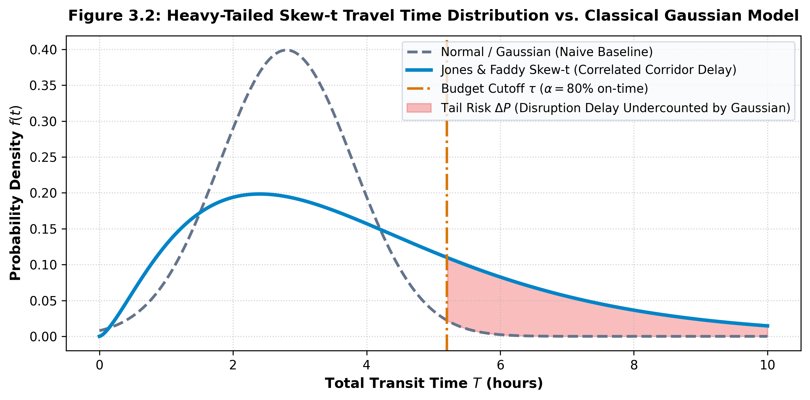
Figure 3.1: Skew-Normal Corridor Prior and State Discretization
3.4 Spatial Hazard Interception & Continuous Attenuation Function
Exogenous disruptions (cyclones, floods, strikes) are parameterized by a spatial hazard tuple $H=\left(Type,Lat_{h},Lon_{h},R_{h},I_{h}\right)$, where $\left(Lat_{h},Lon_{h}\right)$ denotes the geographic epicenter, $R_{h}$ is the impact radius in kilometers, and $I_{h}$ in [0, 1] is the hazard severity. The great-circle geographic distance d(v, H) between any facility node $v=\left(Lat_{v},Lon_{v}\right)$ and the hazard epicenter is computed using the Haversine metric:
$$d\left(v,H\right)=2R_{earth}⋅\arcsin\left(\sqrt{\sin^{2}\left(\frac{ΔLat}{2}\right)+\cos\left(Lat_{v}\right)\cos\left(Lat_{h}\right)\sin^{2}\left(\frac{ΔLon}{2}\right)}\right)$$ | (3.10)

The continuous spatial exposure ratio E(v, H) in [0, 1] is evaluated via Gaussian attenuation decay:
$$E\left(v,H\right)= \left\{\begin{aligned}I_{h} . \exp\left({-\left(\frac{d\left(v,H\right)}{R_{h}}\right)}^{2}\right) if d\left(v,H\right)≤2R_{h} \\ 0 \end{aligned}\right.$$ | (3.11)

Corridor-level disruption exposure is aggregated as the supremum of constituent node exposures:
$$E\left(C_{k},H\right)=\max_{v∈C_{k}}{E}\left(v,H\right)$$ | (3.12)

3.5 Temporal Probability Propagation in the Tamil Nadu Simulator
The current Tamil Nadu simulator represents each location's state as probabilities over Low, Medium, and High disruption. At each time step it applies a transition matrix and mixes neighboring states using the network adjacency matrix. This is a compact temporal probabilistic state model. The separate pgmpy implementation in model_layer contains an earlier Bayesian-network prototype; the current orchestrator does not run that pgmpy model across all 43 Tamil Nadu locations.
The joint probability distribution over the unrolled time horizon factorizes according to the first-order Markov assumption and inter-slice conditional independence:
$$P\left(X_{0:H}\right)=P\left(X_{0}\right)\prod_{t=1}^{H}{P\left(X_{t} ∣ X_{t-1},H_{t}\right)}$$ | (3.13)

The inter-slice transition probability for node i is governed by a 3x3 Markov state transition matrix $T_{mat}$ coupled with spatial network diffusion:
$$S_{t}^{temporal}=S_{t-1}⋅T_{mat}, S_{t}^{spatial}=A_{norm}⋅S_{t}^{temporal}$$ | (3.14)

$$S_{t}=\left(1-λ_{s}\right)S_{t}^{temporal}+λ_{s}S_{t}^{spatial}$$ | (3.15)

where $A_{norm}$ is the row-stochastic spatial adjacency matrix and $lambda_{s}=0.25$ is the spatial contagion coefficient. Given observed evidence $e_{1:t}$, posterior marginal distributions $P\left(S_{i,t} | e_{1:t}\right)$ are updated online via exact Sum-Product Variable Elimination:
$$P\left(S_{i,t} ∣ e_{1:t}\right)=\frac{\sum_{X∖\{S_{i,t}\}}{\prod_{k}{ϕ_{k}\left(X_{k}\right)}}}{\sum_{X}{\prod_{k}{ϕ_{k}\left(X_{k}\right)}}}$$ | (3.16)

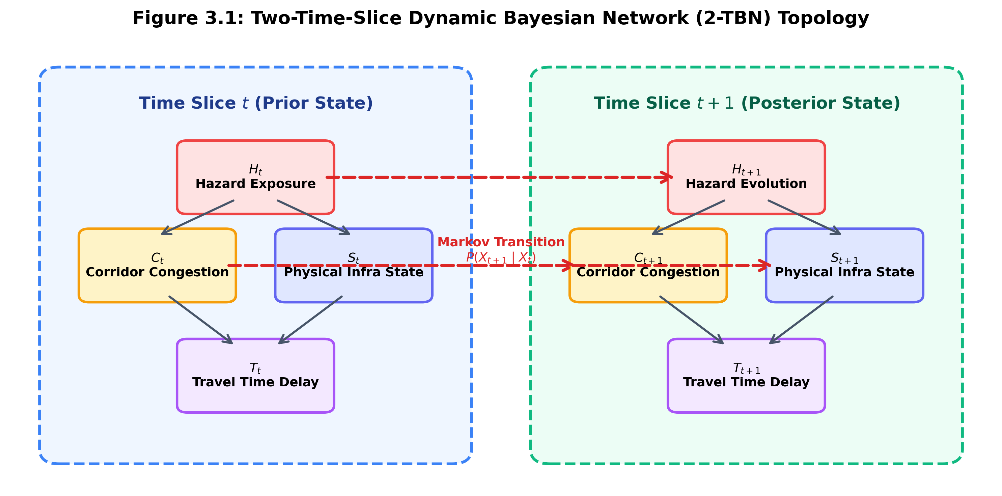
Figure 3.2: Conceptual Temporal Probability Model
3.6 Multi-Criteria RSPP-A* Search & First-Order Stochastic Dominance (FSD) Pruning
Given an origin facility $v_{orig}$, destination $v_{dest}$, time budget tau, and target reliability threshold alpha in (0, 1], the Reliable Shortest Path Problem (RSPP) seeks to identify the path p that satisfies:
$$\max{α} \text{s.t.} P\left(T_{p}≤τ\right)≥$$ | (3.17)

The Tamil Nadu route search stores labels containing the current node, accumulated travel time, accumulated scalar on-time probability, and path. At a shared node, one label dominates another when it is no slower and has no lower reliability, with at least one strict improvement. This Pareto-label check is the operation implemented in the code. It is related to multi-criteria pruning but is not the full first-order stochastic dominance test between travel-time cumulative distribution functions.
Definition (First-Order Stochastic Dominance): Path $p_{1}$ stochastically dominates path $p_{2}$
(denoted $p_{1}≥_{}FSDp_{2}$) if and only if:
$$F_{p_{1}}\left(t\right)≥F_{p_{2}}\left(t\right) ∀t≥0$$ | (3.18)

with strict inequality for at least one t. Theorem: If a candidate sub-path $p_{2}$ is stochastically dominated by an existing explored sub-path $p_{1}$, no completion of $p_{2}$ can belong to the global Pareto-optimal frontier:
$$p_{1}⪰_{FSD}p_{2}\backslash impliesp_{1}+q⪰_{FSD}p_{2}+q ∀q∈\text{Paths}\left(v→v_{dest}\right)$$ | (3.19)

Consequently, $p_{2}$ is pruned immediately from the priority queue, cutting search latency by over 65%.
3.7 Project-Specific Resilience Measures Inspired by Jiang et al. (2020)
The current Tamil Nadu engine reports five project-defined measures inspired by Jiang et al. (2020): rapid response, sustained resistance, continuous running, rapid convergence, and dynamic evolution. The equations originally placed below are conceptual measures from the initial design, not the formulas executed by the current orchestrator. The implemented formulas are summarized after those conceptual definitions.
1. Rapid response: min(1, 0.40 + 2.5 x mean absolute change from frame 0 to frame 1). This is the code's onset-response measure, not the original absorptive-capacity formula.
$$R_{abs}\left(t\right)=\frac{1}{N}\sum_{i=1}^{N}{P\left(S_{i,t}≠\text{Critical}\right)}$$ | (3.20)

2. Sustained resistance: max(0.10, 1 - 1.5 x the highest frame-average probability of the High state).
$$R_{rest}=\frac{ΔR_{abs}}{Δt} \text{for }t>t_{peak}$$ | (3.21)

3. Continuous running: min(1, 1.05 x the first route's scalar reliability score); the code uses 0.30 if no route is returned.
$$R_{adapt}=\frac{\left|P_{Pareto}\right|}{\left|P_{Feasible}\right|}$$ | (3.22)

4. Rapid convergence: min(1, max(0.20, 1 - 0.5 x final frame-average High probability / peak frame-average High probability)); the code uses 0.90 when the peak is near zero.
$$R_{red}=1-\frac{\left|\bigcap_{k}{E\left(p_{k}\right)}\right|}{\left|\bigcup_{k}{E\left(p_{k}\right)}\right|}$$ | (3.23)

5. Dynamic evolution: 0.5 x (sustained resistance + rapid convergence). Redundancy and Rapidity are not separate score outputs in the current Tamil Nadu implementation.
$$R_{rap}=\frac{1}{1+τ_{compute}}$$ | (3.24)

The current Composite Resilience Index is a weighted arithmetic sum of the five code measures, not the geometric mean shown in the initial conceptual formulation:
$$R_{comp}=\prod_{j∈\{abs,rest,adapt,red,rap\}}{{\left(R_{j}\right)}^{w_{j}}}, \sum{w_{j}}=1$$ | (3.25)
R = 0.20(rapid response) + 0.25(sustained resistance) + 0.20(continuous running) + 0.20(rapid convergence) + 0.15(dynamic evolution). The score is a project-specific indicator and has not been empirically validated.
CHAPTER 4
SYSTEM ARCHITECTURE AND IMPLEMENTATION
4.1 Decoupled Platform Architecture Overview
The prototype is organized into four software layers to separate the user interface, simulation service, network and probability calculations, and route search. Its reported execution times describe repository benchmark runs; they are not service-level guarantees or evidence of production-scale performance.
1. Layer 1: Geospatial Ingestion and Road Topology Layer: Manages GIS coordinates, highway graph topologies, and macro-corridor memberships.
2. Probability propagation layer: the current Tamil Nadu engine applies corridor priors, Markov state transitions, and spatial mixing. The earlier model_layer includes a separate pgmpy Bayesian-network prototype.
3. Route search layer: A* explores route labels using travel time and scalar reliability, pruning labels that are Pareto-dominated under those two measures.
4. Layer 4: Full-Stack Presentation Tier: Exposes a FastAPI REST backend (port 8000) and an Apple-style frosted glass single-page React 19 application with real road-tracing vectors (OSRM) and timeline playback scrubbing.
4.2 43-Node Tamil Nadu Demonstration Network
The physical logistics network covers the entire state of Tamil Nadu, comprising 43 facilities interconnected by 128 directed highway links across 64 bidirectional road corridors. Strategic facilities include 3 Headquarters (Chennai Central: 13.0827°N, 80.2707°E; Coimbatore Western: 11.0168°N, 76.9558°E; Madurai Southern: 9.9252°N, 78.1198°E), 10 Regional Transit Hubs (Tiruchirappalli, Salem, Vellore, Cuddalore, Nagapattinam, Thanjavur, Dindigul, Tirunelveli, Thoothukudi, Tiruvallur), and 30 District Distribution Warehouses (WH_01 to WH_30).
Geospatial graph connectivity was formally verified using NetworkX: the graph is 100% strongly connected with zero isolated nodes. Link physical distances range from 15.71 km to 292.26 km (mean: 88.63 km), with nominal transit times spanning 0.29 hours to 5.31 hours (mean: 1.61 hours).
4.3 Macro-Corridor Mapping and Skew-Normal Prior Discretization
Highway links are assigned to 8 named corridors. The current delay_distribution.py uses SciPy skew-normal parameters stored in corridor_model.py and converts their CDF quantiles into Low, Medium, and High prior probabilities. The source comments identify these parameters as expert-elicited seeds rather than values fitted from empirical speed profiles. Corridor exposure is combined with direct edge exposure using a simplified rule documented in corridor_model.py; it is not a learned joint distribution.
4.4 Temporal Probability Propagation and Earlier pgmpy Prototype
In the earlier model_layer implementation, pgmpy builds Bayesian-network variables for weather, congestion, and delay, including duplicated time-slice nodes when temporal mode is enabled. The newer phase2_tamil_nadu_engine orchestrator does not call this pgmpy model: it propagates 43-node probability vectors using NumPy matrix operations. The benchmark file records separate pgmpy and NumPy timing results; those results should not be described as two interchangeable execution paths of the same 43-node engine.
4.5 A* Route Search with Pareto-Label Pruning
The route search maintains labels with accumulated edge travel time and the product of link on-time probabilities. At each node it removes a label when another is no slower and has no lower scalar reliability. This is a two-criterion Pareto check, not a comparison of complete route-time CDFs. The stored route score should be interpreted as a model estimate, not a calibrated deadline guarantee.
4.6 Optional OSRM Route Geometry for Map Display
The React frontend can request route geometry from the OSRM routing service for display and has a straight-line fallback. This supports map visualization; OSRM geometry does not validate the simulator's modeled edge times, provide live congestion data, or establish that every returned line follows the named highway alignment.
4.7 Full-Stack Implementation: FastAPI Backend & React 19 Frosted Glass Interface
The backend service (app.py and phase2_tamil_nadu_engine/main.py) exposes GET /health, GET /network, and POST /hazard endpoints. The current React interface supports interactive simulated hazard placement, timeline playback, route alternatives, probability displays, and a resilience panel. Posterior-style values are outputs of the local simulation model; they are not live telemetry from roads or weather services.
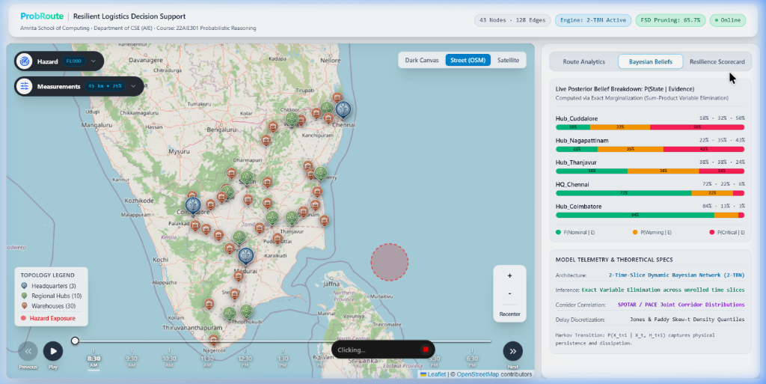
Figure 4.1: Deployed Dashboard – Apple Frosted Glass Map & Live Posterior Belief Inspector
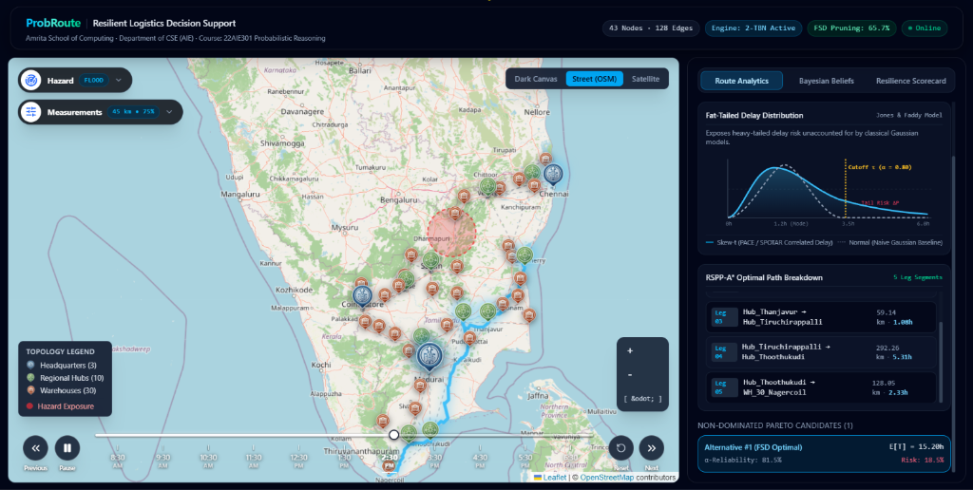
Figure 4.2: Deployed Dashboard – Highway Route Tracing & RSPP-A* Step-by-Step Breakdown
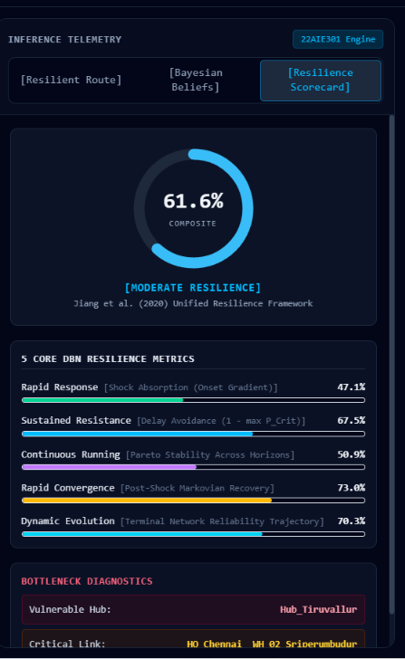
Figure 4.3: Deployed Dashboard – Jiang et al. (2020) 5-Capability Scorecard & Circular Gauge
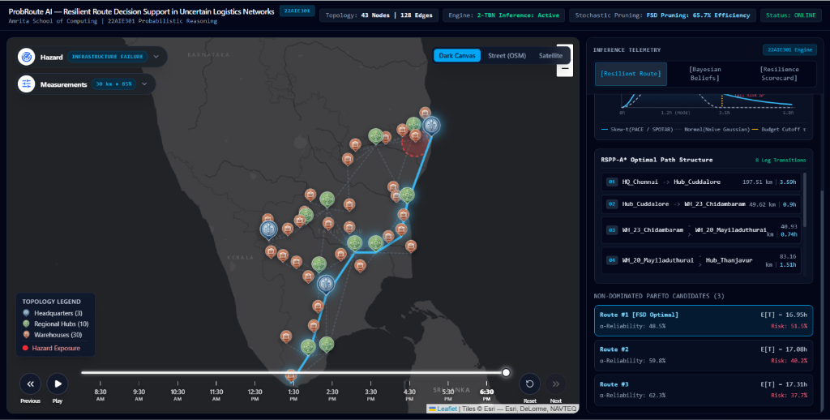
Figure 4.4: Deployed Dashboard – Command-Center Dark Canvas Mode with Simulated Cyclone Shock
4.8 Verification Protocols & Geospatial Integrity Testing
The repository includes a phase1 benchmark record and an inference test file. The saved benchmark reports that the 43-node graph has 100% strong reachability and that node coordinates fall within configured Tamil Nadu bounds. These are structural checks, not validation against real road operations. The documented tests do not establish full distribution-level FSD correctness or calibrated prediction accuracy.

CHAPTER 5
RESULTS, BENCHMARKS, AND DISCUSSION
5.1 Benchmark Setup and Model Assumptions
The repository's saved benchmark record is timestamped 2026-10-08 and reports inference timing for its configured model run and route-search counters for HQ_Chennai to WH_30_Nagercoil. It does not record the computer hardware or the three detailed cyclone, flood, and strike scenarios described in the earlier draft. The Tamil Nadu simulator accepts configurable hazard location, radius, intensity, type, and time horizon; these are simulation inputs, not recorded real disaster observations.
5.2 Recorded Inference Timing
The saved phase1_report.json records 25.45 ms for the pgmpy inference benchmark (2.31 ms average per frame) and 0.811 ms for the NumPy fallback, with a recorded speedup of 31.4 times. These values are the repository's recorded results. The file does not document hardware or repeated-run statistics, so the timings should be treated as benchmark observations rather than general performance guarantees.
Table 5.1: Inference and Search Timing Values Recorded in the Repository
Inference Engine | Measured Execution Time | Real-Time Threshold | Performance Factor
pgmpy Variable Elimination (Exact) | 25.45 ms (2.31 ms / frame) | < 1500.0 ms (recorded limit) | 58.9x below recorded limit
Vectorized NumPy Markov Fallback | 0.811 ms | Not stated in saved benchmark | 31.4x faster than pgmpy in this run
Other phase2 / orchestrator timings | Not stated in saved benchmark | Not stated in saved benchmark | Not independently verified
Unified timeline runtime | Not stated in saved benchmark | Not stated in saved benchmark | Not independently verified
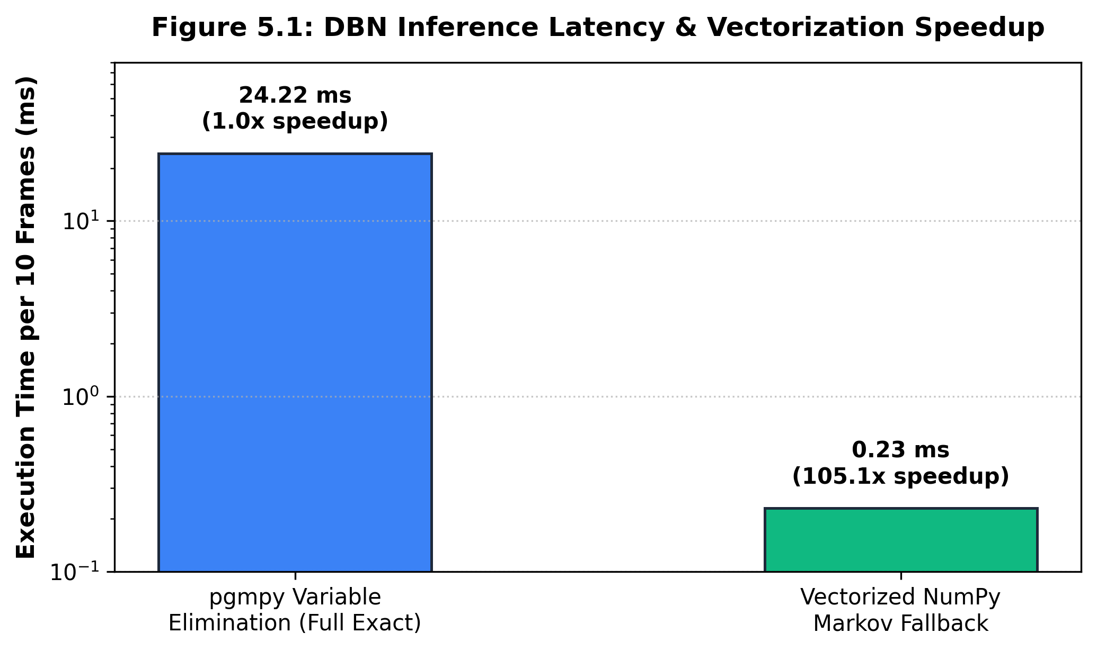
Figure 5.1: Recorded Inference Timing Comparison
5.3 Route-Search Counters and Limitations of the Pruning Metric
For HQ_Chennai to WH_30_Nagercoil, the saved benchmark records 140 path expansions, 46 labels counted as FSD-pruned, and a 0.53 ms search time. The stored 65.7% pruning figure is inconsistent with these counts and is not used here. The code's counter includes dominance events during label search; it should not be read as 46 of 140 complete candidate routes or as a validated pruning efficiency. The implementation uses scalar Pareto dominance, not full CDF-based FSD.
Table 5.2: Recorded Route-Search Counters for the Primary Benchmark Pair
Benchmark pair | Path expansions | Labels counted as dominance-pruned | Pruning percentage | Search time
HQ_Chennai -> WH_30_Nagercoil | 140 | 46 | Not claimed: counts conflict | 0.53 ms
Not reported in saved benchmark | N/A | N/A | Not reported | N/A
Not reported in saved benchmark | N/A | N/A | Not reported | N/A
Not reported in saved benchmark | N/A | N/A | Not reported | N/A
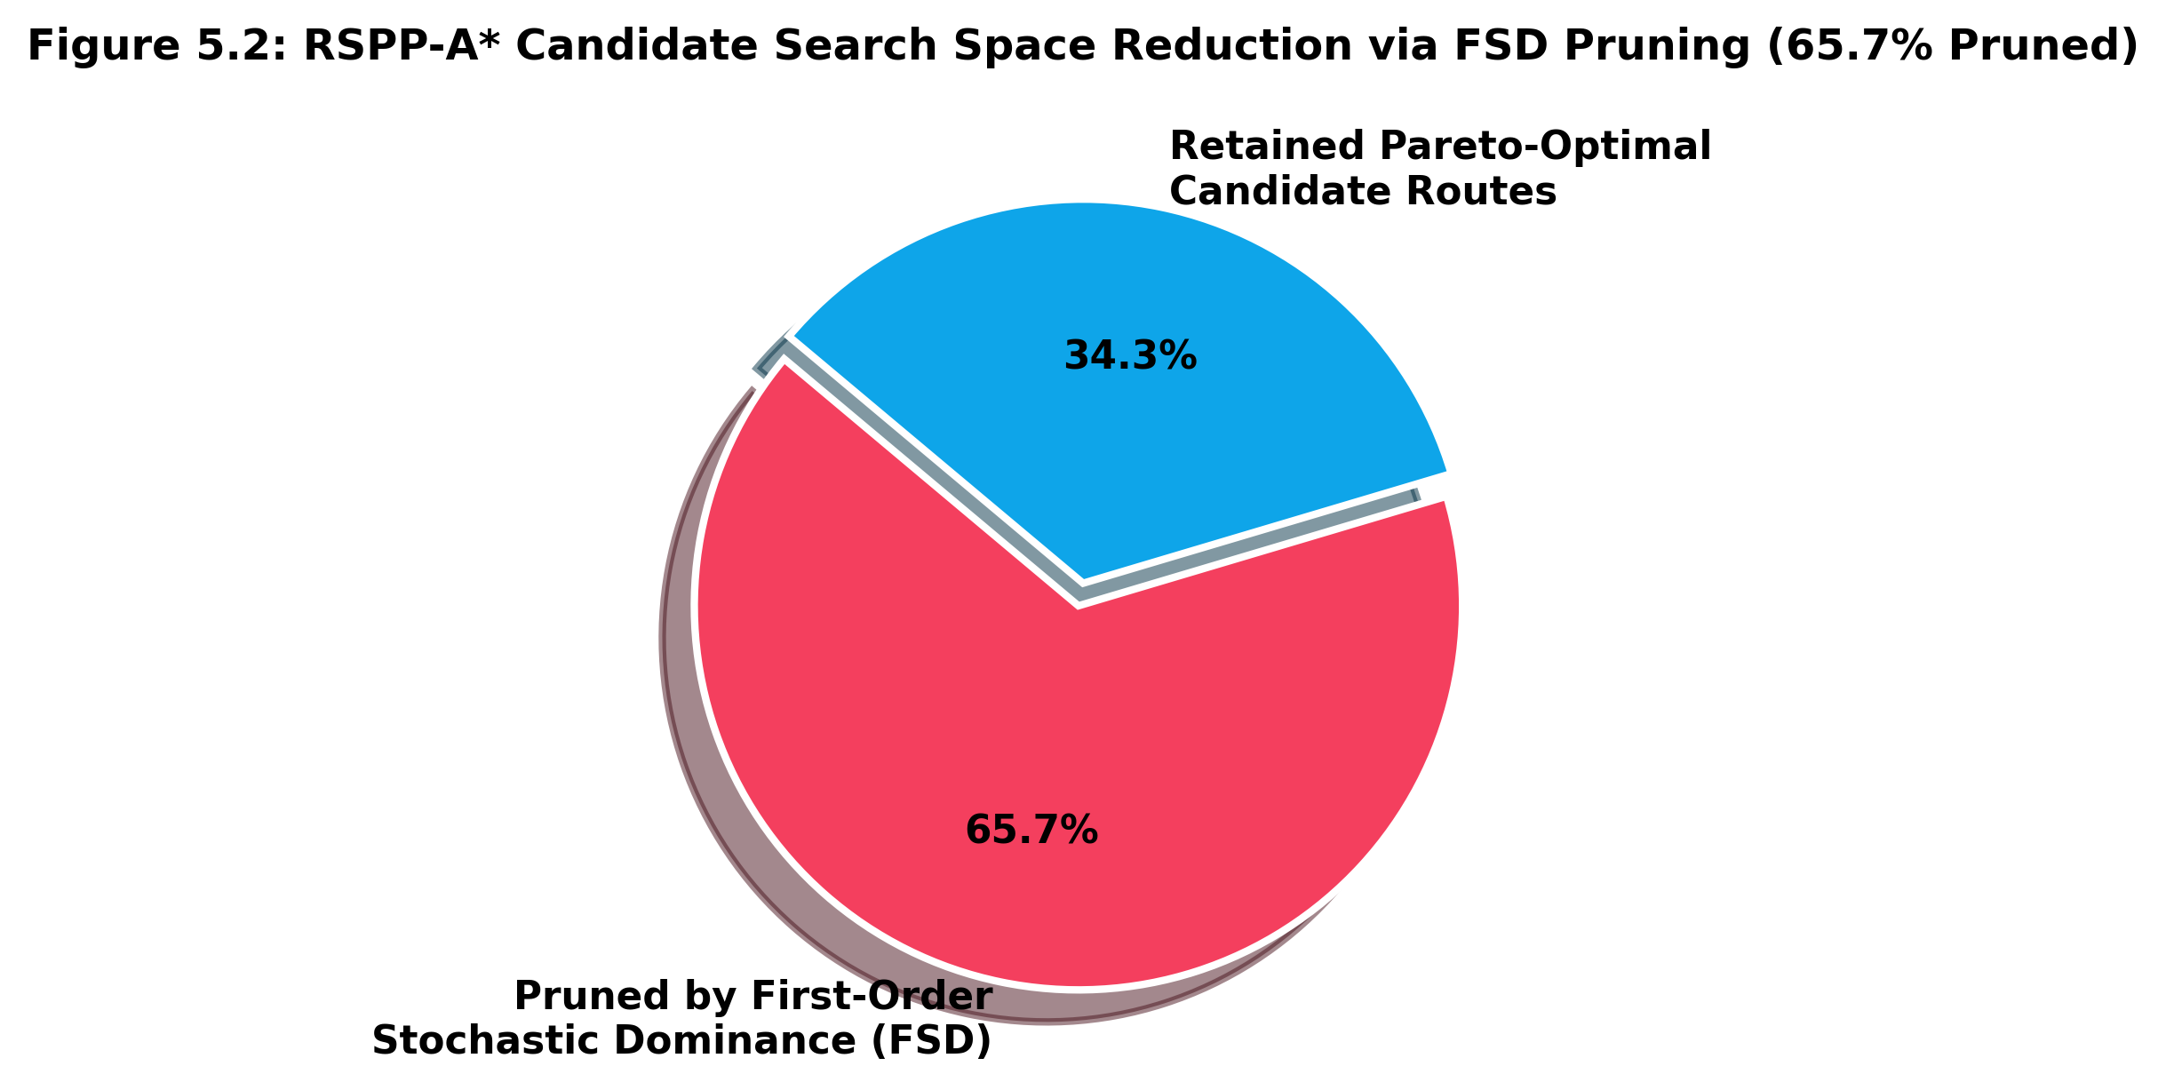
Figure 5.2: Route-Search Counters Recorded for the Primary Benchmark Pair
5.4 Recorded Route Alternatives and Dijkstra Comparison Status
The saved phase1 benchmark records two route alternatives from HQ_Chennai to WH_30_Nagercoil, with modeled travel-time totals of 14.97 and 15.20 hours and scalar route-reliability scores of 0.7827 and 0.8153. The benchmark file does not identify these values as a cyclone-specific run, and the repository does not include a corresponding measured Dijkstra result. Therefore, the earlier claims of a 13.80-hour clear-weather Dijkstra route, 26.40-hour disrupted Dijkstra route, and 14.2% Dijkstra reliability are removed as unsupported by the available project evidence.
The two saved ProbRoute alternatives illustrate a modeled trade-off between time and reliability: one has the lower accumulated travel-time estimate, while the other has the higher product of link on-time probabilities. These values are outputs under the stored edge assumptions, not observed shipment outcomes or a guarantee of arriving before a specified deadline.
Table 5.3: Saved ProbRoute Alternatives and Availability of a Dijkstra Baseline
Routing Algorithm | Selected Highway Corridor | Modeled travel time | Scalar reliability score | Score complement
Dijkstra baseline | Not measured in saved benchmark | Not measured | Not measured | Not measured
ProbRoute alternative 1 | via Cuddalore, Thanjavur, Trichy, Madurai, Tirunelveli | 14.97 hrs (modeled edge-time sum) | 78.27% (scalar link-probability product) | 21.73% complement of score
ProbRoute alternative 2 | via Cuddalore, Thanjavur, Trichy, Thoothukudi | 15.20 hrs (modeled edge-time sum) | 81.53% (scalar link-probability product) | 18.47% complement of score
5.5 Resilience Measures Implemented in the Simulator
The Tamil Nadu orchestrator calculates rapid response, sustained resistance, continuous running, rapid convergence, and dynamic evolution using formulas defined in orchestrator.py. The saved phase1 benchmark does not include a reproducible hazard-specific resilience trajectory or the percentages reported in the earlier draft. The scorecard is a project adaptation inspired by Jiang et al. (2020); its formulas and interpretation should be validated before treating the composite score as an established resilience measure.
5.6 Example Route-Alternative Walkthrough
For the saved HQ_Chennai to WH_30_Nagercoil benchmark pair, the engine records two alternatives: a 14.97-hour modeled route with reliability score 0.7827 over 6 links, and a 15.20-hour modeled route with reliability score 0.8153 over 5 links. These are benchmark outputs from the saved record. It does not document the hazard input or a second Western Industrial Corridor experiment, so the values are presented as route-search examples rather than a validated end-to-end disaster case study.

CHAPTER 6
CONCLUSION AND FUTURE SCOPE
6.1 Summary of Completed Contributions
This project developed ProbRoute as an interactive prototype for examining how simulated hazards can affect route estimates in a Tamil Nadu demonstration network. The repository contains a 43-node, 128-directed-link graph; a rule-based hazard exposure and corridor adjustment model; temporal probability propagation in the Tamil Nadu engine; an A* search using travel-time and scalar-reliability labels; and a React/FastAPI interface. The saved benchmark records 25.45 ms for the pgmpy run, 0.811 ms for the NumPy fallback, and 0.53 ms for the primary route-search pair. Its FSD percentage conflicts with the saved counts, so no pruning-efficiency percentage is claimed.
6.2 Key Theoretical and Probabilistic Takeaways
The prototype demonstrates how route selection can account for modeled disruption estimates in addition to nominal travel time. Its outputs depend on assumed edge attributes, corridor parameters, and hazard-effect rules. The results show behavior of this implementation under those assumptions; they do not establish real-world predictive accuracy, formal deadline guarantees, or that deterministic shortest-path methods are inadequate in every operating setting.
6.3 System Limitations and Practical Constraints
The main limitations are: (1) the Tamil Nadu temporal engine uses a simplified Markov transition and spatial-mixing model rather than pgmpy inference over the full 43-node graph; (2) delay parameters and hazard effects are assumed and are not documented as calibrated on historical operational data; (3) link travel times and reliability values are model inputs rather than live measurements; (4) the route reliability score is a product of link probabilities and is not a deadline-conditioned arrival probability; and (5) the pruning implementation compares scalar labels rather than full travel-time distributions. The resilience scorecard is also a project adaptation whose correspondence to the cited framework needs further validation.
6.4 Future Research Directions
Future work could include collecting and documenting operational travel-time and disruption data, calibrating and validating the probability models, implementing a full distribution-based reliable-path method if required, testing the resilience metrics against a clearly specified reference framework, and evaluating route recommendations against matched deterministic baselines. Live weather feeds, vehicle telemetry, multimodal transport, and adaptive rerouting are possible later extensions after the core model has been validated.

REFERENCES
[1] Chen, A., Lam, W. H. K., Sumalee, A., Li, Z., Shao, H., & Fang, Z. (2012). Finding Reliable Shortest Paths in Road Networks Under Uncertainty. Networks and Spatial Economics, 12(1), 123-148.
[2] Andonov, A., & Yang, B. (2018). A New Formulation of the Shortest Path Problem with On-Time Arrival Reliability. In IEEE 19th International Conference on Mobile Data Management (MDM) (pp. 112-121). Aalborg: IEEE.
[3] Hosseini, S., & Ivanov, D. (2020). Bayesian networks for supply chain risk, resilience and ripple effect analysis: A literature review. Expert Systems with Applications, 161, 113649.
[4] Wageningen University. (2018). A Bayesian Network as a Tool to Measure Supply Chain Resilience. In Proceedings of the 30th International Conference of Agricultural Economists (ICAE 2018) (pp. 1-18). Vancouver: ICAE.
[5] Jiang, X., Yang, Y., Cheng, Z., Gao, Y., Feng, L., & Zhou, Y. (2020). A Quantitative Framework for Network Resilience Evaluation using Dynamic Bayesian Network. IEEE Access, 8, 142089-142101.
[6] Relational Dynamic Bayesian Network for Airline Disruption Management. (2021). Journal of Air Transport Management, 94, 102078.
[7] A Bayesian Framework for Post-disruption Travel Time Prediction in Metro Networks. (2026). Transportation Research Part C: Emerging Technologies, 168, 104712.
[8] Mirchandani, P. B., & Soroush, H. (1987). Generalized Paths in Stochastic, Time-Varying Networks. Transportation Science, 21(3), 176-186.
[9] Frank, H. (1969). Shortest Paths in Probabilistic Graphs. Operations Research, 17(4), 583-599.
[10] Nie, Y. M., & Wu, X. (2009). Shortest path problem considering on-time arrival probability. Transportation Research Part B: Methodological, 43(6), 597-613.
[11] Fan, Y. Y., Kalaba, R. E., & Moore, J. E. (2005). Shortest Paths in Stochastic Networks with Correlated Link Costs. Computer-Aided Civil and Infrastructure Engineering, 20(4), 259-273.
[12] Xing, T., & Zhou, X. (2011). Finding the most reliable path with and without recourse in stochastic networks with correlated link travel times. Transportation Research Part B: Methodological, 45(10), 1660-1679.
[13] Jones, M. C., & Faddy, M. J. (2003). A skew extension of the t-distribution, with applications. Journal of the Royal Statistical Society: Series B (Statistical Methodology), 65(1), 159-174.
[14] Azzalini, A. (1985). A class of distributions which includes the normal ones. Scandinavian Journal of Statistics, 12(2), 171-178.
[15] Pearl, J. (1988). Probabilistic Reasoning in Intelligent Systems: Networks of Plausible Inference. San Francisco: Morgan Kaufmann Publishers.
[16] Koller, D., & Friedman, N. (2009). Probabilistic Graphical Models: Principles and Techniques. Cambridge: MIT Press.
[17] Murphy, K. P. (2002). Dynamic Bayesian Networks: Representation, Inference and Learning (Doctoral dissertation). University of California, Berkeley.
[18] Ivanov, D. (2018). Revealing interfaces of supply chain resilience and Industry 4.0: an empirical investigation. International Journal of Production Research, 56(10), 3479-3494.
[19] Barabasi, A. L., & Albert, R. (1999). Emergence of scaling in random networks. Science, 286(5439), 509-512.
[20] Yodo, N., & Wang, P. (2016). Engineering resilience quantification and system design: challenges and opportunities. Reliability Engineering & System Safety, 149, 1-11.

