Project – Online Library

Work process - Starting the project  
  
Diagram  
  
Register and login page

  
  
Forgot to auto increment the user id so I had to change its identity.  
  
  
  
  
  
  
  
  
  
  
  
  
Touched the css a bit:  
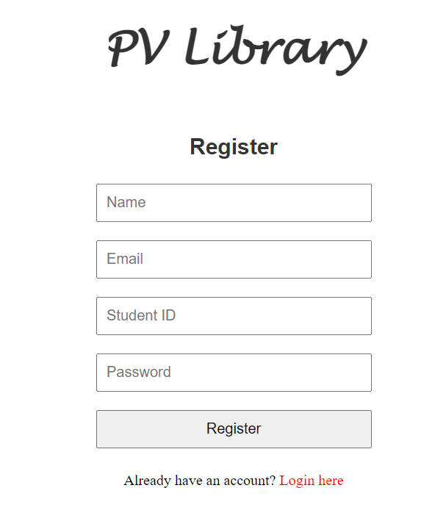  
Made some hyperlinks with hover and active stances that have different colors. Made the mains for both users and admins.

Created a place where you can see every user created and if they are an admin or not, also you can press the marks to make someone or remove the admin permission from someone.

Made the Seat Reservation page.

Created the Reserve a Book page.

Made a page to check books by author:  
  
Made the My Reservations page where you can end your reservations:

If you end your reservation it will be saved into a json file, for seats and books:  
I created on the admin main pages that display all the reservations for the seats and books where the admin can end the reservation

Also created a page where you can see all books orderd by title, in case an admin would want to see how many coppies available are left.

Every page from the admin’s main uses views to fetch the data from the database.