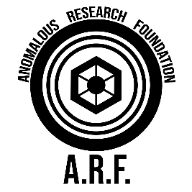

**Biological Hazards:** Human exposure to F-004 poses unique risks, particularly for individuals with pre-existing medical conditions. Sudden shifts in gravity can cause dizziness, nausea, and disorientation. In more extreme cases, the anomaly can trigger serious health issues, including cardiovascular stress or collapse due to the rapid change in gravitational force.

**Environmental Impact:** The unpredictable nature of F-004 makes it particularly hazardous in environments where stability is critical. Vehicles passing through an affected zone may lose traction, become airborne, or suffer damage from intense gravitational pressure. Similarly, structures and infrastructure within the zone are subject to warping, cracking, or collapse if exposed to prolonged gravitational shifts.

**Gravitational Instability:** The core feature of F-004 is its ability to disrupt the gravitational field in a given area. Gravity can fluctuate between extremes—either dramatically reducing, resulting in near weightlessness, or intensifying, making objects and individuals feel significantly heavier. These fluctuations occur randomly and without warning, lasting anywhere from a few seconds to several minutes.

**ANOMALOUS PROPERTIES:**

F-004, codenamed *"Left-Right,"* refers to localized areas where gravity behaves in an unpredictable and erratic manner. These anomalies typically manifest within a **50-100 sqm** radius, causing objects and individuals within the affected zone to experience sudden shifts in gravitational force. Individuals and objects can be subjected to brief periods of weightlessness or extreme heaviness, leading to physical disorientation, erratic movement, and potential harm to those present.

**SUBJECT DESCRIPTION:**

Anomaly: F-004

Codename: “Left-Right”

Anomaly Classification: Force

Discovery Date: 1995

Current Status: Active

A.R.F Anomaly File (ver. 1.4.299 – 1999)

