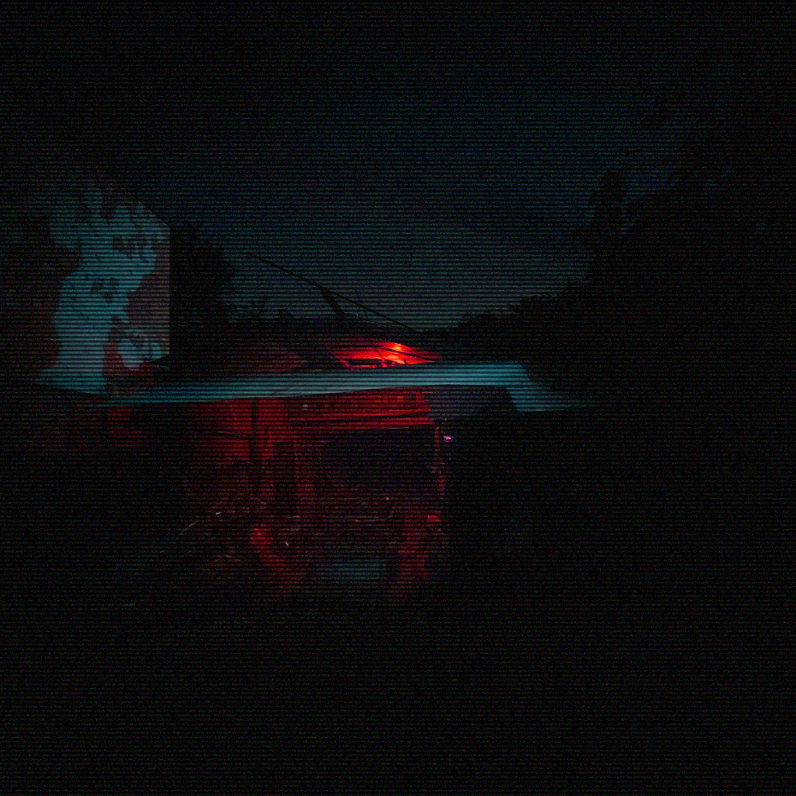

**Spatial Anomalies:** The space around R-053 warps unpredictably. Tools vanish, and the environment distorts in subtle yet disorienting ways. Some individuals have reported seeing different versions of the buggy in their peripheral vision—fully completed one moment and completely disassembled the next. Atmospheric conditions around the vehicle often fluctuate without reason, including temperature drops and abnormal wind patterns.

**Mental Fixation:** Individuals involved with R-053 develop a growing obsession with "finishing" the project. This fixation begins innocuously but escalates over time, with individuals reporting that their every waking thought is consumed by the desire to complete the buggy. Attempts to leave the project or walk away from it are met with psychological resistance and eventual return to the site.

**Temporal Displacement**: R-053 appears to exist outside of conventional time, specifically regarding its completion. Despite extensive work and repairs, the buggy remains in a "work-in-progress" state. Researchers working on it have reported spending hours or even days working on components, only to find them in the same unfinished condition when revisited. Tools left near the vehicle have also been found in different locations or even missing entirely.

**ANOMALOUS PROPERTIES:**

R-053, codenamed "Silent Pursuit," is an unfinished, heavily modified buggy currently located at [CLASSIFIED COORDINATES]. Despite numerous efforts to restore, complete, or remove the vehicle, all attempts have failed. The project has remained perpetually in stasis, with any work done on the buggy being undone in ways that defy conventional understanding. Those involved in the project experience obsessive tendencies, manifesting in a compulsion to complete the vehicle despite an inability to make tangible progress.

**SUBJECT DESCRIPTION:**

Anomaly: R-053

Codename: “Silent Pursuit”

Anomaly Classification: R-053

Discovery Date: 1997

Current Status: Dormant

A.R.F Anomaly File (ver. 1.4.299 – 1999)