# Problem 3 – Sprint Board

## Endpoints

* [**http://localhost:3030/jsonstore/tasks/**](http://localhost:3030/jsonstore/tasks/)**:id**

## Load the Board

Clicking the **[Load Board]** button on the **top left** should send a **GET** request to the server to fetch **all sprint tasks** in your local database. You have to add each task to its **specified column list** (ToDo, In Progress, Code Review, or Done). The tasks should have **different text contents** inside their respective **buttons** depending on which column they are in:

* ToDo – **“Move to In Progress”**
* In Progress – **“Move to Code Review”**
* Code Review – **“Move to Done”**
* Done – **“Close”**

Each Sprint task has the following **HTML** **structure**:

<li class="task">

<h3>Fix Bug</h3>

<p>We have a new bug to fix</p>

<button>Move to In Progress/Move to Code Review/Move to Done/Close</button>

</li>

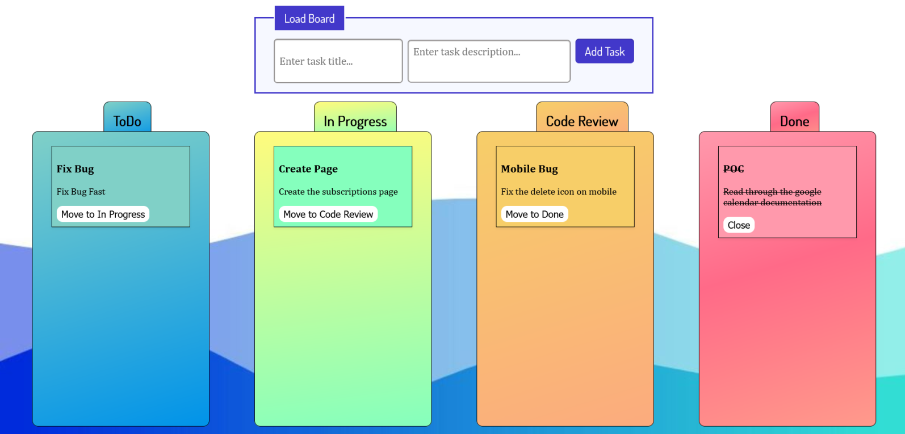

## Add a Task

Clicking the **[Add Task]** button should send a **POST** request to the server creating a new task with a **title** and **description** from the input values (the **status** should have an initial value of **'ToDo'**). After a successful creation, you should send another **GET** request to fetch all the tasks, including the **newly added one** into the **ToDo** column. You should also **clear all input fields** after the creation!

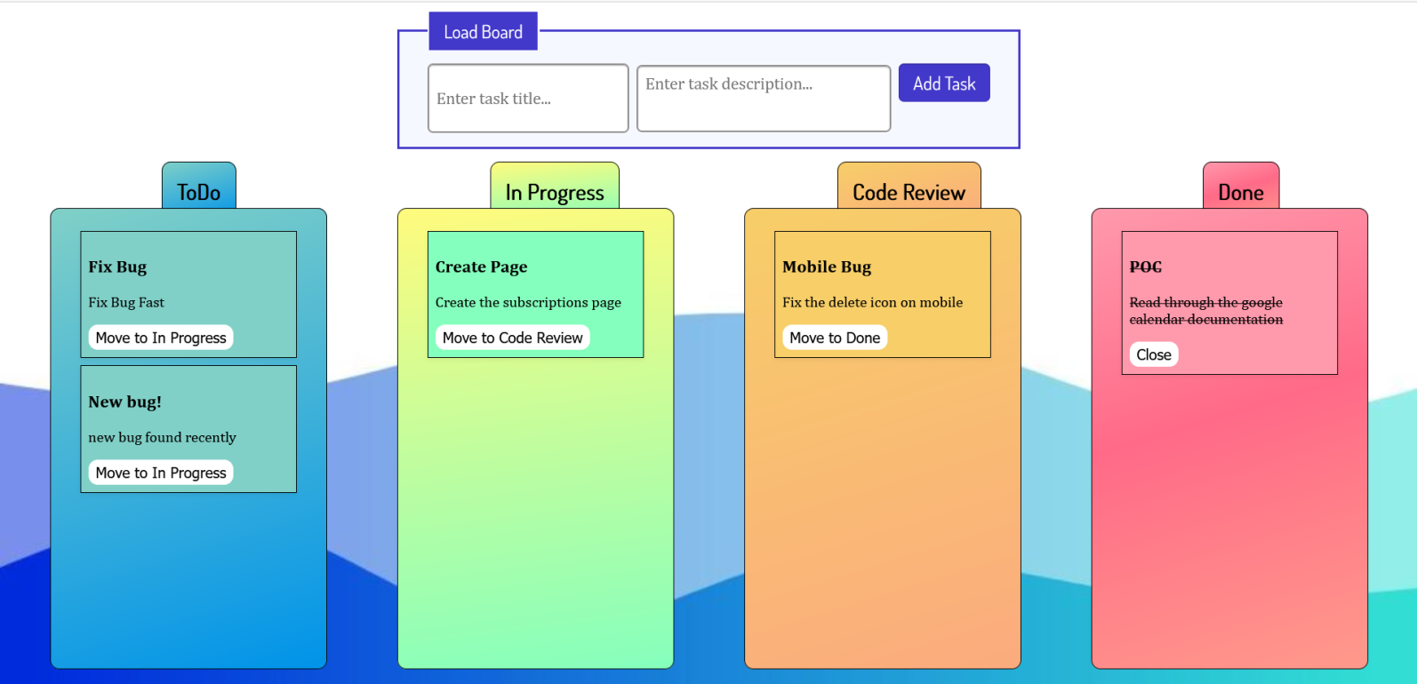

## Move a Task

Clicking the **[Move]** button on the individual tasks from the **first 3 columns** should move the task from one column to the next – from **ToDo** to **In Progress** to **Code Review** and finally to **Done**.

After clicking the **[Move]** button, you should send a **PATCH** request to the server to **modify the status** of the changed item. After the successful request, you should **fetch the items again** and see that the change has been made.

## Close a Task

Clicking the **[Close]** button on the tasks in the **Done section** should send a **DELETE** request to the server and remove the item from your local database. After you’ve removed it successfully, **fetch** the items **again**.

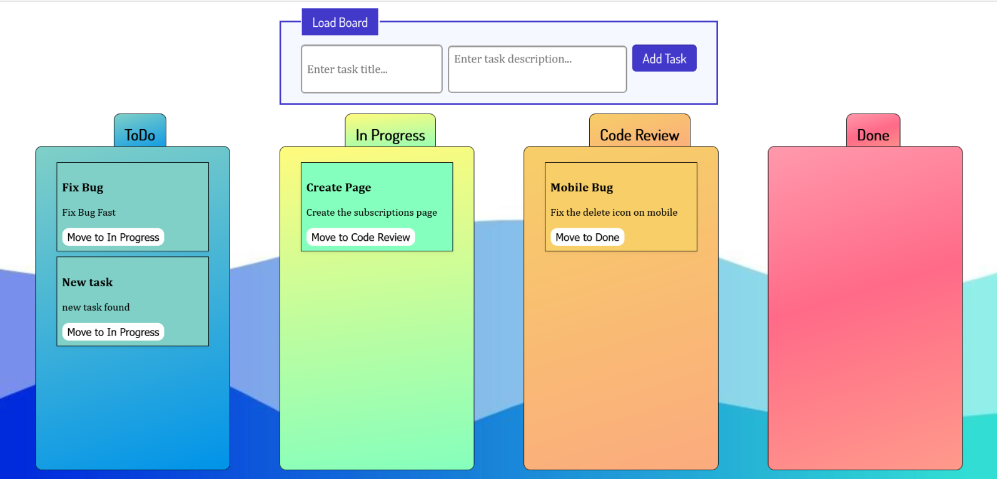

## Submitting Your Solution

Select the content of your working folder (the given resources). Exclude the *node_modules* & *tests* folders. Archive the rest into a **ZIP** file and upload the archive to Judge.

Картина, която съдържа текст

Описанието е генерирано автоматично

Картина, която съдържа текст

Описанието е генерирано автоматично