**MODULE 3**

**Q-1) select unique job from EMP table.**

**Query:** [SELECT](http://localhost/phpmyadmin/url.php?url=https://dev.mysql.com/doc/refman/8.0/en/select.html) DISTINCT job FROM employee;

**Output:**

**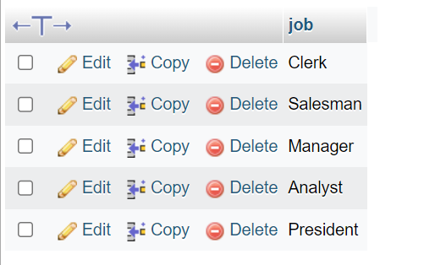**

**Q-2) List the details of the emps in asc order of the Dptons and desc of jobs?**

**Query:** [SELECT](http://localhost/phpmyadmin/url.php?url=https://dev.mysql.com/doc/refman/8.0/en/select.html) \* FROM employee ORDER BY dept\_no ASC, job DESC;

**Output:**

**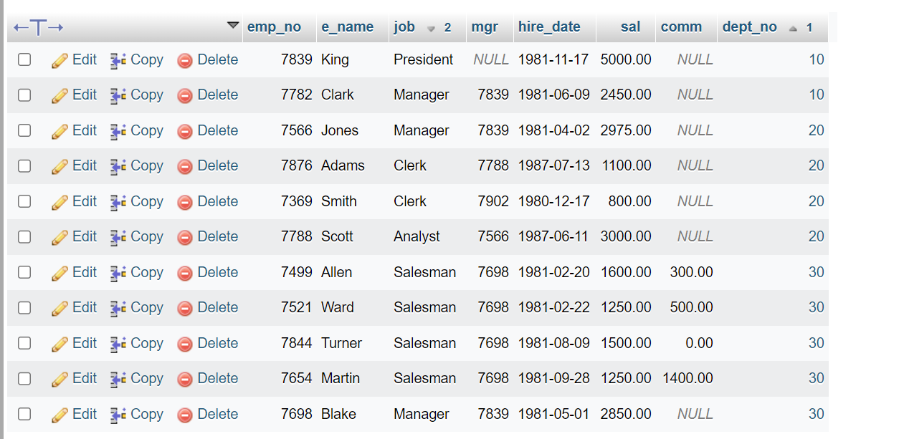**

**Q-3) Display all the unique job groups in the descending order?**

**Query:** [SELECT](http://localhost/phpmyadmin/url.php?url=https://dev.mysql.com/doc/refman/8.0/en/select.html) DISTINCT job FROM employee ORDER BY job DESC;

**Output:**

**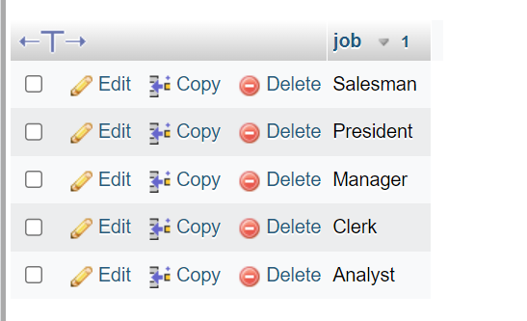**

**Q-4) List the emps who joined before 1981.**

**Query:**

**Output:**

**Q-5) List the Empno, Ename, sal, daily sal of all emps in the order of ansal.**

**Query:**  [SELECT](http://localhost/phpmyadmin/url.php?url=https://dev.mysql.com/doc/refman/8.0/en/select.html) emp\_no, e\_name, sal Monthly\_Salary, sal/30 Daily\_Salary, sal\*12 Anual\_Salary FROM employee ORDER BY Anual\_Salary ASC;

**Output:**

**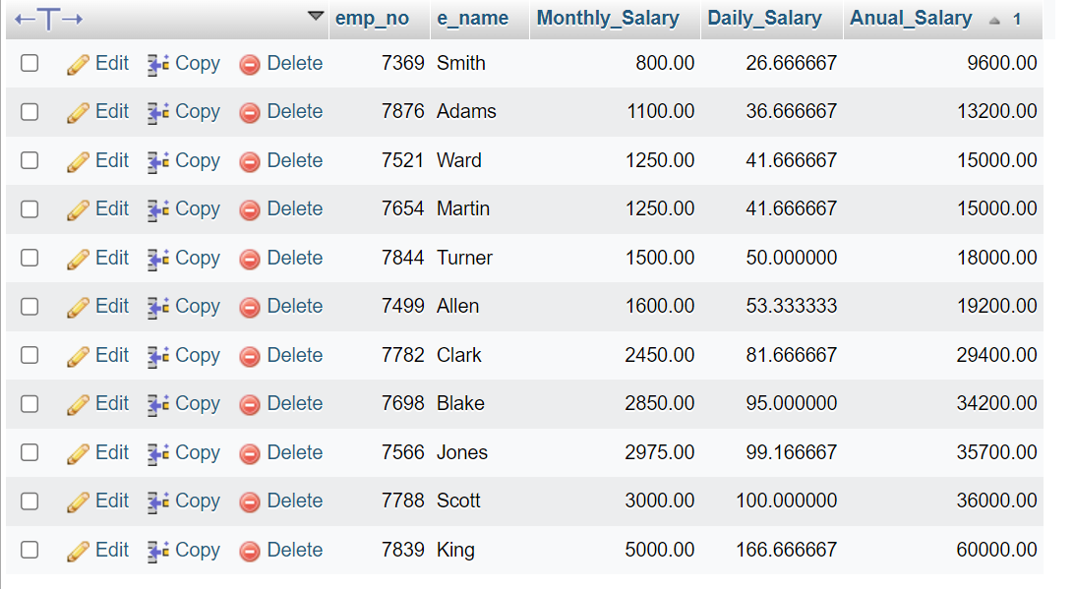**

**Q-6) List the Empno, Enmae, Sal, Exp of all emps working for Mgr 7839.**

**Query:** [SELECT](http://localhost/phpmyadmin/url.php?url=https://dev.mysql.com/doc/refman/8.0/en/select.html) emp\_no, e\_name, sal FROM employee where mgr=7839;

**Output:**

**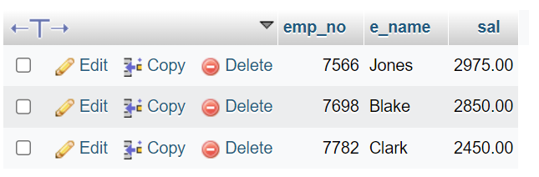**

**Q-7) Display all the details of the emps whos Comm. Is more their Sal?**

**Query:** [SELECT](http://localhost/phpmyadmin/url.php?url=https://dev.mysql.com/doc/refman/8.0/en/select.html) \* FROM `employee` WHERE comm > sal;

**Output:**

**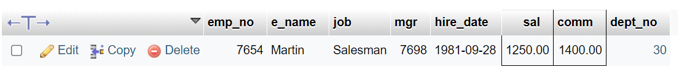**

**Q-8) List the emps who are either ‘CLERK’ or ‘ANALYST’ in the Desc order.**

**Query:** [SELECT](http://localhost/phpmyadmin/url.php?url=https://dev.mysql.com/doc/refman/8.0/en/select.html) \* FROM `employee` where job='CLERK' [OR](http://localhost/phpmyadmin/url.php?url=https://dev.mysql.com/doc/refman/8.0/en/logical-operators.html%23operator_or) job='ANALYST' ORDER BY job DESC;

**Output:**

**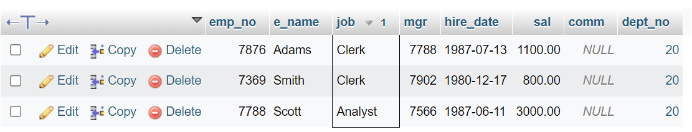**

**Q-9) List the emps who Annual sal ranging from 22000 and 45000.**

**Query:** [SELECT](http://localhost/phpmyadmin/url.php?url=https://dev.mysql.com/doc/refman/8.0/en/select.html) \*,sal\*12 FROM `employee` WHERE sal\*12 BETWEEN 22000 [AND](http://localhost/phpmyadmin/url.php?url=https://dev.mysql.com/doc/refman/8.0/en/logical-operators.html%23operator_and) 45000;

**Output:**

**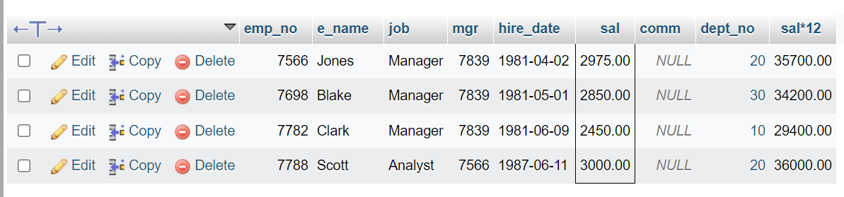**

**Q-10) List the Enames those are starting with ‘S’ and with five characters.**

**Query:** [SELECT](http://localhost/phpmyadmin/url.php?url=https://dev.mysql.com/doc/refman/8.0/en/select.html) e\_name FROM employee where e\_name [like](http://localhost/phpmyadmin/url.php?url=https://dev.mysql.com/doc/refman/8.0/en/string-comparison-functions.html%23operator_like) 'S%' [AND](http://localhost/phpmyadmin/url.php?url=https://dev.mysql.com/doc/refman/8.0/en/logical-operators.html%23operator_and) length(e\_name) = 5;

**Output:**

**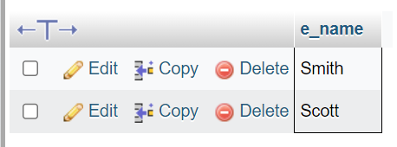**

**Q-11) List the emps whose Empno not starting digit 78.**

**Query:** [SELECT](http://localhost/phpmyadmin/url.php?url=https://dev.mysql.com/doc/refman/8.0/en/select.html) \* FROM employee where emp\_no [NOT](http://localhost/phpmyadmin/url.php?url=https://dev.mysql.com/doc/refman/8.0/en/logical-operators.html%23operator_not) [LIKE](http://localhost/phpmyadmin/url.php?url=https://dev.mysql.com/doc/refman/8.0/en/string-comparison-functions.html%23operator_like) '78%';

**Output:**

**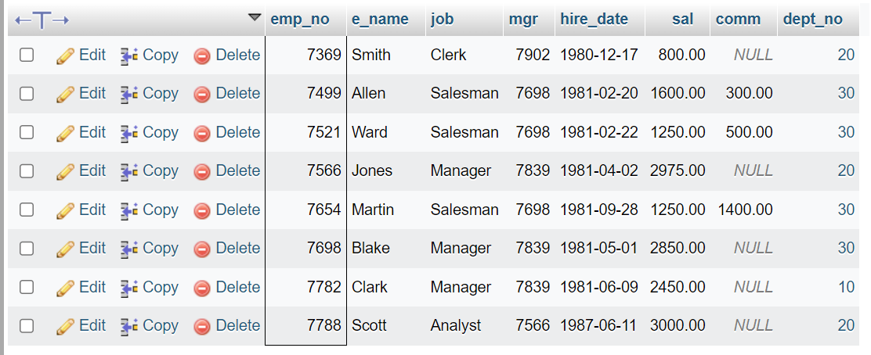**

**Q-12) List all Clearks of Deptno 20.**

**Query:** [SELECT](http://localhost/phpmyadmin/url.php?url=https://dev.mysql.com/doc/refman/8.0/en/select.html) \* FROM employee WHERE job='CLERK' [AND](http://localhost/phpmyadmin/url.php?url=https://dev.mysql.com/doc/refman/8.0/en/logical-operators.html%23operator_and) dept\_no=20;

**Output:**

**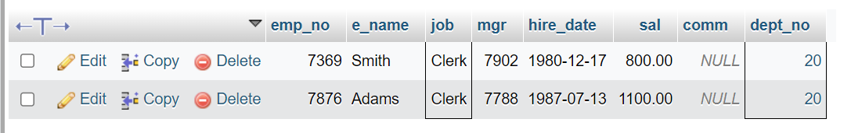**

**Q-13) List the Emps who are senior to their own MGRS.**

**Query:**

**Output:**

**Q-14) List the Emps of Deptno 20 who’s Jobs are same as Deptno 10.**

**Query:** SELECT \* FROM employee WHERE deptno = 20 AND job IN (SELECT DISTINCT job FROM employee WHERE deptno = 10);

**Output:**

**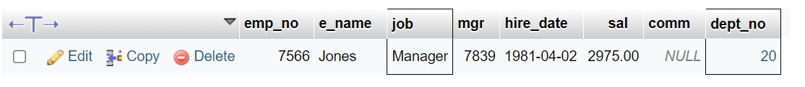**

**Q-15) List the Emps whos Sal is same as FORD or SMITH in desc oeder of sal,**

**Query:** [SELECT](http://localhost/phpmyadmin/url.php?url=https://dev.mysql.com/doc/refman/8.0/en/select.html" \t "mysql_doc) \* FROM employee WHERE sal [IN](http://localhost/phpmyadmin/url.php?url=https://dev.mysql.com/doc/refman/8.0/en/comparison-operators.html%23function_in" \t "mysql_doc)([SELECT](http://localhost/phpmyadmin/url.php?url=https://dev.mysql.com/doc/refman/8.0/en/select.html" \t "mysql_doc) sal FROM employee where e\_name [IN](http://localhost/phpmyadmin/url.php?url=https://dev.mysql.com/doc/refman/8.0/en/comparison-operators.html%23function_in" \t "mysql_doc)('FORD','SMITH')) ORDER BY sal DESC;

**Output:**

**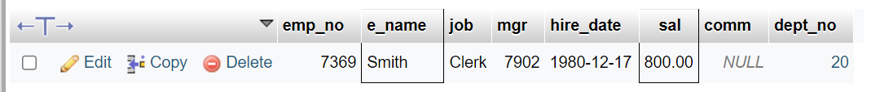**

**Q-16 List the emps whose jobs same as SMITH OR ALLEN.**

**Query:** [SELECT](http://localhost/phpmyadmin/url.php?url=https://dev.mysql.com/doc/refman/8.0/en/select.html) \* FROM employee WHERE job [IN](http://localhost/phpmyadmin/url.php?url=https://dev.mysql.com/doc/refman/8.0/en/comparison-operators.html%23function_in)([SELECT](http://localhost/phpmyadmin/url.php?url=https://dev.mysql.com/doc/refman/8.0/en/select.html) job FROM employee where e\_name [IN](http://localhost/phpmyadmin/url.php?url=https://dev.mysql.com/doc/refman/8.0/en/comparison-operators.html%23function_in)('ALLEN','SMITH'));

**Output:**

**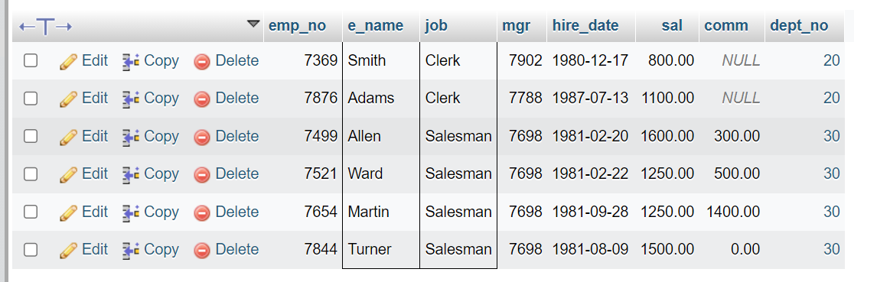**

**Q-17) Any jobs of deptno 10 those that are not found in deptno 20.**

**Query:** [SELECT](http://localhost/phpmyadmin/url.php?url=https://dev.mysql.com/doc/refman/8.0/en/select.html) \* FROM employee WHERE dept\_no=10 [AND](http://localhost/phpmyadmin/url.php?url=https://dev.mysql.com/doc/refman/8.0/en/logical-operators.html%23operator_and) job [NOT](http://localhost/phpmyadmin/url.php?url=https://dev.mysql.com/doc/refman/8.0/en/logical-operators.html%23operator_not) [IN](http://localhost/phpmyadmin/url.php?url=https://dev.mysql.com/doc/refman/8.0/en/comparison-operators.html%23function_in)([SELECT](http://localhost/phpmyadmin/url.php?url=https://dev.mysql.com/doc/refman/8.0/en/select.html) job FROM employee where dept\_no=20);

**Output:**

****

**Q-18) Find the higest sal of EMP table.**

**Query:** [SELECT](http://localhost/phpmyadmin/url.php?url=https://dev.mysql.com/doc/refman/8.0/en/select.html) [MAX](http://localhost/phpmyadmin/url.php?url=https://dev.mysql.com/doc/refman/8.0/en/aggregate-functions.html%23function_max)(sal) FROM employee;

**Output:**

**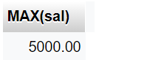**

**Q-19) Find details of highest paid employee.**

**Query:** [SELECT](http://localhost/phpmyadmin/url.php?url=https://dev.mysql.com/doc/refman/8.0/en/select.html) \* FROM employee WHERE sal [IN](http://localhost/phpmyadmin/url.php?url=https://dev.mysql.com/doc/refman/8.0/en/comparison-operators.html%23function_in)([SELECT](http://localhost/phpmyadmin/url.php?url=https://dev.mysql.com/doc/refman/8.0/en/select.html) [MAX](http://localhost/phpmyadmin/url.php?url=https://dev.mysql.com/doc/refman/8.0/en/aggregate-functions.html%23function_max)(sal) FROM employee);

**Output:**

****

**Q-20) Find the total sal given to the MGR.**

**Query:** [SELECT](http://localhost/phpmyadmin/url.php?url=https://dev.mysql.com/doc/refman/8.0/en/select.html) [sum](http://localhost/phpmyadmin/url.php?url=https://dev.mysql.com/doc/refman/8.0/en/aggregate-functions.html%23function_sum)(sal) FROM employee where job='MANAGER';

**Output:**

**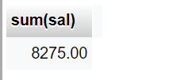**

**Q-21) List the emps whose names contains ‘A’.**

**Query:** [SELECT](http://localhost/phpmyadmin/url.php?url=https://dev.mysql.com/doc/refman/8.0/en/select.html) \* FROM employee where e\_name [LIKE](http://localhost/phpmyadmin/url.php?url=https://dev.mysql.com/doc/refman/8.0/en/string-comparison-functions.html%23operator_like) '%A%';

**Output:**

**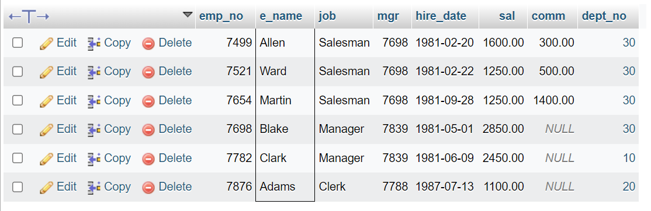**

**Q-22) Find all the emps who earn the minimum Salary for each job wise in ascending order.**

**Query:** [SELECT](http://localhost/phpmyadmin/url.php?url=https://dev.mysql.com/doc/refman/8.0/en/select.html) \* FROM employee WHERE sal [IN](http://localhost/phpmyadmin/url.php?url=https://dev.mysql.com/doc/refman/8.0/en/comparison-operators.html%23function_in)([SELECT](http://localhost/phpmyadmin/url.php?url=https://dev.mysql.com/doc/refman/8.0/en/select.html) [MIN](http://localhost/phpmyadmin/url.php?url=https://dev.mysql.com/doc/refman/8.0/en/aggregate-functions.html%23function_min)(sal) FROM employee GROUP BY job) ORDER BY sal ASC;

**Output:**

**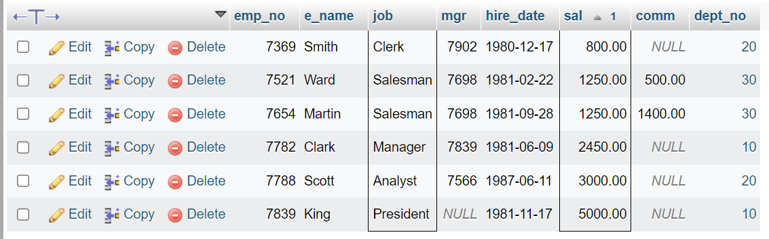**

**Q-23) List the emps whose sal greater than Blake’s sal.**

**Query:**

**Output:**

**Q-24) Create view v1 to select ename, job, dname, loc whose deptno are same.**

**Query:**

**Output:**

**Q-25) Create a procedure with dno as input parameter to fetch ename and dname.**

**Query:**

**Output:**

**Q-26) Add column Pin with bigint data type in table student.**

**Query:**

**Output:**