Wireshark Traffic Analysis Report
1. Number of Packets in the Trace
To ensure the accuracy and cleanliness of the capture, I closed all unnecessary applications that could generate network traffic. Then, I launched Wireshark, initiated packet capturing on the Ethernet interface, and visited https://narva.ut.ee. After the webpage fully loaded, I stopped the capture. The session recorded a total of 514 packets over approximately 3.3 seconds. This set the foundation for the subsequent analysis.
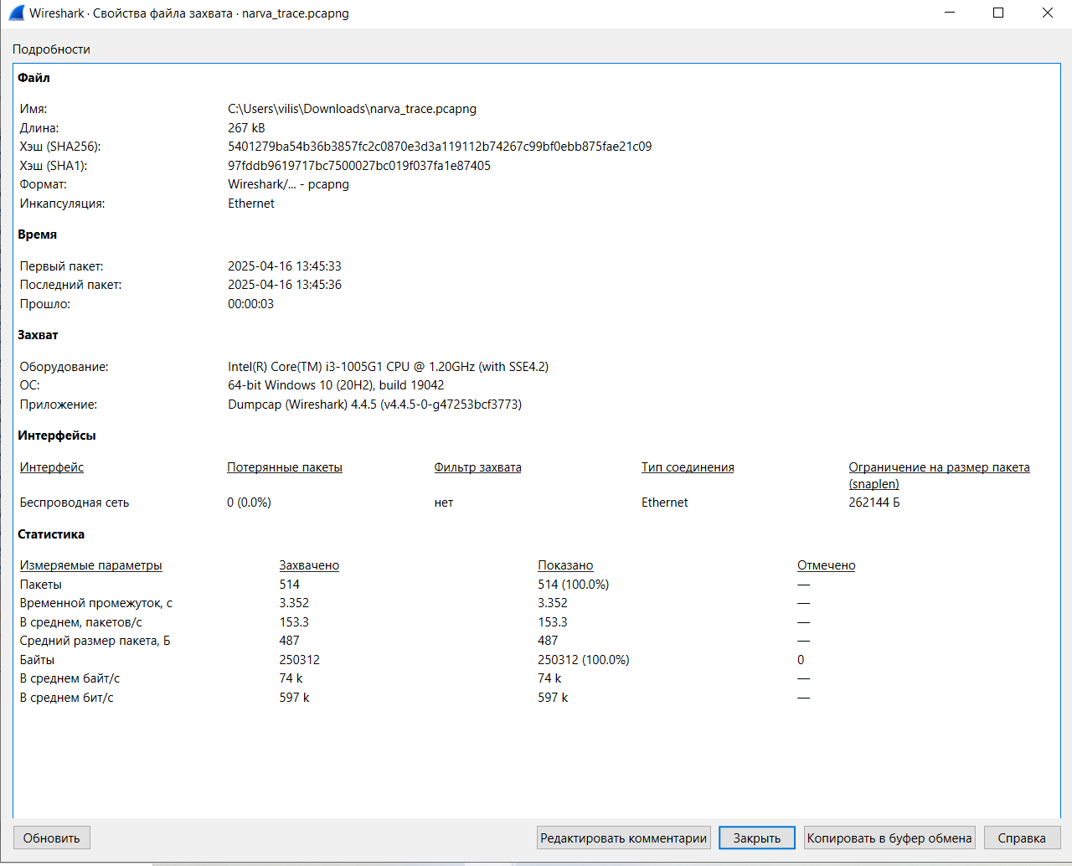
To keep the capture as clean as possible, I shut down all apps using the internet, launched Wireshark, and started the capture on my Ethernet interface. I then opened my browser and visited the Narva College homepage. After the page loaded, I stopped the capture and checked the result: 514 packets were captured in about 3.3 seconds, and everything looked good to go. Wireshark provided all the expected stats like data rate, average packet size, and total bytes transferred.

2. Types of Packets
The Protocol Hierarchy statistics in Wireshark revealed that the captured traffic was composed mainly of UDP packets (61.7%), with a significant portion attributed to the QUIC protocol. TCP packets made up about 38.3% of the traffic, and TLS appeared within that group, indicating secure communications. Additionally, DNS queries were observed at the application layer, highlighting typical web browsing behavior.
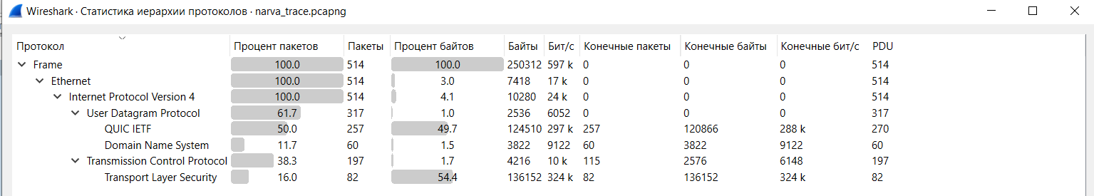
Using the Protocol Hierarchy view in Wireshark, I could see that the majority of the traffic was UDP-based (61.7%), mostly due to QUIC protocol. The rest was TCP (38.3%), and I also saw TLS traffic, which confirmed the use of HTTPS. On the application layer, there were many DNS packets, which makes sense — the browser needed to resolve several hostnames before loading the webpage.

3. MAC Addresses in the Trace
By inspecting the Ethernet II layer, I identified two primary MAC addresses. The source MAC address, associated with my machine, was 0c:9a:3c:0c:13:36. The destination MAC address was 60:15:2b:33:c3:22, likely belonging to a local router or gateway device. This interaction illustrates the fundamental role of MAC addressing in local data transmission.
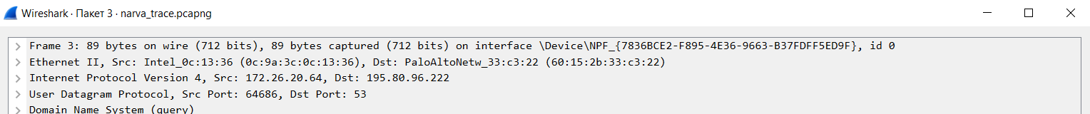
Looking at the Ethernet II layer, I found two MAC addresses involved in most of the traffic. My machine's address was 0c:9a:3c:0c:13:36, and it was communicating with a device identified as 60:15:2b:33:c3:22. That’s likely the router or gateway that forwarded packets further to the internet.

4. Mapping Between IP and MAC Addresses
Interestingly, the capture did not contain any ARP packets. This suggests that the system had already resolved the required MAC addresses before the session began, and thus no ARP requests or responses were needed during the capture period. The mappings remained within the local ARP cache.
No ARP packets were captured. That tells me the ARP cache on my machine already had the required mappings, so there was no need for new ARP requests during the trace.

5. Type of Network Adapter
The capture was conducted on an Ethernet interface, confirming that the system was connected via a wired network. Ethernet connections typically provide more stable and consistent packet captures, making them ideal for network analysis tasks such as this.
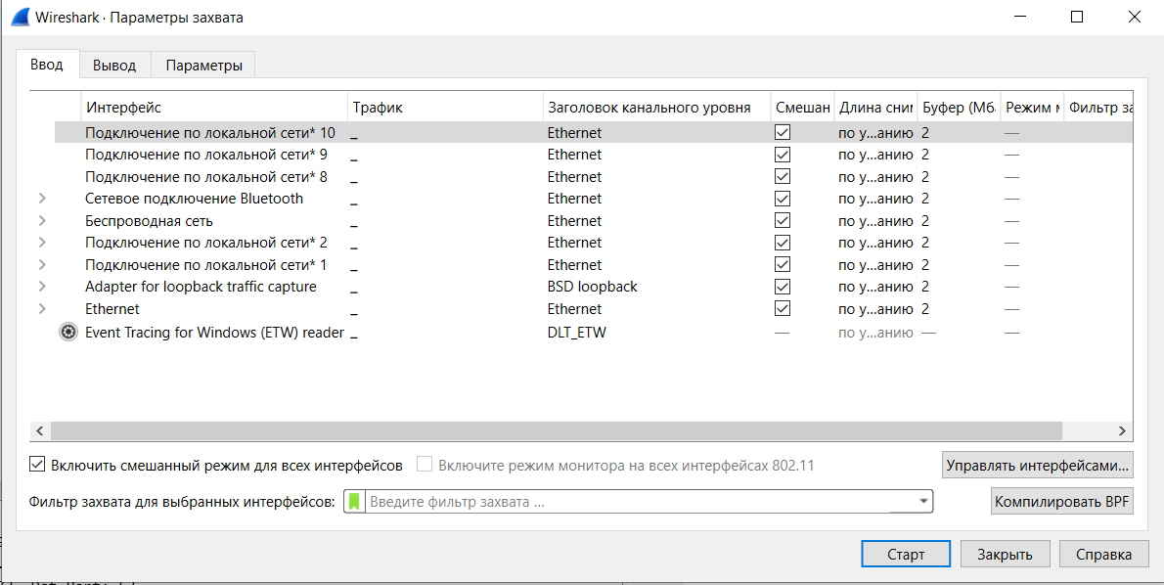
From the capture interface settings, I can confirm that the capture was done over Ethernet. So, this was a wired connection, which usually means a more stable and faster capture with minimal interference.

6. DNS Server Information
The DNS packets observed in the trace indicated that DNS queries were being sent to the server at IP address 195.80.96.222. My local machine, using the address 172.26.20.64, initiated these queries to resolve domain names necessary for rendering the requested webpage. The DNS activity highlights the initial step in establishing connections with remote web servers.
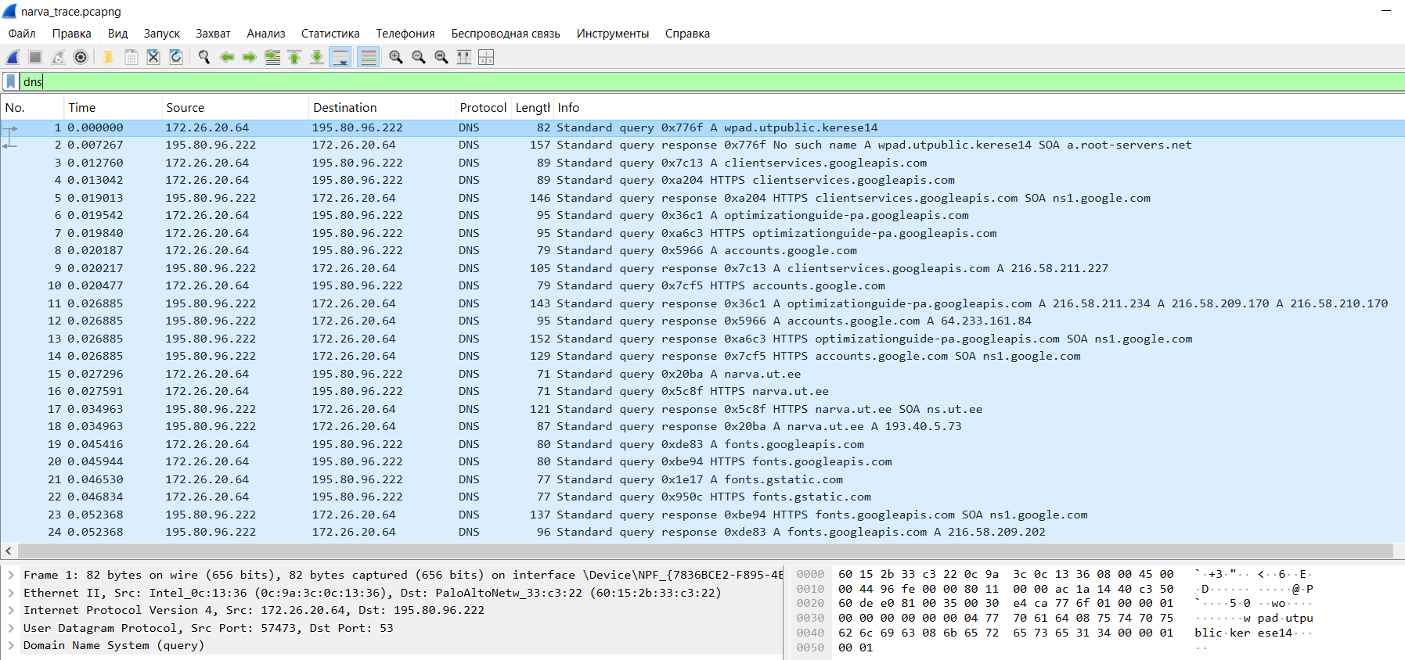
Plenty of DNS traffic was captured, all sent to the DNS server at 195.80.96.222. The local IP of my machine was 172.26.20.64, and from the domains requested (including multiple *.googleapis.com addresses), I could guess that the DNS server was helping resolve both internal resources and third-party content.

7. Distance to Remote Hosts (Hop Count)
By examining the Time To Live (TTL) field in the IP headers, I found a value of 58 in several packets. Assuming a common starting TTL of 64, this suggests that the packets traversed approximately 6 network devices, or "hops," to reach their destinations. This gives a rough estimate of the network distance to the web servers involved.
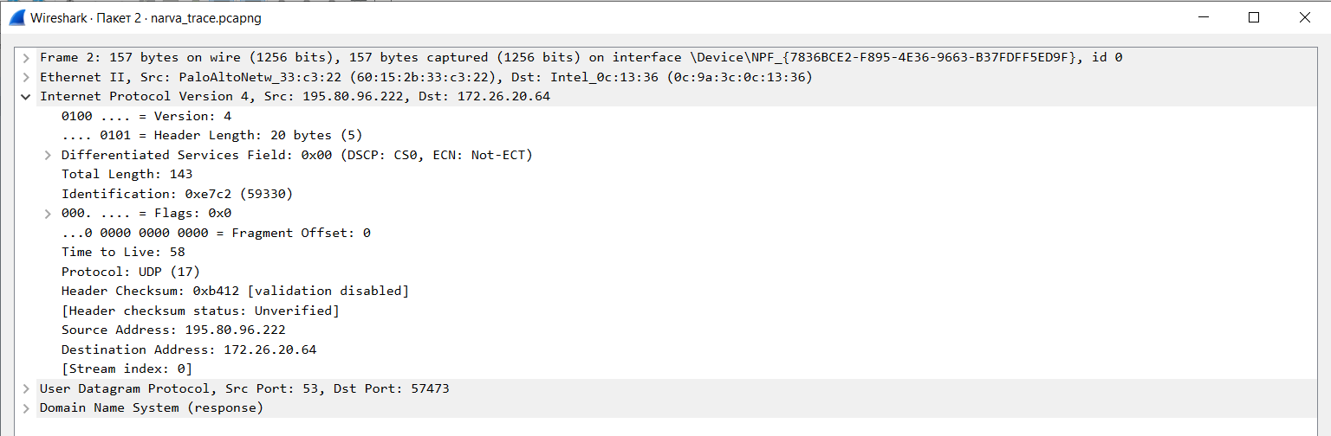
By checking the TTL (Time To Live) field in a few IPv4 packets, I found values like 58. Assuming the sender started with the usual 64, that means the packet passed through about 6 hops. So the remote servers were not too far — probably just a few routers away from my location.

8. IP Fragmentation and DF Flag
The trace did not reveal any fragmented IP packets—there were no instances where the 'More Fragments' flag or fragment offset values were set. However, several packets were marked with the 'Don't Fragment' (DF) flag. This is a common configuration in modern networks to prevent fragmentation, which can complicate packet reassembly and affect performance.
I checked for fragmentation, and — good news — none was found. There were no packets with the 'more fragments' flag set, and no fragment offsets greater than zero. However, I did see quite a few packets with the 'Don't Fragment' flag enabled. That’s common for modern TCP/QUIC traffic to avoid issues with middleboxes or legacy networks.

8. IP Fragmentation and DF Flag
The trace did not reveal any fragmented IP packets—there were no instances where the 'More Fragments' flag or fragment offset values were set. However, several packets were marked with the 'Don't Fragment' (DF) flag. This is a common configuration in modern networks to prevent fragmentation, which can complicate packet reassembly and affect performance.
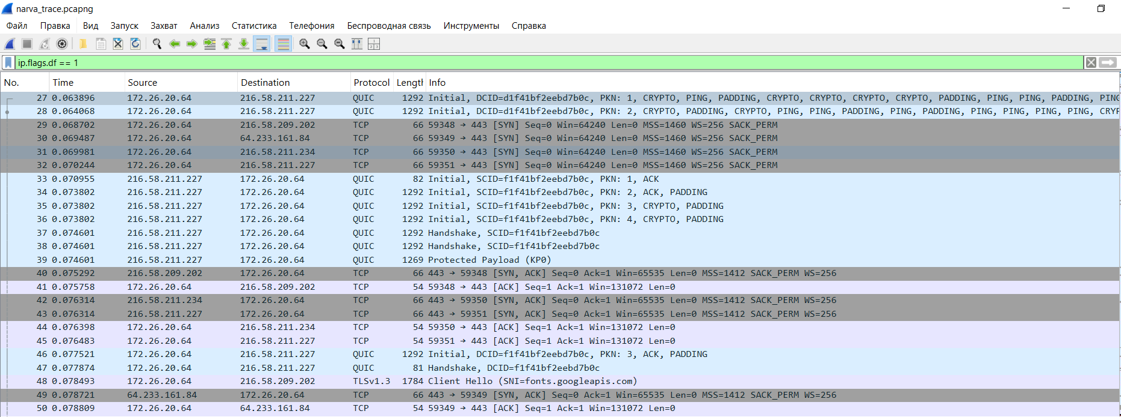
I checked for fragmentation, and — good news — none was found. There were no packets with the 'more fragments' flag set, and no fragment offsets greater than zero. However, I did see quite a few packets with the 'Don't Fragment' flag enabled. That’s common for modern TCP/QUIC traffic to avoid issues with middleboxes or legacy networks.

