DLCV
Hw1

R07945010
許展銘
- Problem 1: Bayes Decision Rule
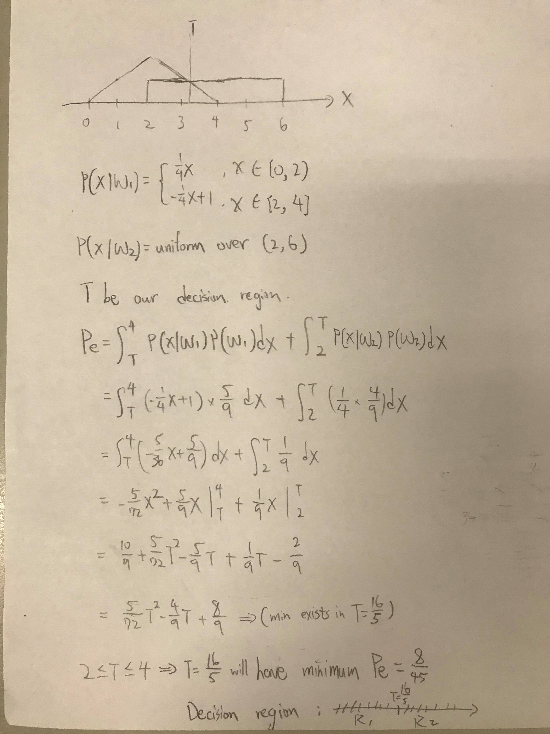
- Problem 2: Principal Component Analysis
1.
Mean face:
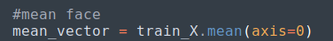

Eigenface:

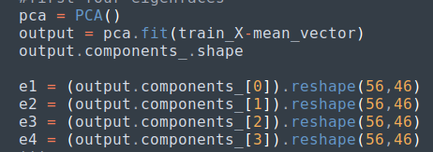

Result:
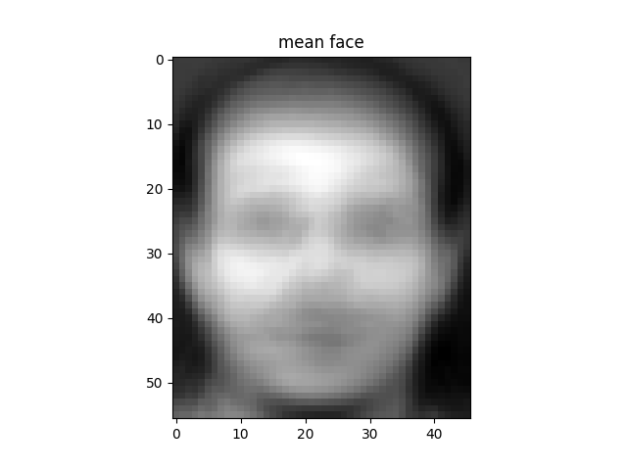

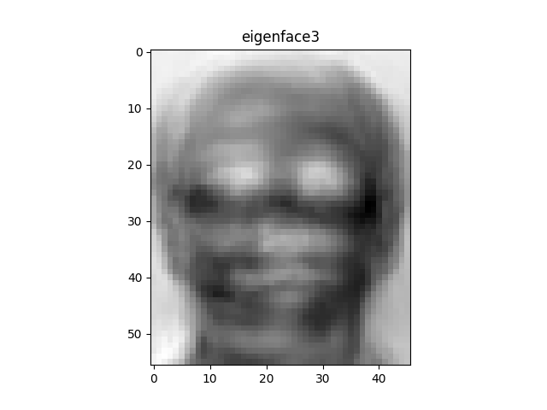

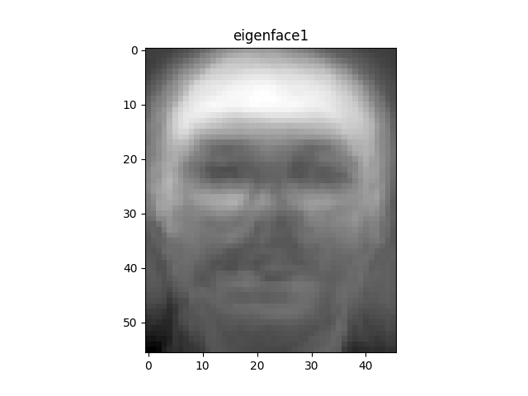
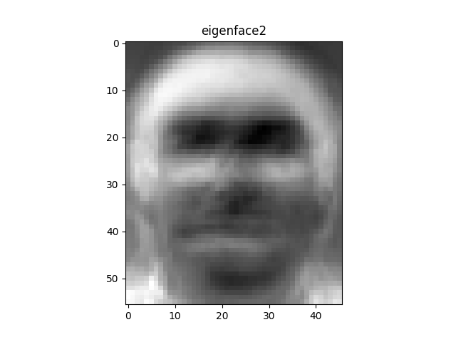
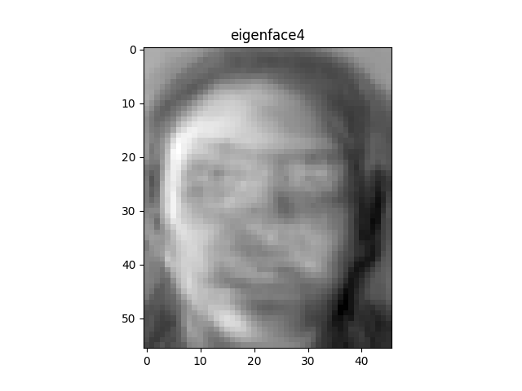

2 and 3. reconstructed images
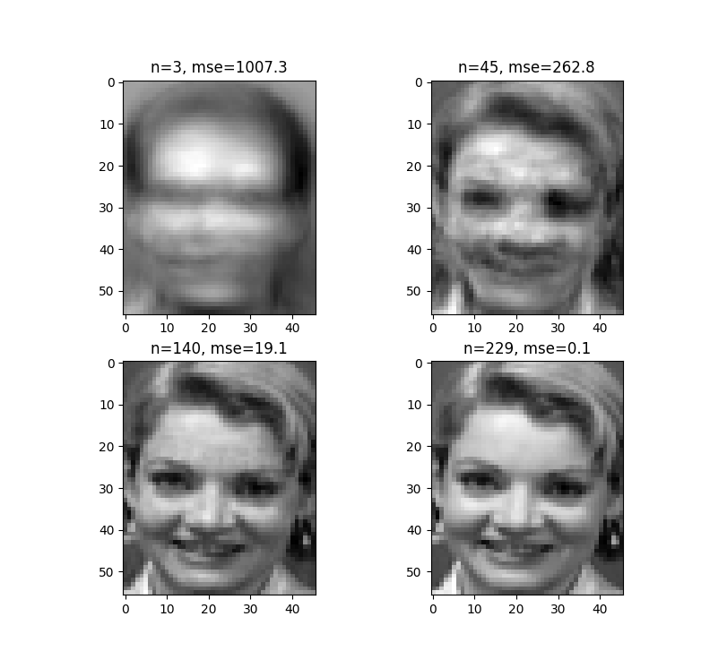

4. k-nearest neighbors
3-fold cross-validation(using GridSearchCV library):
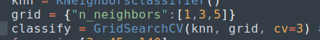

Result of testing model:
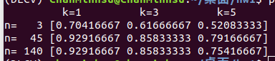

Hence, we can choice k=1, n=45 or 140 since its higher score.
Here we use (k,n) = (1,45) as hyperparameters.
5. recognition rate( Accuracy on testing set)
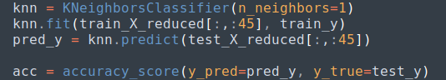
Accuracy:
- Problem 3: Visual Bag-of-Words
1. Picked images vs 3 patches
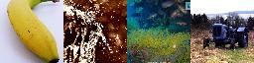
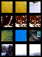

Because of the colors presented in patches(i.e yellow for banana), we easily
classify each image by their patches.

2. Kmeans and PCA
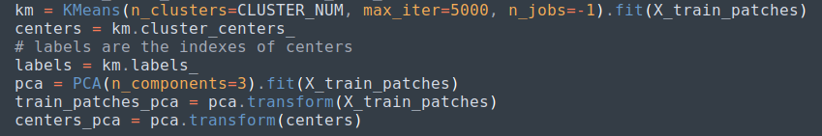
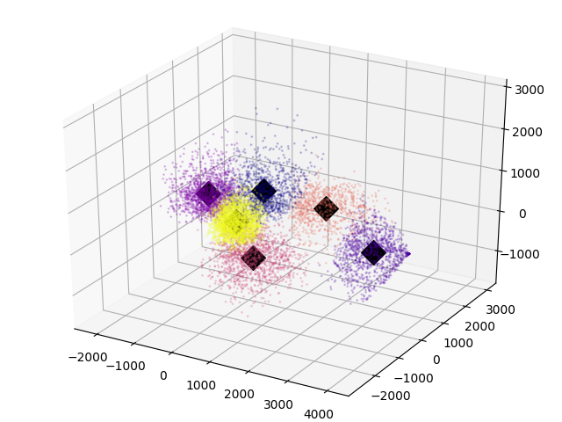

3. BoW using histogram plot(randomly choose four images from each class)
Topleft: Banana Topright: Fountain Downleft: Reef Downright: Tractor
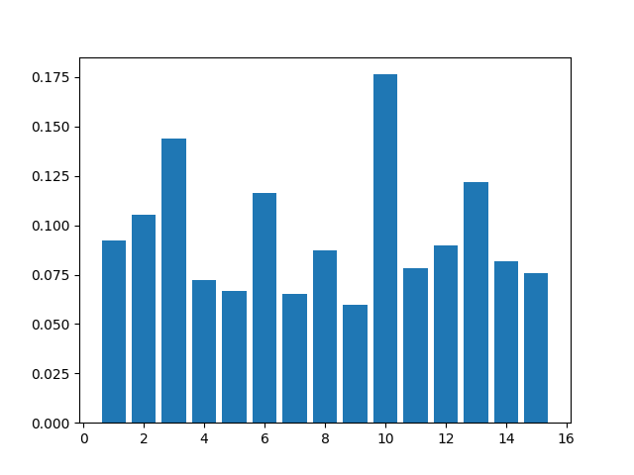
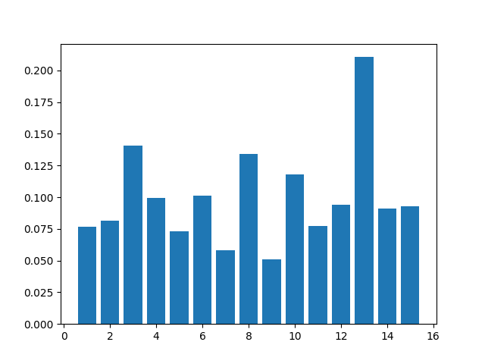
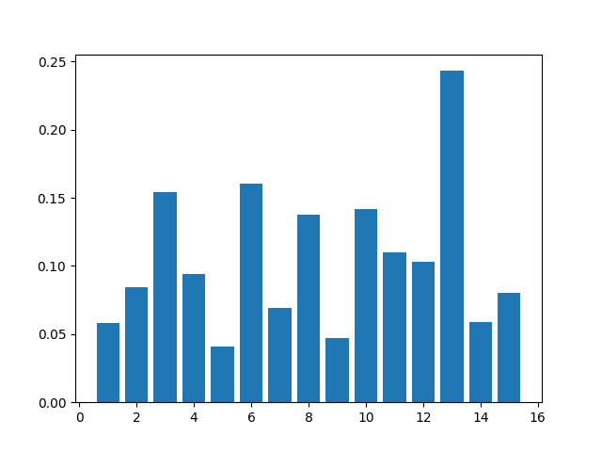
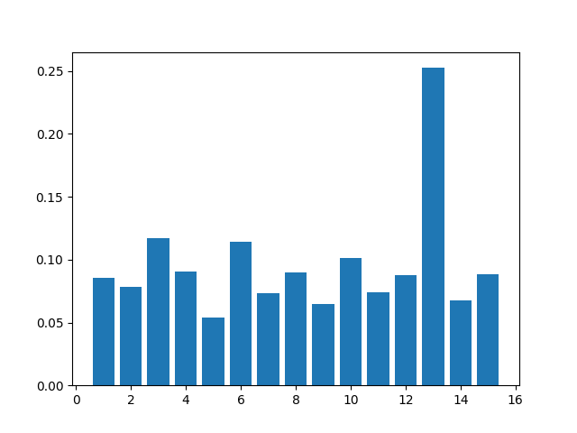
4. Classification accuracy
Accuracy: 0.532

