Computer Vision HW#1 Report B01902040 資工四 鍾毓安

Task:

* Part #1 (Coding):
  + 1. upside-down 上下顛倒
* 2. right-side-left 左右顛倒
* 3. diagonally mirrored 對角線鏡射
* Part #2 (Can use software):
* 4. rotate lena 45 degrees clockwise 順時針 45 度旋轉
* 5. shrink lena in half 長寬各縮小一半
* 6. binarize lena at 128 to get a binary image 二值化圖片，以亮度為 128 當作門檻值，大於 128 則變成 255, 否則變成 0

The original lena:



Code:

Assignment #1 is simple. For tasks 1~3 in part #1and tasks 4 and 5 in part #2, I use imread(...), imwrite(...) in OpenCV for reading and writing image, respectively. Then I use the numerical python library (numpy) to handle the 2D array to achieve each requirement. To be specific, those 5 tasks can all be finished by a simple nested for-loop. Source code is included in main.py and the resulting images are listed as follows (task 1~6, from left to right, from top to down):

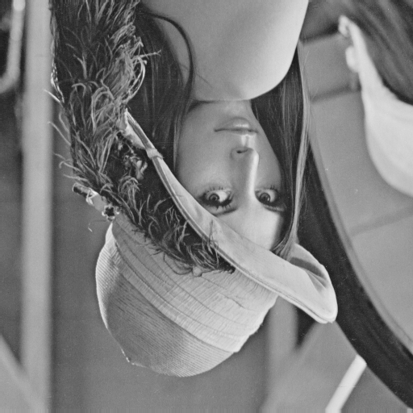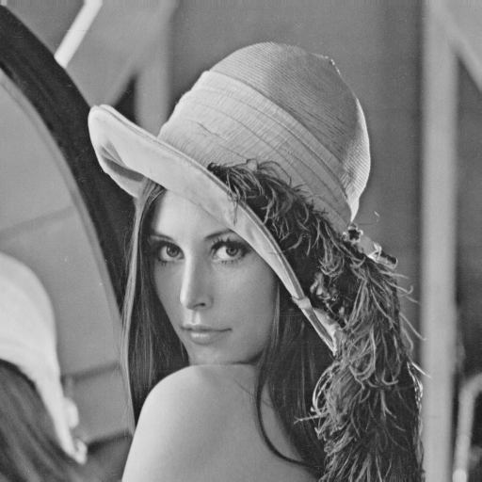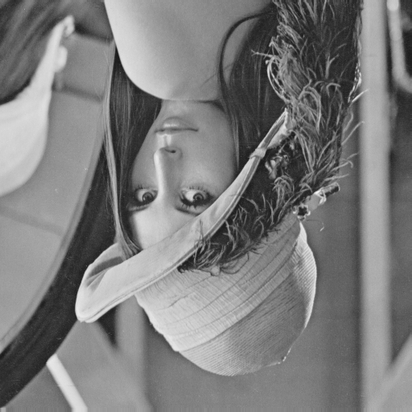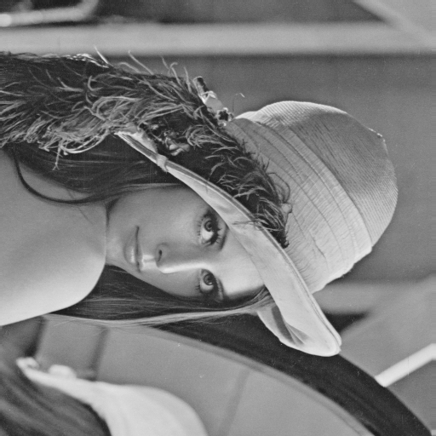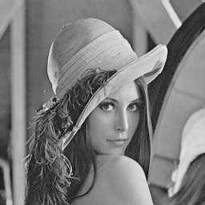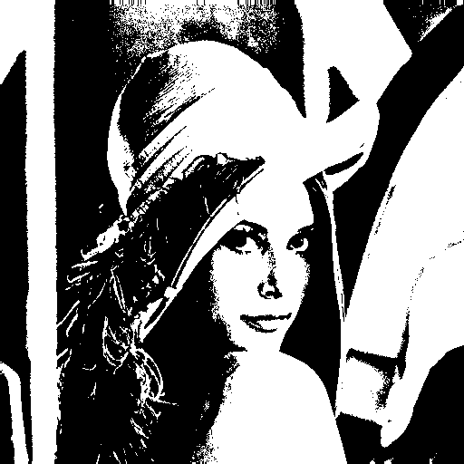

As for task 5 in part #2, I use 預覽程式, which is a built-in utility in Mac OSX. To shrink lena in half, just:

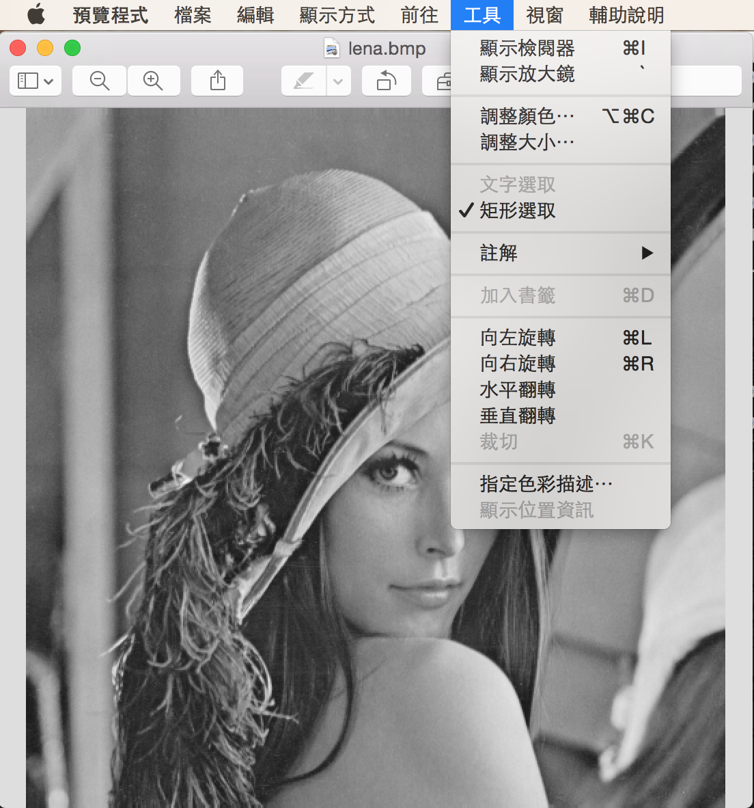  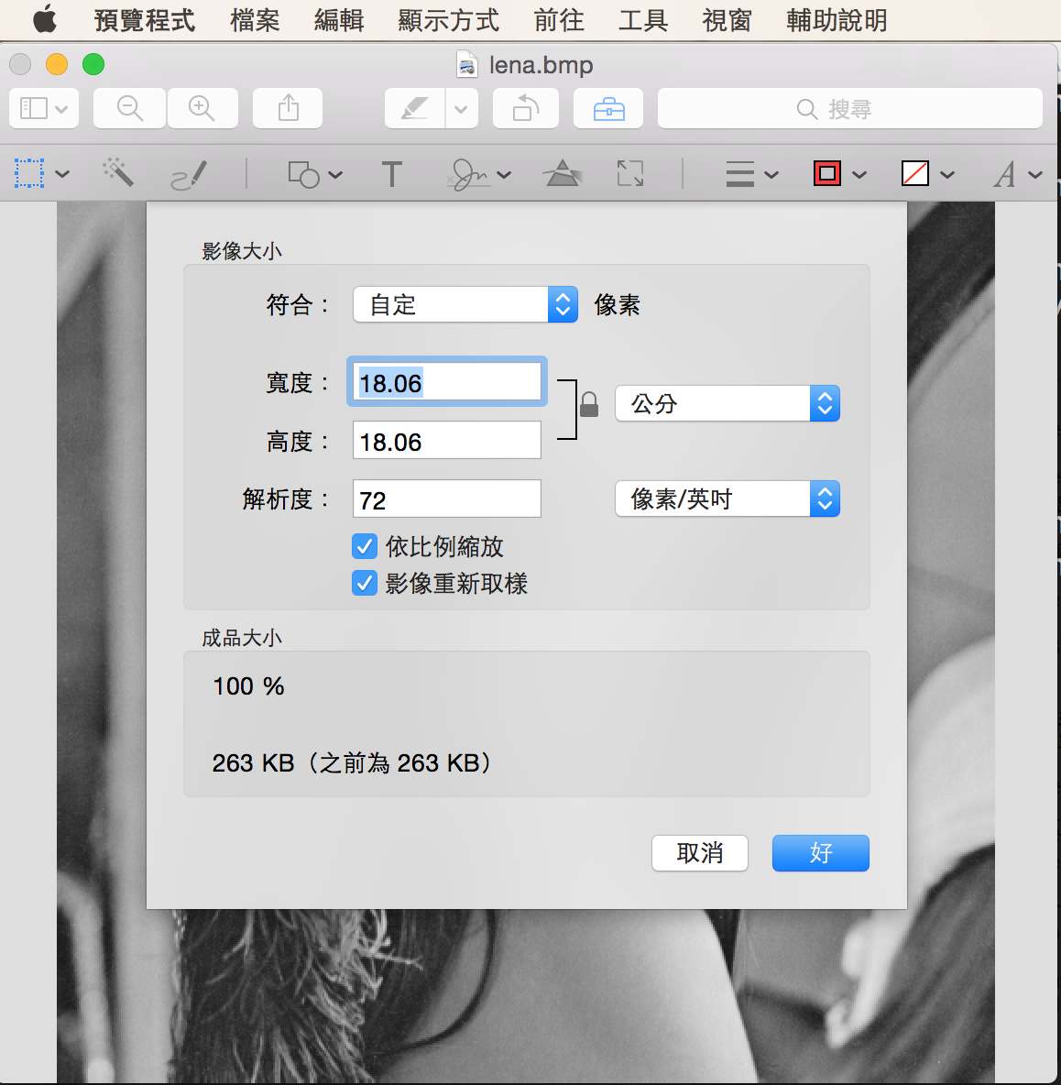

And set both width and height to half. The resulting image is pasted before, please check the uploaded version for more detail.